**Install Guide for gcc on windows**

1. Copy **‘setup-x86_64.exe’** in C: Drive and run it with Admin.
2. Follow instructions and click on next and complete installation

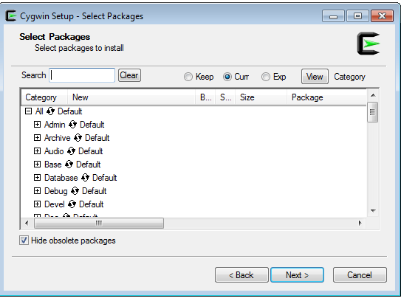

1. It will create **C:\cygwin64 folder**
2. Copy ‘setup-x86_64.exe’ in ‘C:\cygwin64’ folder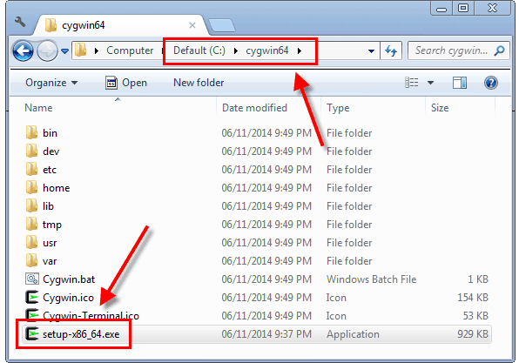
3. Open command prompt ( goto run and type cmd)
4. Change directory using **‘cd C:\cygwin64’**
5. Run below command from command prompt

**setup-x86_64.exe -q -P wget -P gcc-g++ -P make -P diffutils -P libmpfr-devel -P libgmp-devel -P libmpc-devel**

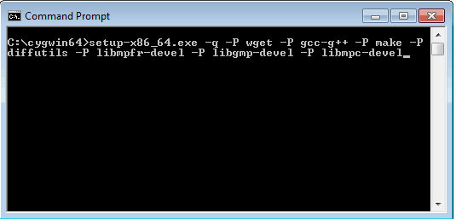

1. After this open Cygwin64 Terminal from Desktop and fire **gcc –version** command

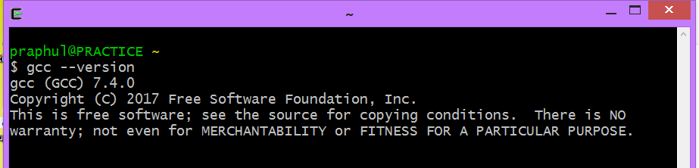

1. Create **Hello.c** file( use notepad++) in any folder like **D:/C_CPP_DS/Test** and change directory as shown ( use forward slash **/** only)

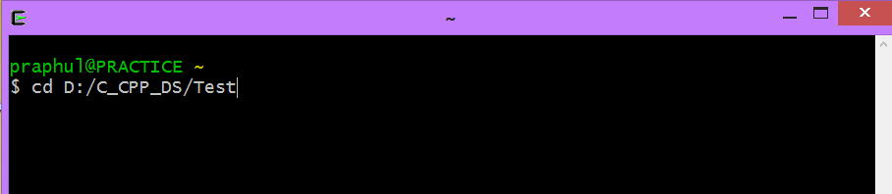

1. Compile Hello.c file using gcc Hello.c command as shown below

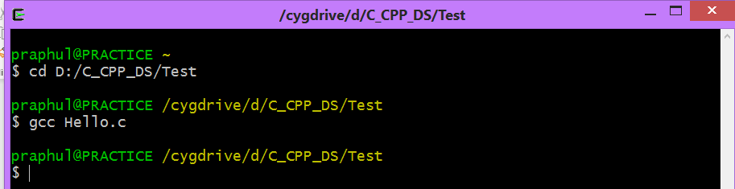

1. If compilation is successful, it will generate a.exe file in the **D:/C_CPP_DS/Test**
2. Run the executable using **./a.exe** as shown below

