

WOLKITE UNIVERSITY

COLLEGE OF COMPUTING AND INFORMATICS

Department of Information Technollogy

course title: Internet Programming ||

Project Tittle: Ethiopian Restaurant Management System

Group Name ID

- Amen Wakwaya………………………………………….. 0084/16
- Amriya Sherif………………………………………………0089/16
- Alewya Sherif ……………………………………………..0075/16
- Amriya Asfaw……………………………………………..0090/16
- Aisha Kabtu ……………………………………………….0065/16
- Biniyam Yoseph …………………………………………..0184/16

Submitted to Mr Abrahum
Submitted Date 2026

Table of Contents

- Introduction…………………………………………………3

- Project Overview…………………………………………….5

- Technologies Used…………………………………………..5

- System Features……………………………………………5

- Installation Guide…………………………………………..15

- Conclusion……………………………………………….15

- Introduction

  - Project Background

In today's fast-paced world, the restaurant industry faces numerous challenges in managing daily operations efficiently. Traditional paper based systems are slow, error-prone, and difficult to maintain. Ethiopian cuisine is rich and diverse, with unique dishes like Doro Wot, Tibs, and Shiro Wet, but many restaurants still struggle with:

- Manual order taking and tracking

- Table management confusion

- Slow payment processing

- Lack of real-time data and reports

- Difficulty in updating menu items

This project aims to solve these problems by providing a comprehensive digital solution tailored specifically for Ethiopian restaurants.

  - Project Objectives

The main objectives of this project are:

- Streamline Order Management: Provide an intuitive Point of Sale (POS) system for quick order taking

- Real-Time Table Tracking: Display table status (Free/Occupied) in real time

- Simplify Menu Management: Allow easy addition, editing, and deletion of food items

- Automate Payment Processing: Handle multiple payment methods with automatic change calculation

- Generate Reports: Provide admin dashboard with key business metrics

- Enhance Customer Experience: Faster service, accurate orders, and professional receipts

1.3 Scope of the Project
The system covers:

User Management

- Secure login system

- Role-based access (Admin/Customer)

- Session management

Restaurant Operations

- Point of Sale (POS) system

- Table management

- Order processing

- Payment handling

- Receipt generation

Administrative Functions

- Dashboard with key metrics

- Menu management

- Order management

- Table management

2. Project Overview
2.1 System Name
Ethiopian Restaurant Management System

2.2 System Type
Web-based Restaurant Management Application

2.3 Target Users
- Administrator: Full Access Manage menu, view reports, manage orders
- Staff / Customer:Limited Access Place orders, make payments

3. Technologies Used
3.1 Backend Technologies
1. PHP _-8.2.12 Server-side scripting
2. Laravel -12.58.0 PHP Framework
3. MySQL -Database Management
4. Composer -Dependency Management

3.2 Frontend Technologies
1. HTML5 - Page Structure
2. CSS3 - Styling
3. JavaScript - Interactive Features

3.3 Development Tools
1. Visual Studio Code Code Editor
2. XAMPP Local Development Server
3. Git Version Control
4. phpMyAdmin Database Management

4. System Features
4.1 Authentication System
4.1.1 Login Page
The login page provides secure access to the system.

Features:

- Email and password authentication

- Remember me functionality

- Role-based redirection

- Error handling for invalid credentials

4.1.2 Registration
New users can register as customers.

Features:

- Name, email, and password validation

- Password confirmation

- Automatic role assignment (customer)

- Redirect to POS after registration

1: LOGIN PAGE
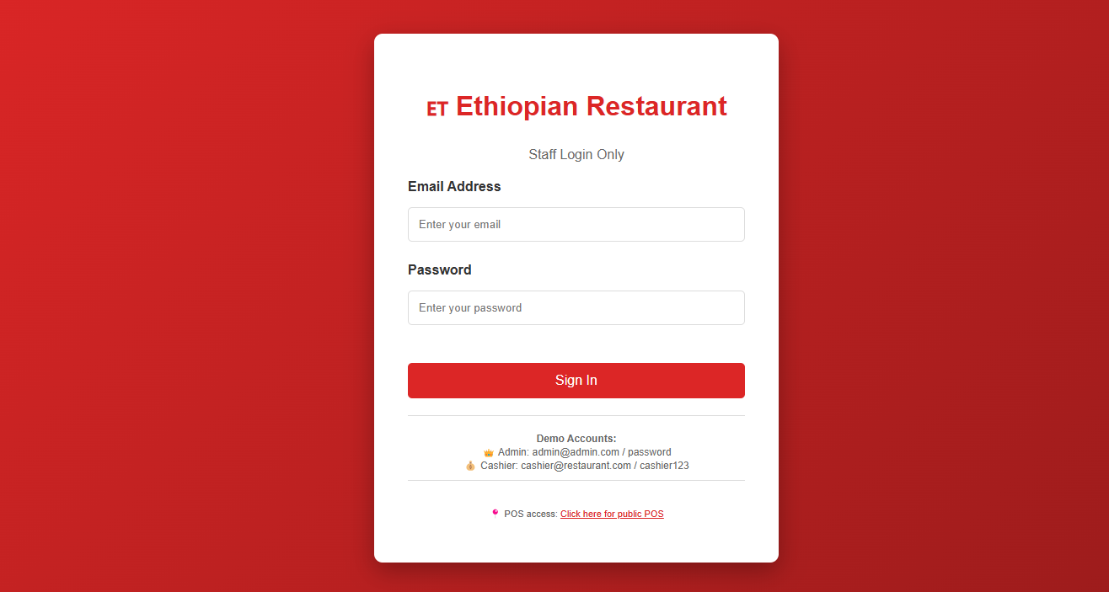

4.2 Point of Sale (POS) System
The POS is the core module where orders are placed.

4.2.1 Menu Display
Features:

- All food items displayed with images

- Shows price, description, and special tags

- Visual indicators for spicy and vegetarian items

- Organized by categories

4.2.2 Cart Management
Features:

- Add items with one click

- Increase/decrease quantities

- Remove items from cart

- Real-time subtotal calculation

- Display tax (5%) and service charge (10%)

4.2.3 Table Selection
Features:

- Dropdown with all tables

- Shows table number and capacity

- Displays FREE/OCCUPIED status

- Disables occupied tables

- Shows table count status bar

2: POS PAGE - MENU AND CART
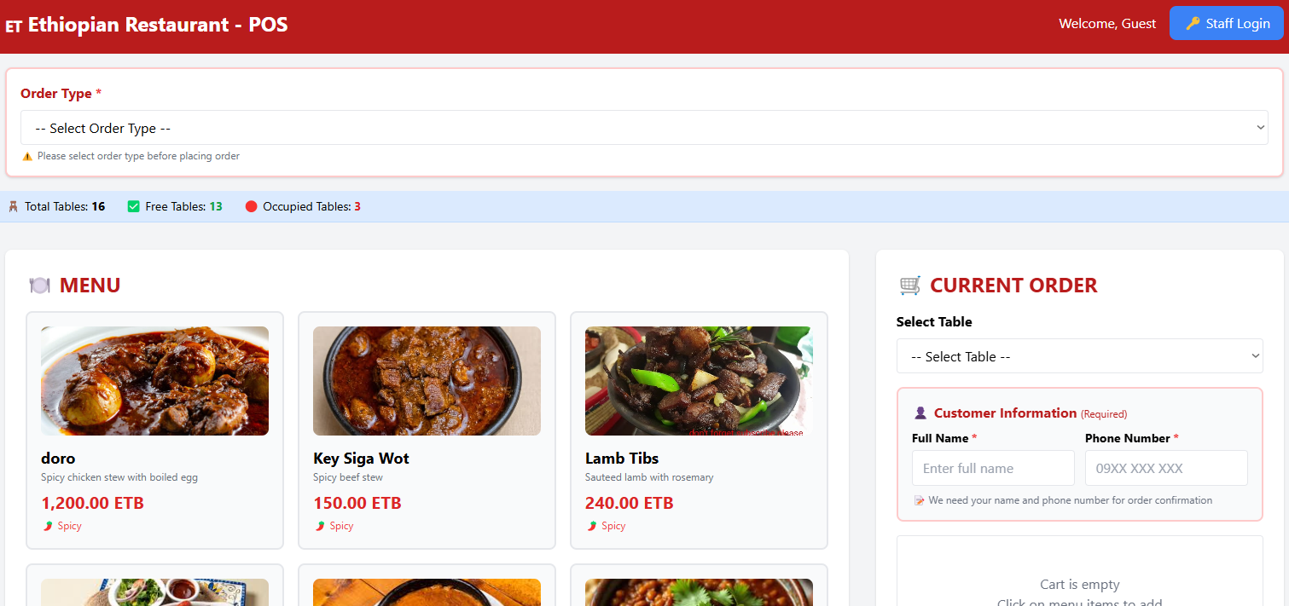

3: POS PAGE - TABLE SELECTION
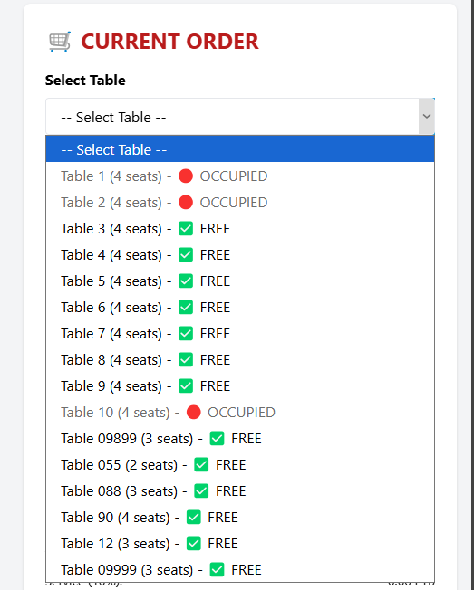

4.3 Payment System
4.3.1 Payment Methods
The system supports four payment methods:

- Cash : Physical currency
- Telebirr : Ethiopian mobile money
- CBE Birr : Commercial Bank of Ethiopia mobile banking

4.3.3 Receipt Generation

- Professional receipt format

- All order items listed

- Subtotal, tax, service, total

- Payment method and change

- Print functionality

- Auto-close after printing

4: PAYMENT MODAL
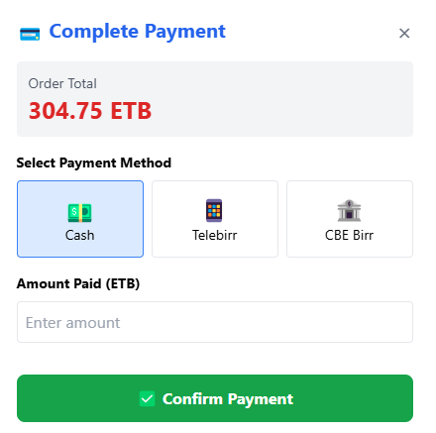

4.4 Table Management
4.4.1 Table Status Tracking
1. Free: Available for new customers
2. Occupied: Currently in use, cannot select

4.4.2 Automation

- Table becomes OCCUPIED when an order is placed

- Table becomes FREE after payment is completed

- Real-time updates in dropdown

4.5 Admin Dashboard
4.5.1 Statistics Cards
1. Total Orders: Total number of orders placed
2. Pending Orders: Orders awaiting completion
3. Revenue: Total revenue generated
4. Total Users: Number of registered users

4.5.2 Recent Orders Table
1. Unique order number
2. Table number
3. Order total amount
4. Current order status
5. Order placement time
6. View order details

4.5.3 Management Cards
1. Menu Management : Add, edit, delete food items
2. Order Management : View and update orders
3. Table Management : Manage tables

5: ADMIN DASHBOARD
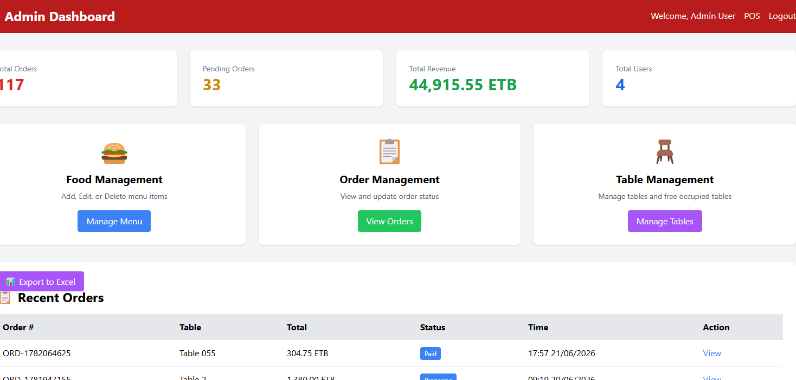

6: RECENT ORDERS TABLE
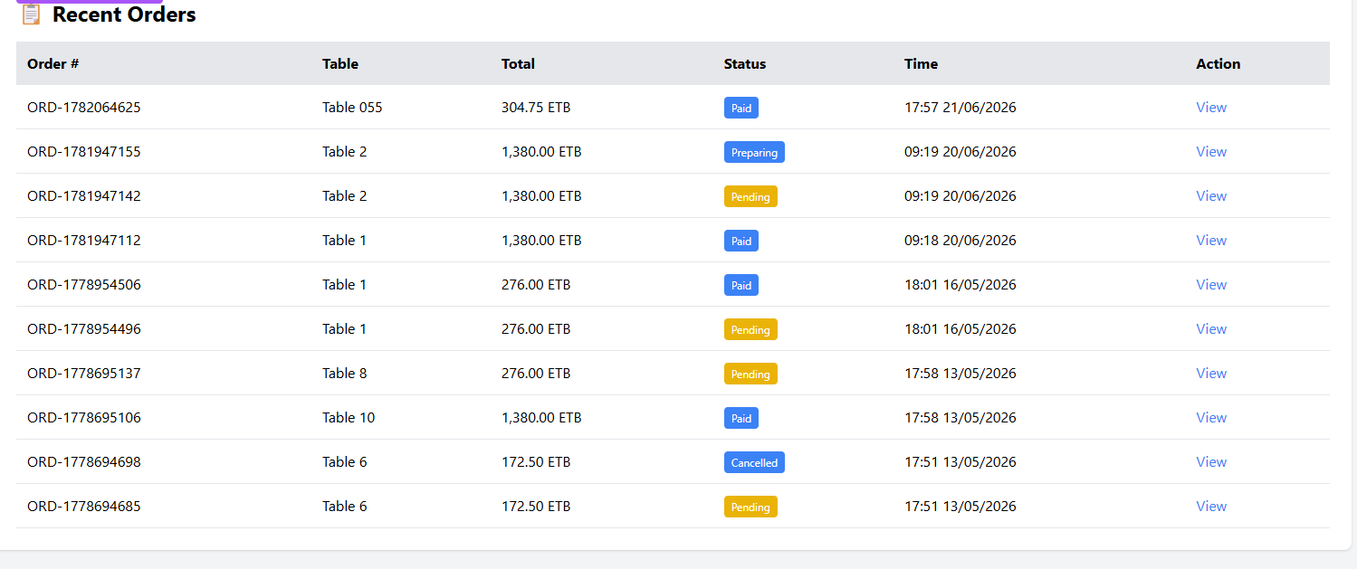

4.6 Food Management
4.6.1 Features
1. Add Food : Create new menu items with name, description, price, category, image
2. Edit Food : Update existing food details
3. Delete Food : Remove items from menu
4. Toggle Availability : Mark items as available/unavailable

7: FOOD MANAGEMENT PAGE
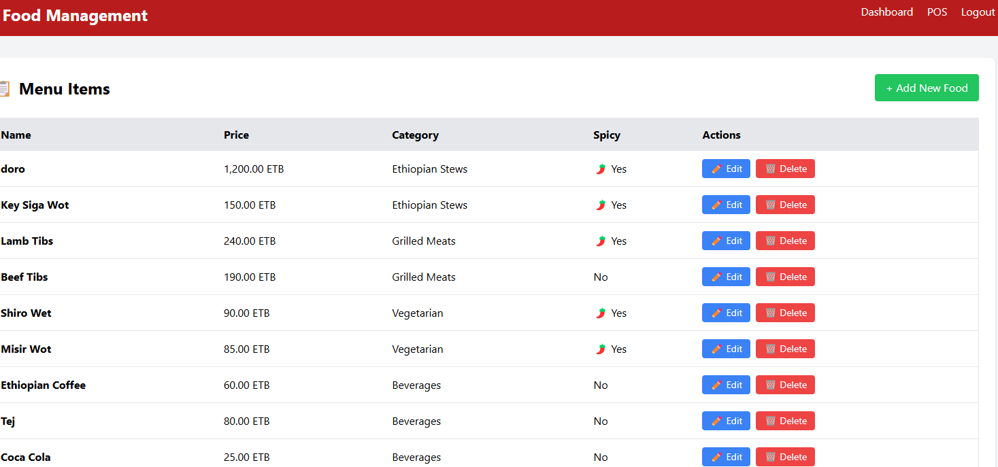

8: ADD FOOD FORM
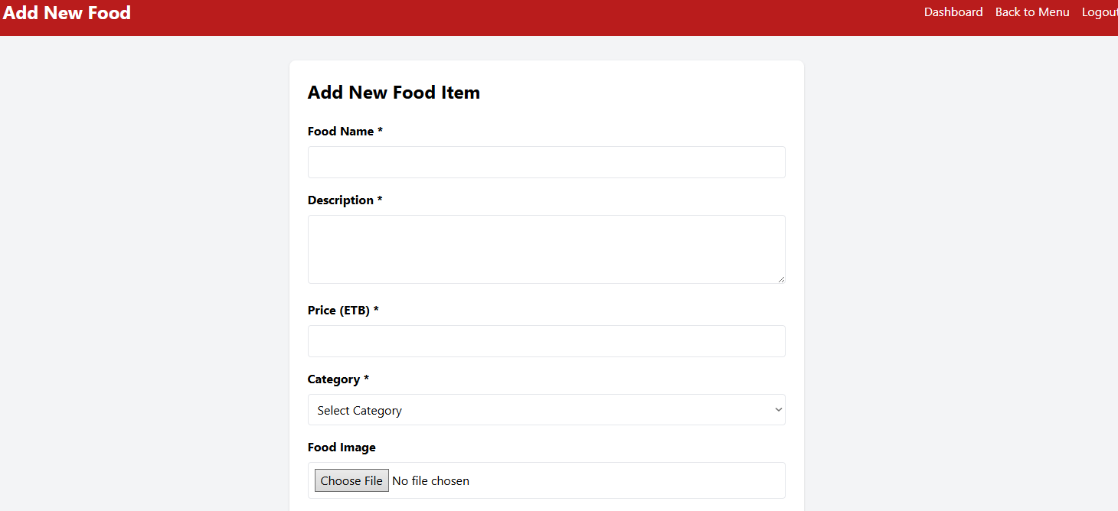

9: EDIT FOOD FORM
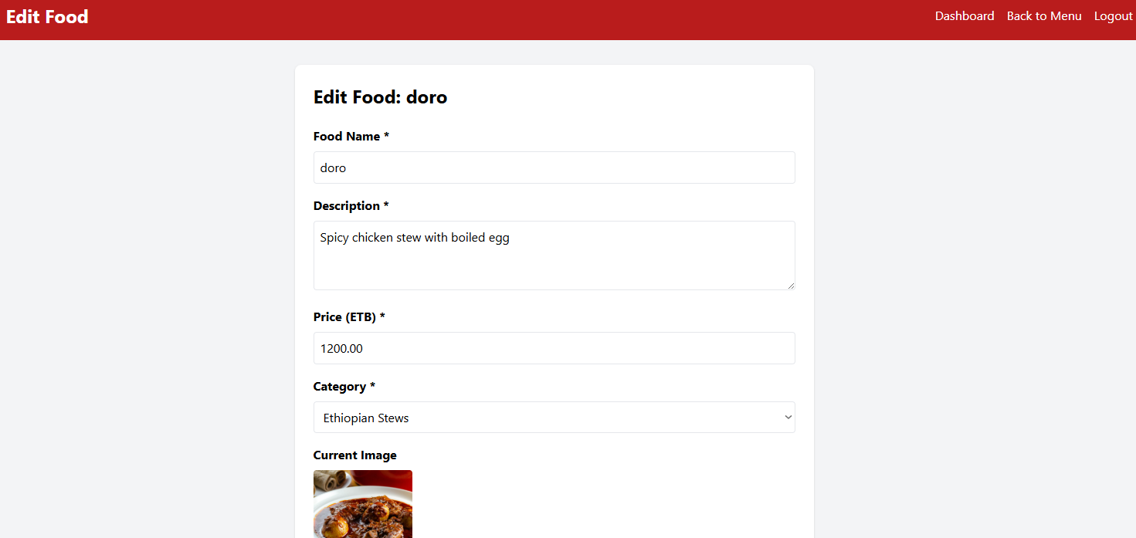

10: ORDER PLACEMENT TEST
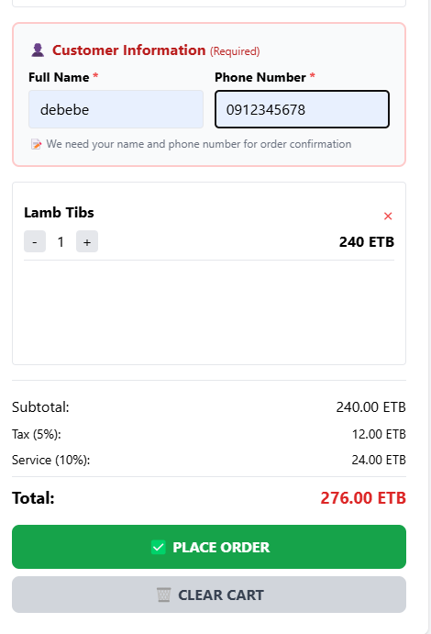

11: ADMIN ORDER VIEW TEST
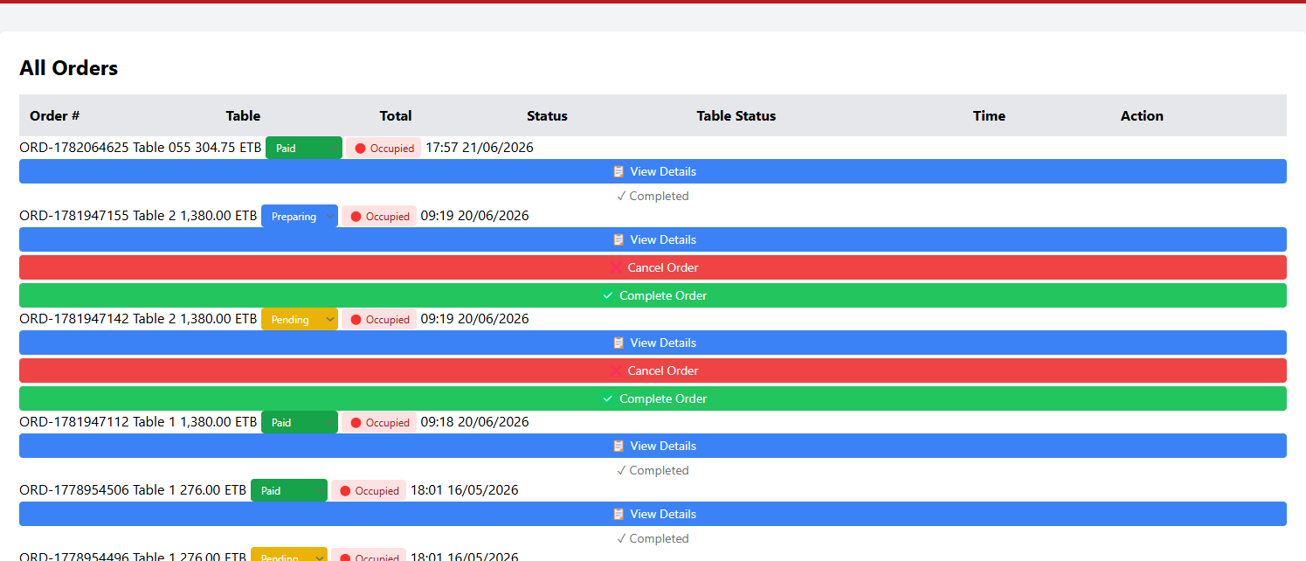

5. Installation Guide
5.1 System Requirements

- PHP 8.1 or higher

- MySQL 5.7 or higher

- Composer

- Node.js & NPM

6. Conclusion
6.1 Project Summary
The Ethiopian Restaurant Management System is a fully functional web application that successfully addresses the needs of a modern restaurant. It provides:

- Efficient Order Processing - Streamlined POS system
- Real-time Table Tracking - Know which tables are free or occupied
- Easy Menu Management - Add, edit, delete food items
- Secure Payment Handling - Multiple payment methods
- Admin Dashboard - Complete overview and control
- User-Friendly Interface - Intuitive design

