●创建canvas

<canvas id="canvas" width="1024" height="768"></canvas>

推荐在标签内用width和height属性来定义canvas的大小，这不只是大小，还定义了canvas的分辨率。

而用css来定义大小，只是定义了canvas的画布大小。

<script>

        window.onload = function () {

            var canvas = document.getElementById('canvas')

            // 用js设置canvas的大小，等同与canvas标签里的width和height属性

            canvas.width = 1024

            canvas.height = 768

            var context = canvas.getContext('2d')

        }

    </script>

在JS也可以设定canvas的大小

以下是带兼容性判断的一个创建canvas的例子

Canvas标签里的内容，如果兼容是不显示的，如果不兼容则会显示

Js里也可以加上if判断浏览器是否兼容

<body>

    <canvas id="canvas" width="1024" height="768" style="border: 1px solid #cccccc; display: block; margin: 50px auto;">

        当前浏览器不支持Canvas,请更换浏览器后再试

    </canvas>

    <script>

        window.onload = function () {

            var canvas = document.getElementById('canvas')

            // 用js设置canvas的大小，等同与canvas标签里的width和height属性

            canvas.width = 1024

            canvas.height = 768

            if (canvas.getContext('2d')) {  //判断浏览器是否兼容canvas

                var context = canvas.getContext('2d')

                //开始绘制

            } else {

                alert('当前浏览器不支持Canvas,请更换浏览器后再试')

            }

        }

    </script>

</body>

设置宽高推荐如下写法

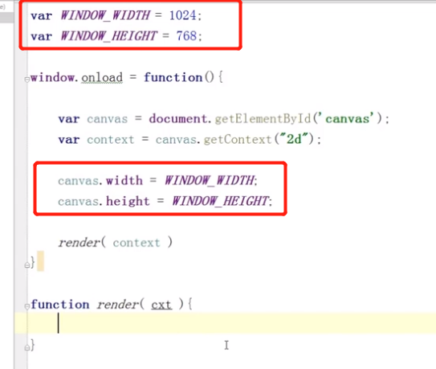

●绘制线条

<!DOCTYPE html>

<html lang="en">

<head>

    <meta charset="UTF-8">

    <meta name="viewport" content="width=device-width, initial-scale=1.0">

    <title>Document</title>

    <style>

        #canvas {

            width: 100%;

        }

        .box {

            width: 50%;

        }

    </style>

</head>

<body>

    <div class="box">

        <canvas id="canvas" width="1024" height="768" style="border: 1px solid #cccccc; display: block; margin: 50px auto;">

            当前浏览器不支持Canvas,请更换浏览器后再试

        </canvas>

    </div>

    <script>

        window.onload = function () {

            var canvas = document.getElementById('canvas')

            // 用js设置canvas的大小，等同与canvas标签里的width和height属性

            canvas.width = 1024

            canvas.height = 768

            if (canvas.getContext('2d')) {  //判断浏览器是否兼容canvas

                var context = canvas.getContext('2d')

                //开始绘制

                context.beginPath()

                context.moveTo(100, 100)

                context.lineTo(700, 700)

                context.lineTo(100, 700)

                context.lineTo(100, 100)

                context.closePath()

                context.lineWidth = 5

                context.fillStyle = "rgb(2,100,30"

                context.fill()

                context.strokeStyle = "#005588"

                context.stroke()

                context.beginPath()

                context.moveTo(200, 100)

                context.lineTo(700, 600)

                context.closePath()

                context.strokeStyle = "black"

                context.stroke()

            } else {

                alert('当前浏览器不支持Canvas,请更换浏览器后再试')

            }

        }

    </script>

</body>

</html>

●绘制圆

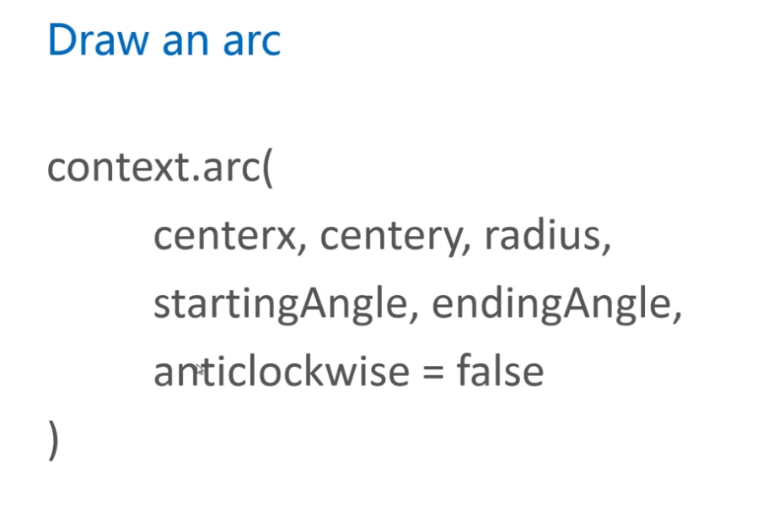

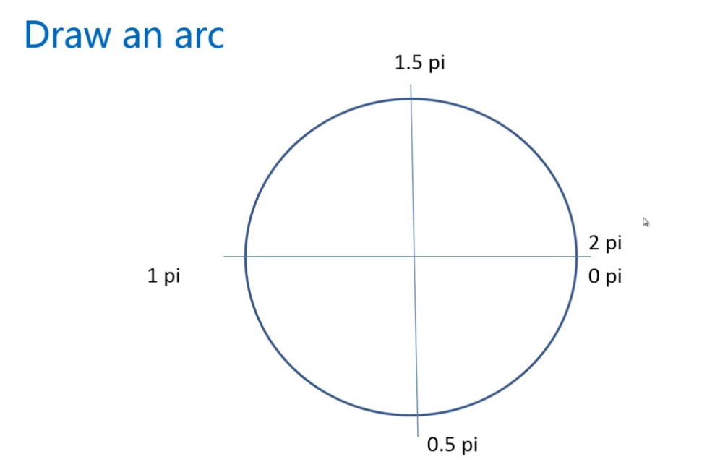

<!DOCTYPE html>

<html lang="en">

<head>

    <meta charset="UTF-8">

    <meta name="viewport" content="width=device-width, initial-scale=1.0">

    <title>Document</title>

    <style>

        #canvas {

            width: 100%;

        }

        .box {

            width: 50%;

        }

    </style>

</head>

<body>

    <div class="box">

        <canvas id="canvas" width="1024" height="768" style="border: 1px solid #cccccc; display: block; margin: 50px auto;">

            当前浏览器不支持Canvas,请更换浏览器后再试

        </canvas>

    </div>

    <script>

        window.onload = function () {

            var canvas = document.getElementById('canvas')

            // 用js设置canvas的大小，等同与canvas标签里的width和height属性

            canvas.width = 1024

            canvas.height = 768

            if (canvas.getContext('2d')) {  //判断浏览器是否兼容canvas

                var context = canvas.getContext('2d')

                //开始绘制

                context.lineWidth = 50

                context.beginPath()

                context.strokeStyle = "#005588"

                context.arc(300, 300, 200, 0, 1.5\*Math.PI)

                context.stroke()

                context.closePath()

                context.beginPath()

                context.strokeStyle = "red"

                context.arc(300, 300, 200, 1.5\*Math.PI, 2\*Math.PI)

                context.stroke()

                context.closePath()

            } else {

                alert('当前浏览器不支持Canvas,请更换浏览器后再试')

            }

        }

    </script>

</body>

</html>

注意点

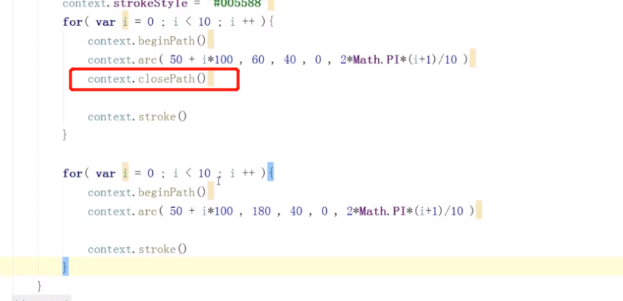

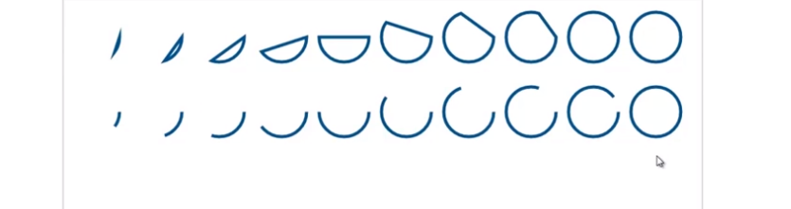

如果加了closePath，则系统自动将不闭合的弧线收尾相连

如果想画开放的，就不加closePath

●

小结

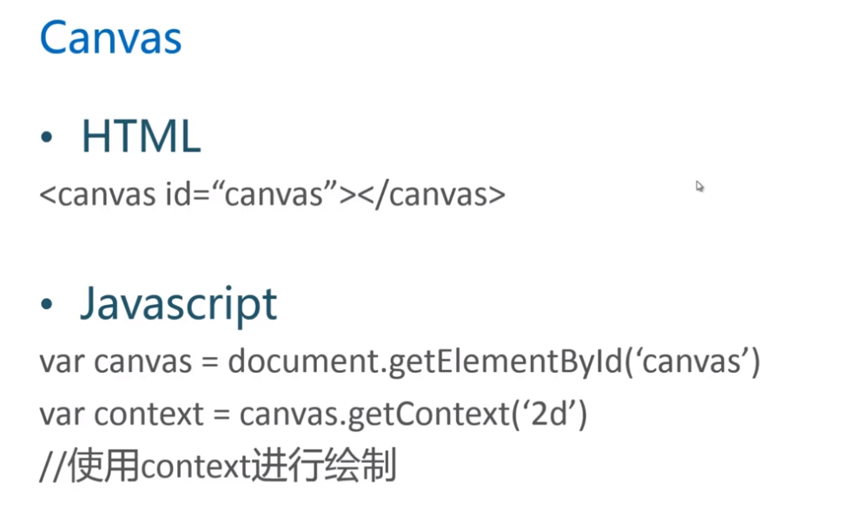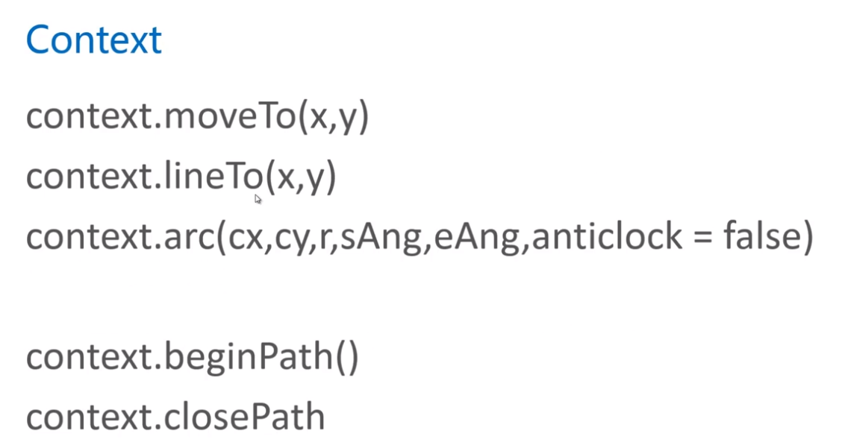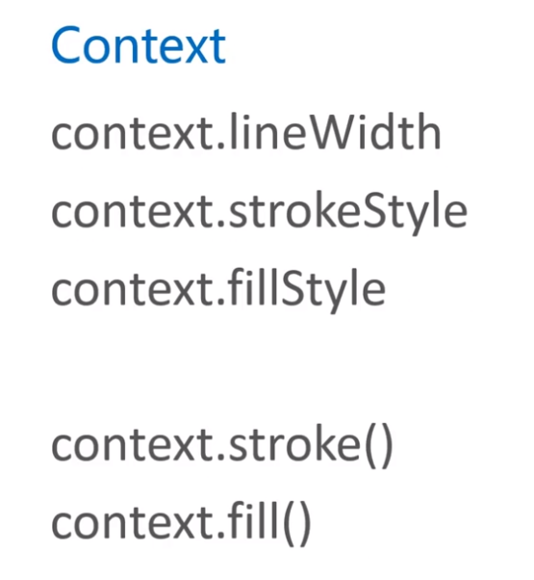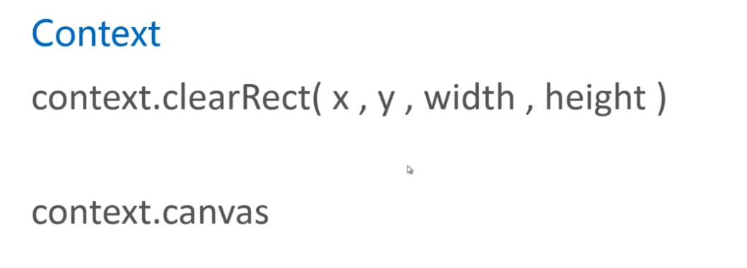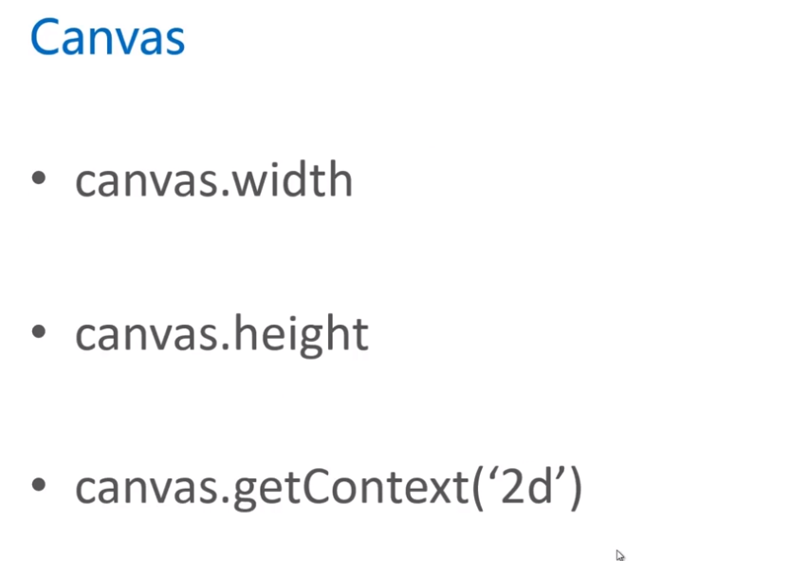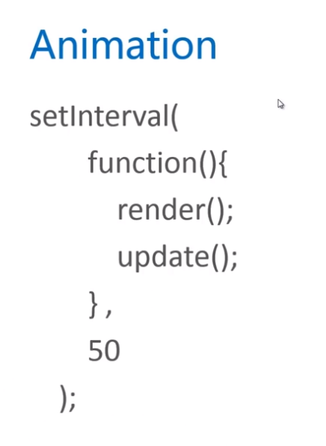

●暂时

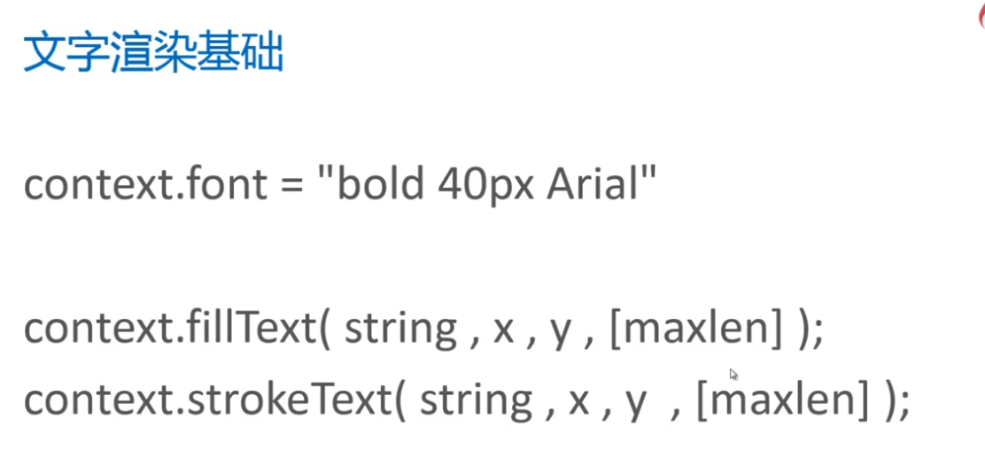

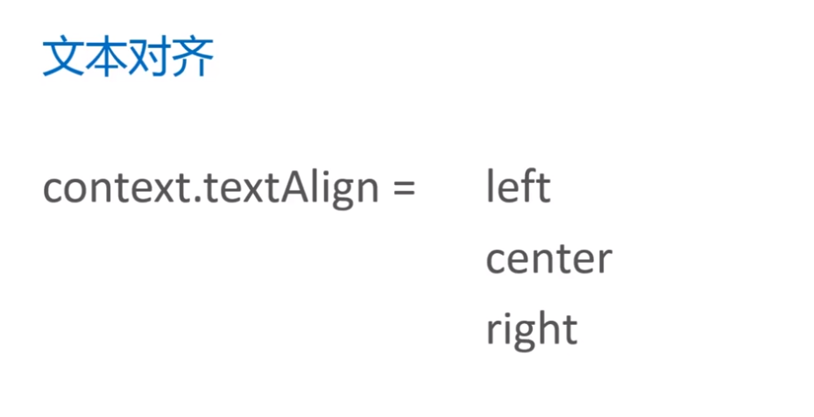

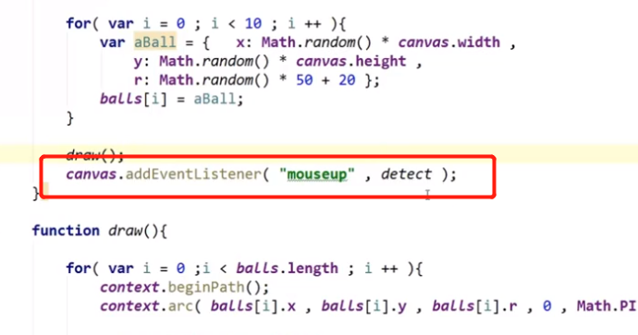

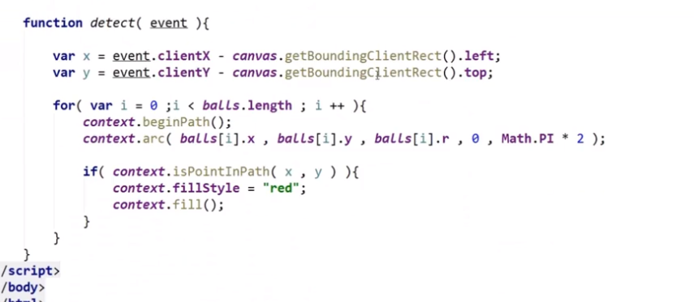

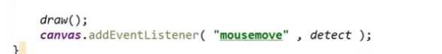

参考文档

<https://www.w3school.com.cn/tags/canvas_shadowblur.asp>