**<https://zhuanlan.zhihu.com/p/89455793>**

**自媒体短视频素材内容，常用工具及教程。（全网最全整理）**

[超级无敌Da魔王](https://www.zhihu.com/people/ni-de-nan-hai-dd)

[**超级无敌Da魔王**](https://www.zhihu.com/people/ni-de-nan-hai-dd)

国家高级摄影师、青年画家、导演。

7 人赞同了该文章

**图文自媒体平台：**微博、微信公众平台、知乎、今日头条、趣头条、快压头条一点资讯、豆瓣、腾讯新闻、百度百家、百度新闻 、搜狐新闻、凤凰新闻、站长之家、蓝鲸、网易新闻等。

**短视频自媒体平台：**抖音 、快手、美拍、秒拍、火山小视频 、微视、一直播、小咖秀、西瓜视频、逗拍、内涵段子 、百思不得姐、奶糖等。

**视频自媒体平台：**优酷，土豆、爱奇艺、搜狐视频、腾迅视频、酷6视频、56视频、youtube、bilibili、twitter等。

**音频自媒体平台：**喜马拉雅FM、考拉FM6、蜻址FM4、茘枝FM2、企鹅FM3、懒人听书、掌阅听书、酷我听书、氧气听书等。

**图文排版工具:**

[365微信编辑器](https://link.zhihu.com/?target=http%3A//www.365editor.com/%3Ff%3Dq%26k%3D333851)、[秀米 XIUMI](https://link.zhihu.com/?target=https%3A//xiumi.us/)、[135编辑器](https://link.zhihu.com/?target=https%3A//www.135editor.com/" \t "_blank)、[创客贴](https://link.zhihu.com/?target=https%3A//www.chuangkit.com/adlp/xinmeitilp.html%3Futm_source%3D360%25E6%2590%259C%25E7%25B4%25A2%26utm_medium%3Dcpc%26utm_campaign%3D%25E7%25A4%25BE%25E4%25BA%25A4%25E5%25AA%2592%25E4%25BD%2593%26utm_content%3D%25E5%2585%25AC%25E4%25BC%2597%25E5%258F%25B7%25E7%25BC%2596%25E8%25BE%2591%25E5%2599%25A8%26utm_term%3Di%25E6%258E%2592%25E7%2589%2588%25E5%25BE%25AE%25E4%25BF%25A1%25E7%25BC%2596%25E8%25BE%2591%25E5%2599%25A8)、[i排](https://link.zhihu.com/?target=http%3A//ipaiban.com/)版、[易撰](https://link.zhihu.com/?target=http%3A//www.yizhuan5.com/)、符号大全、[第九工场](https://link.zhihu.com/?target=http%3A//www.9thws.com/NintFactory_1/BGS1102.html)、[草料二维码生成器](https://link.zhihu.com/?target=https%3A//cli.im/)、[在线生成二维码改图宝](https://link.zhihu.com/?target=https%3A//www.gaitubao.com/qrcode/)

**图片在线设计网站：**[设计坞](https://link.zhihu.com/?target=https%3A//isheji5.com/advertisement/index%3Futm_source%3D360jj%26utm_medium%3DJ1-360%26utm_campaign%3Djp%26utm_term%3D9315" \t "_blank)、[创客贴](https://link.zhihu.com/?target=https%3A//www.chuangkit.com/)、[Fotor懒设计](https://link.zhihu.com/?target=https%3A//www.fotor.com.cn/company/privacy/index.html)、[中国色](https://link.zhihu.com/?target=http%3A//zhongguose.com/)、[Palette](https://link.zhihu.com/?target=https%3A//palette.com/)

**图片处理：**Adobe photoshop、 Photo Size Optimizer、智图、Tinypng、punypng、图好快、美图秀秀

**视频编辑软件：**Premiere、Vegas、AVID7、EDIUS、万兴神剪手、 会声会影、快剪辑、爱剪辑、Final Cut Pro、DaVinci Resolve

**伪原创工具：**

[奶盘SEO伪原创](https://link.zhihu.com/?target=http%3A//www.naipan.com/)、[伪原创](https://link.zhihu.com/?target=http%3A//lc123.net/)、[Ai+极智写作社](https://link.zhihu.com/?target=https%3A//www.xiezuoshe.com/)、[勺捏AI](https://link.zhihu.com/?target=https%3A//www.shaonie.com/)、

微原创 [https://www.mm5212club.com/weiyuanchuang/index](https://link.zhihu.com/?target=https%3A//www.mm5212club.com/weiyuanchuang/index)

**字体素材：**

[求字体网](https://link.zhihu.com/?target=http%3A//www.qiuziti.com/)、[找字网](https://link.zhihu.com/?target=http%3A//www.zhaozi.cn/)

**图片素材：**

[花瓣网](https://link.zhihu.com/?target=https%3A//huaban.com/)、[站酷 (ZCOOL)](https://link.zhihu.com/?target=https%3A//www.zcool.com.cn/)、[500px摄影社区](https://link.zhihu.com/?target=https%3A//500px.me/" \t "_blank)、[素材中国](https://link.zhihu.com/?target=http%3A//www.sccnn.com/)、[站长素材](https://link.zhihu.com/?target=http%3A//sc.chinaz.com/)、[图品汇](https://link.zhihu.com/?target=https%3A//www.88tph.com/%3Futm_source%3D360%26utm_medium%3Dcpc%26utm_campaign%3Dnt)、[昵图网](https://link.zhihu.com/?target=http%3A//www.nipic.com/)、[懒人图库](https://link.zhihu.com/?target=http%3A//www.lanrentuku.com/)、[大作](https://link.zhihu.com/?target=http%3A//www.bigbigwork.com/photographyb.html%3Futm_source%3D360%26utm_medium%3Dsem%26utm_term%3D%25E6%25B3%25BC%25E8%25BE%25A3%25E6%259C%2589%25E5%259B%25BE%26utm_content%3D%25E5%2585%258D%25E7%2589%2588%25E6%259D%2583%25E7%25BD%2591%25E7%25AB%2599%25E5%2590%258D%25E7%25A7%25B0%26utm_campaign%3D%25E5%2585%258D%25E7%2589%2588%25E6%259D%2583%25E8%25AE%25A1%25E5%2588%2592" \t "_blank)、[泼辣有图](https://link.zhihu.com/?target=http%3A//www.polayoutu.com/collections)、[Free-Photos | Pixabay](https://link.zhihu.com/?target=https%3A//pixabay.com/users/free-photos-242387/)、[Unsplash](https://link.zhihu.com/?target=http%3A//unsplash.lofter.com/" \t "_blank)、[图虫Premium](https://link.zhihu.com/?target=https%3A//premium.tuchong.com/" \t "_blank)、[Wallhaven](https://link.zhihu.com/?target=https%3A//alpha.wallhaven.cc/" \t "_blank)、[Soogif](https://link.zhihu.com/?target=https%3A//www.soogif.com/" \t "_blank)、[Kisspng](https://link.zhihu.com/?target=https%3A//www.kisspng.com/" \t "_blank)、[Easyicon](https://link.zhihu.com/?target=https%3A//www.easyicon.net/" \t "_blank)

国家地理中文网 [http://www.ngchina.com.cn/](https://link.zhihu.com/?target=http%3A//www.ngchina.com.cn/)

摄图网 [http://699pic.com/](https://link.zhihu.com/?target=http%3A//699pic.com/)

包图网 [http://ibaotu.com/](https://link.zhihu.com/?target=http%3A//ibaotu.com/)

千库网 视听库[http://588ku.com/](https://link.zhihu.com/?target=http%3A//588ku.com/)

我图网 [http://www.ooopic.com/](https://link.zhihu.com/?target=http%3A//www.ooopic.com/)

**视频素材：**

[视频解析下载](https://link.zhihu.com/?target=https%3A//yunyinyue.iiilab.com/)、[视频DIY](https://link.zhihu.com/?target=http%3A//www.spdiy.net/movie/effects/)、[图片114](https://link.zhihu.com/?target=http%3A//www.tupian114.com/shipin/" \t "_blank)

[720云一站式专业全景平台](https://link.zhihu.com/?target=https%3A//720yun.com/)

美剧优选 [Ratings and Reviews for New Movies and TV Shows - IMDb](https://link.zhihu.com/?target=https%3A//www.imdb.com/)

国外免费4K素材 [Free Stock Video Footage & Motion Graphics Download HD & 4K](https://link.zhihu.com/?target=https%3A//www.videvo.net/)

烂番茄 [Rotten Tomatoes: Movies | TV Shows | Movie Trailers | Reviews](https://link.zhihu.com/?target=https%3A//www.rottentomatoes.com/)

Pexels Videos [https://videos.pexels.com/](https://link.zhihu.com/?target=https%3A//videos.pexels.com/)

Ignite Motion [http://www.ignitemotion.com/](https://link.zhihu.com/?target=http%3A//www.ignitemotion.com/)

Distill [http://www.wedistill.io/](https://link.zhihu.com/?target=http%3A//www.wedistill.io/)

4K中国 [http://www.4k123.com/](https://link.zhihu.com/?target=http%3A//www.4k123.com/)

做视频网 [https://www.zuoshipin.com/](https://link.zhihu.com/?target=https%3A//www.zuoshipin.com/)

VJ师网 [http://www.vjshi.com/](https://link.zhihu.com/?target=http%3A//www.vjshi.com/)

千图网 [http://www.58pic.com/](https://link.zhihu.com/?target=http%3A//www.58pic.com/)

傲视网 [http://www.aoao365.com/](https://link.zhihu.com/?target=http%3A//www.aoao365.com/)

CGMAMA [http://www.cgmama.com/](https://link.zhihu.com/?target=http%3A//www.cgmama.com/)

**声音素材：**

爱给网 [http://www.aigei.com/](https://link.zhihu.com/?target=http%3A//www.aigei.com/)

音笑网、音效网、Freesound、Freeplaymusic、爱给网、Youtube、Musopen、Freepd、Findsounds、Looperman、QQ音乐、网易云音乐、酷我、酷狗

**配音资源：**

[深度配音网](https://link.zhihu.com/?target=https%3A//www.sd235.net/)、[圣世之声配音网](https://link.zhihu.com/?target=http%3A//www.sszvoice.com/)、[微微配音网](https://link.zhihu.com/?target=http%3A//www.vvdub.com/)

酷音 [http://www.cnkuyin.com/](https://link.zhihu.com/?target=http%3A//www.cnkuyin.com/)

**文字转语音：**

[在线文字转语音](https://link.zhihu.com/?target=http%3A//douting.zhanghaixia.top/miaoying365/)、[语音识别极速版](https://link.zhihu.com/?target=https%3A//ai.baidu.com/tech/speech/asrpro%3Ftrack%3Dcp%3Aainsem%257Cpf%3Apc%257Cpp%3Achanpin-yuyin%257Cpu%3Ayuyin-yuyinshibie-pinpai%257Cci%3A%257Ckw%3A10003652)、讯飞语音[在线制作](https://link.zhihu.com/?target=http%3A//peiyin.xunfei.cn/make/%3Fftype%3D1%26bd_vid%3D9411580064504226570" \t "_blank)、录音啦、[讯飞开放平台](https://link.zhihu.com/?target=https%3A//www.xfyun.cn/services/online_tts/)

**图标：**

[Iconfont-阿里巴巴矢量图标库](https://link.zhihu.com/?target=https%3A//www.iconfont.cn/)、[[zh-cn] Create Logo](https://link.zhihu.com/?target=https%3A//www.canva.cn/create/create-logo/%3Futm_content%3D360%26utm_term%3Dicon_tu_biao_zhi_zuo_ruan_jian%26utm_campaign%3DSEM_logo)、[Freepik](https://link.zhihu.com/?target=https%3A//www.flaticon.com/authors/freepik" \t "_blank)、

**学习教程：**

[我爱自学网](https://link.zhihu.com/?target=http%3A//www.52zxw.com/)、[我要自学网](https://link.zhihu.com/?target=https%3A//www.51zxw.net/)、

Oeasy [http://oeasy.org/](https://link.zhihu.com/?target=http%3A//oeasy.org/)  
  
Oeasy 是一个完全免费的视频教程网站，非常良心实用。它提供的视频教程非常丰富并且质量很高，包括：PS 教程、手机摄影教程、Ai 做图教程、Excel 教程、Word 教程、PPT 教程、Pr 视频剪辑教程、Ae 视频特效教程、Au 音频教程、Flash 教程、做网页教程、css 样式教程、js 教程、Cad 制图教程、电路制作教程、Windows 教程、色彩搭配教程、Prezi 演示教程、Keynote 教程、做图标教程。

●软件

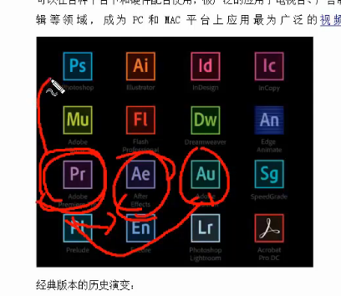

Pr剪辑长视频

Ae短的视频精细，一般以秒为单位

Au编辑音频的

综上，一般的，主要用Pr就可以了

●工具

八爪鱼和火车头

<https://www.bazhuayu.com/>

●PR教程

<http://www.52zxw.com/kecheng_143.html>

<http://www.52zxw.com/course_11184.html>

●转场和过度

片段之间的转场，（溶解—交叉溶解； 溶解—黑场过渡；或者可以用擦除里的）

视频最后和开头，可以用溶解—渐隐为黑色

音频的前后，可以用 音频过度—交叉淡化—恒定功率 来过度

●序列的设置

一般练习用720的就行，用预设这个720p25就行

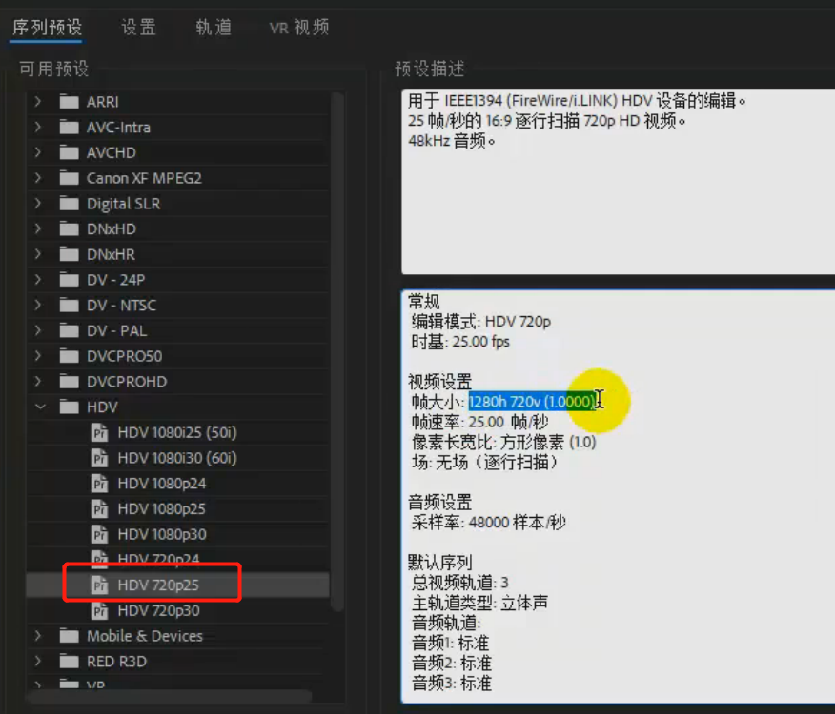

如果是正式，要用1080P的，系统预设的都不合适，要自定义设置：

时基：一般都是25帧/秒

分辨率 1920\*1080

音频采样率一般用48khz

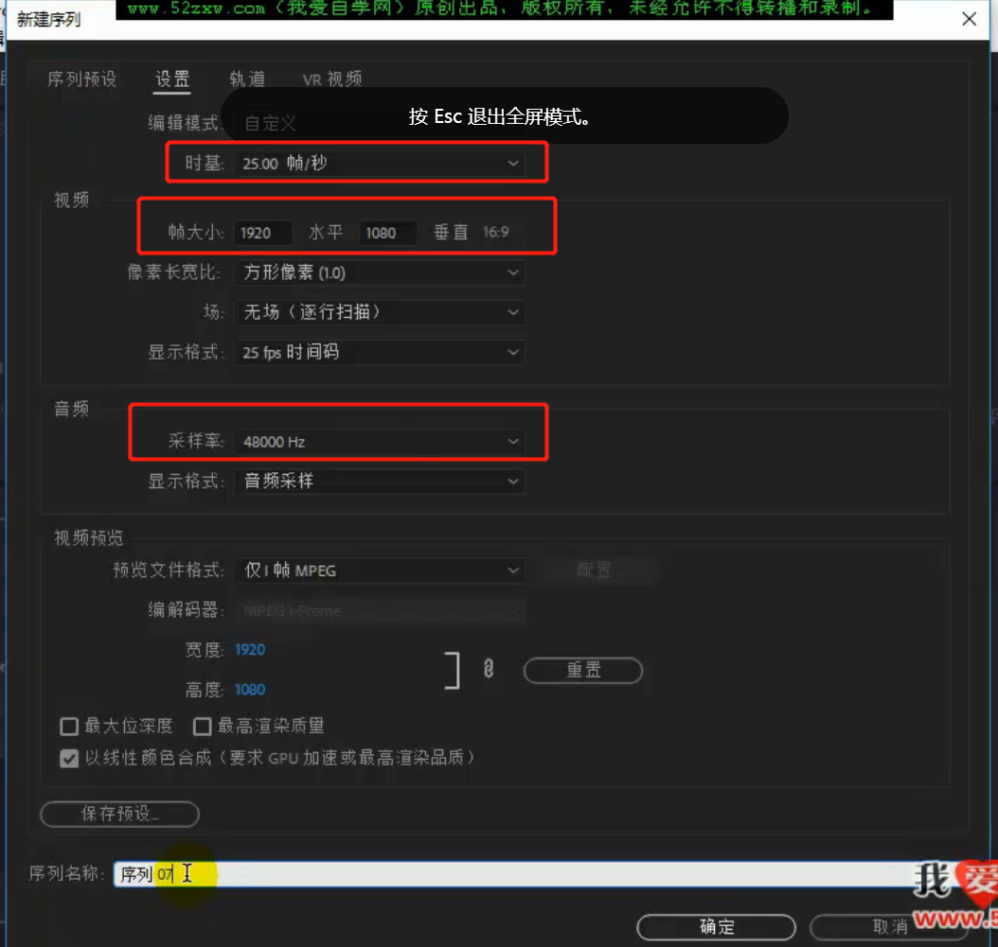

●

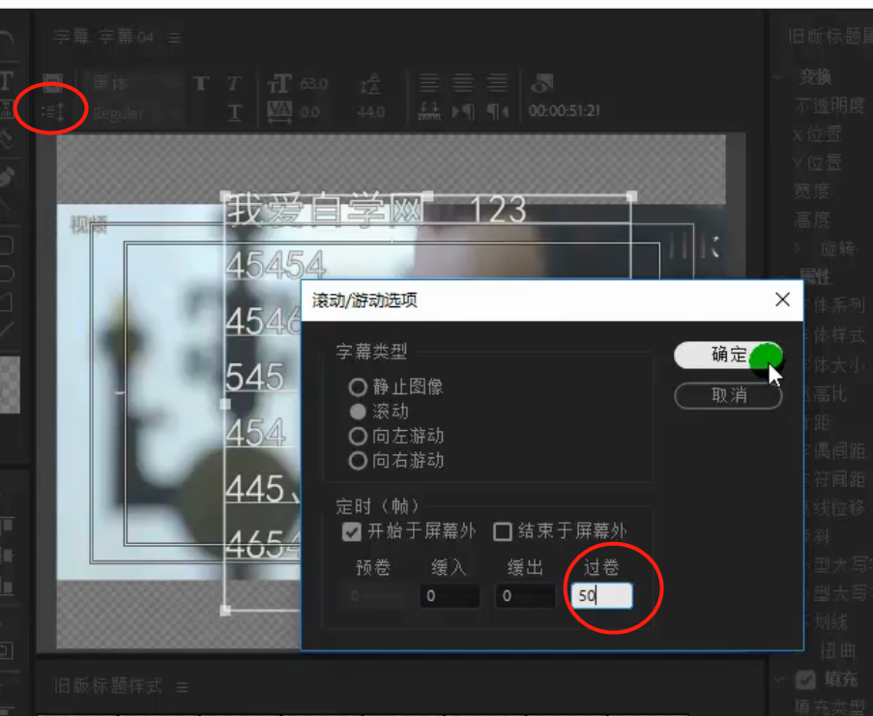

过卷是字幕滚动后，停留多长时间。50就是2秒，因为设置的是25帧每秒。

●背景音乐

<https://music.163.com/#/playlist?id=3053500625>

<https://music.163.com/#/search/m/?id=3053500625&s=%E6%81%90%E6%80%96BGM>

