Tùng Nguyên – Đào Tuấn – Kim Bảo

prn292  FPT University

CSharp final Project



# Topic: A library management system

## Index

*In this document, we will have:*

1. *Scenario*
2. *Use case diagram*
3. *Prototype*
4. *Pages list and their functions*
5. *Requirement and needed stuffs to be repared*
6. *Plan (v0.1)*

## Scenario

* As a librarian, you can manage the books in the library (Add new, Modify and Search information or Hide no more availabled books).
* As a librarian, you can manage the membership registration activity (Add new member, View a member’s history, De-activate a member).
* As a librarian, you can manage the lending – returning activities of the library (View the books currently lending and their borrowers).
* As a member, you can log in to the local website of the library and search for a book.
* As a member, you can change your password.
* As a member, you can bookmark a book.
* As a member, you can view your info in the lending – returning system.
* As a guest, you can login to the system by any in-place computer in the library.
* As a guest, you can search a book. (v0.1)

…

## Use Case Diagram

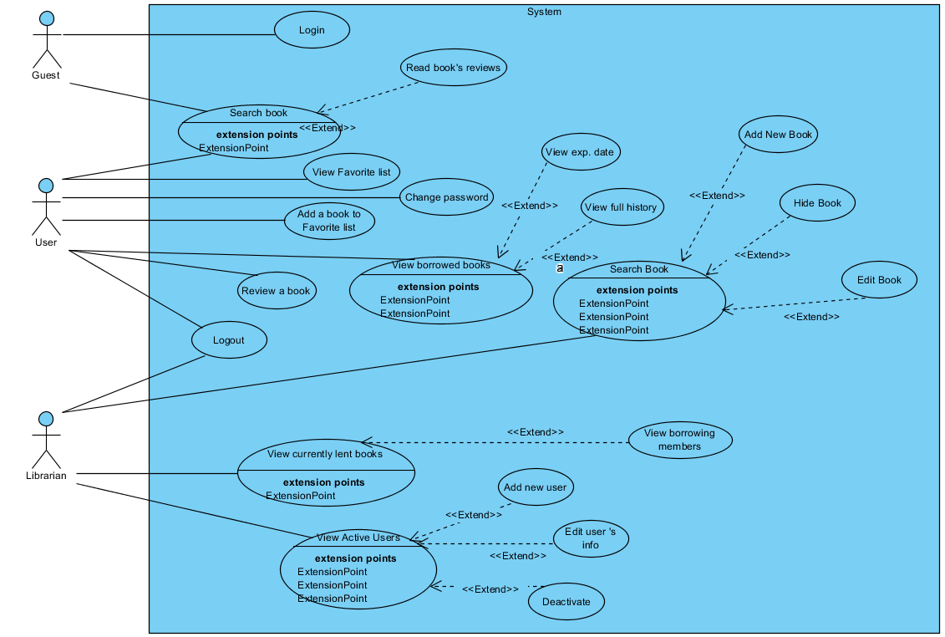

Figure : v0.1

## Prototype of Main page

More prototypes can be added

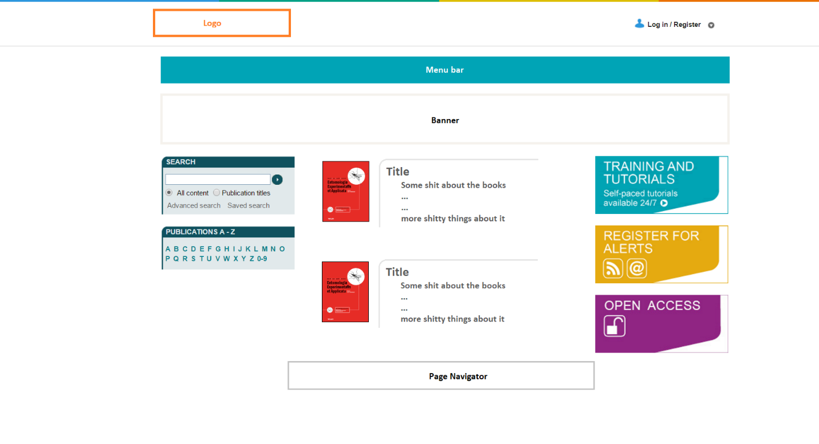

Figure : Mainpage v0

## Page List and Function

1. Main page: (Nguyen)

* Show all of books exist in database
* Search book

1. Book detail page: (Nguyen) (v0.1)

* Show information of a specific book.
* Have a “Add To Favorite” button. (Only enable when it’s a user)
* Have a rating point of a book .
* Show reviews related to that book in the bottom.

1. Member favorite list: (Lu) (v0.1)

* Show member’s favorite list displayed in table form.
* Allow member to remove any title from the table.
* Allow member to go to the book info by clicking in a book’s link from the table.

1. Member borrowed books list: (Tuấn) (v0.1)

* Show books status and expired date in table form.
* Mark being expired soon books by red color in their rows.
* Show fine for late – returning of books (if member have any)
* Have a button to show all of their borrowing – returning history.

1. Member management page (Only for admin): (Nguyên)

* Show a list of users
* Allow admin to execute CRUD functions

1. Book management page (Only for admin): (Tuấn)

* Show books list
* Allow admin to execute CRUD functions

1. Register: (Lu)

* Allow to register a new account

1. Login page: (Nguyen)

* Allow guest to login to the system with memberID and password (default: 12345)

*\*CRUD: Create, Retrieve, Update, Delete*

## Requirement

* Use Git for team working
* Reference website: <http://onlinelibrary.wiley.com/>
* Visual Studio 2017 (at least)

## Plan (v0.1)

* Basic functions need to be completed before Tuesday July 11th 2017
* All team will have to do swap-tests for all the function in that night.
* There will be a meeting on Wednesday for next steps.

*-Thank you for your attention-*