CLAN97 v3.1
SUPPLEMENT to
“A User′s Guide to CLAN97”

by

Claes Andersson

Contents sid

Enhancements and New Features in CLAN 97 v3.1 2

9. Calibration for NonResponse (CNR) 2
9.1. Introduction 2
9.2. A description of the CNR approach 3
9.2.1. The point estimators 3
9.2.2. The variance estimators 4
9.2.2.1. Estimator (1), tx is known 4
9.2.2.2. Estimator (2), tx is estimated 5
9.2.3. A note on cluster designs 5
9.3. A simple illustration 6
9.3.1. The CNR-estimator (1) 6
9.3.2. The CNR-estimator (2) 7
9.4. New parameters in %CLAN 7
9.4.1. Limitations when Calibrations for NonResponse is used 7
9.4.2. Restrictions on wk 8
9.5. New parameter in %AUXVAR 8
9.5.1. New variables in DATAX 8
9.5.2. The calculation of WKOUT 8
9.6. The case with CNR and more than one set of auxiliary variables 8

10. Pareto πps sampling 11
10.1. The πps Sampling Method 11
10.2. Point estimation 12
10.3. Variance estimation 12
10.4. A new parameter in %CLAN 13

11. References 14

Enhancements and New Features in CLAN 97 v3.1
- Calibration for NonResponse (CNR) is added.
- Stratified designs with Pareto πps sampling is added.
- CLAN97 is adapted to SAS 8.e (in fact v3.1 will only work under SAS 8.e and above).
- The names in %TOT, %GREG, %ADD, %DIV, %MULT, %SUB and %ESTIM is no longer limited to 6 or 7 characters, the name length may be as large as SAS 8.e allows for, minus 2.
- Automatic handling of linear dependencies in the x-vector when the GREG-estimator is used.
Sometimes it happens that there is one or more linear dependencies between the elements (variables) in the x -vector. When this is the case, the inversion of 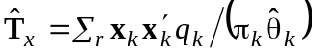 will fail. This may for example happen when the user has put restrictions on the gk:s.
In version 3.1 the dependent variable will be eliminated, a new 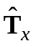 is calculated and will be inverted if possible. If CLAN97 finds a new dependent variable in x it will be eliminated etc.
- Version 3.1 can be distributed as a stored compiled macro file. In that case use the following statements to retrieve the compiled macros stored in 'SAS-data-library',
libname mylib 'SAS-data-library';
options mstored sasmstore=mylib;

9. Calibration for NonResponse (CNR)

9.1. Introduction
Two different response models are considered in the earlier versions of CLAN97 as described in the “User’s Guide to CLAN97” (1998). They are i) independent responses with equal response probabilities within strata, and ii) response homogeneity groups (rhg:s) where each stratum is divided into two or more groups with (assumed) equal response probabilities within the groups.
The aim of the response models are to eliminate or at least reduce the nonresponse bias. The model that can be used in practice is dependent of the available information in the survey. Model i) uses a minimum of information from the survey, while model ii) uses additional information for the definition of the rhg:s and their sizes. If the assumption of equal response probabilities is not valid then we will usually get biased estimates when there is a correlation between the response probability and the variable of interest.
When auxiliary variables can be found, which are assumed to be well correlated with the unknown response probabilities, they can be incorporated into a regression-type estimator. The aim is to derive good proxies of the response probabilities in order to limit the nonresponse bias as much as possible. An approach along this line is described in Lundström and Särndal (1999) and Lundström (1997), here it is called Calibration for NonResponse (CNR).
Usually we can not know if the auxiliary variables have the desired properties or not. However, the approach offers a simple, flexible and convenient way to handle the nonresponse problem. When used in a correct way it may give a reduced sampling variance and added protection against nonresponse bias of the estimates.

9.2. A description of the CNR approach
A sample s of size n is taken from a finite population U = (1, …, k, …, N) of size N, according to the design p(s) with the first and second inclusion probabilities πk>0, πkl>0, k,l∈U. The design p(s) in CLAN97 is assumed to be simple random sampling without replacement (SRS) or Pareto πps (see chapter 10) within strata and the sampling units are elements (SAMPUNIT=E) or cluster of elements (SAMPUNIT=C). This means that πk = nh/Nh when the design is SRS within strata (STSI) and element k belongs to stratum h.
Due to non-response the values of the variable of interest, y, is only recorded for the response set r ⊆ s of size m<n. The (unknown) response probability of object k is denoted θk.
The assumed response model is that the sample elements responds independently such that 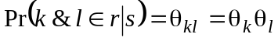 for all k≠l, where θk is the (unknown) response probability for element k.
The parameter of interest may, as before, be a rational function of totals although we will concentrate the description on the point- and variance estimation for a single total 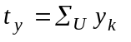, where the value yk exists for each element k∈U. The generalisation to any rational function of totals is obvious and is described in the User’s Guide to CLAN97 (1998), chapter 3.
For element k there is also a value xk = (x1k, …, xjk, …, xJk)′ of the vector x of length J, the elements in the vector x are referred to as the auxiliary variables.
When the CNR approach is used there are two different point estimators available in CLAN97, (1) for the case where the vector of population totals 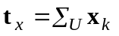 is known and (2) for the case where only the unbiased estimate 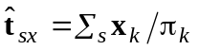 of 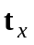 from sample s is known.

9.2.1. The point estimators
All estimators of ty in CLAN97 may be written on the form 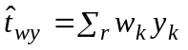. When the CNR approach is used the estimator (1) is obtained by defining wk as 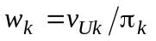, k∈r, where
(9.2.1)
and qk is a known constant. Note the difference between vUk and gk in chapter 6 of the manual. However, both the GREG-estimator and the CNR-estimator (1) based on (9.2.1) have the properties 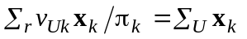.
The second CNR-estimator, (2) is obtained by defining wk as 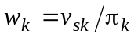, where
(9.2.2)
The weights vsk have the calibration property 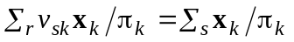.
The inverted weight 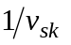can be interpreted as an estimator of the response probability of element k∈r, given the sample s. However, there is no guarantee that the estimated value of will be in the interval [0, 1].

9.2.2. The variance estimators
For each one of the two CNR-estimators, Lundström and Särndal (1999) and Lundström (1997) also suggest a variance estimator, which is implemented in CLAN97.
The variance estimation formulas are derived by using the two-phase sampling approach described in Särndal, Swensson and Wretman (1992) and the assumption that the sample elements respond independently.
The variance estimators can be written on the form 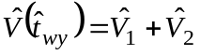, where 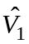 is the first phase component and 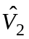 is due to the second (response) phase.
The variance estimators are shown below for the design with stratified simple random sampling without replacement of elements.

9.2.2.1. Estimator (1), tx is known
For the CNR-estimator (1), i.e. when the population total of x is known, we get the following expressions,
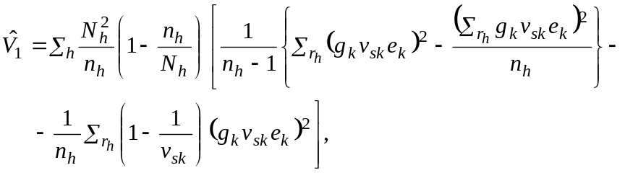 (9.2.3)
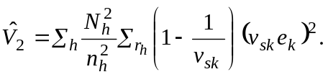 (9.2.4)
Where ek is the estimated residual 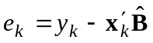, k∈r,
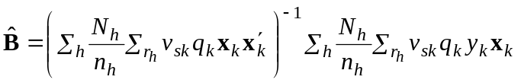 (9.2.5)
and
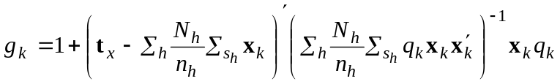 (9.2.6)
which is substituted by,
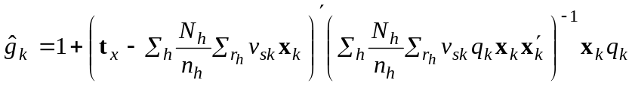 (9.2.7)
in CLAN97 when the response set r only, is supplied.

9.2.2.2. Estimator (2), tx is estimated
For estimator (2), i.e. when the population total of x is unknown, we get the following expressions,
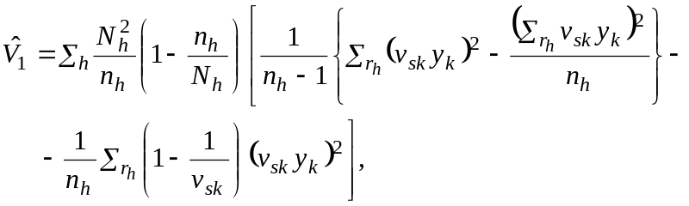 (9.2.8)
(9.2.9)
where ek is the estimated residual , k∈r, with 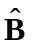 as in (9.2.5).

9.2.3. A note on cluster designs
When the sampling units are clusters (SAMPUNIT=C) the user should be aware of that vsk should be the same for all elements in the same cluster. This is because 1/vsk is seen as an estimate of the response probability of the sampling unit. To achieve that one can use cluster as the model level in %AUXVAR.
When the auxiliary information is available for the elements, it is usually more efficient to use element as the model level, compared to use cluster as the model level. However, it is then difficult to interpret 1/vsk as an estimate of the response probability for a cluster and it may not give the intended reduction of the nonresponse bias.
In CLAN97 3.1, the vsk:s are always calculated at the cluster level when the CNR approach is used and the sample units are clusters. The vsk:s will then be the same for all elements within the same cluster,
, k∈Ui,
where 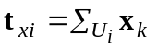, 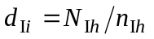when element k belongs to the i:th cluster in stratum h and qIi is a known constant not necessarily equal to qk.
This means that if RTOU=N then MLEVEL=1 is used even if the user has set MLEVEL=2 in %AUXVAR.
The residuals in are 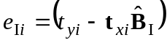 where 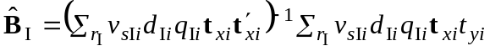 and 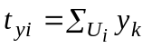.
If RTOU=Y and MLEVEL=2 then CLAN97 3.1 will use the eIi residuals in while ek is used when is calculated.

9.3. A simple illustration

9.3.1. The CNR-estimator (1)
The SAS data set DAB1 contains the variables VARA, VARB, YVAR, NU, NS, STRATUM, ID (among others). A simple table of totals for the variable YVAR in the cells defined by VARA×VARB is estimated. The totals for VARA are known for the population. Strata are defined by STRATUM, the stratum size is in NU and the number of selected element is in NS. The data set DAB1 contains the whole sample s and the response set r is identified by ID≥20000.
The SAS code,
data margu; /* define the margins */
input var $ n mar1-mar4 xtype $ xdom $;
cards;
vara 4 18000 25000 10500 5500 c .
;
run;

%macro FUNCTION(r,c);
rv=(varb=&r);
cv=(vara=&c);
if &c eq &maxcol then cv=1;

%auxvar(datax=margu)
%greg(tg,yvar,rv and cv)

%tabsum(table=tg,frow=1-4, trow=5)

%estim(tg)

%mend;
options sasautos='c:\clan97\clanauto31';
%CLAN(DATA=dab1,NPOP=nu,NSAMP=ns,STRATID=stratum,MAXCOL=5,MAXROW=5,
CNR=Y,RTOU=Y,SET=S,RESPONSE=(id>=20000))

The parameters CNR, RTOU, SET and RESPONSE are new in version 3.1, CNR tells whether Calibration for NonResponse will be used or not, if so (CNR=Y(ES)) the RTOU tells if the calibration is done from r to s (=N) or from r to U (=Y). The parameter SET tells CLAN whether DATA contains the whole sample s (=S) or the response set r only (=R). RESPONSE is necessary to identify the response set when SET=S, otherwise it is ignored.

9.3.2. The CNR-estimator (2)
When DAB1 only contains the response set, it is not possible to calculate 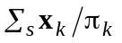 from the input data set. The user will have to supply the estimated totals in the same way as the known population totals. The estimated totals from s are named TSXj, where j=1, 2, …, J. The following is an example of the appropriate SAS code .
data margu;
input var $ n tsx1-tsx4 xtype $ xdom $;
cards;
vara 4 12078.61 29712.70 13815.65 4393.04 c .
;
run;

%CLAN(DATA=dab1,NPOP=nu,NSAMP=ns,STRATID=stratum,MAXCOL=5,MAXROW=5,
CNR=Y,RTOU=N,SET=R)

9.4. New parameters in %CLAN
As noticed in section 9.3 there are four additional parameters in %CLAN that have effect on the CNR approach. They are,
CNR is set to Y(ES) if the Calibration for NonResponse approach is used in the estimation, otherwise it is set to N(O) (the default). When CNR=Y, the response homogeneity groups are not allowed, i.e. RHG must be =N(O).
If CNR=Y then NSAMP must be used. The variable referred to by NSAMP must contain the sample size, see A User´s Guide to CLAN97 (1998).
When CNR=Y then the following parameters will have effect.
RTOU is set to Y(ES) (the default) if the total tx is known for the whole population U. N(O) means that only an estimate of tx from the sample s is available.
SET is equal to R (the default) the data set that is referred to by the parameter DATA only contains the response set.
SET is equal to S when the data set contains all sample elements.
RESPONSE when SET=S, this parameter must contain a valid SAS expression which takes value 1 for elements that belongs to the response set and value 0 otherwise, the default=1.
Only the first character in the CNR-, RTOU- and SET- parameter values are considered.

9.4.1. Limitations when Calibrations for NonResponse is used
When CNR=Y(ES) the following limitations are in effect,
- %TOT is not allowed, %GREG must be used,
- WKIN will be ignored, i.e. external g-weights are not allowed,
- if SET=R then the estimated totals must be given in the data set referred to by DATAX in %AUXVAR, see sections 9.3.2. and 9.5. ,
- response homogeneity groups (rhg:s) are not allowed.

9.4.2. Restrictions on wk
When CNR=Y(ES) and restrictions are imposed by the parameters U and L in %AUXVAR, then the limits will have effect on vUk when RTOU=Y and on vsk when RTOU=N, see section 9.2.1. .

9.5. New parameter in %AUXVAR
There is one new parameter in %AUXVAR,
QI is the name of a numerical variable >0 in the observational data set, or a SAS-expression giving a numerical result >0. QI is given the value of qIi which is used in the calibration of the response phase when SAMPUNIT=C, see section 9.2.3. above. It is only used in that case, otherwise QK should be used and QI will be ignored.

9.5.1. New variables in DATAX
If CNR=Y(ES) and SET=R then the variables TSX1-TSXJ must exist in the data set referred to by DATAX in %AUXVAR. The variable TSXj is supposed to contain the value of the jth estimated total of x from the sample s. As before, MAR1-MARJ are supposed to contain the known totals of x for the population U.
If CNR=Y(ES) and RTOU=N(O) then MAR1-MARJ are ignored.
If CNR=Y(ES) and SET=S then the totals of x are calculated from the input data set in DATA, the TSXs will be ignored even if they are given in the DATAX dataset.

9.5.2. The calculation of WKOUT
If WKOUT is given a valid variable name in %AUXVAR, i.e. when the user wants to save the calculated weights, then
- WKOUTk=dk × vsk × WEIGHT when RTOU=N(O),
- WKOUTk=dk × vUk × WEIGHT when RTOU=Y(ES),
where 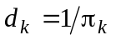, that is 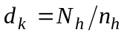 for the STSI design when element k belongs to stratum h.
Note that WKOUT is calculated for the whole sample s when SET=S.

9.6. The case with CNR and more than one set of auxiliary variables
There are situations when more than one set of auxiliary variables may be used. For example in a case where the sample (or a predetermined part of it) is a panel and the data is collected for the same units at two or more occasions.
It is not uncommon that certain function based on totals from different occasions are of interest, for example the difference 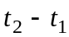 between occasion 2 and 1 or, maybe more common, the ratios 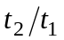or 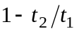. The point estimates of such parameters can easily be obtained by the technique used by CLAN97. The problem is the variance estimation when the CNR approach is used.
Recall that the assumed response model is that the sample elements responds independently such that for all k≠l, where θk is the (unknown) response probability for element k which is estimated by 1/vsk.
Now, suppose that data is collected from the same sample s at two different occasions, 1 and 2, with different response sets r1 and r2. The set of elements that responded at both occasion is denoted r12. The values (and the known totals) for the auxiliary variables may be different between occasion 1 and 2. Even if the auxiliary variables are the same at all occasions their values may have been updated. This should cause no problems for the point- and variance estimates when they are calculated separately for each occasion. This means that we have two, possibly different, values of the x-vector, x1k and x2k for element k.
The estimators 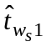 and 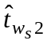 of the totals of y1 and y2, measured at occasion 1 and 2 respectively, are obtained from the response set r12. Suppose that we are interested in the variance estimate of an estimated rational function of these two totals, for example the ratio, then how should the covariance between the estimators 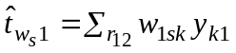 and 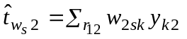 be estimated when the CNR approach is used?
The problem is to estimate the probability 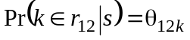, where θ12k is the unknown probability that element k responds at both occasions.
Usually, the CNR estimates 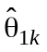 and 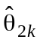 will be different due to different sets of auxiliary variables, then which one of them should be used as an estimator for θ12k?
In CLAN97, θ12k is estimated by the geometric mean of and , i.e.
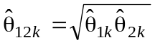 (9.6.1)
The unknown θ1k and θ2k are estimated by , calculated with xk=x1k and x2k, respectively and 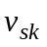is defined by (9.2.2).
When x1k= x2k for all k∈r12 then 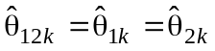 and we obtain the same covariance estimator as if there were only one set of auxiliary variables.
The drawback is that 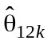 cannot be calculated if 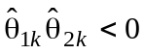 which might happen in practice.
There is no guarantee that all vsk>0 even if they normally should be slightly larger than 1. When vsk<0 the square root is not defined and some action has to be taken. In CLAN97 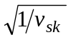 is set to 0 when vsk<0. When RTOU=N it is possible to put a restriction on by the parameter U in %AUXVAR, when RTOU=Y there is no such possibility.
However, this is only a problem when there is more than one %AUXVAR.

10. Pareto πps sampling
Until now it has been assumed in CLAN97 that the sample was taken as a simple random sample without replacement (SRS) within strata (if any). When the sample was taken with probability proportional to size with replacement (pps) or without replacement (πps) only approximate estimates of the variances was possible. The transformation 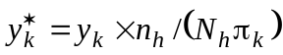 can be used in CLAN to obtain a correct point estimator but will only give an approximate variance estimator. It is not generally known how good the approximation is, although it is expected to be good for “small” values of 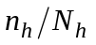.
In version 3.1 of CLAN97 a more accurate procedure is available when πps sampling has been used. There is no need for the transformation trick above and the variance estimator is believed to be good even for “small” samples and “large” .
Several πps-schemes with different pros and cons are described in the literature. There are only a few general schemes that combine the properties, fixed (arbitrary) size sample, simple sample selection, good estimation accuracy and available variance estimators that always gives non-negative estimates. The Pareto πps sampling scheme suggested by Rosén (2000) is an order πps scheme that meets the desired properties at the expense of some imperfections. However, these imperfections have negligible effects in most practical survey situations, even for a quite small sample size.
The estimator bias of the Pareto πps scheme is discussed in Rosén (2000).

10.1. The πps Sampling Method
There exists a sampling frame with N sampling units from the population U. The population U may be divided into h, h=1, …, H disjoint strata where Uh contains Nh units. For unit k∈Uh there exists a size value xk>0 in the frame. The x-values are typically positively correlated with the values of the study variable y. We want to take a sample of fixed size nh from each Uh such that the sample inclusion probability πk is proportional to xk.
The desired inclusion probabilities are then 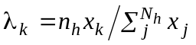, k∈Uh. It is assumed that the sampling procedure is such that all λk≤1.
The Pareto πps-scheme has the property that πk≈λk holds with good approximation for k=1, …, N.
The sampling procedure is very simple,
- Compute the desired probabilities λk within each stratum.
- For each population unit, generate an independent random variable uk with uniform distribution on the interval [0, 1]. Calculate,
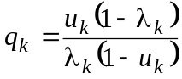, k=1, …, N.
- The sample sh consists of the units with the nh smallest q-values within stratum h.

10.2. Point estimation
An estimator of a total 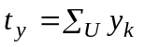 is obtained as 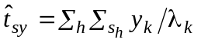 when there is no nonresponse. This is only an approximate HT-estimator since πk≈λk, however, the bias is almost always negligible in practice.
When the GREG or CNR estimator is used, yk is substituted by the appropriate transformation, (see Chapter 6 in A User’s Guide to CLAN97 and Chapter 9 above in this supplement).
When nonresponse occurs the adjustment is based either on the simple assumption of equal and independent response probabilities within strata or on the CNR approach.
Under the simple assumption, let mh be the number of respondents in stratum h and use 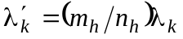, k∈Uh, instead of λk.
A point estimator of the total is then 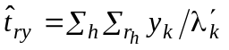with obvious generalisations when the GREG or CNR estimator is used. When the sampling units are clusters, yk is substituted by and its counterparts for the GREG and CNR estimators.
The response homogeneity group approach for nonresponse in combination with the Pareto πps scheme is not implemented in CLAN97 v3.1.

10.3. Variance estimation
The approximate variance estimator of the estimator 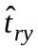 used in CLAN97 v3.1 for (stratified) simple random sampling and no CNR approach is,
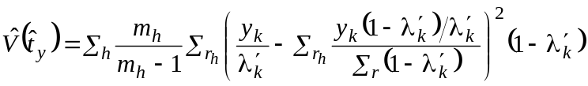 , (10.3.1)
where rh is the set of mh respondents.
When the GREG estimator is used, yk is substituted by gkek, (see Chapter 6 in A User’s Guide to CLAN97).
When the sampling units are clusters yk is substituted by and its counterparts for the GREG estimator.
When the CNR approach is used the variance components (9.2.3) and (9.2.4) are calculated as,
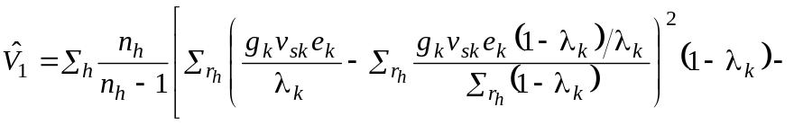
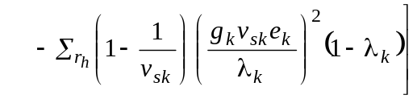 (10.3.3)
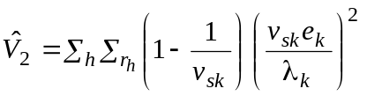 (10.3.4)
with obvious analogies with (9.2.8) and (9.2.9).
When the sampling units are clusters the appropriate cluster totals are used instead of gkvskek and vskek.

10.4. A new parameter in %CLAN
One additional parameter in %CLAN is necessary in order to get the estimates when the Pareto πps sampling scheme has been used.
LAMBDA is the name of a numerical variable in the observational data set, which takes a positive value ≤1. When LAMBDA is used, then also the parameters NRESP (mh) and NSAMP (nh) have to be specified. The parameter NPOP (Nh) is ignored. Response homogeneity groups (rhg:s) are not allowed.
The lambda values are assumed to be the original ones, defined with n as .
Except for the RHG approach for the nonresponse all other possibilities in CLAN97, the CNR approach, the use of auxiliary variables, cluster sampling etc. can be combined with the Pareto πps estimator.

11. References
Andersson, C. and Nordberg, L. (1998). A User’s Guide to CLAN97. Statistics Sweden.
Lundström, S. (1997). Calibration as a Standard Method for Treatment of Nonresponse. Doctorial dissertation, Stockholm University.
Lundström, S. and Särndal, C. E. (1999). Calibration as a Standard Method for Treatment of Nonresponse. Journal of Official Statistics, 15, 305-327.
Rosén, B. (2000). A User’s Guide to Pareto πps Sampling. Statistics Sweden R&D Report 2000:6.
Särndal, C. E., Swensson, B. and Wretman, J. (1992). Model Assisted Survey Sampling. New York: Springer Verlag.

