Deleting and Restarting

Sometimes it’s easier to just start over. If you have a repository on Gryd that’s “broken” in some way and you have a copy on GitHub that you want to start over from, you can just delete the entire folder for that repository on Gryd and run git clone again to pull down a fresh copy.

Here are more detailed steps for this process. We’ll assume I want to start over with a fresh copy of the “lab-binomial-mle-bayes-evanlray” repository.

1. Delete the broken repository
   1. Sign into Gryd
   2. In the notebook file browser, navigate to a place where you can see the folder for the repository you want to delete:

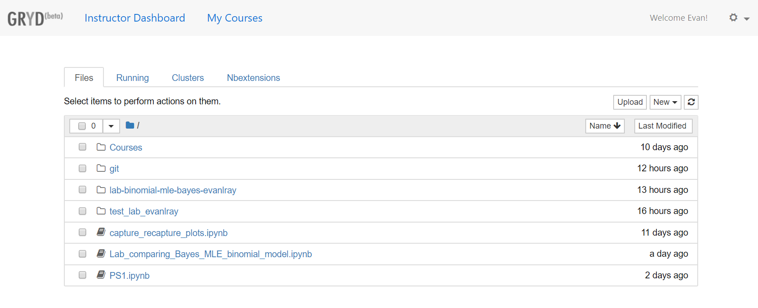

* 1. Select that folder and click the delete button (red trash can near the top):

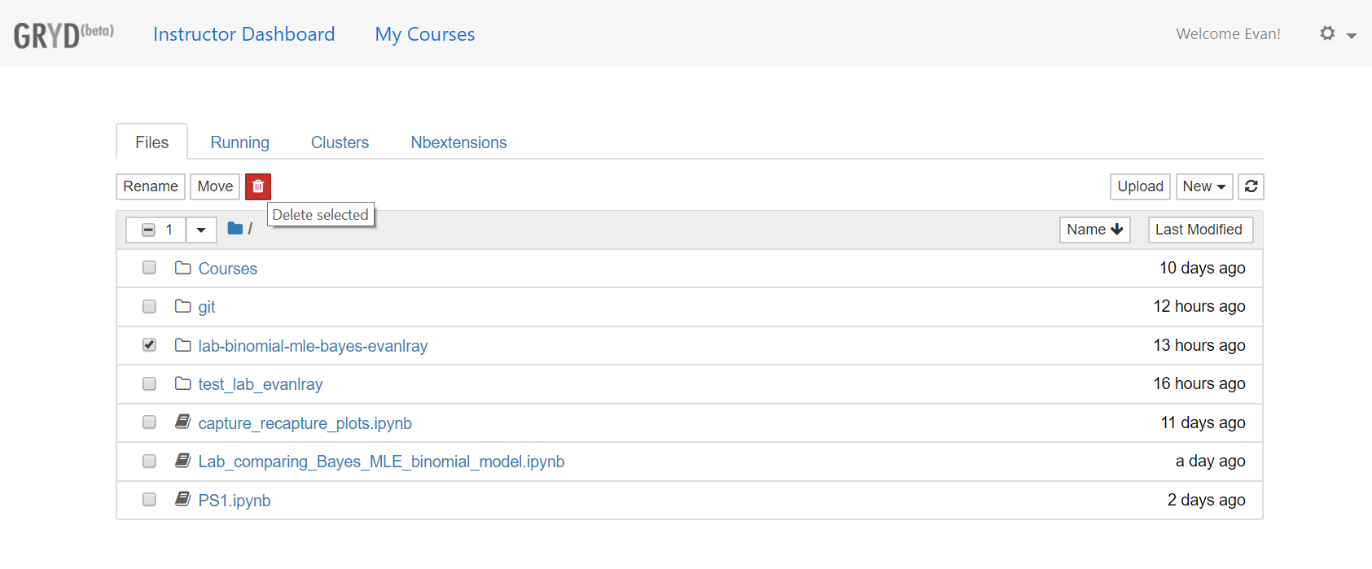

1. Clone a fresh copy
   1. Sign into GitHub
   2. Find the repository you want to clone. There is a search box to find repositories on the main page of GitHub:

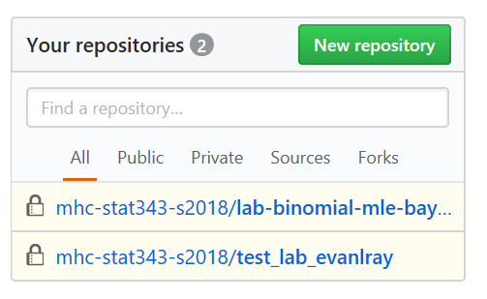

* 1. On the GitHub page for the repository you want to clone, click the green “Clone or download” button, and copy the web address there:

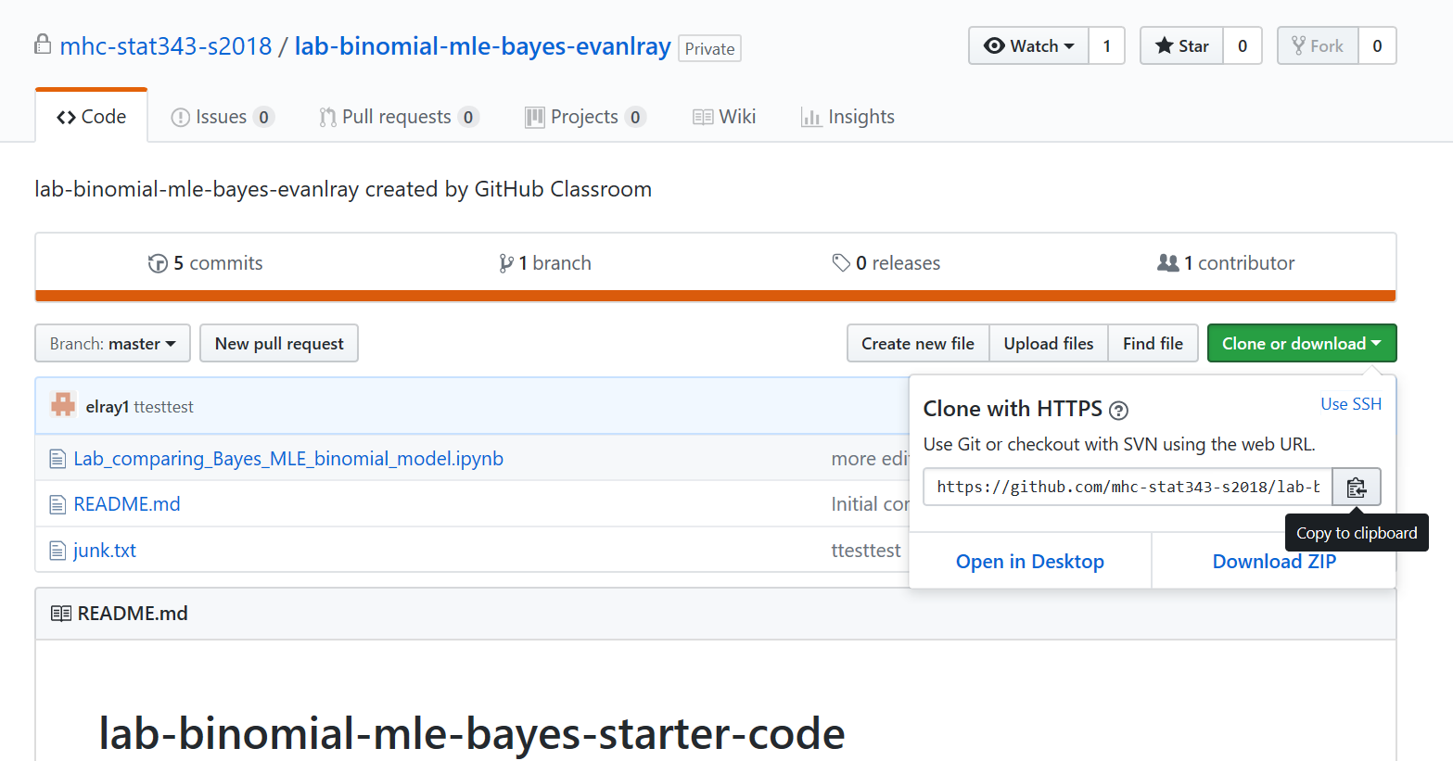

* 1. Go back to Gryd, and open a new terminal session:

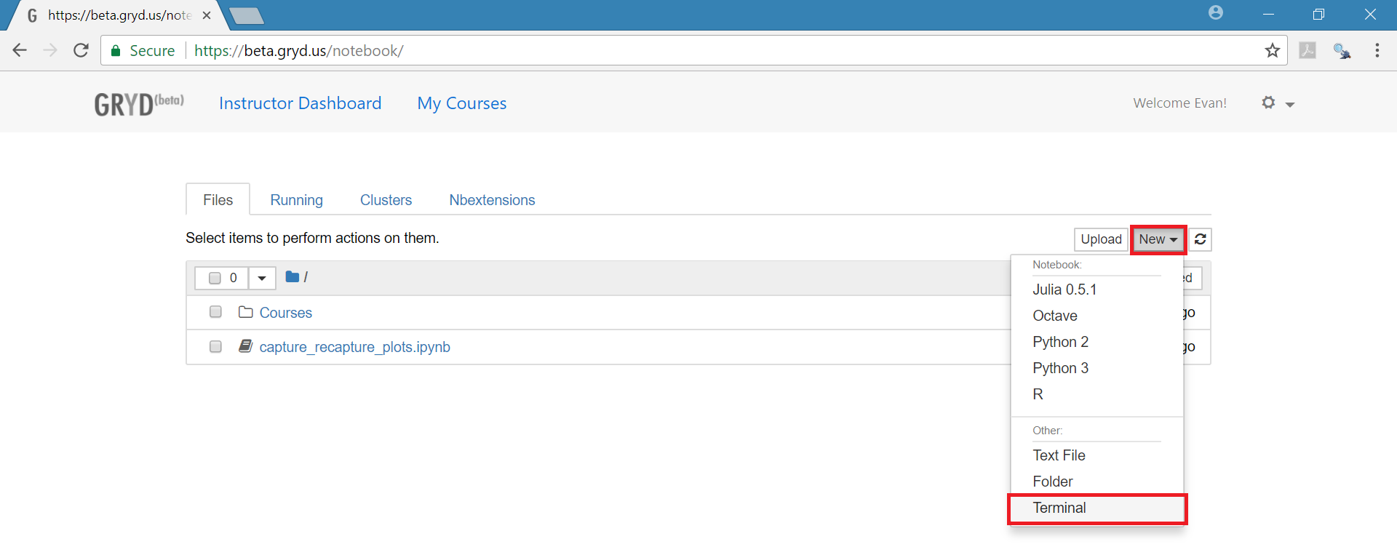

* 1. In the terminal type “git clone ”, and paste in the web address for the GitHub repository that you copied in step 2) c. Hit enter, and enter your username and password for GitHub at the prompts (as you type your password, no characters will appear).

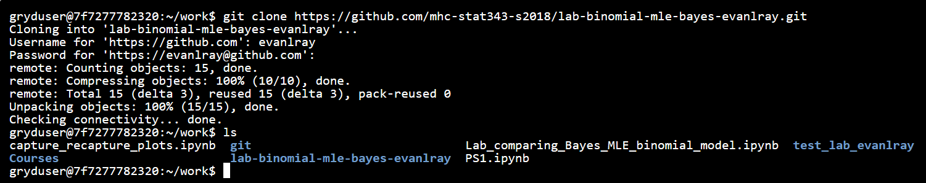

* 1. If you want to verify that the files are there, you can type “ls” to list the files and folders in your present working directory, as in the screenshot above.