Inferring RNA Ancestors

COMP 598: Advanced Computation Biology Methods & Research

Project Report

*Haji Mohammad Saleem*

260508983

**Introduction**

Multiple species that inhabit this planet have been shown to share genetic similarities. Phylogenetics is the study of evolutionary history and relationships among such individuals or groups of organisms. Phylogenies are branching diagrams that represent the ancestral relationships among a set of species. Internal nodes in a phylogeny tree are referred to as ancestors. When an ancestor diverges, the two species are assumed to evolve independently of each other.

One of the ways to construct a phylogenetic tree of related set of genetic sequences is through maximum parsimony, a non-parametric statistical model, first introduced by Walter M. Fitch in 1971. A phylogeny constructed through parsimony prefers evolution with least changes.

This project implements Sankoff’s algorithm [1,2], a generalized version of the Fitch’s algorithm. We use RNA families from the Rfam database for the analysis [3], extracted in the Stockholm format [4]. In this project with compute the sequence and predict the secondary structure of each ancestor and analyze its conservation in relation to the consensus structure.

**Methods**

We extract the sequences of the leaf nodes and the consensus structure of the RNA family from the Stockholm files obtained from the RFAM database. We also acquire the phylogeny tree for the family from the database. Next, based on the phylogenetic tree, we predict the ancestral sequence, using the Sankoff Algorithm. The algorithm uses the following cost matrix to account for gaps:

|  |  |  |  |  |  |
| --- | --- | --- | --- | --- | --- |
|  | A | C | G | U | - |
| A | 0 | 2 | 1 | 2 | 2 |
| C | 2 | 0 | 2 | 1 | 2 |
| G | 1 | 2 | 0 | 2 | 2 |
| U | 2 | 1 | 2 | 0 | 2 |
| - | 2 | 2 | 2 | 2 | 0 |

The weights for leaf nodes in the phylogeny is initialized such that the present nucleotide has a weight 0 while the other possible nucleotides have a weight “inf”. Next for each ancestral sequence, we calculate the index weight as

$$S_{a}\left(i\right)= \min_{j}\left[c_{ij}+S_{l}\left(j\right)\right]+ \min_{k}[c_{ik}+S_{r}\left(k\right)]$$

where $S_{a}\left(i\right)$ is the smallest cost for node $a$ for the state $i$. The states are chosen to minimize the cost to move to state j and k for left and right child. Thus, for each index of the ancestral sequence, we choose the nucleotide with the minimum cost.

To conserve the base pair dependencies of the consensus secondary structure, we remove the possibility of gaps at positions with base pairs in the consensus structure and use a matching nucleotide to complete base pairs at base pair closing indices.

**Data**

For our initial analysis (Objective 1-7), we use the **RF00754:** microRNA mir-279 RNA family

**Code**

python sankoff_algo.py -h

usage: sankoff_algo.py [-h] -r RFAM [-p] [-e]

Implementation of the Sankoff Algorithm

optional arguments:

  -h, --help            show this help message and exit

  -r RFAM, --rfam RFAM  RNA family id

  -p, --printit         Print additional information

  -e, --extended        Use Sankoff with base pair preservation

**Results**

**Stockholm Parser (Objective 1)**

We implement the Stockholm class in stockolm_parser.py. It extracts the consensus structure and the sequence of all the member species.

**Output**

RNA family RF00754

Consensus Secondary Structure

                               ::::<<<<<<<<<<<<<<<<<<<<<<<.<<<<<<----<<<<<___________...____>>>>>>>>>>>.>>>>>>>>>>>>>>>>>>>>>...>>::

Sequence Alignment

AADE01000363.1/2006-2100       UCAUACUACUGUUUUUAGUGAGUGAGG-GUCCAGUGUUUCACAUUGAUUUUCUUA-GUAUUUGUGACUAGAU-CCACACUCAUUAAUAACGGUA---GUUC

AANI01014375.1/46325-46420     GCGUACUACUGUUUUUAGUGAGUGAGG-GUCCAGUGUUUCACAUUCGUUUUUUCAAGUAUUUGUGACUAGAU-CCACACUCAUUAACAACGGUA---GUUC

AAGE02017556.1/117017-116925   CAUCCCAACGGUUGUCGAUGGGUGUGA-AUCUAGUGUUUCACAUGAUUUUCGAUA-GCC--UGUGACUAGAU-CCACACUCAUUAACAAAAGUU---GCCG

AAPT01018378.1/277640-277732   CCGUAUUACUGUUUUUAGUGGGUGAGG-GUCCAGUGUUUCACAUUGUUUAUUUG---UAUUUGUGACUAGAU-CCACACUCAUUAAAAACGGUA---GUUC

AAJJ01000015.1/255293-255381   AAUUUGAUCCGUUCUUGAUGGGUUCGG-GUCUAGUGG--CACGGUUUUUUCA-----ACUUCGUGACUAGAU-CCACACUCAUUAAGGAAGUUU---CACA

AEKZ01010226.1/4670-4585       UUUCCUGAAUUUGCCAAAUGAGUGAAG-GUCUAGUG---CACAGAAAAUGAA-------AUUGUGACUAGAU-CCACACUCAUUAAGUACGUUC---AGGU

JN211060.1/1022-1116           UCAUACUACUGUUUUUAGUGGGUGGGG-GUCCAGUGUUUCACAUUGAUUUUCUUA-GUAUUUGUGACUAGAU-CCACACUCAUUAAUAACGGUA---GUUC

AAJJ01003219.1/11291-11201     UGGAGCUCUCGGUGUAAGCCAGUGUUCAGUCUAUUGUUUCACAUUGGUUUCG-------AUUGUGACUAGAUCGAACACUCGCUUGCAACCUGG---GUUU

AAZX01001678.1/20489-20404     CCAGCCGAUUGUACUGAGUGAGUGAUG-GUCUGGUG-----CACGGUUUAUC-----GAUCUGUGACUAGAU-CCACACUCAUUAAGUACGUUC---GGCU

AAPP01019575.1/159482-159391   UACUACUACUGUUUUUAGUGGGUGAGG-GUCCAGUGUUUCACAUUGAUUUCUG----UAUUUGUGACUAGAU-CCACACUCAUUAAUAACGGUA---GUUC

AADG06007490.1/6579-6668       UUGUUCGAUGGCCUUGGAUGGGUUUGA-AUUCAG---UCCACGUU--UUUUAUUU-UUAUUCGUGACUAGAU-CCACACUCAUCCAAGGAAAUC---GAGC

AAWU01001985.1/8444-8349       GCUUCCCACUAUUGUCGAUGGGUGUGA-AUCUAGUGGUUCACAUGAGCUUUGCC--A-AACUGUGACUAGAU-CCACACUCAUUAACAAGAGUGCUCGGAA

**Sankoff Algorithm (Objective 2-5)**

We implement the Sankoff class in sankoff_algo.py. The initial cost matrix is designed for the four nucleotides. The class uses the RNA family id along with the Stockholm object. The phylogeny tree file is read by readTree(). To get the ancestral sequences, first use getAncestorWeight() and then use getAncestorSeq().To include gaps, the cost matrix is upgraded to account for gap transitions, executed by includeGaps(). We use wrappers for RNAfold and RNAdistance.

python sankoff_algo.py -r RF00754 -p

**Output**

                      Sankoff Analysis for RF00754 Family.

----------------------------------------------------------------------------------------------------

                    RF00754 Family Tree

----------------------------------------------------------------------------------------------------

           ________ AAPP01019575.1/159482-159391

  ________|

 |        |         _________ AADE01000363.1/2006-2100

 |        |________|

 |                 |_________ JN211060.1/1022-1116

 |

 |                  _________ AAGE02017556.1/117017-116925

 |         ________|

_|        |        |_________ AAWU01001985.1/8444-8349

 |________|

 |        |         _________ AAJJ01000015.1/255293-255381

 |        |________|

 |                 |_________ AADG06007490.1/6579-6668

 |

 |         ________ AAPT01018378.1/277640-277732

 |        |

 |________|         _________ AANI01014375.1/46325-46420

          |        |

          |________|                   _________ AAZX01001678.1/20489-20404

                   |          ________|

                   |_________|        |_________ AEKZ01010226.1/4670-4585

                             |

                             |________ AAJJ01003219.1/11291-11201

----------------------------------------------------------------------------------------------------

                    Leaf Nodes: 12, Ancestor Nodes: 11, Sequence Length: 101

----------------------------------------------------------------------------------------------------

                                        Cost Matrix

----------------------------------------------------------------------------------------------------

                     A C G U -

                    A 0 2 1 2 2

                    C 2 0 2 1 2

                    G 1 2 0 2 2

                    U 2 1 2 0 2

                    - 2 2 2 2 0

----------------------------------------------------------------------------------------------------

                                        Ancestors

----------------------------------------------------------------------------------------------------

Ancestor                                 Left Child                               Right Child

1                                        AADE01000363.1/2006-2100                 JN211060.1/1022-1116

2                                        AAPP01019575.1/159482-159391             1

3                                        AAGE02017556.1/117017-116925             AAWU01001985.1/8444-8349

4                                        AAJJ01000015.1/255293-255381             AADG06007490.1/6579-6668

5                                        3                                        4

6                                        AAZX01001678.1/20489-20404               AEKZ01010226.1/4670-4585

7                                        6                                        AAJJ01003219.1/11291-11201

8                                        AANI01014375.1/46325-46420               7

9                                        AAPT01018378.1/277640-277732             8

10                                       2                                        5

11                                       10                                       9

----------------------------------------------------------------------------------------------------

                                        Leaf Nodes

----------------------------------------------------------------------------------------------------

Accession                      Sequence

AADE01000363.1/2006-2100       UCAUACUACUGUUUUUAGUGAGUGAGG-GUCCAGUGUUUCACAUUGAUUUUCUUA-GUAUUUGUGACUAGAU-CCACACUCAUUAAUAACGGUA---GUUC

AADG06007490.1/6579-6668       UUGUUCGAUGGCCUUGGAUGGGUUUGA-AUUCAG---UCCACGUU--UUUUAUUU-UUAUUCGUGACUAGAU-CCACACUCAUCCAAGGAAAUC---GAGC

AAGE02017556.1/117017-116925   CAUCCCAACGGUUGUCGAUGGGUGUGA-AUCUAGUGUUUCACAUGAUUUUCGAUA-GCC--UGUGACUAGAU-CCACACUCAUUAACAAAAGUU---GCCG

AAJJ01000015.1/255293-255381   AAUUUGAUCCGUUCUUGAUGGGUUCGG-GUCUAGUGG--CACGGUUUUUUCA-----ACUUCGUGACUAGAU-CCACACUCAUUAAGGAAGUUU---CACA

AAJJ01003219.1/11291-11201     UGGAGCUCUCGGUGUAAGCCAGUGUUCAGUCUAUUGUUUCACAUUGGUUUCG-------AUUGUGACUAGAUCGAACACUCGCUUGCAACCUGG---GUUU

AANI01014375.1/46325-46420     GCGUACUACUGUUUUUAGUGAGUGAGG-GUCCAGUGUUUCACAUUCGUUUUUUCAAGUAUUUGUGACUAGAU-CCACACUCAUUAACAACGGUA---GUUC

AAPP01019575.1/159482-159391   UACUACUACUGUUUUUAGUGGGUGAGG-GUCCAGUGUUUCACAUUGAUUUCUG----UAUUUGUGACUAGAU-CCACACUCAUUAAUAACGGUA---GUUC

AAPT01018378.1/277640-277732   CCGUAUUACUGUUUUUAGUGGGUGAGG-GUCCAGUGUUUCACAUUGUUUAUUUG---UAUUUGUGACUAGAU-CCACACUCAUUAAAAACGGUA---GUUC

AAWU01001985.1/8444-8349       GCUUCCCACUAUUGUCGAUGGGUGUGA-AUCUAGUGGUUCACAUGAGCUUUGCC--A-AACUGUGACUAGAU-CCACACUCAUUAACAAGAGUGCUCGGAA

AAZX01001678.1/20489-20404     CCAGCCGAUUGUACUGAGUGAGUGAUG-GUCUGGUG-----CACGGUUUAUC-----GAUCUGUGACUAGAU-CCACACUCAUUAAGUACGUUC---GGCU

AEKZ01010226.1/4670-4585       UUUCCUGAAUUUGCCAAAUGAGUGAAG-GUCUAGUG---CACAGAAAAUGAA-------AUUGUGACUAGAU-CCACACUCAUUAAGUACGUUC---AGGU

JN211060.1/1022-1116           UCAUACUACUGUUUUUAGUGGGUGGGG-GUCCAGUGUUUCACAUUGAUUUUCUUA-GUAUUUGUGACUAGAU-CCACACUCAUUAAUAACGGUA---GUUC

----------------------------------------------------------------------------------------------------

                                        Ancestor Nodes

----------------------------------------------------------------------------------------------------

Accession                      Sequence

1                              UCAUACUACUGUUUUUAGUGAGUGAGG-GUCCAGUGUUUCACAUUGAUUUUCUUA-GUAUUUGUGACUAGAU-CCACACUCAUUAAUAACGGUA---GUUC

2                              UAAUACUACUGUUUUUAGUGGGUGAGG-GUCCAGUGUUUCACAUUGAUUUCCGUA-GUAUUUGUGACUAGAU-CCACACUCAUUAAUAACGGUA---GUUC

3                              CAUCCCAACGAUUGUCGAUGGGUGUGA-AUCUAGUGGUUCACAUGAGCUUCGACA-ACAACUGUGACUAGAU-CCACACUCAUUAACAAAAGUGCUCGCAA

4                              AAGUUCAACCGCCCUGGAUGGGUUCGA-AUCCAGUGGUCCACGGUUUUUUCAUUU-UAAUUCGUGACUAGAU-CCACACUCAUCAAAGAAAAUC---CACA

5                              AAUUCCAACGGUUCUCGAUGGGUGUGA-AUCUAGUGGUCCACAUGAUUUUCACU--ACAACCGUGACUAGAU-CCACACUCAUUAAAAAAAAUU---GACA

6                              CCACCCGAAUGUACCAAAUGAGUGAAG-GUCUAGUG---CACACAAAAUAAA-----GAACUGUGACUAGAU-CCACACUCAUUAAGUACGUUC---AGCU

7                              UCAACCGAUCGGACUAAGCCAGUGAUCAGUCUAGUGUUUCACACAGAUUACA-------AUUGUGACUAGAUCCAACACUCACUAACAACCUGC---GGCU

8                              GCGAACUACUGUUCUAAGUGAGUGAGG-GUCCAGUGUUUCACAUUCGUUUUAUCAAGUAAUUGUGACUAGAU-CCACACUCAUUAACAACGGUA---GUUC

9                              CCGUACUACUGUUUUUAGUGAGUGAGG-GUCCAGUGUUUCACAUUGGUUAUUUC---UAUUUGUGACUAGAU-CCACACUCAUUAAAAACGGUA---GUUC

10                             UACUACAACUGUUUUUAAUGGGUGAGA-AUCCAGUGGUUCACAUUAAUUUCAUU--GUAUUUGUGACUAGAU-CCACACUCAUUAACAAAAGUA---GACA

11                             UCAUACUACUGUUUUUAGUGGGUGAGG-GUCCAGUGUUUCACAUUGUUUUUUUC---UAUUUGUGACUAGAU-CCACACUCAUUAACAACGGUA---GUUC

----------------------------------------------------------------------------------------------------

                                        Secondary Structures

----------------------------------------------------------------------------------------------------

Accession                      Sequence

1                              UCAUACUACUGUUUUUAGUGAGUGAGG-GUCCAGUGUUUCACAUUGAUUUUCUUA-GUAUUUGUGACUAGAU-CCACACUCAUUAAUAACGGUA---GUUC

Dist: 20                       ......(((((((.((((((((((.((.(((.((....(((((..................))))))).))).)).)))))))))).))))))).......

2                              UAAUACUACUGUUUUUAGUGGGUGAGG-GUCCAGUGUUUCACAUUGAUUUCCGUA-GUAUUUGUGACUAGAU-CCACACUCAUUAAUAACGGUA---GUUC

Dist: 20                       ......(((((((.((((((((((.((.(((.((....(((((..................))))))).))).)).)))))))))).))))))).......

3                              CAUCCCAACGAUUGUCGAUGGGUGUGA-AUCUAGUGGUUCACAUGAGCUUCGACA-ACAACUGUGACUAGAU-CCACACUCAUUAACAAAAGUGCUCGCAA

Dist: 58                       .......((..((((.((((((((((..((((((((((((....)))))...(((......))).)))))))..)))))))))).))))..))........

4                              AAGUUCAACCGCCCUGGAUGGGUUCGA-AUCCAGUGGUCCACGGUUUUUUCAUUU-UAAUUCGUGACUAGAU-CCACACUCAUCAAAGAAAAUC---CACA

Dist: 68                       .............((.(((((((.....(((...(((((.((((.((..........)).)))))))))))).....)))))))..)).............

5                              AAUUCCAACGGUUCUCGAUGGGUGUGA-AUCUAGUGGUCCACAUGAUUUUCACU--ACAACCGUGACUAGAU-CCACACUCAUUAAAAAAAAUU---GACA

Dist: 70                       ................((((((((((..((((((((((.....(((...))).......)))...)))))))..)))))))))).................

6                              CCACCCGAAUGUACCAAAUGAGUGAAG-GUCUAGUG---CACACAAAAUAAA-----GAACUGUGACUAGAU-CCACACUCAUUAAGUACGUUC---AGCU

Dist: 28                       ......((((((((..((((((((..(.(((((((....((((..................))))))))))).)..))))))))..)))))))).......

7                              UCAACCGAUCGGACUAAGCCAGUGAUCAGUCUAGUGUUUCACACAGAUUACA-------AUUGUGACUAGAUCCAACACUCACUAACAACCUGC---GGCU

Dist: 70                       ....((....))....((((((((....((((((....(((((..................)))))))))))....)))).................))))

8                              GCGAACUACUGUUCUAAGUGAGUGAGG-GUCCAGUGUUUCACAUUCGUUUUAUCAAGUAAUUGUGACUAGAU-CCACACUCAUUAACAACGGUA---GUUC

Dist: 26                       ..(((((((((((...((((((((.((.(((.((....(((((..................))))))).))).)).))))))))...)))))))...))))

9                              CCGUACUACUGUUUUUAGUGAGUGAGG-GUCCAGUGUUUCACAUUGGUUAUUUC---UAUUUGUGACUAGAU-CCACACUCAUUAAAAACGGUA---GUUC

Dist: 16                       ......((((((((((((((((((.((.(((.((....(((((..................))))))).))).)).)))))))))))))))))).......

10                             UACUACAACUGUUUUUAAUGGGUGAGA-AUCCAGUGGUUCACAUUAAUUUCAUU--GUAUUUGUGACUAGAU-CCACACUCAUUAACAAAAGUA---GACA

Dist: 44                       .......(((....((((((((((.(..(((...((((.((((..................)))))))))))..).))))))))))....)))........

11                             UCAUACUACUGUUUUUAGUGGGUGAGG-GUCCAGUGUUUCACAUUGUUUUUUUC---UAUUUGUGACUAGAU-CCACACUCAUUAACAACGGUA---GUUC

Dist: 20                       ......(((((((.((((((((((.((.(((.((....(((((..................))))))).))).)).)))))))))).))))))).......

**Base pair conservation (Objective 6,7)**

To preserve the base pairs, we propose two things:

1. Remove the possibility of gaps at base pair sites.
2. Select a matching nucleotide at the closing base pair site to increase the likelihood of base pair formation.

python sankoff_algo.py -r RF00754 -p –e

**Output**

                                        Sankoff Analysis for RF00754 Family with base pair conservation.

----------------------------------------------------------------------------------------------------

                                        Secondary Structures

----------------------------------------------------------------------------------------------------

Accession                      Sequence

1                              UCAUACUACUGUUUUUAGUGAGUGAGG-GUCCAGUGUUUCACAUUGAUUUUCUUA-GUAUUUGUGACUGGAU-CCUCACUCAUUAAAAACGGUA---GUUC

Dist: 8                        ......(((((((((((((((((((((.((((((....(((((..................))))))))))).))))))))))))))))))))).......

2                              UAAUACUACUGUUUUUAGUGGGUGAGG-GUCCAGUGUUUCACAUUGAUUUCCGUA-GUAUUUGUGACUGGAU-CCUCACUCAUUAAAAACGGUA---GUUC

Dist: 8                        ......(((((((((((((((((((((.((((((....(((((..................))))))))))).))))))))))))))))))))).......

3                              CAUCCCAACGAUUGUCGAUGGGUGUGA-AUCUAGUGGUUCACAUGAGCUUCGACA-ACAACUGUGACUAGAU-UCACACUCAUUGACAAUCGUUCUCGGAA

Dist: 38                       ..(((.(((((((((((((((((((((.((((((((((((....)))))...(((......))).))))))).)))))))))))))))))))))...))).

4                              AAGUUCAACCGCCCUGGAUGGGUUCGA-AUCCAGUGGUCCACGGUUUUUUCAUUU-UAAUUCGUGGCUGGAU-UCGAACUCAUCCAGGGCGGUU---GACA

Dist: 18                       ..(((.(((((((((((((((((((((.((((((....((((((.((..........)).)))))))))))).)))))))))))))))))))))...))).

5                              AAUUCCAACGGUUCUCGAUGGGUGUGA-AUCUAGUGGUCCACAUGAUUUUCACU--ACAACUGUGGCUAGAU-UCACACUCAUUGAGAACCGUU---GGCA

Dist: 8                        ......(((((((((((((((((((((.((((((....(((((..................))))))))))).))))))))))))))))))))).......

6                              CCACCCGAAUGUACCAAAUGAGUGAAG-GUCUAGUG--ACACACAAAAUAAA-----GAACUGUGUCUAGAU-CUUCACUCAUUUGGUACGUUC---GGCU

Dist: 2                        ...((.(((((((((((((((((((((.((((((....(((((..................))))))))))).)))))))))))))))))))))...))..

7                              UCAACCGAUCGGACUAAGCCAGUGAUCAGUCUAGUGUUUCACACAGAUUACA-------AUUGUGACUAGAUCGAUCACUGGCUUAGUCCGAUC---GGCU

Dist: 0                        ....(((((((((((((((((((((((.((((((....(((((..................))))))))))).)))))))))))))))))))))...))..

8                              GCGAACUACUGUUCUAAGUGAGUGAGG-GUCCAGUGUUUCACAUUCGUUUUAUCAAGUAAUUGUGACUGGAU-CCUCACUCAUUUAGAACGGUA---GUUC

Dist: 8                        ..(((((((((((((((((((((((((.((((((....(((((..................))))))))))).)))))))))))))))))))))...))))

9                              CCGUACUACUGUUUUUAGUGAGUGAGG-GUCCAGUGUUUCACAUUGGUUAUUUC---UAUUUGUGACUGGAU-CCUCACUCAUUAAAAACGGUA---GUUC

Dist: 8                        ......(((((((((((((((((((((.((((((....(((((..................))))))))))).))))))))))))))))))))).......

10                             UACUACAACUGUUUUUAAUGGGUGAGA-AUCCAGUGGUUCACAUUAAUUUCAUU--GUAUUUGUGACUGGAU-UCUCACUCAUUAAAAACAGUU---GUCA

Dist: 8                        ......(((((((((((((((((((((.((((((....(((((..................))))))))))).))))))))))))))))))))).......

11                             UCAUACUACUGUUUUUAGUGGGUGAGG-GUCCAGUGUUUCACAUUGUUUUUUUC---UAUUUGUGACUGGAU-CCUCACUCAUUAAAAACGGUA---GUUC

Dist: 8                        ......(((((((((((((((((((((.((((((....(((((..................))))))))))).))))))))))))))))))))).......

**Family Analysis (Objective 8)**

We run the extended Sankoff algorithm on a set of RNA families.

|  |  |  |  |  |  |
| --- | --- | --- | --- | --- | --- |
| RNA family | # Ancestors | Seq Length | RNA Dist | GC content | MFE freq |
| RF00434 | 16 | 130 | 606 | 877 | 0.5836985 |
| RF00489 | 9 | 49 | 108 | 231 | 2.768614 |
| RF00754 | 11 | 101 | 114 | 428 | 2.2431504 |
| RF00951 | 23 | 52 | 366 | 329 | 9.90876 |
| RF01313 | 4 | 57 | 86 | 100 | 0.193195 |
| RF01318 | 11 | 37 | 64 | 141 | 4.966388 |
| RF01320 | 9 | 37 | 24 | 110 | 5.537081 |
| RF01696 | 14 | 70 | 0 | 511 | 11.298948 |
| RF01909 | 24 | 155 | 3732 | 1723 | 0.2666189 |
| RF01978 | 9 | 103 | 1076 | 310 | 0.41786508 |
| RF02045 | 17 | 150 | 2304 | 893 | 0.160442971 |
| RF02114 | 9 | 123 | 980 | 463 | 0.1883405 |
| RF02353 | 11 | 84 | 260 | 561 | 3.522485 |
| RF02375 | 12 | 233 | 1208 | 756 | 0.144271489 |
| RF02506 | 13 | 95 | 244 | 794 | 4.4512913 |

Table 1: *Number of ancestors, length of sequence, RNA distance, GC content and MFE frequency of various RNA families*

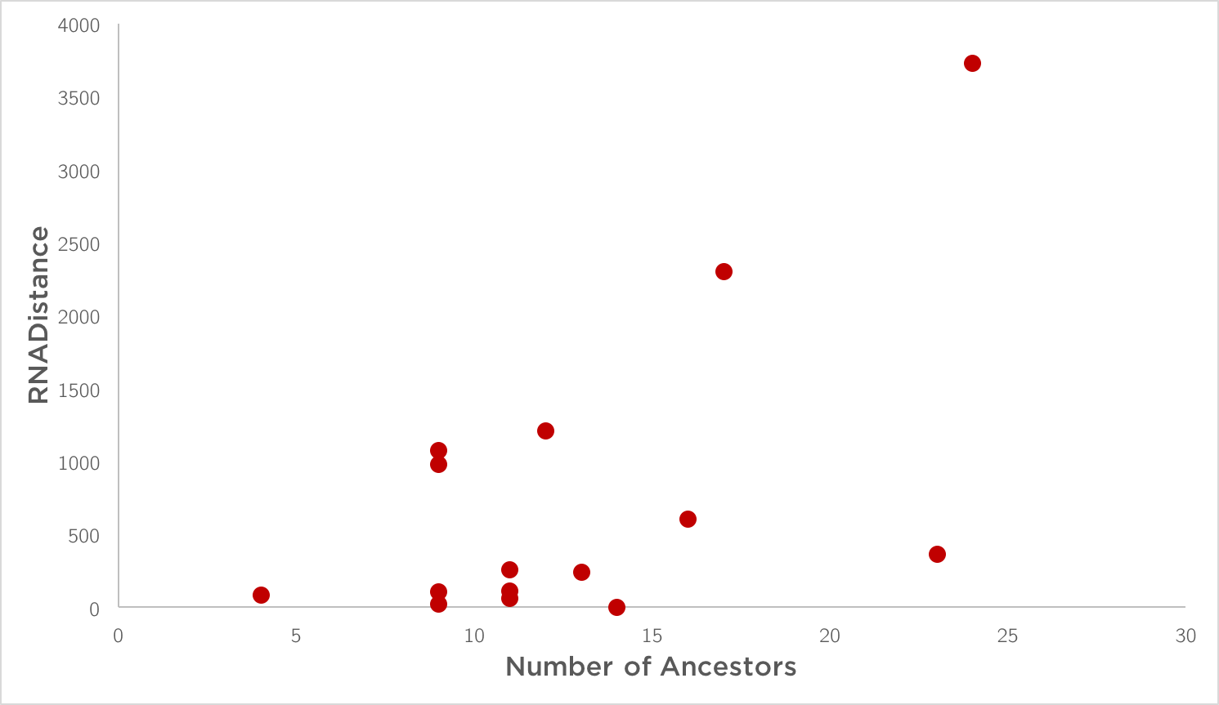

Figure 1: *Number of ancestors vs the net RNADistance in an RNA family*

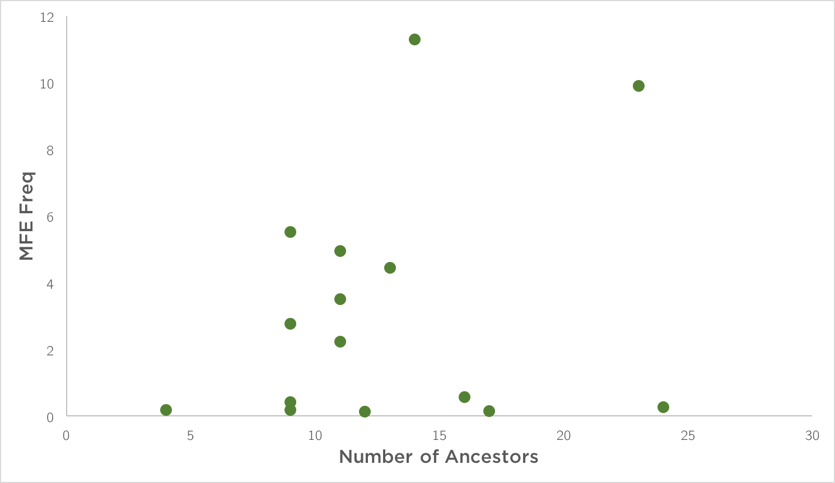

Figure 2: *Number of ancestors vs the net MFE frequency in an RNA family*

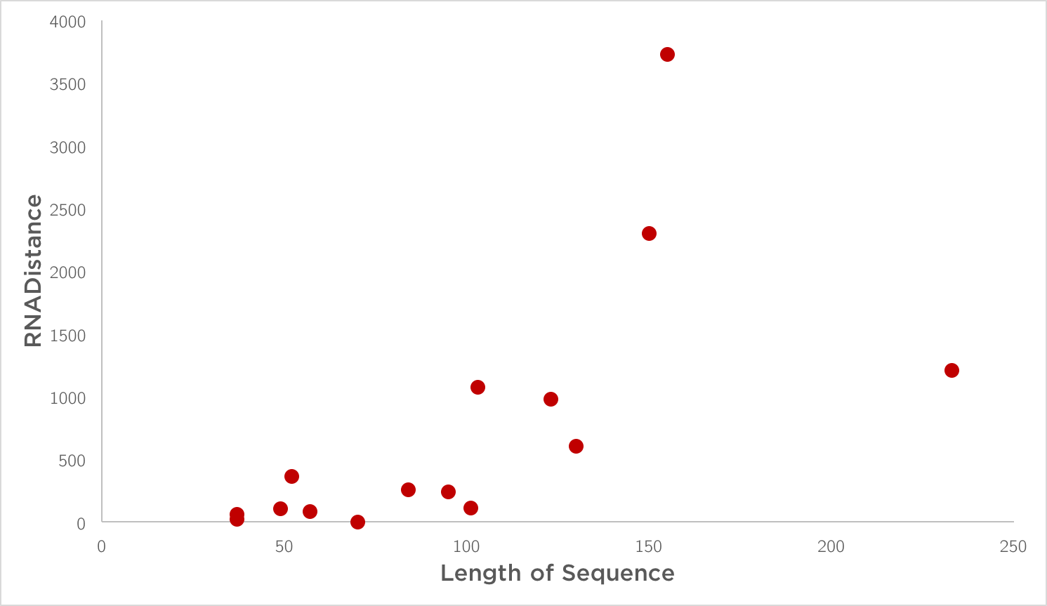

Figure 3: *Length of sequence vs the net RNADistance in an RNA family*

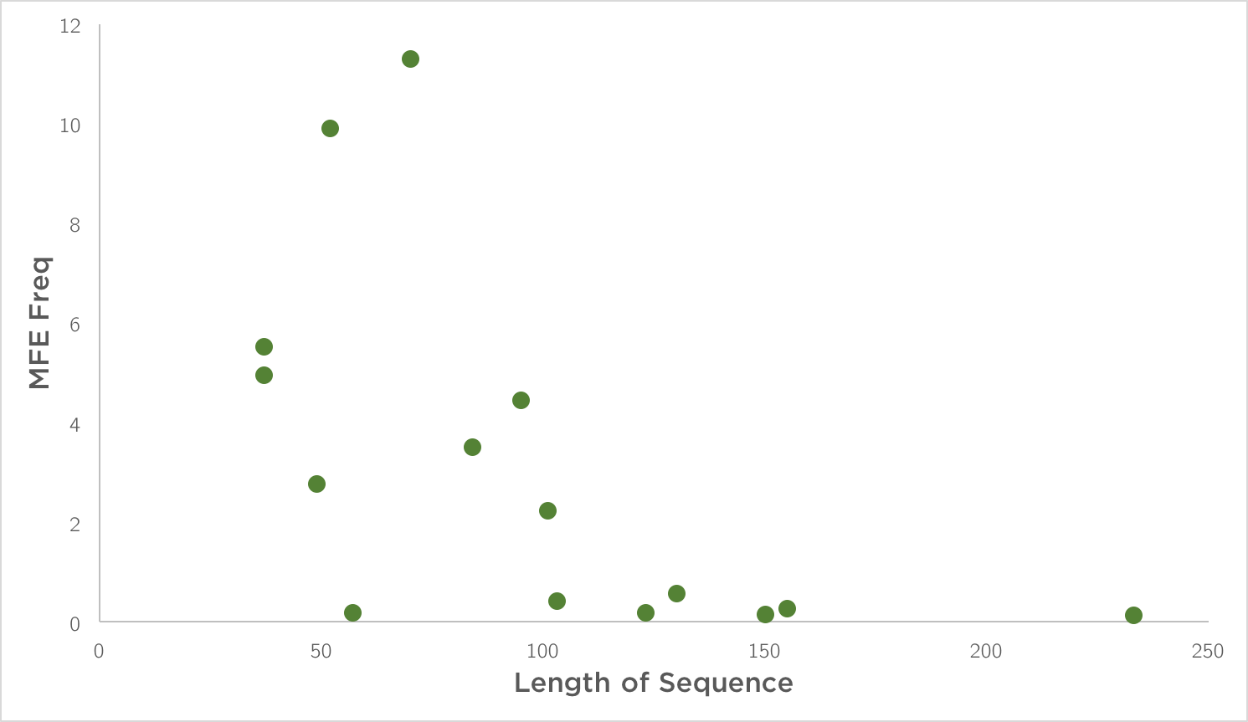

Figure 4: *Length of sequence vs the net MFE frequency in an RNA family*

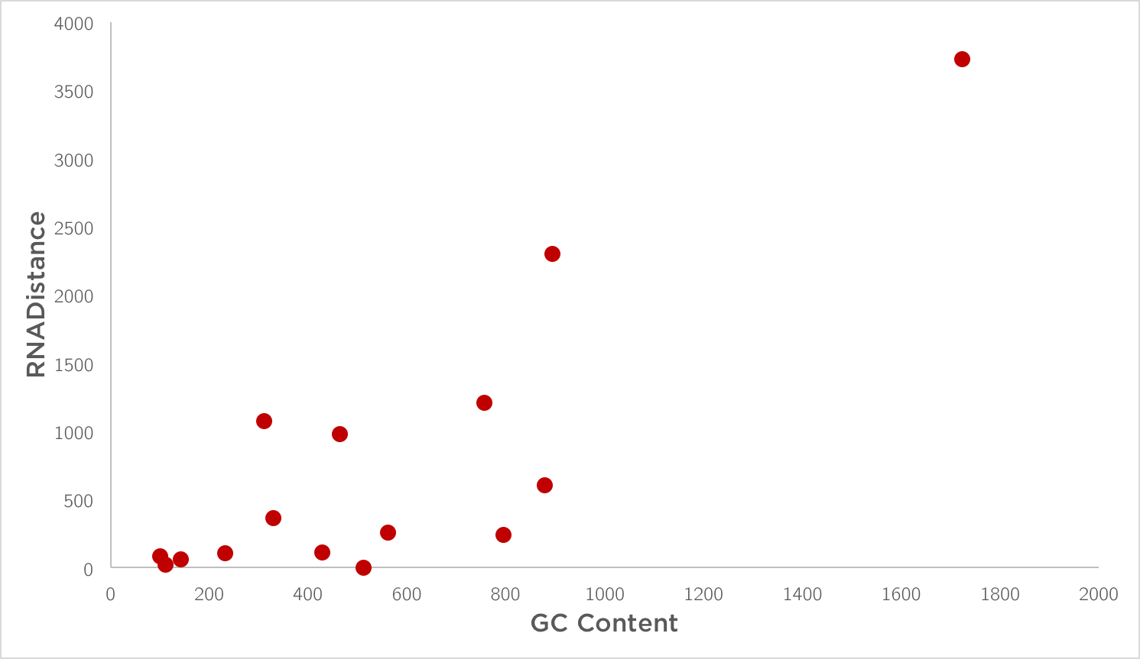

Figure 5: *GC content vs the net RNADistance in an RNA family*

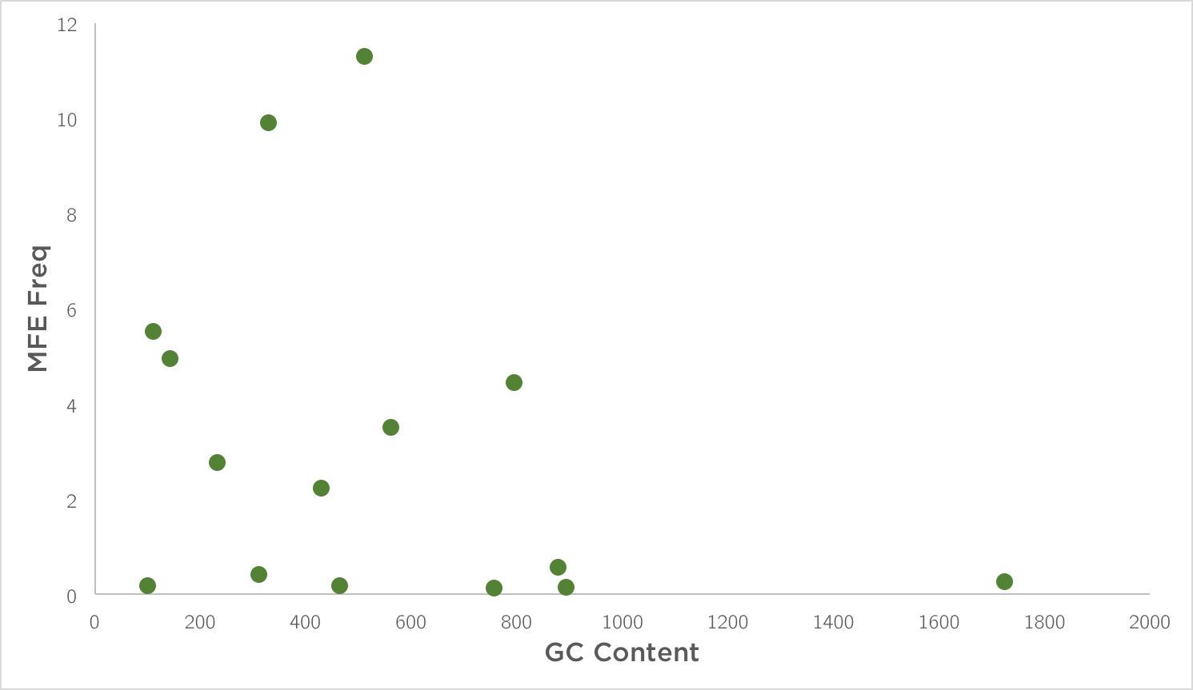

Figure 6: *GC content vs the net MFE frequency in an RNA family*

**Discussion**

We see that RNA Distance and the MFE frequency largely increases as the number of ancestors increase. We can say that they consensus structure dependencies are more conserved in s smaller phylogeny and the possibility of base pair mutations increases as the ancestral size increases.

For length of sequence, we find that longer sequences had a higher RNA Distance from the consensus structure. Also, shorter sequences tend to have higher MFE frequency.

GC content also behaves similarly. Higher GC content takes the secondary sequence away from the consensus structure and lower GC content generally has higher MFE frequency.

**References**

[1] Sankoff, David. Minimal mutation trees of sequences. SIAM Journal of Applied Mathematics 28:1 (1975) 35-42.

[2] Sankoff, David, and Pascale Rousseau. "Locating the vertices of a Steiner tree in an arbitrary metric space." Mathematical Programming 9.1 (1975): 240-246.

[3] Rfam: Home Page - http://rfam.xfam.org/

[4] Stockholm format - http://sonnhammer.sbc.su.se/Stockholm.html