# Description

This study focuses on individuals from three institutions: TU Delft, Leiden University and Leiden University Medical Center.

# Bibliometric data

## CWTS- Web of Science

Variables needed:

* Cluster_id
* All classic bibliometric indicators
* Number of collaborators from same institution
* Number of external collaborators
* Number of collaborators from same institution by publication
* Number of external collaborators by publication
* Author position

# Preliminary attempts

## Screening

The following network includes all researchers identified using an author name disambiguation algorithm (Caron & van Eck, 2014) whose main organization is TU Delft and have published at least 5 publications in collaboration with other institutional partners between 2008 and 2017. Clusters are based on the Leiden algorithm, but this should be better refined to Ludo’s field classification to get a better idea of what is going on.

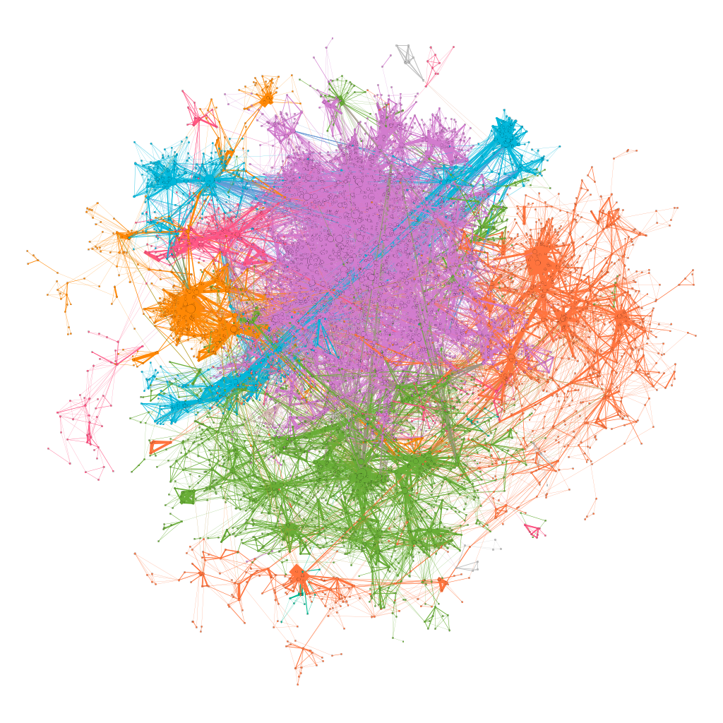

I have identified some individuals at the center of some groups randomly. However, to better refine on the objective field I have analyzed TU Delft profile using Ludo’s classification scheme. While most of TU Delft’s output is focused on Physical Sciences and Engineering they tend to publish in all areas. However, they tend to focus greatly on specific topics. After looking at some of the ones related to Medical Sciences I selected cluster 649 as it is also related with engineering, imaging, etc.

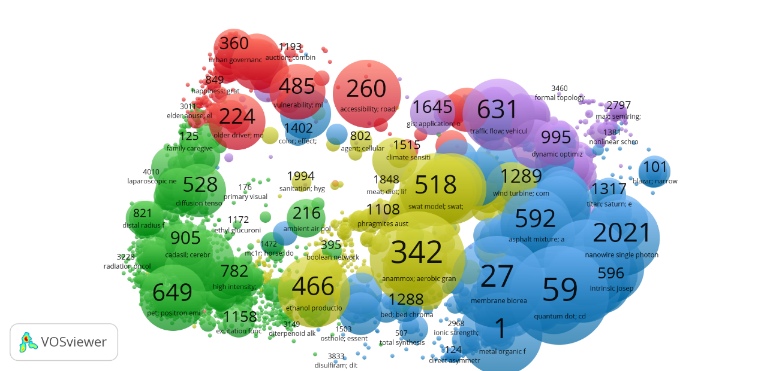

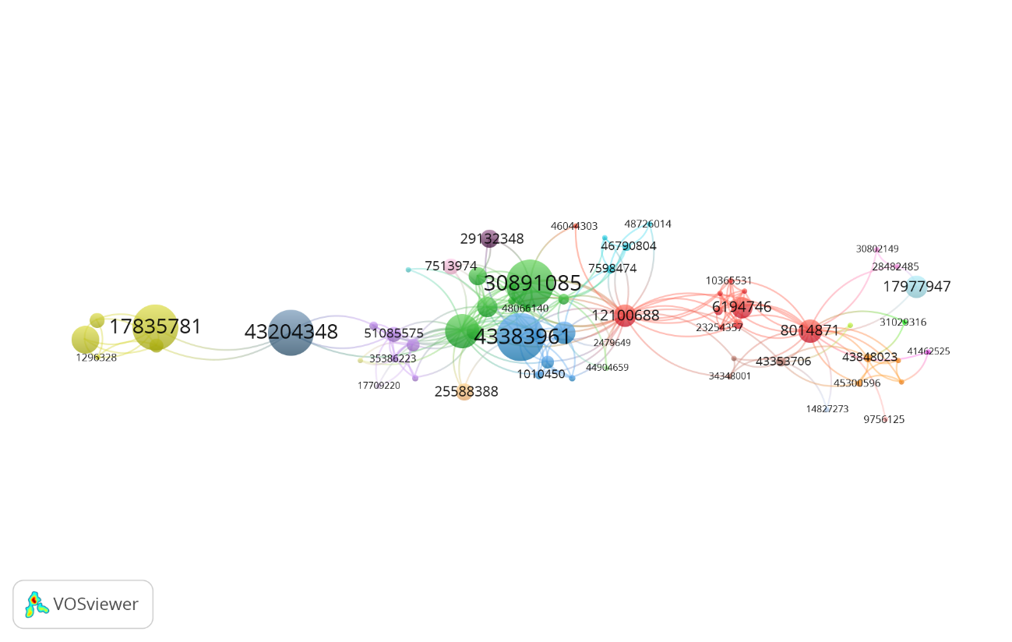

Based on a collaboration network only for publications included in cluster 649, I have selected a couple few researchers, following I include my first potential candidates.

|  |  |  |  |
| --- | --- | --- | --- |
| **cluster_id** | **full_name** | **field** | **notes** |
| 21558751 | van loosdrecht, mcm | Chemical Engineering | <https://www.tudelft.nl/tnw/over-faculteit/afdelingen/chemical-engineering/scientific-staff/freek-kapteijn/> |
| 30084098 | pronk, jt | Industrial Microbiology | <https://www.tudelft.nl/en/faculty-of-applied-sciences/about-faculty/departments/biotechnology/research-groups/industrial-microbiology/jack-pronk-group/> |
| 14941681 | kouwenhoven, lp | Quantum Physics | lab http://kouwenhovenlab.tudelft.nl |
| 6194746 | hagen, cw | Imaging Physics | does not seem to have a formal lab or team https://www.tudelft.nl/en/faculty-of-applied-sciences/about-faculty/departments/imphys/people/kees-hagen/ |
| 43204348 | weinans, h | Tissue Biomechanics and implants | Affiliated to TUDelft and UMC Utrecht |
| 12100688 | schaart, dr | Medical Physics and Technology | no formal research team identified. |