Ethan Roberts

Ruby Assignment Output_part02

CS 417

Roberts.E.assn05_part02

**Problem 1 (source-code and output):**

# Ethan Roberts

# CS 417 Topics in OOP

# This script finds all positive ints

# less than "n" that are not mcnugget numbers

# Ruby Assignment

# cite: https://stackoverflow.com/questions/12112765/how-to-reference-global-variables-and-class-variables

# used this link for syntax help with defining a global variable

# cite: http://mathworld.wolfram.com/McNuggetNumber.html

# used this link to get non-mcnugget values

# cite: https://launchschool.com/books/ruby/read/loops_iterators

# used to reference using "until" loop

**$mcnuggetAry** **=** **[**1**,**2**,**3**,**5**,**7**,**11**]** #global array holding all non-mcnugget nums

**def** **findNonMcnuggetNums(**value**)**

print "\n--User entry: "

puts value

print "--Non-mcnugget integer(s): "

i **=** 0

**if** value **>** 11

**$mcnuggetAry.**each **do** **|**n**|**

print " "

print n

**end**

**else**

**while** **($mcnuggetAry[**i**]** **<** value**)**

print **$mcnuggetAry[**i**]**

print " "

i **=** i **+** 1

**end**

**end**

print "\n\n"

**end**

# Loop for displaying output and

# accuracy of program

x **=** 0

y **=** 1

**until** x **>** 14

findNonMcnuggetNums**(**y**)**

x **=** x **+** 1

y **=** y **+** 1

**end**

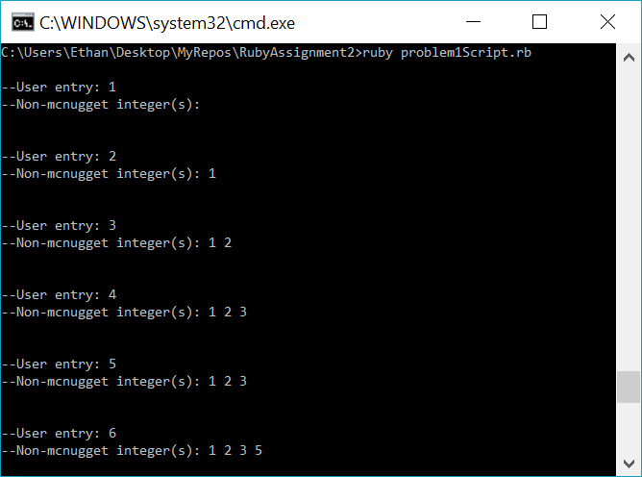

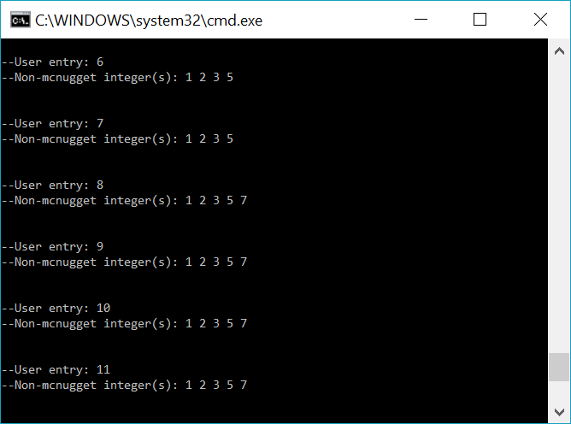

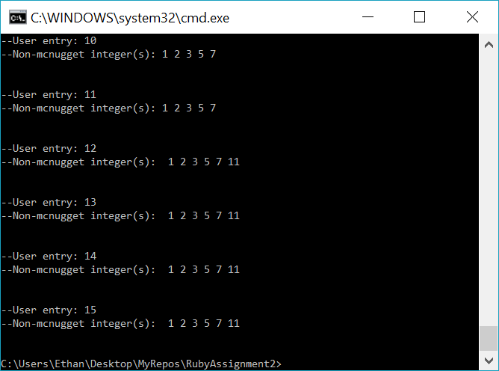

**Problem 2 (source-code and output):**

# Ethan Roberts

# CS 417 Topics in OOP

# This script deals with light switches and lights

# Ruby Assignment

# cite: https://ruby-doc.org/docs/ruby-doc-bundle/Tutorial/part_02/user_input.html

# Used this link to teach myself how to get user-input from terminal

# cite: https://apidock.com/ruby/String/to_i

# Used to learn how to convert terminal input to int

**class** **Switch**

**def** **initialize** # self-note: initialize is a ruby-defined "constructor"

@maxToggle **=** 3 #@ sign means instance variable

@numOfSwitches **=** 0

@remainder **=** 0

**end**

**def** **findNumberOfLights(**entry**)**

**if** entry **<** 2

**return** 0

**elsif** entry **==** 2

**return** 1

**else**

@remainder **=** entry **%** @maxToggle #checking to see if there is a remainder

**if** @remainder **>** 0

**return** **((**entry **/** @maxToggle**)** **+** 1**)**

**else**

**return** **(**entry **/** @maxToggle**)**

**end**

**end**

**end**

**end**

mySwitch **=** Switch**.**new**()**

myAnswer **=** 0

entry **=** 0

i **=** 0

# get user input 12 times to show accuracy of program

**while** **(**i **<** 12**)**

print "\nEnter number of lights you need to turn on: "

entry **=** gets**.**to_i

myAnswer **=** mySwitch**.**findNumberOfLights**(**entry**)**

**if** **(**myAnswer **==** 0**)**

puts "Entry must be two or more lights...try again."

**else**

print "Total light-switches needing flipped: "

puts myAnswer

**end**

i **=** i **+** 1

**end**

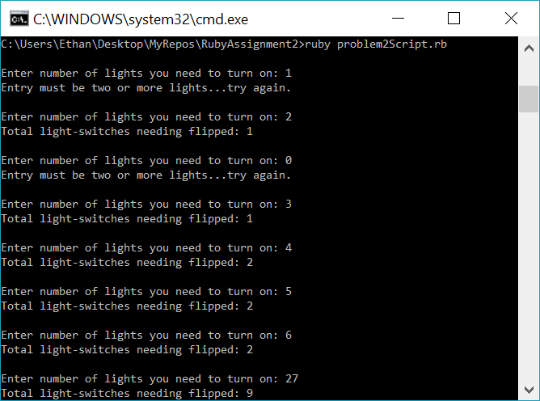

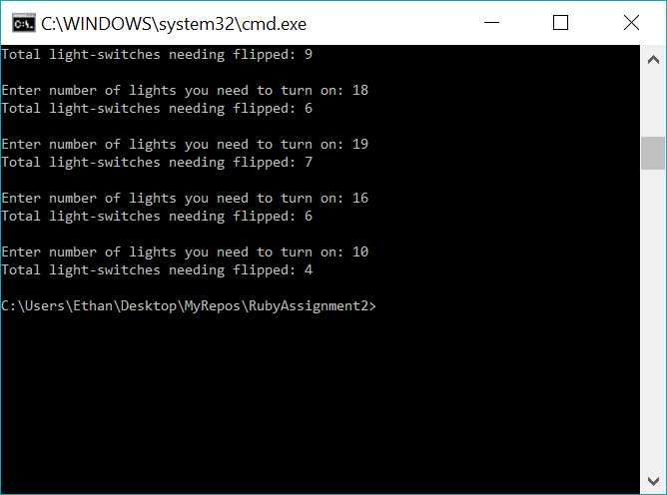

**Problem 3 (source-code and output):**

# Ethan Roberts

# CS 417 Topics in OOP

# This script deals with a single-elimination tournament

# Ruby Assignment

**class** **Tournament**

**def** **initialize** # self-note: initialize is a ruby-defined "constructor"

@playersPerMatch **=** 2

@playersInTourney **=** 0

**end**

**def** **getRounds(**entry**)**

counter **=** 0

dividend **=** 0

remainder **=** 0

@playersInTourney **=** entry

dividend **=** entry **/** @playersPerMatch # first round

remainder **=** entry **%** 2

dividend **=** dividend **+** remainder

counter **=** counter **+** 1

**while** **(**dividend **>** 1**)**

remainder **=** dividend **%** 2

dividend **=** dividend **/** @playersPerMatch

dividend **=** dividend **+** remainder

counter **=** counter **+** 1

**end**

**return** counter # number of matches played in tournament

**end**

**def** **getMatches**

**return** @playersInTourney **-** 1 # matches played formula: number of players - 1

**end**

**end**

myGame **=** Tournament**.**new**()**

myAnswer **=** 0

entry **=** 0

i **=** 0

#while-loop to show program accuracy...runs progam 10 times

**while** **(**i **<** 10**)**

print "\nEnter number of players playing: "

entry **=** gets**.**to_i

myAnswer **=** myGame**.**getRounds**(**entry**)**

print myAnswer

print " round(s) in this tournament.\n"

myAnswer **=** myGame**.**getMatches

print myAnswer

print " match(es) in this tournament.\n"

myAnswer **=** myAnswer **-** 1 #formula to get second-best: matches played - 1

print myAnswer

print " match(es) need to be played to get second-best player.\n"

i **=** i **+** 1

**end**

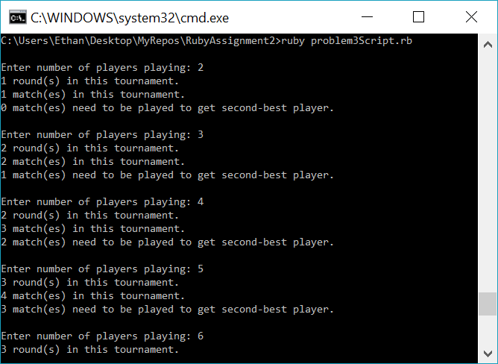

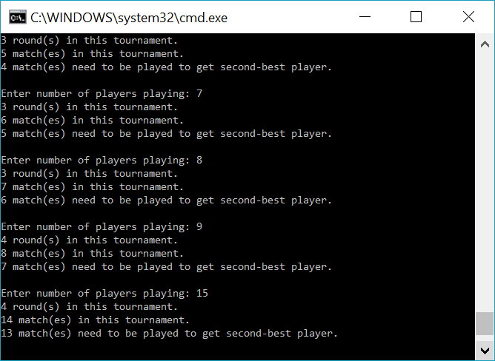

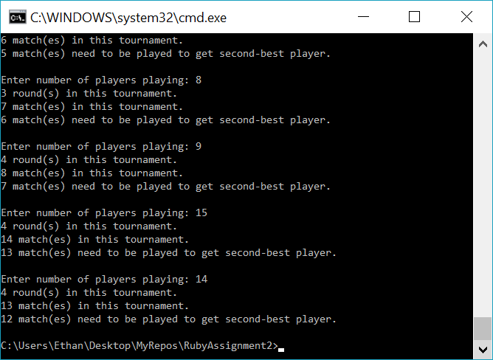

**Test Data:**

**Problem 1:**

Enter any number (must be a positive integer) and the program will return back to the user the number of non-mcnugget numbers that are less than the user’s entry.

(Data used to test: 1, 2, 3, 4 ,5 6, 7, 8, 9, 10, 11 ,12, 13, 14, 15)

**Problem 2:**

Enter any number (must be greater than 2) and the program will return back to the user the number of light-switches needing to be flipped in order to turn all lights on.

(Data used to test: 1, 2, 0, 3, 4, 5, 6, 27, 18, 19, 16, 10

**Problem 3:**

Enter any number (must be an interger greater than zero) and the program will return back to the user three different answers regarding number of matches needing to be played based on user-entered number of players in tournament, number of rounds in the tournament, and the number of matches needing to be played to get second-best player.

(Data used to test: 2, 3, 4 ,5 6, 7, 8, 9, 15, 14)