**TROJAN MALWARE DETECTION**

**TABLE OF CONTENTS:**

1. **Abstract ……………………………………………….**
2. **Introduction …………………………………………..**
3. **Problem Statement ………………………………….**
4. **Types of Trojans ……………………………………..**
5. **Tools for detection …………………………………..**
6. **System Architecture ………………………………...**
7. **Consequences ……………………………………….**
8. **Description of Dataset ………………………………**
9. **Algorithms …………………………………………….**

**10. Conclusion …………………………………………...**

**11.References ……………………………………………**

**ABSTRACT:**

This project mainly focuses on Trojan horse viruses. This thoroughly describes about what is a Trojan horse Virus, how it got the name, what types of Trojan horse viruses are present, how does the Trojan horse virus work, the usage of Trojan horse for hackers, how to recognize a Trojan virus and how to protect yourself from Trojan viruses, and a few examples of Trojan horse virus attacks. Key elements like behavior-based detection, signature-based detection, anomaly detection, and machine learning-based detection methods are highlighted in the abstract. In order to improve the efficiency of Trojan virus detection, it also highlights the significance of preventative measures including routine updates, patch management, and user awareness training. The abstract also examines new developments in Trojan detection, such as sandboxing, network traffic monitoring, and the application of cutting-edge AI algorithms. The suggested abstract offers information on how Trojan malware detection is currently doing and lays the groundwork for future study in this important field of cybersecurity.

**INTRODUCTION:**

A Trojan horse is a sort of malware that disguises itself as a genuine software and installs onto a computer or a mobile device. A Trojan virus may appear to be a harmless or even useful program, but it contains malicious code that can damage or compromise your computer. For example, a Trojan virus may allow a hacker to gain unauthorized access to your computer or steal sensitive data like passwords and financial information. Trojan viruses are typically spread through email attachments, downloads from untrusted websites, or by exploiting vulnerabilities in outdated software. A Trojan horse does not replicate itself or spread on its own, but relies on user interaction to be installed. Trojan software is made to let intruders into networks, steal confidential data, or let nefarious actors operate them remotely. Trojans seek to function silently and go unnoticed for a long time, as opposed to other forms of malware that spread quickly or cause disturbances. Trojan detection is a complex and difficult operation because of the stealthy behavior that enables them to carry out destructive activities while evading conventional security measures. A multifaceted strategy integrating a variety of approaches, methodologies, and technologies is needed to identify Trojan software. This study focuses on examining the various approaches used by security practitioners and researchers to recognize and reduce the threats brought on by Trojan virus.

**PROBLEM STATEMENT:**

Trojan malware poses a significant threat to computer systems, and detecting its presence has become increasingly challenging as cybercriminals continue to develop sophisticated attack methods. The problem statement for Trojan malware detection includes:

* Identifying new and emerging forms of Trojan malware that are designed to evade detection by traditional antivirus software.
* Ensuring that detection methods are reliable and can distinguish between genuine system activity and malicious behavior.
* Keeping up-to-date with the latest trends and techniques used by cybercriminals to ensure that the detection system remains effective and efficient.

**Types of Trojans:**

* **Backdoor Trojan:** This type of Trojan creates a "backdoor" or opening in the infected computer, which allows hackers to remotely control the system.
* **Banking Trojan:** This type of Trojan is designed to steal sensitive information such as banking credentials and credit card numbers.
* **DDoS Trojan:** A DDoS Trojan is used to launch Distributed Denial of Service (DDoS) attacks on targeted websites or servers.
* **Ransomware Trojan:** This type of Trojan is used to encrypt files on a computer and demand a ransom in exchange for the decryption key.
* **Remote Access Trojan (RAT):** This type of Trojan allows a hacker to remotely control a computer and steal sensitive information.
* **Rootkit Trojan:** A rootkit Trojan is designed to gain root-level access to a computer, which allows it to hide from detection by antivirus software and other security measures.
* **SMS Trojan:** This type of Trojan sends text messages from the infected device to premium-rate numbers, resulting in high charges for the device owner.
* **Spy Trojan:** This type of Trojan is designed to spy on the user's activities, such as keystrokes, screen captures, and network traffic.

**Tools for Detection:**

Even Though we have various tools for detection, there is no 100 percent guarantee that you can protect yourself from trojan. The best way is by following good security practices such as keeping your software up to date.

* **Network analyzers:** Some Trojans rely on network communication to carry out their malicious activities. Network analyzers can help you detect suspicious traffic on your network and identify the source of the problem.
* **Malware scanners:** There are a number of malware scanners available online that can scan your device for Trojan malware. These tools are typically free to use and can be a good way to check for malware if you suspect that your device has been compromised.
* **Rootkit scanners:** Rootkits are a type of Trojan malware that can hide themselves from detection by antivirus software. Rootkit scanners can help you detect and remove these types of Trojans from your device.
* **Antivirus Software:** One of the initial actions to identify and stop Trojan assaults is to install credible antivirus software. To find known and potential Trojans, these technologies employ behavioural analysis, heuristic scanning, and signature-based detection.

**System Architecture:**

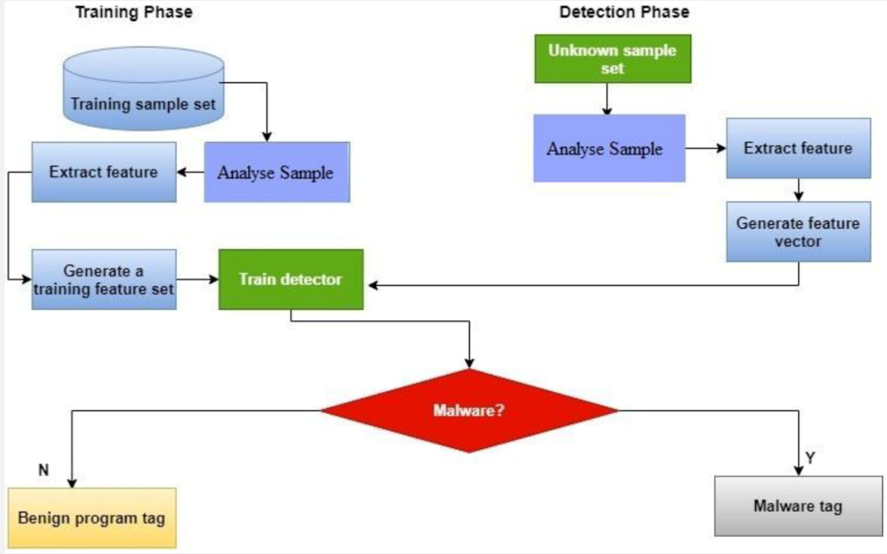

**Consequences:**

* **Unauthorized access:** A Trojan can allow an attacker to gain unauthorized access to your computer or device, giving them the ability to steal sensitive information, install additional malware, or remotely control your device.
* **Data theft:** A Trojan can be designed to steal personal or sensitive information, such as login credentials, credit card numbers, or other sensitive data.
* **System damage:** A Trojan can damage or destroy files, software, and hardware on your computer or device. This can lead to crashes, system instability, or even a complete system failure.
* **Ransomware:** Some Trojans are designed to encrypt your files and demand a ransom payment in exchange for the decryption key.
* **Botnet formation:** A Trojan can also turn your device into a part of a botnet, allowing an attacker to use it to carry out further attacks on other devices.
* **Reduced performance:** A Trojan can slow down your computer or device, causing it to run more slowly than usual.

**Description of Dataset:**

**Trojan Malware Detection Dataset**

* **Description:** The dataset at hand is focused on Trojan malware detection in electronic systems or circuits. It encompasses various features that provide insights into the characteristics of the circuits. These features include the number of ports, nets, cells, and various types of components such as combinational and sequential cells, macros/black boxes, and buf/inv. The dataset also includes information about the area occupied by different circuit elements, power consumption metrics including internal power, switching power, leakage power, and total power for various components. Additionally, it contains label information indicating whether a circuit is benign or infected with a Trojan.
* **Shape of the dataset:** 907 x 50

**Algorithms and Results:**

* **Random Forest:** Random Forest is an ensemble method that combines the predictions of multiple decision trees to improve overall accuracy and robustness. Random Forest has been used for detecting malware based on a range of features, including packet header information and statistical features.
* **Support Vector Machines (SVMs):** SVMs are a type of binary classification algorithm that can be used for detecting malware based on specific features or attributes. SVMs have been used for detecting malware based on features such as packet header information and payload content.
* **Multi-Layer Perceptron (MLPs):** The Multilayer Perceptron (MLP) is a feedforward neural network with multiple interconnected layers. It applies an activation function to transform inputs and produce outputs, allowing it to capture complex patterns and solve classification and regression tasks. MLPs are trained using backpropagation to adjust weights and minimize prediction errors, making them suitable for handling non-linear relationships and large datasets.
* **Gradient Boosting:** Gradient Boosting combines weak prediction models iteratively to form a strong predictive model. It corrects errors by training each weak learner to predict the residuals of the previous model. This technique is effective for complex datasets, capturing non-linear relationships, and achieving high accuracy, but it requires careful hyperparameter tuning to prevent overfitting.
* **KNN Neighbors:** KNN (K-Nearest Neighbors) is a versatile machine learning algorithm used for classification and regression. It predicts the label or value of a test instance by considering the K nearest neighbors in the training set. KNN assumes that similar instances have similar outcomes. The choice of K affects the balance between bias and variance. While KNN is simple to implement, it can be computationally expensive for large datasets and requires appropriate feature scaling for optimal performance.
* **Logarithmic Regression:** Logarithmic regression, or logarithmic curve fitting, is a regression analysis technique used to model relationships between variables with logarithmic patterns. It fits a logarithmic function, such as y = a * ln(x) + b, to the data. This regression model captures nonlinear relationships, especially when the dependent variable exhibits diminishing returns or growth. It finds applications in economics, finance, and biological sciences for analyzing and predicting phenomena following logarithmic patterns.
* **XG Boosting:** XGBoost, short for Extreme Gradient Boosting, is a powerful and scalable machine learning algorithm that belongs to the boosting family. It is an optimized implementation of gradient boosting that offers higher accuracy and faster training speed. XGBoost combines multiple weak prediction models (decision trees) in an additive manner, iteratively improving the model by minimizing the loss function through gradient descent. It employs advanced techniques such as regularization, parallelization, and tree pruning to enhance performance and handle large datasets effectively. XGBoost is widely used for various machine learning tasks, including classification, regression, and ranking.

After implementing the aforementioned models, we conducted evaluations using metrics including the confusion matrix, accuracy, and training time. Based on the results, we compared the performance of the mentioned models and found that both XG Boost and Gradient Boosting models exhibited the highest accuracy. Furthermore, in terms of execution time, XG Boost demonstrated the lowest time required for training.

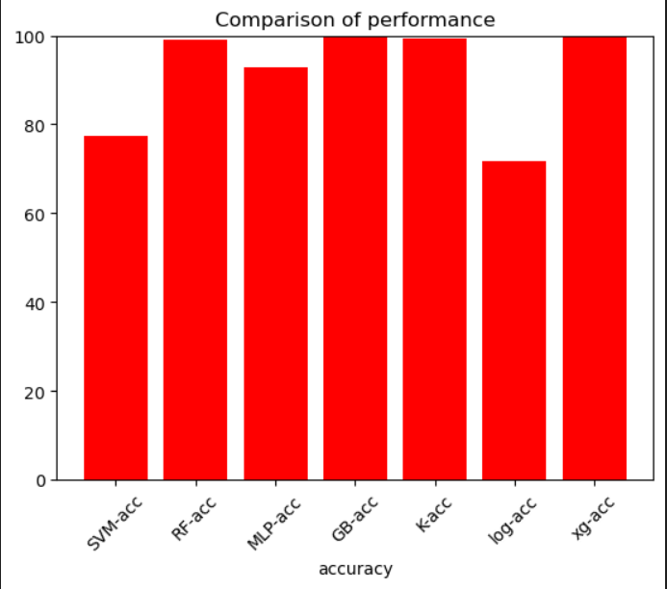 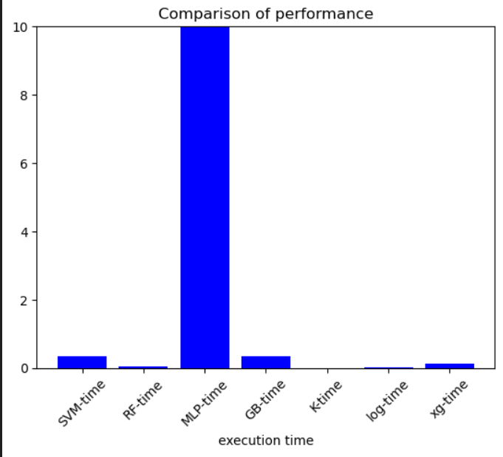

**Conclusion:**

A crucial component of preserving the security and integrity of computer systems is the detection of Trojan malware. Trojans are well-known for their capacity to avoid detection and seriously harm networks and data. A multi-layered strategy involving both preventive and detective techniques is required to detect Trojan assaults. In this paper, we looked at a variety of Trojan malware detection tools and methods. In order to recognize known Trojan signatures and prevent harmful files from running, antivirus software is essential. It's crucial to remember that using antivirus software alone is insufficient because many sophisticated Trojans use obfuscation techniques to avoid detection.

In conclusion, identifying Trojan malware necessitates a thorough and proactive strategy that incorporates a variety of detection methods and technologies. Organizations can considerably improve their capacity to identify and reduce the risks posed by Trojan assaults by putting in place a multi-layered defense strategy, protecting their systems and data from possible harm. Our machine learning models, specifically the ensemble model called XG Boost, have demonstrated a remarkable ability to detect trojans with an accuracy rate of approximately 99%. This high detection rate has been achieved through the training of our model using a comprehensive dataset specifically designed for trojan detection.

**References:**

* Liu, Y.F., Zhang, L.W., Liang, J., Qu, S. and Ni, Z.Q., 2010, July. Detecting Trojan horses based on system behavior using machine learning method. In 2010 International Conference on Machine Learning and Cybernetics (Vol. 2, pp. 855-860). IEEE.
* Liu, Y., Zhang, L., & Wang, X. (2018). A novel approach for trojan detection based on improved random forests. International Journal of Security and Its Applications, 12(1), 165-174.
* Ali, M. A., Islam, M. R., Islam, M. S., & Bhuiyan, M. Z. A. (2020). Trojan detection using machine learning: A systematic literature review. Journal of Ambient Intelligence and Humanized Computing, 11(2), 641-655.
* Zafar, M. A., Javed, M. Y., & Rehman, S. U. (2019). Malware detection using machine learning techniques. International Journal of Advanced Computer Science and Applications, 10(6), 20-27.
* Hossain, M. S., & Muhammad, G. (2019). A machine learning approach to detect trojan malware. Journal of Information Security, 10(1), 34-47.
* Raja, R. A., Ganapathy, S., & Kannan, A. (2018). Detecting trojan malware using machine learning techniques. International Journal of Engineering and Technology, 7(2.5), 48-53.