PTP and TSN Configuration Manual
Command-Line Interface (CLI)
English translation of 《PTP及TSN配置手册 - CLI》 (49-page source, WPS Writer, created 2023-11-01).
All CLI commands, command syntax, parameter names, configuration samples and command outputs are reproduced byte-for-byte from the source. All prose has been translated into English.
All 23 embedded figures (topology diagrams, frame-format diagrams and CLI screenshots) are reproduced from the source PDF unchanged and placed at their original positions. Exactly two of them (Figures 7 and 11) contain Chinese labels, which are left untranslated (PASS); the remaining 21 figures are already entirely in English. See Appendix A of the Translator’s Notes.

Contents
Part I. PTP
1.1 PTP Overview
1.2 Configuration
1.3 Configuration Examples
Part II. TSN
1. 802.1Qbv TAS
1.1 Overview
1.2 Basic Concepts
1.3 802.1Qbv TAS Configuration
1.4 TAS Configuration
1.5 802.1Qbv TAS Configuration Example
2. 802.1Qbu Frame Preemption
2.1 Overview
2.2 Basic Concepts
2.3 Frame Preemption Configuration
2.4 Frame Preemption Configuration Example
3. 802.1Qci PSFP
3.1 PSFP Introduction
3.2 PSFP Configuration
3.3 PSFP Configuration Example
4. 802.1CB FRER
4.1 Overview
4.2 Basic Concepts
4.3 Configuration
4.4 Configuration Example
Translator’s Notes (source anomalies and items passed over)

Part I. PTP

1.1 PTP Overview
PTP (Precision Time Protocol) is a time-synchronization protocol that can be used for high-precision time synchronization and frequency synchronization between devices. PTP provides sub-microsecond time-synchronization accuracy.

1.1.1 PTP Protocol Standards
A PTP protocol standard is also called a PTP profile. Different PTP profiles deliver different PTP capabilities. The PTP profiles are as follows:
▪ IEEE 1588 version 2 (1588v2 for short): IEEE 1588 specifies the principles and the message-interaction procedures used for high-precision clock synchronization in a network. It was originally applied in industrial automation and is now mainly used in bridged LANs. IEEE 1588 imposes no mandatory requirements on the network environment, so it is broadly applicable.
▪ IEEE 802.1AS (802.1AS for short): 802.1AS is a profile derived from IEEE 1588 that refines the implementation of IEEE 1588 in bridged LANs. The BMC (Best Master Clock) algorithm supported by 802.1AS differs slightly from that of IEEE 1588 and draws on the implementation approach of MSTP (Multiple Spanning Tree Protocol). The physical media supported by 802.1AS are limited to point-to-point full-duplex Ethernet links, IEEE 802.11 links and IEEE 802.3 EPON links.

1.1.2 Clock Domains
A single physical network can be divided into multiple logical clock domains. Each clock domain has one synchronization time, and all devices within the domain are synchronized to that time. Different clock domains each have their own synchronization time and are independent of one another.
A device can pass through the time of multiple clock domains (this can be used in a bearer network to supply several mobile operators’ networks with their own distinct synchronization times), but the device itself can join only one clock domain and synchronize to only one synchronization time.

1.1.3 Clock Node Types
Every node in a time-synchronization network is called a Clock. The 1588v2 protocol defines three basic clock node types:

OC (Ordinary Clock)
An OC has only one 1588v2 clock port. Through that port it either synchronizes time from an upstream node (1588v2 protocol) or distributes time to a downstream node (1588v2 protocol).

BC (Boundary Clock)
A BC has multiple 1588v2 clock ports; one of those ports synchronizes time from an upstream device (1588v2 protocol) and the remaining ports distribute time to downstream devices (1588v2 protocol).
In certain special cases — for example, a device obtains standard time from a BITS device through an external time interface (not the 1588v2 protocol) and distributes time downstream through two other ports (1588v2 protocol) — the device is also called a BC node, because it has more than one 1588v2 port.

TC (Transparent Clock)
The key difference between a TC and a BC/OC is this: a BC/OC must keep its own time synchronized with other devices, whereas a TC does not keep time synchronization with other devices. A TC has multiple 1588v2 clock ports; it merely forwards 1588v2 protocol messages between those ports and corrects them for forwarding delay. It does not synchronize time from any port.
TC nodes fall into two types: E2E TC (End-to-End Transparent Clock) and P2P TC (Peer-to-Peer Transparent Clock).

TC+OC
TC+OC is a special type of TC node: in terms of time synchronization it behaves the same as a TC node (forwarding 1588v2 messages and correcting forwarding delay), and in addition it performs clock synchronization on ports with OC attributes (clock synchronization only — not time synchronization).
As described above, a TC node applies delay correction to the 1588v2 messages it forwards. As long as the ingress-port and egress-port times of the TC device stay synchronized, the difference between the two is the forwarding delay of the message. However, if the clock of the TC device is not synchronized with the BC/OC nodes that perform time synchronization, the message forwarding delay it derives is inaccurate; this introduces error into the time-synchronization calculations of the BC/OC and reduces time-synchronization accuracy.
In general, users are advised to achieve clock synchronization between the TC device and the BC/OC by means of a physical clock (such as a WAN clock or a Synchronous Ethernet clock). If no such physical clock is available, the TC device must recover the frequency from the 1588v2 Sync messages periodically sent by the upstream device, so as to achieve clock synchronization with the upstream device. This is TC+OC.
TC+OC nodes also fall into two types: E2E TC+OC and P2P TC+OC.

1.1.4 Master–Slave Relationship
The master–slave relationship is a relative one. For a pair of clock nodes that synchronize with each other, the following master–slave relationships exist:
▪ Master/Slave node: the clock node that distributes the synchronization time is called the Master Node; the clock node that receives the synchronization time is called the Slave Node.
▪ Master/Slave clock: the clock on the master node is called the Master Clock; the clock on the slave node is called the Slave Clock.
▪ Master/Slave port: the PTP interface on a clock node that distributes the synchronization time is called the Master Port; the PTP interface that receives the synchronization time is called the Slave Port. Both master and slave ports can exist on a BC or an OC.
In addition, there is a kind of PTP interface that neither distributes nor receives synchronization time; it is called a Passive Port. In a PTP network, all clock node types (except TC) are linked together through master–slave relationships. The master–slave relationship between clock nodes can be produced automatically by the BMC algorithm, or specified manually.

1.1.5 Clock Source Types
A clock node supports the following two clock sources:
▪ Local clock source: the 38.88 MHz clock signal generated by the crystal oscillator inside the clock monitoring module.
▪ External clock source (ToD clock source): generated by an external clock device and sent/received through a dedicated interface on the device (the 1PPS/ToD interface); hence it is also called the ToD clock source.

1.1.6 Grandmaster Clock
All clock nodes within a PTP domain are organized together in a hierarchy. The reference time of the whole domain is the Grandmaster Clock (GM) — the clock at the highest level. By exchanging PTP protocol messages and using the clock priority, time class, clock accuracy and other information carried in those messages, the clock nodes elect the Grandmaster for the entire PTP domain.
TN-1 — The corresponding source sentence ends abruptly (“…选举出整个PTP域”, literally “…elect the entire PTP domain”) with no object. The English rendering above supplies the implied object (“the Grandmaster”) for readability; no other change was made.

1.1.7 Time Source Selection
In a 1588v2 time-synchronization network, all clocks are organized together according to the master–slave synchronization hierarchy, and the reference time of the system is the Grandmaster Clock — the highest-level clock. This topology can be established by static configuration or generated automatically by the protocol; the protocol referred to here is the 1588v2 BMC (Best Master Clock) source-selection algorithm.
The 1588v2 protocol defines the Announce message, which is used to exchange time-source information between clock nodes, including: the Grandmaster’s priority, time class and time accuracy, the number of hops to the Grandmaster, and so on. Using this information, each clock node can select one node as the Grandmaster and select the port through which it will synchronize to the clock distributed by the Grandmaster, thereby determining the master–slave relationship between two nodes. The result of source selection is a loop-free, fully connected tree rooted at the Grandmaster — that is, a spanning tree.
For two nodes in a master–slave relationship, the Master node periodically sends Announce messages to the Slave node. If the Slave node does not receive an Announce message from the Master node within a certain period, that master–slave relationship is considered invalid and source selection is performed again; the node ultimately switches over to another port and establishes a new master–slave relationship and time synchronization.
The device also supports the PTSF (Packet Timing Signal Fail) source-switching feature. When the current time source suffers a signal failure caused by an offset jump (greater than 1.1 µs continuously for 3 seconds) or by the loss of Sync messages, the device automatically switches to another valid time source.

1.1.8 PTP Synchronization Principle
The basic principle of PTP synchronization is as follows. Once the master–slave relationship between the clocks has been confirmed, the master and slave devices exchange time-synchronization messages in both directions. From the transmit and receive timestamps of the messages, the total round-trip delay between the two devices is calculated; if the delay is the same in both directions, half of the round-trip delay is the one-way delay. The time offset of the Slave relative to the Master can then be derived, and the Slave adjusts its local time according to that time difference, thereby achieving time synchronization with the Master.

1.2 Configuration

1.2.1 PTP External Clock Configuration
① Run the command configure terminal to enter global configuration mode.
② Run the command ptp ext output. If timestamping is done by the PHY, configure One_PPS_Mode as output.

1.2.2 Creating a Clock Instance and Configuring the PTP Profile
① In global configuration mode, run the command ptp 0 mode boundary profile ieee1588 to select the 1588v2 profile.
② Run the command ptp 0 mode boundary profile 802.1as to select the 802.1AS profile.

1.2.3 Configuring the Clock Priority Parameters
① In global configuration mode, run the command ptp 0 priority1 0-255 to set the priority1 parameter; a low priority ensures successful BMCA master election.
② Run the command ptp 0 priority2 0-255 to set the priority2 parameter.
TN-2 — “优先级低可以保证BMCA选主成功” is rendered literally as “a low priority ensures successful BMCA master election”. Under IEEE 1588 BMCA a numerically lower priority1 value wins the election, which is consistent with the literal reading.

1.2.4 Enabling the PTP Feature on an Interface
① In global configuration mode, run the command interface 10GigabitEthernet <port_type_list> to enter interface configuration mode.
② Run the command ptp 0 to enable the PTP feature on that port.

1.2.5 Adjusting the Transmission and Reception of PTP Synchronization Messages
① In interface configuration mode, run ptp 0 announce interval X to configure the transmission period of the master device’s Announce messages as 2 to the power of X seconds.
② Run the command ptp 0 sync-interval X to configure the transmission period of the master device’s Sync messages as 2 to the power of X seconds.
③ Run the command ptp 0 announce timeout X to configure the reception timeout multiplier for Announce messages.

1.2.6 Viewing the PTP Status of the Device
① In system mode, run the command show ptp 0 default to view the current PTP configuration.
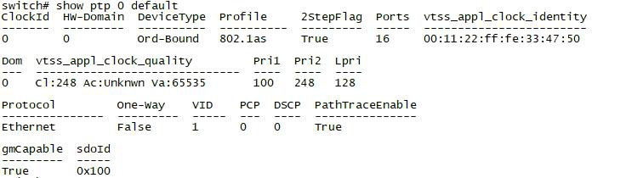
Figure 1 — Output sample: show ptp 0 default (source screenshot, p.8 — CLI output in English, reproduced unchanged)
② Run the command show ptp 0 port-ds to view information about the PTP clock port data set.
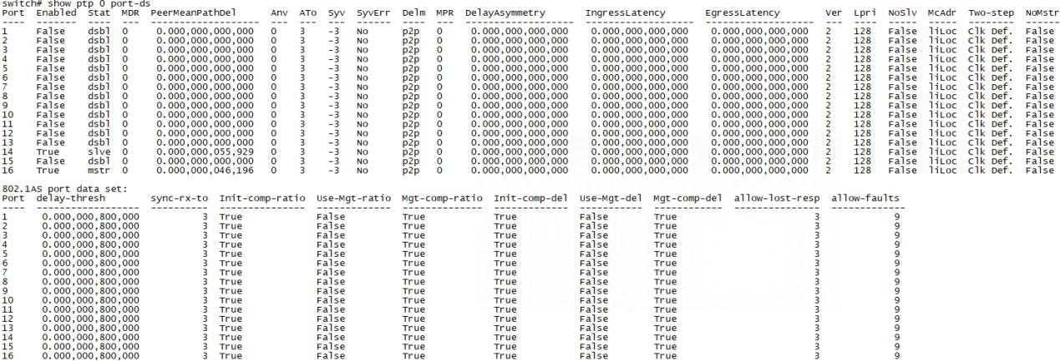
Figure 2 — Output sample: show ptp 0 port-ds (source screenshot, p.8 — CLI output in English, reproduced unchanged)
③ In system mode, run the command show ptp 0 port-state to view the master and slave mode of the ports.
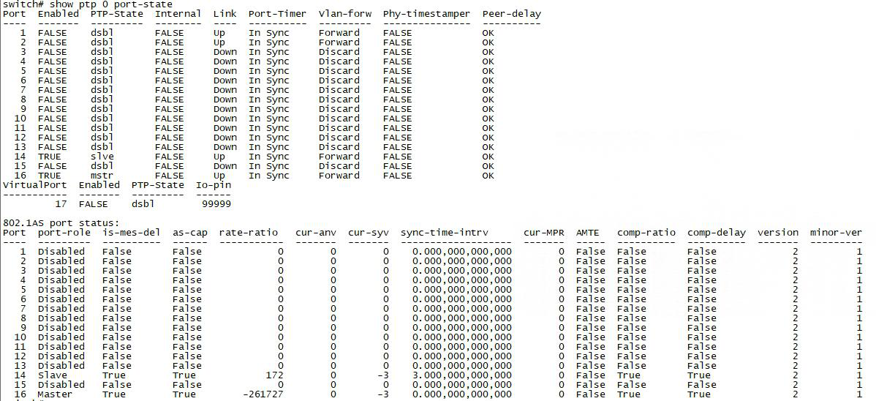
Figure 3 — Output sample: show ptp 0 port-state (source screenshot, p.9 — CLI output in English, reproduced unchanged)
④ Run the command show ptp 0 parent to view information about the master and the Grandmaster.
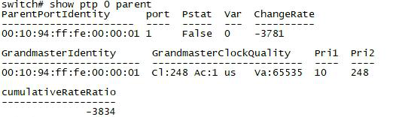
Figure 4 — Output sample: show ptp 0 parent (source screenshot, p.9 — CLI output in English, reproduced unchanged)
⑤ Run the command show ptp 0 slave to view the PTP synchronization status. PHASE_LOCKED indicates that the clock is locked and synchronization has succeeded.
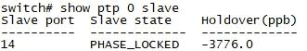
Figure 5 — Output sample: show ptp 0 slave showing PHASE_LOCKED (source screenshot, p.9 — CLI output in English, reproduced unchanged)
⑥ Run the command show ptp 0 current to view the parameters related to the current PTP clock offset.
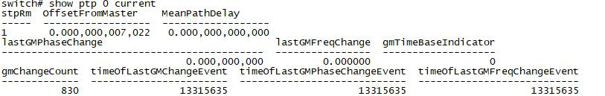
Figure 6 — Output sample: show ptp 0 current (source screenshot, p.9 — CLI output in English, reproduced unchanged)

1.3 Configuration Examples

1.3.1 1588 Configuration Example
Connect 10G interface 1 of Switch A to 10G interface 2 of Switch B, and use the 1588v2 protocol so that 10G interface 1 of Switch A negotiates as Master and 10G interface 2 of Switch B negotiates as Slave.
Switch A configuration:
configure terminal
ptp ext output
ptp 0 mode boundary profile ieee1588
ptp 0 priority1 10
interface 10GigabitEthernet 1/1
ptp 0
Switch B configuration:
configure terminal
ptp ext output
ptp 0 mode boundary profile ieee1588
interface 10GigabitEthernet 1/2
ptp 0
TN-3 — The source writes “协商成Mater” (typo for Master) and “1588V2”. Corrected in translation to “Master” and “1588v2”.

1.3.2 802.1AS Configuration Example
To use the 802.1AS protocol, simply change ptp 0 mode boundary profile ieee1588 above to ptp 0 mode boundary profile 802.1as. All other configuration is the same.

Part II. TSN

1. 802.1Qbv TAS

1.1 Overview
TSN (Time-Sensitive Networking) is a new generation of network standards based on Ethernet. It provides a common set of time-sensitive mechanisms for the MAC layer of the Ethernet protocol, so that critical data such as voice, video and industrial-automation commands can be transmitted over Ethernet deterministically, with low latency and high reliability. The TSN standards mainly comprise time synchronization, traffic control, reliability and security. Building on IEEE 802.1Q, the TSN working group proposed the IEEE 802.1Qbv standard. IEEE 802.1Qbv defines the Time-Aware Shaper, which is intended to optimize the transmission priority of Ethernet frames and guarantee that information is delivered within the specified time; it belongs to the traffic-control part of the TSN protocol family.
Based on the critical services running in the network, the user analyzes the flow characteristics and the operating times of those critical services and, by means of the 802.1Qbv feature, makes the designated critical services enter designated interface forwarding queues, then schedules those queues flexibly and periodically so that the device achieves zero congestion loss when forwarding this critical service traffic. 802.1Qbv creates and distributes a time schedule among the participating network devices; the schedule defines the gate open/close states and mechanisms of the transmit queues at the egress of a TSN switch. The queue carrying scheduled traffic is released for transmission in its predetermined time window, while the queues carrying other unscheduled traffic within that same time window are paused, so scheduled traffic is not disturbed or blocked by unscheduled traffic. Deploying the 802.1Qbv feature across the entire TSN network keeps the forwarding latency of critical service traffic within the TSN network at the microsecond level.
TN-4 — The source phrase “在预定的时间窗口大大后会被放行传输” contains an apparent typo (“大大后”). It has been rendered as “is released for transmission in its predetermined time window”, which is the only reading consistent with the surrounding text.

1.2 Basic Concepts

1.2.1 Time Synchronization
The time-aware shaper has the ability to schedule transmissions from each queue relative to a known global time scale. Global time is maintained by using the specific version of the Precision Time Protocol (PTP) defined in IEEE 802.1AS-Rev, which keeps time accuracy in the TSN network at the sub-microsecond level and allows the devices in the TSN network to work in coordination.

1.2.2 Forwarding Queues
The basic idea of time-aware scheduling is to divide Ethernet communication into fixed-length, repeating time slices, called cycles; each cycle is further divided into multiple finer-grained time slices, called time slots. Each time slot can be assigned to one or more of the eight Ethernet priorities, thereby forming a virtual communication channel during a specific time period, so that specific real-time data can be interleaved with non-real-time data traffic, reducing the impact of other bursty or abnormal transmission requests on real-time data transmission.
Each interface of the switch has eight forwarding queues, numbered 0 to 7. When an interface needs to transmit packets, packets are first placed into the corresponding queue according to certain rules; for packets within the same queue, the packet that entered first is forwarded first. The priority queues are configured with corresponding time slots. When traffic is transmitted, the TSN device knows exactly which priority queues should be transmitted in each time slot, as shown in the figure below:
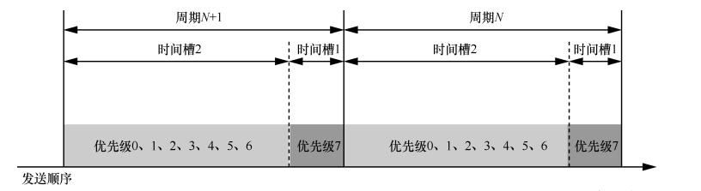
Figure 7 — Cycle, GCL time slots and priority queues (source diagram, p.12; the Chinese labels inside the image are left untranslated — PASS, see Appendix A)
In the figure above, each cycle is divided into 2 GCL time slots, and each time slot can be configured with different priority queues. As shown, time slot 1 is configured with priority 7 and time slot 2 with priorities 0 to 6, meaning that each time slot can transmit only the data traffic of the priorities configured for it.

1.2.3 Gate Control List (GCL)
802.1Qbv supports configuring multiple gate control lists; the current system supports a maximum of 256 entries on a device. Each entry contains the following attributes, through which one time slot’s worth of traffic transmission is accomplished:
▪ Node index: 802.1Qbv schedules entries in ascending order of node index.
▪ Gate operation: three operations are available — set | set-hold | set-release.
▪ Queue gate state: the open/closed state of an interface’s forwarding queues is expressed as an 8-bit binary string (XXXXXXXX), read from right to left: the rightmost bit represents the state of queue 0, the second bit from the right represents the state of queue 1, and so on. When a bit is 0 the queue is closed, i.e. packets in that queue are not allowed to be transmitted; when a bit is 1 the queue is open, i.e. packets in that queue are allowed to be transmitted.
▪ Gate state duration: the duration of the open/closed state of the interface forwarding queues within the node. When this time expires, the next node is executed and the queue gate state of that next node takes over.
TN-5 — Source: “当前系统最大支持设备256条” is grammatically incomplete. Rendered as “the current system supports a maximum of 256 entries on a device”.

1.2.4 Cycle Time
The cycle time is the duration for which the system executes the control list once. Timing begins when 802.1Qbv starts executing the first node, and the control list is executed in order. When the cycle time expires, execution of the control list automatically restarts from the first node.

1.2.5 Guard Band
A time period is inserted between every two GCL cycles; it is called the guard band. This ensures that no frame is still in the middle of being transmitted when the cycle switches over. Within the guard band, no new frame is allowed to begin transmission, but a frame that had already begun transmitting before the guard band may continue and complete its transmission inside the guard band. If the port cannot determine the transmission time of the next frame, the guard band must be long enough to cover the transmission time of the longest frame on the current link. Therefore:
▪ If the 802.1Qbv guard-band feature is disabled, 802.1Qbv immediately executes the next node; the data frame currently being transmitted is truncated, and the remaining content may be discarded, or may have to wait until the next polling cycle before it can be transmitted.
▪ If the 802.1Qbv guard-band feature is enabled, 802.1Qbv finishes transmitting the remaining part of that data frame before executing the next node.
▪ The guard band is fixed when the device leaves the factory and cannot be changed by configuration.

1.2.6 Base Time
The time at which the interface begins executing the 802.1Qbv forwarding-queue scheduling policy.
The base time is used to calculate when the device executes the scheduling algorithm. For example, if the user plans to begin executing the 802.1Qbv scheduling algorithm at 12:00:00 on 18 March 2020, the time difference between that moment and 00:00:00 on 1 January 1970 must first be calculated and converted into PTP time format (seconds plus nanoseconds); the resulting seconds and nanoseconds are then used for the configuration.

1.2.7 Operating Procedure
The 802.1Qbv workflow is:
(1) When the device system time reaches the base time, the 802.1Qbv feature is started.
(2) Packets received on the interface are classified according to their flow characteristics and, according to the configured CoS value, enter the corresponding forwarding queue.
(3) The queue gate state in each node of the control list controls which queues are opened and closed; the duration of the gate state controls whether the traffic in each queue is transmitted or blocked, and the time at which it is transmitted or blocked.
(4) The control list is executed cyclically, transmitting TSN flows according to the schedule.
TSN technology is based on time synchronization. Through network planning, all devices in the TSN network first achieve nanosecond-level time synchronization; the same 802.1Qbv configuration is then deployed on every device, so that TSN traffic enters the same queue on all TSN devices and the queue gate states and gate times are identical, achieving the effect that TSN flows are forwarded linearly across the TSN network.

1.3 802.1Qbv TAS Configuration

1.3.1 Prerequisites
Before configuring the 802.1Qbv feature, first configure the PTP feature and use the IEEE 802.1AS profile so that all TSN devices in the TSN network complete time synchronization. You can use the show ptp 0 slave command (where 0 is the index of the configured PTP instance) to view the time-synchronization status of the TSN switch; PHASE_LOCKED indicates that the clock is locked and synchronization has succeeded.

1.3.2 Configuring the TSN Guard Band
The CLI syntax for enabling the guard band in global configuration mode for 802.1Qbv TAS is:
(1) Run configure terminal to enter global configuration mode.
(2) Run tsn tas always-guard-band to enable the guard-band feature globally, so that the guard band is applied to traffic scheduled on any queue.
(3) Run no tsn tas always-guard-band to disable the guard-band feature globally; once disabled, traffic scheduled on queues no longer applies the guard band.

1.4 TAS Configuration

1.4.1 Configuring the Base Time and the Cycle Time
The TAS base time is the time at which TSN flows begin to be scheduled according to the 802.1Qbv TAS scheduling algorithm. This time must be later than the current time, and is configured in PTP time format (composed of a seconds part and a nanoseconds part).
(1) Enter global configuration mode.
configure terminal
(2) Enter the Layer 2 Ethernet interface view.
interface interface-type interface-number
(3) Configure the base time.
tsn tas base-time seconds <seconds> nanoseconds <nanoseconds>
By default, no base time is configured for TAS scheduling of the interface forwarding queues; the default value is 0, meaning no waiting — gating takes effect immediately.
(4) Configure the cycle time.
tsn tas cycle-time <time> { ms | us | ns }
tsn tas cycle-time-extension <extension> (optional)
Determine the size of the cycle time from the “gate-state duration” and the “guard band”:
▪ If the time required to execute all nodes in the control list is less than the cycle time, the unconfigured nodes first automatically execute the queues’ default gate states to transmit packets, with each node lasting 262136 ns. If the cycle time has still not expired at that point, packets are forwarded according to the chip’s default behaviour until the cycle time expires, after which execution of the control list restarts.
▪ If the time required to execute all nodes in the control list is greater than or equal to the cycle time, then when the cycle time expires execution of the control list restarts, which may cause some nodes not to be executed.

1.4.2 Configuring the Control List
Whether TSN flows passing through the device can be forwarded within a deterministic time is related to the control-list configuration. Each node of the control list corresponds to the gate states of a port’s eight forwarding queues and the duration of those states. Opening the gate of the queue in which the TSN flow resides, closing the gates of the queues in which non-TSN flows reside, and configuring the gate-state duration to be the transmission time of the TSN flow — this configuration guarantees that TSN flows are forwarded first.
(1) Enter global configuration mode.
configure terminal
(2) Enter the Layer 2 Ethernet interface view.
interface interface-type interface-number
(3) Configure the length of the control list.
tsn tas control-list-length <length>
(4) Configure the control list for TSN forwarding scheduling.
tsn tas control-list index <index> gate-state queue <0-7 queue> { open | closed } time-interval <interval> [ operation { set | set-hold | set-release } ]
▪ By default, no control list is configured for TSN forwarding scheduling.
▪ index <index> — starts at 0, maximum 256.
▪ gate-state queue <0-7 queue> { open | closed } — the queue range is 0–7; a single number or a range can be specified.
▪ The combined value of time-interval must not exceed the value of the cycle time; it may be less. When it is less, the remaining time is forwarded according to the chip’s default behaviour, i.e. no additional scheduling is applied.
▪ operation { set | set-hold | set-release } — normally set is chosen; set-hold or set-release need to be configured only when frame preemption is set up.

1.4.3 Enabling TAS and Making the Configuration Take Effect
(1) Enter global configuration mode.
configure terminal
(2) Enter the Layer 2 Ethernet interface view.
interface interface-type interface-number
(3) Configure the gate states.
tsn tas gate-states queue <queue> { open | closed }
By default, all gates are in the open state.
(4) Enable TAS.
tsn tas gate-enabled
(5) Make the TAS configuration take effect.
tsn tas config-change
Once the configuration above is complete, the TAS configuration has not yet taken effect — it is stored as a pending configuration. Finally, the tsn tas config-change command must be used to make the configuration take effect.
TN-6 — Step (3) is headed “配置使能门控” (“enable gating”) in the source but the command given is tsn tas gate-states …, which sets gate states. The heading has been rendered as “Configure the gate states” to match the command.

1.4.4 Configuring MAX-SDU
(1) Enter global configuration mode.
configure terminal
(2) Enter the Layer 2 Ethernet interface view.
interface interface-type interface-number
(3) Configure max-sdu.
tsn tas max-sdu queue <queue> <sdu>

1.4.5 Viewing TAS
(1) Enter the view/inspect configuration mode.
end
(2) View the TAS status of a specified port.
show tsn tas status interface 10GigabitEthernet 1/4
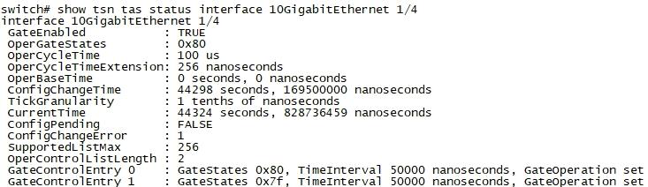
Figure 8 — Output sample: show tsn tas status interface 10GigabitEthernet 1/4 (source screenshot, p.17 — CLI output in English, reproduced unchanged)

1.5 802.1Qbv TAS Configuration Example

1.5.1 Example Requirements
(1) Configure a TAS schedule on port 1, i.e. the ingress; port 2 is the ingress.
TN-7 — The source states “在端口1 即入口上配置一个TAS的调度计划，端口2为入口”, which names both ports as ingress. From the configuration that follows (TAS is configured only on GigabitEthernet 1/1, while GigabitEthernet 1/2 receives only QoS mapping), port 2 is evidently the egress. The source wording is preserved here and the discrepancy is flagged rather than silently corrected.
(2) The gate control list to be configured is as follows:
▪ Entry 0: open queue 7 and close all other queues, and configure an open time of 125000 nanoseconds
▪ Entry 1: open queue 6 and close all other queues, and configure an open time of 125000 nanoseconds
▪ Entry 2: open queue 5 and close all other queues, and configure an open time of 125000 nanoseconds
▪ Entry 3: open queue 4 and close all other queues, and configure an open time of 125000 nanoseconds
▪ Entry 4: open queue 3 and close all other queues, and configure an open time of 125000 nanoseconds
▪ Entry 5: open queue 2 and close all other queues, and configure an open time of 125000 nanoseconds
▪ Entry 6: open queue 1 and close all other queues, and configure an open time of 125000 nanoseconds
▪ Entry 7: open queue 0 and close all other queues, and configure an open time of 125000 nanoseconds
(3) The cycle time of this control-list schedule is one cycle every 1000 microseconds.

1.5.2 Prerequisites
Please configure the PTP feature first, using the IEEE 802.1AS profile so that all TSN devices in the TSN network complete time synchronization. For the related PTP configuration, see “PTP”.

1.5.3 Configuration Procedure
# Enter global configuration mode
configure terminal
# Add VLAN 100
vlan 100
# Exit back to global configuration mode
exit
# Enter port 1
interface GigabitEthernet 1/1
# Configure port 1 as a trunk and allow all added VLANs to pass
switchport mode trunk
switchport trunk allowed vlan all
# Configure the length of the control list.
tsn tas control-list-length 8
# Configure the cycle time.
tsn tas cycle-time 1000 us
# Configure the control list for TSN forwarding scheduling.
tsn tas control-list index 0 gate-state queue 7 open time-interval 125000 operation set
tsn tas control-list index 1 gate-state queue 6 open time-interval 125000 operation set
tsn tas control-list index 2 gate-state queue 5 open time-interval 125000 operation set
tsn tas control-list index 3 gate-state queue 4 open time-interval 125000 operation set
tsn tas control-list index 4 gate-state queue 3 open time-interval 125000 operation set
tsn tas control-list index 5 gate-state queue 2 open time-interval 125000 operation set
tsn tas control-list index 6 gate-state queue 1 open time-interval 125000 operation set
tsn tas control-list index 7 gate-state queue 0 open time-interval 125000 operation set
# Enable TAS.
tsn tas gate-enabled
# Make the TAS configuration take effect.
tsn tas config-change
# Enable the QoS feature on Port 1
qos trust tag
# Exit back to global configuration mode
exit
# Enter port 2
interface GigabitEthernet 1/2
# Configure port 2 as a trunk and allow all added VLANs to pass
switchport mode trunk
switchport trunk allowed vlan all
# By default, VLAN priority COS 0 is mapped to local queue DPL 1 and COS 1 is mapped to DPL 0;
# this can be modified with the following configuration
qos map tag-cos pcp 0 dei 0 cos 0 dpl 0
qos map tag-cos pcp 0 dei 1 cos 0 dpl 1
qos map tag-cos pcp 1 dei 0 cos 1 dpl 0
qos map tag-cos pcp 1 dei 1 cos 1 dpl 1
# Enable the QoS feature on Port 2
qos trust tag
After the above configuration is complete, the TAS schedule has been enabled on port1; traffic passing through that port will be scheduled in time according to its tag, and each queue obtains 125000 ns of open time, starting from the control-list entry index.
TN-8 — Source: “从控制链表序号开始” is elliptical and has been rendered literally as “starting from the control-list entry index”.

1.5.4 Verifying the Configuration
Enter show running-config interface GigabitEthernet 1/1 to view the configuration.
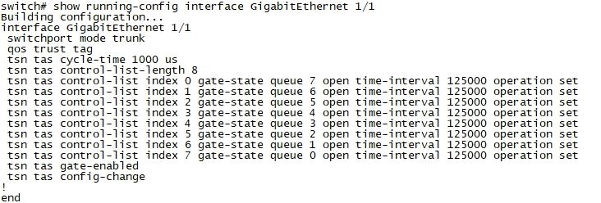
Figure 9 — Output sample: show running-config interface GigabitEthernet 1/1 (source screenshot, p.20 — CLI output in English, reproduced unchanged)
Enter show running-config interface GigabitEthernet 1/2 to view the configuration.
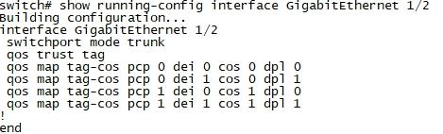
Figure 10 — Output sample: show running-config interface GigabitEthernet 1/2 (source screenshot, p.21 — CLI output in English, reproduced unchanged)

2. 802.1Qbu Frame Preemption

2.1 Overview
The TSN 802.1Qbu work and the IEEE 802.3 working group jointly developed IEEE 802.3br — the preemptable MAC frame mechanism (Frame Preemption, FP for short). The transmission mechanism based on preemptable MAC is shown in the figure below.
It adopts the frame preemption mechanism of 802.3TG, splitting a given egress into two MAC service interfaces, respectively called the Preemptable MAC (pMAC) and the Express MAC (eMAC). A pMAC can be preempted by an eMAC; after entering the data stack it waits until the eMAC data transmission has completed before transmitting. As shown below:
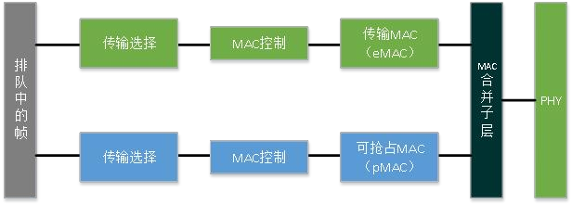
Figure 11 — Transmission mechanism based on preemptable MAC (source diagram, p.21; the Chinese labels inside the image are left untranslated — PASS, see Appendix A)
Frame preemption is the ability to pause the transmission of non-time-critical frames and to allow one or more time-critical frames to be transmitted. When the time-critical frames have been transmitted, transmission of the non-time-critical frame resumes. A non-time-critical frame can be preempted multiple times.
Using frame preemption together with time-aware shaping reduces the required guard band from the size of the largest possible interfering frame to the size of the largest possible interfering fragment, as shown below.
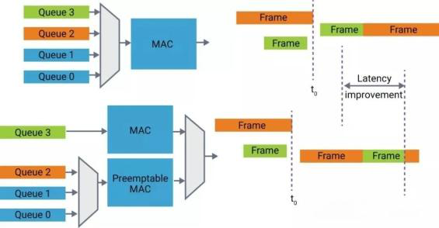
Figure 12 — Reduction of the required guard band by frame preemption plus time-aware shaping (source diagram, p.22 — labels in English, reproduced unchanged)
TN-9 — The source writes “pAMC-Preemptable MAC” (transposition typo) and “Preemptable” throughout instead of the standard spelling “Preemptible”/“Preemptable”. “pMAC” and the source spelling “Preemptable” are used consistently in this translation. “802.3TG” is left as written (it refers to the IEEE 802.3 Task Group work).

2.2 Basic Concepts

2.2.1 Traditional Ethernet Frame Format
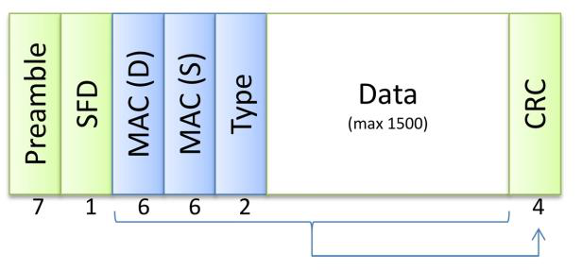
Figure 13 — Traditional Ethernet frame format (source diagram, p.22 — labels in English, reproduced unchanged)
A traditional Ethernet frame format contains a 7-byte Preamble and a 1-byte SFD (Start Frame Delimiter); these 8 bytes are the frame’s preamble. Next come the DMAC, the SMAC and the Type; the Data part is the data portion of the frame (containing network-layer and higher-layer data); the CRC is the trailer, used to verify the correctness of the frame (the preamble portion is not included).

2.2.2 IEEE 802.3br Frames
The main difference between an IEEE Std 802.3br frame and a traditional Ethernet frame in terms of frame format lies in the 8th byte of the data frame’s Preamble. In a traditional Ethernet frame the 8th byte serves as the Start Frame Delimiter; in an IEEE Std 802.3br frame the 8th byte is used to determine the data frame category.
IEEE 802.1br defines two kinds of frames: the Express frame (eMAC frame) and the Preemptable frame (pMAC frame). Express frames (eMAC frames) and Preemptable frames (pMAC frames) are distinguished by the frame category in the 8th byte of the preamble. The formats of the two frames are as shown below:
(1) eMAC frame
An Express frame is the same as an ordinary Ethernet frame; the 8th byte of its Preamble is fixed at D5.
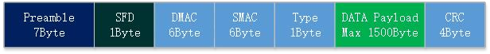
Figure 14 — eMAC (Express) frame format (source diagram, p.23)
(2) pMAC frame
A Preemptable frame differs from a traditional Ethernet frame in that the 8th byte of the frame Preamble is SMD-Sx.
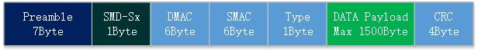
Figure 15 — pMAC (Preemptable) frame format (source diagram, p.23)
When a pMAC frame is preempted by an eMAC frame, the preempted pMAC frame is divided into a pMAC fragment first frame, pMAC fragment intermediate frames and a pMAC fragment last frame. The three data frame formats are as shown below:
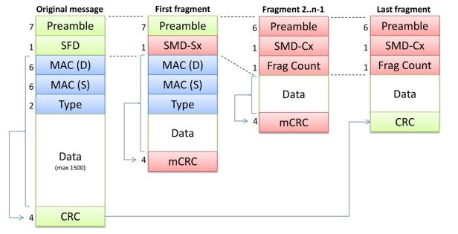
Figure 16 — pMAC fragment first / intermediate / last frame formats (source diagram, p.23)
SMD-Sx (with the value 0xE6, 0x4C, 0x7F or 0xB3) is used to transmit the first fragment (First fragment) of a Preemptable frame.
The subsequent fragments of the message (2..n-1, if any) and the last fragment (Last fragment) use a different message format. IEEE shortens the preamble to 6 bytes; the 7th byte is SMD-Cx (the value of SMD-Cx being 0x61, 0x52, 0x9E or 0x2A) and the 8th byte is the Frag Count (fragment counter), so that the receiver knows how to identify the order of the content it has received and whether any fragment has been lost.
The standard Ethernet portion of each fragment is at least 60 bytes; an Ethernet frame that is to be transmitted without being fragmented must be no smaller than 120 bytes, otherwise it is transmitted immediately — this ensures that the Ethernet minimum frame transmission requirement is met.
Fragment first frames and fragment intermediate frames use the mCRC check code. When frame preemption occurs, in order to guarantee the accuracy of fragment first frames and fragment intermediate frames, the TSN switch must add a check field to the fragment. To distinguish it from the CRC check code of the original data frame, the newly added field is called mCRC. The mCRC calculation process is as follows:
▪ Calculate the CRC value from the data of that fragment; this step is the same as the CRC calculation method for an ordinary Ethernet frame.
▪ XOR the 32-bit CRC with 0x0000FFFF to obtain the mCRC value. The fragment last frame uses the CRC check code, and its CRC check code is the same as the CRC check code of the original preemptable frame.
(3) Backward compatibility
In order to be compatible with devices that do not support Frame Preemption, IEEE defined a “Verify” and “Respond” mechanism. Through this mechanism it is determined whether both sides support Frame Preemption, preventing fragments whose preamble and CRC have changed from being discarded by a device that does not support Frame Preemption. The “Verify” and “Respond” messages are as shown below:
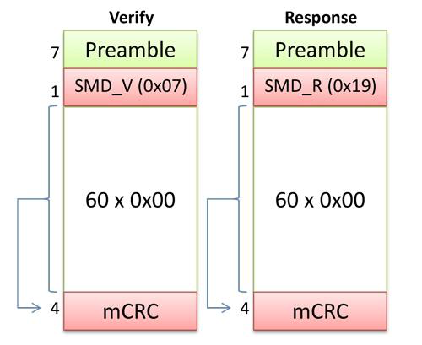
Figure 17 — “Verify” and “Respond” messages (source diagram, p.24)
A device that wishes to send frame-preemption messages first sends a “Verify” message to the peer device. When the peer device sends back a “Respond” message, this indicates that it also supports frame preemption, and Frame Preemption fragments can then be sent to the peer; otherwise Frame Preemption is not started. Normally this negotiation process must be enabled and completed.
(4) Encoding reference tables for SMD and Frag Count
Table — SMD encoding
mPacket type | Frame# | SMD
SMD-Sx  Preemptable  Frame start | 0 | 0xE6
 | 1 | 0x4C
 | 2 | 0x7F
 | 3 | 0xB3
SMD-Cx  Non-initial  fragment | 0 | 0x61
 | 1 | 0x52
 | 2 | 0x9E
 | 3 | 0xAD
Verify |  | 0x07
Respond |  | 0x19

Table — Frag Count encoding
Frag Count | Frag
0 | 0xE6
1 | 0x4C
2 | 0x7F
3 | 0xB3

TN-10 — Two source inconsistencies are reproduced verbatim in the tables above: (a) the SMD table gives SMD-Cx Frame#3 = 0xAD, whereas the body text of §2.2.2 lists the SMD-Cx values as 0x61, 0x52, 0x9E or 0x2A; (b) the Frag Count table maps Frag Count 0–3 to 0xE6/0x4C/0x7F/0xB3, which are the SMD-Sx values rather than fragment-counter values. Also, the source table header reads “Premptable” (typo), corrected to “Preemptable” here.

2.2.3 LLDP
Before frame preemption is enabled, the switching device sends a verification frame to neighbouring devices through the LLDP protocol. If a response frame from the neighbouring device is received within the specified time, frame preemption verification succeeds and the frame preemption feature can be enabled. If no response frame from the neighbouring device is received within the specified time, the switching device sends the verification frame to the neighbouring device again; if a response frame is still not received, frame preemption verification fails and the frame preemption feature cannot be enabled. After the frame preemption feature has passed verification, the additional information of the data frame is added to the mPacket header, describing its preemption characteristics.

2.3 Frame Preemption Configuration

2.3.1 Prerequisites
Frame Preemption is based on QoS queues. Before configuring FP, the QoS configuration of the ports must be planned and configured.

2.3.2 Configuring FP
FP decides whether to preempt according to the matching policy at the egress, so the FP feature is configured at the egress.
(1) Enter global configuration mode.
configure terminal
(2) Enter the Layer 2 Ethernet interface view.
interface interface-type interface-number
(3) Enable the FP TX feature.
tsn frame-preemption
(4) Disable verification of the peer’s FP capability.
tsn frame-preemption verify-disable
Note that once this is disabled, the peer is not verified for FP support, and packet loss may occur if the peer does not support FP.
(5) Configure the device not to wait for the peer’s LLDP message verification before enabling the FP feature.
tsn frame-preemption ignore-lldp
Note that ignoring LLDP messages when starting FP means that FP is started on the local side regardless of whether the peer supports FP.
(6) Configure the queues on which FP is preemptable.
tsn frame-preemption queue <0-7 queue>
After configuration, these queues can be preempted; for example, if queue 1 is configured, then frames in queue 1 can be preempted.
(6) To delete a configuration or turn it off, prefix the command from steps 1–5 above with no and run it again; the configuration is then successfully deleted or turned off. For example, to turn off frame preemption on a port:
no tsn frame-preemption
TN-11 — The source numbers two consecutive steps as “(6)” in §2.3.2. The duplication is reproduced as-is.
(7) View the FP configuration.
switch# show running-config
Building configuration...
......
interface 10GigabitEthernet 1/2
switchport hybrid allowed vlan 100
switchport mode hybrid
qos trust tag
qos map tag-cos pcp 0 dei 0 cos 0 dpl 0
qos map tag-cos pcp 0 dei 1 cos 0 dpl 1
qos map tag-cos pcp 1 dei 0 cos 1 dpl 0
qos map tag-cos pcp 1 dei 1 cos 1 dpl 1
no spanning-tree
tsn frame-preemption
tsn frame-preemption verify-disable
tsn frame-preemption ignore-lldp
tsn frame-preemption queue 0
tsn frame-preemption queue 1
(8) View the FP port status.
# show tsn frame-preemption status interface GigabitEthernet 1/1
interface GigabitEthernet 1/1
HoldAdvance : 0 nanoseconds
ReleaseAdvance : 0 nanoseconds
PreemptionActive : FALSE
HoldRequest : FALSE
StatusVerify : disabled
LocPreemptSupported : TRUE
LocPreemptEnabled : TRUE
LocPreemptActive : FALSE
LocAddFragSize : 0 (64 octets)

2.4 Frame Preemption Configuration Example

2.4.1 Example Requirements
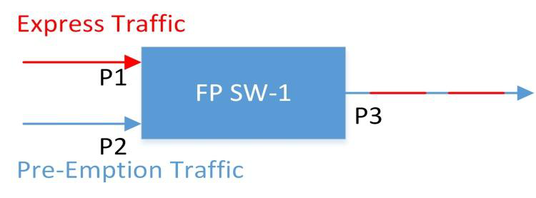
Figure 18 — Frame Preemption example topology: SW-1 ports P1/P2/P3 (source diagram, p.27; Chinese labels inside image not translated — PASS)
▪ Enable the FP feature on P3 of SW-1, preempting frames in queue 1.
▪ The flow entering SW-1 from P1 is a Priority 7 data flow, VLAN 100.
▪ The flow entering SW-1 from P2 is a Priority 1 data flow, VLAN 100.

2.4.2 Configuration Procedure
Configuration of SW-1:
# Enter global configuration mode and add VLAN 100
configure terminal
vlan 100
exit
# Enter the P1 port
interface GigabitEthernet 1/1
# Configure the VLAN of the P1 port
switchport hybrid allowed vlan 100
switchport mode hybrid
# Enable QoS on the P1 port and configure the qos tag map
qos trust tag
qos map tag-cos pcp 0 dei 0 cos 0 dpl 0
qos map tag-cos pcp 0 dei 1 cos 0 dpl 1
qos map tag-cos pcp 1 dei 0 cos 1 dpl 0
qos map tag-cos pcp 1 dei 1 cos 1 dpl 1
# Enter the P2 port
switch(config)# interface GigabitEthernet 1/2
# Configure the VLAN of the P2 port
switchport hybrid allowed vlan 100
switchport mode hybrid
# Enable QoS on the P2 port and configure the qos tag map
qos trust tag
qos map tag-cos pcp 0 dei 0 cos 0 dpl 0
qos map tag-cos pcp 0 dei 1 cos 0 dpl 1
qos map tag-cos pcp 1 dei 0 cos 1 dpl 0
qos map tag-cos pcp 1 dei 1 cos 1 dpl 1
# Enter the P3 port
switch(config)# interface GigabitEthernet 1/3
# Configure the VLAN of the P3 port
switchport hybrid allowed vlan 100
switchport mode hybrid
# Enable QoS on the P3 port and configure the qos tag map
qos trust tag
qos map tag-cos pcp 0 dei 0 cos 0 dpl 0
qos map tag-cos pcp 0 dei 1 cos 0 dpl 1
qos map tag-cos pcp 1 dei 0 cos 1 dpl 0
qos map tag-cos pcp 1 dei 1 cos 1 dpl 1
# Enable the FP TX feature on the P3 port
tsn frame-preemption
# Configure the FP queue on the P3 port as 1
tsn frame-preemption queue 1
TN-12 — §2.4.1 requires the P1 flow to be Priority 7 and the P2 flow to be Priority 1, but the qos map tag-cos lines in §2.4.2 only map pcp 0 and pcp 1 (to cos 0 and cos 1). No mapping for pcp 7 is configured anywhere in the example. Reproduced verbatim; the gap is flagged rather than filled in.

2.4.3 Verifying the Configuration
# View the SW-1 configuration
switch# show running-config
Building configuration...
......
interface 10GigabitEthernet 1/1
switchport hybrid allowed vlan 100
switchport mode hybrid
qos trust tag
qos map tag-cos pcp 0 dei 0 cos 0 dpl 0
qos map tag-cos pcp 0 dei 1 cos 0 dpl 1
qos map tag-cos pcp 1 dei 0 cos 1 dpl 0
qos map tag-cos pcp 1 dei 1 cos 1 dpl 1
no spanning-tree
!
interface 10GigabitEthernet 1/2
switchport hybrid allowed vlan 100
switchport mode hybrid
qos trust tag
qos map tag-cos pcp 0 dei 0 cos 0 dpl 0
qos map tag-cos pcp 0 dei 1 cos 0 dpl 1
qos map tag-cos pcp 1 dei 0 cos 1 dpl 0
qos map tag-cos pcp 1 dei 1 cos 1 dpl 1
no spanning-tree
!
interface 10GigabitEthernet 1/3
switchport hybrid allowed vlan 100
switchport mode hybrid
qos trust tag
qos map tag-cos pcp 0 dei 0 cos 0 dpl 0
qos map tag-cos pcp 0 dei 1 cos 0 dpl 1
qos map tag-cos pcp 1 dei 0 cos 1 dpl 0
qos map tag-cos pcp 1 dei 1 cos 1 dpl 1
no spanning-tree
tsn frame-preemption
tsn frame-preemption queue 1
TN-13 — The show running-config output above lists the interfaces as 10GigabitEthernet 1/1–1/3, whereas the configuration procedure in §2.4.2 configures them as GigabitEthernet 1/1–1/3. Reproduced as printed in the source.

3. 802.1Qci PSFP

3.1 PSFP Introduction

3.1.1 Overview
IEEE 802.1Qci, in full Per-Stream Filtering and Policing (referred to below by its abbreviation, PSFP), applies filtering and policing policies to each individual data flow, in order to ensure that ingress traffic conforms to specification and thereby to avoid the impact of abnormal traffic bursts caused by faults or by malicious attacks (such as DoS attacks).
TN-14 — The source writes “IEEE 802.1 Qci” (with a stray space) and “Dos”; normalized here to “IEEE 802.1Qci” and “DoS”.

3.1.2 Basic Concepts
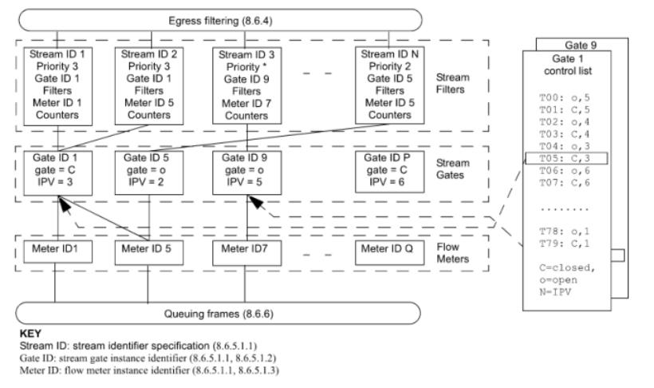
Figure 19 — PSFP architecture: Stream Filters, Stream Gates and Flow Meters (source diagram, p.30 — labels in English, reproduced unchanged)
PSFP is accomplished by the three tables shown in the figure — Stream Filters, Stream Gates and Flow Meters — working together. First, the stream filter uses the stream identifier (Stream ID) and priority (Priority) information defined in it to identify whether the traffic matches that filter. If the traffic is governed by that filter, the corresponding gate decides whether the traffic is allowed to flow in. If it is allowed to flow in, the parameters in the flow meter then determine whether the limit is exceeded; if the limit is exceeded, the configuration decides whether to rate-limit or to block.
For traffic from unknown sources, PSFP prevents suspicious traffic from flowing in by setting the gate to closed. For abnormal traffic from known sources — where the abnormality is not limited to bandwidth (bandwidth exceeding the reserved bandwidth) but also includes, for example, the maximum Service Data Unit (SDU) length exceeding the requirement — PSFP can choose either to block or to rate-limit. Through its filtering and policing policies on inbound traffic, PSFP improves the reliability of the network.
Brief introduction:
▪ Stream Filters — the stream filter table. Each entry represents the filter corresponding to a particular stream, and is associated with the specific Gate and Meter described below.
▪ Stream Gates — the stream gate table. Each entry represents the gating measure applied to a particular stream (for example, a gate state of closed means the corresponding traffic is not allowed to flow in).
▪ Flow Meters — the flow meter table. Each entry represents the traffic accounting for a particular stream; when that traffic exceeds the bandwidth limit, rate-limiting or blocking control is applied.

3.2 PSFP Configuration
PSFP configuration comprises Stream, Flow Meter, Stream Filters and Stream Gate.

3.2.1 Prerequisites and Precautions
QoS and VLAN configuration.

3.2.2 Configuring a Stream
① Creating a Stream
Stream instances are not configured by default; an instance must be added, after which the Stream view is entered to perform the related VCL configuration.
(1) Enter global configuration mode.
configure terminal
(2) Create a new Stream in global configuration mode.
Stream <1-127>
▪ <1-127> — the Stream instance ID; minimum 1, maximum 127.
② Configuring a Stream
Stream configuration must be performed inside the view of an already-created Stream ID. In that view you can configure matching on the data flow — for example matching on Ethernet type, IPv4 address, IPv6 address, MAC address, VLAN and other match conditions. You may configure no match condition, one condition, or a combination of multiple conditions.
(1) Enter global configuration mode.
configure terminal
(2) Enter Stream configuration mode.
Stream <1-127>
(3) Configure the Ethernet type.
etype <etype_type>
▪ etype_type — Ethernet type match. The Ethernet type range is 0x0600 to 0xFFFF. For example, etype 0x0800 means matching data frames whose Ethernet type is 0x0800.
(4) Configure VLAN matching.
inner-tag [ vid { <vid> [ / <vid_mask> ] | any } ] [ pcp <pcp_val> [ / <pcp_mask> ] ] [ dei <dei_val> ] [ { c-tag | s-tag } ]
▪ vid { <vid> [ / <vid_mask> ] | any } — match one specific VLAN or all VLANs.
▪ pcp <pcp_val> [ / <pcp_mask> ] — match the PCP value; PCP can be set in the range 0–7.
▪ dei <dei_val> — in Ethernet this need not be set.
▪ { c-tag | s-tag } — set whether the match is on the c-tag or on the s-tag.
Note: one or more of the configuration options may be selected, or none at all.
(5) Configure IPv4 matching.
ipv4 [ proto { <pr4> | tcp | udp | any } ] [ sip { <sip4> | any } ] [ dip { <dip4> | any } ] [ dscp { <dscp4> | { be | af11 | af12 | af13 | af21 | af22 | af23 | af31 | af32 | af33 | af41 | af42 | af43 | cs1 | cs2 | cs3 | cs4 | cs5 | cs6 | cs7 | ef | va } | any } ] [ fragment { yes | no | any } ] [ dport { <dp4> | any } ]
▪ proto { <pr4> | tcp | udp } — match the IP protocol; tcp or udp can be matched. <pr4> sets the IP protocol number, which can be set in the range 0–255.
▪ sip { <sip4> | any } / dip { <dip4> | any } — match the source IP address <sip4> or all source IPs; match the destination IP address <dip4> or all destination IP addresses.
▪ dscp { <dscp4> | { be | af11 | af12 | af13 | af21 | af22 | af23 | af31 | af32 | af33 | af41 | af42 | af43 | cs1 | cs2 | cs3 | cs4 | cs5 | cs6 | cs7 | ef | va } | any } — match a specific DSCP marking or all of them.
▪ fragment { yes | no | any } — match IPv4 fragments: yes matches, no does not match, any matches all fragments.
▪ dport { <dp4> | any } — match the destination port. When an IP protocol is selected, the destination port of the selected protocol is matched; otherwise the destination port of udp/tcp is matched.
Note: one or more of the configuration options may be selected, or none at all; when none is selected, all IPv4 packets are matched.
(6) Configure IPv6 matching.
The description of the command options is the same as for IPv4.
ipv6 [ proto { <pr6> | tcp | udp | any } ] [ sip { <sip6> | any } ] [ dip { <dip6> | any } ] [ dscp { <dscp6> | { be | af11 | af12 | af13 | af21 | af22 | af23 | af31 | af32 | af33 | af41 | af42 | af43 | cs1 | cs2 | cs3 | cs4 | cs5 | cs6 | cs7 | ef | va } | any } ] [ dport { <dp6> | any } ]
Note: one or more of the configuration options may be selected, or none at all; when none is selected, all IPv6 packets are matched.
(7) Configure destination MAC address matching.
dmac { <dmac_addr> [ / <mask_mac_addr> ] | multicast | broadcast | any }
▪ <dmac_addr> [ / <mask_mac_addr> ] | any — match a specified destination MAC address or all destination MAC addresses.
▪ multicast | broadcast — match destination MAC addresses of broadcast or multicast type.
(8) Configure source MAC address matching.
smac { <mac_addr> [ / <mask_mac_addr> ] | any }
▪ <smac_addr> [ / <mask_mac_addr> ] | any — match a specified source MAC address or all source MAC addresses.
(9) Delete configuration.
To delete a configuration, add the no parameter in front of the command; the configuration is then deleted.
▪ Delete the dmac configuration: no dmac { <dmac_addr> [ / <mask_mac_addr> ] | multicast | broadcast | any }
▪ Delete the smac configuration: no smac { <mac_addr> [ / <mask_mac_addr> ] | any }
▪ Delete the etype configuration: no etype [ <0x600-0xffff> ]
▪ Delete the inner-tag configuration: no inner-tag
▪ Delete the ipv4 configuration: no ipv4 [ proto { <pr4> | tcp | udp | any } ] [ sip { <sip4> | any } ] [ dip { <dip4> | any } ] [ dscp { <dscp4> | { be | af11 | af12 | af13 | af21 | af22 | af23 | af31 | af32 | af33 | af41 | af42 | af43 | cs1 | cs2 | cs3 | cs4 | cs5 | cs6 | cs7 | ef | va } | any } ] [ fragment { yes | no | any } ] [ dport { <dp4> | any } ]
▪ Delete the ipv6 configuration: no ipv6 [ proto { <pr6> | tcp | udp | any } ] [ sip { <sip6> | any } ] [ dip { <dip6> | any } ] [ dscp { <dscp6> | { be | af11 | af12 | af13 | af21 | af22 | af23 | af31 | af32 | af33 | af41 | af42 | af43 | cs1 | cs2 | cs3 | cs4 | cs5 | cs6 | cs7 | ef | va } | any } ] [ dport { <dp6> | any } ]
TN-15 — Step (3) states the etype range as 0x0600–0xFFFF, while the no etype line in step (9) gives <0x600-0xffff>. Both are reproduced as printed. Similarly, step (7)’s command uses <dmac_addr> but its explanation line reads <smac_addr>; and step (8)’s command uses <mac_addr> while its explanation line reads <smac_addr>. These placeholder mismatches are in the source and are flagged rather than silently harmonized.
③ Binding a Stream to a Port
The Stream ID must be bound to a specific port in order to determine on which port it takes effect.
(1) Enter global configuration mode.
configure terminal
(2) Enter the Layer 2 Ethernet interface view.
interface interface-type interface-number
(3) Bind the specified Stream ID.
stream-id <uint>
▪ <uint> is an already-created Stream ID, in the range 1–127.
④ Configuring the SMAC or DMAC Match Mode of the Stream Port
(1) Enter global configuration mode.
configure terminal
(2) Enter the Layer 2 Ethernet interface view.
interface interface-type interface-number
(3) Set the MAC match mode.
vcl { dmacdip | smacsip }
▪ dmacdip — sets the stream’s match mode to destination-MAC / destination-IP mode.
▪ smacsip — sets the stream’s match mode to source-MAC / source-IP mode.

3.2.3 Configuring a Flow Meter
A Flow Meter can perform rate control on the traffic of a matched stream, and block that traffic according to how far the rate is exceeded.
① Creating a flow meter
Flow meter instances are not configured by default; an instance must be added, after which the flow meter view is entered to perform the related configuration.
(1) Enter global configuration mode.
configure terminal
(2) Create a new flow meter in global configuration mode.
tsn flow meter <0-1022>
▪ <0-1022> — the Flow meter instance ID; minimum 1, maximum 1022.
TN-16 — The command syntax allows instance ID 0 (<0-1022>) while the description states that the minimum is 1. Reproduced as printed.
② Configuring a Flow meter
(1) Enter global configuration mode.
configure terminal
(2) Enter flow meter configuration mode in global configuration mode.
tsn flow meter <0-1022>
(3) Configure the committed burst and rate.
Traffic that passes within the committed burst size and committed information rate is green traffic.
cbs <cbs>
▪ <cbs> — configures the committed burst size, in bytes.
cir <cir>
▪ <cir> — configures the committed information rate: the rate at which tokens are added to the cbs each second (for the concept of tokens, please study the related token-bucket material), in bits.
(4) Configure the excess burst and rate.
When the committed burst size and committed information rate are exceeded, the traffic becomes excess traffic — yellow traffic.
ebs <ebs>
▪ <ebs> — configures the excess burst size, in bytes.
eir <eir>
▪ <eir> — configures the excess information rate: the rate at which tokens are added to the ebs each second (for the concept of tokens, please study the related token-bucket material), in bits.
(5) Configure dropping of yellow packets.
drop-on-yellow
After configuration, when the sizes and rates configured for ebs and cir are exceeded, the traffic entering ebs and eir is dropped.
TN-17 — The source says “超过ebs和cir配置的尺寸和速率时”, mixing the excess burst (ebs) with the committed rate (cir). Reproduced verbatim; the expected pairing would be ebs/eir or cbs/cir.
(6) Configure dropping of red packets.
mark-red-enable
After configuration, once the transmitted matching traffic exceeds the rate and size configured for committed and excess, the matching traffic is permanently blocked.
(7) Delete configuration.
To delete a configuration, use the no command, as follows:
no cbs <cbs> # delete the cbs configuration
no cir <cir> # delete the cir configuration
no drop-on-yellow # delete the drop-on-yellow configuration
no ebs <ebs> # delete the ebs configuration
no eir <eir> # delete the eir configuration
no mark-red-enable # delete the mark-red-enable configuration
TN-18 — The # comments in the block above were appended by the translator for readability; the source presents each command followed by a separate Chinese sentence (“删除cbs 配置” etc.). Command text is unchanged.
(8) View the configuration.
switch# show running-config
Building configuration...
.....
!
tsn flow meter 1
cir 1024
ebs 4096
eir 2048
drop-on-yellow
!
.....
(9) When permanent blocking of red traffic is enabled, check whether traffic has been permanently blocked because of red traffic.
switch# show tsn flow meter <0~1023>
switch# show tsn flow meter 1 status
Flow Mark all
Meter frames red
----- ----------
1 false
▪ false means not blocked; true means blocked.
▪ When the value is true, the following command can be used to restore it to false:
switch# clear tsn flow meter mark-red <0~1023>

3.2.4 Configuring a Stream Gate
A Stream Gate can open or close the gate for the traffic of a matched stream, thereby either letting the traffic pass or permanently blocking it.
① Creating a Stream Gate
Stream Gate instances are not configured by default; an instance must be added, after which the Stream Gate view is entered to perform the related configuration.
(1) Enter global configuration mode.
configure terminal
(2) Create a new Stream Gate in global configuration mode.
tsn stream gate <0-1022>
▪ <0-1022> — the Stream Gate instance ID; minimum 1, maximum 1022.
② Viewing and clearing status
(1) View the configuration.
switch# show running-config
Building configuration...
.....
!
tsn stream gate 1
state open
enable
config-change
!
.....
(2) View the status.
switch# show tsn stream gate status
Stream Gate 1 status:
State: closed
Cycle time: 0 ns
Cycle time extension: 0 ns
Base time: 0 seconds 0 nanoseconds
Config change time: 0 seconds 0 nanoseconds
Tick granularity: 1 ns
Current time: 1673366869 seconds 901042059 nanoseconds
Config pending: false
Config change errors: 0
Priority value: 0
Closed-due-to-invalid-rx: false
Closed-due-to-octets-exceeded: false
TN-19 — In the source PDF this output is laid out in two spatially separated columns, so the extractor yields each label and value on separate lines. The label/value pairs above are the source content, re-aligned into a single conventional CLI layout. No field names or values were changed.
(3) Clear the blocked state.
When the matching traffic has been permanently blocked because Closed-due-to-invalid-rx or Closed-due-to-octets-exceeded has become true, the following commands can restore it to false:
clear tsn stream gate gate-closed-due-to-invalid-rx
clear tsn stream gate gate-closed-due-to-octets-exceeded
③ Configuring a Stream Gate
(1) Enter global configuration mode.
configure terminal
(2) Enter Stream Gate configuration mode in global configuration mode.
tsn stream gate <0-1022>
(3) Configure the cycle time.
cycle-time <cycle_time> { ms | us | ns }
(4) Configure the control list length.
control-list-length <gcl_length>
(5) Configure the control list for batch traffic forwarding scheduling.
control-list index <index> gate-state { open | closed } time-interval <interval> { ms | us | ns } [ ipv <ipv> ] [ octet-max <octet_max> ]
▪ By default, no control list is configured for TSN forwarding scheduling.
▪ index <index> — starts at 0, maximum 256.
▪ gate-state { open | closed } — sets the open/closed state of the entry.
▪ The combined value of time-interval must not exceed the value of the cycle time; it may be less. When it is less, the remaining time is forwarded according to the chip’s default behaviour, i.e. no additional scheduling is applied.
▪ octet-max <octet_max> — the maximum number of bytes; used together with close-due-to-octets-exceeded-enable.
▪ ipv <ipv> — internal priority: the priority marked internally for the traffic within the time interval.
TN-20 — The source explanation for time-interval reads “time-interval，的值综合不能超过…” (stray comma after the parameter name). Rendered smoothly; the technical content is unchanged.
(6) Configure the gate open/close actions.
When traffic is received during the closed time within the cycle time, permanently block the matching traffic:
close-due-to-invalid-rx-enable
When traffic received within the cycle time exceeds octet-max, permanently block the matching traffic:
close-due-to-octets-exceeded-enable
(7) Configure gate enable and make the configuration take effect.
Configure the gate state:
state { open | closed }
By default, all gates are in the closed state.
Enable gating:
enable
Make the gate configuration take effect:
config-change
(7) Delete configuration.
To delete a configuration, use the no command.
TN-21 — The source numbers two consecutive steps as “(7)” in §3.2.4③. The duplication is reproduced as-is. Also note the contrast with §1.4.3, where the TAS default gate state is stated as open while here the Stream Gate default is stated as closed — both are as printed in the source.

3.2.5 Configuring a Stream Filter
A Stream filter can bind a stream instance, a Flow meter instance and a Stream Gate instance.
① Creating a Stream filter
Stream filter instances are not configured by default; an instance must be added, after which the Stream filter view is entered to perform the related configuration.
(1) Enter global configuration mode.
configure terminal
(2) Create a new Stream filter in global configuration mode.
tsn stream filter <0-1022>
▪ <0-1022> — the Stream filter instance ID; minimum 1, maximum 1022.
② Configuring a Stream filter
(1) Enter global configuration mode.
configure terminal
(2) Enter the Stream filter configuration view in global configuration mode.
tsn stream filter <0-1022>
(3) Bind the stream.
stream-id <id>
(4) Bind the flow meter.
flow-meter id <id>
(5) Bind the gate.
gate id <id>
(6) Set the SDU and trigger blocking.
Set the SDU size:
max-sdu <sz>
When the matching traffic is greater than or equal to the configured SDU size, permanently block the traffic:
block-due-to-oversize-enable
(7) Delete configuration.
To delete a configuration, use the no command.
③ Viewing and clearing status
(1) View the configuration.
switch# show running-config
Building configuration...
.....
!
tsn stream filter 10
stream-id 10
gate id 10
flow-meter id 10
!
.....
(2) View the statistics status of the matching traffic.
switch# show tsn stream filter 10 statistics
Filter Matching Passing Not passing Passing Not passing Red
Id frames frames frames sdu count sdu count frames
------ -------- ------- ----------- ---------- ----------- -------
10 11000 0 11000 0 0 0
(3) Clear the traffic statistics status.
switch# clear tsn stream filter statistics
(4) View the SDU blocked state.
switch# show tsn stream filter 10 status
Filter Stream blocked due to
Id oversize frame
------ ---------------------
10 false
(5) Clear the SDU blocked state.
When the SDU state is true, the following command can be used to restore it to false:
switch# clear tsn stream filter stream-blocked-due-to-oversize-frame
TN-22 — As with TN-19, the show tsn stream filter outputs are laid out in separated columns in the source PDF; they are re-aligned here without changing any field name or value. The §3.2.5(2) statistics header is a two-row header in the source: “Filter / Matching / Passing / Not passing / Passing / Not passing / Red” over “Id / frames / frames / frames / sdu count / sdu count / frames”, i.e. the columns are Filter Id, Matching frames, Passing frames, Not passing frames, Passing sdu count, Not passing sdu count, Red frames.

3.3 PSFP Configuration Example

3.3.1 Example Requirements
▪ Configure stream ID 2, matching traffic whose SMAC is 00-00-00-00-00-09 and whose VLAN is 10, and bind it to port G1/4.
▪ Configure flow meter ID 2 with cbs 4096, cir 2048, eir 2048 and ebs 4096, and enable mark-red-enable.
▪ Configure a stream filter binding stream ID 2 and flow meter 2.
Test topology:
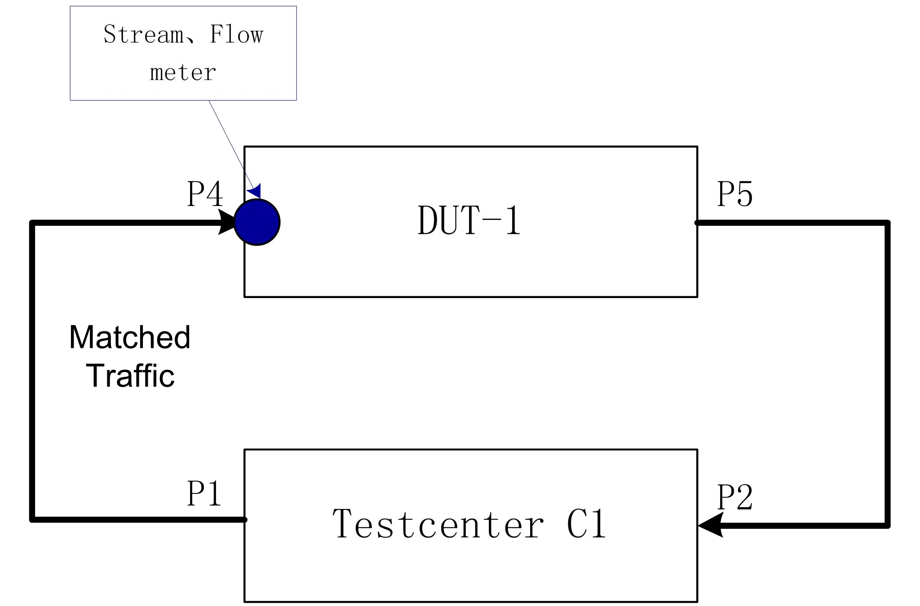
Figure 20 — PSFP example test topology (source diagram, p.41 — labels in English, reproduced unchanged)

3.3.2 Configuration Procedure
① Configure the flow meter on DUT-1
# Enter global configuration mode
configure terminal
# Create and configure the flow meter
switch(config)# tsn flow meter 2
# Configure cbs as 4096
switch(config-flow-meter)# cbs 4096
# Configure cir as 2048
switch(config-flow-meter)# cir 2048
# Configure eir as 2048
switch(config-flow-meter)# eir 2048
# Configure enable # Configure eir as 2048
switch(config-flow-meter)# mark-red-enable
TN-23 — The source comment on the last line reads “#配置开启#配置eir 为2048” — a duplicated/garbled comment (it repeats the eir text although the command is mark-red-enable). Rendered literally as “# Configure enable # Configure eir as 2048” so the defect remains visible; the command line itself is unchanged.
② Configure the stream on DUT-1
# Enter global configuration mode
configure terminal
# Create and configure the stream
switch(config)# stream 2
# Configure the matching SMAC as 00-00-00-00-00-09
switch(config-stream)# smac 00-00-00-00-00-09
# Configure the matching vid as 10
switch(config-stream)# outer-tag vid 10
# Bind the stream id to the port and configure the other necessary settings
switch(config-stream)# exit
switch(config)# interface GigabitEthernet 1/4
switch(config-if)# stream-id 2
switch(config-if)# switchport mode hybrid
switch(config-if)# switchport hybrid allowed vlan 10
switch(config-if)# exit
switch(config)# interface GigabitEthernet 1/5
switch(config-if)# switchport mode hybrid
switch(config-if)# switchport hybrid allowed vlan 10
③ Configure the stream filter on DUT-1
# Enter global configuration mode
configure terminal
# Create and configure the stream filter
switch(config)# tsn stream filter 2
# Bind the stream id
switch(config-stream-filter)# stream-id 2
# Bind the flow meter id
switch(config-stream-filter)# flow-meter id 2
④ Save the configuration of DUT-1
switch(config-stream-filter)# end
switch# copy running-config startup-config
⑤ View the configuration of DUT-1
switch# show running-config
Building configuration...
.....
!
stream 2
smac 00-00-00-00-00-09
outer-tag vid 10
!
interface GigabitEthernet 1/4
switchport hybrid allowed vlan 10
switchport mode hybrid
stream-id 2
!
interface GigabitEthernet 1/5
switchport hybrid allowed vlan 10
switchport mode hybrid
!
tsn flow meter 2
cbs 4096
cir 2048
ebs 1024
eir 2048
mark-red-enable
!
tsn stream filter 2
stream-id 2
flow-meter id 2
!
.....
TN-24 — §3.3.1 requires ebs to be 4096, but the show running-config output in §3.3.2⑤ shows ebs 1024. The source also never issues an ebs command in the configuration steps. Both readings are reproduced as printed; the discrepancy is flagged rather than corrected.

4. 802.1CB FRER

4.1 Overview
The IEEE 802.1CB protocol
Frame Replication and Elimination for Reliability (FRER) is an important feature of the IEEE 802.1CB protocol, intended to enhance the reliability of Ethernet networks. FRER uses frame replication and elimination techniques to provide redundancy protection and fast recovery from link failures.
Application scenarios for FRER — the IEEE 802.1CB protocol:
▪ High reliability requirements — In critical network applications such as power-system automation, intelligent transport systems or industrial control systems, high reliability and fault tolerance are indispensable. FRER provides redundant paths and a frame replication mechanism, ensuring continuously available network communication even in the event of a link failure.
▪ Minimizing link downtime — A link failure causes network interruption and data loss. By using FRER, redundant frames can be replicated and transmitted over an alternative path, thereby ensuring the integrity and reliability of the data. This minimizes the impact of a link failure and speeds up recovery time.
▪ Seamless redundancy switchover — FRER provides fast fault detection and recovery, and is able to switch automatically to an alternative path or port when a link fails. This seamless redundancy switchover ensures the continuity and reliability of network services.
▪ Support for high-bandwidth applications — Certain network applications require high bandwidth and real-time performance, for example high-definition video streaming, real-time data acquisition or virtual reality. FRER can provide redundancy and fault-recovery capabilities, ensuring uninterrupted, high-quality data transmission for these high-bandwidth applications even during a link failure.

4.2 Basic Concepts
Frame replication and elimination for reliability, as specified in IEEE 802.1CB, provides streams with higher reliability (a reduced packet loss rate) by sequence-numbering and selectively replicating each packet in the source system within the network, and by eliminating those replications in the destination system. When redundancy is used, latency can be guaranteed even in the presence of a single point of failure.
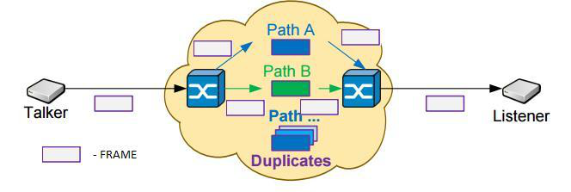
Figure 21 — Reliable transport structure for frame replication and elimination (source diagram, p.44 — labels in English, reproduced unchanged)
Reliable transport structure for frame replication and elimination
Sequence Encode
Encodes the sequence number into the packet so that it can be decoded by its peer, normally by encoding the sequence number into the packet data by some method — for example a Redundancy Tag (R-TAG). The R-TAG is one example of a sequence encode/decode function. It is a 48-bit tag located immediately after the VLAN tag; the first 16 bits are the R-TAG EtherType (“0xF1C1”) and the last 16 bits are the FRER sequence number.
Sequence Decode
Extracts the sequence number from the packet passed to it, and can remove the sequence-number encapsulation from the packet.
TN-25 — The source heading for §4.2 reads “IEEE802.1CB 中规定的帧复制和可靠性消除”; the standard English name of the mechanism is “Frame Replication and Elimination for Reliability”, which is how it is rendered. “醚类型” (a literal calque of EtherType) is rendered as “EtherType”. The figure caption “帧复制和消除的可靠性传输结构” appears below the figure in the source and is retained in that position.

4.3 Configuration
(1) Enter global configuration mode.
configure terminal
(2) Create a stream for the FRER instance, for example matching on the destination MAC.
stream <1-127>
dmac <mac_addr>
(3) Create the FRER instance ID.
tsn frer FRER_instance_number
(4) Map the stream to the FRER instance.
ingress stream-id-list <stream_list>
(5) The stream matched at the ingress is tagged with the VLAN tag configured for the FRER instance.
frer-vlan <vid>
(6) Configure the FRER mode. The generation mode applies the R-Tag to the stream; the recovery mode eliminates the replicated stream and the R-Tag.
mode { generation | recovery }
(7) Select the egress hit by this FRER instance.
egress interface (<port_type> [<port_list>])
(8) Remove the R-Tag after the frame leaves the egress.
recovery terminate
(9) Enable or disable the instance.
admin-state { enable | disable }
(10) View FRER details.
show tsn frer detail
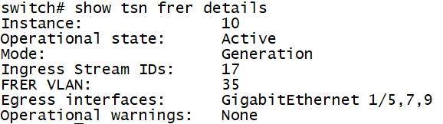
Figure 22 — Output sample: show tsn frer detail (source CLI screenshot, p.45 — output in English, reproduced unchanged)
TN-26 — The source sentence for step (6) reads “generation 模式会将流R-Tag 标签”, which is missing a verb (literally “generation mode will [apply] the stream R-Tag”). Rendered as “applies the R-Tag to the stream”, which is the meaning required by the rest of the sentence and by §4.4.

4.4 Configuration Example

4.4.1 Example Requirements
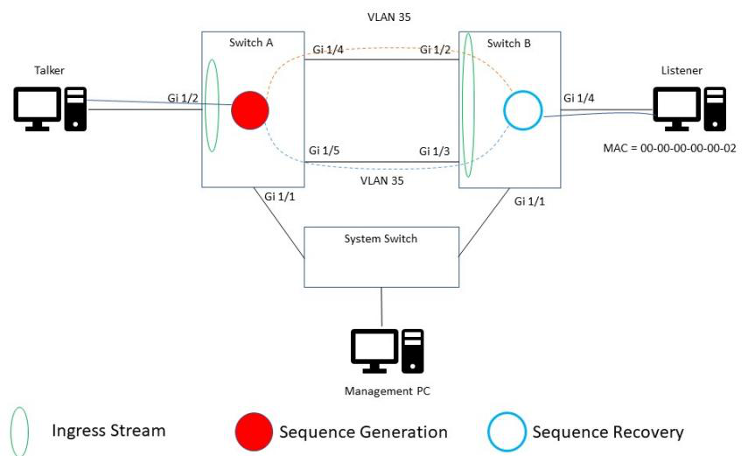
Figure 23 — FRER example topology: Switch A (generation) and Switch B (recovery) (source diagram, p.45 — labels in English, reproduced unchanged)
Switch A is responsible for classifying the frames coming from the Talker into a FRER instance and splitting the stream into two paths. Switch B is responsible for merging the two paths and presenting the original frames to the Listener.
In this example we choose to match all frames on Gi 1/2 against the Listener’s destination MAC address (DMAC), map them to a FRER instance, and tag them with an outer tag of VLAN 35. The Listener’s DMAC is 00-00-00-00-00-02.
The FRER instance on Switch A is configured in generation mode and generates two identical replicated frames on its configured egress ports. When the frames leave Switch A’s Gi 1/4 and Gi 1/5 they carry the R-Tag. Switch B looks for frames arriving on Gi 1/2 and Gi 1/3 that carry the outer VLAN 35 tag, changes that VLAN tag to FRER VLAN 100, and on Gi 1/4 eliminates the replicated frames and removes the R-Tag and the FRER VLAN tag.

4.4.2 Configuration Procedure
Switch A:
# Create the VLAN
configure terminal
vlan 35
exit
# Enable spanning tree
interface *
spanning-tree
exit
# Exclude VLAN 35 from being blocked
spanning-tree mst te vlan 35
# Create a stream for FRER instance frame classification
stream 17
dmac 00-00-00-00-00-02
exit
# Assign the stream to the Gi 1/2 port, i.e. the ingress; only when associated with the ingress can the stream be recognized and tagged with the FRER VLAN
interface GigabitEthernet 1/2
stream-id 17
switchport hybrid allowed vlan none
switchport mode hybrid
exit
# Set the Gi 1/4 and Gi 1/5 ports as hybrid ports and allow the FRER VLAN through
interface GigabitEthernet 1/4,5
switchport hybrid allowed vlan 1,35
switchport hybrid native vlan 1
switchport hybrid port-type c-port
switchport mode hybrid
exit
# Disable learning of VLAN 35 frames, so that they are not added to the MAC address table, which would cause the stream to be forwarded only to the designated ports
no mac address-table learning vlan 35
# Create a FRER instance in generation mode and associate it with stream 17
tsn frer 10
mode generation
ingress stream-id-list 17
# Tag the matched stream with a VLAN TAG
frer-vlan 35
# Select the egress hit by this FRER instance: Gi 1/4 and Gi 1/5
egress interface GigabitEthernet 1/4,5
# Enable the FRER instance
admin-state enable
Switch B:
# Create the VLAN
configure terminal
vlan 100
exit
# Enable spanning tree
interface *
spanning-tree
exit
# Exclude VLAN 100 from being blocked
spanning-tree mst te vlan 100
# Create a stream for FRER instance frame classification
stream 20
outer-tag vid 35
exit
# Assign the stream to the Gi 1/2 and Gi 1/3 ports
interface GigabitEthernet 1/2,3
stream-id 20
switchport hybrid allowed vlan 1
switchport mode hybrid
# Configure the Gi 1/4 port
interface GigabitEthernet 1/4
switchport mode access
switchport access vlan 100
exit
# Create a FRER instance in recovery mode and associate it with stream 20
tsn frer 20
mode recovery
ingress stream-id-list 20
# Tag the matched stream with a VLAN TAG
frer-vlan 100
# Select the egress hit by this FRER instance: Gi 1/4
egress interface GigabitEthernet 1/4
# Remove the R-tag
recovery terminate
# Enable the FRER instance
admin-state enable
end

4.4.3 Verifying the Configuration
View the configuration of Switch A:
switch# show running-config
Building configuration...
......
vlan 1,35
......
no mac address-table learning vlan 35
spanning-tree mst te vlan 35
!
stream 17
dmac 00-00-00-00-00-02
......
interface GigabitEthernet 1/2
switchport hybrid allowed vlan none
switchport mode hybrid
stream-id 17
!
interface GigabitEthernet 1/4
switchport hybrid allowed vlan 1,35
switchport mode hybrid
......
interface GigabitEthernet 1/5
switchport hybrid allowed vlan 1,35
switchport mode hybrid
......
tsn frer 10
mode generation
ingress stream-id-list 17
frer-vlan 35
egress interface GigabitEthernet 1/4,5
admin-state enable
!
View the configuration of Switch B:
switch# show running-config
Building configuration...
......
vlan 1,100
!
......
spanning-tree mst te vlan 100
!
stream 20
outer-tag vid 35
......
interface GigabitEthernet 1/2
switchport hybrid allowed vlan 1
switchport mode hybrid
stream-id 20
!
interface GigabitEthernet 1/3
switchport hybrid allowed vlan 1
switchport mode hybrid
stream-id 20
!
interface GigabitEthernet 1/4
switchport access vlan 100
!
......
tsn frer 20
mode recovery
ingress stream-id-list 20
frer-vlan 100
egress interface GigabitEthernet 1/4
recovery terminate
admin-state enable
TN-27 — In Switch B’s configuration the interface GigabitEthernet 1/2,3 block is not terminated with an exit before # Configure the Gi 1/4 port, and switchport hybrid allowed vlan 1 is shown on the same indentation level as switchport mode hybrid. Reproduced exactly as printed in the source. The verification output for Switch B nevertheless shows both Gi 1/2 and Gi 1/3 carrying stream-id 20, confirming the intended configuration.

Translator’s Notes (source anomalies and items passed over)
This translation is a full-volume rendering of all 49 pages of 《PTP及TSN配置手册 - CLI》. Nothing in the source prose has been omitted or summarized. The notes below record (a) exactly what was passed over, and (b) every place where the source is internally inconsistent, so that no defect has been silently repaired.

A. Items passed over (PASS)
▪ Chinese labels inside two figures (Figures 7 and 11). Of the 23 embedded figures, exactly two contain Chinese text: Figure 7 (cycle / GCL time-slot diagram, source p.12: 周期, 时间槽, 优先级, 发送顺序) and Figure 11 (preemptable-MAC transmission mechanism, source p.21: 排队中的帧, 传输选择, MAC控制, 传输MAC/eMAC, 可抢占MAC/pMAC, MAC合并子层). Translating them would require redrawing the figures, which is outside the scope of a text translation; both figures are therefore reproduced unchanged and their Chinese labels are left as in the source (PASS). No information is lost: the time-slot/queue assignment of Figure 7 is fully restated in §1.2.2 and §1.5.1, and the pMAC/eMAC structure of Figure 11 in §2.1–§2.2.
▪ The remaining 21 figures. All other embedded figures — CLI screenshots (Figures 1–6, 8–10, 22) and frame-format / topology diagrams (Figures 12–21, 23) — are already entirely in English in the source. They are reproduced unchanged at their original positions, each with an English caption; nothing in them required translation, so nothing was passed over.
▪ Nothing else was passed over. Every heading, paragraph, bullet, command, syntax line, parameter range, default value, table and CLI output sample in the source is present in this translation.

B. Reproduction conventions
▪ CLI commands, command syntax, parameter names, value ranges and command output are reproduced byte-for-byte from the source; only the surrounding prose and the # comments inside configuration listings were translated.
▪ Where the source lays a CLI output out in two spatially separated columns (which the PDF text extractor splits into interleaved lines), the label/value pairs have been re-aligned into one conventional CLI layout. No field name or value was altered. See TN-19 and TN-22.
▪ Sub-configuration lines in show running-config output are shown with a single leading space, matching the source’s indentation convention.
▪ Units: the source writes “us” for microseconds in prose; this is rendered with the correct SI symbol µs (for example §1.1.7 “greater than 1.1 µs continuously for 3 seconds”). Inside CLI syntax lines the source spelling us is kept unchanged, since it is part of the command grammar.
▪ Step numbering, including duplicated step numbers in the source (§2.3.2 has two “(6)”; §3.2.4③ has two “(7)”), is reproduced as printed.

C. Index of source anomalies flagged in-line
Note | Location | Anomaly in the source
TN-1 | §1.1.6 | Sentence ends with no object (“…选举出整个PTP域”).
TN-2 | §1.2.3 | “优先级低可以保证BMCA选主成功” is ambiguous as to numeric direction; rendered literally.
TN-3 | §1.3.1 | Typos: “Mater” → Master; “1588V2” → 1588v2.
TN-4 | §1.1 (TSN) | Garbled phrase “在预定的时间窗口大大后会被放行传输”.
TN-5 | §1.2.3 (TSN) | “当前系统最大支持设备256条” is grammatically incomplete.
TN-6 | §1.4.3 | Step heading says “enable gating” but the command is gate-states.
TN-7 | §1.5.1 | Both port 1 and port 2 are called “入口” (ingress); port 2 is evidently the egress.
TN-8 | §1.5.3 | Elliptical closing clause “从控制链表序号开始”.
TN-9 | §2.1 | Typo “pAMC” for pMAC; “802.3TG” left as written.
TN-10 | §2.2.2(4) | SMD-Cx Frame#3 = 0xAD in the table but 0x2A in the body text; Frag Count table lists SMD-Sx values; “Premptable” typo.
TN-11 | §2.3.2 | Two consecutive steps numbered “(6)”.
TN-12 | §2.4 | Priority 7 flow required, but no pcp 7 qos map is configured.
TN-13 | §2.4.3 | Verification output says 10GigabitEthernet; configuration says GigabitEthernet.
TN-14 | §3.1.1 | “IEEE 802.1 Qci” stray space; “Dos” → DoS.
TN-15 | §3.2.2 | etype range 0x0600–0xFFFF vs no etype [ <0x600-0xffff> ]; dmac/smac/mac_addr placeholder mismatches between command and explanation.
TN-16 | §3.2.3 | Syntax <0-1022> allows 0, description says minimum is 1.
TN-17 | §3.2.3(5) | “超过ebs和cir” mixes excess burst with committed rate.
TN-18 | §3.2.3(7) | # comments appended by the translator for readability; command text unchanged.
TN-19 | §3.2.4② | Two-column CLI output re-aligned; also gate default is closed here vs open in §1.4.3.
TN-20 | §3.2.4③(5) | Stray comma: “time-interval，的值综合…”.
TN-21 | §3.2.4③ | Two consecutive steps numbered “(7)”.
TN-22 | §3.2.5③ | Two-column CLI output re-aligned; two-row statistics header explained.
TN-23 | §3.3.2① | Garbled duplicated comment “#配置开启#配置eir 为2048” on the mark-red-enable line.
TN-24 | §3.3 | ebs required as 4096, but show running-config displays ebs 1024 and no ebs command is ever issued.
TN-25 | §4.2 | “醚类型” calque rendered as EtherType; caption position retained.
TN-26 | §4.3(6) | Missing verb in “generation 模式会将流R-Tag 标签”.
TN-27 | §4.4.2 | Switch B interface block lacks an exit before the Gi 1/4 block.

D. Terminology
Source term | Rendering used
时间敏感网络 | Time-Sensitive Networking (TSN)
精确时间协议 | Precision Time Protocol (PTP)
时间感知调度 / 时间感知整形 | time-aware scheduling / time-aware shaper
门控制链表 (GCL) | gate control list (GCL)
循环时间 / 时间槽 / 保护带 / 基础时间 | cycle time / time slot / guard band / base time
帧抢占 | frame preemption (FP)
切片帧首帧 / 中间帧 / 尾帧 | fragment first frame / fragment intermediate frame / fragment last frame
流过滤器 / 流门控 / 流量计 | stream filter / stream gate / flow meter
承诺突发 / 超额突发 | committed burst / excess burst
绿色流量 / 黄色流量 / 红色流量 | green traffic / yellow traffic / red traffic
永久阻塞 | permanently blocked
全局配置模式 / 二层以太网接口视图 | global configuration mode / Layer 2 Ethernet interface view
缺省情况下 | by default
最优时钟 / 时钟域 | Grandmaster Clock (GM) / clock domain
选源 | source selection

