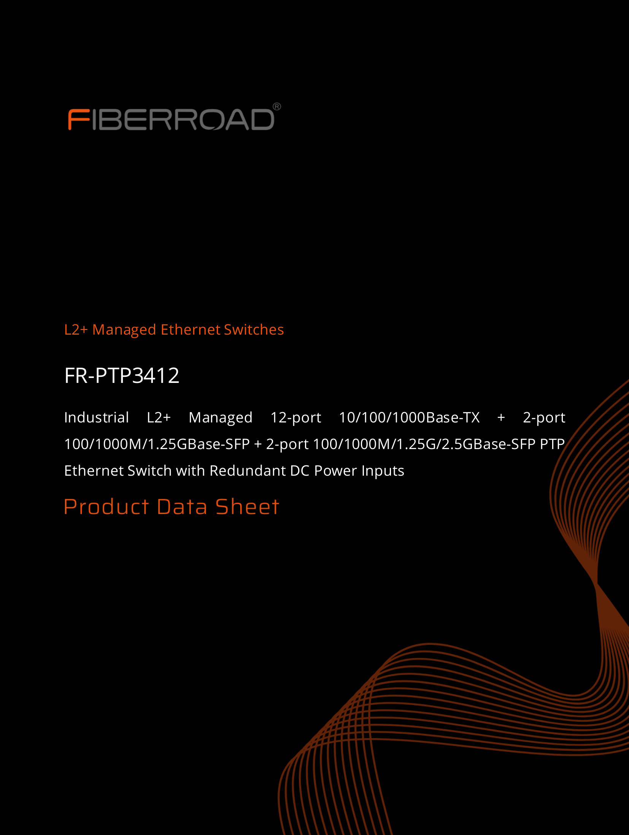

L2+ Managed Ethernet Switches | www.fiberroad.com
FR-PTP3412
FR-PTP3412 is an industrial grade ethernet switch independently developed by Fiberroad that supports PTP precise clock synchronization function. This product is mainly aimed at industrial application scenarios with strict delay forwarding requirements for Ethernet business flows. It supports hardware timestamps based on IEEE1588 protocol and 802.1AS, and supports clock modes such as BC, TC, OB, etc.
Supports multiple Ethernet link redundant ring network functions such as STP/RSTP/MSTP, ERPS, MRP, etc. It supports single ring, tangent ring, and inter ring coupling topologies, with redundant switching time ≤ 50ms, which can meet the redundant networking needs of most industrial control field sites.
Support high reliability, high availability, and high precision time delay in scenarios with low latency and high bandwidth, such as industrial Internet of Things, industrial Internet, smart grid, smart factory, smart city, and intelligent transportation, or scenarios with real-time analysis and collaboration requirements, such as remote installation, vehicle road collaboration, industrial control, driverless driving, mobile computing, and smart medicine.
Supports 4 SFP slots and can flexibly choose gigabit 2.5G, 1.25G, or 100Mbps optical modules. It also supports 12x10/100/1000M adaptive RJ45 ports, meeting the front-end access and networking needs of industrial sites.
Supports layer 2 Ethernet protocols such as VLAN, QoS, multicast, ring network, etc. It also supports PTP1588 and 802.1AS based timing, as well as multiple modes such as transparent clock, boundary clock, master/slave clock, etc. It can be flexibly configured and used according to the real-time and non real-time requirements of the network.
Supports various access methods for management such as CLI, Web, Telnet, SSH, etc. It also supports our FR-VIEW upper switch management and can meet the requirements of a unified management platform.
FR-PTP3412 is an industrial switch designed by Fiberroad Technology Co., Ltd. to meet the high-performance and high reliability requirements of industrial video, voice, and data applications brought about by the increasing integration of information technology in industrial sites. It can be used as a high bandwidth main controllable network in industrial scenarios, improving the reliability and availability of IT/OT integrated applications.
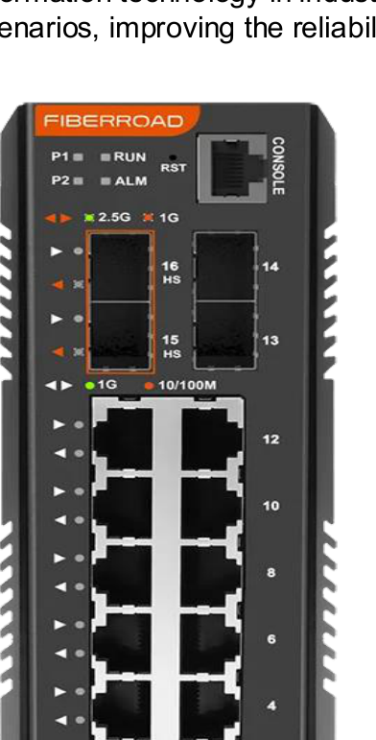 | 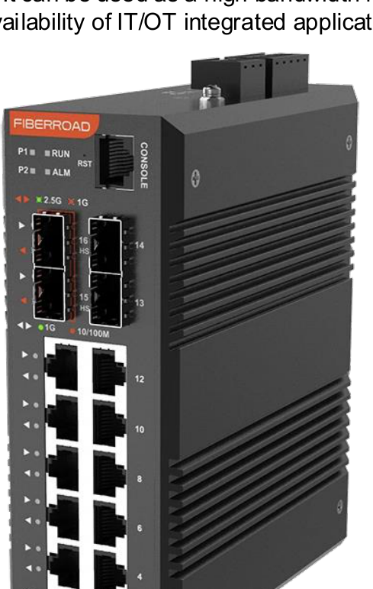 | 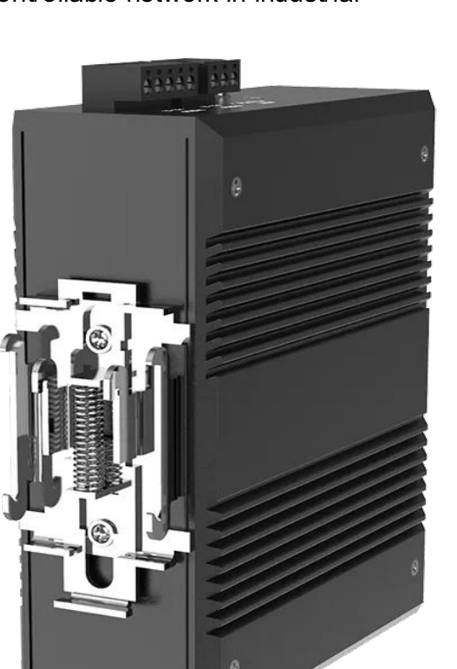

Product Specifications
Hardware  Specifications | FR-PTP3412
IEEEStandards | 802.1D、802.1p、802.1Q、802.1s、802.1w、802.3ab、802.3ad、802.3x、802.3z、802.3az、803.2ae、  G.8032、IEEE1588
Exchange Performance | MACAddress: 8K  Bandwidth：36GbpsPacket  Buffer Size: 4M  Delay Time: 5μs(Normal, not in Time-Synchronization Mode)  Transmission Mode: Store and Forward，Support 9600Bytes Jumbo Frame
Ethernet Ports | 4 SFP slots, Port15-16 supports optional 2.5G, 1.25G, or 100M optical modules  Port13-14 supports 1.25G or 100M optical modules  Optical port supports comprehensive DDM diagnostic function  Support 12x10/100/1000M adaptive RJ45 ports
Management Port | RS232interface, RJ45, 115200bps,8,N,1
Indicator | Power indicator, Operation Indicator, Alarm Indicator, Optical Port and Electrical Port Indicator
Reset Button | Support one click reset button, long press for 10 seconds
Power Requirement | Input voltage: DC9~56V  Input method: Redundant dual input  Interface type: 5-Pin 5.08 pitch Phoenix terminal blocks  Support Overload Current Protection, Overload Voltage Protection, Reverse Polarity Protection
Alarm | DC24V@1A 3-Pin Phoenix terminals with 5.08 pitch, supporting dual alarms
Power Consumption | DC12V@1.3A Power consumption ≤ 15W (Normal Value)
Environment Requirement | Operating temperature: -40 ℃~75 ℃  Storage temperature: -40 ℃~85 ℃  Operating humidity: 5%~95% (no condensation)
Dimension | Installation method: DIN Rail Installation or Wall Mounted Installation  Installation dimensions: Length x Width x Height (mm): 154 x 127 x 54 (Excluding Din -Rails and Hanging  Plates)  Heat dissipation: natural heat dissipation (fanless design)
MTBF | ≥300000hours
Warranty | 5years

Product Specifications
Software  Specifications | FR-PTP3412
System Information | Equipment panel graphical overview  Equipment and system information  CPU status information  IPv4, IPv6 interface and routing status information  Support log record
System Management | Support system information configuration  Support system user management and user level management  Support IPv4 and IPv6 management interface configuration and management interface  Support IP Route gateway  Support SNMPv1/v2/v3 protocol, support Web and Telnet access management, and support FR-VIEW  Support LLDP link discovery protocol
Network Clock | Support NTP protocol and network host time synchronization  Support 1588, 802.1AS and on-board AS clock protocol  Support transparent clock, boundary clock, master clock, slave clock and other modes
Layer 2 Management | Support port status, port traffic statistics, port priority status and other details and management control  Support SFP optical module DDM diagnostic information function  Supports port VLAN and VLAN Tag modes, and supports Access, Trunk, and Hybrid modes  Support private PVLAN, voice VLAN and GVRP dynamic VLAN  Support VLAN based on MAC, protocol, IP subnet or stream  Support QoS, DSCP based mapping and SP scheduling algorithms, and credit based algorithms  Support port aggregation function based on static and LACP  Support IGMP snooping multicast, support multicast LAN auto registration MVR function  Support MVRP multi VLAN registration protocol based on MSTI
Ring Network  Redundancy | Support RSTP, MSTP  Support MRP media redundancy protocol  Support ERPSv2 redundancy protocol  Support APS automatic loop switching protocol
Layer 3 Route | Support Static Route
Security | Support SSH and HTTPS based secure WEB configuration access  Support RMON statistics, events and alarms  Support port security and port+VLAN+MAC binding function  Support network access service control, RADIUS, guest VLAN  Support ACL access control list, support access control based on IPv4, IPv6, protocol and port  Static IP source address protection function  Static and dynamic ARP protection function  AAA protection
Device Management | Support SNMPv1/v2/v3 protocol, support Web and Telnet access management, and support FR-VIEW  Support LLDP  Support DHCP Snooping and DHCP server management  Support port mirroring  Support “sFlow” flow sampling function  Support configuration of download and upload functions
Network Maintenance | Support CFM connectivity detection function, loopback function and link tracking function  Support Ping and Traceroute diagnosis  Link OAM management

Dimension（Unit:mm）
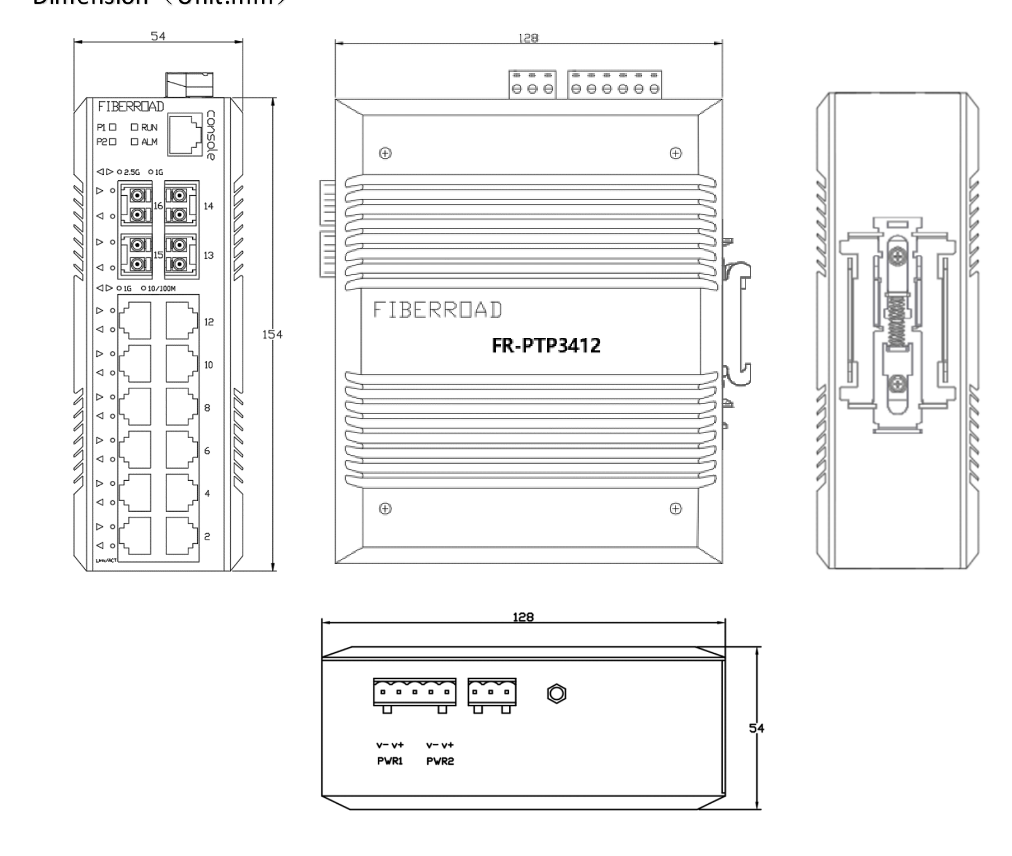

Ordering Information
Available Model | Description | Input Voltage | Operating Temp.
FR-PTP3412 | Industrial L2+ Managed 12-port 10/100/1000Base-TX + 2-port 100/1000M/1.25GBase-SFP +  2-port 100/1000M/1.25G/2.5GBase-SFP PTP Ethernet Switch with Redundant DC Power  Inputs | Dual DC9-56V | -40 to +75℃

Optional Accessories (to be purchased separately)
SFP Optical Transceiver
(S)=SFP Option | Please select your SFP on our SFP Modules page for details.

Precautions
To prevent equipment damage or personal injury caused by improper operation, please observe the following precautions:
❖ Turn off the power before installation. Wear an anti-static wrist strap and ensure proper skin contact to prevent electrostatic discharge (ESD) damage.
❖ Ensure the power supply voltage matches the voltage specified on the switch.
❖ Before powering on the switch, verify that the power circuit is not overloaded to avoid abnormal operation or equipment damag e.
❖ Do not open the chassis while the switch is operating. To avoid the risk of electric shock, do not disassemble the device.
❖ Disconnect the power before cleaning. Do not use a wet cloth or liquid cleaners.
❖ When installing in a rack, mount equipment from bottom to top to prevent overloading.
❖ Do not place heavy objects on the switch.

Specifications are subject to change without notice. Fiberroad Technology Co., Ltd. makes no warranties, either expressed or implied, regarding the information contained herein. Please contact us for the latest product information.
© Fiberroad Technology Co., Ltd. All rights reserved. | July 2026

