**GOOGLE MEET’S PERFORMANCE ACROSS VARIETY OF INTERNET CONDITION**

**A.Y. 2021-2022**

**A Research Paper Presented To the Of Senior High School Faculty**

**Of Senior High School Division of**

**La Concepcion College**

**In Partial Fulfillment of the Requirement**

**In the Subject Practical**

**Research 2**

**Austria, Vince**

**December 2021**

**CERTIFICATE OF ORIGINALITY**

I, hereby which certify that this research is our work and that, so the best of our knowledge and understanding, it contains no material previously written or published by another person or group, not any material has been accepted for the award of any other degree or diploma from university or institution of higher learning, except where due acknowledgement is made thereof. Furthermore, we declare that the intellectual contact of this research is the product of our work although we received assistance from others on the ‎ manner of organization, presentation, language, and style.

Austria, Vince

**APPROVAL SHEET**

This is to certify the study entitled, **“GOOGLE MEET’S PERFORMANCE ACROSS VARIETY OF INTERNET CONDITION A.Y. 2021-2022”** prepared by Austria, Vince have been EXAMINED and PASSED for our Final Oral Defense on [ADD DATE]

**MS. NELYN VICENTE**

Research Project Adviser

**ACKNOWLEDGEMENT**

I would like to thank everyone who makes this research study posssible.

I, would like to thank the experts who were involved in the validation letter for this research paper.

I, would like to thank Ms. Nelyn Vicente, our adviser, for giving us instructions we needed to do in making our research.

I, would like to thank my allies on providing free internet connection throughout this research.

I, would like to thank my family on providing nourishment and financial help to jump start this research and providing me all electronic equipment I need.

I, would like to thank ICT TVL 12 A for moral support.

Lastly, to my cat Taktus who always on my side purring and to our dog Satchi which stresses me everyday.

Lastly to people whom I didn't knew personally but inspires me to make this research:

* u/xxEvieEvelyn
* Dave Warren (on discovering a serious bug in my research)
* LinusTechTips Facebook group
* R Statistical Software Facebook group

Thank you very much!

**ABSTRACT**

The need for effective and reliable video conferencing software is more pronounced than ever in the past two years. This comes with a variety of problems and solutions that helps everyone from offices to learning institutions to continue throughout these challenging times. With this surge in demand, tech companies such as Google creates ways to conquer the new problem and ride out the storm of inter-travel transportation. By creating software that uses the tried and true technology with a modern twist, Google ended up with Google Meet. The leading video conferencing software that tens of thousands of students utilize every single day. In relation to the digital divide, there's a disparity between families on overall internet speed and capability. Based on this predicament.

This research focused on Google Meet performance across a variety of internet conditions by using automation and statistical models, the researchers paved the way for the new wave of data gathering and by employing momentary time sampling as in the experiment to capture the dynamic nature of the variables. The analysis of data collected that the influence of latency and internet speed has a strong correlation to Google Meet performance. This comes with a non-linear movement throughout the experiment but still displays the latter.

In conclusion, Google Meet’s performance is influenced by latency and internet speed signifying that the digital divide in families can have a profound impact on remote learning by the users in the family.

**TABLE OF CONTENTS**

**TITLE PAGE………………………………………………………………………….. i**

**CERTIFICATE OF ORIGINALITY……………………………………………… ii**

**APPROVAL SHEET………………………………………………….……………… iii**

**ACKNOWLEDGEMENT……………………………………………...…………….. iv**

**ABSTRACT……………………………………………………………...……………. v**

**CHAPTER 1 THE PROBLEM AND ITS BACKGROUND**

**Introduction………………………………………………………………………..1**

**Background of the Study………………………………………………………….2**

**Statement of the Problem…………………………………………………………4**

**Scope and Delimitation……………………………………………………………6**

**Objectives of the Study……………………………………………………………7**

**Significance of the Study………………………………………………………….8**

**Hypothesis of the Study…………………………………………………………...9**

**Definition of Terms………………………………………………………………..11**

**CHAPTER 2 REVIEW OF RELATED LITERATURE AND STUDIES**

**Introduction……………………………………………………………………….13**

**Foreign Literature………………………………………………………………...13**

**Foreign Study……………………………………………………………………..16**

**Local Literature…………………………………………………………………..19**

**Local Study………………………………………………………………………..22**

**Conceptual Framework…………………………………………………………..25**

**Theoretical Framework……………………………………………………...28**

**CHAPTER 3 RESEARCH METHODOLOGY**

**Introduction…………………………………………………………………..32**

**Experiment Design…………………………………………………………...32**

**Sampling Procedure………………………………………………………….34**

**Research Instrument…………………………………………………………36**

**Data Gathering Procedure…………………………………………………...38**

**Ethical Consideration………………………………………………………...39**

**Data Analysis………..………………………………………………………...39**

**Statistical Treatment………………………………………………………….41**

**CHAPTER 4 PRESENTATION, ANALYSIS, AND INTERPRETATION**

**Introduction…………………………………………………………………..49**

**Specification Profile………………………………………………………….49**

**Qualitative Rubric on Testing……………………………………………….51**

**Experimentation Significance……………………………………………….76**

**CHAPTER 5 SUMMARY OF FINDINGS, CONCLUSIONS AND RECOMMENDATIONS**

**Introduction………………………………………………………………….84**

**Summary of Findings………………………………………….…………….84**

**Conclusion…………………………………………………….……………...86**

**Recommendation……………………………………….……………………87**

**LIST OF REFERENCES……………………………..…..………………………90**

**SPECIMENS………………………………………………………………………96**

**CURRICULUM VITAE…………………………………………………………..98**

**CHAPTER 1**

**THE PROBLEM AND ITS BACKGROUND**

**Introduction**

There’s an influx of industries and companies implementing remote work regimens for their employees. This is in part with the stringent government policies to curtail the spread of infection. Many people suddenly realize that they are now stuck at home for an indefinite amount of time. With economic pressure on their side, the tech industry suddenly got a problem in hand. In which how they can connect and keep the world running of almost everyone are now stuck at home? This led to an exodus of transitions into remote work. Thus, putting a strain not only on the development of a new and faster protocol for video conferencing but also in a way that consumes fewer network resources compared to the previous methods (AI video compression, Nvidia developer, 2020) On the resurgence of infection all around the world (Second Wave, 2021) and the uncertainty of learning. Learning institutions all around the world embraced the idea that learning would take a new path, greatly aided by the current technology in order to keep the flame going for the months and years to come. As such, there are countless startups and companies try to curtail this unprecedented demand. Companies such as Skype Technologies which is in the sector for more than 18 years are one of the pioneers of modern-day video conferencing, Zoom which gained popularity on the first wave of the Covid-19 pandemic takes a share of the demand, and Google Meet, which is former Hangouts are commonplace on learning institution such as the place of this study.

**BACKGROUND OF THE STUDY**

Video conferencing is not a new thing, but the demand for this solution at present greatly skyrocketed compared to the past decades.(20 Astonishing Video Conferencing Statistics for 2021, 2021) As many people thought, "Internet makes the world smaller" and impart it is. Software such as Google Meet allows us to tackle and brainstorm ideas whenever and wherever they are. It's such a renovation of the past and becomes even better. As students and employees need services that help them to connect through video with collaboration in mind, Google meet offers these services in such a manner that is accessible. Since Google is a technology giant (Statista, 2021) which gives them an upper hand on pushing their video conferencing software forward. With the distinctive look and feel of Google's other products and services.

With all the advantages of software such as Google meet, the idea of stopping schools altogether becomes something worth mentioning. (Academic freeze – the best option, 2021) The idea of using computers and mobile devices for learning is almost unheard of in our country. Sure, there are institutions that leverage the technology but not on such a huge scale as this.(Edukasyon.ph, 2018) Others argue that as our country doesn't have the fastest internet connection and the cost of prepaid data,(Ookla, 2021) it seems trivial that schools might come to a grinding halt if issues like this aren't wrinkled out. Issues like this are somewhat complacent in the tech industry. As consideration of internet speed is often being forgotten. Since developers that code and makes applications such as Google Meet have the best equipment in the industry. Companies such as Google are incentivized to give their developers the right tool for their job. (Better hardware for better devs, 2015) Such as a faster computer compared to the household one, a fast internet than the average.

This creates hindsight issues that wouldn't show on quality assurance testing of the software on their "normal" system. (Software Obsolescence, Peter Sandbord IEEE, 2007) But would yield something undesirable when tested on slower than average equipment. This is especially true in our country, as they often value technology such as laptops, cellphones, and PC. They often are used for more than their rated lifespan. and when this software is being pushed into these devices, the certainty that they slowed down is higher adding to the fact that there are times that they experience mediocre internet connection and unreliability would follow.

This study focused on Google Meet as the majority of faculty staff in La Concepcion College leveraged the Meet's platform for distributing and teachings students in the institution. Since internet connection varies from location to location and time to time. Researchers materialized that conducting a study on the most used video conferencing platform in La Concepcion College. The key aim of this study is to figure out the usability performance of Google Meet across a wide variety of internet conditions. The study is conducted in laboratory conditions in the researcher's place of living.

**STATEMENT OF THE PROBLEM**

This study aims to measure the usability performance of Google Meet across variety of Internet Condition. This also sought to answer the following questions:

1. Specification profile of the experiment?

1.1 Hardware specifications;

1.2 Software profile;

2. Define qualitative rubric for testing Google Meet:

2.1 Total drop time

2.2 Audio Cache miss

2.3 Video cache miss

2.4 FPS Drop on screen share

2.5 Total data usage

3. Is there any significant difference between the control group and the preceding test?

3.1 Does the difference between control group and the preceding test statistically significant?

3.2 Does Google Meet's performance drop below acceptable efficacy?

3.3 Did the independent variables influence Google Meet's performance equally or skewed?

4. How Δ in latency affect Google Meet's performance?

5. How Δ in speed affects Google Meet's performance?

6. What are the negative impact of slow internet speed and high latency experimentation in Google Meet? (worst case scenario/stock settings)

7. What are the positive impact of slow internet speed and high latency with tweaked setting in Google Meet? (worst case scenario/tweaked settings)

8. Does purposely slowing down internet speed would save data whilst maintaining a usable Google Meet experience?

**SCOPE AND DELIMITATION OF THE STUDY**

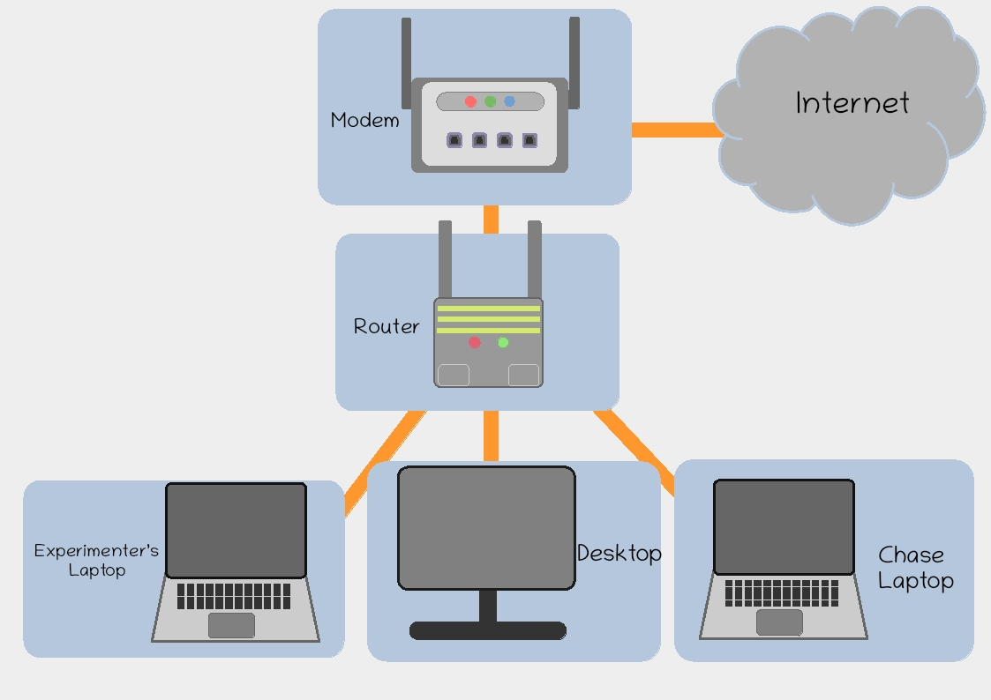

(fig1: LAN Visualization of the Experiment)

This study is conducted in the researcher's house in a laboratory network set up using Vaio VGN-FW190 laptop with dual-core/dual threads processor @2.5GHz, 4GB DDR2 RAM, ZLT S10G modem (OEM of Globe Prepaid WiFi), bridged by 300mbps TP-Link router. The software being experimented on is the web version of Google Meet being deployed on version 93 of Firefox running on top of Lubuntu 20.04.3 LTS kernel 5.4.0-88-generic. The researcher would set up all the equipment and run the experiment with a predetermined set of conditions every Tuesday 11:00 up until 16:45 of the same day and would continue again on Wednesday of the same week starting on 13:00 up until 18:00. To yield real-world data, the researcher concluded that they will conduct experimentation during their online class on Google Meet on the period already mentioned. There would be no personally identifiable information gathered in the entirety of the experiment and all data yielded in logging would be analyzed and treated accordingly to relevant privacy laws.

**OBJECTIVES OF THE STUDY**

The main goal of the study is to find out the performance of Google Meet across different internet conditions.

This study aims to determine the following:

1. Evaluate testing equipment profile by information such as make and capability.

2. Create a baseline rubric for determining (Google Meet's performance.

3. Manipulate and study both internet speed and latency versus its perceived effects on Google Meet performance.

4. Compare Google Meet's performance between the control group and the variable of interest.

5. Accurately predict Google Meet's performance based on internet speed and latency envelope.

6. Recommend setting changes in Google Meet to cater to slow internet connection.

7. Figure out if internet speed and latency play statistically significant changes on Google Meet's performance.

8. To state the negative impact of slow internet speed and latency on Google Meet's performance.

9. Figure out if purposely slowing down internet speed can yield significant data savings while still being usable.

**SIGNIFICANCE OF THE STUDY**

1. Faculty members- The research would benefit the school administration as this study would give them insights on how Google Meet performs across different internet conditions. Which would them to create redundant plans to mitigate reception issues.

2. Students- Tweaking different settings in Google Meet, students would gain very valuable information on how to adapt and tackle connectivity issues on the platform.

3. Parents- Though they're not a first-hand user of Google Meet in this school, they can still gain valuable insight on how the platform used by their child works and how it performs on internet slowdowns.

4. School Administration- By sharing the results gained by this research, they can assemble and formulate time-sensitive actions on remote learning experience that is based on facts and data gathered.

5. Developers- By studying Google Meet's performance on both slow and ideal network conditions, developers can implement solutions that would compensate for the lack of fast internet speed in some areas. VP9 which is baked into Google Meet can be improved or replaced by neural-based video encoding.

**HYPOTHESIS OF THE STUDY**

The idea of this research is to measure Google Meet’s performance across different internet conditions. Researchers determined that there are two Independent variables in this research.

Independent Variable 1- Internet speed (measured in KB/s or kb/s) since internet speed is a formula we can derive the number by dividing the size of data transfer per second.

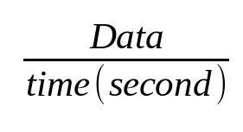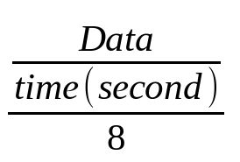

( deriving internet speed in bits per second)

(converting bits per second to bytes)

Though looks complicated at first converting bits to bytes and vice versa is just dividing or multiplying the base value to 8. So the confusion here is that Internet Service Provider advertises their speed at bps (bits per second) instead of more standard appreciable Bps. (bytes per second)

Independent variable 2 - Latency (in milliseconds) is the second independent variable of this research. As video conferencing is a time-sensitive process analyzing the current latency of the network would give us the usability performance of Google Meet in real-time. With this, they would hopefully eliminate the time-sensitive recitation that some faculty members do, as not all people have stable latency every time. Internet speed and latency are independent of each other and should not be used to describe one another.

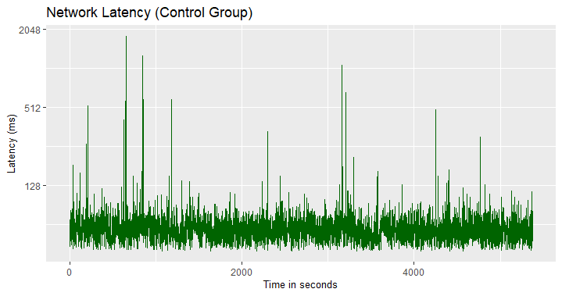

(fig2: latency over time)

Since researchers determined the two independent variables which is the dependent variable is depending. The hypothesis is:

“Google Meet’s Performance is the dependent variable thus its characteristics is dependent in the independent variable, and thus we will test both independent variables while observing Google Meet’s performance and usability, moreover Google Meet’s performance is directly proportional to its independent variable”

**H0:** No there’s no any correlation between Google Meet’s performance and changes in both Transfer Speed and Latency.

**H1:** There’s a correlation between Google Meet’s performance and the changes in both transfer speed and latency

**H2:** There’s a correlation between Google Meet’s performance but only on transfer speed and it is not affected by Δ latency.

**H3:** There’s a correlation between Google Meet’s performance but only on Latency and it is not affected by Δ Transfer Speed.

**DEFINITION OF TERMS:**

Δ – Delta, shortform of “change in”

Audio Cache Miss- A phenomenon that happens when an audio buffer is lost due to high latency. This is characterized by choppy unintelligible audio.

Bashtop- TUI-based application similar to Windows Task Manager.

Firefox- A free and open-source (FOSS) web browser developed by Mozilla Foundation.

FPS Drop on Screenshare- Lower than expected 24FPS screen share caused by slow internet connection. Characterized by loss of illusion to moving pictures.

Google Meet- Video conferencing platform developed by Google as a successor of Google Hangouts.

Lubuntu- A Ubuntu-based Linux distribution with LXQT environment for lightweight operation. The research's experiment host Operating System.

Modem- Network-enabled equipment that modulates and demodulates incoming traffic signals to a format understandable by the router.

Netem- A commonly bundled feature in Linux kernel that limits bandwidth characteristics such as transfer speed and latency. It can be accessed by using "tc" and "qdisc"

Nethogs- A TUI-based utility that monitors real-time internet traffic.

Ping- A TUI-based utility that monitors single server latency round trip.

Router- Network-enabled equipment that routes internet traffic through and from LAN and WAN.

SSH- A software that allows Linux-based PC to be controlled on any SSH-enabled devices on the same network.

Terminal- Textual user interfaced-based application that can be used on a variety of tasks such as network logging and monitoring.

Total data usage- Total data measured in Megabytes or Gigabytes used in a period.

Total Drop Time- Defines as the total number of times Google Meet call disconnects completely.

Video Cache Miss- Lag in which the video stops due to buffer lost. But not severe enough for the call being dropped.

**CHAPTER 2**

**REVIEW OF RELATED LITERATURE AND STUDIES**

**Introduction**

This chapter presents an in-depth review of related literature from both foreign and local publications. This helps to augment information from this research, the gathered information from this chapter will be used in the succeeding chapter of the paper on the interpretation of the experiment results.

**Related Foreign Literature and Studies:**

**Foreign Literature**

"Web Video Conferencing(WVC), allows students to participate in live interaction with the tutor and share relevant questions as well as exchange arguments in peer-to-peer discussions. In the WVC session, students are more likely to be motivated, because they can simultaneously collaborate with other members using audiovisual communication tools in an activity stream." (A Scoping Review of Videoconferencing Systems in Higher Education: Learning Paradigms, Opportunities, and Challenges, 2019)

Web-based video conferencing platform such as Google Meet offers a liver interaction between students and educators in a formal classroom like manner. According to media naturalness theory, people are more inclined to participate in a conversation of the said medium of the conversation appears to be more akin to natural face-to-face communication. This makes the participants more engaged, furthermore, students that utilize web video conferencing as an alternative medium of learning tend to understand lectures and lessons more effectively compared to other less natural forms of learning medium.

“A very nice feature is that Google Meet doesn’t require any client installation. If you don’t want the full Workspace experience, you can simply navigate to the Google Meet page and click “Start a Meeting." From there, you can copy the invite link and send it to anyone else that needs to join, and then conduct your meeting through the browser experience. Note that Google Chrome is definitely where you'll find the best experience, though Google Meet will work on other browsers. However, your mileage will vary.” (Google Meet Review, 2021)

Google Meet's ability to be used natively in a browser offers advantages such as security since browsers often get security updates over time. Browser act as a standalone package in all websites and address protocol it can open. This mean is individual developer doesn't necessarily need to patch their web app when major security issues and zero-day attacks emerge which commonly tries to gain secured information in the system. Not only this, but the ability of Google meet to be used in a browser opens it to a wide range of devices running different types of Operating systems as the mere requirements are just working browser. This can be considered a lower barrier to entry as users aren't forced to acquire new devices in order to install standalone software to it. An example of this is Google Meet's ability to run in $35 Raspberry Pi 4. A cheap open-source single board computer that can easily be acquired. (How to Turn Your Raspberry Pi into a Video Conferencing Station, 2020)

“Google, the world’s largest search engine, recently introduced a new feature to its video conferencing tool, Google Meet, which allows users to limit their app data consumption. According to Google, when this feature is enabled, it not only controls data usage but also reduces battery usage and the need for a CPU on mobile. Speaking about this feature, he said, “Google Meat automatically configures your device, network, and set up to provide the best meeting experience. However, you may want to adjust the quality of your meeting to minimize the impact on your mobile phone.“(Google Meet Data Saver Mode: Is there any way to save mobile data?, 2021)

Since some users don't have access to unlimited data connections, Google meet pushes updates about data-saving functions that lower overall data usage while maintaining a usable experience. Not only that, but it also aims to lower the device's CPU usage for longer battery life. These are all held automatically without any user intervention and would dynamically shift during the entire time of usage when the internet connection swings back and forth.

**Foreign Study**

"Selective Forwarding Unit (SFU) Style user interface was popularized in the consumer market with Google Hangouts (now Google Meet) and is used by other services. Front and center with the vast majority of screen real estate is the video of whoever is the current speaker. All of the participants are seen in their own thumbnail, usually in the right or across the bottom. We want the active speaker's video in the middle to look great so that is high resolution. The thumbnails on the bottom right are small, so high resolution there would be a waste of bandwidth. To optimize for these different modes we need each sender's video in multiple resolutions. Which is solved by simulcast. All senders encode 3 different resolutions and send them to SFU" (Suspending Simulcast Streams for Savvy Streamlining, 2018)

Previous literature delved into the subject of bandwidth management and how latency and bits transfer over a period of time be minimized while still maintaining usable experience. While the study above focuses on using an intermediary server called SFU. The SFU is a secondary server alongside a signaling server that is optional in the previous WebRTC standard. SFU's job is to selectively sends and compress (change word) audio and video streams to the participants. This gives the flexibility for full-duplex connection while still saving significant network infrastructure in the process. By integrating SFU to multipart video stream and adding simultaneous casting (simulcast), the server can selectively change and adjust multiple video streams to various qualities such as low (360p), medium (720), and high (1080p*) based upon by determining who's the active speaker in the session. This is especially true in online classes as most of the time, the active speaker is the teacher. Which is not just an active speaker but also the center point of attention including their shared screen. This type of singular stream, multi audience conference are common and thus, SFU makes use of simulcast by prioritizing most of the bandwidth to the point of attention and downsampling other streams. Through the use of thumbnails. (*low, medium and high progressive resolution are based on standard convention. May vary between service providers.)

"In the networking aspect, video conference traffic, which consists of audio and video data, is delay- and loss-sensitive. This means that the quality of a video conference service is highly affected by obtained delay and drop of packets during the communication process. In one-way communication, voice requires delay (latency) to be lower than 150ms with a loss rate below 1%, while video requires latency to be lower than 400ms with a loss rate below 1%. For video streaming,

high-definition video (HD-video) requires network latency between 150ms to 400ms and a loss rate below 1%, while standard-definition (SD-video) requires network latency between 400ms to 1s and loss rate between 1% to 2%. A higher value of latency or loss rate leads to lower quality of experience, which depends on end-user perception. The main aspect that affects obtained delay is network condition." (QoS analysis for WebRTC video conference on bandwidth-limited network, 2017)

Video conferencing applications such as Google Meet are delay-sensitive processes. As the literature above focuses on the WebRTC implementation which is the same forked protocol being used in Google Meet. Latency must be kept in check in order to have a quality user experience. At around 150ms is the recommended latency of the paper with packet loss less than 1%. In this context, a delay is referred to as the round trip latency of the data packet in the network. Depending on the number of participants in the video conference session, latency swings from peer to peer. As WebRTC is a peer-to-peer network, this means that all participants in the session communicate directly without a central server. This stands true in Google Meet's implementation. Both audio and video are being transmitted peer to peer while non-bandwidth sensitive features such as poll, messages, and whiteboard are held by Google's internal server. This web-like network assures that Google's server and its supporting network infrastructure won't be overloaded with unnecessary traffic, second reduced apparent latency all participants central servers are eliminated, and third, redundancy since WebRTC facilitates peer to peer communication. Any issue from a single computer won't bring down the whole session down unless it's the signaling and media server that facilitates handshake operations.

"Newer techniques classify traffic by recognizing statistical patterns in externally observable traffic attributes, which include the length and arrival time of the packet. The main goal of the statistical method is based on grouping or classifying network traffic flows into groups that have identical statistical properties. The need to classify or group large data sets is one of the reasons for the introduction of Machine Learning (ML) techniques. Statistical methods for accurate and efficient traffic recognition can be divided based on the type of machine learning used, supervised or unsupervised. This paper aims to propose a model for recognizing traffic generated during WebRTC audio and video communication based on statistical characteristics and the use of machine learning." (A Congestion Avoidance Mechanism for WebRTC Interactive Video Sessions in LTE Networks, 2018)

Since not all of the users of Google Meet and its open-source derivative WebRTC have up to spec internet connection, the paper considers employing Machine Learning(ML) algorithms in order to dynamically tune quality-based settings on the platform by using aggregated information from past and present trends of individual users. This is different from statistical models which use stiffed often unelastic pattern recognition in the traffic. The classification of this metric would increase the platform's performance while still running on out of spec internet connection. As ML-based algorithm learns through pseudo experience, it is projected that ML's classification ability would increase when they exposed on this metrics over time.

**Related Local Literature and Studies**

**Local Literature**

“Meet meeting codes are complex by default and therefore resilient to brute-force “guessing.” Meet video meetings are encrypted in transit, and all recordings stored in Google Drive are encrypted in transit and at rest.”(Google Meet premium video conferencing free for everyone, everywhere, 2020)

According to the article, Google meet is resilient to brute force technique in which the attacker randomly guest the nine alpha characters (eg: hsx-awed-kom) as meeting code. This meeting code is being used by Google Meet as a signaling protocol in order to initiate the call. This is the simplified version of signaling as supposed to WebRTC standard which uses up to 40 lines of code. Google Meet, opt for this character in order to maintain simplicity and signaling integrity as the user can't see the actual code needed for initiating the call. Encryption is also a vital part of Google Meet's service by encrypting the traffic during transit and through its media server. Though baked into WebRTC standard, this double encryption offers data security not only during transit (which minimizes man in the middle attack) and in Google's server.

"The work-from-home revolution brought on by the novel coronavirus sparked a teleconferencing phenomenon over the past few months. Zoom, which has been plagued with security issues, announced last week it hosts 300 million meeting participants a day. Facebook is adding its own entrant with a video conference tool for its Messenger app called Messenger Rooms. Alphabet CEO Sundar Pichai said in its earnings call Tuesday that Meet recently "surpassed a significant milestone" and is adding 3 million new users every day. Usage has increased 30-fold since January and Meet now has more than 100 million daily meeting participants, according to Pichai." (Google makes Meet, its Zoom and Skype competitor, free for everyone, 2020)

The users of video conferencing platforms such as Google Meet saw a spiked in usage when the coronavirus hit and are still on a trend to the present time. Especially in the Philippines where face-to-face classes are still limited, many students and educators are still using this type of remote conferencing platform in order to continue schooling. As the user base increased, security-related issues also popped up not just in Zoom which is about their email system but even on Google Meet in which there's a couple of published incidents in which a meeting code has been leaked into broader internet and caused a splurge of unwanted participants entering the conference. (Singapore teachers drop Zoom after online class gatecrashed, 2020) Though, this is fixed by allowing the call initiator to review and approve anyone who wants to participate or by using the whitelist function through Google domain service.

“Other new features in this release include Meet's capability to automatically spruce up your video feed a bit to make sure you're more visible in a dark environment and enhance your video when you are sitting in front of a bright background. This will roll out in the coming weeks. There's also autozoom, which uses AI to automatically zoom in on you and put you in the middle of your frame. That's coming to paid Google Workspace subscribers in the coming months. (Google Meet gets a refreshed UI, multi pinning, autozoom, and more, 2021)

As the previous literature highlighted, most of Google Meet's big updates are focused on user experience which includes automation such as zoom, brightness control through the use of Artificial Intelligence. This means that the feature can adapt to a wider variety of conditions as it utilizes AI in the process compared to the algorithm-based one. Similarly, the background changer of Google Meet is also based on AI processing, thus eliminating the need for a green screen and can be used in a wide variety of cameras with an option to emulate light sources from the background. (Total Relighting: Learning to Relight Portraits for Background Replacement, 2021)

**Local Study**

“Video Conferencing will not violate any quarantine protocols and this will ensure the safety of both students and the teachers, in times like this, we need to adopt the new technology platforms embracing the effects of COVID-19 and might lead to the opening of the New Normal in all sectors.” (The Impact of Video Conferencing Platform in all Educational Sectors Amidst Covid-19 Pandemic, 2020)

The study accepts that video conferencing not only follows strict quarantine protocols by the government in reducing face-to-face contact. So most sectors are trying to embrace and adopt these remote services in order to continue and thrive during the heights of the pandemic. Similarly, there's an influx of people trying to migrate from traditional and natural forms of a conference to much more flexible video conference platforms such as Google Meet. Services like this offer the educational sector a way to continue educating young aspirants throughout the hardships brought by the Covid-19 pandemic.

“According to Sarmiento, majority of the teachers are from the rural areas where common internet connection used is mobile data. It is known that mobile data are capped per day which is why many of the teachers have difficulties in delivering remote lessons. With this, internet access, connectivity, and speed were among the challenges of the teachers compared to those who have a fiber connection." (Emergency Remote Teaching Experiences brought by COVID-19, 2021)

The study highlights the key barriers for remote learning; this are internet access, also define as internet penetrability which is the scope of reach by the internet in certain areas. second, connectivity defines as the ability and ease of usage of internet-based services, and third, internet speed is the speed on how fast a byte or bytes can traverse from device to server and vice versa. This is especially true in rural areas in which this three-factor contributes to the inability and impracticability of using conference platforms such as Google Meet really presents. Though the study argued that people with fiber connections are much better, the researchers don't agree with certainty. First, though fiber is actually fast compared to DSL/copper, the average broadband speed in the Philippines is just 71.85Mbps (Ookla, 2021) which is nowhere near the maximum speed of a normal cat6 copper ethernet port at 1Gbps which is easily available and cost less than plastic fiber. Fiber is fast but if the infrastructure can't support it, it'll just perform just as best or even worst compared to copper.

“The integration of computers, smartphones, and other devices in the teaching and learning process is a move that every school must embrace to become relevant in the present time. The need to include e-learning in the curriculum has been made more prominent with the onslaught of the COVID 2019 (Sahi, Mishra, & Singh, 2020). Government agencies, such as the Department of Education (DepEd) and the Commission on Higher Education (CHED), advocate online classes or flexible learning to address pandemic issues and the constraints imposed on schools to observe health protocols and practice social distancing. Thus, schools are now looking into the viability of implementing online classes or flexible learning, including online and offline courses” (Narmada & Somasundaram, 2020). (Readiness for Flexible Learning amidst COVID-19 Pandemic of Saint Michael College of Caraga, Philippines, 2020)

To keep the education sector running, the paper suggests that the sector should use technology and e-learning platforms such as Edmodo, Google Classroom, and others. To keep students learning, this regiment keeps everyone safe from the threat of Covid-19 and uses the mix of online and offline modes of learning throughout the pandemic. A very necessary move in order to curtail the R0 of Covid 19 and lower the reported cases over time, a possibility of resuming face-to-face classes is still not official but the availability of Covid 19 vaccines are increasing every day, so does the people being inoculated by this.

**Conceptual Framework**

Conceptual framework contains the input, process and output of the study. A conceptual framework demonstrates what the researchers supposed to find through the study. It is often signified in a visual plan.

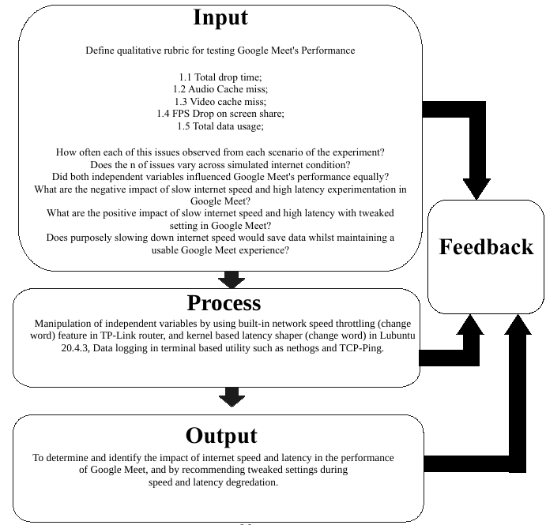

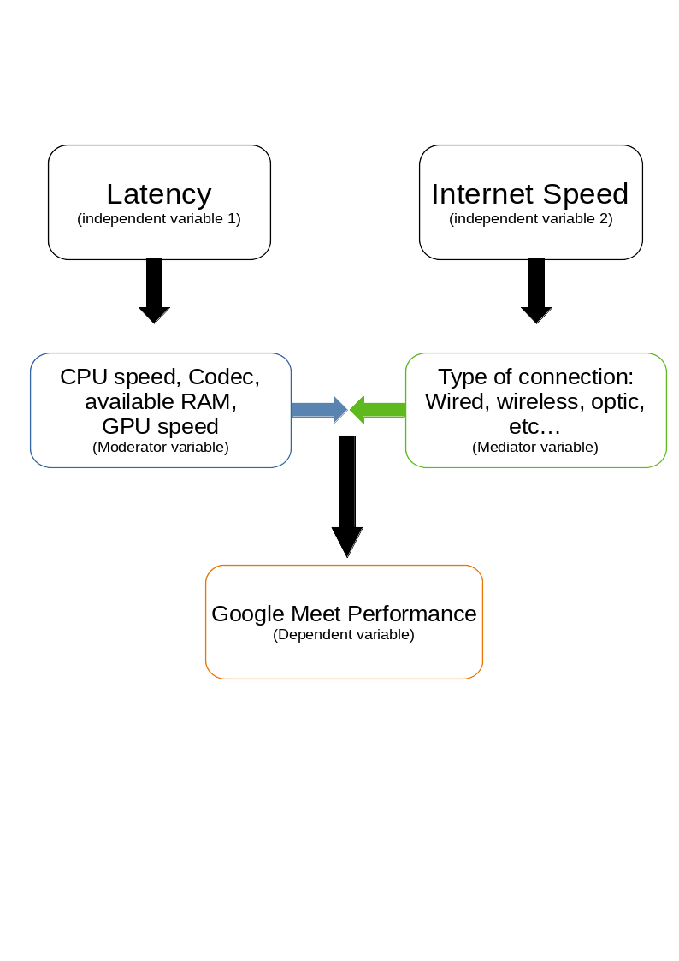 The conceptual framework highlights the variables that affect the experiment result. Researchers determined three types of variables that influence the dependent variable. First is the independent variable which consists of the experiment’s variable of concern, which is the latency and internet speed respectively. This is the variable that the researchers manipulate to understand the behaviour of the dependent variable. In order to have an accurate result in the preceding experiment. The researcher assigns other variables that might affect the dependent variable into two categories. The moderator variable can affect the dependent variable in an accounted way and the Mediator variable can be affected by the independent variable.

**Moderator Variable**- This consists of entities and values that might affect the dependent variable behavior and consequently its results. The researcher pointed out the four major units as follows:   
 **CPU Speed**- Google Meet is CPU intensive application as it decrypts, sends, receives, decodes, and encodes video and audio feed at the same time and slow CPU speed can affect the Google Meet performance in a way that this research did not cover. In order to minimize the effect of this variable, the researchers used a modern 64BIt processor which offers more than enough speed to process Google Meet requirements thus, minimizing CPU processing issues.   
 **Codec**- Codec is software that encodes and decodes audio/video feed and a poorly written code can cause high CPU usage in most cases. This is outside of the paper’s scope and thus didn’t observe.   
 **RAM availability**- Depending on the browser, systems with RAM lower than 2GB greatly affects Google Meet performance but all system responsiveness. The researchers’ test computer is equipped with 4GB of RAM more than enough Google Meet’s official requirements. (Requirements for using Google Meet, 2021)  
 **GPU Speed**- Researchers found out that GPU speed plays a major role in Google Meet performance as it handles video output. Integrated and dedicated GPU manufactured 15 years ago is enough to run Google Meet smoothly.   
  
Variables that can be affected by the independent variables are called **mediator variables**. They can greatly affect the dependent variable in ways not been covered in this study. The researchers found out that independent variables can affect mediator variables in different amounts. An example of which is the independent variable 1 (Latency) can be affected by the mediator variable based on the connection used (eg; ethernet, Wi-Fi, fiber, etc...) Each medium is different from the others thus, affecting latency. To mitigate the mediator variable’s influence, researchers use ethernet cable in order to minimize unwanted latency and interference on a wireless network.

**Theoretical Framework**

**Google Meet perceived usability-** The study proves that the attitude to the platforms influences the intention to use online meeting platforms. The attitude to the platforms is influenced by perceived ease of use and perceived usefulness. So, the meeting platforms providers must raise perceived ease of use and usefulness of their platforms during a high competition in this industry. To collect information about what competitors have done, doing, and will do is one of the market-oriented dimensions. It is the competitor orientation. An organization needs to do in its industry to get competitive advantage and sustainability. Online meeting platforms are competing to convince consumers that their products are the best. (The Factors Affecting Intention to Use Google Meet Amid Online Meeting Platforms Competition in Indonesia, 2020)

The study’s definition is the most relevant to this study. As it, emphasizes user perception in a qualitative manner such as ease of use and user’s perceived usefulness. Which vary from person to person and are thus subjective. But this doesn’t mean that this subjective perception doesn't hold value in quantitative research such as this study. An aggregation of reports about google meet’s usability gauges the whole user base on how they perceived the usability and ease of use of the platform. Moreover, the study fits the varied concept of this research as it focuses on an academic setting in which the demographic population are all student which is the sole source of feedback.

**Internet speed**- According to official Google Meet hardware requirements. Google recommends at least 250KB/s of internet speed for standard definition (SD) video conferencing of more than 10 participants in call instances. (Google Meet hardware requirements,2021)  
 Researchers doesn’t agree in full with the theoretical minimum set by Google, as the researcher’s experiments suggest that Google Meet is still usable with minor hiccups at speed as low as 100KB/s of bandwidth on default quality settings set by Google meet automatically in the browser. Given with latency not exceeding 400ms as stated in the latency part of this theoretical framework.

**Latency**- ITU-T Recommendation G.114 specifies that one-way transmission delay should preferably be kept below 150ms, and delays above 400ms are considered unacceptable (Performance Evaluation of WebRTC-based Video Conferencing, 2018)

This study predicts with outstanding accuracy the Google Meet’s behavior and subsequent usability rubric based on latency. This research suggests that there's a strong correlation between latency and Google Meet’s performance. Our experiment results validate this theory that latency fluctuations influences Google Meet usability widely and causes hiccups during latency spikes and since this study focuses on the usage of Google Meet in academic settings (ie: online class) in which the participants turn their cameras off in order to conserve bandwidth and mostly relying on presentation (i.e. screen share) of the main speaker and oral accompaniment on gathering information. Latency spikes that induce audio cache miss greatly influence the performance of the platform.

fig3: visual representation of variables

Google Meet’s performance relies on its two independent variables which are Internet Speed and Latency. In order to increase Google Meet performance, the user should increase both of these variables up to a point in which researchers called "Optimal Performance Plateau", which is the point where Google Meet’s performance would no longer increase. For internet speed, the minimum speed required to reach this plateau is 500KB/s and higher. While latency would reach the performance plateau at 80ms and lower at that point, the performance is determined by outside factors such as; speaker’s internet speed and latency (ie: if the user is the listener) or listener’s internet speed and latency (ie: if the user is the speaker). This scenario is said to be double coupling, where the outcome of two values is influenced by their own current values.

**Double coupling:**

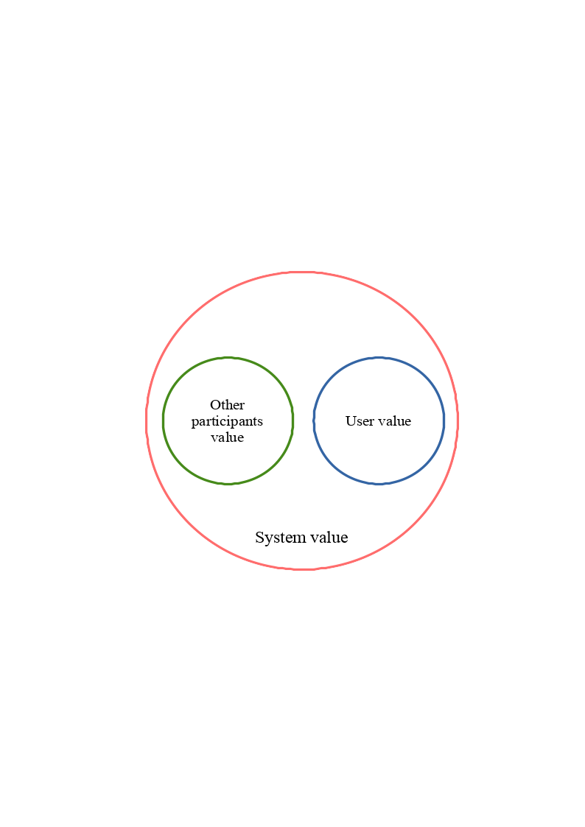The scenario is said to be double coupled when both unit influences the other unit's value. In this case, the unit's value is its performance. Moreover, the chance of double coupling greatly increases when the state of the system reaches its performance plateau. Furthermore, relative performance plateau is not arbitrary number but consist of the mean of both latency and internet speed of the system. Thus, system is defined as the average of of all unit value. In short, the system is said to be double coupled if (OPV) and (UV) influenced the value of (SV).

Fig4: subcompact visualization of system relationship

The system’s value can be determined by this formula:

sv(System Value) = opv (Other Participants Value) + uv (User Value)

**CHAPTER 3**

**RESEARCH METHODOLOGY**

**Introduction**

This chapter presents an in-depth explanation of methodologies used by the researchers, and how this can be reproduced in the future replication study. This includes experiment design, sampling procedure, research instrument, and data analysis.

**Experiment design**

Contains the setup procedures, such as hardware location and software preparation, gathering of important metrics during the experiment, and declaring any stray variables that might affect the experiment's result yet outside of this study.

**1.1 Setup procedures (Hardware)**

The modem is placed in the experimenter's house first quadrant. (*figure 1*) In which there's a reliable internet speed of more than 10megabits per second, this modem would act as the gateway of the router during the experiment. In which this router is configured to run in "bridge mode" (*figure 2*) which allows the router to act as an intermediary between the modem and the laptop in which the experiment would occur. In this same router, researchers also control the internet speed through the use of Dynamic Host Configuration Protocol (DHCP) and bandwidth limiting. (*figure 3)* Which covers the first independent variable (internet speed).

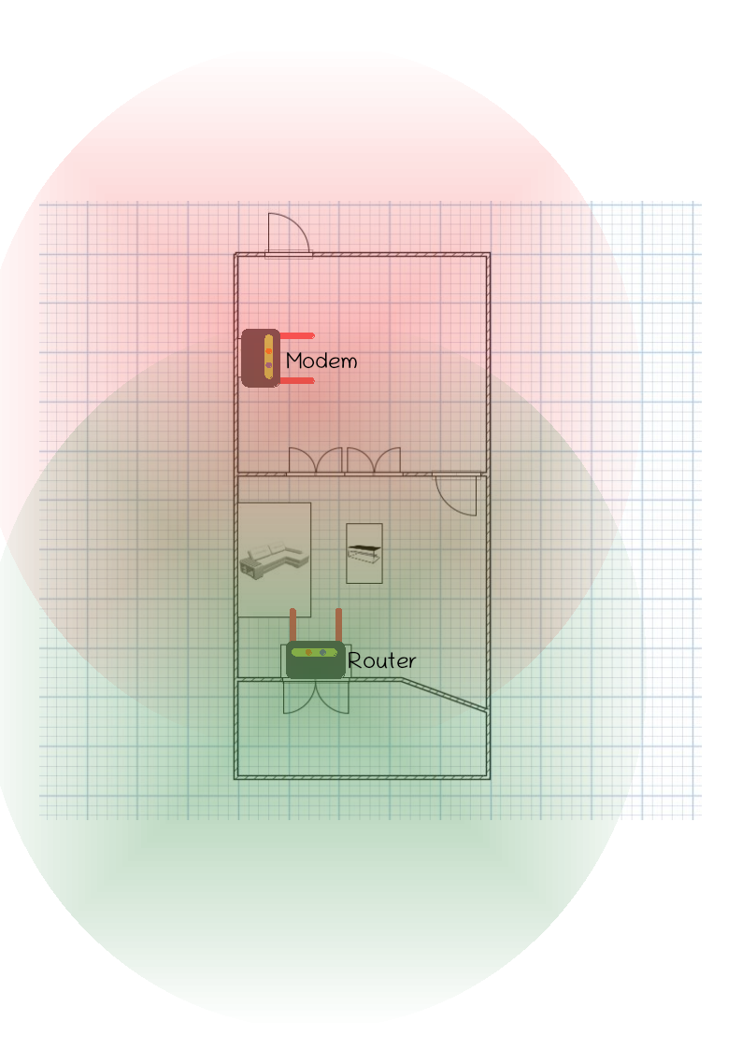

figure 5: signal propagation modem (red) and router (green)

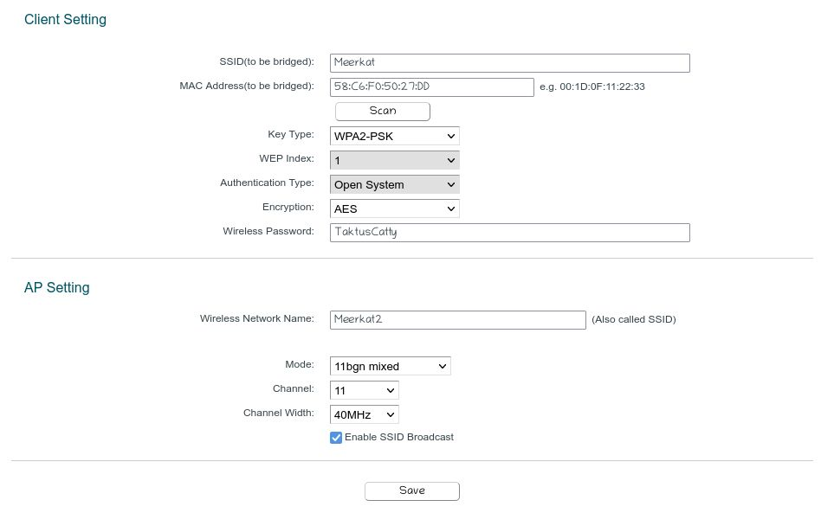

figure 6: router's bridge mode

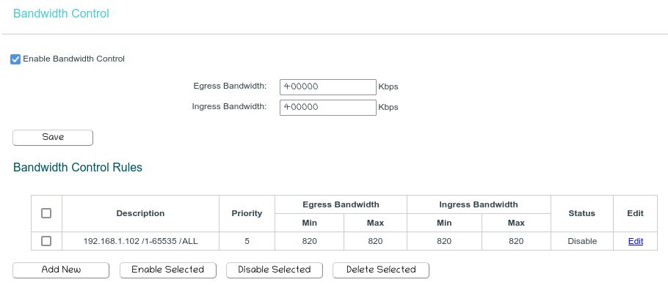

figure 7: DHCP and bandwidth limiting settings

To eliminated latency brought by wireless protocol (ie: wifi) the experimenter's laptop is connected to the router using cat6 ethernet cable. This eliminates unnecessary latency caused by external variables (such as wireless protocol) which is not covered by this study.

**1.2 Setup Procedured (Software)**

The experimenter's laptop is connected directly through the router. In which it runs version 93 of Firefox with a single tab running Google Meet. While researchers control the second independent variable (latency) using a built-in kernel feature called "tc". Which would be logged in the terminal as a text file.



figure 8: command for latency manipulation

**Sampling Procedure (Momentary Time Sampling)**

The sampling procedure is based on momentary time sampling in which samples both the independent variable in a fixed amount of time. Researchers chose to use this type of sampling as both independent variables are continuous, which means that it has infinite values in between two values. As such, it is impractical to measure this gradient of values in the most minute parts. Thus, researchers sample both independent variables in a fixed amount of interval. Which is per second, this is the default time sampling in the networking industry as it offers an instantaneous yet coherent stream of information. A second is a fixed arbitrary measurement of time, based on Cesium 133 radiation oscillation which equates to 9.19GHz. (13th General Conference on Weights and Measures, 1968) Since the researchers don't have access to Cesium or Rubidium-based atomic clocks. Researchers based the value of seconds on 32.768KHz which is the oscillating frequency of quartz crystal which is commonly used in almost all electrical equipment that requires time synchronization.

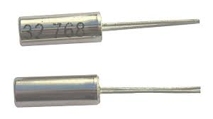

Figure 9: THT based quartz oscillator; note the number printed

In terms of real-time clock synchronization, researchers used the standard Network Time Protocol (NTP) which is being used worldwide in providing accurate internet-based clock signaling with accuracy within 10ms. (Building a more accurate time service at Facebook scale, 2020) In order to collect the data needed, the researchers used two distinct techniques in order to examine Google Meet's performance across different internet connections. First, by using automated software such as ping and net hogs the researchers can draw a baseline between the supposed characteristic of the variable versus what it actually exhibits during the experiment. This is especially true in the second independent variable as the latency fluctuates every time and maintaining an exact latency lock is improbable in the given set of software. Thus, instead of using exact latency value (in milliseconds), researchers decided that opting for the average would be a better representative over the course of the experiment. This means that even though the experiment called for strict latency in milliseconds the aggregated results would be the total average logged over time. This means, there would be a slight fluctuation between the desired value and real value. The same applies to internet speed.   
 Second, by manipulating the two independent variables and logging the change per second over the course of the experiment, the researchers would also evaluate Google Meet's performance through a pre-determined rubric in the span of time. In summary, researchers would gather three data points in this study. The internet speed and latency which is the independent variable and Google Meet's performance in the rubric, the dependent variable.

Figure 10:Command for logging dataset

**Research Instrument**

The researchers would conduct two separate experiments in testing the two independent variables. Prior to this, the researcher would conduct a one-time unmodified experiment to serve as the control group. This is where the independent variables would be left as is while logging Google Meet's performance in the rubric. Once all the data has been gathered in the controlled group, the researchers would conduct controlled testing of the independent variables. First of which is the Transfer speed, where the internet speed is manipulates based on pre-determined values per iteration while the latency remains constant. The second which, the latency is changing and the internet speed is constant. In which the researchers would carefully examine Google Meet's performance and subsequently logged it into the rubric for later analysis. This is where the software in the sampling procedure would be used.

**Pre determined values of the independent variable**

Experimentation on Transfer Speed

|  |  |  |
| --- | --- | --- |
| Experiment iteration count | Internet Speed (KB/s) | Latency |
| 1 | 50 | 80ms |
| 2 | 100 | 80ms |
| 3 | 250 | 80ms |
| 4 | 500 | 80ms |

Experimentation on Latency (1)

|  |  |  |
| --- | --- | --- |
| Experiment iteration count | Internet Speed (KB/s) | Latency |
| 1 | 50 | 80ms |
| 2 | 50 | 100ms |
| 3 | 50 | 250ms |
| 4 | 50 | 500ms |

Experimentation on Latency (2)

|  |  |  |
| --- | --- | --- |
| Experiment iteration count | Internet Speed (KB/s) | Latency |
| 1 | 100 | 80ms |
| 2 | 100 | 100ms |
| 3 | 100 | 250ms |
| 4 | 100 | 500ms |

Experimentation on Latency (3)

|  |  |  |
| --- | --- | --- |
| Experiment iteration count | Internet Speed (KB/s) | Latency |
| 1 | 250 | 80ms |
| 2 | 250 | 100ms |
| 3 | 250 | 250ms |
| 4 | 250 | 500ms |

Experimentation on Latency (4)

|  |  |  |
| --- | --- | --- |
| Experiment iteration count | Internet Speed (KB/s) | Latency |
| 1 | 500 | 80ms |
| 2 | 500 | 100ms |
| 3 | 500 | 250ms |
| 4 | 500 | 500ms |

**Data Gathering Procedure**

The researchers would gather the dataset of two independent variables and compare them to the dependent variables which measure Google Meet's performance qualitatively. This would be done in a series of experiments with one and half hour allocation for each pre-determined value above. This includes the change of internet speed and latency. The researcher selected time, effort, and cooperation on developing these values so as to serve its intended subject. The dataset would be log using built-in command-line software with further refinement in Featherpad for easier statistical analysis.

**Ethical Consideration**

The researcher will be conducting the study in consideration to privacy and following ethical principles in research including but not limited to, justice, consent, confidentiality and integrity. The researchers take time and effort to ensure that the information in this study was correct at written date. There would be no personally identifiable information (PII) to be recorded in any for of transmitting media thus, the data to be collected from the experiment will be secured and researchers would follow a strict privacy oriented protocol to ensure the former. In regards to both local and international privacy statutes.

**Data Analysis**

The researcher would analyze the data gathered using three stages. First is the refinement procedure, in which all unnecessary information logged by the command line software would be deleted. Using the find and replace function. Second, is the standardization where the data would be formatted into a standard that statistical software can understand. This includes inserting cardinal numbers on each interval. This allows the statistical software to aggregate the dataset based on time for both independent variables. As both are continuous variables and take decimal values. Once the dataset is refined and standardized, the statistical software would aggregate all of the data in the dataset and perform various calculations to it such as hypothesis testing, variable relationship, and data visualization. The researchers chose to use R studio as the statistical software as it can accommodate and analyze significantly more data points compared to excel, R studio uses R programming language which is the standard on big data analysis as it offers streamlined performance in larger data set and R studio offers different kinds of hypothesis testing which is fast and simpler to deal with.

**Factor Analysis**

In this section, the researcher would process the predetermined variables of the independent variables in to treatment. Where the variables would be assigned with different conditions equating to a specific experiment treatment. The researchers categorize each treatment based on their position and iteration experiment count based on the predetermined value chart on the preceeding page. Example, Transfer ItrX.X meant that the experiment treatment is focus on investigating internet speed, Itr is a shortform of the word “iteration” and X.X is the total number of iteration preceeding the treatment of concern. Whilst, the researchers assigned purple as color of Internet speed, while latency is green.

|  |  |  |  |  |
| --- | --- | --- | --- | --- |
|  | 50KB/s | 100KB/s | 250KB/s | 500KB/s |
| 80ms | Transfer Itr1 | Transfer  Itr2 | Transfer Itr3 | Transfer Itr4 |
| 80ms | Latency Itr1.1 | Latency Itr2.1 | Latency Itr3.1 | Latency Itr4.1 |
| 100ms | Latency Itr1.2 | Latency Itr2.2 | Latency Itr3.2 | Latency Itr4.2 |
| 250ms | Latency Itr1.3 | Latency Itr2.3 | Latency Itr3.3 | Latency Itr4.3 |
| 500ms | Latency Itr1.4 | Latency Itr2.4 | Latency Itr3.4 | Latency Itr4.4 |

**Statistical Treatment**

The researcher would analyze the data gathered from the experiment. Using R and studio as statistical tool. Furthermore, the researcher will use Pearson Correlation test to validate the relationship of the independent variable to the dependent variable using this formula.

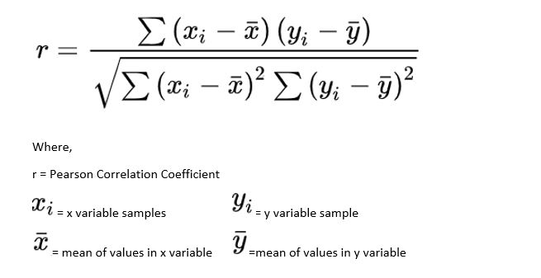

Figure 11: mathematical formula of Pearson’s coefficient

The statistical test would determine if the independent variable actually influences the dependent variable and the researcher would find out the extent of such influence.

**Descriptive Statistics**

The researchers would visualize the dataset overtime by employing a line graph in a logarithmic scale to present skewness toward large values and to show multiplicative movement. The dataset includes Latency, and Internet speed (upload and download) as the variables to be visualize.

**Visualizing Latency**

t %>%

ggplot(aes(y=ping, x=time))+

ggtitle("Network Latency ")+ #formatting

labs(y = "Latency (ms)", x = "Time in seconds")+

theme(

axis.title.x = element_text(size = 10),

axis.title.y = element_text(size = 10))+

#scale_y_continuous(trans='log2')+ #log function for better view

geom_line(size = 0.2, color = "dark green")

Where:

ggplot- is the library for data visualization.

ggtitle- for formatting the graph with title, and index for x and y axis.

scale_y_continuous- for binary logarithm which is equal to x = log2 or 2x = n

geom_line- is for line graph aesthetics and size

On line graph’s title, the researcher would modify the code for every treatment that would be conducted during the experiment. This includes neccesary information in the pre determined values for the independent variable.

**Visualizing Internet Speed:**

s %>%

ggplot(aes(y=download, x=time))+

ggtitle("Google Meet Download Data Usage (Control Group)")+ #formatting

labs(y = "Download (KB/s)", x = "Time in seconds")+

theme(

axis.title.x = element_text(size = 10),

axis.title.y = element_text(size = 10)

)+

scale_y_continuous(trans='log2')+ #log function for better view

geom_line(size = 0.5, color = "blue")

#visualizing upload over time

s %>%

ggplot(aes(y=upload, x=time))+

ggtitle("Google Meet Upload Data Usage (Control Group)")+ #formatting

labs(y = "Upload (KB/s)", x = "Time in seconds")+

theme(

axis.title.x = element_text(size = 10),

axis.title.y = element_text(size = 10)

)+

scale_y_continuous(trans='log2')+ #log function for better view

geom_line(size = 0.5, color = "red")

Where:

ggplot- is the library for data visualization.

ggtitle- for formatting the graph with title, and index for x and y axis.

scale_y_continuous- for binary logarithm which is equal to x = log2 or 2x = n

geom_line- is for line graph aesthetics and size

The researchers assigned different colour to each variable. Dark green for the latency, blue for the download speed, and red for the upload speed.

**Comparing experiment's groups**

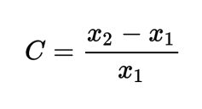

Where:

C = relative change x1 = initial value x2 = final value

Which corresponds to this Rscript

compACM <- c(30,28,35,47,47,17,15,17,25,37,10,8,10,14,21,5,4,8,5,7) #enter ACM values

x2 <-mean(compACM) #get the mean

x1 <-c(17) #define initial value

x3 <- x1-x2 #subtract x1 and x2

x4 <- x3/x1 #divide the difference with the initial value

x5 <- x4*100 #multiply by 100 to get percentage

print (-x5) #print and add absolute value to be positive

The researchers would use this mathematical formula and its R derivative to compare the each treatment group’s dataset to each other and to rule out if this changes are statistically significant.

**Inferential Statistics**

The researchers would test the study’s hypothesis by using Pearson correlation coefficient. In doing so, researchers can make a conclusion if the independent variable do influence the dependent variable and how statistically significant it is. By using the formula presented in figure 7, researchers can deduce the correlation sample estimate. This sample estimate is between -1 and +1 while having a correlation estimate of 0 equates that the variables that being compared don’t have any correlation at all. Using R studio, the researchers will deduce the correlation sample estimate using Pearson’s correlational test.

cor.test(dataset$dataframe1, dataset$dataframe2, method = "pear")

Where:

cor.test- library initiator to tell Rstudio the operation to be done.

dataset$dataframe1- to instruct Rstudio where the data is located.

method = “pear”- to instruct Rstudio what correlation test is needed to be performed, in this case “pear” short form of Pearson.

**Statistical Model**

The statistical model below is a collection of all statistical calculations that has been used in this research. Such use correlation test, data visualization, and dataset summarization. This is based on R language which a well known programming language in statistics and big data analysis besides to Python. Whilst, the R interpreter is encapsulate in R studio IDE which offers a variety of tools that the researchers use throughout the study. R scripts are interpreted and represents a mathematical model. Researchers opt for R as it offers a fast and accurate calculation compared to traditional means such as transistor based scientific calculator.

**#**based on R language/ R studio build 372

install.packages("tidyverse") #Install this packages first

install.packages("ggpubr")

library("ggplot2")

library("ggpubr")

library("tidyverse")

cor.test(tgroup2.fps$latency, tgroup2.fps$fps.drop, method = "pear")

ggscatter(tgroup4.fps, x = "latency", y = "fps.drop",

add = "reg.line", conf.int = TRUE,

cor.coef = TRUE, cor.method = "pearson",

xlab = "Latency (ms)", ylab = "Video Cache Miss")

#visualizing the independent variables

lt2 <- lat2ping

lt2 %>%

ggplot(aes(y=ping, x=time))+

ggtitle("Network Latency ")+ #formatting

labs(y = "Latency (ms)", x = "Time in seconds")+

theme(

axis.title.x = element_text(size = 10),

axis.title.y = element_text(size = 10))+

scale_y_continuous(trans='log2')+ #log function for better view

geom_line(size = 0.2, color = "dark green")

latencytdt <- c(44,31,15,2)

lab <- c("TGroup 1", "TGroup 2", "TGroup 3", "TGroup 4")

barplot(latencytdt, names.arg=lab, xlab="Treatment Groups", ylab="FPS Drop", col="purple", border="purple")

sum(control.speed$upload)

sum(control.speed$download)

compACM <- c(30,28,35,47,47,17,15,17,25,37,10,8,10,14,21,5,4,8,5,7) #enter ACM values

x2 <-mean(compACM) #get the mean

x1 <-c(17) #define initial value

x3 <- x1-x2 #subtract x1 and x2

x4 <- x3/x1 #divide the difference with the initial value

x5 <- x4*100 #multiply by 100 to get percentage

print (-x5) #print and add absolute value to be positive

compspeed <- c(353090,550148, 1336455, 2833350 ) #enter ACM values

x2 <-mean(compspeed) #get the mean

x1 <-c(31517.631) #define initial value

x3 <- x1-x2 #subtract x1 and x2

x4 <- x3/x1 #divide the difference with the initial value

x5 <- x4*100 #multiply by 100 to get percentage

print (-x5) #print and add absolute value to be positive

kb <- c(31517.631, 1268261)

lab <- c("Control Group", "Treatments")

barplot(kb, names.arg=lab, xlab="Mean", ylab="Data Usage (KB)", col="purple", border="purple")

m <- c(80,80,100,250,500) #pre determined values in latency

mean(m)

summary(m)

x1 <- c(202) #ch4 part3; mean of trgroups in latency

x2 <- c(60.8) #mean of latency by control group

x3 <- x2 - x1

x4 <- x3/x1

x5 <- x4*100

print (-x5)

mean(ping.control$ping)

#comparing all treatment groups performance issue (latency, each number follows: 80,80,100,250,500ms)

tr1 <- c(106,103,120,140,147)

tr2 <- c(75,68,71,88,97)

tr3 <- c(38,34,34,41,71)

tr4 <- c(9,9,15,11,20)

lat <- c(80,80,100,250,500,80,80,100,250,500)

summary(Untitled.8) #calculation

ln <- linearregressiontest

lin <- lm(Untitled.8$tr1+Untitled.8$tr2+Untitled.8$tr3+Untitled.8$tr4 ~ Untitled.8$lat, data = ln)

summary(lin)

ggplot(Untitled.8,aes(y=lat))+ #visualization

labs(x = "Error rate", y = "Latency (ms)")+

geom_line(aes(x=tr1, colour = "treatment 1 (50KB/s)"))+

geom_line(aes(x=tr2, colour = "treatment 2 (100KB/s)"))+

geom_line(aes(x=tr3, colour = "treatment 3 (250KB/s)"))+

geom_line(aes(x=tr4, colour = "treatment 4 (500KB/s)"))

**CHAPTER 4**

**PRESENTATION, ANALYSIS, AND INTERPRETATION OF DATA**

**Introduction**

In this section, the researchers present the data that has been collected throughout the experiment and how this would answer the research questions. The data presented in this section are broken into four main treatment groups and each iteration has a different condition of both independent variables. Moreover, this chapter presents the presentation, analysis, and interpretation of the data gathered. Which would provide the necessary information needed for probing hypotheses and drawing a conclusion.

**Part I.**

**1:** The specification profile of the research experiment.

1.1 Hardware Specifications

|  |  |
| --- | --- |
| Vaio VGN-FW190 laptop | 2C/2T @2.5GHz 4GB DDR2 RAM |
| ZLT S10G modem | 4G LTE 2.4GHz WiFi |
| TP-Link router | 300mbps 2.4GHz quad mode router |

The table above lists the hardware equipment that is used to conduct the experiment. This equipment is stringently chosen in order to minimize and negate the effects on both moderator and mediator variables in the experiment. The researchers conducted a hardware survey and found out that the hardware equipment above is a representative specification of most computers (Statista, 2020) that is being used by students in the place of this research have a median age of 5.6 years. Furthermore, Globe manufactures the modem that is been used in the study which according to Statista (2020) currently have 76.6 million mobile subscribers adding to the fact that the modem only supports 4G LTE and Globe Telecom are currently phasing out their 3G transmission towers (Globe Removes Consumer 3G SIMs Across Distribution Chains, 2020) it is certain to conclude that this modem not only represents the population of WiFi AP but also the entire users of 4G LTE band. This includes but not limited to mobile phones, tablets, and laptops that have optional wireless capability onboard.

In addition, TP-Link routers are prevalent and equipped with the standard IEEE 802.11 b/g/n specification which allows these routers to have a standardized capability while maintaining compatibility with a wide range of WiFi-enabled devices.

1.2 Software Profile

The researchers uses a variety of software in order to measure and log the variables in this study this includes the following in alphabetical order:

Bashtop- TUI based application similar to Task manager

Firefox- A open source browser developed by Mozilla foundation

Lubuntu- The experiment’s operating system’s

Netem- Kernel based utility for network shaping

Nethogs- Application for logging Internet speed

Ping- dedicated for logging latency

Rstudio- Statistical software use for data visualization and analysis

LibreOffice- Open source alternative to excel use for data conditioning.

Researchers are committed to the study’s reproducibility as such, researchers decided to use free and open-source software (FOSS) in order for future researchers to reproduce the study without using paid and proprietary software that can hinder innovation and productivity. Evidently, this allows future researchers to examine every component of this experimental research as the software’s source code is openly available for everyone to access.

**Part II.**

**2:** The qualitative rubric for testing Google Meet performance.

2.1.1 Total Drop Time

Defines as the total number of times Google Meet call disconnects completely. This is accompanied by an error message such as “You lost your connection trying to reconnect” Please refer to factor analysis for treatment groups information.

**Treatment Group 1 (Δ latency @ 50KB/s)**

|  |  |
| --- | --- |
| **Experiment Iteration** | **Total Drop Time Occurrence** |
| Transfer Speed Iteration 1 | 5 |
| Latency Iteration 1.1 | 4 |
| Latency Iteration 1.2 | 5 |
| Latency Iteration 1.3 | 7 |
| Latency Iteration 1.4 | 10 |

Based on the data in the table, the researchers would use Pearson correlation test using the statistical model on statistical treatment of this study.

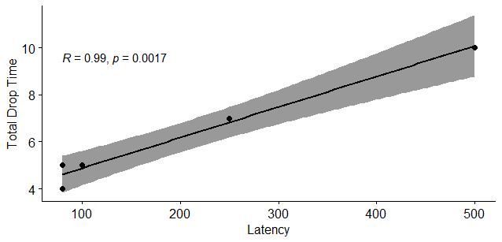

Figure 12: relationship of treatment group 1

As revealed by the scatterplot, there’s a strong positive linear relationship between latency and total drop time. With an R-value of 0.99, 95% CI between 0.813 – 0.9991, and t value of 10.737. Therefore the experiment on Treatment group 1 in latency equates to that increase in latency will yield an increase of Total drop time or meeting disconnection.

**Treatment Group 2 (Δ latency @ 100KB/s)**

|  |  |
| --- | --- |
| **Experiment Iteration** | **Total Drop Time Occurrence** |
| Transfer Speed Iteration 2 | 2 |
| Latency Iteration 2.1 | 3 |
| Latency Iteration 2.2 | 3 |
| Latency Iteration 2.3 | 3 |
| Latency Iteration 2.4 | 4 |

Based on the data in the table, the researchers would use Pearson correlation test

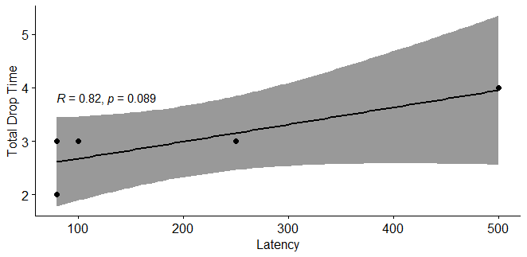

Figure 13: relationship of treatment group 2 to performance variable

As the scatterplot on the previous page shown, there’s still a positive linear correlation between latency and total drop time. Yet in this instance, the R-value drop significantly this is because the total bandwidth is doubled from the previous 50KB/s to 100KB/s thus, giving Google Meet breathing room to aggressively cached video and audio information. Albeit on increasing latency. In addition, treatment group 2 have an R-value of 0.82, 95% CI of 0.226 – 0.987, and t value of 2.478

**Treatment Group 3 (Δ latency @ 250KB/s)**

|  |  |
| --- | --- |
| **Experiment Iteration** | **Total Drop Time Occurrence** |
| Transfer Speed Iteration 3 | 1 |
| Latency Iteration 3.1 | 1 |
| Latency Iteration 3.2 | 0 |
| Latency Iteration 3.3 | 2 |
| Latency Iteration 3.4 | 5 |

Based on the data in the table, the researchers would use Pearson correlation test using the statistical model on statistical treatment of this study.

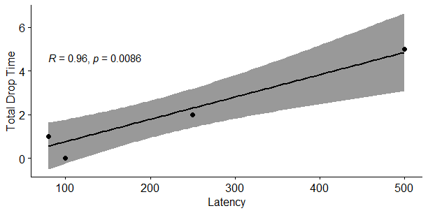

Figure 14: relationship of treatment group 3 to variables

Yet again, there’s a strong positive linear correlation between latency and total drop time.

With R value of 0.967, 95% CI of 0.534 – 0.997 and t value of 6.168

**Treatment Group 4 (Δ latency @ 500KB/s)**

|  |  |
| --- | --- |
| **Experiment Iteration** | **Total Drop Time Occurrence** |
| Transfer Speed Iteration 4 | 0 |
| Latency Iteration 4.1 | 0 |
| Latency Iteration 4.2 | 0 |
| Latency Iteration 4.3 | 0 |
| Latency Iteration 4.4 | 0 |

Based on the data in the table, the researchers would use Pearson correlation test using the statistical model on statistical treatment of this study.

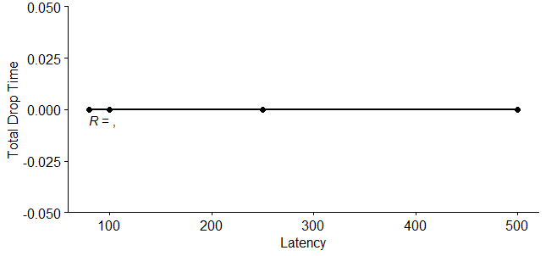

figure 15: relationship of treatment group 4 to variables indicating 0

There’s no linear correlation between latency and total drop time in treatment group 4. As such, the R-value can’t be calculated so does p, t, and 95% CI. This behaviour happens as Google Meet has a lot of bandwidth to work on. Consequently, it resulted in a smoother experience. The researchers theorized that since the internet speed is high enough Google Meet just receives more packets from the Selective Forwarding Unit. Less often to alleviate latency issues. This behaviour is similar to prebuffering where the audio/video stream is not nearly as real-time (1000-5000ms) but lag caused by latency spiked is smoothened out as Google Meet doesn’t need to throw as many out of time packets than on lower bandwidth scenario. This is meant that the minimum Optimal Performance Plateau has been reached.

2.1.2 Total Drop Time relative to Transfer Speed

**Treatment Group 1 ( Δ speed (50KB/s) @ 80ms)**

|  |  |
| --- | --- |
| **Experiment Iteration** | **Total Drop Time Occurrence** |
| Transfer Speed Iteration 1 | 5 |

**Treatment Group 2 ( Δ speed (100KB/s) @ 80ms)**

|  |  |
| --- | --- |
| **Experiment Iteration** | **Total Drop Time Occurrence** |
| Transfer Speed Iteration 2 | 2 |

**Treatment Group 3 ( Δ speed (250KB/s) @80ms)**

|  |  |
| --- | --- |
| **Experiment Iteration** | **Total Drop Time Occurrence** |
| Transfer Speed Iteration 3 | 1 |

**Treatment Group 4 ( Δ s****peed (500KB/s) @80ms)**

|  |  |
| --- | --- |
| **Experiment Iteration** | **Total Drop Time Occurrence** |
| Transfer Speed Iteration 4 | 0 |

It is observed that in the case of the Total drop time rubric, the issues that arise from each of the treatment groups greatly decrease when the transfer speed increase. With a constant latency of only 80ms.The total drop time would drop by half if the transfer speed increase by half. This shows a strong inverse relationship between transfer speed and total drop time respectively.

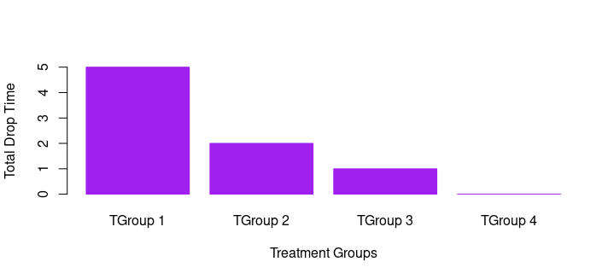

Figure 16: performance increase per treatment group

2.2.1 Audio Cache Miss

Occurs when an audio buffer is lost due to high latency. This is characterized by choppy unintelligible audio. Furthermore, Google Meet uses Opus as an audio codec that is optimized for low bandwidth conditions. Yet, it is still susceptible to latency issues as audio streams are transferred in real-time and any late audio packets must be discarded to avoid user confusion.

**Treatment Group 1 (** **Δ latency @ 50KB/s)**

|  |  |
| --- | --- |
| **Experiment Iteration** | **Audio Cache Miss Ocurrence** |
| Transfer Speed Iteration 1 | 30 |
| Latency Iteration 1.2 | 28 |
| Latency Iteration 1.2 | 35 |
| Latency Iteration 1.3 | 47 |
| Latency Iteration 1.4 | 47 |

Using the dataset above, Rstudio would determine if there’s any correlation between latency and audio cache miss.

Using Pearson’s correlation test, the dataset above have an R-value of 0.85, t value of 2.78, and 95% CI of -0.132 to 0.989 With a positive linear correlation, therefore audio cache miss which is the subgroup of the dependent variable is indeed influenced by changes in the independent variable latency.

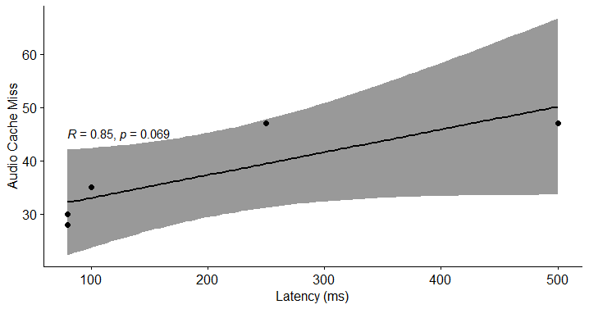

Figure 17 treatment group 1 correlation plot

**Treatment Group 2 ( Δ latency @ 100KB/s)**

|  |  |
| --- | --- |
| **Experiment Iteration** | **Audio Cache Miss Occurrence** |
| Transfer Speed Iteration 2 | 17 |
| Latency Iteration 2.1 | 15 |
| Latency Iteration 2.2 | 17 |
| Latency Iteration 2.3 | 25 |
| Latency Iteration 2.4 | 37 |

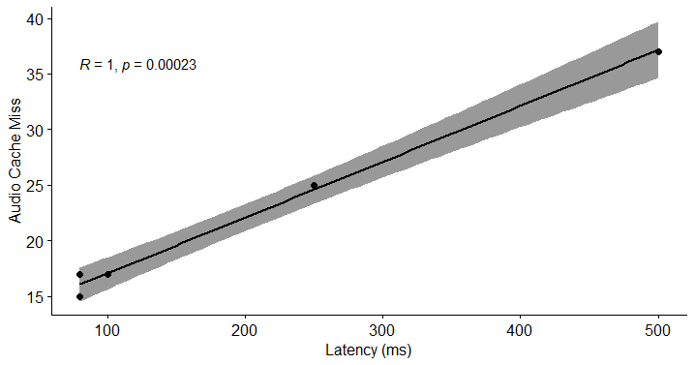The treatment group 2 table shows a clear rise of Audio cache miss occurrence relative to increased latency per treatment. This Undoubdetly gives us a very strong correlation between the dependent and independent variables. By using the r code similar to the Treatment group 1, the result looks like this:

figure 18

Treatment group 2 shows a perfect positive linear correlation with R value of 1,the highest positive value in Pearson correlation test, with t of 21.25 and 95% CI of 0.948 – 0.999

**Treatment Group 3 ( Δ latency @ 250KB/s)**

|  |  |
| --- | --- |
| **Experiment Iteration** | **Audio Cache Miss Occurrence** |
| Transfer Speed Iteration 3 | 10 |
| Latency Iteration 3.1 | 8 |
| Latency Iteration 3.2 | 10 |
| Latency Iteration 3.3 | 14 |
| Latency Iteration 3.4 | 21 |

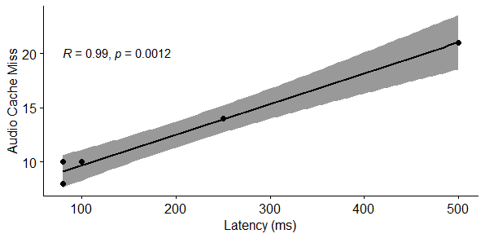

figure 19

Even with an almost similar R-value to treatment group 2, it doesn’t mean that treatment group 3 fare the same as the preceding treatment group. By directly comparing treatment group 2 to treatment group 3’s reported Audio cache miss occurrence, it is clear that there’s a wide gap between the two. It’s noteworthy to remember that correlation tests like Pearson focus only on the direct relationship between two variables. But doesn’t take into account the relative performance gain between the two treatment groups.

**Treatment Group 4**  **(**  **Δ latency @ 500KB/s)**

|  |  |
| --- | --- |
| **Experiment Iteration** | **Audio Cache Miss Occurrence** |
| Transfer Speed Iteration 4 | 5 |
| Latency Iteration 4.1 | 4 |
| Latency Iteration 4.2 | 8 |
| Latency Iteration 4.3 | 5 |
| Latency Iteration 4.4 | 7 |

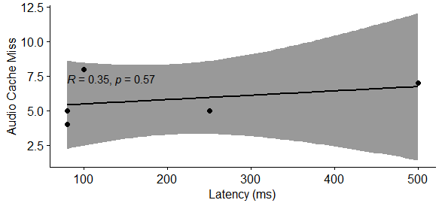

figure 20

With an R-value of 0.36, the researchers are hesitant to conclude that there’s any correlation between latency and audio cache miss. But this is not a surprise as treatment group 4 showed on the past experiment on the total drop time rubric. 500KB/s is the point where the performance plateau starts. This is the point where any increase in speed won’t affect performance as heavily even with increasing latency. As again SFU transfers prebuffered packets to Google Meet.

2.2.2 Audio Cache Miss relative to Transfer Speed

**Treatment Group 1 (** **Δ speed (50KB/s) @80ms)**

|  |  |
| --- | --- |
| **Experiment Iteration Count** | **Audio Cache Miss Occurrence** |
| Transfer Speed Iteration 1 | 30 |

**Treatment Group 2 ( Δ speed (100KB/s) @80ms)**

|  |  |
| --- | --- |
| **Experiment Iteration Count** | **Audio Cache Miss Occurrence** |
| Transfer Speed Iteration 2 | 17 |

**Treatment Group 3 ( Δ speed (250KB/s) @80ms)**

|  |  |
| --- | --- |
| **Experiment Iteration Count** | **Audio Cache Miss Occurrence** |
| Transfer Speed Iteration 3 | 10 |

**Treatment Group 4 ( Δ speed (500KB/s) @80ms)**

|  |  |
| --- | --- |
| **Experiment Iteration Count** | **Audio Cache Miss Occurrence** |
| Transfer Speed Iteration 4 | 5 |

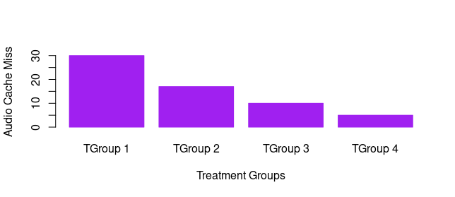

2.3.1 Video Cache Miss

Lag in which the video stops due to the buffer being lost. But not severe enough for the call being dropped. This happened as the Google Meet session buffer is lost cause of a spike in latency in which the SFU failed to transmit packets that are necessary for the session buffer to continue. Video cache miss is inherently similar to audio cache miss as it happens instantaneously and in a short amount of time (> 1000ms). Unlike FPS Drop, a video cache miss is characterized by total loss of video stream, or in some cases, Google Meet displays the last video buffer present. While FPS drop is a continuous stream of video data in reduce framerate, due to low bandwidth alone.

**Treatment Group 1 (**  **Δ latency @ 50KB/s)**

|  |  |
| --- | --- |
| **Experiment Iteration** | **Video Cache Miss Occurrence** |
| Transfer Speed Iteration 1 | 27 |
| Latency Iteration 1.1 | 29 |
| Latency Iteration 1.2 | 30 |
| Latency Iteration 1.3 | 34 |
| Latency Iteration 1.4 | 40 |

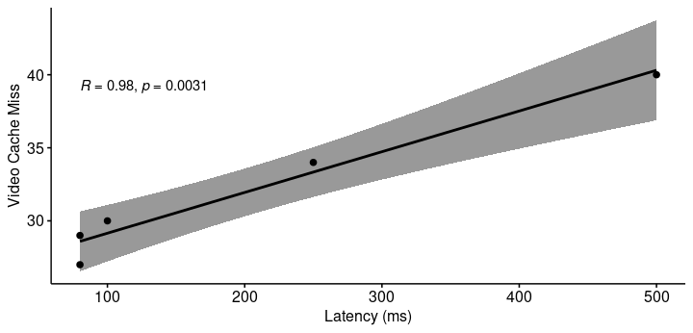

With r value of 0.98, the video cache miss experiment in treatment group 1 shows an increasing positive trend on issues as the latency of progress to worsen. Following with t value of 8.79, p of 0.0031 and 95% CI of 0.753 – 0.998

**Treatment Group 2 (** **Δ latency @ 100KB/s)**

|  |  |
| --- | --- |
| **Experiment Iteration** | **Video Cache Miss Occurrence** |
| Transfer Speed iteration 2 | 25 |
| Latency Iteration 2.1 | 22 |
| Latency Iteration 2.2 | 25 |
| Latency Iteration 2.3 | 32 |
| Latency Iteration 2.4 | 28 |

The statistical software revealed that treatment group 2 on the video cache miss experiment shows a somewhat weak correlation compared to latency. However, this doesn’t mean that Google Meet’s performance becomes better compared to previous experimentation on treatment group 2.

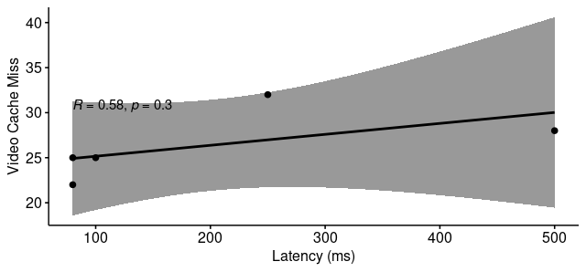

figure 23

Treatment group 2, Pearson correlation test results are as follows; r of 0582, t of 1.241, and 95% CI of -0.616 – 0.967.

**Treatment Group 3 (** **Δ latency @ 250KB/s)**

|  |  |
| --- | --- |
| **Experiment Iteration** | **Video Cache Miss Occurrence** |
| Transfer Speed Iteration 3 | 12 |
| Latency Iteration 3.1 | 12 |
| Latency Iteration 3.2 | 12 |
| Latency Iteration 3.3 | 10 |
| Latency Iteration 3.4 | 20 |

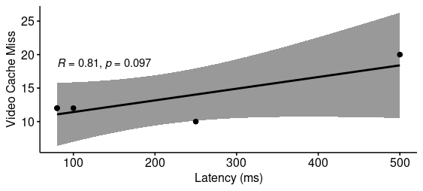

figure 24

According to both the table and scatterplot, there’s a positive linear correlation between treatment group 3 and the latency variable. This follows the general trend of this research which the dependent variable tends to exhibit poor performance on decreasing independent variable characteristics. In addition, Treatment group 3 on video cache miss yield a r-value of 0.809 a strong indication of positive linear correlation, t of 2.39 and 95% CI of -0.253 – 0.986

**Treatment Group 4 (** **Δ latency @ 500KB/s)**

|  |  |
| --- | --- |
| **Experiment Iteration** | **Video Cache Miss Occurrence** |
| Transfer Speed Iteration 4 | 2 |
| Latency Iteration 4.1 | 3 |
| Latency Iteration 4.2 | 7 |
| Latency Iteration 4.3 | 6 |
| Latency Iteration 4.4 | 8 |

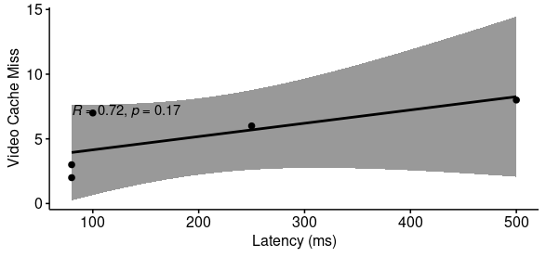

figure 25

Treatment group 4 video cache miss occurred ( (∑ tgrp3 vcm ÷ ∑ tgrp4 vcm) x 100) 39% less compared to treatment group 3. Even with twice the bandwidth, this does not yield 50% less video cache miss issues as latency remains the same in both treatments. As a result of the r-value of treatment group 4 is a bit less at 0.72, t of 1.79, and 96% CCI of -0.447 – 0.979.

2.3.2 Video Cache Miss Relative to Transfer Speed

**Treatment Group 1 (** **Δ speed (50KB/s) @80ms)**

|  |  |
| --- | --- |
| **Experiment Iteration Count** | **Video Cache Miss Occurrence** |
| Transfer Speed Iteration 1 | 27 |

**Treatment Group 2 ( Δ speed (100KB/s) @80ms)**

|  |  |
| --- | --- |
| **Experiment Iteration Count** | **Video Cache Miss Occurrence** |
| Transfer Speed Iteration 2 | 25 |

**Treatment Group 3 ( Δ speed (250KB/s) @80ms)**

|  |  |
| --- | --- |
| **Experiment Iteration Count** | **Video Cache Miss Occurrence** |
| Transfer Speed Iteration 3 | 12 |

**Treatment Group 4 ( Δ speed (500KB/s) @80ms)**

|  |  |
| --- | --- |
| **Experiment Iteration Count** | **Video Cache Miss Occurrence** |
| Transfer Speed Iteration 4 | 2 |

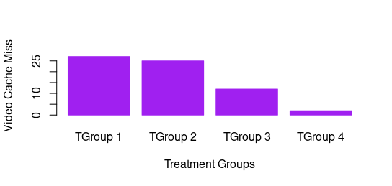

figure 26

Video cache miss occurrence shows a non linear decrease on inverse of the internet speed variable.

2.4.1 FPS Drop

A drop in FPS in Google Meet video feed where the bandwidth needed isn’t met or the video feed quality is deemed to be higher than the current network condition. Instead of dropping all video feed, Google Meet through the use of the VP9 codec would salvage any remaining frames that reach the user device at the correct time. Alternatively, FPS drop is defined as a noticeable drop in video smoothness in which the user’s perception of moving picture is lost. Furthermore, 24fps and above is deemed to be usable and 20fps and below is a significant drop in user experience. Recent studies showed that low FPS in video feeds can cause motion sickness and nausea. (Key factors for reducing motion sickness in 360° virtual reality scene, 2020)

**Treatment Group 1 (** **Δ latency @ 50KB/s)**

|  |  |
| --- | --- |
| **Experiment Iteration** | **FPS Drop Occurrence** |
| Transfer Speed Iteration 1 | 44 |
| Latency Iteration 1.1 | 42 |
| Latency Iteration 1.2 | 50 |
| Latency Iteration 1.3 | 52 |
| Latency Iteration 1.4 | 50 |

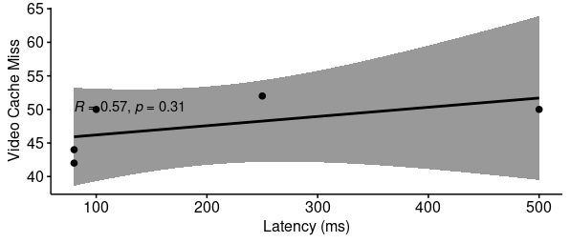

Treatment group 1 with a maximum internet transfer speed of 50KB/s and latency step between 80ms to 500ms. With five present experiment iteration on this treatment group, the researchers find a low positive linear correlation as per the r value of 0.57 in the correlation test. This result however doesn’t mean that the user experience is any better compared to a better internet condition. Here, the experiment t value is 1.213, and 95% CI of -0.6244 – 0.966.

**Treatment Group 2 (** **Δ latency @100KB/s)**

|  |  |
| --- | --- |
| **Experiment Iteration** | **FPS Drop Occurrence** |
| Transfer Speed Iteration 2 | 27 |
| Latency Iteration 2.1 | 28 |
| Latency Iteration 2.2 | 26 |
| Latency Iteration 2.3 | 28 |
| Latency Iteration 2.4 | 31 |

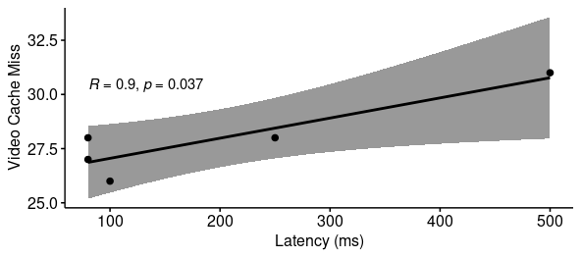

figure 28

As the scatterplot illustrates, treatment group 2 shows a very positive linear correlation between the first independent variable namely latency, and one of the subparts of the dependent variable which is FPS drop this proves that in an increase of latency, the occurrence of FPS drop also increased. Especially on speed below the performance plateau. Here is the statistical value of treatment group 2 experiment: r-value of 0.899, t of 3.574, and 95% CI of 0.085 – 0.993

**Treatment Group 3 (** **Δ latency @ 250KB/s)**

|  |  |
| --- | --- |
| **Experiment Iteration** | **FPS Drop Occurrence** |
| Transfer Speed Iteration 3 | 15 |
| Latency Iteration 3.1 | 13 |
| Latency Iteration 3.2 | 12 |
| Latency Iteration 3.3 | 10 |
| Latency Iteration 3.4 | 20 |

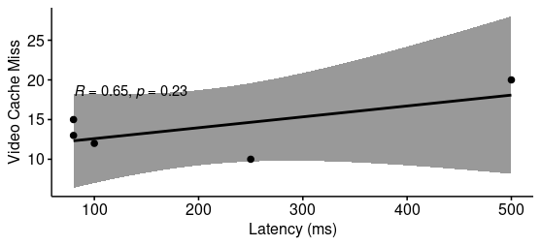

figure 29

As Google Meet is nearing to reach its performance plateau at 500KB/s treatment group 3 still shows a positive linear correlation on latency but the reported FPS drop occurrence is almost half compared to previous treatment group 2. This means most users can expect a substantial increase in perceived quality on their Google Meet calls. Here are the numerical values that the statistical software gives: r of 0.652, t value of 1.490, and 95% CI of 0.541 – 0.974

**Treatment Group 4 ( Δ latency @ 500KB/s)**

|  |  |
| --- | --- |
| **Experiment Iteration Count** | **FPS Drop Occurrence** |
| Transfer Speed Iteration 4 | 2 |
| Latency Iteration 4.1 | 2 |
| Latency Iteration 4.2 | 0 |
| Latency Iteration 4.3 | 0 |
| Latency Iteration 4.4 | 5 |

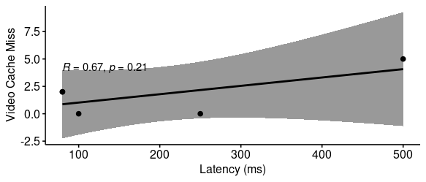

figure 30

Treatment group 4 yield a 12.86% decrease of FPS drop compared to treatment group 3. Exclusively, this meant a 50% increase in internet speed given with constant growth of latency would not lead to 50% increase in performance. Here’s the statistical value; r of 0.674, t of 1.583, and 95% CI of -0.512 – 0.975

2.4.2 FPS drop relative to Transfer Speed

**Treatment Group 1 ( Δ speed (50KB/s) @80ms)**

|  |  |
| --- | --- |
| **Experiment Iteration Count** | **FPS Drop Occurrence** |
| Transfer Speed Iteration 1 | 44 |

**Treatment Group 2 ( Δ speed (100KB/s) @80ms)**

|  |  |
| --- | --- |
| **Experiment Iteration Count** | **FPS Drop Occurrence** |
| Transfer Speed Iteration 2 | 31 |

**Treatment Group 3 ( Δ speed (250KB/s) @80ms)**

|  |  |
| --- | --- |
| **Experiment Iteration Count** | **FPS Drop Occurrence** |
| Transfer Speed Iteration 3 | 15 |

**Treatment Group 4 ( Δ speed (500KB/s) @80ms)**

|  |  |
| --- | --- |
| **Experiment Iteration Count** | **FPS Drop Occurrence** |
| Transfer Speed Iteration 4 | 2 |

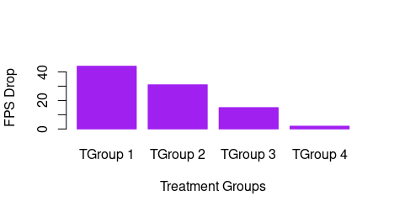

figure 31

2.5 Total data usage

The total data usage is calculated by combining both the upload and download transfer speed into a single value which represents the total data usage. This would give the researchers the necessary data they need in order to draw a conclusive result to answer the study’s statement of the problem. Furthermore, the analysis of total data usage versus both latency and transfer speed would allow the researchers to find out if there’s a significant relationship between data usage and both of the independent variables. To get the total upload and download usage, the researchers Get the total summation of upload and download data frame to the dataset. Using Rstudio, this can be expressed using the code:

sum(control.speed$upload) #upload calculation

sum(control.speed$download) #download calculation

Using the “sum” function, (where sum = n1+n2+n3…) and pointing it to the dataset of concern using pointers, Rstudio derived the total value of both upload and download speed. Since nethog’s logging is based on Kilobytes, in order to make the total value into the unit of choice. Simply divide or multiply by 1000 in order to get the value into that unit.

**Control Group**

|  |  |  |  |
| --- | --- | --- | --- |
| **Latency (ms)** | **Upload (Kilobytes)** | **Download (Kilobytes)** | **Recorded Error** |
| 60.84 | 5908.021 | 25609.61 | 17 |

To convert this into megabytes, just divide the base value to 1000. Additionally, the Control group only recorded audio cache miss (16) and FPS drop(1) as a subpart of the dependent variable.

**Treatment Group 1 (** **Δ latency @50KB/s)**

|  |  |  |  |
| --- | --- | --- | --- |
| **Experiment Iteration** | **Latency (ms)** | **Upload (KB)** | **Download (KB)** |
| Latency Iteration 1.1 | 80 | 149573 | 148232 |
| Latency Iteration 1.2 | 100 | 138703 | 138538 |
| Latency Iteration 1.3 | 250 | 135166 | 134471 |
| Latency Iteration 1.4 | 500 | 135200 | 134454 |

**Treatment Group 2 (** **Δ latency @100KB/s)**

|  |  |  |  |
| --- | --- | --- | --- |
| **Experiment**  **Iteration** | **Latency (ms)** | **Upload (KB)** | **Download (KB)** |
| Latency Iteration 2.1 | 80 | 266836 | 266848 |
| Latency Iteration 2.2 | 100 | 267668 | 265147 |
| Latency Iteration 2.3 | 250 | 262786 | 266594 |
| Latency Iteration 2.4 | 500 | 275537 | 278248 |

**Treatment Group 3 (** Δ **latency @250KB/s)**

|  |  |  |  |
| --- | --- | --- | --- |
| **Experiment Iteration** | **Latency (ms)** | **Upload (KB)** | **Download (KB)** |
| Latency Iteration 3.1 | 80 | 673565 | 671659 |
| Latency Iteration 3.2 | 100 | 673749 | 672314 |
| Latency Iteration 3.3 | 250 | 675837 | 681308 |
| Latency Iteration 3.4 | 500 | 672520 | 670414 |

**Treatment Group 4 ( Δ latency @500KB/s)**

|  |  |  |  |
| --- | --- | --- | --- |
| **Experiment Iteration** | **Latency (ms)** | **Upload (KB)** | **Download (KB)** |
| Latency Iteration 4.1 | 80 | 1360402 | 1368177 |
| Latency Iteration 4.2 | 100 | 1399488 | 1386555 |
| Latency Iteration 4.3 | 250 | 1377425 | 1382661 |
| Latency Iteration 4.4 | 500 | 1617901 | 1617861 |

2.5.2 Total Data usage relative to Internet Speed

**Treatment Group 1 ( Δ speed (50KB/s) @80ms)**

|  |  |
| --- | --- |
| **Upload (Kilobytes)** | **Download (Kilobytes)** |
| 138353 | 214737 |

**Treatment Group 2 ( Δ speed (100KB/s) @80ms)**

|  |  |
| --- | --- |
| **Upload (Kilobytes)** | **Download (Kilobytes)** |
| 275982 | 274166 |

**Treatment Group 3 ( Δ speed (250KB/s) @80ms)**

|  |  |
| --- | --- |
| **Upload (Kilobytes)** | **Download (Kilobytes)** |
| 660684 | 675771 |

**Treatment Group 4 (** **Δ speed (500KB/s) @80ms)**

|  |  |
| --- | --- |
| **Upload (Kilobytes)** | **Download (Kilobytes)** |
| 1414405 | 1418945 |

**Part III.**

**3:** Significant comparison between the control group and the preceding test.

By comparing the performance rubric of the single control group to the mean of 20 experimental iterations in each of the four treatment groups. There’s a 14.7% difference between the unmodified free roam control group compared to Google Meet sessions with controlled Latency and Internet speed. This is done using this rscript

Moreover, by comparing the control group's total data usage (upload + download = total data usage) to the mean of transfer speed treatment group 1 to 4. It is uncovered that the difference between the two experimental groups is 3923%, what this means is the control group uses way less bandwidth compared to the mean of the experimented group. The mean of the four treatment groups combined is 1268261 Kilobytes in total while the control group utilizes only 31517 Kilobytes in its run. But, since the control group is only conducted once throughout this research, the researchers believe that there is more variance if there are just numerous control groups in the experiment as stated by the law of big numbers. (Investopedia, 2020) Though the confidence of having a fluke control group is unlikely as Google Meet behaves predictably most of the time. Thus, yielding more reproducibility correctness.

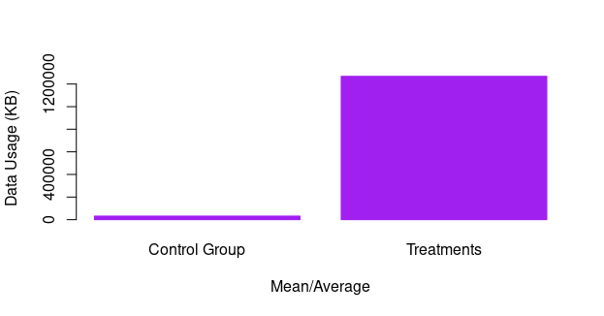

Figure 35 comparative average between control and treatment group

3.1 Does the difference between control group and the preceding test statistically significant?

Since anything above 5% is deemed to be statistically significant, the 14.7% difference between the two experimental groups is indeed significant. This is calculated using the rscript on the preceding page. The difference between the dependent variable of the control group and the treatment groups is large enough to be statistically relevant. Furthermore, there’s a 69.9% difference between the control group’s average latency and all of the treatment group’s average latency. (60.8ms vs 202ms) Even with the treatment group’s large difference compared to the control group, this is in fact in line as the former contains latency way above the control group logged during the experiment. That means, that the treatment group’s overall average is skewed greatly to the right as the experiment allocated latency between 250ms and 500ms.

Additionally, by comparing the four treatment groups into latency while keeping transfer speed included. It is uncovered that overall R value of the treatment groups is 0.9683, suggesting a strong positive linear correlation, p value of 0.0024 which is below that 0.5 threshold, with standard error of 0.265 and t value of 9.57.

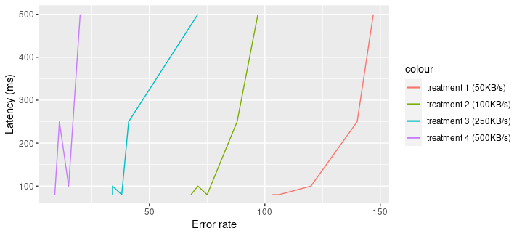

figure 36 line graph showing study’s general trend

The line graph above describes the total response of the treatment groups to increasing latency with internet speed supplied as colour with treatment group representation. T

3.2 Does Google Meet’s performance drop below acceptable efficacy?

|  |  |
| --- | --- |
| **Treatment Groups** | **Average Issues** |
| Treatment Group 1 | 123.2 |
| Treatment Group 2 | 79.8 |
| Treatment Group 3 | 43.6 |
| Treatment Group 4 | 12.8 |

Referring to the table above, it is apparent that treatment groups 1 and 2 exhibits a more than the acceptable number of issues. Especially on total drop time (refer to the research specimen) where treatment group 1 has an average of 6.2. This means that on average, a Google Meet session on a speed of 50KB/s @ 80-500ms latency is likely to completely disconnected to the session 6.2 times in a span of 1.5 hours. This is not acceptable as every connection attempt took around a minute to initiate. Additionally, treatment group 2 with the speed of 100KB/s @80-500ms has an average total drop time of 3.2. This is where user tolerance comes into the perceptive performance of Google Meet. As every person has a different perception of “just fine” usage. To put that into perspective, a Google Meet session with connection specification similar to treatment group 2 have. Can only expect total disconnection every half an hour. Which depending on latency might be less or more. As highlighted in the previous chapters, latency have a profound role in fetching the audio and video feed of a Google Meet session.

3.3 Did the independent variables influence Google Meet’s performance equally?

As discussed in the theoretical framework of this study, the researchers discovered that there’s a point in which Google Meet’s performance stabilizes even with an increase in latency and vice versa. This is strongly true in speeds above 500KB/s as the SFU can provide the Google Meet session with a slightly delayed packet in response to increased latency. But, on speeds below 250KB/s, the latency variable influences Google Meet’s performance more than the internet speed. As the built-in VP9 codec in Google Meet can variably adjust in less than ideal internet speed but still susceptible to latency spikes, thus a noticeable delay in packet delivery.

**4:**  Δ in latency affects Google Meet performance.

As presented in Part 2 of this chapter, the change in latency correlates to a change in Google Meet performance negatively. A negative metric is defined as the positive increase of errors on the Google Meet session which equates to a significantly numerous noticeable dip in performance. In addition to this, the relationship of latency to Google Meet performance manifests as a positive linear correlation according to the Pearson correlation test. As highlighted in part 3.3, latency greatly affects Google Meet performance in speeds below the Performance Plateau while above this said metric, it is observed that any increase in latency won’t affect the performance as heavily compared to instances with slower internet speed. In addition to this, the linear increase in latency would have some unnoticeable impact on Google Meet usage. This includes but is not limited to; chat delays, polls, breakout room joining and leaving, microphone and camera initialization, and especially the Raising hand feature of Google Meet. The feature issues in Google Meet caused by latency are had to detect until time-sensitive activities ensue. This includes, first come first serve recitation both aural and text-based. From the user’s point of view, the audio and video stream being displayed by Google Meet are live, but depending on the internal system’s latency this is not always the case. As Google Meet can adapt to different internet conditions there’s a certain case where timing is more necessary than video and audio quality.

**5:** Δ in speed affects Google Meet’s performance.

The change in speed affects Google Meet performance in a non-linear way. As the experiment pointed out, Google Meet is resilient to changing internet conditions. It is observed that Google Meet consumes more bandwidth when the internet speed is faster. But there’s a point where any increase in Internet speed won’t make the experience much better as highlighted in the theoretical framework. The total performance of Google Meet is just partly dependent on the individual user’s latency and internet speed but also on the collective performance of the said conference. Since Google Meet uses VP9 as a codec, it offers a lossless compression without sacrificing bandwidth and quality. (Jane Ozer, 2015) Which equates to bandwidth savings, but as the internet speed increases. Google Meet would switch to the uncompressed version of the video stream which offers the best quality in regards to bandwidth. In short, there’s a possibility of data saving by purposely slowing down the internet so that Google Meet would use VP9 compression which offers almost similar visual fidelity to uncompressed stream but with huge bandwidth savings.

**6:** The negative impact of slow internet speed and high latency experimentation in Google Meet. (stocked setting)

A significant increase in performance-based issues. This includes total drop time, audio cache miss, video cache miss, and FPS drop. Which more or less rise linearly in relation to dropping internet speed and increase in latency. As presented in the past chapter. In addition to this, the negative impact of this scenario includes but is not limited to:

* Lower productivity output – both academically and in industrial application. A subpar internet connection often results in lower productivity output and confusion. Often users lose more time waiting for a webpage to load than to do work which translates to lost of income. (How much money Filipino loose Due to slow internet connection, 2014)
* User frustration – some Google Meet users just stop trying and grew frustrated due to a slow internet connection. As highlighted by previous studies on the topic.

**7:** The positive impact of slow internet speed and high latency with tweaked settings in Google Meet.

Referring to part 2.5 total data usage, it is observed that with low internet bandwidth (upload+download) the total data usage is lower compared to a faster one. Which is an axiom at this point. Less bandwidth always equates to lower data usage. This information allows the researchers to derive a point in which latency, internet speed, and data usage all fall into an equilibrium. By examining over 250,000 data points in the span of this study the researchers landed on the equilibrium value that is based on the pre-determined values. Which falls between 100 KB/s to 250KB/s with latency no more than 80ms at this point, the user would have a pleasant Google Meet experience while saving internet bandwidth. This equilibrium point is below the performance plateau but with almost the same performance. It is worth noting that the equilibrium value is dynamic and would change depending on the condition of the independent variables. Apart from this, the equilibrium value of Google Meet with tweaked settings (360p, single video at a time) is lower than the stocked settings. This gives the user some sort of compromise on quality while still maintaining usability on top of data savings.

**8:** Does purposely slowing down internet speed would save data whilst maintaining a usable Google Meet experience.

Yes, as stated on SOP 7, by knowing the equilibrium value of the system the user would have a lower internet data usage while still maintaining a usable performance. This also comes with a number of advantages such as; less strain in the overall network system, which would decongest the network system by a margin. (depending on the number of users), less CPU, GPU, and RAM strain that has a direct impact on the overall power consumption of the computer being used, and lastly by synthetically slowing down the internet speed, it allows more people to have access to Google Meet without spending as much. By synthetically slowing the internet down, there’s a piece of pressing evidence that doing so would not only save the user on internet cost but also even on electrical consumption as well. It should be noted that there are a lot of variables on this efficiency metric that the researchers didn’t cover in this study. This includes the computer’s overall power efficiency, its power supply efficiency, and so on. This all contributes to the overall power negations that are unique to every device. As each component aren’t exactly manufactured equally. These variables are so minute that they either add or negate each other out depending on the system. x86 CPU tends to be less efficient than ARM CPU that can influence performance per watt. Even with the same running software.

**CHAPTER 5**

**SUMMARY OF FINDINGS, CONCLUSIONS AND RECOMMENDATIONS**

**Introduction**

This chapter presents the summary of finding, conclusions and recommendations of the study. This includes the statement of the problem, and recommendations by the researchers to the steak holders.

**Summary of Findings**

1. Specification profile of the experiment

1.1 Hardware specifications – This includes the laptop, modem and a router that is used in conducting the experiment.

1.2 Software profile – The software that is used in the experiment includes Firefox, Nethogs, Featherpad, tc, and Rstudio. Which is free and open source application.

2. Qualitative rubric for testing Google Meet – There are 5 parameters that makes up the performance rubric on measuring Google Meet. This includes total drop time, audio cache miss, video cache miss, fps drop, and total data usage. Each parameter is observe while the independent variables are manipulated in the experiment. Overall, there’s a clear trend where this 5 parameters increase when the latency and internet speed

degrades.

3. Significant change between the control group and the treatment group – There’s a huge difference between the control group and the overall average of treatment group. With 14.7% difference on latency while there’s 69.9% difference on overall data usage between the control group and the latter. Additionally, this difference are deemed statistically significant by the researchers as the values are far apart to each other. Furthermore, this changes cause a drop in performance on speed not exceeding 50KB/s @80ms+. While both independent variable influences Google Meet performance depending on the total latency and speed of the system. This mean is the latency and speed can influence the performance of Google Meet on a non linear way. As stated on theoretical framework, there’s a certain speed threshold where increased in latency won’t affect Google Meet’s performance in significant way. Conversely, at lower speeds internet speed don’t have a very profound effect on Google Meet’s performance more than latency.

4. Does the Δ in latency affects Google Meet performance – Yes, but the impact in performance is proportional to internet speed to an extent. The slower the internet speed the higher the effect of latency on Google Meet performance. (r = 0.9683, p = 0.0024)

5. Does the Δ in speed affects Google Meet performance – Yes, but the impact in performance is proportional to latency to an extent. The higher the latency the higher the effect of internet speed on Google Meet performance.(r = 0.9683, p = 0.0024)

6. The negative impact of slow internet speed and high latency on Google Meet? (stocked settings) – The negative impact of this are decrease productivity output which causes the user a substantial amount of potential income due to slow internet connection. Which can be used for conference instead that is more likely to cause user frustration in a long run.

7. Positive impact of slow internet speed and high latency with tweaked settings on Google Meet – A slow internet connection can offer a appreciable data savings, if the latency doesn’t exceed 80ms. The researchers recommend to run on this “lean” speed.

8. Does purposely slowing down internet speed would save data whilst maintaining a usable Google Meet experience? - The possibility of saving data while still have a usable Google Meet performance is measurable. But this value is not arbitrary, thus data and power savings are case to case basis. Though running lean can offer a significant monetary savings.

**Conclusion**

Based on the statistical evidence analyzed in this research, to find Google Meet’s performance across a variety of internet conditions. Researchers conclude that Google Meet is resilient on a wide range of internet conditions. From slow upload and download speeds to latency fluctuations. But even with this inherent capability, Google Meet is still a time-sensitive software and its performance still relies on jitter-free connection. Additionally, Google Meet has the capability to resist high latency by utilizing an internet connection. As highlighted in the previous chapters, Google Meet can choose to optimize both of the independent variables in whichever have a better performance. So a Google Meet session with a slow internet connection but with low latency would still have a usable experience given these speeds aren’t below 50KB/s as conducted in this study. Furthermore, there’s pressing evidence that by synthetically manipulating the user’s internet speed and latency, the possibility of bandwidth and electrical cost savings can be realized. But this is not a universal consensus and this possibility should be analyzed on case to case basis on a system to system configuration. As there are a lot of computing components available which can influence the overall system efficiency and performance.

In summary, Google Meet’s performance can be influenced by the independent variable in a nonlinear way. Though, there’s still a general trend on Google Meet’s performance correlation when plotted against latency and internet speed. Which Google Meet performance is inversely proportional to a rise in latency while directly proportional to an increase in internet speed. This is based on over 327,753 data points recorded in the experiment of this study. Therefore, by following the theory of large numbers (Investopedia, 2020) this research is conclusive. Albeit, not in a linear way.

**Recommendations**

Faculty Members:

1. The researchers recommend to limit time sensitive participation during a live video conference in Google Meet. As this research found out, Google Meet can create a false sense of being in the live stream even if it is delayed by a second and above. Which can possibly cause an uncompetitive and unfair judgment of who is actually respond first. That can lead to other issues down the line.

Students:

2. The researchers hope that students should participate in the class proactively and be understanding of both of their peers and proctors during performance drop in Google Meet.

3. Students can implement a technical forecasting approach on time-sensitive activities such as recitation by actively monitoring their internal latency and responding ahead of their video stream to offset latency-induced penalties on their conference.

Parents:

4. Parents should enlighten their child on connectivity issues like this and be mindful of technical problems both minor and major that is force majeure in all parties. While actively communicating to their Internet Service Provider to sough of any issues during the conference.

School Administration:

5. The results of this research can provide valuable insight on how online learning actually happens and formulate time-sensitive actions and policies that can ease up issues on remote learning experience on both students and the faculty members.

Developers:

6. Google developers should implement systems in place in their development process in order to have a usable quality experience on low bandwidth connections. This includes synthetic speed throttling tests on testing, network simulations, and VM limited hardware limitation testing to ensure a wide range of access.

7. Implement new technologies on the platform such as neural-based video compression that would open up Google Meet capabilities to a wider range of users. This offers a superior video compression compared to a traditional algorithm-based techniques while

being resistant to latency spikes. (Nvidia, 2020)

**LIST OF REFERENCES**

**Studies**

• A Congestion Avoidance Mechanism for WebRTC Interactive Video Sessions in LTE Networks, 2018

<https://www.researchgate.net/publication271948148_A_Congestion_Avoidance_Mechanism_for_WebRTC_Interactive_Video_Sessions_in_LTE_Networks>

• A Scoping Review of Videoconferencing Systems in Higher Education: Learning Paradigms, Opportunities, and Challenges, 2019 <https://www.researchgate.net/publication/334780632_A_Scoping_Review_of_Videoconferencing_Systems_in_Higher_Education_Learning_Paradigms_Opportunities_and_Challenges>

• Emergency Remote Teaching Experiences brought by COVID-19, 2021

<https://link.springer.com/article/10.1007/s10639-021-10520-4>

• Performance Evaluation of WebRTC-based Video Conferencing, 2018

<https://dl.acm.org/doi/10.1145/3199524.3199534>

• QoS analysis for WebRTC video conference on bandwidth-limited network, 2017

<https://ieeexplore.ieee.org/document/8301873>

• Readiness for Flexible Learning amidst COVID-19 Pandemic of Saint Michael College of Caraga, Philippines, 2020

<https://ejournals.ph/article.php?id=15551>

• Software Obsolescence, Peter Sandbord IEEE, 2007

<https://www.researchgate.net/publication/426202_Editorial_Software_Obsolescence-Complicating_the_Part_and_Technology_Obsolescence_Management_Problem>

• Suspending Simulcast Streams for Savvy Streamlining, 2018

<https://webrtchacks.com/suspending-simulcast-streams/>

• The Factors Affecting Intention to Use Google Meet Amid Online Meeting Platforms Competition in Indonesia, 2020

<https://www.researchgate.net/publication/343225921_The_Factors_Affecting_Intention_to_Use_Google_Meet_Amid_Online_Meeting_Platforms_Competition_in_Indonesia>

• The Impact of Video Conferencing Platform in all Educational Sectors Amidst Covid-19 Pandemic, 2020

<https://www.researchgate.net/publication/342672267_The_Impact_of_Video_Conferencing_Platform_in_all_educational_sectors_amidst_COVID-19_Pandemic>

**Literatures**

• 13th General Conference on Weights and Measures, 1968

<https://www.nature.com/articles/220651a0>

• AI video compression, Nvidia developer, 2020

<https://blogs.nvidia.com/blog/2020/10/05/gan-video-conferencing-maxine/>

• Coronavirus Second Wave, 2021

<https://www.hopkinsmedicine.org/health/conditions-and-diseases/coronavirus/first-and-second-waves-of-coronavirus>

• Google Meet Data Saver Mode: Is there any way to save mobile data?, 2021

<https://swordstoday.ie/google-meat-data-saver-mode-is-there-any-way-to-save-mobile-data-oh-i-do-not-know-how-to-turn-on-data-saver-mode-via-google-meet-step-by-step-guide/>

• Google Meet gets a refreshed UI, multi pinning, autozoom, and more, 2021

<https://techcrunch.com/2021/04/21/google-meet-gets-a-refreshed-ui-multi-pinning-autozoom-and-more/>?

• Google makes Meet, its Zoom and Skype competitor, free for everyone, 2020,

<https://www.cnn.ph/business/2020/4/30/Google-Meet-premium-video-conferencing-tool-free-download.html>

• Google Meet premium video conferencing free for everyone, everywhere, 2020

<https://manilastandard.net/tech/tech-news/322704/google-meet-premium-video-conferencing-free-for-everyone-everywhere.html>

• Google Meet Review, 2021

<https://www.pcmag.com/reviews/google-meet>

• How to Turn Your Raspberry Pi into a Video Conferencing Station, 2020

<https://www.maketecheasier.com/turn-raspberry-pi-video-conferencing-station/>

• Singapore teachers drop Zoom after online class gatecrashed, 2020

<https://ph.news.yahoo.com/singapore-teachers-drop-zoom-online-class-gatecrashed-081050263.html>?

**Electronic**

• 20 Astonishing Video Conferencing Statistics for 2021, 2021

<https://digitalintheround.com/video-conferencing-statistics/>

• Academic freeze – the best option, 2021

<https://www.manilatimes.net/2021/03/11/campus-press/academic-freeze-the-best-option/849679>

• AI Can See Clearly Now: GANs Take the Jitters Out of Video Calls, 2020

<https://blogs.nvidia.com/blog/2020/10/05/gan-video-conferencing-maxine>

• AI Can See Clearly Now: GANs Take the Jitters Out of Video Calls, 2020

<https://blogs.nvidia.com/blog/2020/10/05/gan-video-conferencing-maxine/>

• Better hardware for better devs, 2015

<https://medium.com/google-developers/better-hardware-for-better-devs-aadb68b8a3b2>

• Building a more accurate time service at Facebook scale, 2020

<https://engineering.fb.com/2020/03/18/production-engineering/ntp-service>

• Globe Removes Consumer 3G SIMs Across Distribution Chains, 2020

<https://www.globe.com.ph/about-us/newsroom/corporate/3g-sims-removal-distribution-chains.html>

• Google Meet hardware requirements, 2021

<https://support.google.com/meet/answer/7317473?hl=en>

• Law of large numbers, 2020

<https://www.investopedia.com/terms/l/lawoflargenumbers.asp>

• Number of subscribers of Globe Telecom in the Philippines in 2020, by segment , 2020

<https://www.statista.com/statistics/1261399/philippines-subscribers-globe-telecom-by-segment/>

• Law of large numbers, 2020

<https://www.investopedia.com/terms/l/lawoflargenumbers.asp>

• Schools with Online Courses in the Philippines, 2018

<https://www.edukasyon.ph/blog/schools-offering-online-courses-in-the-philippines>

**Research Dataset and Repository**

https://github.com/elsaversailles/Practical-Research-2

**SPECIMEN**



