**Term 2Assignment: #1 Computational Thinking in Scratch**

|  |  |  |  |
| --- | --- | --- | --- |
| **Teacher Name** | **Mr Elsayed** | **Department** | **ICT** |
| **Deadline Date** | **24-09-2023** | **Grade** | **7** |

|  |  |
| --- | --- |
| **Student Name :** |  |

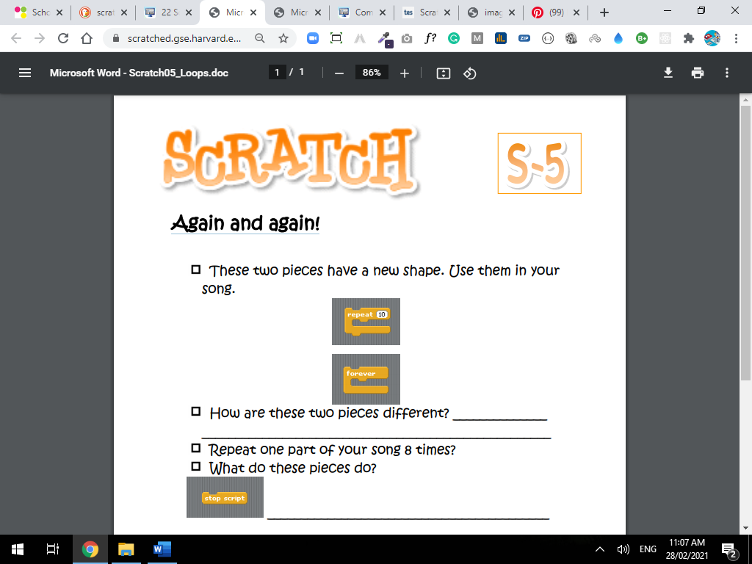

**By using Online Scratch app use the block to make the same in the picture below:**

**Take a screenshot for the blocks and past it in the file and upload it again to the system**

