1.What i will learn?
you will learn how to get weather forecast from openweathermap.org and get appikey from openweathermap.org
in this tutorial you will familiar with kivy's network module and make request from http protocol. Also you will learn use of python json module and learn how to import kivy complementation setting jar file.

2.Requirements
Python 2.7 :https://www.python.org/downloads/
Kivy https://kivy.org/#download
Pycharm https://www.jetbrains.com/pycharm/download/#section=windows
For complementation jar file
https://github.com/Zen-CODE/kivybits/blob/master/IDE/PyCharm_kv_completion.jar?raw=true

(optional)
Python experiment and Object Oriented Programming skills

- Description
Hi friends in this tutorial you will register openweathermap.com for obtain apikey then you will familier with request thoughout openweathermap and get response from site.
Before implementation you will download kivy complementation jar file and import to settings for pycharm editor. For do this task follow file>import settings and find your downloaded jar file.

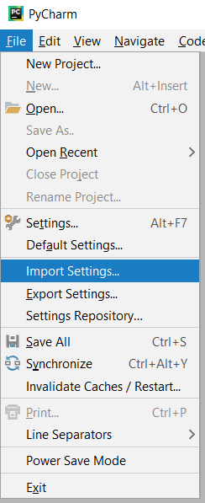

After import settings then you will request to “http://api.openweathermap.org/data/2.5/forecast?q=London,us" url and print your response with this implementation, which is given below.
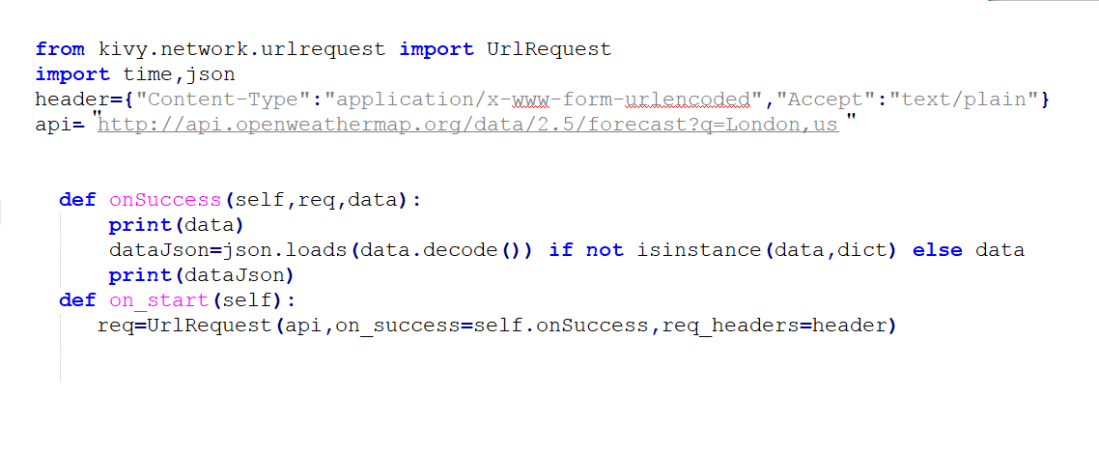

You will learn kivy application on_start function and give ids to your widgets. And learn how to parse json response simplify with online tools. (given below)
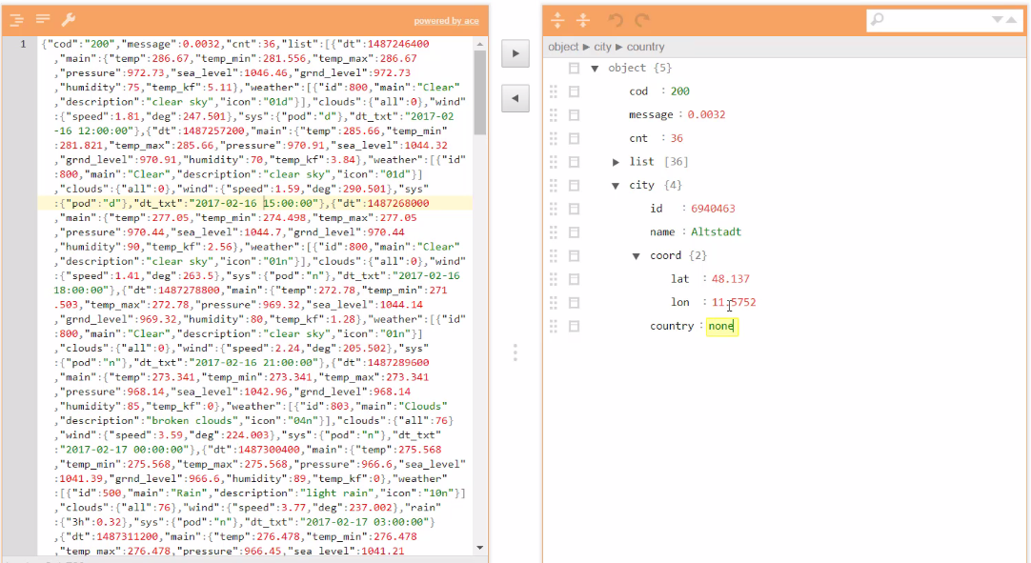

Level:
intermediate

title: Create A Weather App - 3

