Brain Decoding using EEG-controlled

Rapid Serial Visual Presentation

Thomas Maillart[[1]](#footnote-1), Nick Merrill[[2]](#footnote-2), John Chuang[[3]](#footnote-3)

School of Information, UC Berkeley, Berkeley, CA, USA

1. Introduction

Reading out, or decoding, mental content from brain activity is a challenging problem in neuroscience. Recent functional magnetic resonance imaging (fMRI) studies have suggested the possibility to reconstruct visual experience from brain measurements [1-3]. This research typically involves in depth studies of the brain circuitry with cutting-edge equipment, which comes at the expense of scalable and reproducible identification of human activity in naturalistic environments. Instead, we focus on decoding human activity from low quality signal delivered by consumer-grade EEG headsets in a rapid serial visual presentation (RSVP) setting. The development of such lightweight and affordable technique is critical for consumer ready applications, such as special brain-computer interfaces to handle large ows of information.

2. Method

Twenty-one healthy subjects aged 18 to 55 participated in this study. Each participant read 4 texts, randomly selected out of 6 newspaper articles (389 to 990 words per text). The texts were displayed through rapid serial visual presentation (RSVP) [4, 5], while measuring brain activity with the cheapest consumer-grade EEG headset available on the market (Neurosky Mindwave, approx. $100). Neurosky device collects EEG signal on the left forehead (Fp1 position in the 10-20 system) with a dry electrode. For each new word displayed on the screen, the Shannon entropy of the power spectrum of the signal [6] was computed out of the last 512 voltage measures (i.e., one second of EEG data at a 512 Hz sampling rate). The Shannon entropy is used here as a powerful method to compress the information contained in the power spectrum (i.e., a vector with 512 values) into a scalar value [7].

Three randomized treatments were applied: (i) constant RSVP rate (125 milliseconds per word, applied to 2 over 4 texts), (ii) RSVP rate increases with higher entropy and conversely, (iii) RSVP rate decreases with higher entropy (see Fig. 1 for experiment setting). For treatments (ii) and (iii), if the participant cannot control RSVP with her brain activity, the rate drifts away, very slow or very fast.

Here, we consider the EEG signal when the participant is subjected to a coherent source of sequential stimuli (i.e., words of a text presented one at the time in a sequential order). The brain decoding procedure aims at identifying the text from the sequence of entropy measures computed from the participant's EEG signal.

3. Results

For 17 over 21 participants, the RSVP rate was characterized by a balanced joint probability of (rate change x word size frequency) in treatments (ii) and (iii) (Fig. 2a). Long words triggered the largest change of entropy (resp. rate), while words smaller than the average size (approx. 5.5 characters) were associated with reverse entropy (resp. rate) change (Figs. 2b, 2c).

Despite the large variation of entropy, texts could be decoded by matching the sequence of entropy measures (associated with each word) with the unique sequence of word lengths (Fig. 3). Our results did not require preliminary identification of participants, and the success rate was 27.4%, roughly 11% above chance (i.e., 1**/**6 approx. 16.67%), when considering the first 300 words of each text.

4. Conclusion

Our results show that brain decoding is feasible with a simple EEG headset, in a near naturalistic environment where stimuli are presented to the eyes at fast pace. Neither calibration nor prior participant identification was required. It is sufficient to recognize that a text is made of a unique sequence of word lengths. Small and large words, which are less frequent in texts of size < 1000 words, account for largest absolute values of entropy (resp. rate variation).

Extending to other stimuli (e.g. audio, non text visual stimuli), this brain-decoding interface may help future development of lightweight interfaces, between the brain and the sensory input from the environment, and made available at large scale. This may in turn help further understand brain functioning in naturalistic environments.

References

1. Kay KN, Naselaris T, Prenger RJ, Gallant JL (2008) Identifying natural images from human brain activity. Nature 452: 352-355.

2. Naselaris T, Prenger RJ, Kay KN, Oliver M, Gallant JL (2009) Bayesian reconstruction of natural images from human brain activity. Neuron 63: 902-915.

3. Nishimoto S, Vu AT, Naselaris T, Benjamini Y, Yu B, et al. (2011) Reconstructing visual experiences from brain activity evoked by natural movies. Current Biology 21: 1641-1646.

4. Potter MC (1984) Rapid serial visual presentation (rsvp): A method for studying language processing. New methods in reading comprehension research 118: 91-118.

5. Potter MC, Faulconer BA (1975) Time to understand pictures and words. Nature 253: 437-438.

6. Tellenbach B, Burkhart M, Sornette D, Maillart T (2009) Beyond Shannon: Characterizing Internet Traffic with Generalized Entropy Metrics. In: Proceedings of the 10th International

Conference on Passive and Active Network Measurement. Berlin, Heidelberg: Springer-Verlag, PAM '09, pp. 239-248.

7. Ornstein DS, Weiss B (1993) Entropy and data compression schemes. IEEE Transactions on Information Theory 39: 78-83.

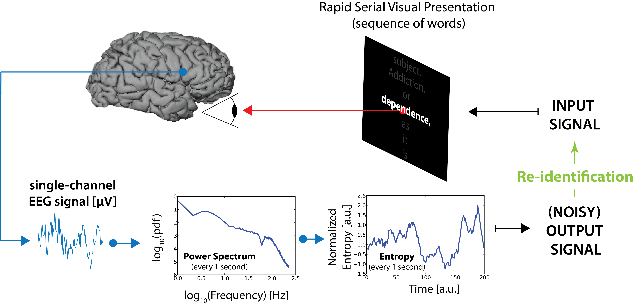

**Figure 1.** Brain speed-reader apparatus

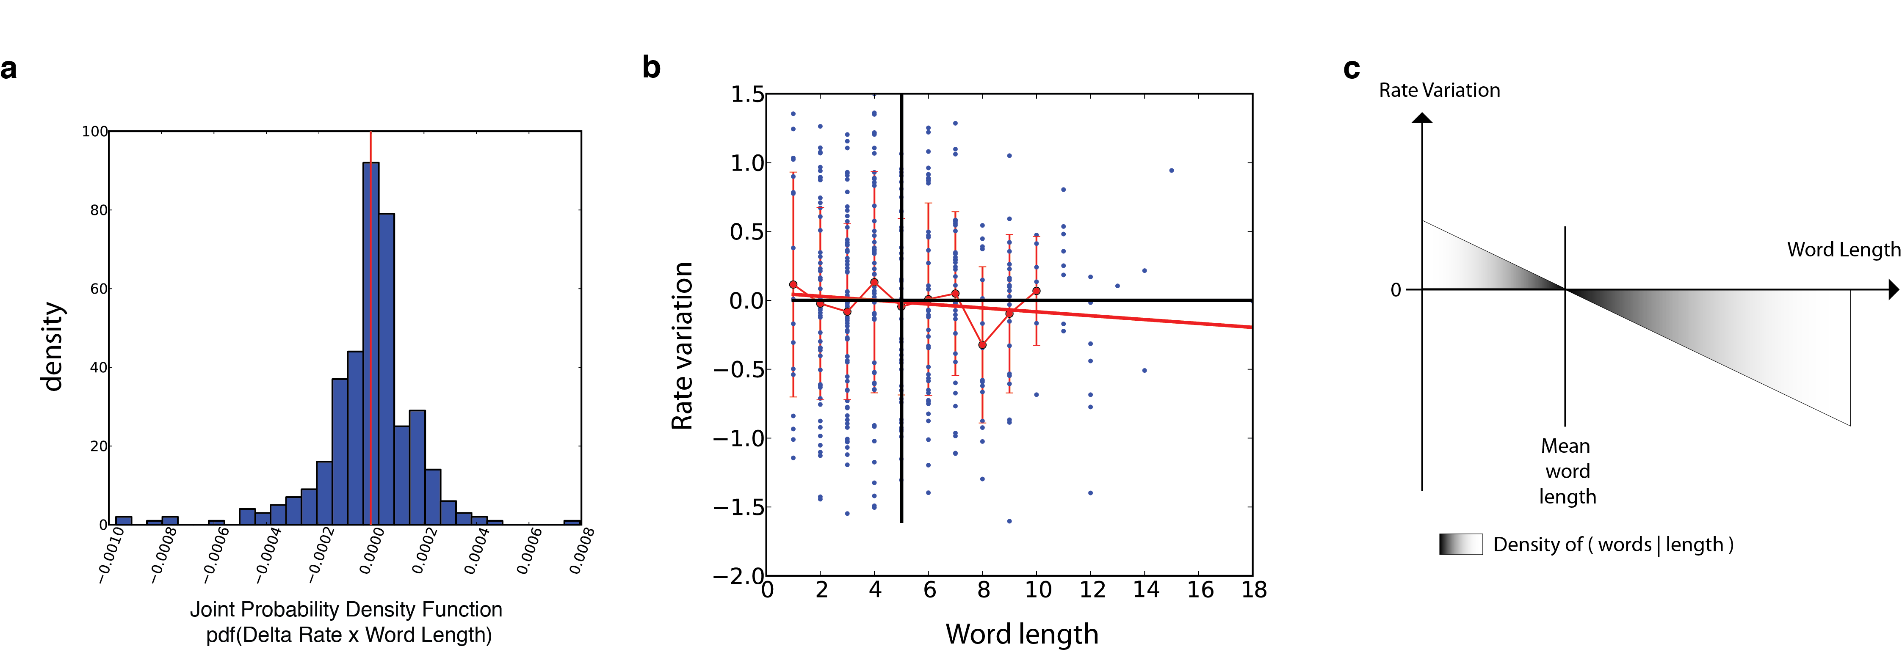

**Figure 2.** statistical evidence of controlled RSVP by a subject reading a text.

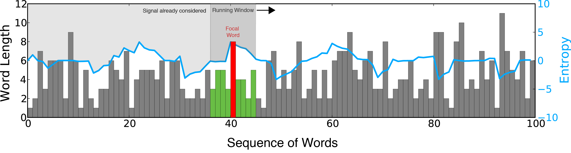

**Figure 3.** Brain decoding by matching the sequence of word lengths and entropy.

1. maillart@berkeley.edu [↑](#footnote-ref-1)
2. ffff@berkeley.edu [↑](#footnote-ref-2)
3. [john.chuang@berkeley.edu](mailto:john.chuang@berkeley.edu" \t "_blank) [↑](#footnote-ref-3)