ELSHAN HASANOV 604.18E
REPORT

Feature Selection for Breast Cancer Diagnosis

Abstract
Breast cancer is one of the primary causes of death among the women worldwide. It has become a common factor nowadays. Unfortunately, despite the fact, some of the general hospitals have the facilities (not all) to predict breast cancer diagnosis through mammograms. Waiting for diagnosing a breast cancer for a long time causes increasing the percentage of the cancer spreading. Therefore a computerized breast cancer diagnosis has been developed to reduce the time taken for diagnosing the breast cancer and as well as the death rate.
This paper addresses feature selection for breast cancer diagnosis using genetic algorithms, which can be used to improve the accuracy of predicting cancer.
To evaluate effectiveness of feature selection method, genetic algorithm based classifier is employed on “Breast Cancer Wisconsin” datasets in this paper.

Introduction
A major class of problems in medical science involves the diagnosis of disease which based on a number of tests done on the patients. Because of welter data, the ultimate diagnosis may be difficult to obtain. Improvements in facilities lead to collect very large databases in medicine which needs to discover relationship buried in data. Data mining approaches in medical domains are used intensively for these purposes. One of the applications of analysing database is automated diagnostic systems. These system helps doctors in their decision making. Another application can be finding ways to improve patient outcome that reduces cost and enhances clinical studies. And in addition, need for automated diagnosis has been very acute in case of deadly disease such as cancer, where early detection can enhance the chances of long-term survival and reduce the cost.
Breast cancer has become one of the most common diseases among women which leads to death. It can be diagnosed by classifying tumors such as malignant and benign tumors. Doctors need a reliable diagnosis procedure to distinguish between tumors these tumors (malignant or benign). But generally it is very difficult to find such procedure even by the medical experts. Hence automation of diagnostic system is needed for diagnosing tumors for prediction. Many researchers have used machine learning algorithms such as genetic algorithms, classification algorithms, etc. and it is also been proved by them that these algorithms work better in detecting cancer diagnosis for future selection.
In this paper, we’ll apply :
- Classification algorithm for binary classification
- Sequential Forward Search, Sequential Backward Search and Genetic Algorithms for selection optimal features subset.

Material and Methods
Dataset
We use the “Breast Cancer Wisconsin” dataset from UCI Machine Learning Repository in this study. In 1989-1991, they have been collected by Dr.William H.Wolberg at the Wisconsin Madison Hospitals University. The detail of this dataset is described below :
Dataset Name – Wisconsin Breast Cancer (WBS)
Number of attributes - 11
Number of Instances - 699
Number of Classes - 2

According to details, we see that in Wisconsin Breast Cancer dataset there are 699 records that each of them has 9 attributes (we’ll name as chromosome of all together and gene in separately each of them), besides ID Number and Class . These 9 attributes are graded on an interval scale from a normal state of 1-10, with 10 being the most abnormal state. According to other’s research, in this datebase 241 records are malignant and others are benign.

Attribute Domain
- Sample code number ID number
- Clump thickness 1 – 10
- Uniformity of cell size 1 – 10
- Uniformity of cell shape 1 – 10
- Marginal adhesion 1 – 10
- Single epithelial cell size 1 – 10
- Bare nuclei 1 – 10
- Bland chromatin 1 – 10
- Normal nucleoli 1 – 10
- Mitoses 1 – 10
- Class 1 – 10

In this research, Genetic Algorithm was devised based on input variables that help prediction. While implementing our algorithm , we’ll name instances as population and 9 attributes (as told above) as chromosome of all together and gene in separately each of them in our genetic algorithm. Algorithm will be implemented in Python. Therefore, we’ll use methods & functions in Jupiter notebook ( or may be Spyder) to implement the genetic algorithm. And only 20 of 699 records will be taken. Then we’ll divide these records into two parts, 60% of them for training phase, and other 30% for testing phase. Nine clinical variables (genes) is used as inputs : clump thickness, uniformity of cell size, uniformity of cell shape, marginal adhesion, single epithelial cell size, bare nuclei, bland chromatin, normal nucleoli, and mitoses. Then the existing data will be normalized through the logistic regression in such a way that numerical values can be expressed in terms of binary sets such as 0 (malignant) and 1 (benign) to be used for future selection.

Binary Classification
Binary Classification is the method that helps us classify the elements of a set into two groups on the basis of a classification rule. Basic binary classification include medical testing ( determining if a patient has certain disease or not), quality control (deciding whether a specification has been met or not) and information retrieval (deciding whether page should be in the result set of a search or not).
There are many machine learning algorithms ranging from Naive Bayes to deep learning networks that solve binary classification problems. Top 10 most common algorithms is shown below :
- Naive Bayes
- Logistic Regression
- K-Nearest Neighbours
- Support Vector Machine
- Decision Tree
- Bagging Decision Tree (Ensemble Learning 1)
- Boosted Decision Tree (Ensemble Learning 2)
- Random Forest (Ensemble Learning 3)
- Voting Classification (Ensemble Learning 4)
- Neural Network (Deep Learning)
Now, we’ll prefer Logistic Regression.

Logistic Regression
Logistic Regression is one of the popular algorithms that is used to solve classification problems. We identify problem as classification problem when independent variables are continuous in nature and dependent variable is in categorial form. E.g;
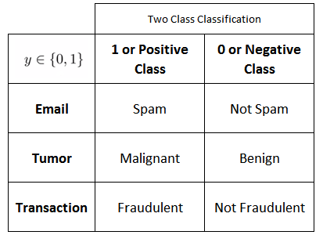
All these problem’s answers are in categorial form i.e. YES or NO and therefore they are called as two class classification problems. Also in some situations we may come across more than 2 classes and these type of problems are known as multi class classification problems.
In Logistic Regression , we use standard logistic function that is known as sigmoid function. This function takes any real value between 0-1 . It is formulated as :
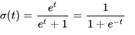
So, let’s consider t as linear function (can be known as hypothesis) in a univariate regression model. Formul of this function is :
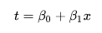
Thus, the Logistic Regression Equation becomes as :
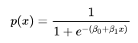

Sequential Forward Search Algorithm
Sequantial Forward Search Algorithm is included Sequantial Feature Algorithms (or Greedy Search Algorithms) have been developed as a suboptimal solution to the computationally exhaustive search.
This algorithms takes the whole D – dimensional feture set as input.
Input $→ Y=\{y_{1},y_{2}, …, y_{D}\}$
Then, as output it returns a subset of features; the number of features, where $k<d$ , has to be specified a priori.

Output $→ X_{k}= \left\{x_{j} \right| j=1,2, …, k; x_{j}∈Y\} where k=(0,1,2,…,d)$

Algorithm is initialized with a null set $∅$, so k is equal to 0 (because it is the size of the subset)
Step 1: Inclusion
- In this step, we add an additional feature $x^{+}$ to our feature subset $X_{k}$ .
- $x^{+}$ is the feature which maximazes our criterion function that is the feature is associated with the best classifier performance if it is added to $X_{k}$ .
- This procedure is repeated until the termination criterion is satisfied with result.
$x^{+}=\arg{\max{J }}($ $X_{k}+x )$ where $x ∈ Y-X_{k}$
$X_{k+1}= X_{k}+ x^{+}$
$k=k+1$
Go to Step 1 .

Termination : $k=p$
Features is added from the feature subset $X_{k}$ until the size of the feature subset contains the number of desired features $p$ that is specified as a priori.

Sequential Backward Search Algorithm
As the Sequantial Forward Search Algorithm, the Sequential Backward Search Algorithms is also included Sequantial Feature Algorithms .
This algorithms takes the whole D – dimensional feture set as input.
Input $→ Y=\{y_{1},y_{2}, …, y_{D}\}$
Then, as output it returns a subset of features; the number of features, where $k<d$ , has to be specified a priori.

Output $→ X_{k}= \left\{x_{j} \right| j=1,2, …, k; x_{j}∈Y\} where k=(0,1,2,…,d)$

Algorithm is initialized with a null set $∅$, so k is equal to 0 (because it is the size of the subset)
Step 1: Exclusion
- In this step, we add an additional feature $x^{+}$ to our feature subset $X_{k}$ .
- $x^{-}$ is the feature which maximazes our criterion function that is the feature is associated with the best classifier performance if it is added to $X_{k}$ .
- This procedure is repeated until the termination criterion is satisfied with result.
$x^{-}=\arg{\max{J }}($ $X_{k}-x )$ where $x ∈ Y-X_{k}$
$X_{k-1}= X_{k}- x^{-}$
$k=k-1$
Go to Step 1 .

Termination : $k=p$
Features is added from the feature subset $X_{k}$ until the size of the feature subset contains the number of desired features $p$ that is specified as a priori.

Genetic Algorithm
Genetic Algorithm was developed by Holland. It is a computational optimization paradigm modelled on the concept of biological evolution. Genetic Algorithm is an optimizaton procedure that operates in binary spaces and manipulates population of potential solutions. In binary spaces, a point is represented by a finite sequence of 0s and 1s, called a chrosome.
The quality of possible solutions is determined by a fitness function. A fitness function estimates the importance of the answer in the evaluation step. In this function, there are two major operators : crossover and mutation functions. They have the key impact on the fitness value. Chrosomes for reproduction are selected by finding the fitness value, and the bigger one is obtained, by selecting the chromosome with higher probability. The fitter chromosomes have higher likelihood to be selected into the recombination pool using either the tournament or the roulette. The formula of fitness value is represented as :
$$F.F= \frac{1}{n}\sum_{t=1}^{n}{{(t-out)}^{2}}$$

In here , n is the number of outputs, t is the target output .

The mutation operator randomly alerts a bit in chromosomes. And the crossover operator randomly swaps a portion of chromosomes between two chosen parents to produce child chromosomes. To accomplish better performance, Genetic Algorithm - based selected features are applied as an input to classifiers.
There are 3 criterias to model fitness function : model accuracy, cost and number of selected features. This means for any chromosome with acceptable classification accuracy rate, selection of only significiant and informative features and reduced cost result in satisfactory fitness value. The chromosome which has higher fitness value rather than others will have better chance to be used in the next generation, so these are properly expressed according to user’s specifications. To get accurate feature selection in Genetic Algorithms, these steps are followed :

- Data processing (scaling) : There are two advantages of scaling, one of them is evading of attributes in bigger numeric range to control attributes in lesser numeric range and other one is avoiding of numerical difficulties in calculations.
- Convertion of genotype : Here each feature chromosome is converted.
- Feature subset
- Fitness evaluation
- Termination criteria ( if it is met, process is stopped; otherwise procedure continues with next generation)
- Genetic operation : In this step, better solution is being searched by genetic operations.
Here Genetic Algorithms is used to eliminate insignificiant features. Therefore we define each chromosome as a subset of features. The size of chromosome (in other words we can say the number of genes) is equal to the number of features that represent the specification of a cancer patient. For convenience, a chromosome is represented in form of binary string that consists of 0 or 1. 1 means the corresponding feature is selected and 0 means that it isn’t selected.
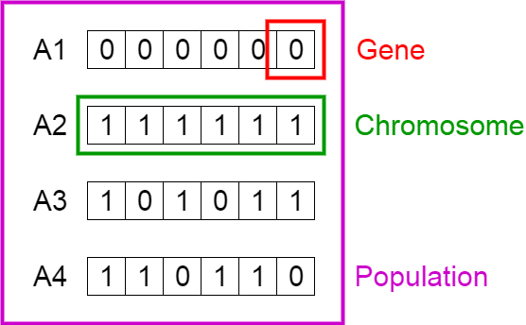

İmplementation of Methods and their results
- Classification using Logistic Regression
First of all, we need classify to predict whether the given patient is having Benign or Malignant tumor based on features in our dataset. So, I would prefer to use Logistic Regression
I have used 300 models and splited them into training set (60%) and testing set (40%). After running program , accuracy becomes 97.47899159663865 % . It means that 116
models in testing set is suitable. And parameters (in vector shape) is :

[[ 0.36008746]
[-0.07577295]
[ 0.21758752]
[ 0.36163057]
[ 0.12460227]
[ 0.29588436]
[ 0.10182899]
[ 0.2393072 ]
[ 0.04379449]]

Other outputs

b : -6.112267432039582

cost value: 0.13261344

learning rate : 0.005

iterations : 50000

- Sequential Search Algorithms
Via this algorithms we can select the most significant features from a vast set of features in the given dataset. For a dataset with d input features, the feature selection process results in k features such that k < d, where k is the smallest set of significant and relevant features. The Wrapper Methods was used for feature selection.

Sequential Forward Selection :

sfs = SFS(RandomForestClassifier(n_estimators=100, random_state=0, n_jobs = -1),
k_features = 8,
forward= True,
floating = False,
verbose= 2,
scoring= 'accuracy',
cv = 4,
n_jobs= -1
).fit(x_train, y_train)
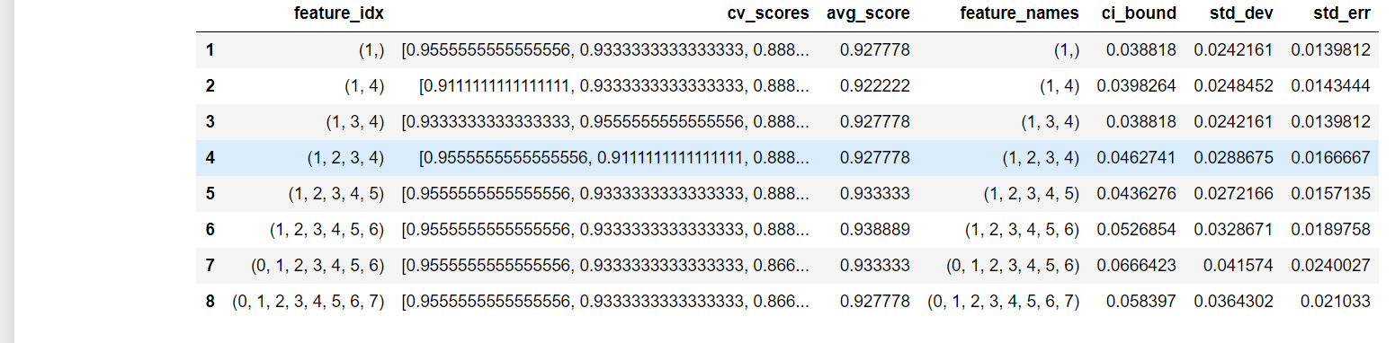
After applying Forward Selection Algorithm, I obtained :
Optimal value : 0.938889
Optimal Features : (1, 2, 3, 4, 5, 6) - [“Clump thickness”, “Uni_of_cell_size”, “Uni_of_cell_shape”, “Marginal adhesion”, “Single_epi_cell_size”, “Bare nuclei”]

Sequential Forward Selection :
sfs = SFS(RandomForestClassifier(n_estimators=100, random_state=0, n_jobs = -1),
k_features = 1,
forward= False,
floating = False,
verbose= 2,
scoring= 'accuracy',
cv = 4,
n_jobs= -1
).fit(x_train, y_train)
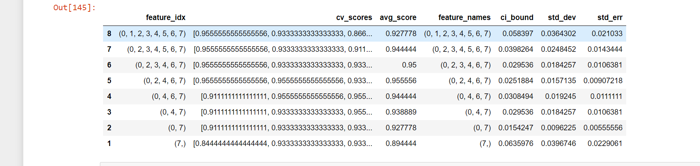
Then, the results after applying Backward Selection are :
Optimal value : 0.955556
Optimal Features : (2, 4, 6, 7) - [“Uni_of_cell_size”, “Marginal adhesion”, “Bare nuclei”, “Bland_Chromatin”]

- Genetic Algorithm

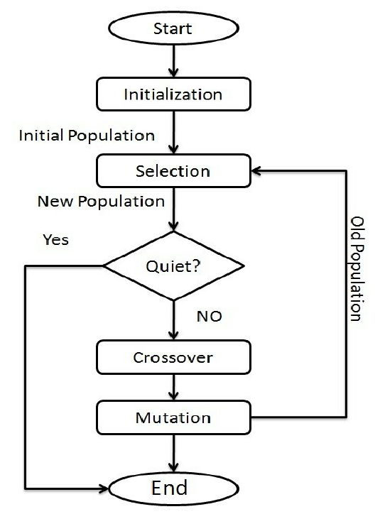
As seen from the flowchart of the genetic algorithms, our pseudocode will be :
Start
Generate initial population
Compute fitness
Repeat
Selection
Crossover
Mutation
Untill population has converged
End

Starting
At first , I have imported required libraries for Genetic Algorithms :
import numpy as np
import pandas as pd
import math
from sklearn.model_selection import train_test_split
from sklearn.metrics import accuracy_score
from sklearn.metrics import mean_squared_error
from sklearn.linear_model import LogisticRegression

The next operation is loading the data into program :
data = pd.read_csv("breast-cancer.csv", nrows = 300)
feature_list=data.iloc[: ,1:10]
target=data.iloc[: ,-1]
We should note that name of the dataset is breast – cancer .csv in my computer. In here, I took 300 samples and 9 nine features for each sample.

Creating initial population
Population Initialization is the first in the Genetic Algorithm Implementation. Population is known as a subset of solutions in the current generations. There are a lot of initialization methods. One of them is Random Initialization method which I used in this program. Random Initialization populate the initial population with completely random solution. So , my code is :
def init_population(m,n):
return np.array([[math.ceil(e) for e in pop] for pop in (np.random.rand(m,n)-0.5)])
d=init_population(150,9)
print("\n\nInitial population :\n",d)
print("\n\nSet of chromosome :\n")
for chromosome in d:
print(chromosome)
As seen from the code, I created 150 chromosomes as the initial population in array shape :
[[0 0 0 ... 1 1 0]
[0 1 1 ... 0 0 1]
[0 0 0 ... 1 0 0]
...
[0 0 1 ... 0 1 0]
[1 1 1 ... 1 0 0]
[0 0 0 ... 1 0 0]]

Then I divided the data into two parts : feature_list which is the list of input variables, and target represents the output variables :
feature_list=data.iloc[:300,1:10]
target=data.iloc[:300,-1]

x=feature_list
y=target

Then I applied train_test_split function to create training set (70%) and testing set (30%).
x_train, x_test, y_train, y_test = train_test_split(x, y, test_size=0.3, random_state=10)

Generating Fitness function
Fitness function find the fitness value of the each of the chromosomes(a chromosome is a set of parameters which define a proposed solution to the problem that the genetic algorithm is trying to solve).
def fitness_score(population):
scores = []
for chromosome in population:
log_model.fit(x_train.iloc[:,chromosome],y_train)
predictions = log_model.predict(x_test.iloc[:,chromosome])
scores.append(accuracy_score(y_test,predictions))
scores, population = np.array(scores), np.array(population)
inds = np.argsort(scores)
return scores[inds][::-1],list(population[inds,:][::-1])
fit=fitness_score(d)

print(fit)
Therefore output will be :
array([0.92222222, 0.92222222, 0.92222222, 0.92222222, 0.92222

0.92222222, 0.92222222, 0.92222222, 0.92222222, 0.92222

0.92222222, 0.92222222, 0.92222222, 0.92222222, 0.92222

0.92222222, 0.92222222, 0.92222222, 0.92222222, 0.92222

This array describes all the scores of each test part which are combined together.

Generating Crossover Function
Crossover Function create new set of chromosomes by combining the parents and add them to new population set. I used single point crossover method for my dataset. By using single point crossover, a location is randomly selected within chromosome. A crossover mask is generated, which consists of a bit-string of the same length as the chromosome. For all bits before the crossover point, a zero is stored in the bit-string, and for all other locations, a one is stored in the bit string.

def single_point_crossover(population):
r,m, n = population.shape[0], population.shape[1], np.random.randint(1,population.shape[1])
for i in range(0,r,2):
population[i], population[i+1] = np.append(population[i][0:n],population[i+1][n:m]),np.append(population[i+1][0:n],population[i][n:m])
return population

print(single_point_crossover(d))

Output is :
[[0 0 0 ... 1 0 1]
[0 1 1 ... 0 1 0]
[0 0 0 ... 1 0 0]

Selection
Selection– Select the best fitted chromosomes as parents to pass the genes for the next generation and create a new population.
def random_selection(population):
r = population.shape[0]
new_population = population.copy()
for i in range(r):
new_population[i] = population[np.random.randint(0,r)]
return new_population

[[0 1 0 ... 1 0 1]
[0 0 1 ... 1 1 1]
[1 0 0 ... 1 0 1]
...
[0 1 0 ... 0 1 1]
[0 1 1 ... 1 1 1]
[1 0 1 ... 0 0 0]]

Mutation
Mutation - perfrom mutation which alters one or more gene values in a chromosome in the new population set generated. Mutation helps in getting more diverse oppourtinity. Obtained population is used in the next generation. The code is shown below :

def flip_mutation(population):
return population.max() – population
print(random_selection(d))

Output :
[[1 1 1 ... 0 1 0]
[1 0 0 ... 1 0 1]
[1 1 1 ... 0 1 1]
...
[1 1 0 ... 1 0 0]
[0 0 0 ... 0 1 1]
[1 1 1 ... 0 1 1]]

After all these procedures, we can run our Genetic Algorithm.

def GA(data, feature_list, target, n,c, max_iter):
population= init_population(n,c)
zzz=fitness_score(d)
fitness = fit[0]
optimal_value = max(fitness)
optimal_solution = population[np.where(fitness==optimal_value)][0]

for i in range(max_iter):
population = random_selection(population)
population = single_point_crossover(population)
if np.random.rand() < 0.3:
population = flip_mutation(population)

fitness = fit[0]

if max(fitness) > optimal_value:
optimal_value = max(fitness)
optimal_solution = population[np.where(fitness==optimal_value)][0]

return optimal_solution, optimal_value*100

res=GA(data,feature_list, target, 150 , 9, 1000)
print('\nOptimal solution :',res[0] )
print('\n\n Accuracy : ',res[1])
features=['x1','x2','x3','x4','x5','x6','x7','x8','x9']
o=res[0]
z=0
feature_set=[]
for k in o:
if k==1:
feature_set.append(features[z])
z+=1
print("\n\nOptimal feaures :", feature_set)
This code returns us optimal solution, accuracy for optimal feature and optimal features.
Optimal solution : [0 1 1 0 0 0 1 0 0]

Accuracy : 92.22222222222223

Optimal feaures : ['x2', 'x3', 'x7']

Optimal solution : [1 0 1 1 0 0 1 0 0]

Accuracy : 92.22222222222223

Optimal feaures : ['x1', 'x3', 'x4', 'x7']

Optimal solution : [0 1 0 0 1 1 0 0 1]

Accuracy : 92.22222222222223

Optimal feaures : ['x2', 'x5', 'x6', 'x9']

Optimal solution : [0 1 0 1 1 1 1 0 0]

Accuracy : 92.22222222222223

Optimal feaures : ['x2', 'x4', 'x5', 'x6', 'x7']

Optimal solution : [0 0 0 0 1 1 1 1 0]

Accuracy : 92.22222222222223

Optimal feaures : ['x5', 'x6', 'x7', 'x8']

Conclusion
In this paper, I assessed a feature selection method using Genetic Algorithm and Wrapp er methods (SFS vs SBS) for selecting the best subset of features for breast cancer diagnosis system. And I also applied Logistic Regression for binary classifications for converting the feature values into binary values (0 means that it isn’t selected, 1 otherwise). This leaded me to create binary vectors. According my observations in this research, Logistic Regression is more accurate than others. This research proved that feature selection can improve accuracy of prediction of medical diseases.
Logistic Regression | 97.47899159663865 %
Sequential Forward vs Backward Search | 95,5556 % ,
Genetic Algorithm | 92,2222222222223 %

