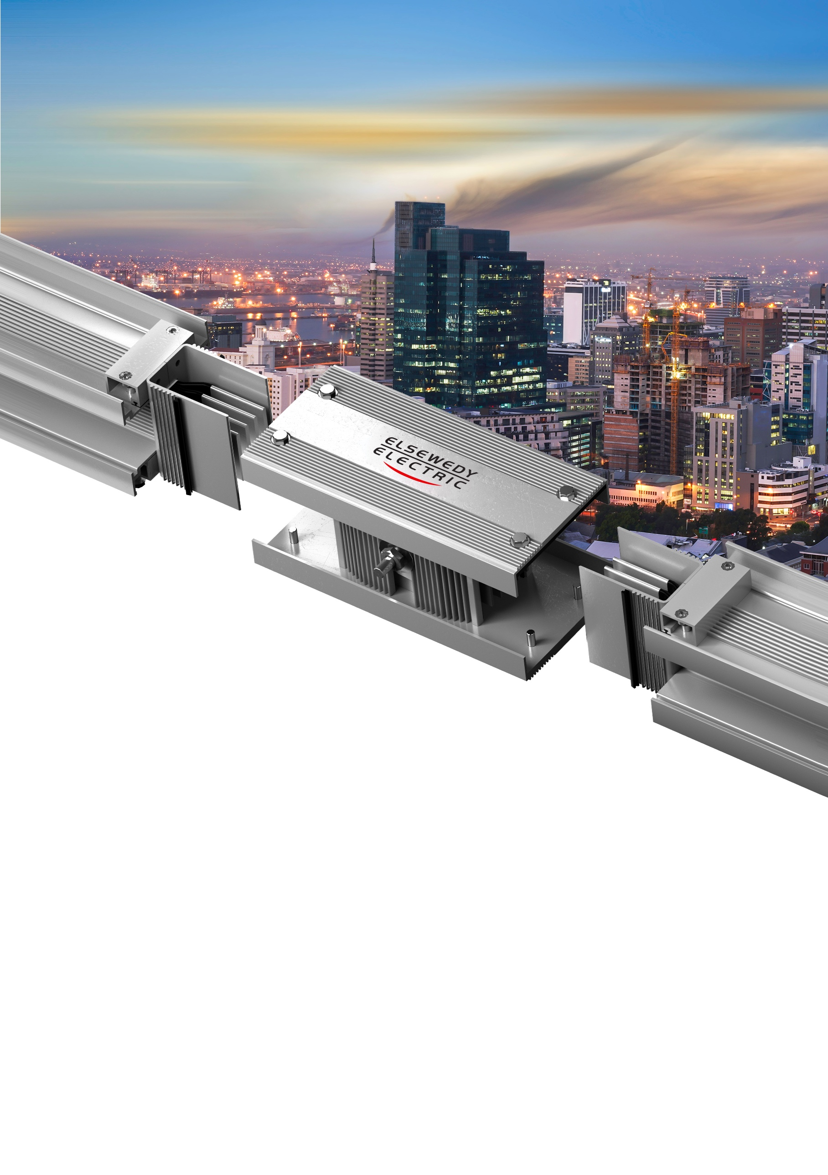
COMMERCIAL & TECHNICAL OFFER
PROJECT NAME: CEER Automotive
CLIENT NAME: XXXXXXX
DATE: 22-10-2025
REFERENCE: 240146SP-SAU-R2
REVISION: R2

Table of Contents
Company Introduction 3
Factory Overview 3
Product Overview 4
SPINE 4
PowerCast 5
Technical Specification 6
SPINE 6
PowerCast 6
Price Breakdown 7
Commercial Offer 8
Payment 8
Delivery 8
Price 8
Validity 8
Terms & Conditions 9
Warranty 9
Conditions of Sale 9
Factory Test 9

COMPANY INTRODUCTION
A global leader that has evolved from a local manufacturer of electrical products into an integrated infrastructure solutions provider; with over 19,000 employees and recorded revenues of more than USD 5 billion in 2023. We operate in five key business sectors: Wire, Cable & Accessories, Electrical Products, Engineering & Construction, Digital Solutions, and Infrastructure Investments. With a presence in 19 countries and 31 production facilities across Africa and Asia, we export high-end products to over 110 countries worldwide.

Factory Overview
Our state-of-the-art production facility in Egypt spans over 70,000 square meters, making it one of the largest in the Middle East & Africa (MEA) region. Equipped with cutting-edge technology, the factory specializes in manufacturing sandwiched non-ventilated busway systems.

PRODUCT OVERVIEW

SPINE — Aluminium Bi-Metal Conductor
Our busway system is a next generation prefabricated electrical distribution solution, designed for efficiency, flexibility, and safety. Encased in a durable protective housing, it integrates dielectric-insulated bus bars, straight lengths, fittings, devices, and accessories.
Product Diagram
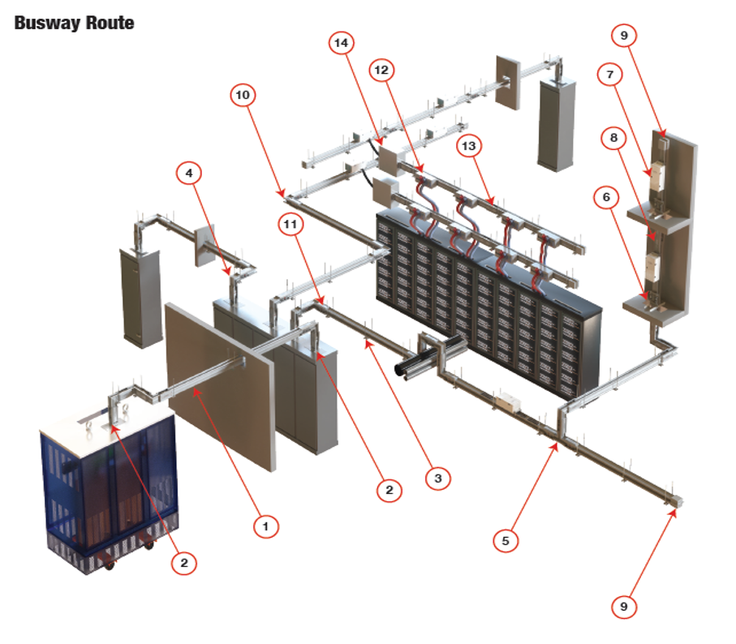
Certifications
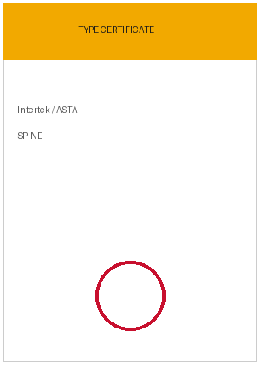 |  |  | 

PowerCast — Pure Copper Conductor
Our busway system is a next generation prefabricated electrical distribution solution, designed for efficiency, flexibility, and safety. Encased in a durable protective housing, it integrates dielectric-insulated bus bars, straight lengths, fittings, devices, and accessories.
Product Diagram
▢
PRODUCT DIAGRAM
PowerCast — image to be inserted
Certifications
CERT  PowerCast | CERT  PowerCast | CERT  PowerCast

TECHNICAL SPECIFICATION

SPINE — Aluminium Bi-Metal
Product Guarantees
STANDARD | PROTECTION | FREQUENCY | AMBIENT TEMP.
IEC 61439-1 & 6 | IP55 / IP65 | 50 / 60 Hz | -5 / +55 °C
INSULATION (UI) | OPERATIONAL (UE) | MECH. IMPACT (IK) | CONDUCTOR
1000 V | 1000 V | 10 | Aluminium Bi-Metal
Selected Ratings
3 ratings selected: 1600, 2500, 4000 A.
Rating (In)  A | Icw (1s)  kA | Ipk  kA | Resistance  µΩ/m | Voltage Drop  V/100m/A | Dimensions  W×H mm | Weight  kg/m
1600 | 65 | 143 | 43.3 | 0.010 | 140 × 205 | 17.5
2500 | 100 | 220 | 20.5 | 0.004 | 140 × 380 | 30
4000 | 120 | 264 | 12.3 | 0.003 | 140 × 530 | 43

PowerCast — Pure Copper
Product Guarantees
STANDARD | PROTECTION | FREQUENCY | AMBIENT TEMP.
IEC 439-2 | IP68 | 50 / 60 Hz | -50 / +40 °C
INSULATION (UI) | OPERATIONAL (UE) | TANK COLOUR | CONDUCTOR
690 / 1000 V | 400–690 V | Light grey / yellow | Pure Copper
Selected Ratings
3 ratings selected: 400, 1000, 2500 A.
Rating (In)  A | Icw (1s)  kA | Ipk  kA | Resistance  µΩ/m | Voltage Drop  V/m @0.9
400 | 30 | 63 | 120.7 | 0.099
1000 | 50 | 105 | 66.5 | 0.124
2500 | 80 | 176 | 23.4 | 0.121

PRICE BREAKDOWN
Consolidated schedule (pasted from Excel). Line items grouped by product.
# | Type | Description | Qty | Unit | Unit Price | Total
SPINE — 2500A, Aluminium, 4-Wire, Housing ground
1 | Feeder [4-Wire] | Powerlink, Al, 2500A, Feeder, 3L+N, IP55 | 115 | M | 400.00 | 46,000.00
 |  | Flange End, 3L+N | 4 | EA | 180.90 | 723.62
 |  | Elbow, 3L+N | 1 | EA | 210.98 | 210.98
 |  | Flexible Link, One Set (4-Bar) | 2 | SET | 812.00 | 1,624.00
PowerCast — 1000A, Copper, 4-Wire
2 | Feeder | PowerCast, Cu, 1000A, Feeder, 3L+N, IP68 | 60 | M | 333.33 | 19,999.80
 |  | Joint Set | 3 | SET | 266.67 | 800.01
Total Price (USD) |  |  |  |  |  | 55,642.59

COMMERCIAL OFFER

Delivery Period
To be advised according to final quantity.

Delivery Place
Ex Works, ELSEWEDY factory, 10th of Ramadan city, Egypt.

Payment
- 100% LC by Mix payment
- 30% Advance Payment Against Invoice
- 20% upon Shop Drawings Approval by the Customer
- 50% Deferred Payment 30 Days from the Bill of Lading Date

Price
- Does not include installation. Add 15% if installation is required.
- Only site supervision is included.

Country of Origin
Egypt.

Specifications
As per attached technical offer, in accordance with IEC 61439-6 standard.

Validity
This quotation expires seven calendar days from its offered date.

TERMS & CONDITIONS

Warranty
ELSEWEDY ELECTRIC, Electrical Products warrants the busway to be free from defects in material and workmanship under use for (12) months from the date of delivery, not covering any mis-use.

Conditions of Sale
- Prices shown related to USD & LME (9000 USD per Ton) current prices on date and will be aligned accordingly upon payment date.
- The prices are subject to changes of LME price of copper. Any increase or decrease at the time of LC opening / Advance payment will be a variation in the unit price based on the escalation formula.
Price Escalation Formula
P1 = P0 [ 0.7 ( Cu1 − Cu0 ) / Cu0 + 1 ]
Cu1 = New Copper Price (LME at manufacturing shop drawing approval)
Cu0 = Old Copper Price (9000 USD per Ton)
P1 = New Unit Price
P0 = Old Unit Price
- Accessories lengths are considered in total straight lengths; unit prices for accessories are labor charges only.
- This quotation does not include the below points:
  - Spare Parts
  - Type Test Repetition
  - Adaptation at site for panels, transformer or Generator
- Any item not included in our drawings is hereby excluded from our offer.
- Packing will be Elsewedy standard packing.
- Any Cancellation after confirmed PO will be subjected to cancellation fees:
  - 10% Order received, work not started.
  - 30% Drawings for approval submitted.
  - 60% Approved drawings returned, job released.
  - 80% Material accumulated, production started.
  - 100% Manufacturing completed.

Factory Test
Standard factory test procedures to be performed. Field-testing, customer inspections and witness tests are not included unless specifically noted herein.

