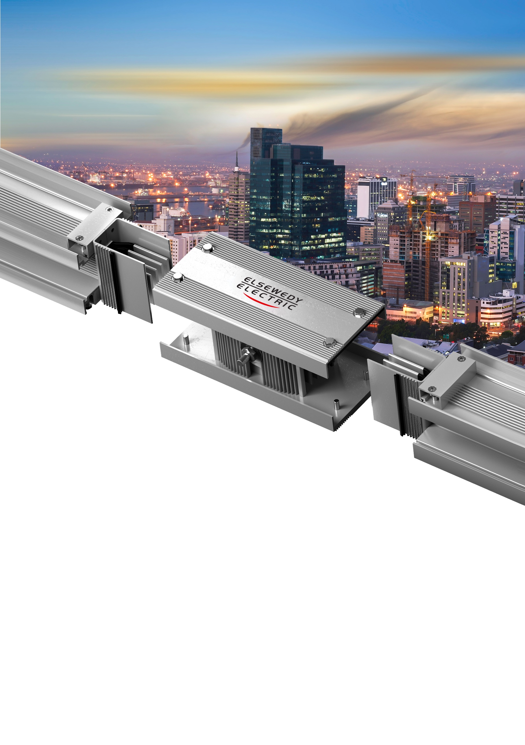

COMMERCIAL & TECHNICAL OFFER

PROJECT NAME: {{PROJECT_NAME}}
Client Name: {{CLIENT_NAME}}
DATE: {{DATE}}
Reference Number: {{REFERENCE}}
Revision Number: {{REVISION}}

COMPANY INTRODUCTION

A global leader that has evolved from a local manufacturer of electrical products into an integrated infrastructure solutions provider; with over 19,000 employees and with recorded revenues of more than USD 5 billion in 2023. We Operate in five key business sectors: Wire, Cable & Accessories, Electrical Products, Engineering & Construction, Digital Solutions, and Infrastructure Investments. With a strong presence in 19 different countries, 31 production facilities spread across African and Asian countries including Egypt, Algeria, KSA, Qatar, Indonesia, Pakistan, and Tanzania. We export a wide range of high-end products to over 110 countries worldwide. At the heart of our approach is an all-in-one integrated Engineering, Procurement & Construction (EPC) service, enabling us to deliver the most complex turnkey projects on time and with the highest efficiency.

Factory Overview
Our state-of-the-art production facility in Egypt spans over 70,000 square meters, making it one of the largest in the Middle East & Africa (MEA) region. Equipped with cutting-edge technology, the factory specializes in manufacturing sandwiched non-ventilated busway systems, cast resin busway systems, open-track data center busway systems, and lighting busway systems.

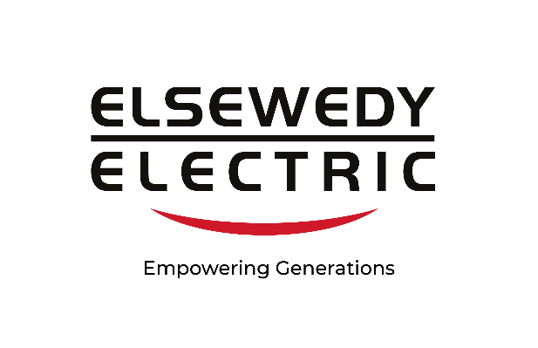

PRODUCT OVERVIEW
POWER LINK: Pure Copper Conductor

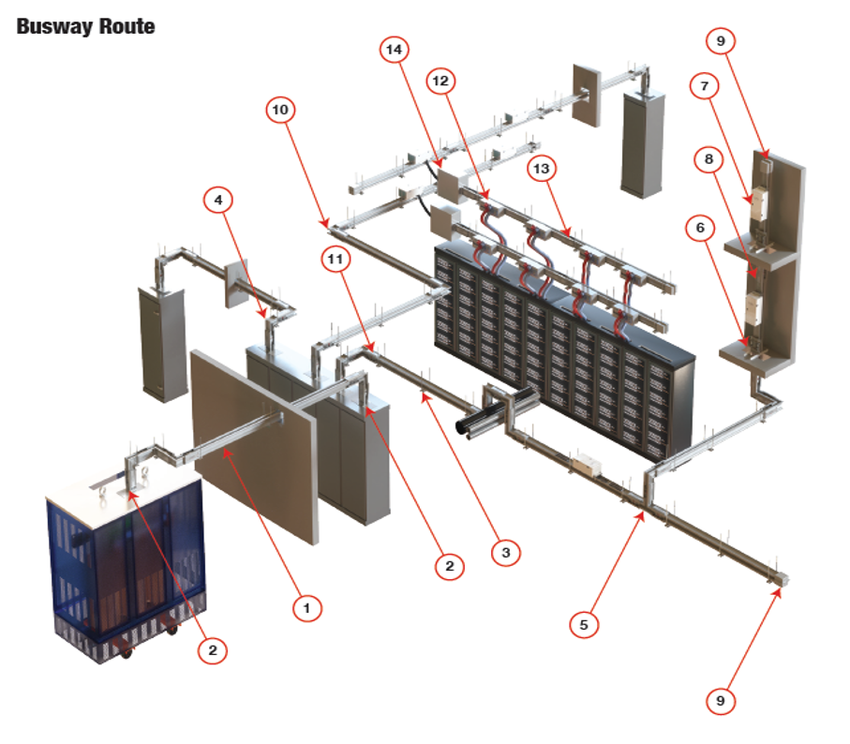

Product Summary
Our busway system is a next generation prefabricated electrical distribution solution, designed for efficiency, flexibility, and safety. Encased in a durable protective housing, it integrates dielectric-insulated bus bars, straight lengths, fittings, devices, and accessories.
CERTIFICATIONS
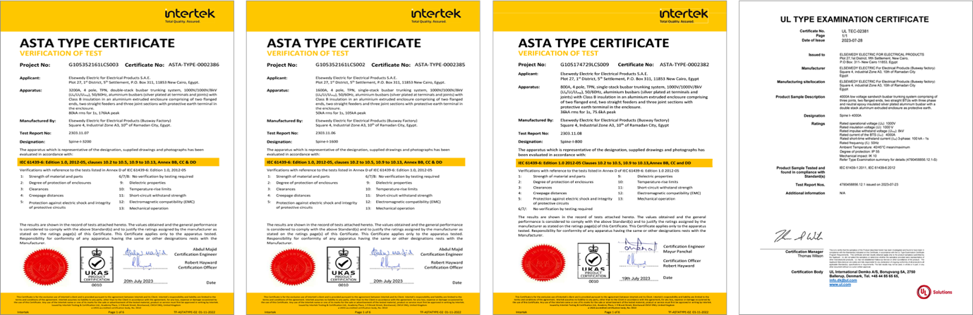

Technical Specification
Rating
Bus Way Rating | In | A | 800 | 1000 | 1250 | 1600 | 2000 | 2500 | 3200 | 3500 | 4000 | 5000 ₂ | 5000 ₃ | 6000 | 6300
Standards & Specifications |  |  | IEC 61439-1&6
Degree of Protection | IP |  | IP / 55 & 65
Frequency | F | Hz | 50 / 60
Ambient Temperature Min./Max. | T | ˚C | -5 / + 55
Rated Insulation Voltage Ui | Ui | V | 1000
Rated Operational Voltage Ue | Ue | V | 1000
Mechanical Impacts | IK |  | 10
Rated Short Time Withstand Short Circuit Current (1 Sec) | Icw | kA | 36 | 50 | 50 | 65 | 80 | 100 | 120 | - | 120 | 150 | - | - | 150
Peak Withstand Short Circuit Current | Ipk | kA | 79.2 | 110 | 110 | 143 | 176 | 220 | 264 | - | 264 | 330 | - | - | 330
Resistance (µΩ/m) | R₂₀ | µΩ/m | 77.2 | 51.0 | 47.2 | 30.5 | 21.3 | 15.1 | 12.9 | 12.9 | 10.0 | 7.2 | 6.0 | 6.0 | 5.0
 | R₃₅ |  | 100.6 | 68.7 | 62.1 | 41.3 | 28.2 | 20.1 | 17.7 | 17.7 | 13.0 | 9.7 | 7.8 | 7.8 | 6.7
Reactance (X µΩ/m) | X |  | 97.9 | 24 | 21.0 | 17.9 | 13.7 | 10.9 | 4.8 | 4.8 | 4.6 | 3.7 | 2.5 | 2.5 | 3.6
Impedance (Z µΩ/m) | Z₂₀ |  | 124.6 | 56.4 | 51.6 | 35.4 | 25.3 | 18.6 | 13.8 | 13.8 | 11.0 | 8.1 | 6.5 | 6.5 | 6.2
 | Z₃₅ |  | 140.3 | 72.8 | 65.6 | 45.0 | 31.4 | 22.9 | 18.3 | 18.3 | 13.8 | 10.4 | 8.2 | 8.2 | 7.6
Voltage Drop (V/100m/A) | Cos φ | 1.0 | 0.013 | 0.009 | 0.008 | 0.005 | 0.004 | 0.003 | 0.002 | 0.002 | 0.002 | 0.001 | 0.001 | 0.001 | 0.001
 |  | 0.9 | 0.019 | 0.010 | 0.009 | 0.006 | 0.004 | 0.003 | 0.002 | 0.002 | 0.002 | 0.001 | 0.001 | 0.001 | 0.001
 |  | 0.8 | 0.021 | 0.010 | 0.009 | 0.006 | 0.004 | 0.003 | 0.002 | 0.002 | 0.002 | 0.001 | 0.001 | 0.001 | 0.001
 |  | 0.7 | 0.021 | 0.009 | 0.008 | 0.006 | 0.004 | 0.003 | 0.002 | 0.002 | 0.002 | 0.001 | 0.001 | 0.001 | 0.001
Dimensions | W | mm | 140 | 140 | 140 | 140 | 140 | 140 | 140 | 140 | 140 | 140 | 140 | 140 | 140
 | H | mm | 115 | 120 | 140 | 160 | 220 | 260 | 330 | 330 | 450 | 530 | 680 | 680 | 800
Approximate Weight | Wt | kg/m | 14 | 18 | 22 | 25 | 35 | 48 | 60 | 60 | 74 | 95 | 112 | 112 | 144
Plating | Tin |  |  |  |  |  |  |  | Silver
Insulation | Epoxy |  |  |  |  |  |  |  | Mylar

Price Breakdown

Technical Notes:
1- Offered Elsewedy Compact Busway System, (Powerlink change base on busway offering), Copper Conductor, Aluminum Housing, Class B, Tin Plated on Joint, 4.5 Wires.
2- This quotation is prepared based on the BOQ&SLD received from customer.
3- Final BOQ will based on the final approved shop drawings, and the quotation will be updated accordingly.
4- Accessories lengths are considered in the total straight lengths so, unit prices shown for accessories are only for labor charges.
5- Our quotation does not include any adaptation boxes and interlink connections with switchboards, transformers or generators.
6- All submitted ratings are normal rating, indoor type; for outdoor parts a canopy should be installed for all length by the contractor.
7- Our Offer excludes Fire barrier, Civil works, Seismic Support, Spare Parts, Training, and Monitoring System.
8- For PowerTrack & PowerCast (if applicable) – note that 1 set of joints will be offered for every 3 meters of feeder, and 1 set of joints will be offered for every flange end, elbow, expansion. Any additional accessories will be at an additional cost.
9-Regarding Data Center Busway, PowerTrack, if applicable – that 1 set of joints will be offered for every 3 meters of feeder, and 1 set of joints will be.

Commercial Offer

DELIVERY PERIOD
To be advised according to final qty.

DELIVERY PLACE
Ex Works, Elsewedy factory, 10th of Ramadan city, Egypt.

PAYMENT
- 100% LC by Mix payment
- 30% Advanced Payment Against Invoice
- 20% of the Total Price Upon Shop Drawings Approval by the Customer
- 50% Deferred Payment 30 Days from the Bill of Lading Date

PRICE
- Does not include installation
- Site Supervision is included as mentioned below:
  - Installation supervision by ELSEWEDY ELECTRIC Engineer / Rep during installation, is limited to 7 days only. Additional visits will be charged at 500 USD per day per person.
  - Technical supervision by ELSEWEDY ELECTRIC Engineer during Testing and Commissioning is limited to 7 days only. Additional day will be charged at 500 USD per day per person.

COUNTRY OF ORIGIN
Egypt.

SPECIFICATIONS
As per attached technical offer, this is in accordance to
IEC 61439-6standard.

VALIDITY
The quotation is valid for {{VALIDITY}}.

Terms & Conditions

WARRANTY
ELSEWEDY ELECTRIC, Electrical Products warrants the busway to be free from any defects in material and workmanship under use for ({{WARRANTY_MONTHS}}) months from the date of delivery and that is not covering any mis-use or mis-leading.
CONDITIONS OF SALE

- Prices shown related to USD & LME (9000 USD per Ton) current prices on date and will be aligned accordingly upon payment date.
- The prices are subject to changes of LME price of copper. Any increase or decrease in the LME of copper at the time of LC opening/ Advance payment will be variation (Increase or Decrease) in the unit price of LOI based on the escalation formula.
P1=P0*((0.7(Cu1-Cu0)/Cu0) +1)
Cu1 = New Copper Price (LME price at the date of the manufacturing shop drawing approval)
Cu0 = Old Copper Price (9000 USD per Ton)
P1 = New Unit Price
P0 = Old Unit Price
**This calculation formula may be applied for partially on the contract based on the manufacturing shop drawing approval
- Accessories lengths are considered in the total straight lengths so, unit prices shown for accessories are only for labor charges.
- Total length for each run measured from first point of end flange to the run end. So no fraction meter per run will be considered.
- This quotation does not include the below points:
- Spare Parts
- Type Test Repetition
- Adaptation at site for panels, transformer or Generator
- Any item not included in our drawings is hereby excluded from our offer
- Our offer for supply only & does not include any site work or drawings approval from clients or consultant.
- Packing will be Elsewedy standard packing.
- All submitted rating is normal rating.
- Initial design will be issued from the factory within one month week from customer's full coordinated drawings, all data & confirmed PO.
- Shop drawings will be issued later after site coordination workshop with all concerned parties and issuing a MOM with all points agreed that enable to release a final shop drawings.
- Customer approval cycle for shop drawings will be four weeks otherwise drawings Cycle time by El Sewedy may vary if drawing approval time is excessive.
- This proposal is limited to the attached Bill of Material only, Changes to scope will require a revised proposal.
- Our offer does not include any civil work.
- Storage at site not included in our offer
- In the event that the customer for any reason does not comply with the conditions of shipment which got delayed for any reason not within control of El Sewedy Electric, the price shall be increased 2% for each full month or fraction
- Any Cancellation in the order after the confirmed PO will be subjected to cancellation fees
- 10% In case of order received and entered on factory, work not started, material not started.
- 30% In case of drawings for approval submitted.
- 60% In case of Approved drawings returned and job released for manufacture and shipment.
- 80% In case of material accumulated and production started.
- 100% In case of manufacturing completed.

FACTORY TEST
Standard factory test procedures to be performed. Field- testing, customer inspections, customer witness tests and any other non-STD, Non-standard test procedures are not included unless specifically noted herein.




ELSEWEDY ELECTRIC for Electrical Products S.A.E
- Factory: 3rd Industrial Zone A4, 10th of Ramadan City.
- Head Office: Plot No. 13co3, Cairo Festival City, 5th Settlement,
P.O.Box 310, New Cairo 11835, Egypt.
- Tel: (+202) 275 99 700 Fax: (+202) 275 99 731
- Email: info-transformers@elsewedy.com
- Website: www.elsewedyelectric.com

