fix schedule & test schedule

buy something

test speedome & setting & put in callbackfunction & test

django-admin startproject cfehome .

https://httpbin.org/#/Redirects

python3 manage.py runserver 8000

python3 manage.py startapp djused

startproject => setting +’’創見的startapp name
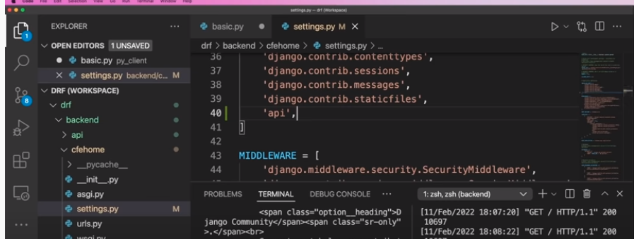

在創見的startapp djused view.py
from django.http import JsonResponse
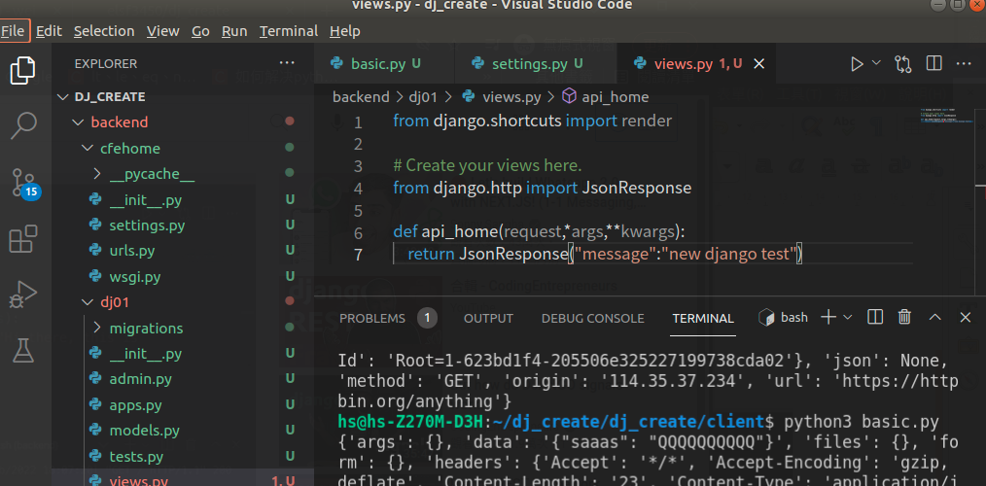

每個startapp 底下資料夾創見urls.py
給予link
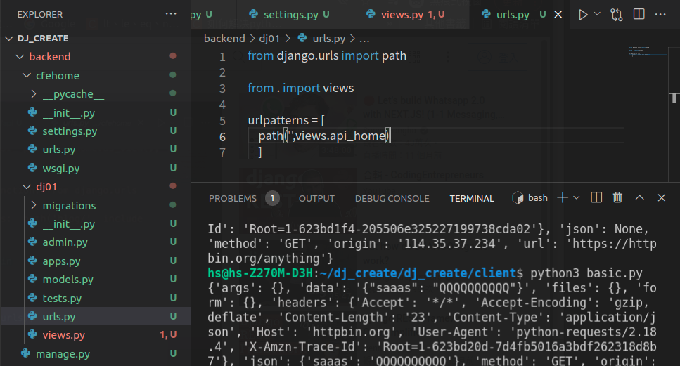
再回到主urls.py
import include 將剛剛startapp的urls 做include
path 那邊加的dj01 是link 假設點起來 127.0.0.1 =>127.0.0.1/dj01 就可以拿到startapp 的view data
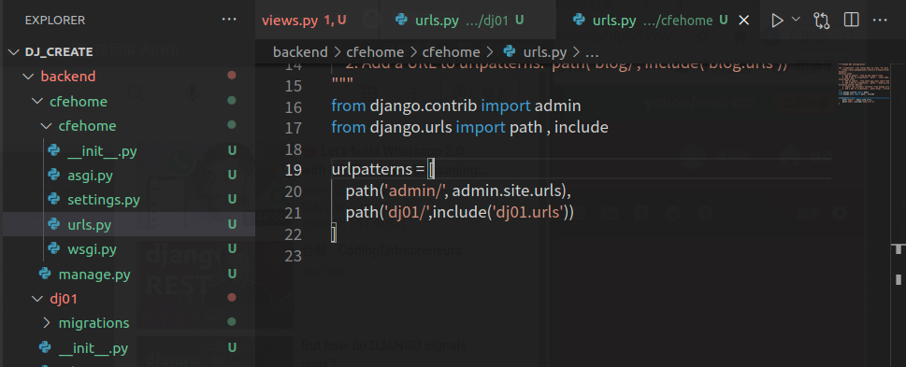

get數值 拿取
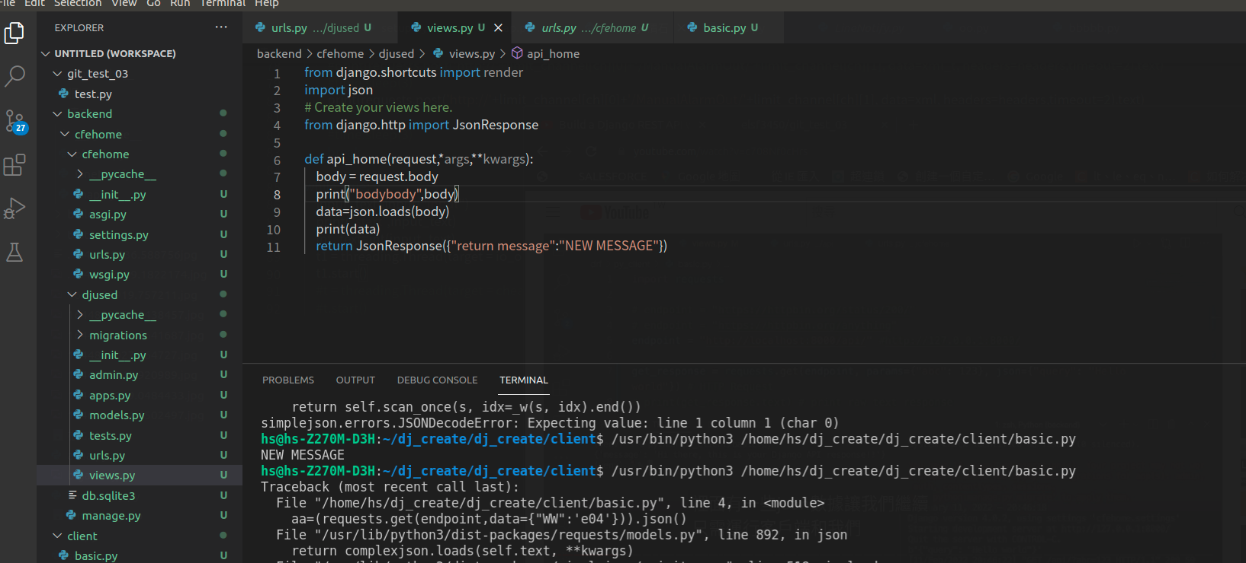
用戶端傳送數值 （json內部）
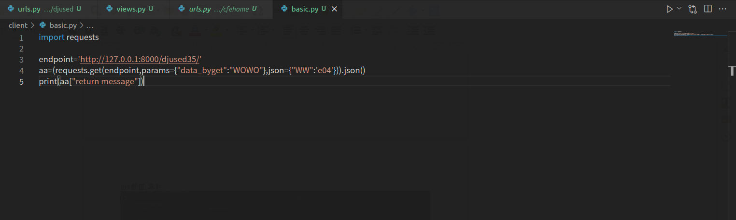

load 回傳變為 dict / dump 變為str
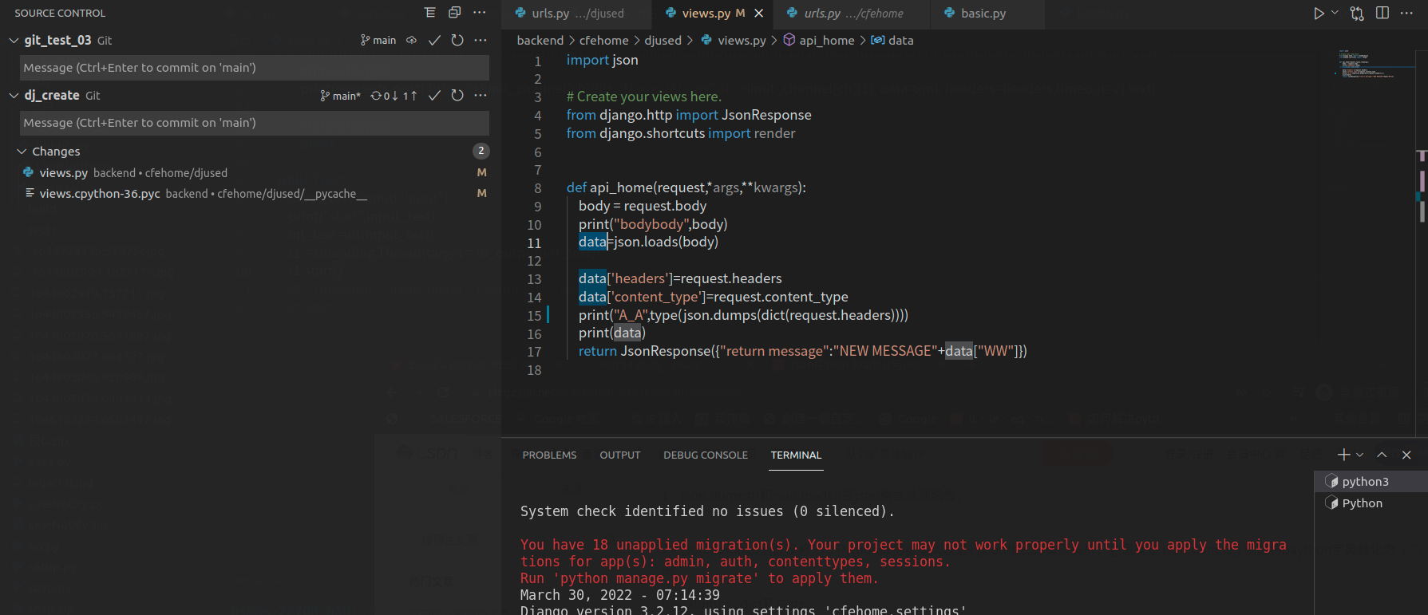

request.GET 拿到 params內部帶的數值
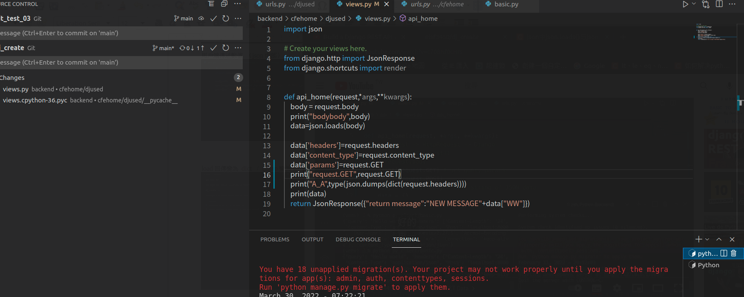

在創一個新的
python3 manage.py startapp dj_product

到models
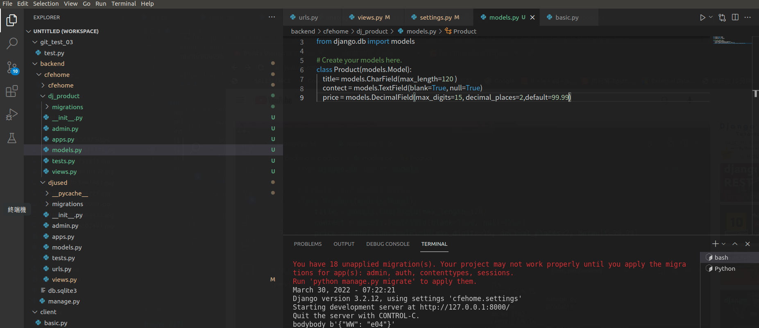
並
python3 manage.py makemigrations
python3 manage.py migrate
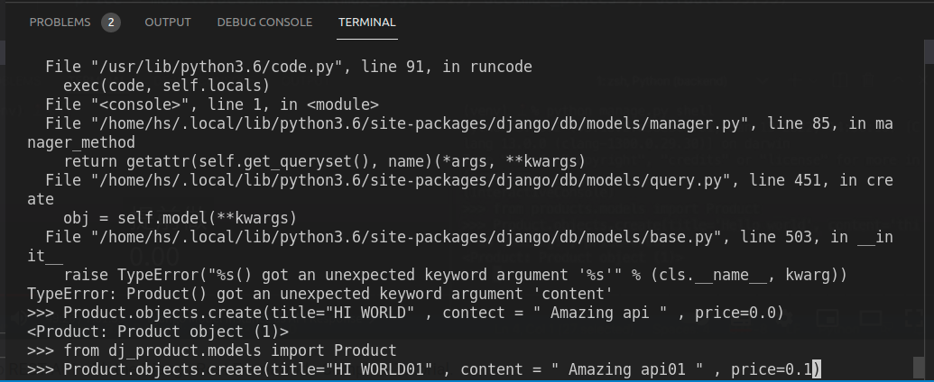
python3 manage.py shell 下指令新增數值

