



DEPARTMENT OF COMPUTING AND INFORMATICS

BICT 413: Project II
Proposal

TITLE
(A concise and descriptive title for your project)

STUDENT NAME
REGISTRATION NUMBER

SUPERVISOR:
Supervisor’s Name

A PROJECT PROPOSAL SUBMITTED IN PARTIAL FULFILMENT OF THE REQUIREMENTS FOR AWARD OF A BACHELOR OF SCIENCE DEGREE IN INFORMATION AND COMMUNICATION TECHNOLOGY OF
THE LAIKIPIA UNIVERSITY

JANUARY 2026

DECLARATION

This proposal is my original work and to the best of my knowledge has not been presented in any other university or institution for a degree or for consideration of any certification.

Signature: Date:
Student Name
Registration Number

This proposal has been submitted with my approval as the university supervisor.

Signature: Date:
Supervisor’s Name
Department of Computing and Informatics
Laikipia University

ABSTRACT

CONTENTS
DECLARATION i
ABSTRACT ii
LIST OF TABLES iv
LIST OF FIGURES v
CHAPTER 1: INTRODUCTION 1
1.1. Project Background and Motivation 1
1.2. Problem Statement 1
1.3. Project Objectives 1
1.4. Scope of the Project 1
CHAPTER 2: LITERATURE REVIEW 2
CHAPTER 4: METHODOLOGY 3
CHAPTER 5: SYSTEM DESIGN 4
2.1 System Architecture 4
2.2 System Components 4
2.3 UML Diagrams (as applicable) 4
REFERENCES 5
IMPLEMENTATION PLAN AND TIMELINE 6
RESOURCES REQUIRED 7
EXPECTED OUTCOMES 8
POTENTIAL CHALLENGES 9
APPENDICES (Include Any Additional Material - Optional) 10
Appendix I: Survey Questions 10
Appendix II: Extended Diagrams 10
Appendix II: Mockups 10

LIST OF TABLES
Table 1: 15
Table 2: 21
Table 3: 35

LIST OF FIGURES
Figure 1: 9
Figure 2: 13
Figure 3: 28
Figure 4: 29
Figure 5: 30

CHAPTER 1: INTRODUCTION

Project Background and Motivation
Describe the background of the problem area. Why is this project important? What real-world issues does it address?

Problem Statement
Clearly define the problem you intend to solve. Include the limitations of current Solutions (if any).

Project Objectives

General Objective
This is the overall aim of the project that captures the core purpose of the project. It should be written as one clear sentence, using an action verb such as design, develop, implement and evaluate.
Eg: “The aim of this project is to design and develop a web-based student attendance management system for Laikipia University.”

Specific Objectives
This is a list of 4 to 6 objectives that break the general objective in to clear and measurable goals. Use action verbs such as analyze, design, develop, implement, test, evaluate and deploy
- To analyze the existing attendance tracking methods used at Laikipia Univeristy.
- To design a database and system architecture for the attendance management system.
- To develop a web-based application for recording and managing student attendance.
- To test the system for functionality, usability, and performance.
- To evaluate the effectiveness of the system in improving attendance tracking accuracy.
NOTE: Ensure that you achieve ALL your objectives as each one will be assessed during your presentation and in your report. Do not include objectives that you can not do.

Scope of the Project
Define what your project will and will not cover. Set realistic boundaries.

CHAPTER 2: LITERATURE REVIEW
Brief summary of related work or existing systems. Identify gaps your project will fill. Include references (APA style). Review at least 5 existing systems and point out their weaknesses.

Case Studies of Existing Systems

Case 1: Title of the System
Overview of the system and its weaknesses / gaps. Include a screen shot of the system.

Case 2: Title of the System
Overview of the system and its weaknesses / gaps. Include a screen shot of the system.

Case 3: Title of the System
Overview of the system and its weaknesses / gaps. Include a screen shot of the system.

Case 4: Title of the System
Overview of the system and its weaknesses / gaps. Include a screen shot of the system.

Case 5: Title of the System
Overview of the system and its weaknesses / gaps. Include a screen shot of the system.

Summary of Gaps
Create a summary table that shows the gaps your project will fill.
Feature | Case 1 | Case 2 | Case 3 | Case 4 | Case 5 | Your Solution
Feature i | ❌ | ❌ | ✔ | ❌ | ✔ | ✔
Feature ii | ✔ | ❌ | ❌ | ❌ | ❌ | ✔
Feature iii | ✔ | ❌ | ❌ | ❌ | ❌ | ✔
Feature iv | ❌ | ✔ | ❌ | ✔ | ✔ | ✔
Feature v | ❌ | ❌ | ❌ | ❌ | ❌ | ✔
Feature vi | ✔ | ❌ | ❌ | ❌ | ❌ | ✔
Feature vii | ✔ | ❌ | ❌ | ❌ | ✔ | ✔
….
….

CHAPTER 4: METHODOLOGY
Describe your approach to solving the problem:
- Software Development Methodology (e.g., Agile, Waterfall, Spiral)
- Programming Languages and Tools
- Development Environment
- Data Sources (if applicable)
- Testing Approach

CHAPTER 5: SYSTEM DESIGN

System Architecture
Provide a diagram and description of the overall system architecture (e.g., client-server, layered, microservices, etc.)

System Components
Describe key components/modules and their interactions. Examples:
- User Interface
- Backend Logic
- Database Layer
- APIs or External Services
- Authentication & Authorization

UML Diagrams (as applicable)
Include and briefly explain the following:
- Use Case Diagram
- Class Diagram
- Sequence Diagram
- Activity Diagram
- ER Diagram (if applicable)

REFERENCES
Use APA 7th edition formatting for any cited works.

IMPLEMENTATION PLAN AND TIMELINE
Provide a Gantt chart or table showing the stages of development and estimated completion times:
Note that project start in September and ends in March/April.
| Phase | Tasks | Duration | Expected Completion |
|-------|-------|----------|----------------------|
| Planning | Requirement analysis | 1 week | ... |
| Design | Architecture & Diagrams | 2 weeks | ... |
| Development | Coding main features | 4 weeks | ... |
| Testing | Unit, Integration, User | 2 weeks | ... |
| Documentation | Report & User Manual | 1 week | ... |[

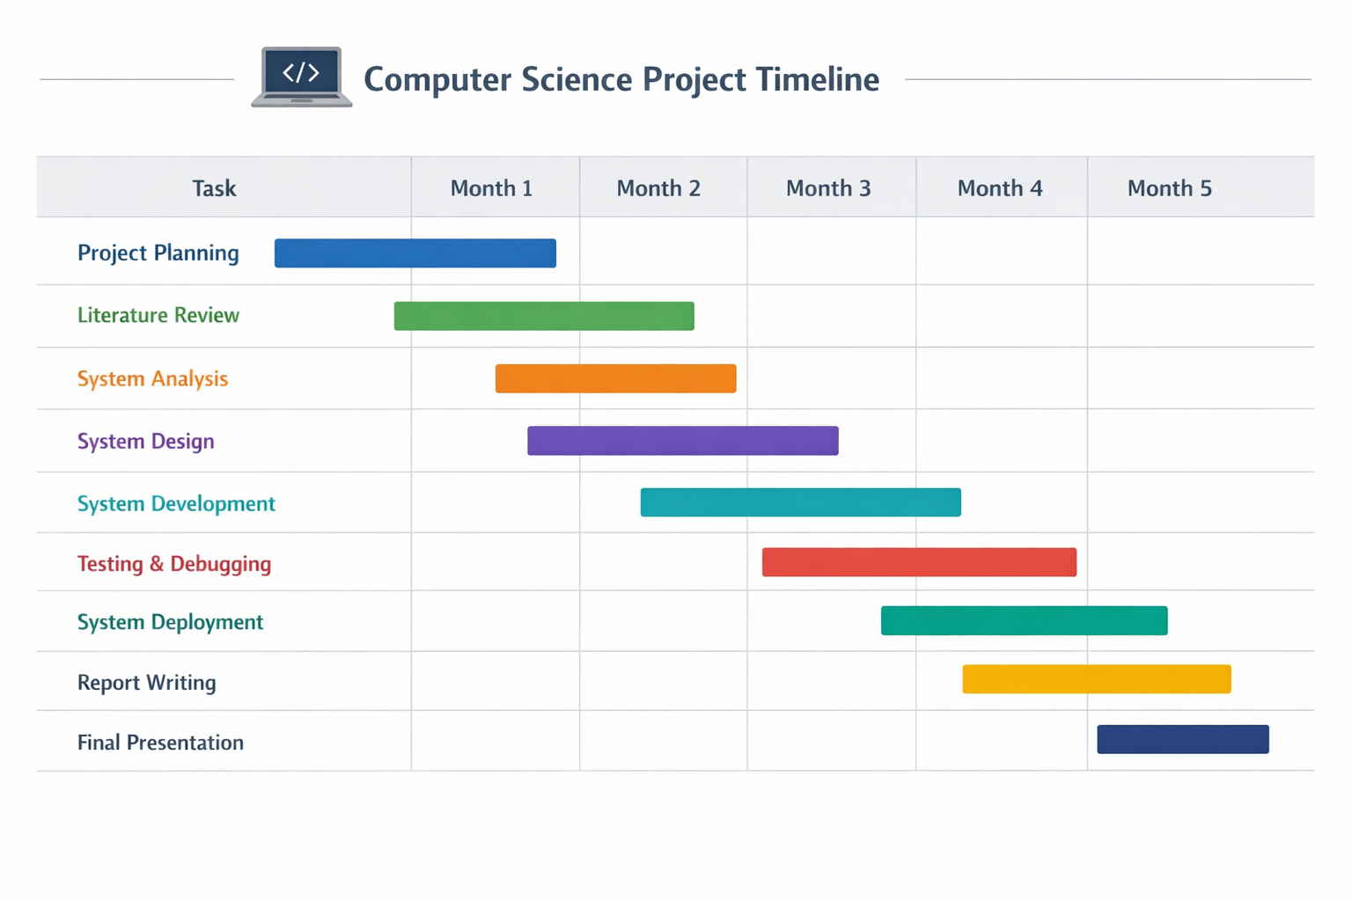

RESOURCES REQUIRED
List hardware, software, datasets, libraries, or other resources needed for the project.

EXPECTED OUTCOMES
Describe what you expect to deliver (e.g., a working prototype, documentation, deployment, performance metrics, etc.)

POTENTIAL CHALLENGES
Identify risks or challenges that may affect the success of your project and how you plan to mitigate them.

APPENDICES (Include Any Additional Material - Optional)

Appendix I: Survey Questions

Appendix II: Extended Diagrams

Appendix II: Mockups

