

UNIVERSIDAD INTERNACIONAL DEL ECUADOR

Network Prototype

Date: 04/11/2026

Grade: Tecnología de Comunicación de Información en Red
3-B
Name: Kevin Almache

REPOSITORIO
https://github.com/elskibidikevinxd/proyecto-integrador-correos.git

1. Updated Architecture and Justification of Changes
The initial prototype connects two enterprise sites (Site-A and Site-B) via a point-to-point perimeter link simulated on Cisco router interfaces. This topology models the architecture that will be deployed on OpenWrt hardware platforms (Raspberry Pi/x86) starting in Week 10.
Implemented Elements: Edge routers, Access switches, Test hosts in active user subnets, Point-to-point serial/Ethernet WAN link, and active DHCP services.
Planned Elements (Post Week 10): VLAN segmentation (802.1Q Trunking, Router-on-a-Stick), EtherChannel link aggregation, Rapid Spanning Tree Protocol (RSTP), dynamic OSPF routing, NAT address translation, and perimeter firewall rules.

Diagrama
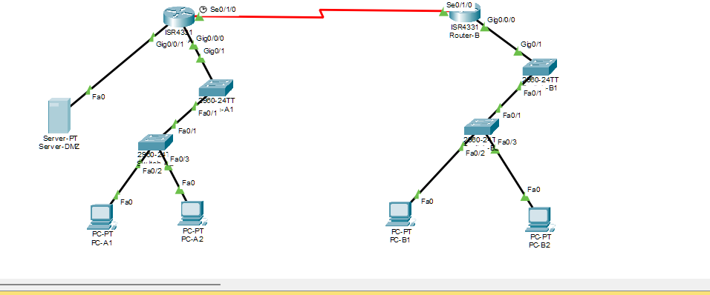

Figure 1. Implemented Packet Tracer IPv4 topology for Site-A and Site-B, including two switches per site and the Site-A DMZ server.

2. VLSM Addressing Plan (Block 10.10.0.0/16)
Derived from the primary allocation block 10.10.0.0/16, the subnetting plan is structured to satisfy current host requirements while reserving contiguous subnets for planned VLANs in Phase 3.

Subnet Purpose | Hosts | Network | Prefix | Mask | Usable Range | Broadcast | Allocation
Site-A: User LAN | 50 | 10.10.10.0 | /26 | 255.255.255.192 | 10.10.10.1 - 10.10.10.62 | 10.10.10.63 | DHCP Pool A
Site-A: DMZ / Servers | 20 | 10.10.10.64 | /27 | 255.255.255.224 | 10.10.10.65 - 10.10.10.94 | 10.10.10.95 | Static
Site-B: User LAN | 50 | 10.10.20.0 | /26 | 255.255.255.192 | 10.10.20.1 - 10.10.20.62 | 10.10.20.63 | DHCP Pool B
Intersite Link (WAN) | 2 | 10.10.255.0 | /30 | 255.255.255.252 | 10.10.255.1 - 10.10.255.2 | 10.10.255.3 | Static
Reserved Future VLANs | - | 10.10.100.0 | /24 | 255.255.255.0 | Reserved for Expansion | - | Planned
Tabla de vlans

(la tabla se pondrá en el repo de git ya que aquí no entra)

Tabla de todos los dispositivos
Device Name | Interface / Type | IP Address | Subnet Mask | Default Gateway | Assignment
Router-A | Gi0/0/0 (LAN Site-A) | 10.10.10.1 | 255.255.255.192 | N/A | Static
Router-A | Gi0/0/1 (DMZ Site-A) | 10.10.10.65 | 255.255.255.224 | N/A | Static
Router-A | Se0/1/0 (WAN Intersite) | 10.10.255.1 | 255.255.255.252 | N/A | Static
Router-B | Gi0/0/0 (LAN Site-B) | 10.10.20.1 | 255.255.255.192 | N/A | Static
Router-B | Se0/1/0 (WAN Intersite) | 10.10.255.2 | 255.255.255.252 | N/A | Static
Switch-A1 | VLAN 1 (Management) | 10.10.10.2 | 255.255.255.192 | 10.10.10.1 | Static
Switch-A2 | VLAN 1 (Management) | 10.10.10.3 | 255.255.255.192 | 10.10.10.1 | Static
Switch-B1 | VLAN 1 (Management) | 10.10.20.2 | 255.255.255.192 | 10.10.20.1 | Static
Switch-B2 | VLAN 1 (Management) | 10.10.20.3 | 255.255.255.192 | 10.10.20.1 | Static
PC-A1 | FastEthernet0 | 10.10.10.11 | 255.255.255.192 | 10.10.10.1 | DHCP
PC-A2 | FastEthernet0 | 10.10.10.12 | 255.255.255.192 | 10.10.10.1 | DHCP
Server-DMZ | FastEthernet0 | 10.10.10.66 | 255.255.255.224 | 10.10.10.65 | Static
PC-B1 | FastEthernet0 | 10.10.20.11 | 255.255.255.192 | 10.10.20.1 | DHCP
PC-B2 | FastEthernet0 | 10.10.20.12 | 255.255.255.192 | 10.10.20.1 | DHCP

3. Basic Device Configuration and MAC Tables
Initial baseline configurations were applied to edge devices to establish administrative access and interface connectivity.
Router-A(config)# hostname Router-A
Router-A(config)# interface GigabitEthernet0/0/0
Router-A(config-if)# ip address 10.10.10.1 255.255.255.192
Router-A(config-if)# no shutdown
Router-A(config)# interface GigabitEthernet0/0/1
Router-A(config-if)# ip address 10.10.10.65 255.255.255.224
Router-A(config-if)# no shutdown
Router-A(config)# interface Serial0/1/0
Router-A(config-if)# ip address 10.10.255.1 255.255.255.252
Router-A(config-if)# clock rate 64000
Router-A(config-if)# no shutdown

Router-B(config)# hostname Router-B
Router-B(config)# interface GigabitEthernet0/0/0
Router-B(config-if)# ip address 10.10.20.1 255.255.255.192
Router-B(config-if)# no shutdown
Router-B(config)# interface Serial0/1/0
Router-B(config-if)# ip address 10.10.255.2 255.255.255.252
Router-B(config-if)# no shutdown

MAC Address Table Dynamics
Switches dynamically populate their MAC address tables by recording the source MAC address of incoming Ethernet frames and mapping them to physical ingress ports (e.g., FastEthernet0/1). This enables efficient Layer 2 unicast forwarding without broadcast flooding.
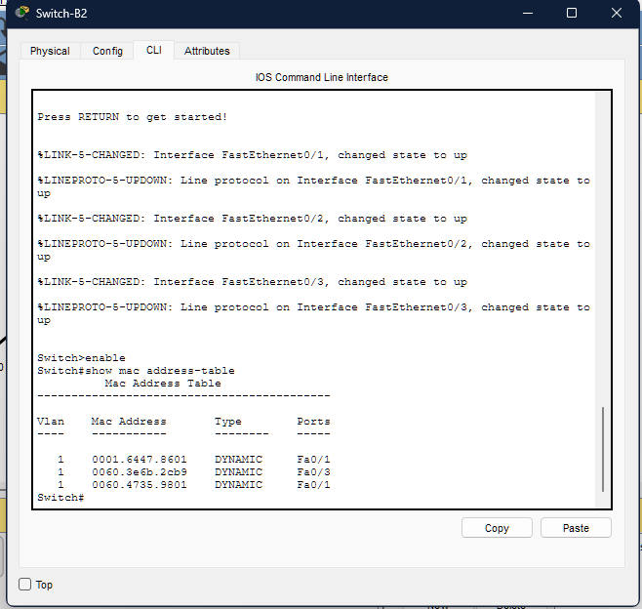

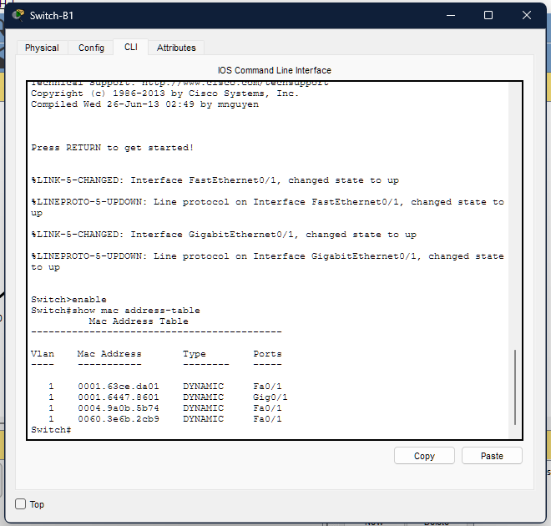
Figure 2. Switch-B1 MAC address table with dynamically learned VLAN 1 entries and active uplink ports.

Figure 3. Switch-B2 MAC address table with dynamically learned VLAN 1 entries and connected access ports
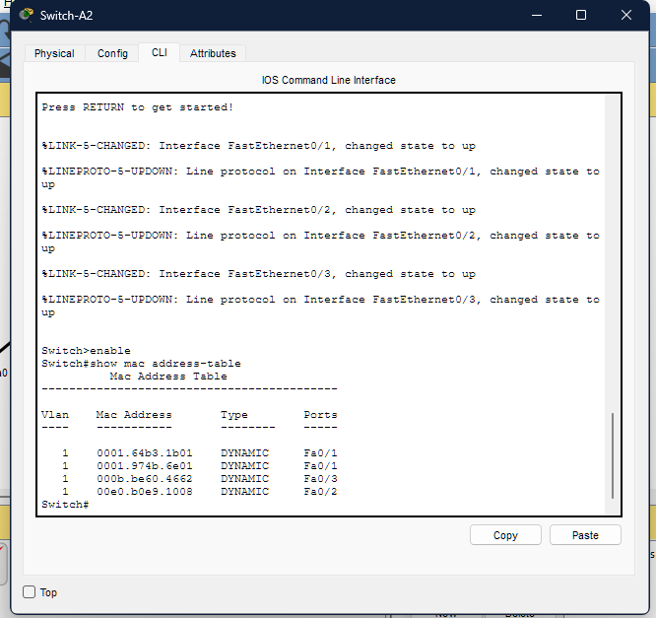
Figure 4. Switch-A2 MAC address table showing learned host MAC addresses on its access ports and the switch
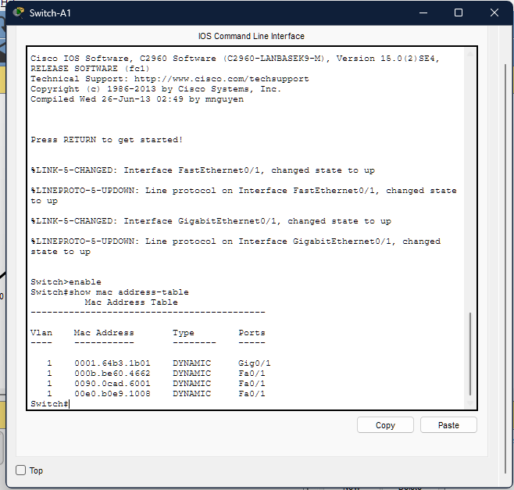
Figure 5. Switch-A1 MAC address table showing VLAN 1 entries learned from the router and downstream switch.
4. DHCP Configuration and Verification
Local DHCP pools were configured on the edge routers to automatically assign network configurations to active end-user devices, while excluding static IP address ranges reserved for default gateways, management switches, and DMZ servers.
Site-A DHCP Pool: Network 10.10.10.0/26, Default Gateway 10.10.10.1, DNS Server 8.8.8.8. Excluded IP Range: 10.10.10.1 - 10.10.10.10.
Site-B DHCP Pool: Network 10.10.20.0/26, Default Gateway 10.10.20.1, DNS Server 8.8.8.8. Excluded IP Range: 10.10.20.1 - 10.10.20.10.
Verification: End-user clients dynamically received valid IPv4 leases within their respective active subnets. For example, PC-A1 successfully obtained 10.10.10.11/26 with default gateway 10.10.10.1.
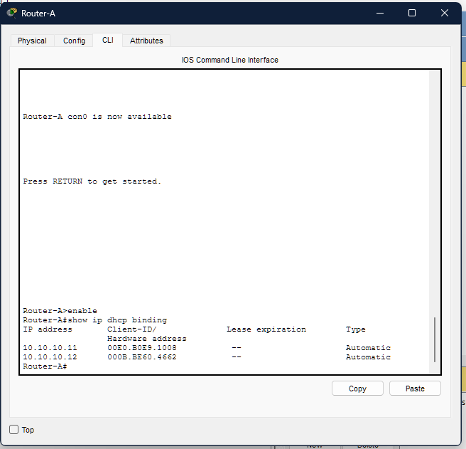
Figure 6. Router-A DHCP bindings showing automatic leases 10.10.10.11 and 10.10.10.12.

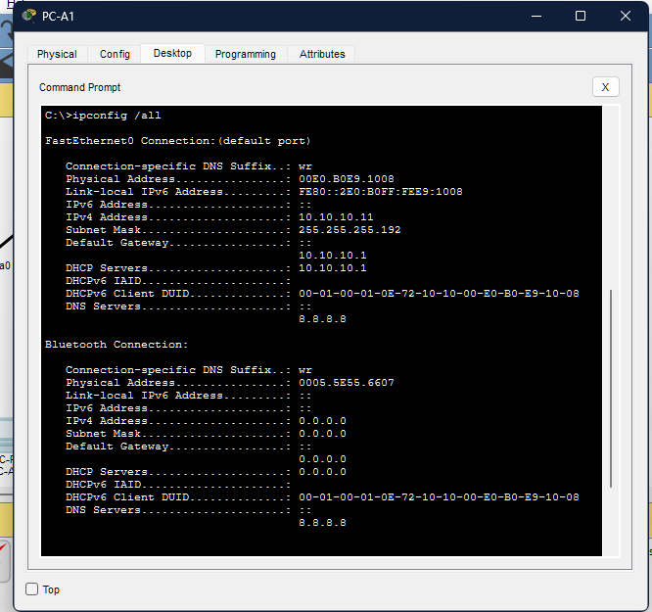
Figure 7. PC-A1 ipconfig /all output showing its DHCP address, subnet mask, gateway, and DNS server.

5. Initial Intersite Routing
Static routes were established across the serial/Ethernet WAN link to validate intersite reachability during Phase 2:
Router-A: ip route 10.10.20.0 255.255.255.192 10.10.255.2
Router-B: ip route 10.10.10.0 255.255.255.192 10.10.255.1
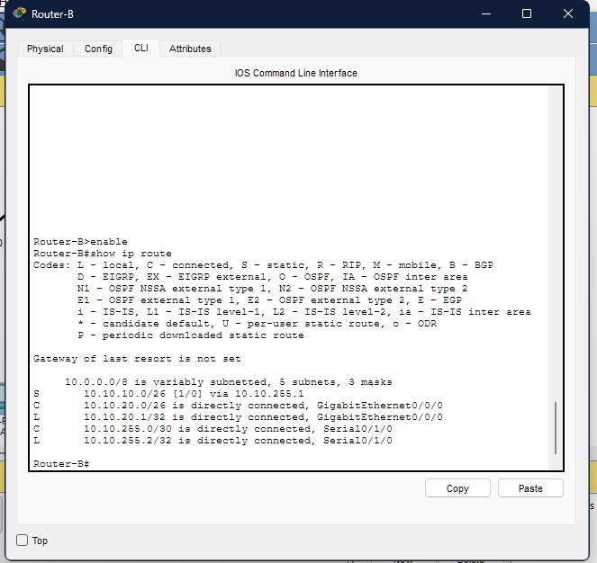
Figure 8. Router-B routing table showing the static return route to Site-A and the connected Site-B and WAN networks.
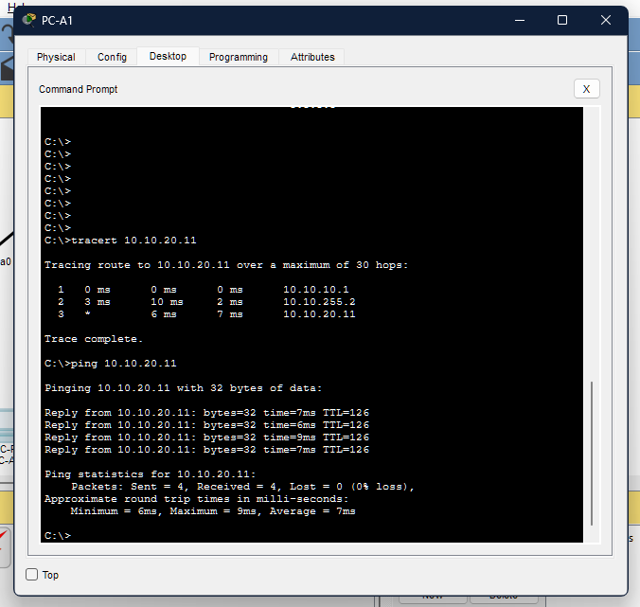

Figure 9. PC-A1 traceroute and ping results for PC-B1 at 10.10.20.11 across the intersite link.
OSPF Transition (Phase 3): In Phase 3, these temporary static routes will be replaced by dynamic OSPF Area 0 (router ospf 1) to enable scalable multi-area convergence on OpenWrt, which are static route on router A (ip route 10.10.20.0 255.255.255.192 10.10.255.2) and the static route on router B (ip route 10.10.10.0 255.255.255.192 10.10.255.1)
6. Administration and Troubleshooting Log
Implementation Issue Log (Troubleshooting)
Symptom: ICMP Echo Requests failed between PC-A1 (Site-A) and PC-B1 (Site-B).
Diagnosis: Running traceroute confirmed packets reached Router-B but were dropped on return.
Root Cause: Missing return route to subnet 10.10.10.0/26 in Router-B routing table (Asymmetric routing failure).
Remediation: Configured missing static route on Router-B (ip route 10.10.10.0 255.255.255.192 10.10.255.1) and saved to NVRAM (copy run start).
Retest: Repeated ping tests yielded a 100% success rate (0% packet loss, RTT < 2ms).
7. Preliminary Test Matrix

Test ID | Source | Destination | Procedure | Expected Result | Observed Result | Status
PR-01 | PC-A1 | Gateway A | ping 10.10.10.1 | 4/4 replies received | 0% loss | Passed
PR-02 | PC-A1 | DHCP Server | ipconfig /renew | Valid lease in range | Assigned 10.10.10.11 | Passed
PR-03 | PC-A1 | PC-B1 | ping 10.10.20.11 | Intersite connectivity | 4/4 packets received | Passed
PR-04 | Switch-A | Router-A | VLAN Subinterfaces | 802.1Q Trunking | Pending W10 Hardware | Pending

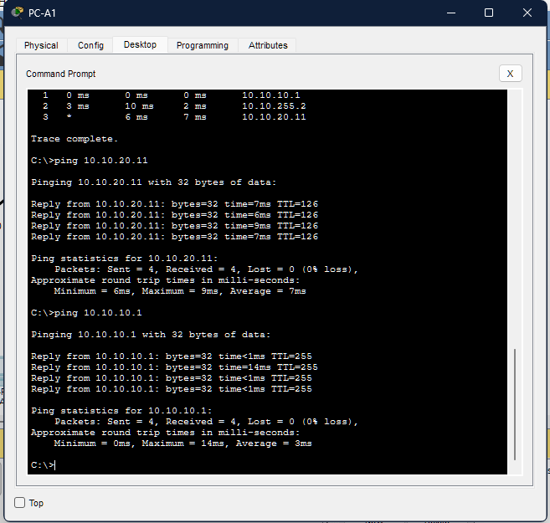
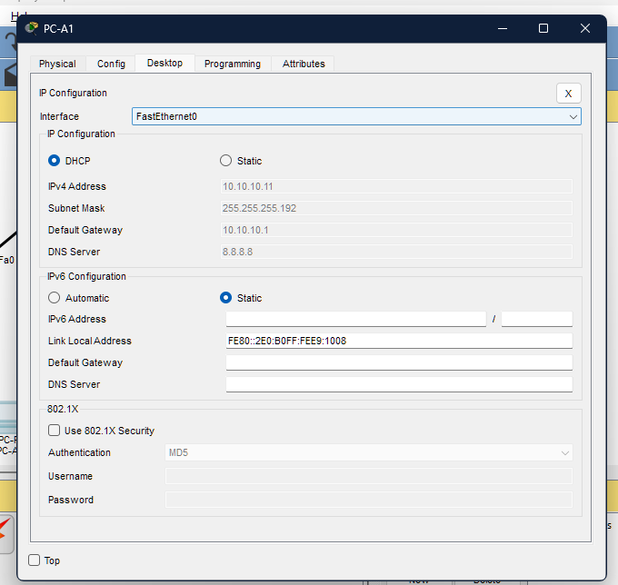
Figure 10. PC-A1 IP Configuration window showing DHCP and the assigned IPv4 settings.

Figure 11. PC-A1 command prompt showing successful connectivity checks and DHCP lease renewal.
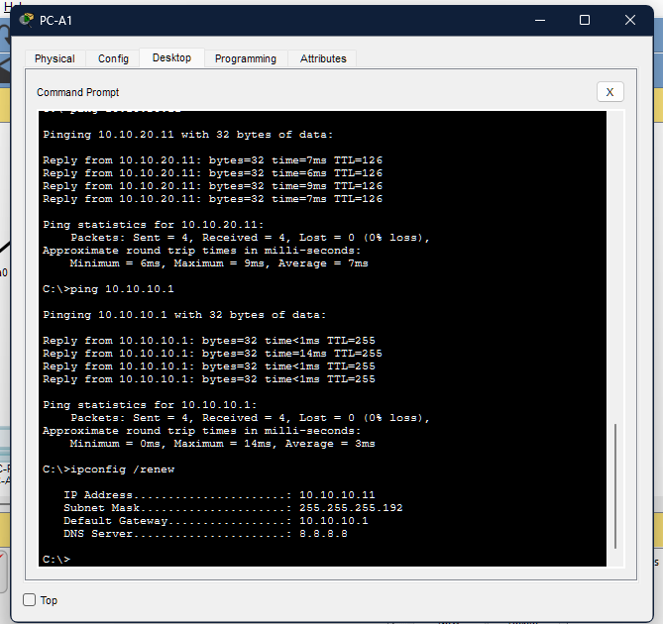
Figure 12. PC-A2 ping results for PC-B1 and PC-B2 across the intersite network.
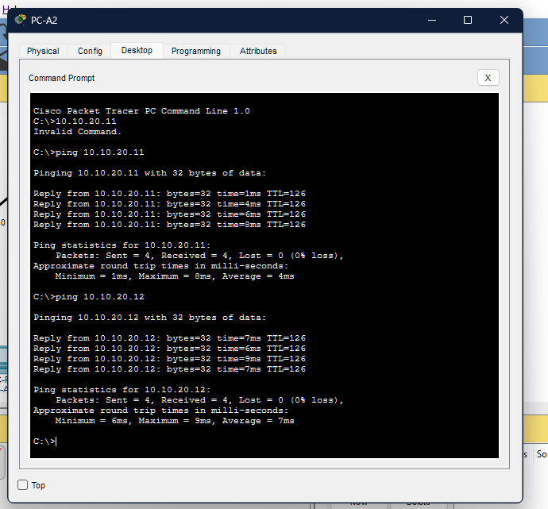
Figure 13. PC-A1 connectivity checks and ipconfig /renew output confirming its Site-A DHCP settings.
8. Completion and OpenWrt Migration Plan
Because Cisco IOS CLI syntax cannot be directly pasted into OpenWrt, the table below maps prototype Cisco configuration concepts to OpenWrt Unified Configuration Interface (UCI) syntax and /etc/config/ files:
Network Function | Cisco IOS Configuration (Complete) | OpenWrt Equivalent Syntax (Complete UCI / File)
Interface Addressing | interface GigabitEthernet0/0/0  ip address 10.10.10.1 255.255.255.192  no shutdown | File: /etc/config/network  text<br>config interface 'lan'<br> option device 'eth0'<br> option proto 'static'<br> option ipaddr '10.10.10.1'<br> option netmask '255.255.255.192'<br>
DHCP Server | ip dhcp excluded-address 10.10.10.1 10.10.10.10  ip dhcp pool POOL_SITE_A  network 10.10.10.0 255.255.255.192  default-router 10.10.10.1  dns-server 8.8.8.8 | File: /etc/config/dhcp  text<br>config dhcp 'lan'<br> option interface 'lan'<br> option start '11'<br> option limit '52'<br> option leasetime '12h'<br> list dhcp_option '6,8.8.8.8'<br>
Static Routes | ip route 10.10.20.0 255.255.255.192 10.10.255.2 | File: /etc/config/network  text<br>config route<br> option interface 'wan'<br> option target '10.10.20.0/26'<br> option nexthop '10.10.255.2'<br>
VLAN & Trunking (RoaS) | interface GigabitEthernet0/0/0.10  encapsulation dot1Q 10  ip address 10.10.10.1 255.255.255.192 | File: /etc/config/network  text<br>config device<br> option type '8021q'<br> option ifname 'eth0'<br> option vid '10'<br> option name 'eth0.10'<br><br>config interface 'vlan10'<br> option device 'eth0.10'<br> option proto 'static'<br> option ipaddr '10.10.10.1'<br> option netmask '255.255.255.192'<br>
EtherChannel (Link Aggregation) | interface Port-channel 1  interface range FastEthernet0/1 - 2  channel-group 1 mode active | File: /etc/config/network  text<br>config interface 'bond0'<br> option device 'bond0'<br> option proto 'bonding'<br> list slaves 'eth1'<br> list slaves 'eth2'<br> option mode '802.3ad'<br>
RSTP (Spanning Tree) | spanning-tree mode rapid-pvst  spanning-tree vlan 1 priority 4096 | File: /etc/config/network  text<br>config device<br> option name 'br-lan'<br> option type 'bridge'<br> list ports 'eth0'<br> list ports 'eth1'<br> option stp '1'<br>
Dynamic Routing (OSPF) | router ospf 1  router-id 1.1.1.1  network 10.10.10.0 0.0.0.63 area 0  network 10.10.255.0 0.0.0.3 area 0 | File: /etc/frr/frr.conf (via FRRouting daemon)  text<br>router ospf<br> ospf router-id 1.1.1.1<br> network 10.10.10.0/26 area 0<br> network 10.10.255.0/30 area 0<br>
NAT & Firewall | access-list 1 permit 10.10.10.0 0.0.0.63  ip nat inside source list 1 interface Serial0/1/0 overload | File: /etc/config/firewall  text<br>config nat<br> option name 'MASQUERADE_LAN'<br> option src 'lan'<br> option dest 'wan'<br> option target 'MASQUERADE'<br>

Individual Work Statement and AI Assistance Disclosure
This project was independently developed by Kevin Almache. Conversational AI tools were responsibly utilized for report structuring and VLSM subnetting validation in compliance with course guidelines.

