**3.2**

**(1)**

r1 =0.2; r2=0.25 f1=0.15; f2=0.1

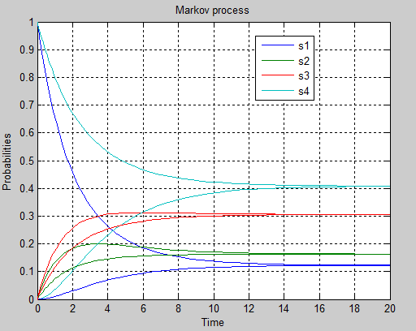P1= [1 0 0 0] and P2 = [0 0 1 0]

**(2)**

r1= 0.4; r2 =0.5; f1= 0.15; f2=0.1

P1 = [1 0 0 0] p2 = [0 0 1 0]

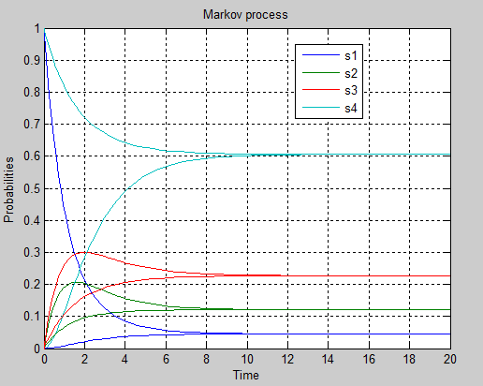

**3.3**

Yes the process is ergodic, stationary values and eigenvalues are in the left half plane

**(1)**

stationary_solution_vector = [0.1224 0.1633 0.3061 0.4082)

Eigenvalues_of_A = [-0.7000 -0.3500 -0.0000 -0.3500)

**(2)**

Stationary_solution_vector = [0.0455 0.1212 0.2273 0.6061]

Eigenvalues_of_A = [-1.1500 -0.0000 -0.5500 -0.6000]

**3.4**

**3.5**

**(1)**

Sum (0.1224 0.1633 0.3061 0.4082) =1, Checked.

**(2)**

Sum (0.0455 0.1212 0.2273 0.6061) =1, Checked.

**3.6**

**(1)**

Eigenvalues_of_A = [-0.7000 -0.3500 -0.0000 -0.3500)

We see that all the eigenvalues are in the left half plane which gives us an stable system.

**(2)**

Eigenvalues_of_A = [-1.1500 -0.0000 -0.5500 -0.6000]

Since the system is continuous and all eigenvalues are in the left half plane therefor we can conclude that the system is stable.

3.7

We have eight states, one can calculate with the formula 2*2*(N+1) where N is the maximum number of items that the buffer can contain

3.8

-0.2500 0.1500 0.1000 0 0 0 0 0

0.1200 -0.2200 0 0.1000 0 0 0 0

0.0700 0 -0.72 0.1500 0 0 0.5000 0

0 0.0700 0.1200 -0.6900 0 0 0 0.5

0 0 0 0 -0.2500 0.1500 0.1000 0

0 0.7000 0 0 0.1200 -0.92 0 0.15

0 0 0 0 0.0700 0 -0.2200 0.15

0 0 0 0.7000 0 0.0700 0.1200 -0.89