2.1
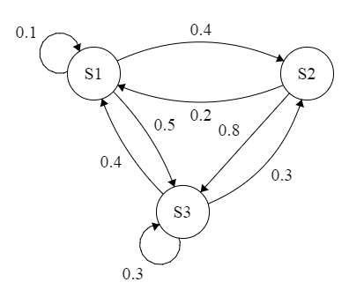

2.2
Eigenvalues: [1 -0.3-0.1414i -0.3+0.1414i]
Yes, it is ergodic. One eigenvalue is one and the rest reaching same stationary values from any initial state

2.3

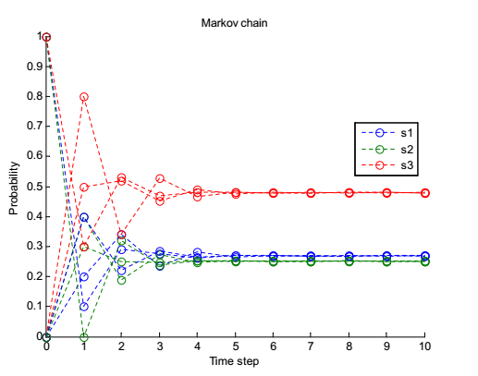
2.4 -2.7
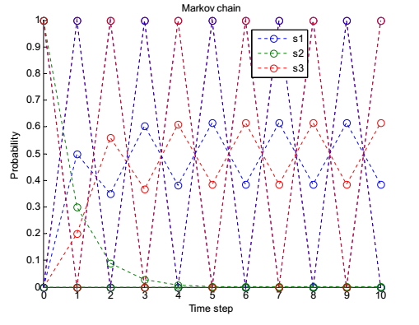
Not ergodic, periodic and does not reach stationary values.
Ergodic: Absorbing state and reaching same stationary values from any initial state.

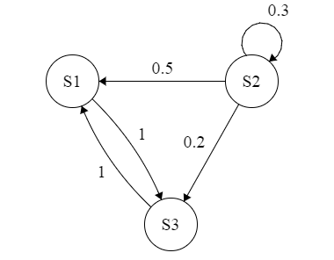
Eigenvalues: [0.3 1 -1]
Two eigenvalues are 1 which gives not ergodic.

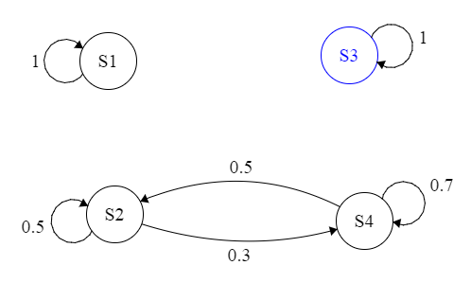
Eigenvalues: [1 0.2 1 1]
Three eigenvalues are 1 which gives not ergodic

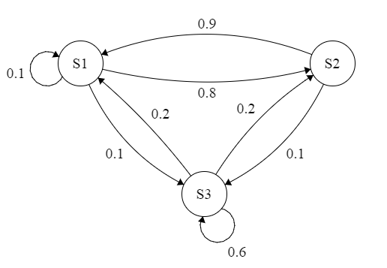

2.9
