2.1. Verify Reset Operation
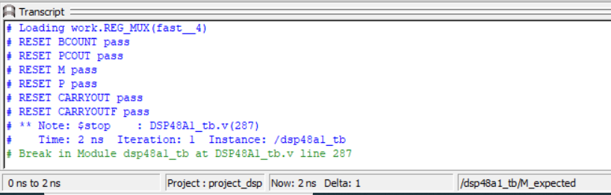
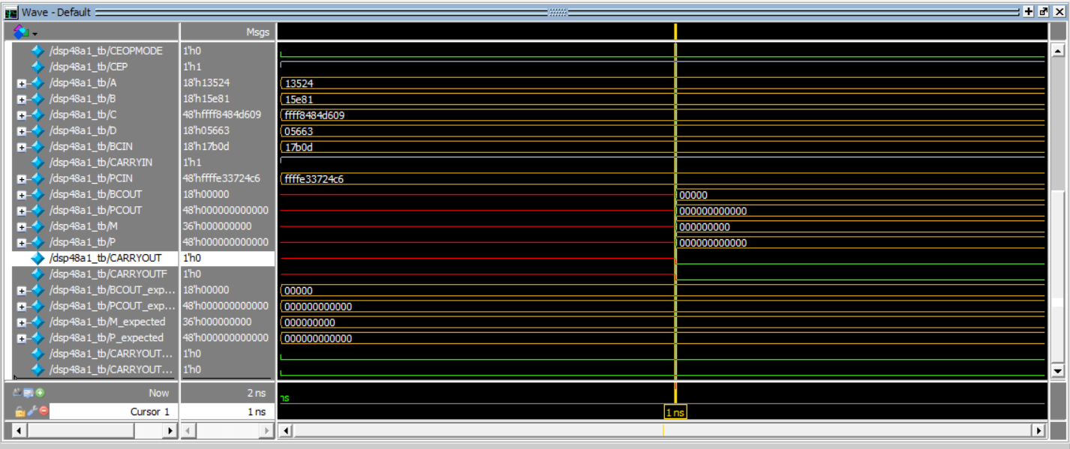

2.2. Verify DSP Path 1

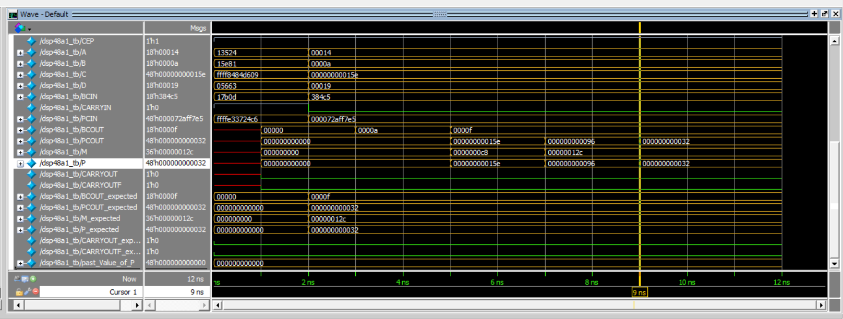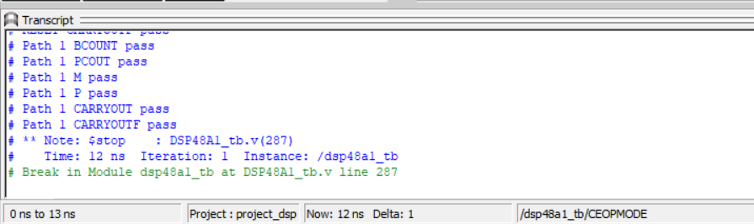

2.3. Verify DSP Path 2

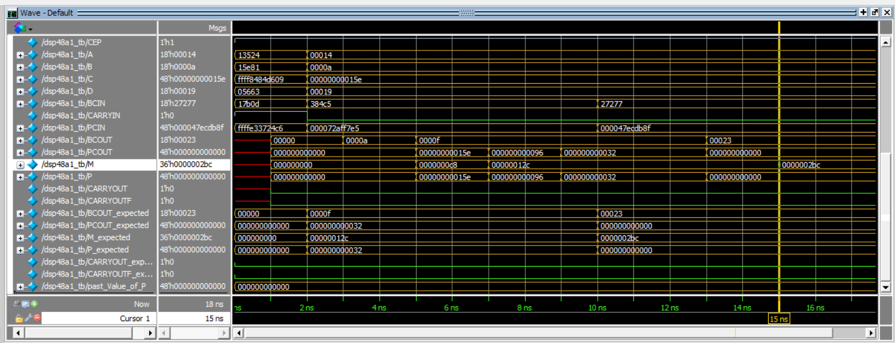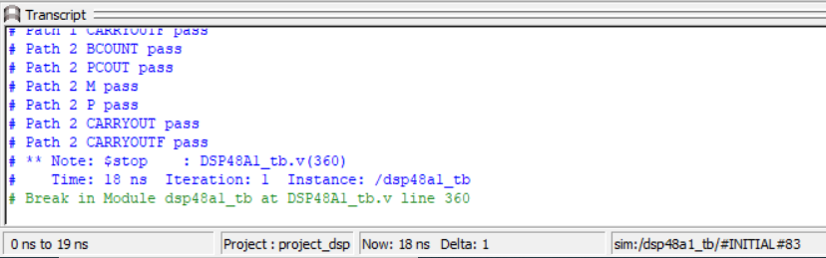

2.4. Verify DSP Path 3

2.5. Verify DSP Path 4
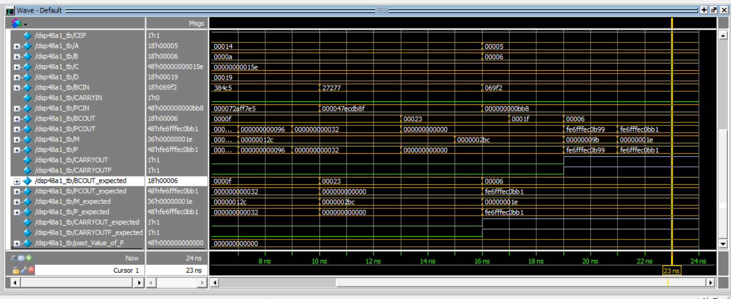
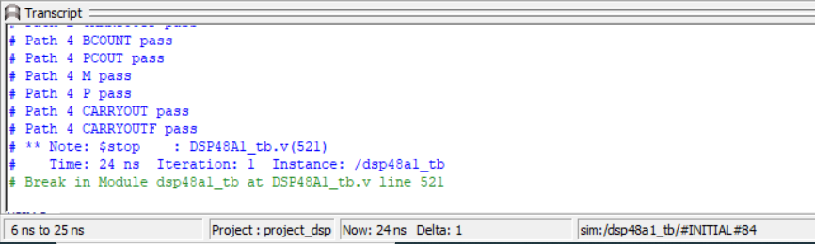

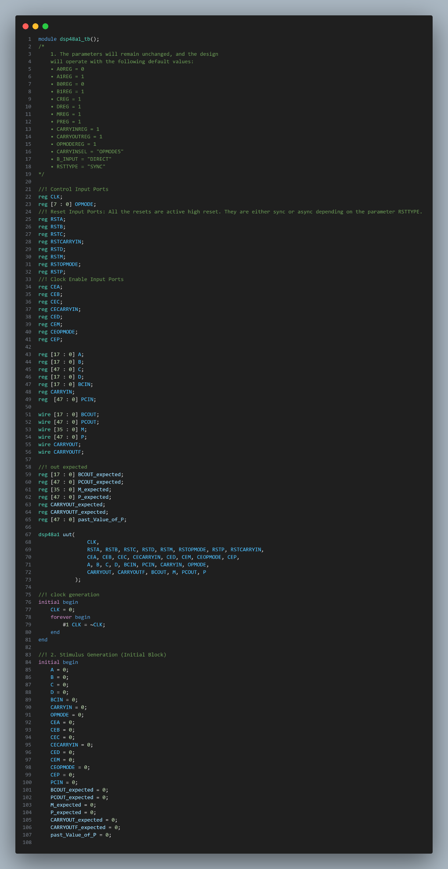
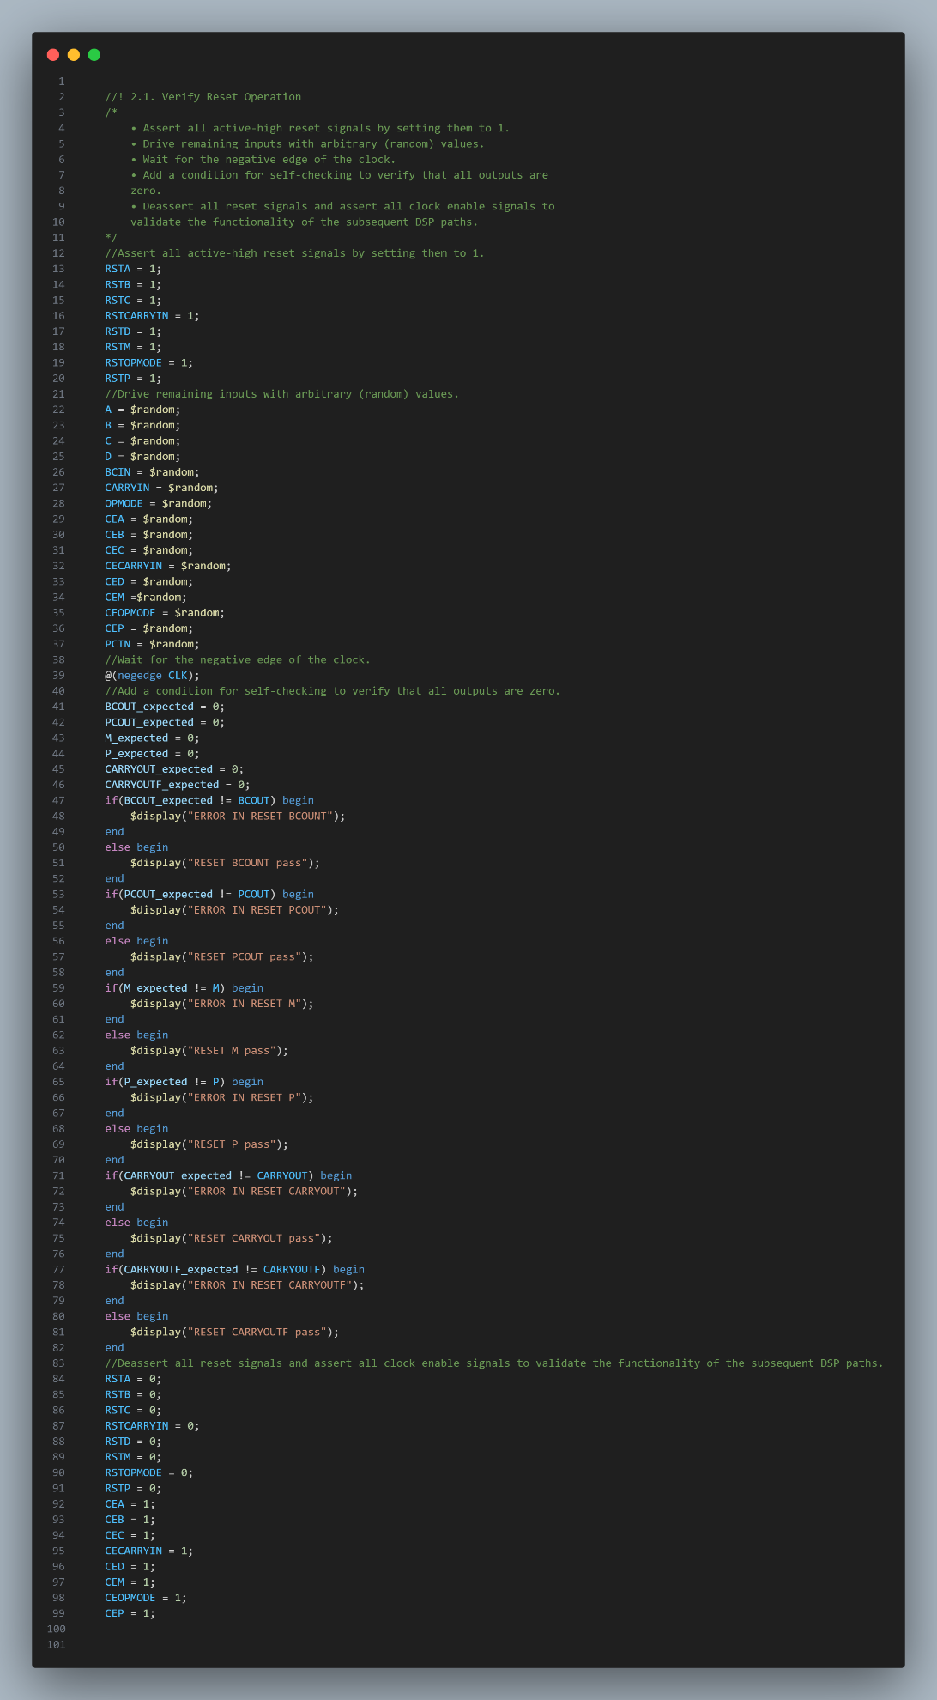
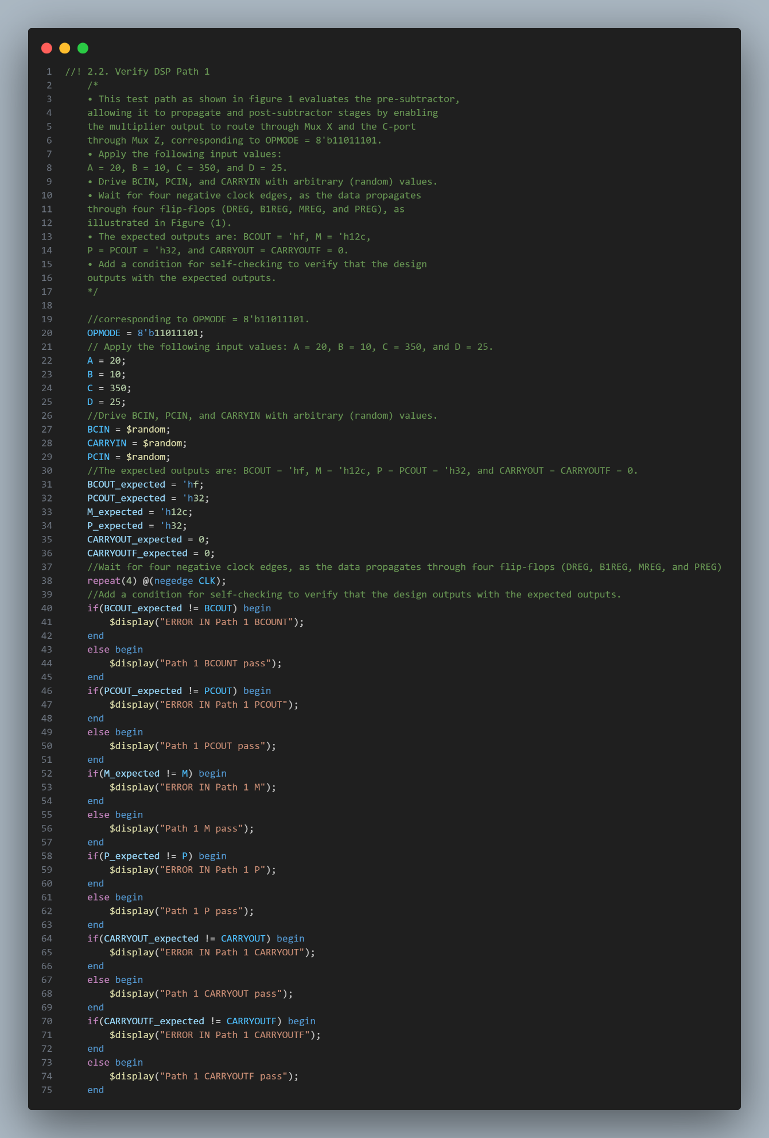
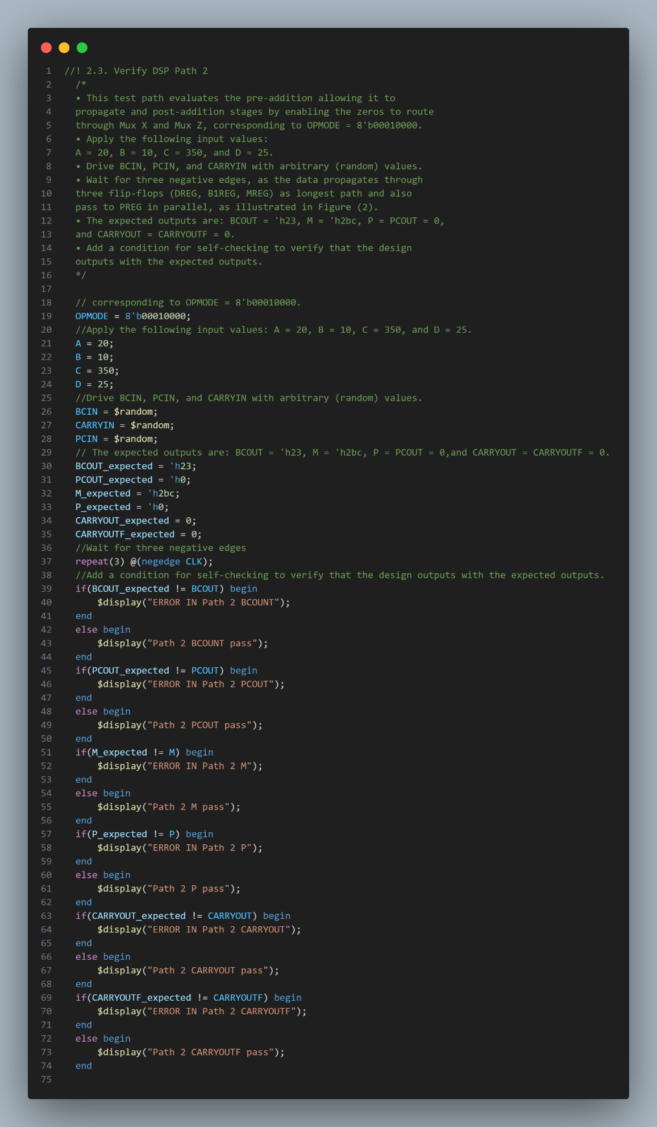
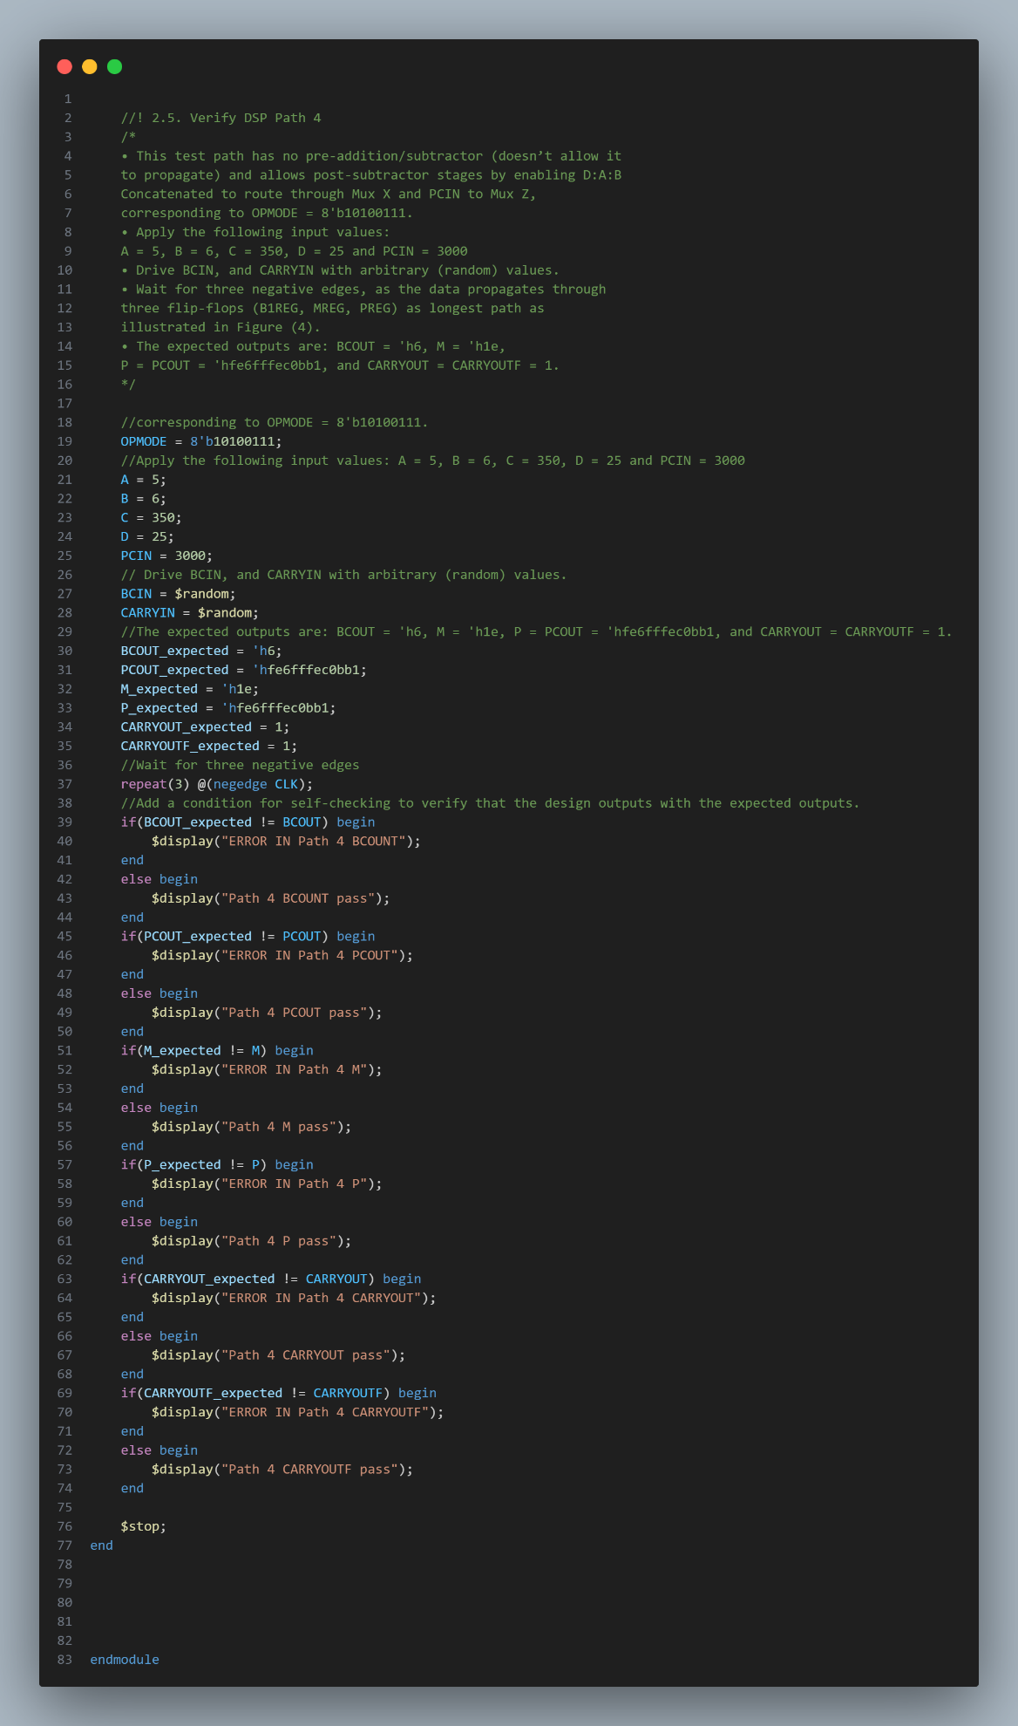
module dsp48a1_tb();
//! 1. The parameters will remain unchanged.
//! Control Input Ports
reg CLK;
reg [7 : 0] OPMODE;
//! Reset Input Ports: All the resets are active high reset. They are either sync or async depending on the parameter RSTTYPE.
reg RSTA, RSTB, RSTC, RSTCARRYIN, RSTD, RSTM, RSTOPMODE, RSTP;
//! Clock Enable Input Ports
reg CEA, CEB, CEC, CECARRYIN, CED, CEM, CEOPMODE, CEP;

reg [17 : 0] A, D, B, BCIN;
reg CARRYIN;
reg [47 : 0] PCIN, C;
wire [17 : 0] BCOUT;
wire [47 : 0] PCOUT, P;
wire [35 : 0] M;
wire CARRYOUT, CARRYOUTF;

//! out expected
reg [17 : 0] BCOUT_expected;
reg [47 : 0] PCOUT_expected, P_expected;
reg [35 : 0] M_expected;
reg CARRYOUT_expected, CARRYOUTF_expected;
reg [47 : 0] past_Value_of_P;
reg past_value_of_CARRYOUT;
reg [48 : 0] result;

dsp48a1 uut(
CLK, RSTA, RSTB, RSTC, RSTD, RSTM, RSTOPMODE, RSTP, RSTCARRYIN,
CEA, CEB, CEC, CECARRYIN, CED, CEM, CEOPMODE, CEP, A, B, C, D, BCIN, PCIN, CARRYIN, OPMODE,
CARRYOUT, CARRYOUTF, BCOUT, M, PCOUT, P
);

