URL to GitHub Repository: https://github.com/elthomas20/Week-3-Lab
URL to Your Coding Assignment Video: https://drive.google.com/file/d/1oC4grx9zXhu73_-0kqHOg1gAr_wkuQiu/view?usp=sharing
After watching the video, Source Control with git, you should have already set up a GitHub account for this program.
If you have not setup your GitHub account, review the above video in the Week 3: Weekly Videos and Curriculum and set your account up before proceeding with this assignment.
Instructions:
- Create a new repository on GitHub for this week’s assignments and push this document, and any files that you have created to the repository.
- Include the URLs for this week’s repository and video where instructed.
- Submit this document as a .PDF file in the LMS.
Assignment Steps:
- The link below has a zipped file that contains an empty directory (folder) for your assignments.
- Download the file to your computer and unzip it.
- This directory (folder) should be used to organize each week’s projects in the course.
https://drive.google.com/file/d/1WDc_WJ8I0MfwbrbmtMsxHdTpupZsPjXT/view
Note: In the following Git/GitHub Tutorial, a file is created in Terminal (on a Mac) using touch filename
To do the same thing in Command Prompt (on Windows), use the following command:
(Windows or Mac) echo “text-to-put-into-file” > filename

- Following the Git/GitHub tutorial in your week 0 video:
  - Create a directory (folder) inside Week 03 directory
  - Create a repository on the GitHub website.
  - Push your directory of files to GitHub as instructed in the video.
  - After your first push, please ensure that you make some changes to your directory (folder), such as adding a new file or changing your code.
  - Push those changes to your repository a second time (as shown in the video).
https://www.youtube.com/watch?v=NGeksLUB1e8
- When complete, paste a screenshot of your terminal or command prompt that shows the commands above completed.
Pushing the README.md:
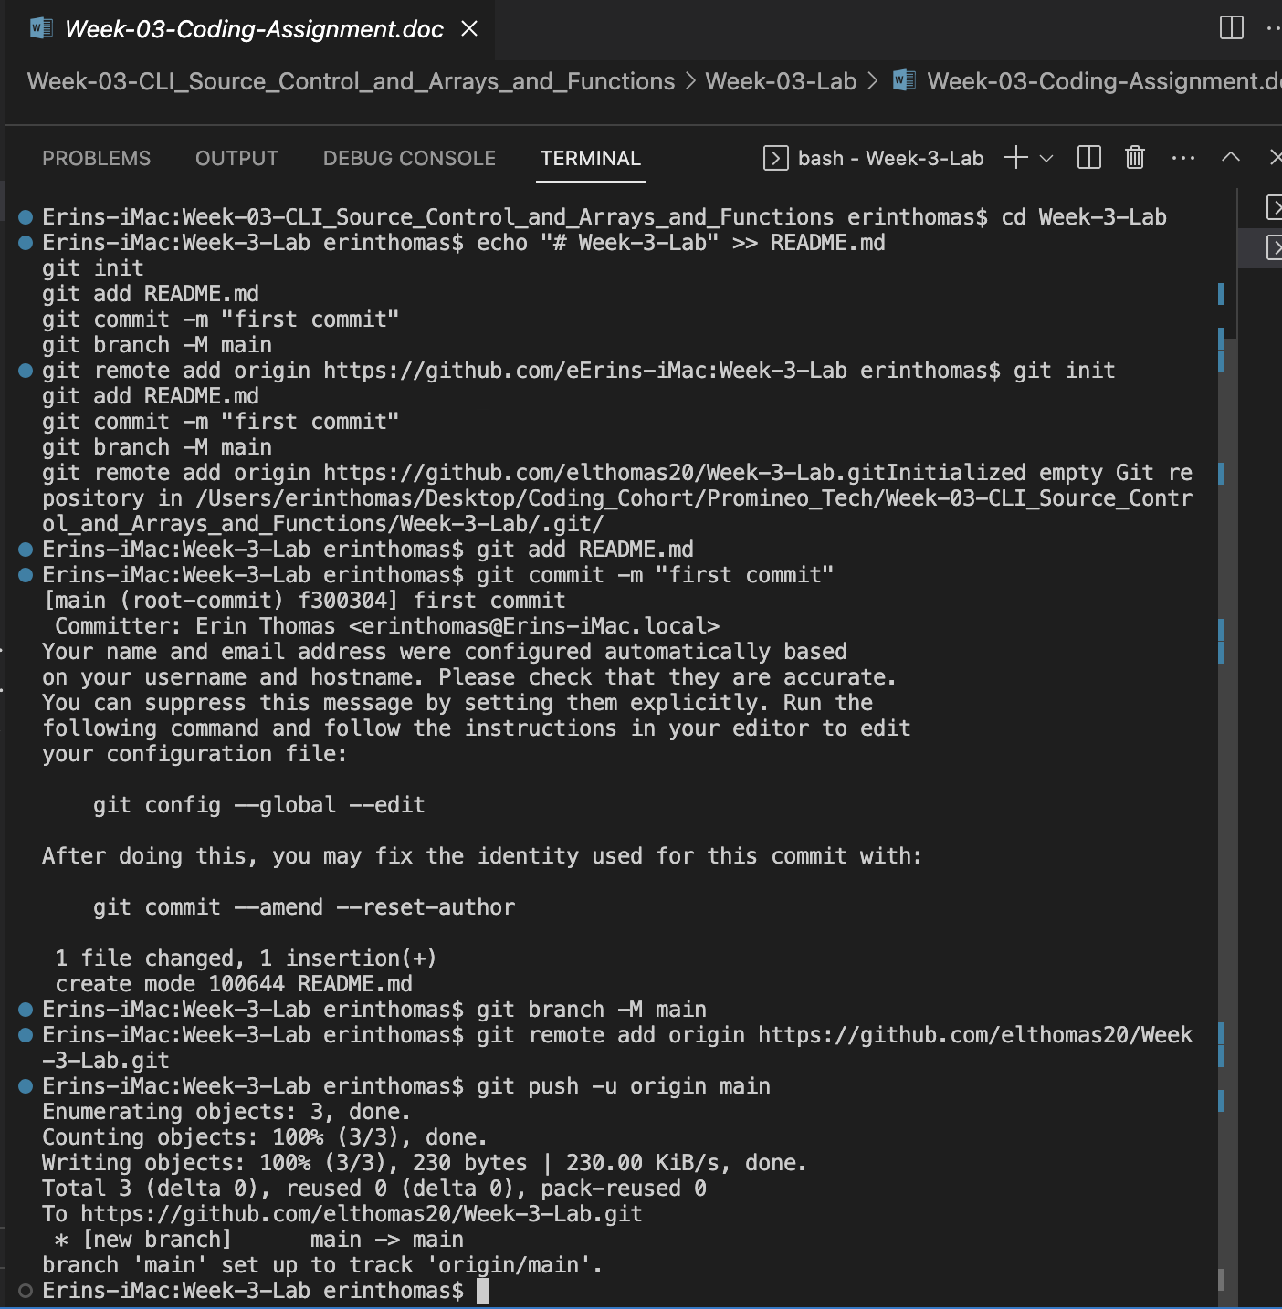

Pushing updated files:
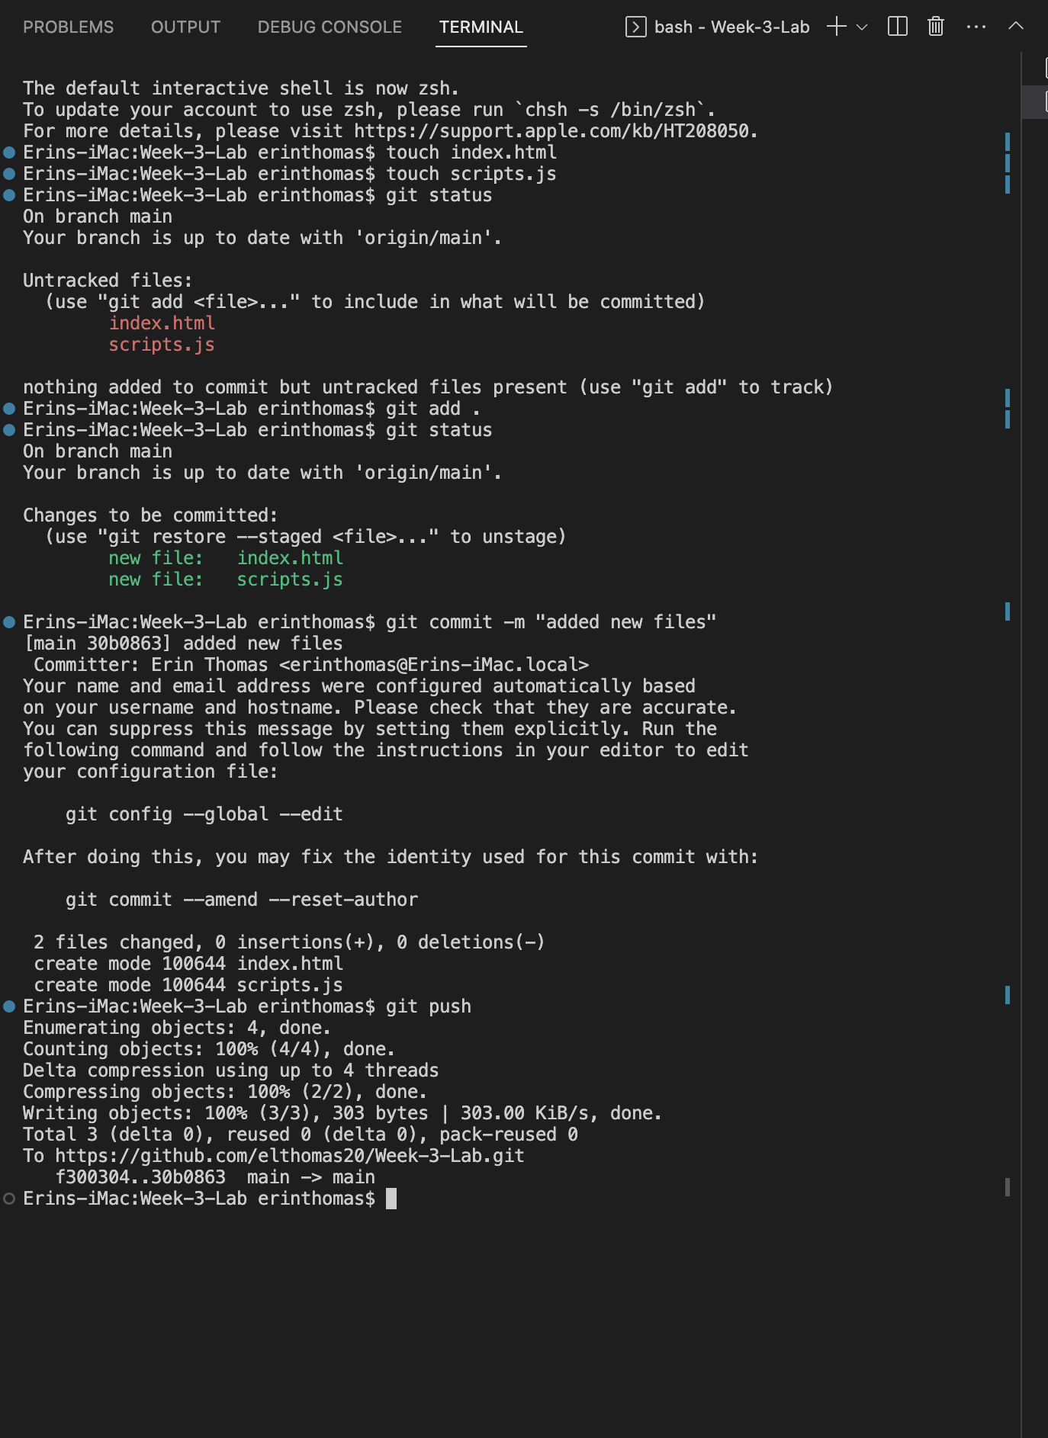

Video Steps:
- Create a video, up to five minutes max, showing and explaining exactly what you did for this assignment Git/GitHub.
- This video should be done using screen share and voice over.
- This can easily be done using Zoom, although you don't have to use Zoom, it's just what we recommend.
  - You can create a new meeting, start screen sharing, and start recording.
  - This will create a video recording on your computer.
- This should then be uploaded to a publicly accessible site, such as YouTube.
  - Ensure the link you share is PUBLIC or UNLISTED!
  - If it is not accessible by your grader, your project will be graded based on what they can access.

