Edinburgh Twins Club
Newsletter

October 2005

Hello and welcome to the October edition of our Newsletter!

Personally I love this time of year. Autumn has always been one of my favourite times, crisp mornings, beautiful colours and a fresh feeling in the air - time to get cosied up in the evenings with the latest ETC newsletter!.

It also marks the changes for The Edinburgh Twins Club Committee as we enter our final phase with the current set up. We have been very pleased with the positive response form members to join the next committee from January 2006. Many of the positions look like they may be filled however one or two still remain! Namely: membership and social organisers - we have one of each so far so its just someone else to join in and help. Please think about it and let me know if you think you could help out. Our Newsletter Editor will also be stepping down after the January issue so if you have any experience in this area, do get in touch. Please see the announcement of our AGM on Monday 9th January, 8pm at The Murrayfield Hotel. This will be the official hand over date for the new committee and we would encourage as many members out there as possible to come along. It is not just for those interested in joining the new committee but it is the main meeting for any member to come along to and have a say, so please come along if you can.
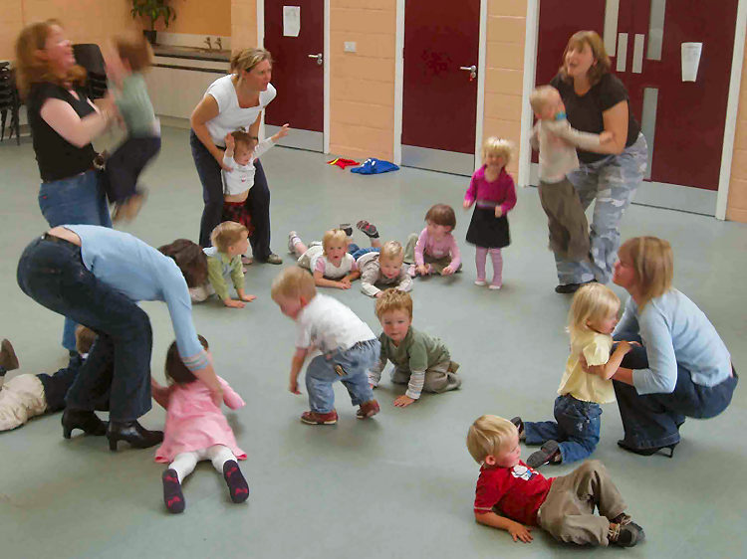
Also it’s time to book up for the Christmas party again! Catriona and Sarah have been busy organising a special day for children of all ages again this year. Remember to get your form back to them as soon as possible.

So its good bye from me and a special thanks to all the committee for being such a terrific support this year, everyone has brought something to the team and I have really enjoyed my time as Chair person, I would never have taken it on without such a wonderful team.

I wish everyone good luck for next year hope you find it as rewarding as I have.
Thank you
Vicky Petrie
Chairperson
339-0135
victoria@lesterpetrie.freeserve.co.uk
Competition hots up at the weeklyToddler Hurling Contest. It’s one way to keep fit!

 | Membership Update  Welcoming the newest members of ETC | 2 |  | Daytime Activities  Times, venues, directions, news. Photos of the group in action! | 9
 | AGM Agenda  Agenda for the Twins Club AGM in January. | 3 |  | Discounts  Everyone’s favourite perk – which shops and how much | 11
 | Member’s story  An honest, eloquent birth story from one of our members | 4 |  | Snippets  Bite sized chunks of news, information and trivia | 12
 | Starting School  The best days of their lives? Tales of the first day of school. | 6 |  | Swap Shop  For sale + wanted, everything from buggies to nannies | 15
 | Social Snaps  Some stunning extra-terrestrial sightings! | 8 |  | Social Calendar  The party season is upon us! Forms by 16th November please. | 16

Membership Update

Dear Members
Some of our new members have had their babies since we last wrote, CONGRATULATIONS to:
- Lesley-Ann and Andrew Broadley have had two little boys, Christopher and Nicholas, born on 15th August 2005, baby brothers for Rachel who was 2 past July;
- Marie Green and Gary Holland have had two little boys: Daniel and Joseph Holland were born on 21st July 2005;
- Helen and Dave Massie have had two little girls Louise and Fiona, born on 19th September, siblings for big brother, Ewan, born on 6 January 1999;
- Cara and Tom Chambers have had a little boy and girl, Cameron Michael and Ailsa Jane born on 6 September 2005.
Well done and MANY CONGRATULATIONS to all our new arrivals!
We have the following families who have joined the Club since the last newsletter – WELCOME to:
- Kirstin and Charlie Evans, and their son Benjamin aged 2 past February, and twins Amelia and Imogen born in June;
- Paula and Chris Ryan, who are expecting twins in January 2006;
- Gillian and Aonghas Morrison; who have twins Ross and Ellen born in February this year;
- Frances and Craig Burgess; who have a little boy Euan born in August 2002, and twins Kyle and Alex born in September;
- Morag and Ian Inglis; who are also expecting their twins in January 2006; and to
- Hayley and Derek King-Hay; who have a little boy Ashton born in April 2004 and are expecting twins this month.
Our membership list currently consists of 130 families.

ARE YOU LEAVING…We would be really grateful to hear from you should you not wish to continue your membership of the Club. It would be interesting for us to know why you don’t want to continue membership, bearing in mind we are aware that there is perhaps less need for support as the children get older. Also, hearing from you would greatly assist our admin hence a quick call or e-mail would be very much appreciated!
IF THERE IS A MEMBERSHIP FORM WITH THIS NEWSLETTER…your membership is either due or overdue for renewal. Please complete the form and send it with your cheque to Gillian Smith by mid-November 2005. The Club’s AGM is in January and we would really appreciate having all records up to date by late December in order to provide a full and accurate final report. Please, if your renewal is due this quarter but you do not intend to stay as members, please advise Gillian or Karen as soon as possible.
PLEASE LET US KNOW YOUR BABY NEWS… Please do not forget to call Karen or Gillian and let us know news of your arrivals – this really will help us come Newsletter time. If we have missed the birth of your babies, or you are a new member and we have missed you from our list, please let us know so that we can add you to our next newsletter.
FINALLY…THANK YOU to all our members. We have thoroughly enjoyed being involved with the Edinburgh Twins Club as your Membership Secretaries, and have enjoyed sharing, for the most part, some very special stories and have been deeply saddened by others. We really have laughed with you and cried with you as you have told us of your baby news. Thank you for taking the time to share your special moments with us over the last two years, we really are proud to have been involved at the heart of such a great Club.
We wish you every success in the future and hope to see you at some forthcoming ETC event. After all, we really had better remain members!

Best wishes,
Karen and Gillian, Membership Secretaries

Karen Winfield  23 Bluebell Glade  Adambrae Parks  LIVINGSTON EH54 9JJ   +44 (0) 1506-416 412  Karen@the-winfields.com | Gillian Smith  22 Braid Avenue  Morningside  EDINBURGH EH10 6EE   +44 (0) 131-447 3000  Gillian@bitts22.freeserve.co.uk

Please note that we will include you on our membership page within the Newsletter unless we hear otherwise by telephone, e-mail or by your indication on your Application Form when you join.
Edinburgh Twins Club AGM
Notice is hereby given that the Annual General Meeting of the Edinburgh Twins Club will be held at The Murrayfield Hotel, 18 Corstorphine Road, Edinburgh,
EH12 6HN Scotland on
Monday 9 January 2006 at 8:00pm for the following purposes:

The Chairperson to note that due Notice of the AGM was given and that a quorum is present in accordance with article 6.5 of the Constitution;

To consider the Report from the Chairperson and the Treasurer;

To approve the Accounts for the year to 30th September 2005;

To accept the resignation of each serving Officer and Committee Member of the Club;

To elect each Officer and new Committee Member of the Club for the following year: 2006 to 2007; ^{[4]}

To consider any other business or resolution that has been submitted to the Committee for approval at least 28 days in advance of the meeting.
By order of the Committee,
Jenifer Robertson
Secretary
Date: 17th October 2005

Notes:
1 If you are unable to attend in person, a member who is entitled to attend and vote [in accordance with article 6.7 of the Constitution ‘Eligibility to Vote shall be determined by possession of a current Club membership card’] is also entitled to appoint a proxy (or proxies) to attend and, on a poll, vote instead of him. A proxy need not be a Member of the Club. A proxy may not speak at the meeting except with permission from the Chairman of the AGM.
2 A Form of Proxy is available and can be forwarded upon request. Any requests for Proxy Forms should be made to the current Secretary, Jenifer Robertson. The appointment of a proxy will not prevent a member from subsequently attending and voting at the meeting in person.
3 To be effective the proxy must be deposited with Jenifer Robertson, not less than 48 hours before the time for holding the Meeting.
4 In the event more than one person is proposed for the same Appointment as an Officer or Committee Member of the Club, the persons proposed for that Appointment will leave the Meeting and a vote will be taken. In accordance with article 6.8 of the Constitution ‘Motions shall pass or fail on a simple majority’. Appointments will be made in accordance with article 5.1 of the Constitution for:

Office of Chairperson
Office of Secretary and Vice-Chairperson
Office of Treasurer

Daytime Co-ordinator, Edinburgh
Daytime Co-ordinator, East Lothian
Daytime Co-ordinator, West Lothian
Fundraiser
Membership Secretary [1 or 2 persons]
Newsletter Editor
Social Convenor [1 or 2 persons]
Website Controller/Administrator [1 person]

Members’ Stories

This issue we have a roller-coaster of a Birth Story from Gabby Carlyon. Those of you who have ‘been there’ will find much to identify with and we hope those of you waiting for the big event will be encouraged to know, no matter what, it’s all worth it in the end! Thanks for sending this in Gabby, and reminding us of the emotional high of being parents – something all too easy to forget in the course of the daily chaos. It’s almost enough to make us old hands feel broody again – well, almost!

The Day my babies were born

The night before the big day, I lay in bed thinking about this huge bump and what was going to happen. Up until then pregnancy seemed like a game, albeit a not very fun one most of the time. At 6.30am my sister, Leigh, picked us up. I could only think, ‘I hope I’m not sick in her new car’. I was sick just before we left the house. Oh how I looked forward to the pregnancy sickness being over!

We arrived at the hospital and went up to the ward after a couple of ‘before’ photos in the car park. In the room I was told to get unpacked and wait for the nurse to come. We sat waiting, feeling the emotion, you could have cut it with a knife. The nurse came, went through things and gave me a rather fetching gown to put on. I had cream put on my hand and lower spine to numb them, blood taken to check my blood and then it was section time.

After shuffling along the corridor with my bum hanging out and my red fluffy slippers on, we finally made it to the pre-op room - so many machines, lights and people! I was put up on a table, asked to take off my slippers. For some reason all I could think of was loosing my slippers! I was told by a doctor to try and lean forward as far as I could but to stick my bum out and arch my back… with this belly?! You must be joking! I didn't feel the epidural needle but certainly felt the stuff going in, although I was too excited to feel it as real pain. Within seconds I couldn't feel my legs and when the catheter was put in I didn't feel a thing!

I was then lifted onto a trolley and wheeled into the theatre. A frame and then a sheet were put up so that we couldn't see anything. I remember looking into the big lights to try and see if I could see a reflection of my belly, but I couldn't. Then the operation began, music was playing although I couldn't tell you what it was. I remember lying there thinking this was like watching an episode of Casualty, only I was the star!

Some time later, I don’t know how long, I asked if they had opened me up yet and was told they had.

I felt some tugging, like they were kneading my belly, but no pain - a very odd sensation indeed. Then a sudden rush of activity, a big pulling feeling and…a baby! Commotion! 11.27am, a tiny little foot and some bright ginger hair went passed my head. ‘It’s a boy! 5lbs 4oz’. Then more movements and more commotion. 11.30am, ‘It’s a girl! 6lbs 7oz’. James and Eilidh, I immediately thought. My babies, our babies. Andy kissed me and I cried. I wanted to see them.
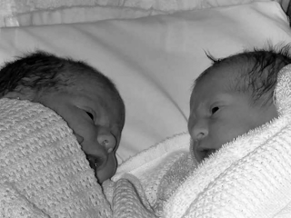
James and Eilidh at 2 hours old

Its quite common with Caesarean births that the baby, or babies, need a little help to start breathing, and then there they were. First a tiny little red haired boy with a very serious looking wee face and then a bright red and chubby cheeked little girl with a mop of dark brown hair. My overwhelming immediate feelings of love rushed through me, I just couldn’t take the emotion. I cried my eyes out. I held James for a bit while Andy held Eilidh, then my arms went all shaky and I had a sudden shooting, agonising pain in my shoulder. James was taken from me and I was given morphine, something to do with trapped air under my diaphragm.

A while later James and Eilidh in cots on wheels, me on a bed with a drip and Andy following, were taken to the recovery suite. It’s all a bit of a haze, the next couple of hours. I tried to feed James and Eilidh but I had hardly any milk. I massaged and Andy drew up what little milk there was into a syringe. At one point he squirted it all up the curtain trying to get an air bubble out. 25 minutes to get 2.5mls of milk and he squirted it all away - funny looking back but we were not amused at the time!

On the Tuesday, after numerous heel pricks to test his blood sugar levels, James was diagnosed as having Low Glucose levels and the Midwife told me he was to be taken to neo-natal care to be tube fed. When they took him away I was heart broken. Eilidh however was feeding better but not from me. I made the difficult decision to put them both onto formula bottles. I felt like such a failure but it was the only thing I could do. They needed milk! So, onto bottle-feeding and it all started to come together.

Andy spent the next few days between my room and the neo natal unit taking care of James, asking lots of questions and reporting back. The neo-natal unit was so far away from my ward and it took me ages to get there. The first time I went, I cried. James was in a plastic cot, all bundled up with blankets with tubes coming out his nose and hand. It was hard to see my little baby looking so helpless. The nurses told me he was going to be there for a few days.

On the Thursday Eilidh and I came home. I was torn between wanting to be at home, in my own bed and wanting to be near James. But he was being taken very good care of by the staff and by his Daddy that I thought the best thing was for me to go home, recover a bit and get used to having at least one baby in our flat.

When we got home, we put Eilidh down onto her cabbage patch and we just stared at her. Our daughter. She was in our care now, no midwife, no doctors - we were on our own.

James got better and his blood sugar levels went up over the next couple of days. Andy went to see him every day and he was allowed to come home on the Saturday, on a strict four hourly feeding routine. I was so happy and so proud to have my little family all in the one place.

We had two babies now to care for. Seeing James, our handsome little fella, and Eilidh together on their mat on the floor was the most wonderful feeling, I was overjoyed. Andy just beamed with pride. It was all up to us now, we were their parents and we had to get on with it and be the best parents we could. Which is what we have been doing ever since. We have our ups and downs but we are a family now.

James and Eilidh now

My Mum always said to me that there is no feeling like the feeling of love you have for your children. I never really understood that until I had children myself. It’s completely overwhelming, amazing and indescribable. It’s love that you have with your whole body and soul… and it will never go away, infact it grows stronger and stronger as each day passes.

To be continued… I am now pregnant with baby number three due in November this year!
Gabby Carlyon

HAVE YOUR SAY!

It’s always great to have input from members to include in the newsletter. If you have a story to share or piece of advice you think would be useful to members, please do send you ideas in.

With this sharing of experience in mind, we thought it would be useful to run a feature on best/worst buggy purchases. The whole field of double buggy buying is fraught with decisions – there are so many more models out there these days for one thing. Please let us have the benefit of your buggy expertise and we will share the results in a future newsletter.

 School Days
Starting school is a big event for children, not to mention their parents! With twins, or more, this momentous occasion carries another dimension – to separate or not to separate? Will they cope? How will the parents cope with suddenly having time on their hands after having pre-school multiples around all the time? These questions were put to a few of our members whose multiples have recently embarked on their formal education.

Ben and Lewis
With Lewis and Ben not 5 until October 31st we were slightly apprehensive that they might be too young to start School this August. I had always believed playing and social skills were the most important learning experiences at this age. However in a country that advocates early formal schooling we went with advice form the nursery and they started in August. It has been very successful so far I am pleased to say.

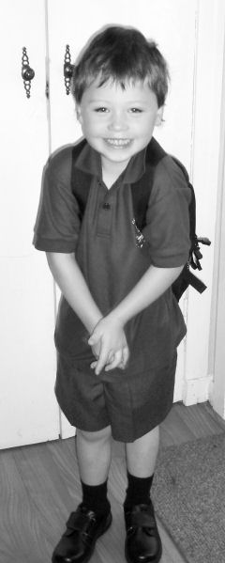
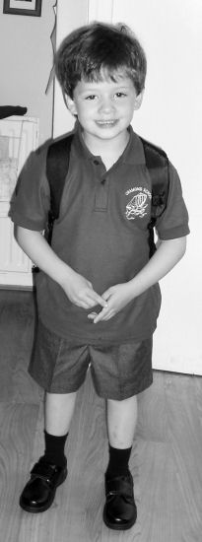
I think partly the familiarity with their school surroundings has helped as they were at the nursery for nearly 2 years previously and were used to the environment of the school, joining in with P1’s and P2’s for assembly on a Friday for example. They have gone in to separate classes a decision we made but I think the School advocate, though they leave the decision entirely to the parents. There are another set of twins also placed in different p1 classes. It has been a good decision as it gives the boys time apart with different friends and I think has encouraged them to tell each other and us their stories at the end of the day, they see each other at playtime and lunch time anyway.

Until September we had only half days which I think has been a lovely gradual introduction for them. Now they cope with the full day very well and also have settled in to the routines of school dinners etc admirably. There has been plenty of support with all the p1s having a lunch monitor to settle them in.

Homework has come from week 2 and the learning does fairly move on a pace…phonics and reading books being the main theme. It is nice to be able to see what they have been doing and it’s a time to talk over things with them, if they are too tired then we just leave it till another day.

All in all I would say it has been a very happy and encouraging experience so far...long may it last!

Gavin and Katie
Gavin & Katie were really excited to start school and they both love it and enjoy doing homework (I somehow think that will change in years to come !!). I'm glad we made the decision to hold them back a year (January birthday) as I don't think either of them would have been as confident (especially Katie). They're both in the same class at Longstone which only actually has the one p1 class but I don't think it matters as much when they're girl/boy twins as they both have different friends anyway.

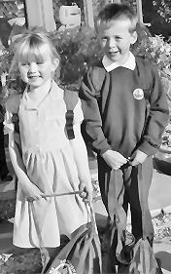
I did find the homework a bit of a problem because they're twins. I was finding that doing the homework together didn't work as Katie would help Gavin out and it made him a wee bit lazy. I now have to do each one at a time (usually on individual nights) which does sometimes make it quite tricky fitting it in with Katie's social life !!! Looking on the positive side, it's nice to spend time with each one separately.

Because it's all still new to them and so structured compared to Nursery they are still getting extremely tired by the end of the week. Either of them can burst into tears at the pettiest wee thing and you find yourself having to be very patient and keep reminding yourself that it's just tiredness. Katie in particular does a lot of after-school activities (swimming, Rainbows, gymnastics & diving) so we'll have to keep an eye on whether she's coping and maybe cut down on classes if she isn't.

As for me, I thought I'd have a lot more time on my hands than I do, but thanks to a new puppy (my new baby) and being involved in the golf club I still sometimes struggle to fit things in (especially cleaning the house !!!). And the one thing I'm always doing at the moment is arranging things for Friday lunchtime and then afterwards remembering that the kids have a half day on a Friday - I'll get use to this new routine eventually!

Tara and Declan

The School: South Morningside Primary

The Children: Tara Smith; age 4, adamant that she did not want to go to school and would not wear a skirt or pinafore – only trousers.

Declan Smith; age 4, happy to go to school and would wear shorts or trousers (but not skirts)

The leadup: we had elected to put them in two separate classes. Both teachers had met Declan and Tara before the school holidays and sent out letters welcoming them to school including a photograph of themselves. This is still up on our noticeboards beside their beds for their friends and “interested parties” to see. Through the holidays the teachers had written to them saying how much they were looking forward to teaching them and how much fun school would be.

When the first day eventually came Tara still did not want to go to school. She dressed herself that morning - In her normal clothes. The tantrum was unleashed when Mummy asked her gently to take off the clothes she had chosen and put on her school uniform. Daddy was required to intercept and was reported being seen chasing Tara round
the house with the sweetie box such was our desperation to coax her into doing “the right thing”. A cleverly negotiated toy (by Tara) was the cost of getting the uniform on and getting her to school for the time required (but not, you’ll notice, in time to have her photo taken with her brother!).

However, once in the playground, meeting up with her friends and having a chase round, all her concerns seemed to be over. She has transformed into a girl that loves her teacher, likes school and never needs coaxing except to do homework!

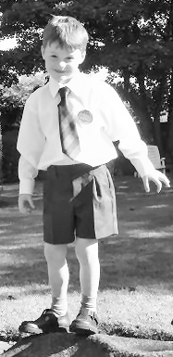
Declan was happy to go to school and seemed to fit in relatively easily. Until he started telling me in days to follow that “no one played with him” and that he “wasn’t having fun”. To alarm me further, the teacher advised me that he was having difficulty concentrating, got tired very quickly and was struggling to keep up. (!!!!!!) After pestering him all weekend to do extra homework and stressing the importance of paying attention to the teacher and doing what she asks, he seems to be happier in the classroom. The problem with no-one apparently playing with him seemed to sort itself out once they started their full day at school when lunchtime became a good opportunity to mix and play with the other boys in his class.

Social Snaps
Singing Kettle

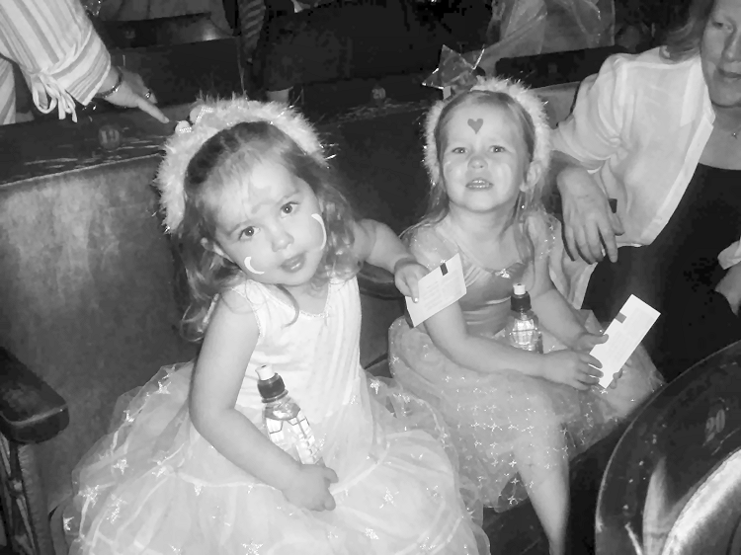

A great afternoon out was had by all at this summer’s 'Blast Off' Singing Kettle on Sunday 24 July. The children made a great effort to come dressed up and all looked fantastic. There were aliens, cosmic princesses, buzz lightyears and many more. I don't think any child would have come back down to earth until they were to sleep that night.



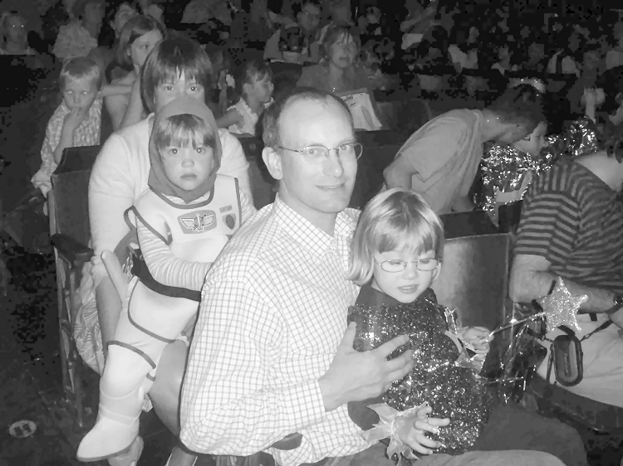

Daytime Activities

Oxgangs Neighbourhood Centre
Firrhill Drive
Bumps, Babies & Toddlers Group
0131 441 755

Tuesdays 3pm – 4.30pm (songs at 4.15pm)
Thursdays 10am – 11.30am (songs at 11.15am)
£1.20 per member family. £2.40 non-members
Daytime Convenor: Jenny Love, Tel:445-3403

All families & Mums-to-be are very welcome. Meeting other people who understand the joys and hazards of life with twins can really help.

Daytime News

Despite our concern that the Tuesday group was not being well attended, since the last issue of the newsletter it seems to have picked up again. Of course these things go in phases – recently a lot of the older toddlers that attended on a Tuesday have started school, but this meeting is still running. We are keen to fit in with what suits the most members so if another time (maybe a morning slot?) or day is more convenient, in terms of fitting in with naps and feeds then please let us have your thoughts.

It’s perhaps also worth pointing out that although there were a lot of toddlers attending Tuesdays, this day is not exclusively for older children – the whole range (bumps, babies and toddlers) are welcome at either of our weekly meetings.

Some photos from Oxgangs are on the next page!

Jenny
Daytime Convenor

Library

The Twins Club has a large number of books on multiples & children in general. The books can be lent out during the sessions for a couple of weeks.

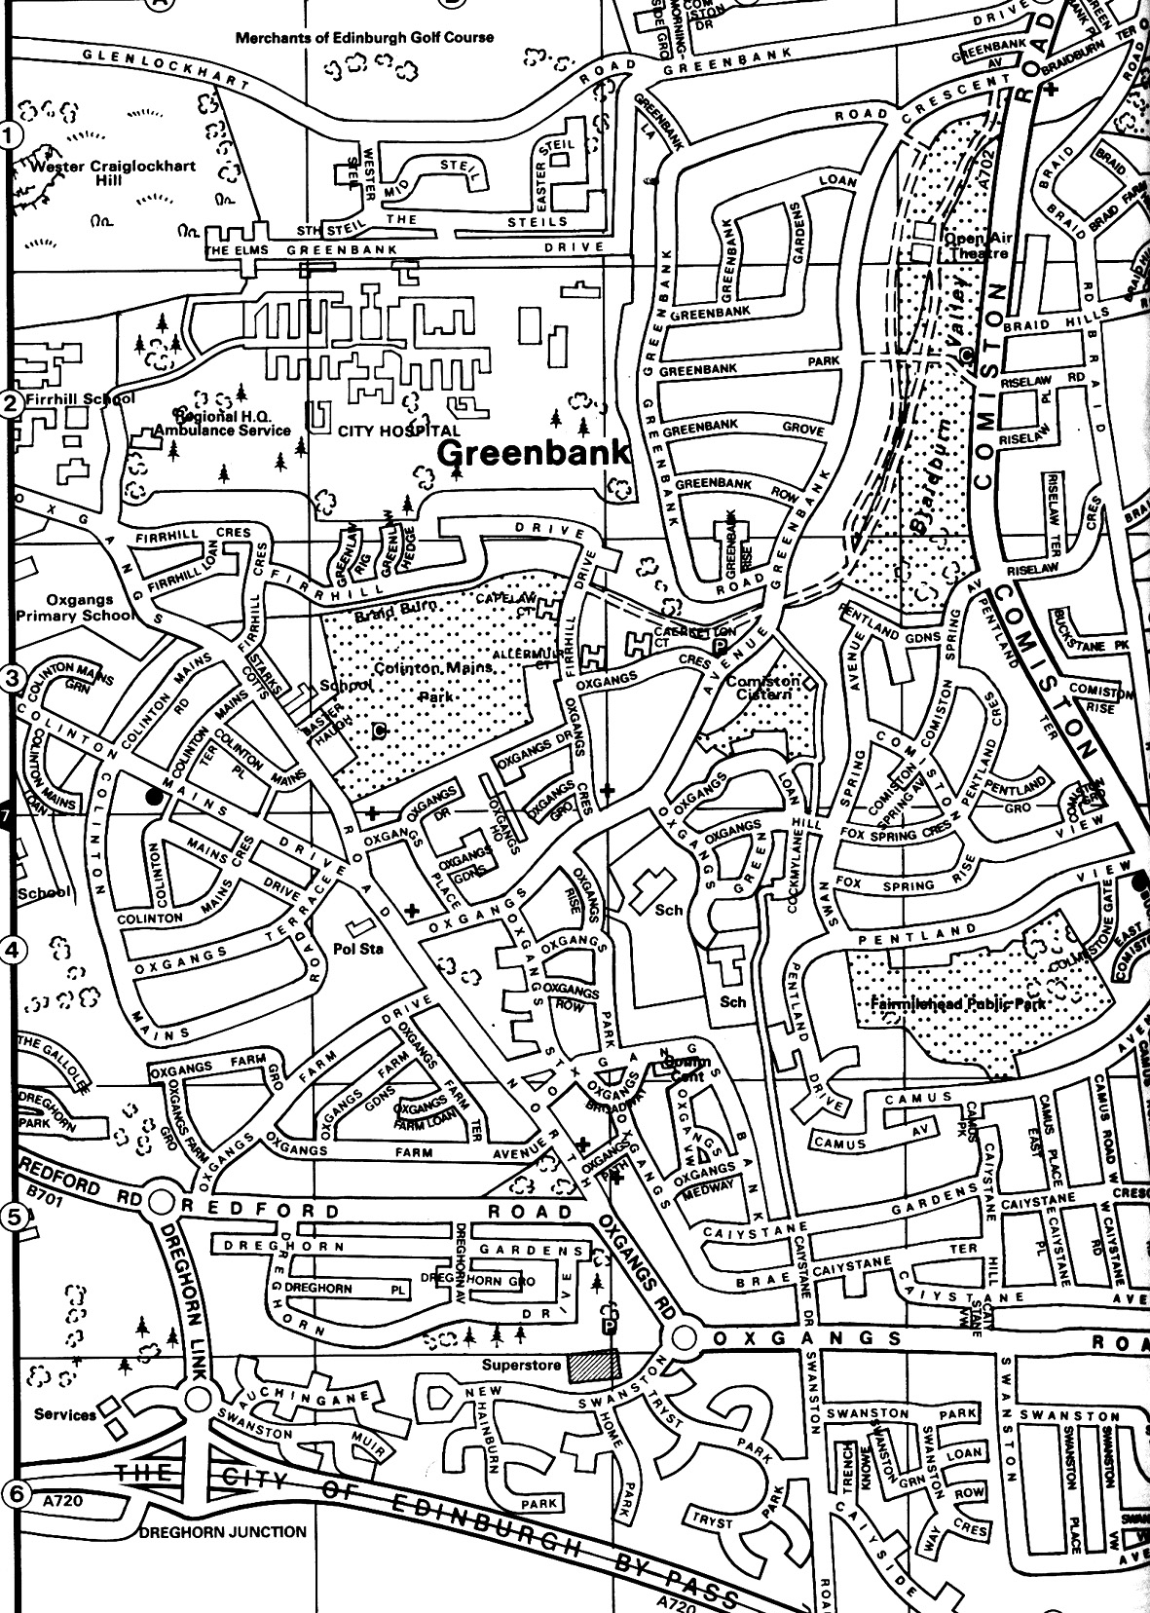

Note
The insurance we have at Oxgangs doesn’t cover children over five. You may want to bring older brothers or sisters over the holidays but that will, as they say, be “at the owners own risk”.

East Edinburgh / EAST LOTHIAN
at
St Phillips Parish Church, Brunstane Rd North, Joppa

On the 1st and 3rd Monday of each month
10am – 11.30am
Easy Parking, Coffee available

For more info please contact either

- Carol Frith (Health Visitor), Esk Medical Centre
Tel: 653 0400 or
- Susan Sinclair (mum of twins) Tel: 657 1550 or
- Helen Nettleship (mum of twins)Tel: 665 4321

ALL HELP TO SET UP/TIDY AWAY TOYS WOULD BE APPRECIATED

Daytime Activities cont…
The Twins Club hold two weekly get-togethers, Tuesday 3pm-4.30pm and Thursday 10am-11.30am with a sing-a-long for the last fifteen minutes with musical instruments. The picture on this issue’s front cover is actually the end bit of ‘A Sailor Went to Sea…’ Here are a few more photos from the Thursday group.

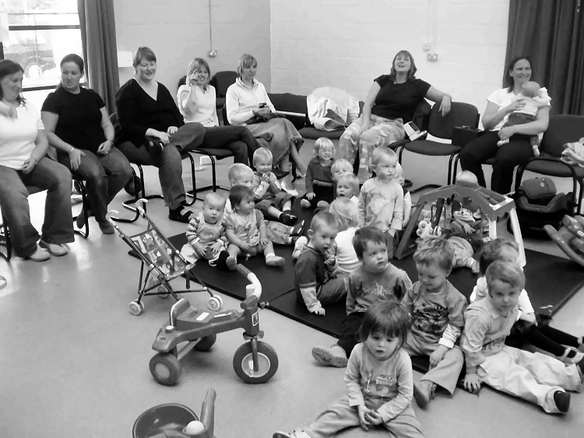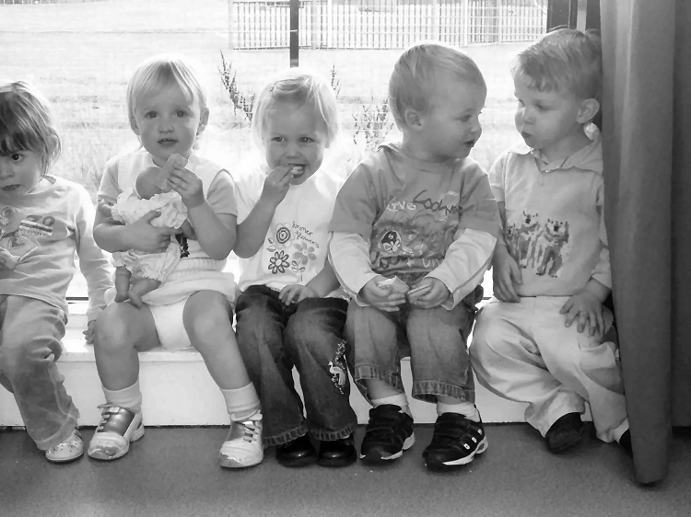

It is a great chance for mums/dads/nannies and mums-to -be to meet and chat as they are the people who understand best what life is like with twins or more. It’s an ideal opportunity to pick up tips and is held in a very friendly and relaxed atmosphere. The kids have plenty of toys to keep them amused while mums and dads can have a chat with a tea or coffee. The centre itself is very friendly and there is always someone on hand to help you in and out of the club if need be. There are also plenty of mums who love a cuddle and the chance to feed a baby again instead of you having to juggle two or more.

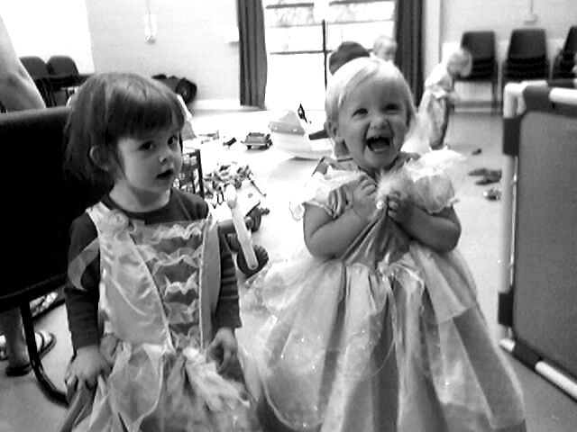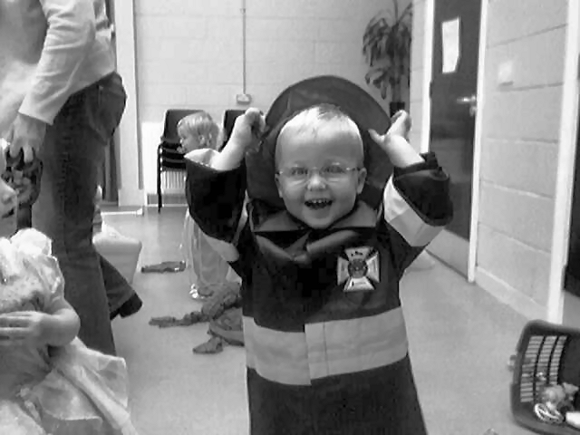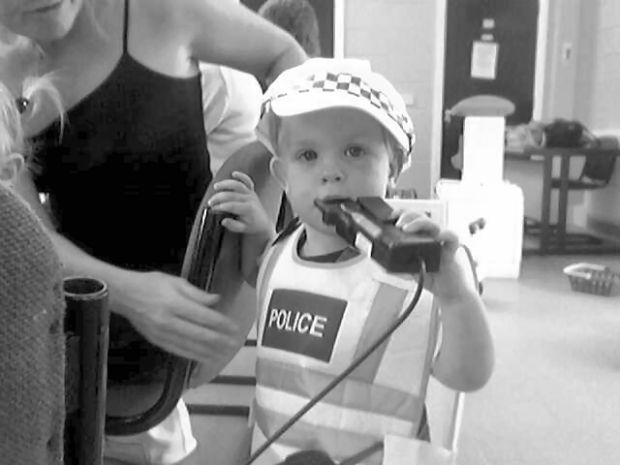

We have recently purchased dressing up clothes for use at weekly groups. There are 10 outfits for the kids to choose from. As you can see from the photos the children have very quickly taken advantage of there new dressing up outfits. They had great fun chasing each other around the hall, the policeman trying to arrest the princess, barbie trying to stop spiderman climbing the wall and the fireman helping tinkerbell ride her bike.

We always welcome new members and look forward to seeing you soon.

Jenny
Daytime Convenor
Discounts

We have been trying to negotiate with a number of retailers / clubs in order for Edinburgh Twins Club members to obtain discount. If you already use your card in other shops, please let us know for future Newsletters.

Blessings & Blossoms, 132 St Johns Road, Corstorphine, 0131 334 8322
10% Discount. Children’s Clothes shop.

Cheeky Chimps Indoor Soft Play Centre (Freeport)
HALF PRICE ENTRY. Valid Monday to Friday only. Must show your Twins Club membership card.
Normal Entry Price is £1.50 for under fours and £3 for children over 4 and up to 4ft 9 in height.
Arrangements can be made for cheaper party costs. Contact Angela Caserta on 01501 762 409

CLARKS Shoe Shops
10% discount on production of Twins Club membership card (it does not have to be the TAMBA card). This will apply for all siblings shoes as well! This only applies to Edinburgh stores (Cameron Toll, Gyle, Princes St, Kinnaird Park & Musselburgh) but we have had a few problems with some of these stores accepting our card – please refer any member of staff to their Regional Manager, Nigel Merritt who has agreed this discount scheme countless times. Please do not try to obtain discount from any other store.

Doodles Ceramic Workshop
29 Marchmont Crescent, Edinburgh
10% discount for all visits. Includes evening visits when mums can enjoy some peace and quiet with friends.
15% discount for birthday parties booked in either July or August, either in the Doodles studio or with Doodles to Door (which brings all the fun of Doodles to your home or other venue). Subject to Availability. Call Holly on 0131 229 1399

Golden Hands Silver Feet
10% discount. Your little ones hands and feet captured in Bronze, Brass, Aluminium or Stone.......FOREVER - a unique memento or gift. For more info & prices please see www.goldenhands.co.uk or phone Nicky Summer on 0131 665 8628

Jelly Club
10B Kings Haugh, Peffermill Road, Edinburgh. 15% Discount on production of Membership card

Lorac Carpet Services * * NEW * *
10% Discount. Professional carpet and upholstery cleaning, general repairs, odour treatment, specialised re-tufting, specialised Oriental rug cleaning. For free advice/estimates contact: Phone 0131 468 0996; Mobile 0775 159 4900; email info@loracservices.co.uk

Nightbridge Designs
15% off custom made soft furnishings, bedding & curtains. Contact: Debbie on 01506 431515

Paul Bradford Designer Cakes
10% Discount. Simple cakes to intricate designs. Look fantastic and taste great too! Tel: 01506 671133

Rocking Horses
10% discount. If anyone would like to see/ride a large mahogany horse (called Rocky!!), please contact Gill Petrie on 0131 443 2919.
Contact: Jim McAuley, 73 Manse Street, Saltcoats, KA21 5AA. Tel: 01294 466415

Wendy Beardmore, Freelance Public Relations
15% DISCOUNT
As a member of the twins club, I have recently started out doing freelance PR and Marketing, using my maiden name Wendy Robbins. I am mainly helping small businesses and start ups to develop their marketing. If you have your own business and need some help growing this, or indeed if you know someone else in this situation then give me a call.
Call Wendy on 0131 334 9591 or 07771 966 488.

Snippets

ADVERTISING RATES

The following charges apply to advertisements in the Twins Club Newsletter:

Club Members
Members may advertise a commercial enterprise once for free, any subsequent advertising is charged at £25
Swap Shop and Wanted ads are free to members

Non-members
Non-members may place an advert for a fee of £25

Charges do not apply to the Discounts listings.

COMMITTEE POSITIONS


Many thanks to those of you who responded to last issue’s plea for members interested in helping out on the committee. It’s very encouraging to know there are members out there with some great ideas for the club and the commitment to take them forward. However, more people are still needed if the club is to look forward to a truly bright future and to continue to expand activities for members. So, if you were interested by the article in the last issue, but never got around to responding, or were scared you would be the only one – please get in touch now. Phone or email any member of the committee for an informal chat if you’re interested in lending a hand in any way. Or you can attend the AGM in January – details on page 3.

TAMBA
The Edinburgh Twins Club is affiliated to TAMBA (Twins and Multiple Births Association). Membership is separate however. For details of the benefits of TAMBA membership, visit www.tamba.org.uk
or telephone 0870 770 3305
CUT-PRICE CLAMBERING CANCELLED!

Sorry to report that Edinburgh City Council has withdrawn its 2 for 1 offer at the Commonwealth pool soft play which was available with a City Card (noted in last issue of the Newsletter). Apparently it was too popular! Hmph! Poor show!


Newsletter
Articles to:
Vicki Chung
32 Buckstone Row
Edinburgh
EH10 6TP
vchung@blueyonder.co.uk

by Friday 30th December
FREE use for members

Thanks to a West Lothian grant, the Twins
Club purchased an all-terrain ‘running’ buggy,
Similar to the one pictured.

Anyone interested in using it should phone Vicki Petrie on 339-0135.

Fundraising Teatowel


We thought it would be fun to get as many member children as possible to draw themselves with their first names and have them printed with our logo on a white teatowel (along the lines of the two examples shown), as a record of the club and also to raise a bit of money. The younger ones might just want to draw a face, and for the babies a parents drawing would be great, or a hand or foot print. We have a tried and tested company who have produced great towels still in use 11 years later! We would hope to be selling them at around the £3 mark and have them back in order to be Christmas presents on sale at Oxgangs, via Sarah Warwick in Colinton (441-3722) and at the Christmas party.

Please draw in a thin BLACK FELT TIP PEN , fill up the box (three provided below to allow for our triplet families!) with the picture and include your child’s name. If you need to draw extra boxes they are 6 x 8.5 cm. Budding artists are asked to send in some extra boxes to be space fillers, some ideas are animals, vehicles, flowers or patterns. Please remember to label any extra work so we can tell which family they belong to.

In order to produce a real momento of the club we need as many of you as possible to join in and to get the art work back to Sarah Warwick, 20 REDFORD BANK, EDINBURGH EH13 0AQ ASAP



FAMILY NAME:

Swap Shop

2 Car Seats
Mamas & Papas Primo Viaggio
Suitable from birth to 20lb(9kg).
Including all accessories and Surefix bases
Excellent condition
£30 each

2 Surefix bases
Additional bases for car seats listed above.
Ideal for a 2nd car.
£5 each

2 Musical baby walkers
Graco
Suitable for 6 - 12 months.
Good condition
£15 each

2 Bath Supports
Mamas & Papas Acqua Bambino
Suitable from birth - 6 months.
Excellent condition
£5 each

Bouncy chair (musical)
Mamas & Papas Melino Activity Cradle
Suitable from 2 - 9 months.
Excellent condition including all accessories
£15

Baby carrier
Baby Bjorn
Suitable from birth
Excellent condition
£10

Contact: Naiomi Cowan
Tel: 228 4092
cowand@blueyonder.co.uk

2 Tricycles
Babydriver Charton Berchet tricycles. Suitable for 2-4yrs.
Good condition with handles for pushing.
£15 each.

2 Scooters
Wooden multicoloured four wheel scooters. Suitable for 2-4yrs.
Good condition.
£7.50 each.

Contact: Emma Vickerstaff
Tel: 452 8419

2 Klippan car seats
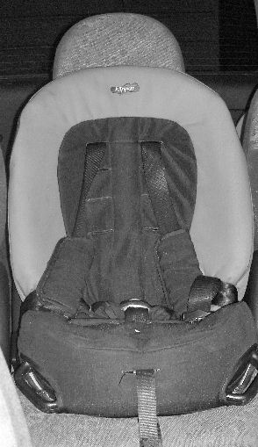

Suitable for children aged 9mths to 6 years approx. Front or rear facing with three point harness
Never been in any sort of accident
Clean and in excellant condition
£85 new
£40 each

Contact:Jenifer Robertson
Tel: 477 6212

Silver Cross Double Push Chair
Rarely Used – Immaculate Condition!!!
Tandem Pram. Front and Rear Adjustable Seats. Great Support for Birth Upwards. Traditional Navy
Silver Chrome Frame. Lots of Accessories: Rain Canopy, Supports, Covers. Happy to arrange to view
£190 ono

Contactl: Tina Cameron
Tel: 07790-948 337
2 Cream Fleecy Snowsuits
Approx size 12 months. Detachable feet so can be worn with shoes/wellies. Co-ordinating hats with attached scarves (so you can tie them on!!) and mitts with strings. Really cute and as new.
£10 each ono

2 Blue Fleecy Snowsuits
Not the same but both approx 3 months. Hoods and feet.
£4 each ono

Wooden Dolls House
Complete with wooden furniture and family. ELC style (cost £160 new). Good condition. Perfect Xmas gift.
£80 ono

Contact: Catriona Hepburn
Tel: 336 1062

Emmajunga Twin Pram/Pushchair
Navy with reflective detail on sprung chasis with adjustable handle. Includes hood sunshade, cosytoes, raincover and large shopping tray. Rear or front facing seat unit, backs and footrests move independently. Birth to 3 years. It made a snug pram for my premature twins over their first winter and has been extremely useful. Good condition with many miles to go.
£100

Mothercare Baby walker
Blue dinosaur design with fixed yellow tray. Adjustable height.Good condition. £5

Snowsuits 3-6 months
M&S pale pink padded fleece and mothercare dark pink. As new condition.
£3 each or £5 for the pair

Mothercare pottychairs
Duck design with yellow insert. Were £10 new
£5 pair

Contact: Sarah Warwick
Tel: 441 3722

Please note that the Edinburgh Twins Club cannot be held responsible for any purchase made through the Swap Shop or Wanted section. Each deal is entered into privately between the two parties involved (i.e. the seller and the buyer).
You can advertise as often as you wish, but you must notify The Editor each time you wish to advertise again.
Please send all items you wish to advertise to:

Vicki Chung: 32 Buckstone Row, Edinburgh EH10 6TP
e-mail: vchung@blueyonder.co.uk
Tel: 477-1404

Social Calendar
Vogrie Country Park    Sunday 6th November (afternoon) | Vogrie Country Park, Gorebridge  Informal meeting  Come along and get a breath of fresh autumn air in the beautiful setting of Vogrie Country Park. Entry to park free. Beautiful grounds. Lots to do. ‘Twin friendly’ Cedar Tree Café.  On the B6372. Follow signposts off the A68 and A7.
Parents’ Pool Night    Saturday 25th November 7.30pm | Marcos Leisure, Grove Street  Show off your hidden talents (or not!!)  Pool and informal bar meal.  Pool tables booked from 7.30-8.30pm when we’ll have a break for food till 9.30, then back on the tables till 10.30pm.  £3 per person for pool. Please pay on booking.  Bar meal pay on night.
Children’s Christmas Party    Saturday 17th December 10am-12pm | Murrayfield Parish Church Hall, Ormidale Terrace  Our annual party for the children.  Party games and entertainment this year by children’s entertainer Scott Lovatt.  Snacks & a pressie from Santa himself for all kids.  Come and join the fun!  £5 per child. Please pay on booking and state names, ages and genders of all children attending.
Clown Around    Sunday 14th January 11am | Clown Around, 109 Restalrig Road  Soft play & trampoline centre. Separate play area for under 2’s.  Play followed by snacks in the party room.  Limited numbers so book quickly!  £5.50 per child. Please pay on booking.

