EDINBURGH TWINS CLUB
edinburgh twins club

CONTACTS (2007)

 | Name | Position | Responsibilities | Phone | E-Mail
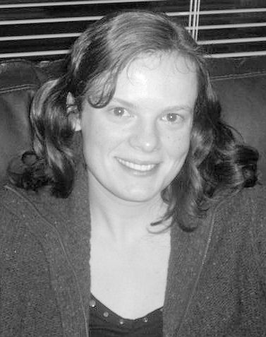 | Rachel Round | Chairperson | I am delighted to hear from any member on any issue relating to the club including advertising and promotion as well as any feedback and comments you have for the committee, remember we are here for you.  Please get in touch | 01506 639809 | rachael@the-rounds.net
 | Jennifer Love | Joint Secretaries | Provide assistance to chairperson and responsible for taking minutes of committee meetings. | 0131 445 3403 | jennylove@blueyonder.co.uk
 | Carole Park | Joint Secretaries |  | 0131 466 4106 | carole.park@blueyonder.co.uk
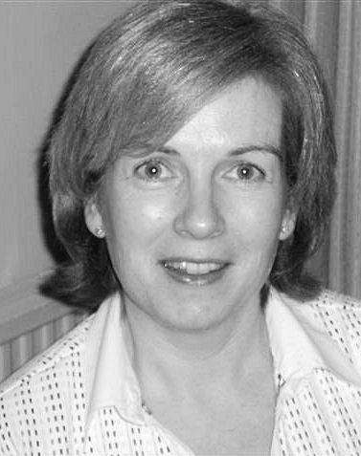 | Miriam Newton | Joint  Membership  Secretaries | Responsible for welcoming our new members, sending out enquiry and membership packs, whilst developing relationships with our existing members.  Miriam administers the annual membership renewals and Gillian is responsible for administering the members' database and producing quarterly reports.  Want support or someone to talk to? Gillian, Miriam and Jenny Love hold the list of members willing to help. | 0131 476 1394 | miriam@newtonhouse.net
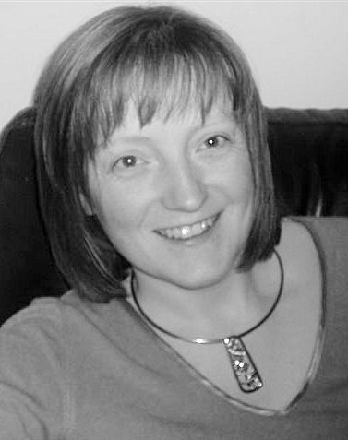 | Gillian Morrison |  |  | 01506 420 143 | gillian_morrison@btinternet.com
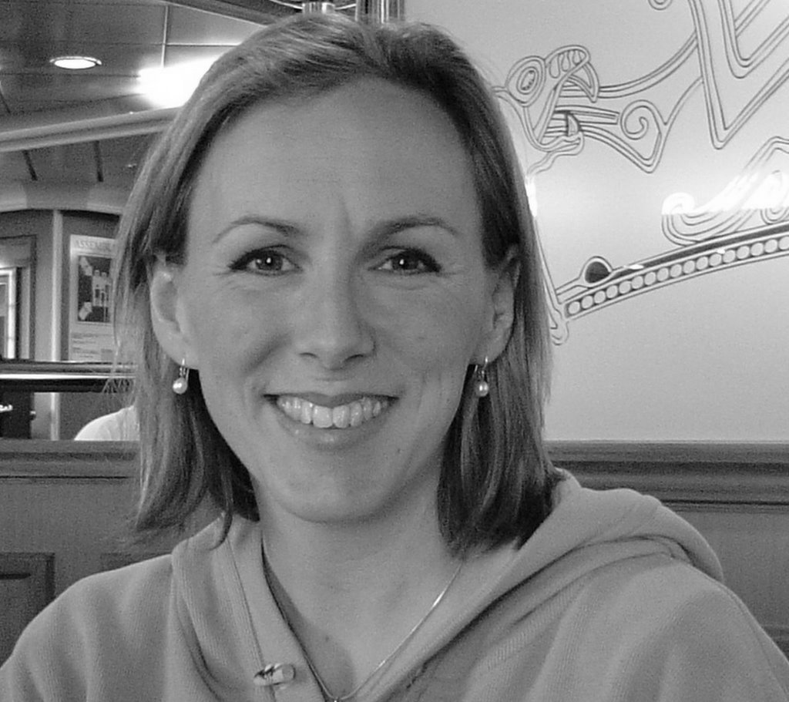 | Karin Ewing | Daytime Convenor (West Edinburgh) | Organises and runs the daytime event at Oxgangs Neighbourhood Centre. All comments welcome on venue, format, toys, etc | 0131 446 0551 | karinphillips@yahoo.com
EDINBURGH TWINS CLUB – CONTACTS 2006 (cont)

 | Name | Position | Responsibilities | Phone | E-Mail
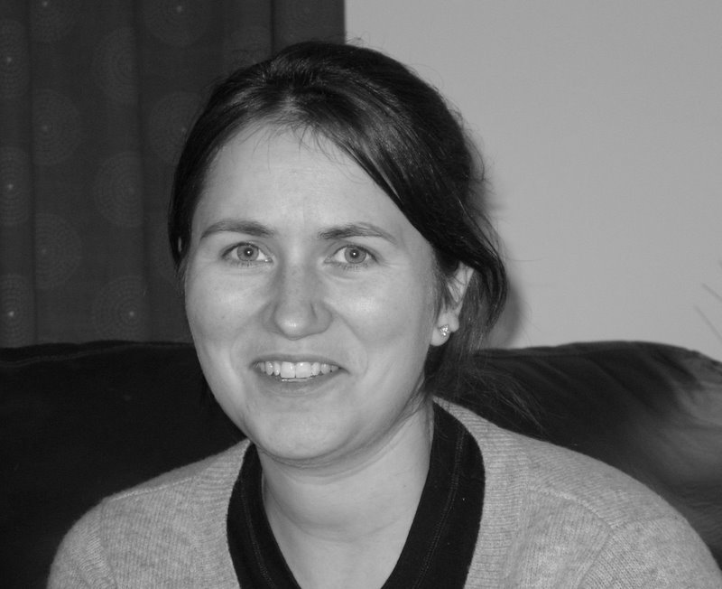 | Kirstin Evans | Social Convenor | Organise social events.  All ideas of outings, venues or locations welcome. | 0131 333 2332 | kirstinevans@hotmail.com
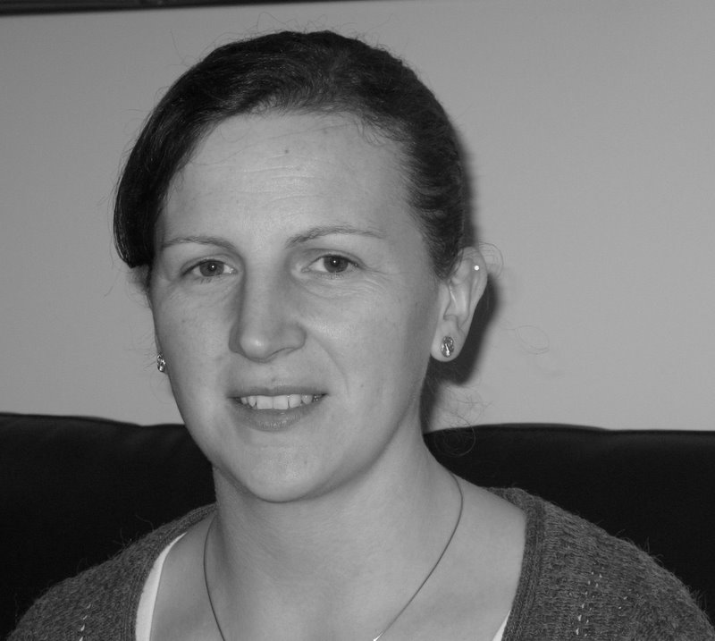 | Donna Dickinson | Joint  Daytime Convenor  (South Queensferry) | Organises and runs the weekly event at the Scout Hall, South Qeensferry.  All comments welcome on venue, format, toys, etc | 01506 671699 | briand@briansd.demon.co.uk
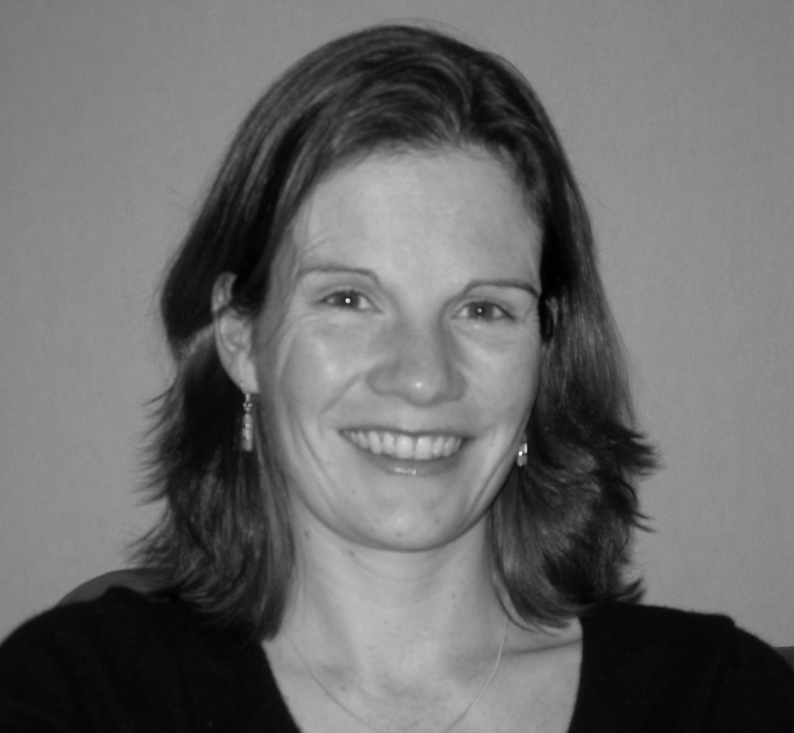 | Lesley Livingston | French Liaison contact &  Joint  Daytime Convenor  (South Queensferry) |  | 01506 840792 | lesley@hughandles.com
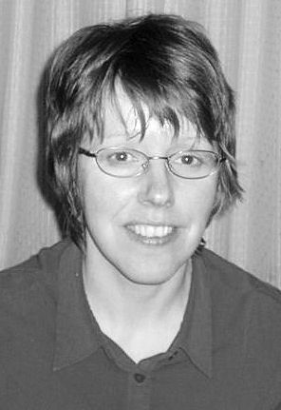 | Kairsty Ashworth | Newsletter Editor | Edits & produces Newsletters. ALL ideas or articles welcome (any time). | 01506 409984 | Kairsty@craiksland.freeserve.co.uk
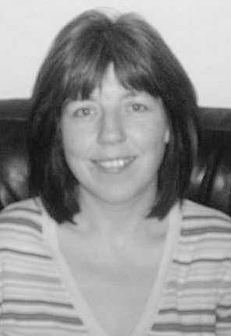 | Gillian Anderson | Treasurer | Responsible for banking monies and producing financial reports. | 0131 447 5462 | g.b.anderson@btinternet.com
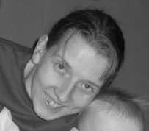 | Mòrag Burgon-Lyon | Website Administrator | Responsible for maintaining and developing the club’s website  www.edinburghtwins.co.uk | 01506 420468 | moragbl@yahoo.co.uk

