edinburgh twins club
Edinburgh Twins Club
Newsletter

April 2005

Hello to you all and welcome to the April edition of our Newsletter!

We have a packed programme again for you with interesting social events including an evening with Maria Robertson, a local lady who will tell us all about what Doulas can offer. I hope this may be of interest to some of our parents-to-be as well as those of you with very young babies, although everyone is very welcome to come along. We are also hosting our Nearly New Sale in June. Please support this event and turn your unwanted items in to some spare cash for yourself and The Club (see page 3).

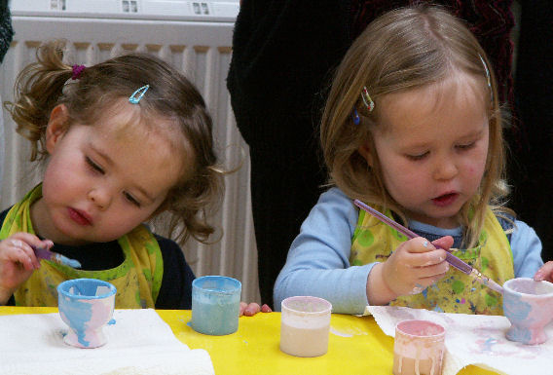
Time as always is passing very quickly and we are again approaching Spring… smells of cut grass are once again in the air, maybe we can manage to have more than 2 BBQs this year if we start soon ! For us it is an exciting time as our 2 boys approach their last term of nursery school before entering primary 1 in August. A landmark time for the children but in many ways even more so for us, always concerned parents. As parents of multiples we are often told that twins and more may develop more slowly with speech, social development and other things which could affect school. However we have been very reassured by enthusiastic staff at the School that all is well and they are on course as any other single children are. This is great news, not that we are neurotic parents, but it is reassuring to get time to talk about them as individuals with their teachers and how they will fit in to the school system as two individual people. Separate classes for them will also, we think, be a great benefit as they will continue to develop in their own special ways and choose different friends and interests. Funnily enough, there are 3 sets of twins this year going from the nursery to p1 so they will be in good company. More information on this subject is available via the TAMBA website at www.tamba.org, where there are booklets on children starting primary as well as secondary school. If anyone feels we should be offering more information in our newsletter or information evenings for school age twins then please let us know and we will do our best to arrange it.
Enjoy this year’s second edition of the newsletter - I know I love reading it in peace when the boys are in bed ! Maybe even outside with a glass of wine ! ☺
Vicky Petrie
Molly and Katie Hepburn get all arty with their egg cups at the Twins Club outing to the Ceramic Experience in February
Chairperson
339-0135
victoria@lesterpetrie.freeserve.co.uk
 | Membership Update  Welcoming the newest members of ETC | 2 |  | Social Snaps  Our roving reporter captures more wee stars at our events | 10
 | Nearly New Sale  Please join in and raise money for the club and yourself! | 3 |  | Daytime Activities  Times, venues, directions. Pay us a visit! | 11
 | Feeding Time  Advice and tips from a survivor of the ‘splatter zone’. | 4 |  | Discounts  Everyone’s favourite perk – which shops and how much | 12
 | Getting away from it all  Two different approaches to escaping the day to day grind. | 5 |  | Snippets  Bite sized chunks of news, information and trivia | 13
 | What’s a Doula?  Is it a midwife? Is it a home help? No! It’s a Doula! | 7 |  | Swap Shop  For sale + wanted, everything from buggies to nannies | 14
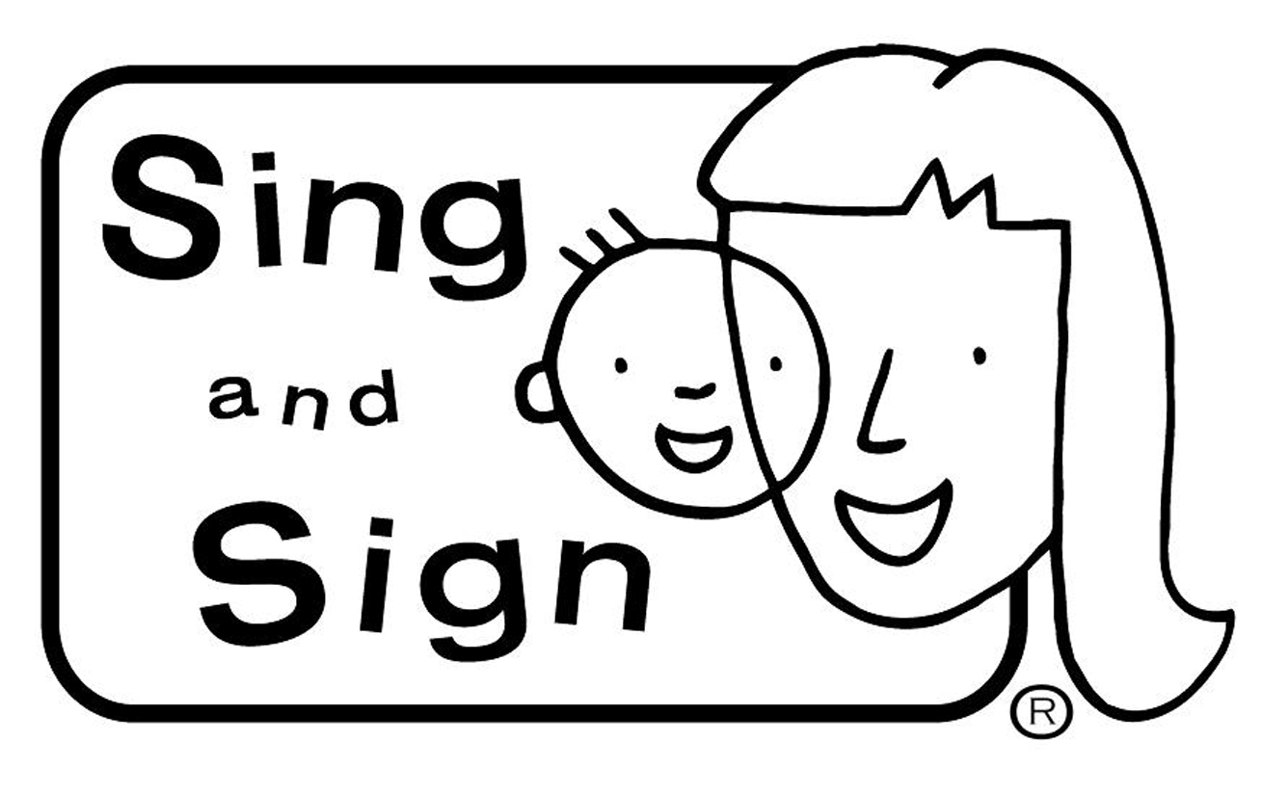 | Sing and Sign  Dee Armstrong explains the theory of baby signing. | 8 |  | Social Calendar  Something for everyone! Forms back by 6th May please. | 16
Membership Update

Dear Members

Congratulations to our members on their baby news!
- Hazel & Duncan Chisolm on the safe arrival of their two little boys, Archie and Hamish, born on 22 March! Many congratulations to a very proud Mum and Dad;
- Maggie & Gavin Brierton who have triplets – two little boys and a little girl born in June 2003 – David, Rory and Gabrielle (Gabby); and to
- Gilly & David Howarth, who have a little girl, Hudson, and a little boy, Frobisher, born on 25 August 2004.
- Elaine & Stuart Lisgo, Mum and Dad to Richard and Alexandra (Alix) born in June 2003;
Well done and many congratulations.

We are also really pleased to welcome the following families who have joined the Club since the last newsletter:
- Charlotte & Simon Kirk, Mum and Dad to Alexander and Thomas born in June 2004, and to Eleanor born on 6 November 2002;
- Gabby & Andy Carlyon, Mum and Dad to James and Eilidh born in July 2003;
- Valerie & Alan Cochrane who had Alasdair in May 2002 – a big brother to twins Cameron and Gregor born 5 days before Christmas 2004;
- Tess & Michael Joyce who are expecting triplets this June;
- Susan & John Douglas, who are expecting twins this June;
- Ann & Graeme Steel who have had triplets – three little girls named Rebecca Louise, Laura Jane and Hannah Elizabeth, siblings for Matthew, who will be 3 this month;
- Gail & Michael Redpath, parents to little Eden & Macy born in July 2004;
- Alison & Gordon Craig, Mum and Dad to Ellen and Catherine, aged 3;
- Ruth & Craig Brown, Mum and Dad to Jake and Dylan, born in November 2003;
- Marie & John Owen, parents to Ralph & Lily born early December last year; and to
- Miriam & David Newton, expecting twins this June.
- Cally & Paul Fraser, Mum and Dad to Hamish aged 4 and Rory who will be 2 in August, the same moth as the twins are expected.

We are really looking forward to hearing all your baby news this Spring and Summer.
Our membership list currently consists of 135 families.
We would be really grateful to hear from you should you not wish to continue your membership of the Club. It would be interesting for us to know why you might feel the Club ceases to be of interest, bearing in mind we are aware that there is perhaps less need for the support as the children get older. Also, hearing from you would greatly assist our admin hence a quick call or e-mail would be very much appreciated, should you not have time to return our little form!
If there is a Membership Form with this newsletter your membership is either due or overdue for renewal. Please complete the form and send it with your cheque to Gillian Smith by mid May 2005.
PLEASE do not forget to call Karen or Gillian and let us know your baby news – this really will help us come Newsletter time. If we have missed the birth of your babies, or you are a new member and we have missed you from our list, please let us know so that we can add you to our next newsletter.
Best wishes,
Karen and Gillian, Membership Committee

Karen Winfield  23 Bluebell Glade  Adambrae Parks  LIVINGSTON EH54 9JJ   +44 (0) 1506-416 412  Karen@the-winfields.com | Gillian Smith  22 Braid Avenue  Morningside  EDINBURGH EH10 6EE   +44 (0) 131-447 3000  Gillian@bitts22.freeserve.co.uk
Please note that we will include you on our membership page within the Newsletter unless we hear otherwise by telephone, e-mail or by your indication on your Application Form when you join.

 Nearly New Sale

Roll Up! Roll Up! Roll Up!

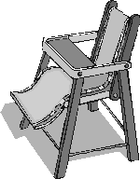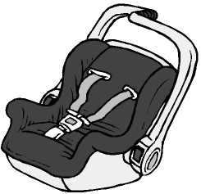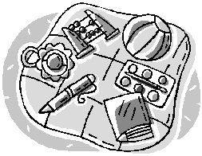

Edinburgh Twins Club are to host a Nearly New Sale of baby and children’s items

On
Saturday 11th June


At
St Stephens Comely Bank Church, 10 Comely Bank Road

Time
11am - 1pm

To help to raise funds both for the club and for individual members. Do you have perfectly good toys, clothes and/or equipment that your babies or toddlers have grown out of? Or maternity clothes you’re sure you won’t need again? This is the perfect opportunity to sell it on, and hopefully make a little money back.

The idea is pretty straight forward: we would like to invite members to take a table on the day to sell their items. We will charge £10 for a table, which will be supplied (you don’t have to bring your own!) and you keep 100% of the proceeds from any sales you make. We will be charging £1 admission at the door and are hoping to have tea, coffe and biscuits available for a small price.

All baby and young children’s items can be sold including car seats, clothes, toys and equipment. Please bear in mind that all items for sale should be in ‘nearly new’ condition, i.e. nothing torn, stained or broken please!

Please let us know ASAP if you are interested in taking a table. The more the merrier! Tick the box on your social return form and remember to send your £10 table fee to secure your place. Please note that the fee is non-returnable. Phone Vicky on 339 0135 or Catriona on 336 0162 if you need more information. We will call you closer to the time to make final arrangements.

We are also looking for volunteers to help with the running of the event i.e.: taking entrance money on the door, making teas and coffees, helping set up tables and so on. If you feel you can lend a hand, please contact us as above.

It’s your chance to sell unwanted items and make come money for yourself and the club so please get involved and have some fun too!!

Of course, even if you have nothing to sell and don’t want to take a table, do come along and see what there is to buy – you may pick up a bargain, or two!


Feeding Time

There is a wealth of advice about weaning and earlyfeeding available, both online and on paper. It’s easy to find the basic ‘rules’. What follows are a few random bits of advice from my personal experience of weaning twins and introducing them to solid food. I hope they prove useful to those of you about to enter the wonderful world of solids with your babies. Please let us have any ‘top tips’ you may pick up along the way so that we can in turn share them with other members.


Mess
You must resign yourselves to the fact that this is a very messy stage. If you can feed your little ones in the kitchen or other area with wipe clean floor, that’s the best idea. If that’s not possible then a collection of old towels or a waterproof tablecloth comes in handy for the area around the bouncy chairs, and later, the highchairs. Bear in mind that as the children get bigger and stronger, the ‘splatter zone’ gets wider. There’s only so much you can do though, best to just relax and make plans to redecorate your home in a couple of years.

Prematurity
I would recommend anyone with premature babies get in touch with BLISS, the premature baby charity. They really know their stuff and are very helpful. I found their leaflet ‘Weaning your Premature Baby’ immensely useful.
By Post: BLISS, 68 South Lambeth Road, London SW8 1RL.
Tel: 020 7820 9471
email: information@bliss.org.uk
Website: www.bliss.org.uk
Parent Support Helpline: FREEPHONE 0500 618140 Monday to Friday 10am-5pm

How many Spoons??
My health visitor (I’m sure there are lots of good ones out there but mine wasn’t one of them!) assured me that I must use two different bowls and two different spoons, all of which were to be sterilised. I must hold my hand up as an irresponsible mother and admit I quickly realised that life was too short and used, (shock horror!) one bowl and one spoon and, after the first few times, reckoned that a thorough wash was good enough without running everything through the steriliser before every meal. Amazingly enough, my children survived!

Are you sitting Comfortably?
Adjustable bouncy chairs are great for feeding before the babies are stable enough to sit up in high chairs. Sit the babies up in their bouncers and get comfy with some cushions on the floor in front of them. I’m afraid I never found it a particularly comfortable experience, partly because of the ducking and diving to avoid the flying mush while attempting to stop them rubbing food in their eyes, putting in their ears/hair/noses etc.
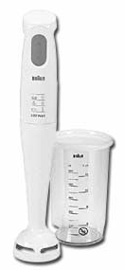
Best Buy
A hand blender is an essential purchase for the making of all kinds of interesting baby mush. You don’t need anything terribly complicated. Ours was a very basic Braun one from Argos, cost under £15, it’s all you really need.

Cubism
Invest in three or four ice cube trays. The flexible rubber ones are best. You can then freeze trays of ice cube sized portions of blended foods to mix and match on days you don’t have time to cook from fresh. Remember to label the bags before putting them in the freezer. Muddling up carrots and mangoes is not always popular. The cube stage is shorter with multiples as you can move on to using small tupperware tubs containing enough for two or three portions as their appetities increase.

Little known Food Facts
- Weetabix, when mixed with milk, then splattered on household surfaces and left to dry for a few hours, attains the consistency of reinforced concrete and can protect your home from nuclear attack.
- Nothing on this earth will remove the orange stains caused by liquidised pumpkin.
- Not all babies thrill to the taste of brocolli and spinach – don’t beat yourself up about it!
- Baby rice splatters from breakfast can harden on your face to resemble large white-heads and no one will mention this to you all day. You will only notice them when brushing your teeth before going to bed.

Last but not least…
Most of all – relax and have fun with it! It’s a journey of discovery, for all of you!

Vicki Jarrett

 Getting away from it all

With summer approaching, many of us will be thinking of summer holidays, hoping the traditional Scottish summer holds off and we are blessed with more than a couple of days of sunshine. How to maximise both enjoyment for the children and relaxation for the adults is a common dilema. Two of our families shared with us their very different approaches to ‘getting away from it all’.

Making the break – Twins in Tarragona

Having spent the last 5 years enjoying reading other people’s efforts and admiring them for finding the time to write, I’ve finally made an effort of my own. This is hopefully the first of a series.


It all started back in 2003. We were becoming increasingly fed up with the Edinburgh weather and convinced that the children needed to be outdoors more – the benefits of less noise in the house and children that slept better seemed hard to beat. Late in 2003 I was lucky enough to be given a chance to take redundancy (or rather, my company wanted to pay me to leave!) and Allan was already at home with a small pension so it was too good an opportunity to miss.

For those of you who don’t know us, Joseph and Abigail were born back in November 1999. Joseph has always been an active boy – at one time he was found upside down in the toy box at Oxgangs. He has a very high pain threshold and perhaps as a consequence falls over a lot (it doesn’t often hurt). Abigail is more sensitive and shy but when she gets going she doesn’t stop talking – we feel for her ‘baby’ Zoe when she repeats things we have said (although I don’t recall ever threatening to throw her on the floor and jump on her head!).

All of our holidays with Joseph and Abigail had been in Spain from the age of six months. Consequently Joseph used to think ‘holiday’ was a place in Spain. From mountain climbing (ok, hill walking) in Andalucia to the tourist beaches of Sitges (at 18 months old neither would go on sand!), Torremelinas and Salou, they’ve loved it all. Admittedly, the food can be a problem – as vegetarians who only like carrots in chilli, they can be fussy eaters but most places will cater for pizza, pasta or a sandwich.

So, late last year Grandma had the pleasure of looking after Joseph and Abigial while we spent a few days looking for our first place to live in Spain. We were lucky, we found a four bedroomed house, with heating, 10 minutes drive from the beach and 40 minutes south of Barcelona and on January 10th we arrived there with 5 large suitcases and 2 very squashed children. We’ve spent the last month laying the foundations for our new life in Spain. This has involved endless beaurocracy and countless incomprehensible conversations in Spanglaise. We have almost got an NIE number, almost got a car, almost registered the children at a local school and seen countless houses (none of which have been quite suitable). On the plus side we’ve also spent at least an hour every day sitting in a bar whilst the children play on the beach (and, yes, go in the sea), and every day but 3 we’ve opened the blinds to see blue skies. We’ve also managed to get the children sleeping through for at least 11 hours from 8 o’clock every night (yes, I know most children do this much earlier).

The children have made friends using a mixture of sign language and giggling. They have started learning Spanish and are looking forward to starting school. Joseph had even had his first dip in a swimming pool, albeit fully clothed (luckily he was able to swim to the side and get out).

Even though most of the time we feel we have two children who just happen to be the same age, it is important to Joseph and Abigail that they are twins (or gemelos). The absence of other children they can talk to and the shortage of toys (they’re mostly in storage somewhere) has made them better friends and better at sharing things. Yes, they still have squabbles and yes they still fight but most of the time they’re playing together. It’ll be interesting to see what happens at school. In Edinburgh they were in the same class whereas Spanish schools seem to have a policy of separating twins.

So until next time…

Hasta Iuego
Adios
Y Buenos Nochos
Jacquie, Allan, Abigail and Joseph Welch

Mini-breaks – Creiff Hydro and Oasis

At the end of last year we had planned to rent a cottage in Northumberland for a week with Katie and Molly (almost 3). However, after the rotten summer, it was hard to imagine how we would entertain them for seven days in the middle of nowhere. We decided to go for two Monday to Friday breaks instead in the family holiday zone!

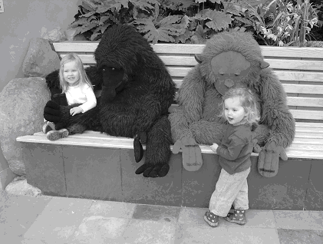
It was off to Crieff Hydro in October. Not the most glam holiday destination, but for an easy break it couldn’t be better. We stayed in one of the self catering chalets in the hotel grounds. Ours was the most basic kind (because of the dog!) and although it was ‘well used’, it was cosy and comfortable. The bedrooms were small and would only accommodate one travel cot but the staff assured me that, with prior notice, they would make space for two cots. There’s plenty of space in the living area for playing and the girls loved the secure balcony.
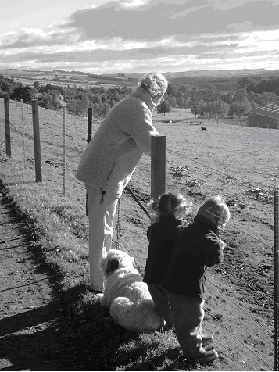
The surroundings are great. Plenty of woodland walks and a good play area (with a ‘real’ chute like the ones I remember – high and scary!). The swimming pool has good family changing rooms and lovely fluffy towels! There is also a Kids Club (for 3-12 yrs) which is free for up to five hours each day. The girls went twice and it was a big hit. A midweek break is very reasonably priced and we would definitely recommend it.

If you do go – pay a visit to Auchingarrich Wildlife Park near Comrie just up the road – it has great play areas, the biggest sandpit I’ve ever seen and a playbarn for wet days. There’s also a CeramicExperience with a soft play near Crieff. The soft play in the hotel is for the Kids Club only.

In November we went to the place David vowed he would never visit! Oasis Whinfell in Cumbria. This was actually our second visit mainly because, again, it’s really easy.

The lodges are really spacious and the twin bedroom easily takes two large travel cots. They do provide two cots (small) and highchairs on request at no extra charge for twins. If you want a refurbished lodge you can pay a little extra when booking.
There’s an outdoor play area and several soft play areas, some including the opportunity for a pint for the parents! There is a kids club but it has a programme of activities mainly aimed at 5yrs upwards. The swimming pool is fantastic with a dedicated toddler area with mini flume etc. Playpens are provided at the side for sleeping babies. The changing area isn’t that great, a bit short on family cubicles.

We found plenty to entertain the girls. We rented bikes with pull along trailers, one each, because neither of us fancied pulling both in one. Of course they wanted to travel together – good exercise!!
The real plus point is the overall environment. There are red squirrels and rabbits everywhere and ponies trotting past. No traffic (apart from Monday and Friday) gives the kids so much freedom to romp and explore and makes it really relaxing for parents.
There is also a well stocked shop and the restaurants are genuinely child friendly. The Lakeside inn serves decent pub food – we found it better than the restaurants.

Best of all there was not a ‘Hi de Hi’ to be heard!!

Although quite different, Crieff and Oasis both provide plenty to do with small children. Go for it!

Catriona Hepburn

 So what exactly is a Doula?

“Doula” is a Greek word loosely translated meaning “in service of” but in this context it is taken to mean a woman who provides sustained physical, emotional and informational support during labour, birth and the early weeks of parenthood (Doula UK 2004). She is a trained professional though not necessarily a medical professional. Doulas are all about supporting a pregnant, labouring or postnatal mother. For that reason doulas come in two main categories, Birth Doulas and Postnatal Doulas but you can also hire a doula for antenatal support. Doulas tend to specialise in either birth or postnatal work as it can be difficult to combine the two.


A birth doula will be a “nurturing presence, providing as much comfort as possible which may include massage or help with breathing and relaxation, encouragement and reassurance” (Doula UK). The birth doula may also act as your advocate and help access information for you so that you can make informed decisions. Your birth doula will be on call for you around your due date. You call her once you are in labour and she will visit you at home and accompany you to hospital if you are having a hospital delivery. She will then stay with you throughout until you have given birth. Your midwives may change but your doula will be constant throughout your labour. Once the baby is born your doula will stay for as long as needed but generally within one to two hours will leave so that you can get to know your new baby. If you have chosen to breastfeed she will assist with getting this started. A follow up visit will happen once you are home to discuss the birth and any other issues. Should you require postnatal support you may need to employ a postnatal doula as not all birth doulas work in postnatal support.

Postnatal Doulas are an alternative to more commonly used help such as maternity nurses. Doulas offer families the flexibility that does not come with maternity nurses. For example, Doulas work flexible hours to suit the families needs, they are also live out so may suit a family who is short of space particularly with visiting parents etc. Doulas also offer support to women that is unique as they are there to support the woman not to care directly for the baby. Doulas encourage bonding and by allowing the mother time to spend with her new baby the bonding process occurs naturally.

Support is a term that is used to describe what Doulas do, as Doulas view their role “as a being not a doing”. Doulas believe in “Mothering the Mother” but each family is unique and the support needed in each family varies hugely. What is so special about doulas is the needs of the new mother are put first and whatever the needs may be, you will be supported and cared for throughout. You are able to individualise your care to suit you and your family. Doulas work flexible hours to suit you, for example she may visit you once a week or five times a week, you decide what will suit you. Doulas are usually happy to help out around the house, preparing meals etc but can also run errands or do the school run. It’s like all the best bits of your mum, your sister and a professional rolled into one.

In today’s society women are leaving it later and later to start a family but a consequence of this is that in turn their parents are older too. So parents that may have been of great assistance are no longer a viable source of support. So the role of the Doula has become more popular and commonplace. In London today it is as difficult to find a doula as it is a maternity nurse and popularity is growing all the time. You only need to look to America to see how it now commonplace to have a doula support you at some time during your pregnancy or early parenthood. Doulas have been highlighted in the Scottish press recently, The Scotsman and The Edinburgh Evening News covered the topic in December after hearing about a local doula setting up a practice.

The process of finding a doula in your local area couldn’t be easier. The Doula UK website www.doula.org.uk lists all doulas’ contact information free of charge as well as lots of interesting information. All you need to do is make contact to arrange a meeting before you find that your local doula has been booked up by someone else.
Maria Robertson

Maria is giving an informal talk for Twins Club members – see Social Calendar for details.

Sing and Sign

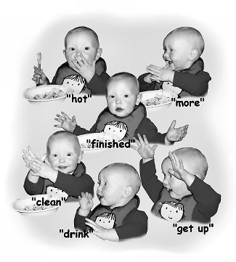
Have you seen “Meet the Fockers” recently and wondered what on earth that baby was up to?! Are you looking for a regular activity you can do with your baby twins which, as well as being fun, is a huge help to their development? If so, Sing and Sign might be for you. Dee Armstrong, who is a member of the Twins Club with her boys Thomas and Patrick (unbelievably aged almost 2 already!), has set up the Edinburgh franchise of a venture called Sing and Sign, which teaches hearing babies to communicate using sign language. Sing and Sign is not just a great fun way to spend an hour with your baby in a musical setting - using Sing and Sign methods, you can open up a new way to communicate with your baby before s/he learns to speak.

What is baby signing?
Typically between 8 and 18 months of age, before speech is well established, babies use a combination of gestures and sounds in attempts to communicate. For example, babies may point, shake their heads for 'no' and wave 'bye-bye'. Sing and Sign introduces some extra gestures at this time to help support and extend a baby's naturally developing communication skills. These extra baby signs enable babies to express themselves more clearly while speech and language skills are developing.

What are the benefits?
- Successful communication with signs encourages speech development.
- Signs can eliminate many of the frustrations of being pre-verbal.
- Babies enjoy increased confidence from being understood and this can boost self esteem and inspire even more communication!
- You expand a baby’s vocabulary and understanding
- Better communication enriches relationships.
- Sing & Sign gives local mothers and babies the chance to meet and get to know each other in a relaxed setting.
- It’s fun!

If a baby can sign, will speech be hindered?
No, not at all! Babies are greatly encouraged towards verbal communication by the introduction of baby signs. Gestures are not a replacement for speech. The use of gesture is a natural form of early communication and giving a baby a larger gestural vocabulary will lead to a larger spoken vocabulary at an early age.
When to start
From around 6-8 months of age children become increasingly receptive to language. You can start showing some key signs from this age and up.

What happens to signs, as a baby begins to speak?
Babies often use signs and immature speech together for a while. As speech improves, signs fade away until they are dropped altogether.

The Sing and Sign approach
The aim of the programme is to provide all the information on baby signing parents and carers may need in a relaxed and enjoyable way. You learn and practice a wide variety of signs using action songs and can then decide which ones your baby is most likely to enjoy. Sing and Sign makes the process of learning fun.

Research supporting baby signing
Several researchers have demonstrated the benefits of baby signing and have shown that babies who started signing at 11 months had a 4/5 month advantage in verbal ability by the age of 3.

Local courses
Sing and Sign is taught by Dee Armstrong. She learned Sing and Sign with her twin boys, Thomas and Patrick, in 2004. They started the course at 9 months and did their first signs (milk and duck) at 11 months. After that they went from strength to strength and at 15 months hit a signing peak, when the new signs were coming almost daily. They even made up their own signs and taught them to each other! Dee enjoyed the Sing and Sign programme with the boys so much that when the opportunity came up to teach the course in Edinburgh she grabbed it.

Taking twins to Sing & Sign.
Don’t be daunted by the prospect of taking your twins to a class like Sing & Sign. Other mums are always happy to lend a hand and as Dee is an experienced twin Mum herself she will always help with one while you deal with the other. As well as teaching her own twins baby signing, she has had two sets of twins through the first term of Sing & Sign (Kate & James Halliday and Murray & Fraser Tasker – ask mums Suzanne and Kenna what they thought of the course!) and the two sets of twins were infinitely better behaved than all the singletons put together! The best news is that unlike some other baby courses, you only pay for one place although there are two children – hurrah!

To book a place on the Sing and Sign course contact:
Dee Armstrong on 07831 409459
or email her at signedinburgh@aol.com.
The Summer Term runs from 15th April to 24th June
and the Autumn term from 16th September to 25th November 2005.
Currently classes are held on Friday mornings at 10am and 11am although Dee is hoping to expand later this year and offer a greater selection of times and venues.
Cost £60
For more information go to www.singandsign.com

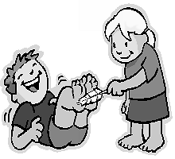
Deep in the backwoods, a woman went into labor in the middle of the night, and the doctor was called out to assist in the delivery. Since there was no electricity, the doctor handed the father-to-be a lantern and said, "Here, you hold this high so I can see what I'm doing." Soon, a baby boy was brought into the world. "Whoa there," said the doctor. "Don't be in a rush to put the lantern down...I think there's another one coming." Sure enough, within minutes he had delivered a baby girl. "No, no, don't be in a great hurry to be putting down that lantern...it seems there's yet another one in there!" cried the doctor. The father scratched his head in bewilderment and asked the doctor, "Do you think it's the light that's attractin' 'em?"


A couple desperate to have a baby went to their priest and asked him to pray for them.
"Next week I am going to Rome and while I am there I will light a candle for you," he replied.
Three years later the priest returned to his parish and went to the young couple's house to visit. He found the wife to be pregnant and busy attending to two sets of twins. The priest felt very elated and asked the girl where her husband was so that he could congratulate him.
"He has gone away for a while," came the harried reply.
"Where has he gone?" asked the priest.
She replied," To Rome, to blow the damn candle out!"

Two men were sitting next to each other at a bar. After a while, one guy looks at the other and says, "I can't help but think, from listening to you, that you're from Ireland." The other guy responds proudly, "Yes, that I am!" The first guy says, "So am I! And where about from Ireland might you be?" The other guy answers, "I'm from Dublin, I am." The first guy responds, "Sure and begora, and so am I! And what street did you live on in Dublin?" The other guy says, "A lovely little area it was, I lived on McCleary Street in the old central part of town." The first guy says, "Faith & it's a small world, so did I! And to what school would you have been going?" “St. Mary’s.” The first guy gets really excited, and says, "And so did I. Tell me, what year did you graduate?" The other guy answers, "Well, now, I graduated in 1964." The first guy exclaims, "The Good Lord must be smiling down upon us! I can hardly believe our good luck at winding up in the same bar tonight. Can you believe it? I graduated from St. Mary's in 1964 my own self." About this time, another guy walks into the bar, sits down, and orders a beer. The bartender walks over shaking his head & mutters..."It's going to be a long night tonight, the Murphy twins are drunk again."

Social Snaps
Happy Gang

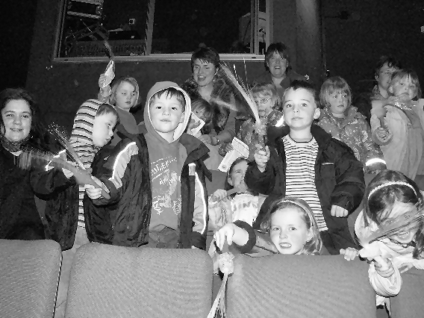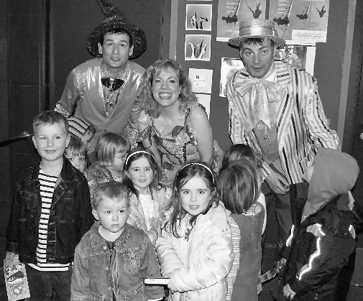

A Magical time was enjoyed in Mussleburgh on March 29th when Twins Club families attended The Happy Gang’s Magical Sweetie Shop Show at the Brunton Theatre. Real audience participation stuff – lots of shouting ‘Wake up Mr P!’, ‘Nicki needs a hanky!’, ‘Spats you’re SO greedy’, ‘Away you go with yer smelly feet!’ etc and enough stinky and snot jokes to keep your average toddler rolling in aisles. Special awards for audience participation go to the Robertson triplets and Gavin Petrie – they may have been operating to their own agenda but with great enthusiasm, which is what it’s all about! Very few parents escaped without the purchase of magical fairy wands which were energetically waved during the performance and,at least in our house, regularly confiscated at lights out many evenings since! Many thanks to the Happy Gang themselves for so charmingly agreeing to have their photos taken with some of our unruly crew!

Ceramic Experience

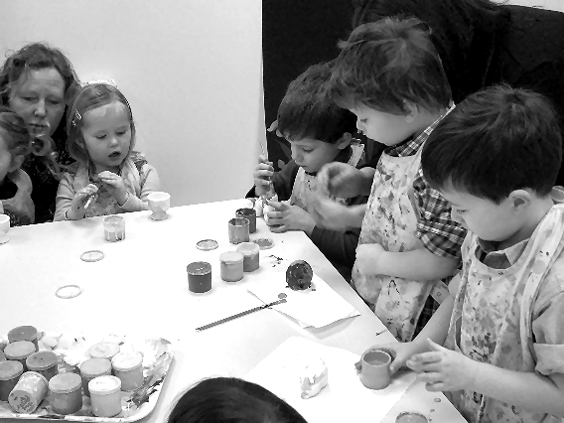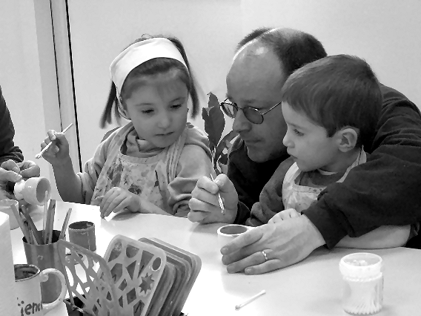

Taking over from last quarter’s mums’ night out, the kids got creative at Ceramic Experience at the end of February. The idea was Easter Egg Cup painting – ideal presents for grandparents etc. Some children proved more co-operative than others in this respect. The possibilities presented by Easter Snails, Easter Caterpillars, Easter Mermaids and Easter Fairies, were too tempting for some. Congratulations to those parents who kept their little ones on target, and commiserations to those of us who ended up with a motely assortment of multi-coloured ‘Easter’ ornaments! Well done to all our young artists. After the painting, most of the kids enjoyed blowing off some steam in the very compact but fun packed soft play area. Both adults and children also enjoyed the excellent café – although some small people maintian the best thing about the place is the unusual toilet seats!
Daytime Activities

COLINTON MAINS DRIVE

Oxgangs Neighbourhood Centre
Firrhill Drive
Bumps, Babies & Toddlers Group
0131 441 755

Tuesdays 3pm – 4.30pm (songs at 4.15pm)
Thursdays 10am – 11.30am (songs at 11.15am)
£1.20 per member family. £2.40 non-members
Daytime Convenor: Jenny Love, Tel:445-3403

All families & Mums-to-be are very welcome. Meeting other people who understand the joys and hazards of life with twins can really help.

Daytime News

Thanks to the mums from the Thursday group who helped in the cleaning of the toys. Can all attendees please ensure they tidy up the toys in the correct boxes at the end of each group.

Due to the increase in price of the hall by the Oxgangs Neighbourhood Centre the cost per family is now £1.20 for members and £2.40 for non-members. There is no cost for first time visitors but this is a members group and everyone who attends should join.

If you are bringing your children in in a buggy please ensure you leave it in the front vestibule as we need to keep the entrance to the hall clear for the health and safety of all.

The Sure Start group have very kindly offered to lend us a door gate on a Thursday to ensure the safety of younger children with the hope they are unable to get out. We should still keep a close eye on our children as it is not a secure fitting and can be moved.

We have started to set up an art box mainly for the older children but it can be used by all. At the moment it only consists of 2 colouring books, crayons, coloured pencils, playdo and 5 magnetic drawing boards. We will buy more when we have sorted out space in the cupboard. Please ensure that your child is being supervised while playing with the art tools as we would not like any pencils to be put up noses etc.

The Oxgangs centre should only be closed for Christmas and the Edinburgh trade holidays. Unfortunately the club has had to close due to boiler failure a few times already this year. We contact our members through e-mail regarding closures so please ensure you keep your details up to date. Any changes can be passed to Jenny who will then pass the information on to Membership.

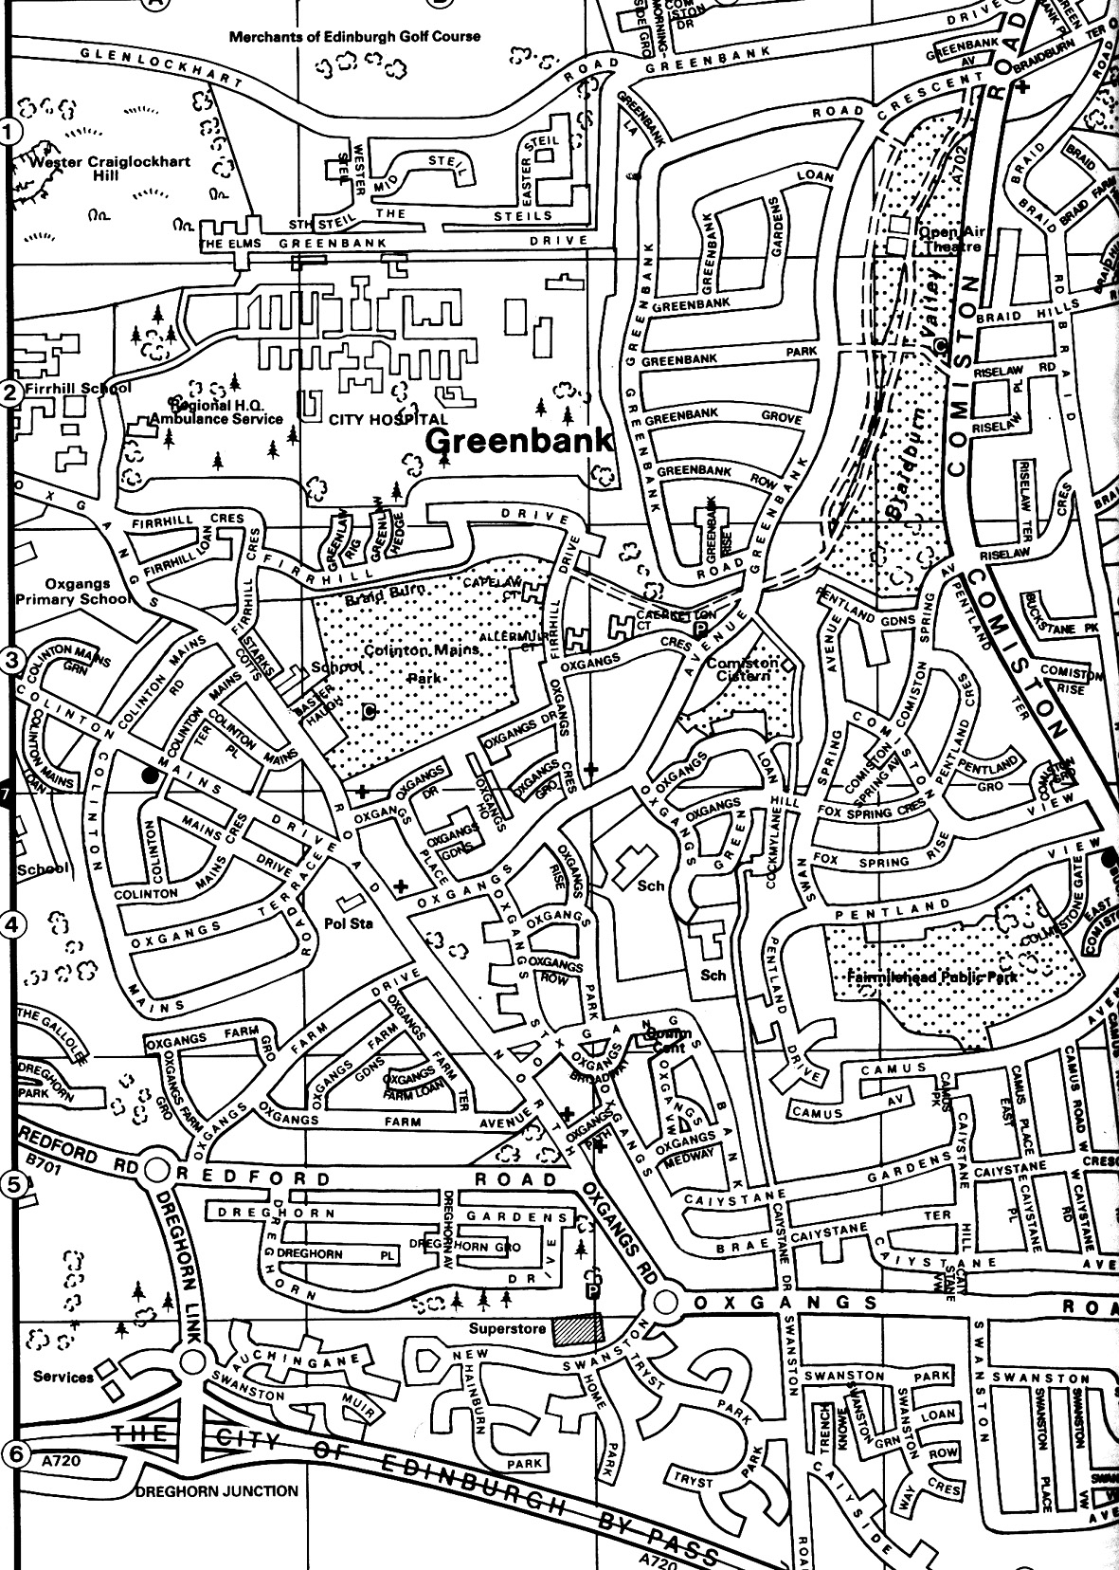
Oxgangs Neighbourhood Centre

Library
The Twins Club has a large number of books on multiples & children in general. The books can be lent out during the sessions for a couple of weeks.

Note
The insurance we have at Oxgangs doesn’t cover children over five. You may want to bring older brothers or sisters over the holidays but that will, as they say, be “at the owners own risk”.

East Edinburgh / EAST LOTHIAN
at
St Phillips Parish Church, Brunstane Rd North, Joppa

On the 1st and 3rd Monday of each month
10am – 11.30am
Easy Parking, Coffee available

For more info please contact either

- Carol Frith (Health Visitor), Esk Medical Centre
Tel: 653 0400 or
- Susan Sinclair (mum of twins) Tel: 657 1550 or
- Helen Nettleship (mum of twins)Tel: 665 4321

ALL HELP TO SET UP/TIDY AWAY TOYS WOULD BE APPRECIATED

Discounts

We have been trying to negotiate with a number of retailers / clubs in order for Edinburgh Twins Club members to obtain discount. If you already use your card in other shops, please let us know for future Newsletters.

Blessings & Blossoms, 132 St Johns Road, Corstorphine, 0131 334 8322
10% Discount. Childrens Clothes shop.

Cheeky Chimps Indoor Soft Play Centre (Freeport)
HALF PRICE ENTRY. Valid Monday to Friday only. Must show your Twins Club membership card.
Normal Entry Price is £1.50 for under fours and £3 for children over 4 and up to 4ft 9 in height.
Arrangements can be made for cheaper party costs. Contact Angela Caserta on 01501 762 409

CLARKS Shoe Shops
10% discount on production of Twins Club membership card (it does not have to be the TAMBA card). This will apply for all siblings shoes as well ! This only applies to Edinburgh stores (Cameron Toll, Gyle, Princes St, Kinnaird Park & Musselburgh) but we have had a few problems with some of these stores accepting our card – please refer any member of staff to their Regional Manager, Nigel Merritt who has agreed this discount scheme countless times. Please do not try to obtain discount from any other store.

Doodles Ceramic Workshop
29 Marchmont Crescent, Edinburgh
10% discount for all visits. Includes evening visits when mum's can enjoy some peace and quiet with friends.
15% discount for birthday parties booked in either July or August, either in the Doodles studio or with Doodles to Door (which brings all the fun of Doodles to your home or other venue). Subject to Availability. Call Holly on 0131 229 1399

Golden Hands Silver Feet
10% discount. Your little ones hands and feet captured in Bronze, Brass, Aluminium or Stone.......FOREVER - a unique memento or gift. For more info & prices please see www.goldenhands.co.uk or phone Nicky Summer on 0131 665 8628

Jelly Club
10B Kings Haugh, Peffermill Road, Edinburgh. 15% Discount on production of Membership card

Lorac Carpet Services * * NEW * *
10% Discount. Professional carpet and upholstery cleaning, general repairs, odour treatment, specialised re-tufting, specialised oriental rug cleaning. For free advice/estimates contact: Phone 0131 468 0996; Mobile 0775 159 4900; email info@loracservices.co.uk

Nightbridge Designs
15% off custom made soft furnishings, bedding & curtains. Contact: Debbie on 01506 431515

Paul Bradford Designer Cakes
10% Discount. Simple cakes to intricate designs. Look fantastic and taste great too ! Tel: 01506 671133

Rocking Horses
10% discount. If anyone would like to see/ride a large mahogany horse (called Rocky !!), please contact Gill Petrie on 0131 443 2919.
Contact: Jim McAuley, 73 Manse Street, Saltcoats, KA21 5AA. Tel: 01294 466415

Wendy Beardmore, Freelance Public Relations
15% DISCOUNT
As a member of the twins club, I have recently started out doing freelance PR and Marketing, using my maiden name Wendy Robbins. I am mainly helping small businesses and start ups to develop their marketing. If you have your own business and need some help growing this, or indeed if you know someone else in this situation then give me a call.
Call Wendy on 0131 334 9591 or 07771 966 488.

Snippets

ADVERTISING RATES

The following charges apply to advertisements in the Twins Club Newsletter:

Club Members
Members may advertise a commercial enterprise once for free, any subsequent advertising is charged at £25
Swap Shop and Wanted ads are free to members

Non-members
Non-members may place an advert for a fee of £25

Charges do not apply to the Discounts listings.

Remember that the new Twins Club website is now live. It can be found at:

http://www.edinburghtwins.co.uk.

The listing of social events is now updated regularly and we are hoping to add more features and information in the coming months.

Please let us know what you think via the e-mail address webmaster@edinburghtwins.co.uk. If you have any ideas for extra content or functionality, send them in too.

CHRISTMAS RAFFLE DONATIONS

The Twins Club would like to offer our apologies to Catherine Longmore of Phoenix Cards for missing her off the list of donors to our Christmas Raffle. Catherine donated a lovely selection of wrapping paper and gift tags. Many thanks and best wishes for a prosperous 2005!

Newsletter
Articles to:
Vicki Jarrett
32 Buckstone Row
Edinburgh
EH10 6TP
vjarrett@blueyonder.co.uk

by Thursday 30th June

LOST PROPERTY

A small black backpack was left at the Shadow Photography event in Balerno last year. It seems to be a nappy bag but also contains a few other items. If it’s yours phone Jenifer Robertson on
477 6212.

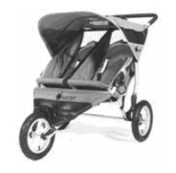
FREE use for members
Thanks to a West Lothian grant, the Twins
Club purchased an all-terrain ‘running’ buggy,
Similar to the one pictured.

Anyone interested in using it should phone Sue Cook on 01506 411881.
TAMBA
The Edinburgh Twins Club is affiliated to TAMBA (Twins and Multiple Births Association). Membership is separate however. For details of the benefits of TAMBA membership, visit www.tamba.org.uk
or telephone 0870 770 3305
Swap Shop

2 Priori Maxi Cosi Car Seats Grey/Yellow fabric, reclines, forward facing, Group 1 (from 9kg), hardly used, was for the spare car. Can be seen on http://www.juniorprofile.co.uk/drive_safety/groups/group1/group1.html but in a different fabric.
Cost £85 each
£25 each or £45 for both .

1 Priori Maxi Cosi Car Seat
As above but grey/black – exactly as seen on picture in http://www.juniorprofile.co.uk/drive_safety/groups/group1/group1.html
Cost £85
£25

1 Iseos Car Seat
Blue/Grey, Front and rear facing. Purchased from John Lewis in Glasgow. £25

Will deliver to convenient location if necessary!
Contact: Sue Cook
Tel: 01506 411 881

2 First Years On The Go Booster Seats
Self inflating booster seats - compact, lightweight and portable. Brilliant for holidays/travelling. See these items at www.firstyears.com
£10 for two

Mamas and Papas Antique Pine Lidia Cot
Large size 74cmx133cm Suitable from birth to toddler
£30

Bag of unused safety locks - free to good home!

Contact: Fiona Constable
Tel: 476 9167
Email: fionaconstable@blueyonder.co.uk

2 Britax Rock-a-Tot car seats
Suitable birth-9 months, rear-facing with carry handle (don't have to disturb sleeping babies!). Velour washable covers in ‘Spellbound’ design (navy with white moon/ stars). Ideal as chairs/ feeding chairs when out & about.
Excellent condition. Never been in a bump or accident.
£15 each or both for £25

Bouncy chairs
1 Marks & Spencer navy/ white check (£40 new), 1 Mothercare lilac check (£34 new). Both are sturdy, have adjustable positions, washable covers & head huggers, and fold flat for storage/ transporting.
£10 each

Travel Cot/ Playpen
Large size, folds flat for storage. Firm base with foam mattress (The Foam Centre can do replacement foam), soft sides, easy to put up & down & big enough for 2 to sleep/ play in. Clean & in good condition.
£15

Double buggy
Maclaren twin umbrella style buggy (purple check), with multi-position seats, hoods, shopping baskets, rain cover, & matching changing bag. Reasonable condition.
£20

Contact: Carole Park
Tel: 667 2369

Emmaljunga Twin Pushchair.
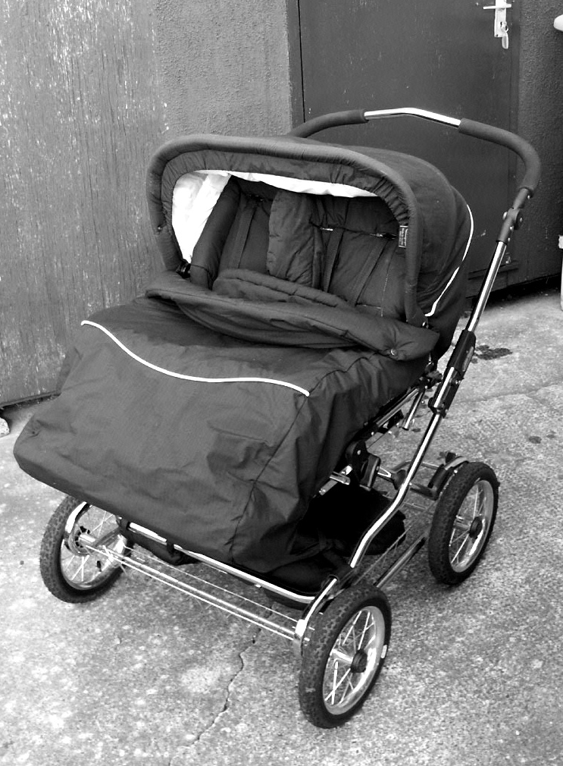

Black with reflective detail. Includes hood, skirt, rain cover, integrated insect net, shopping tray and footmuffs. Seat unit can be front or rear facing, independent foot and back rests. Suitable from 0-3yrs. Cost £500.
£150 ono

2 Potty chairs
One Aqua with lion motif and one yellow and white with duck motif, never been used.
£6 for both

Cosatto cot x 1
(excluding mattress). White
£10

Contact: Helen Nettleship
Tel: 665 4321
Email: helennettleship@aol.com

Mothercare Playnest and Gym
Inflatable 'donut' jungle design, with 5 detachable hanging toys. Suitable from birth, ideal for those learning to sit up unaided. As new condition. (cost £40). £15

Baby Bjorn baby carrier
Comfortable baby carrier (one baby) facing either towards you or outwards. Suitable from 3.5kg to 10kg. Machine washable. Tartan design.
£10

Mothercare door bouncer
Adjustable height & saddle. Suitable from 3 months. Dark Blue colour.
£5

Infant Welly Boots
Soft watertight insulated wellies for little ones who want to walk outside in the rain but are too little for conventional wellies. We think they are great. Red, made by Muddy Puddles, two pairs.
£2 per pair

Over the bath baby bath
Super - fits most baths- free to a good home.

Contact: Gill Anderson
Tel: 447 5462

WANTED
2 High Chairs (preferably foldable frame for easy storage);
2 second stage car seats; 1 playpen.

Contact: Margaret
Tel: 01324 626704

Mothercare Cot
Playbead cot in Beech in excellent condition. Easy and convenient, one-handed drop side mechanism.
3 position base height. 2 teething rails. (Includes mattress and some bedding).
Suitable from birth. Cost £160 new
£60 o.n.o.

WANTED
2 good quality/condition Backpack carriers for 9 mths old upwards.

Contact Mhairi Whyte
Tel:: 01620 892099

Swap Shop (cont’d)

3 Klippan car seats
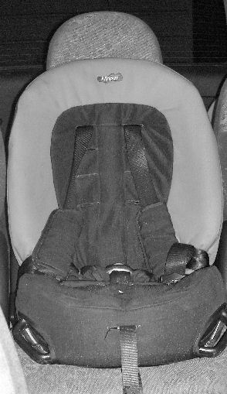

Suitable for children aged 9mths to 6 years approx. Front or rear facing with three point harness
Never been in any sort of accident
Clean and in excellant condition
£85 new
£40 each

Contact:Jenifer Robertson
Tel: 477 6212

Berchet toddler climbing frame
with chute & tunnel (ELC catalogue) £70ono

Berchet toddler play house
£50ono

Contact: Catriona Hepburn
Tel: 336 1062

Tomy Lightshow
Plays soothing music and projects gentle moving lightshow on ceiling. Has straps for attaching to cot and comes with remote control on/off unit.
£5

Cot Bumpers
2 – one with teddy design, one green/purple check.
£2 each

Contact: Vicki Jarrett
Tel: 477 1404

REMEMBER!

If you’re looking for something in particular and don’t see it in this month’s Swap Shop – come along to the Edinburgh Twins Club Nearly New Sale on 11th June. We hope to have lots of members selling on their unwanted baby equipment, toys and clothes. Or, if you meant to put in an ad and never got around to it – take a table yourself. See page 3 for full details.

Available
Experienced Nanny

Nanny with 11 years experience, including 5 years with twins, looking for a new position. Current employers (with twins now aged 2) are leaving for Canada so I am available full or part-time from the end of May (negotiable).

Jane Borthwick
01506409946 or
07742226108

Post natal care for Mum and Baby(s), care and support in your own home for those first
few special weeks. You choose the hours to suit you. Breastfeeding support and advice.
Will help out with school runs, shopping and cooking etc if necessary.

Experience with First Time Parents, Premature Babies and Multiple Births for over 5 years.

Full set of great client references (checkable).
First Aid Certificate & Insurance Certificate.
Member of Doula UK (www.doula.org.uk) and AIMS.

Call me for a chat for more information or email me.
Maria Robertson. 01383 732254 (Home) 07740 681515 (Mobile)
Email: mariaroche1@hotmail.com
Please note that the Edinburgh Twins Club cannot be held responsible for any purchase made through the Swap Shop or Wanted section. Each deal is entered into privately between the two parties involved (i.e. the seller and the buyer).
You can advertise as often as you wish, but you must notify The Editor each time you wish to advertise again.
Please send all items you wish to advertise to:

Vicki Jarrett: 32 Buckstone Row, Edinburgh EH10 6TP
e-mail: vjarrett@blueyonder.co.uk
Tel: 477-1404

Social Calendar

The Jungle Book    Sunday 15th May 10.45am | Dominion Theatre, Newbattle Terrace  This Disney Classic is showing again for our private viewing.  An unmissable classic, loved by all.  Come and sing along!  £3 per person. Please pay on booking
East Links Family Park  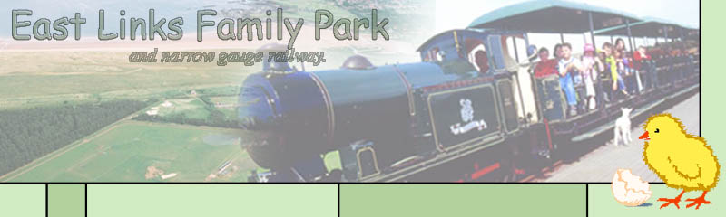  Sunday 29th May 11am | West Barns, Dunbar, East Lothian  Take the West Barns exit at the Thistly Cross roundabout on the A1. It’s next to the John Muir Country Park (www.eastlinks.co.uk)  ‘A fun filled family day out!’  Narrow gauge railway, train safari, farm animals, giant maze etc.  £4.50 per person (twos and under free) Please pay on booking  We have unlimited use of all the facilities and a group area reserved in the picnic barn
Doula Parents’ Talk    Tuesday 31st May 8pm | Venue to be confirmed  An informal evening where we have the chance to learn more about what Doulas can offer. Local Doula Maria Robertson will be on hand to tell us all we need to know. Please indicate if you would like to come along. We will be in touch then to confirm the venue. See Maria’s article on page 6.
Twins Club Nearly New Sale    Saturday 11th June 11am - 1pm | St Stephens Comely Bank Church, 10 Comely Bank Road  £10 per table for vendors. Please pay on booking  £1 admission for buyers. Pay on the day  Come and join in and help raise funds for yourselves and The Club.  See article on page 3.
The Singing Kettle    Sunday 24th^{th} July 3pm | The Festival Theatre, Edinburgh  ‘Blast Off’ with the Singing Kettle!  Come dressed as a Cosmic Princess, an Alien or a Space Cadet.  www.singingkettle.com  Special reduced rates for Club Members  £7 per person (12 months and under £2). Please pay on booking.

