edinburgh twins club
Edinburgh Twins Club
Newsletter

January 2005

Happy New Year to all our members from all of us on the committee for 2005!

The AGM was held on 10th January at The Murrayfield Hotel and a new committee was elected (minute attached). We have been very lucky that many of the members serving on the committee last year have decided to stay on and also that we have some new faces. We really do need more of you with younger children to come forward and show an interest in joining our committee. I would be more than happy to talk over things with anyone who thinks by this time next year they would like to join the committee, contributing to the club as well as gaining a great deal of personal satisfaction for themselves. I can assure you it is very rewarding and a great way to meet friends and have some fun! Many of this year’s members will be standing down next year as their children reach school age so please think about it and give me a call if you are interested.

I am honoured in my final year on the committee to take on the mantle of chairperson as the club has been very close to my heart for the past few years. Initially, as a point of contact when I had young babies as I was desperate to meet others in the new and strange position I found myself in - mother of a new baby…no two new babies!. I still find the friendship and support I have gained over these years invaluable. We have some great ideas for the Club next year but would still really like to hear some of yours! Please let myself or one of the committee members know if you have suggestions - we really do want it to be for you!

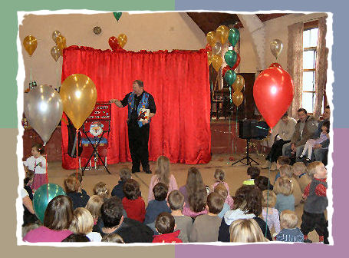
I look forward to a terrific 2005 for all the committee and members of The Edinburgh Twins Club. I’m sure it is going to be a great year.

Remember we have a great website, thanks to Gary Winfield, at www.edinburghtwins.co.uk please have a look at it! Also thanks to Vicki Jarrett who has spent many hours of her time preparing this Newsletter for us at a busy time of year.

Best Wishes

Vicky Petrie
Chairperson
The Twins Club Christmas Party was held on 11th December at Upper Belgrave Hall, Corstorphine. Thanks to all the organisers for a fun-packed morning which included entertainment from Gary James and Stone the Crow, a raffle with great prizes and a guest appearance from Santa. All the children received a present, party food and a balloon.

339-0135
victoria@lesterpetrie.freeserve.co.uk
 | Membership Update  Welcoming the newest members of ETC | 2 |  | Discounts  Everyone’s favourite perk – which shops and how much | 8
 | Members Stories  Two members share with us their trials and truimphs of feeding twins | 3 |  | Snippets  Bite sized chunks of news, information and trivia | 9
 | Social Snaps  All ages enjoyed a good Clown Around and the Mums have a Ceramic Experience. | 6 |  | Swap Shop  For sale + wanted, everything from buggies to nannies | 11
 | Daytime Activities  Times, venues, directions. Pay us a visit! | 7 |  | Social Calendar  A fab selection to start 2005. Forms back by 14th Feb!. | 12
Membership Update

Dear Members

Congratulations to both of our new families this month:

- Kathryn (Kate) and Alistair Henry who have had a little girl and boy, Sarah and Lewis, on 29th December 2004 – Congratulations to a very proud Mum and Dad; and to
- Claire and Mark Burrell who became proud parents to Euan & Sean on the 30th of December last year.

What a fantastic end to 2004 and start to 2005 for both families!

We would also like to welcome the following families who have joined the Twins Club since the last newsletter:

- Claire Hall and Marcus Barnes, and their twins Joseph (Joe) and Finlay (Finn) aged two.
- Kate and Ian Bayne, and their twins Niall and Orla, born on the 25th of October 2004.
- Susan and Gary Sneddon, and their twins Lewis and Ella, born on 25 April 2004.

WELCOME TO OUR NEW MEMBERS AND CONGRATULATIONS AGAIN TO THE HENRY AND BURRELL FAMILIES!

Going into a new year, we thought we would provide you with an update on our figures. Our membership list currently consists of 122 families. We sent 34 renewal forms out in October; of those 24 were returned. Further renewal forms are attached for the 10 families we didn’t hear from with this newsletter. Of the 11 reminders sent to the outstanding renewals from July: 2 families renewed, 9 families did not make any contact but will be reminded once more this month. Of the 9 reminders sent to the outstanding renewals from April: 1 family renewed, 2 families informed us they did not wish to renew and 6 families were deleted.

26 families are due to renew their memberships this month and 19 reminders will be sent to the families who should have renewed in July (9) and October (10).

We would be really grateful to hear from you should you not wish to continue your membership of the Club. It would be interesting for us to know why you might feel the Club ceases to be of interest, bearing in mind we are aware that there is perhaps less need for the support as the children get older. Also, hearing from you would greatly assist our admin hence a quick call or e-mail would be very much appreciated, should you not have time to return our little form!

If there is a Membership Form with this newsletter your membership is either due or overdue for renewal. Please complete the form and send it with your cheque to Gillian Smith by mid February 2005.

If you would like to speak to someone about ANYTHING to do with having multiples, the ETC has a list of volunteers willing to discuss a variety of subjects – CONFIDENTIALLY. PLEASE VOLUNTEER if you have had your babies recently and would not mind sharing your experiences. Please notify us of the topics you would be happy to discuss. Your name would only be passed on when someone requests someone to talk to. A BIG thank you to those that have volunteered!

PLEASE do not forget to call Karen or Gillian and let us know your baby news – this really will help us come Newsletter time. If we have missed the birth of your babies, or you are a new member and we have missed you from our list, please let us know so that we can add you to our next newsletter.

Finally, all the very best to all our members for 2005 – HAPPY NEW YEAR!

Karen and Gillian, Membership Committee:
Karen Winfield  23 Bluebell Glade  Adambrae Parks  LIVINGSTON EH54 9JJ   +44 (0) 1506-416 412  Karen@the-winfields.com | Gillian Smith  22 Braid Avenue  Morningside  EDINBURGH EH10 6EE   +44 (0) 131-447 3000


Members’ Stories

We have been lucky enough this month for two members to share with us their very personal experiences of establishing and maintaining feeding with twins. Each experience is unique and neither represents any mythical ‘norm’. As many of you will be discovering, with multiples, there is no norm! That said, the common purpose of feeding and caring for more than one baby at a time does result in much common ground. Our two authors have kindly agreed to share their experiences in hope of helping other members who may be going through similar experiences or be looking for advice. Both have provided their telephone numbers should any member wish to discuss the issues raised in their pieces.

Breastfeeding Twins: a mother’s tale of trial and error

It is difficult to know how to write an article on breastfeeding twins when I recognise that, since I am still breastfeeding my 12 month old twins, I am in a minority of mums. It is difficult because I do not want to sound smug, like a super mum who had no problems at all. Neither do I want to come across as a woman of remarkable resilience who overcame extreme difficulties in order to win some sort of prize! I am neither of these. I am actually a rather surprised mum who can not quite believe we have got this far. And I say ‘we’ because it has definitely been a team effort.

Ben and Lois were born at 39.5 weeks (I was induced) and I had every hope that I would breastfeed them. We spent five rather difficult days in hospital trying to get the babies to latch on. Ben seemed to be feeding well but Lois struggled and I spent hours of anxious time trying to stuff my breast in her mouth or expressing miniscule amounts of milk that then dribbled down her chin as she was fed by a small plastic cup. One of my nipples became extremely sore and I soon discovered it was cracked. Breastfeeding had not got off to a great start! We wanted to discuss using some formula to help Lois but found the hospital, under pressure to reach their ‘Baby Friendly Initiative’ targets, reluctant to do this. Perhaps we weren’t pushy enough but we were on an emotional roller-coaster, our gorgeous babies having arrived to turn our world upside down!

Once we were back home, with the help of community midwives, we used a combination of breast and bottle feeding, expressed and formula milk, just to ensure that Lois had a full tummy and I had a little extra energy. The cracked nipple failed to heal, despite resting it. I tried breast shields, loads of nipple cream, different feeding positions, talking to a breastfeeding counsellor and regular doses of paracetamol! I came very close to giving up altogether but we came across an article through La Leche League associating cracked nipples with tongue ties. The medics in hospital had identified Ben as having one – this is when the fine sinew which holds the tongue down almost reaches the end of the tongue, thus limiting the tongue’s mobility. The sore nipple was on ‘Ben’s side’. We investigated the treatment and in a few days, took Ben to hospital to have his tongue-tie cut; a procedure which takes seconds. Within days there was an improvement and by 10 weeks, it had healed. This made an enormous difference to me and meant that I could see a future to breastfeeding!
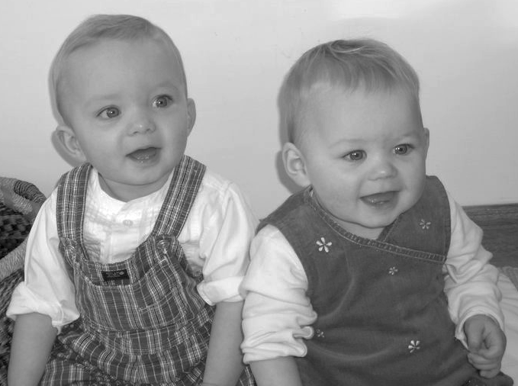
Lois gradually got better at feeding from the breast and we were able to eliminate bottles from the daytime. By 12 weeks, everything became so much easier. The babies started to take only 10 minutes to feed (I had ‘allowed’ them up to 30 minutes each until then). Since I was feeding them one at a time, this reduced the hours spent feeding dramatically and I was able to spend more time playing with the babies and getting jobs done. At this stage, they were getting one bottle of formula before we went to bed and in the night feed, one would have a bottle (Kevin would feed them) and the other would have the breast. We had some very surreal moments in those early hours, half asleep, babies quietly sucking away!
Ben and Lois

By five months, they had dropped the 10.30pm feed and normally the night feed, so they reverted to being 100% breastfed babies. I began to wean them at about 4 months, when Ben started to demand more feeds than I felt able to provide. I became a more confident feeder and could occasionally feed them simultaneously if we were in a hurry to get somewhere.

So here we are at 12 months, with Ben and Lois sleeping through the night (mostly!), three breastfeeds a day, three meals a day, one rather shocked mum and one quietly proud dad! Here is a list of our top tips for feeding twins:

- Combination feeding (using some formula in a bottle and some breastfeeding) provided us with the support we needed to establish breastfeeding. Without this, we would have stopped in the early days.
- Our babies had no problems transferring from breast to bottle. Tracy Hogg has written a book called The Secrets of the Baby Whisperer. We found this gave some useful advice.
- We had ours in a routine from the very beginning, feeding them every 3 – 4 hours. Again, Tracy Hogg has a good bit on twins in a routine.
- I drink lots of water and the occasional can of stout, took some brewers’ yeast initially, eat a large, healthy diet and a daily portion of chocolate. The “I’m eating for 3” line has lasted me over 18 months now!
- Twins are often premature and this can make breastfeeding really difficult.
- If you have to go back to work, there isn’t always as much ‘space’ to work on breastfeeding so don’t be too hard on yourself.
- We all get fresh air every day. It is a great stress relief and helps everyone to sleep.
- One baby has one breast and sticks to the same side. It makes life easier!
- We took one day at a time. The first few weeks were a blur but by 12 weeks, the fog lifted and the fun started.
- I had, and still have, simple expectations of my day to ensure that the babies get good daytime sleep and I don’t wear myself out. I am sure that it will be worth it in the long run.

I am no expert. I have a pair of forgiving and persistent babies and a gentle, encouraging husband. Left alone, I would have used all formula. I hope I have no hang ups about it as I am a healthy adult who was a formula fed baby. But twelve months on, I am very glad to be breastfeeding and I wish you every success if you plan to go down the same road.

Katie Turner
0131 334 3563

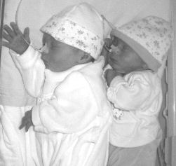
The Whyte Twins Story
Cuddled up in special care, naso-gastric feeding tubes in place

Due to pre-eclampsia, our twin girls were delivered early by cesarean section. I requested skin-to-skin contact, and as the babies were 6 weeks premature only had a few seconds next to my face/shoulders, but it was a special moment my husband and I will never forget. We had 2 beautiful girls: Katie-Rose - 3lb 13oz born at 2.19pm and Mary-Beth - 4lb 7oz born at 2.21pm. My husband cut Mary-Beth’s cord and was beside me throughout.

The babies were taken to Special Care straight away to maintain their temperature and monitor them, but they were fine and needed no extra assistance. I was wheeled in on my bed after recovery and touched them in their incubators. They were tube fed with Aptamil formula and my expressed colostrums/milk as they didn’t have the sucking reflex. Over the next 12 days I learned how to pass a tube into their tummies so that we could get them home.

On Monday 19th July we took our daughters home and within 3 days I had got them off tube feeding and feeding from me (with nipple shields as their mouths were so small).
On Sunday 25th July at 4am I was attempting twin feeding on a v-cushion and Katie-Rose (by then 4-5lb) started choking. I took her off to see if she was ok and she had turned blue around her mouth, eyes and nose. I moved her about but her hands had started turning blue also. I woke my husband up in a panic and he leapt out of bed and put her over his palm and slapped her gently on the shoulder blades. What felt like several minutes later, milk came down her nose and a few seconds later she gasped for breath. I was sitting with Mary-Beth still attached and sobbing in fear and shock as my husband kept saying “please breathe”.

No amount of First Aid training had prepared me for this! We rushed Katie-Rose to the emergency medical centre and by the time we got there she had completely recovered. We were sent by ambulance to St John’s just to make sure all was fine. We spent the next few weeks watching her carefully at feed times.

I lost my confidence and stopped breast-feeding for a few days and this and the stress of everything had cut my milk supply down. I was exhausted, as the babies were feeding 1-2 hourly and had developed colic symptoms, and days and nights merged into each other. Some days I hardly ate or slept and one day I got dressed at 7pm after being in the bedroom feeding and expressing all day.

I contacted my health visitor and the breast-feeding counsellor lines but each had a different opinion and it all became very confusing. Once upon a time I was an enthusiastic and organised Nanny/Nursery Nurse and now I was a Mum I felt a total failure incapable of doing anything properly.


I was having problems establishing feeding again and the babies were thrashing about, arching their backs or curling up and pushing off and I was in pain on attachment. It was excruciating and I fed with streams of tears. I went to The New Royal where the breast-feeding Clinic diagnosed nipple thrush (something I hadn’t heard of) and I was treated with cream/gel and the Babies were treated also as it was in the back of their mouths. Over a couple of weeks this got better but my milk supply was so low I was having to top up the babies with formula, as my milk wasn’t enough to satisfy them for more than 30-60 minutes. I knew the benefits for breast-feeding for the babies and for me and was so determined not to give in, as it’s something I really wanted.
Look at us now! Ready for take off!

Both babies were bringing up feeds regularly and were very colicky, screaming for hours on end. At St John’s clinic they were diagnosed at as having Reflux. The girls were put on SMA Staydown formula for Reflux by the local surgery. but this didn’t improve the feed regurgitation so it was recommended that the babies go on infant Gaviscon as well. We had queried a possible link with the milk but it was dismissed as the girls were still gaining weight.

I tried all the advice from other twin Mums following mixed feeding (one breast and one bottle) or feeding and topping up but nothing seemed to work as I had no time or energy to implement the ideas. Most other Mum’s had had full term babies with less feeding/sleeping problems or had daily help and seemed to have a routine to a t but my 2 wouldn’t fit into any of these plans no matter how hard I tried.

It was hard work on my own (my husband is out from morning till 9pm Monday to Friday) and I have no friends or family close enough to help. At last my health visitor found light at the end of the tunnel via Home Start and I now have a lovely lady that helps for 3 hours a week.

After months of difficulties and the babies being obviously in severe pain (particularly late aft/eve), and after many medical consultations, finally St Johns Hospital were kind enough to assist us by admitting the babies for 2 days the week before Christmas. They changed their formula in the 48 hour period of stay. This clearly made a massive difference in a matter of hours and the babies became less stressed and more relaxed and were settled enough to sleep at night and were also contented through the day.

Our girls had already been changed from Motilium to Ranitidine - prescribed by The Sick Kids Hospital for their Reflux, as the Motilium was causing diarrhoea but after discussing our concerns with our health visitor I queried with the consultant at St John’s why the twins were on Infant Gaviscon in the feed, when it clearly states on the medication not to add it to any other thickening agent (which SMA Staydown is). It was immediately after this appointment at St John’s that the twins were admitted.

The staff on the children’s ward said that SMA Staydown ‘has a history of causing stomach complaints’ and one member of staff had taken her own baby off it after 1 week of hell. They said there that normal formula plus the correct dose of Ranitidine should be enough to do the trick for reflux. It is fortuitous that St John’s had the experience of this problem. We now have VERY contented babies and feel we brought home 2 totally different natured girls after such a simple change. They are now 6 months old and we can enjoy them as we should. They are happy contented wee souls and so are we as parents now we have happy babies – what a great Christmas present!.

I hope our experience can help those out there who think they are the only ones not coping as new parents and that may experience similar problems.

Mhairi and Chalky Whyte
01620 892099

Social Snaps

Clown Around

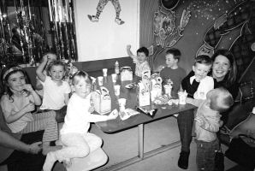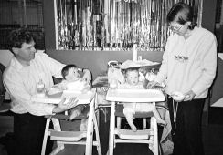

A very good time was had by all at the outing to Clown Around on 17th October. We had a full house and more people on the waiting list who were sadly not able to join us this time but we may well organise another social event in the coming year’s calendar as it was so popular. We had 2 hours of soft play for all ages and a party booking which provided the exclusive hire of the party room for our multiples to munch! (Cook book hint!) Food and drinks were all provided followed by….after the ice cream machine warmed up …some lovely soft ice cream…just as well the baby wipes were handy! The photos should provide you with a flavour of the fun and as you can see it was not only toddlers who enjoyed the day…Elizabeth and Jennifer Ashworth..aged 11 months at the time were our youngest soft players ..see them pictured here along with mum and Dad Stuart and Kairsty Ashworth..well done guys! Thanks to all who came along and made the day a success

Ceramic Experience

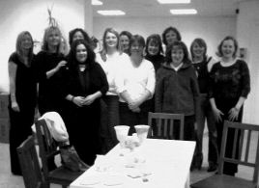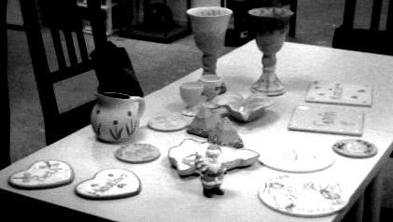

A fun and enjoyable night was had by all at the mums night out at the Ceramic Experience in November. Glorious goblets, exquisitely painted fairies, marvellous mugs and lots more, were produced by our own fair hands. We were entertained by Anna, the owner of Ceramic Experience, who happily kept our glasses topped with wine all night. And, after sitting down to some delicious home-made food, we set about painting. This is when some hidden talent really came out of the closet. For those of us less artistically inclined, there was plenty of help and advice from Anna and friendly encouragement from all, so that - in spite of the wine - we all produced something to be proud of. Who would have thought it!? On a high, from such artistic achievements, we headed for a local bar in Leith where the fun and hilarity continued. Don’t miss it next year!!

Daytime Activities
COLINTON MAINS DRIVE
Oxgangs Neighbourhood Centre

Directions: Colinton Mains Drive/Oxgangs North
Oxgangs Avenue
Oxgangs Crescent
Firrhill Drive

Oxgangs Neighbourhood Centre
Firrhill Drive
Bumps, Babies & Toddlers Group
0131 441 7558

Tuesdays 3.00 – 4.30pm (songs at 4.15pm)
Thursdays 10.00 – 11.30am (songs at 11.15am)
£1 per family

All families & Mum’s-to-be are very welcome. Meeting other people who understand the joys and hazards of life with twins can really help and it’s great to see the children playing and growing up.

Daytime News!

Jennifer Love has kindly agreed to take responsibility for the running of the Oxgangs group. Jennifer usually attends on a Thursday and occasionally on a Tuesday. Responsibility for the Tuesday, if Jennifer cannot be there, will be shared by the attending regulars.

Jennifer will be the main contact for people phoning up enquiring about the club, welcoming new members and will also be responsible for balancing the book and banking any monies.

Enquiries to: Jennifer Love, Tel: 445-3403

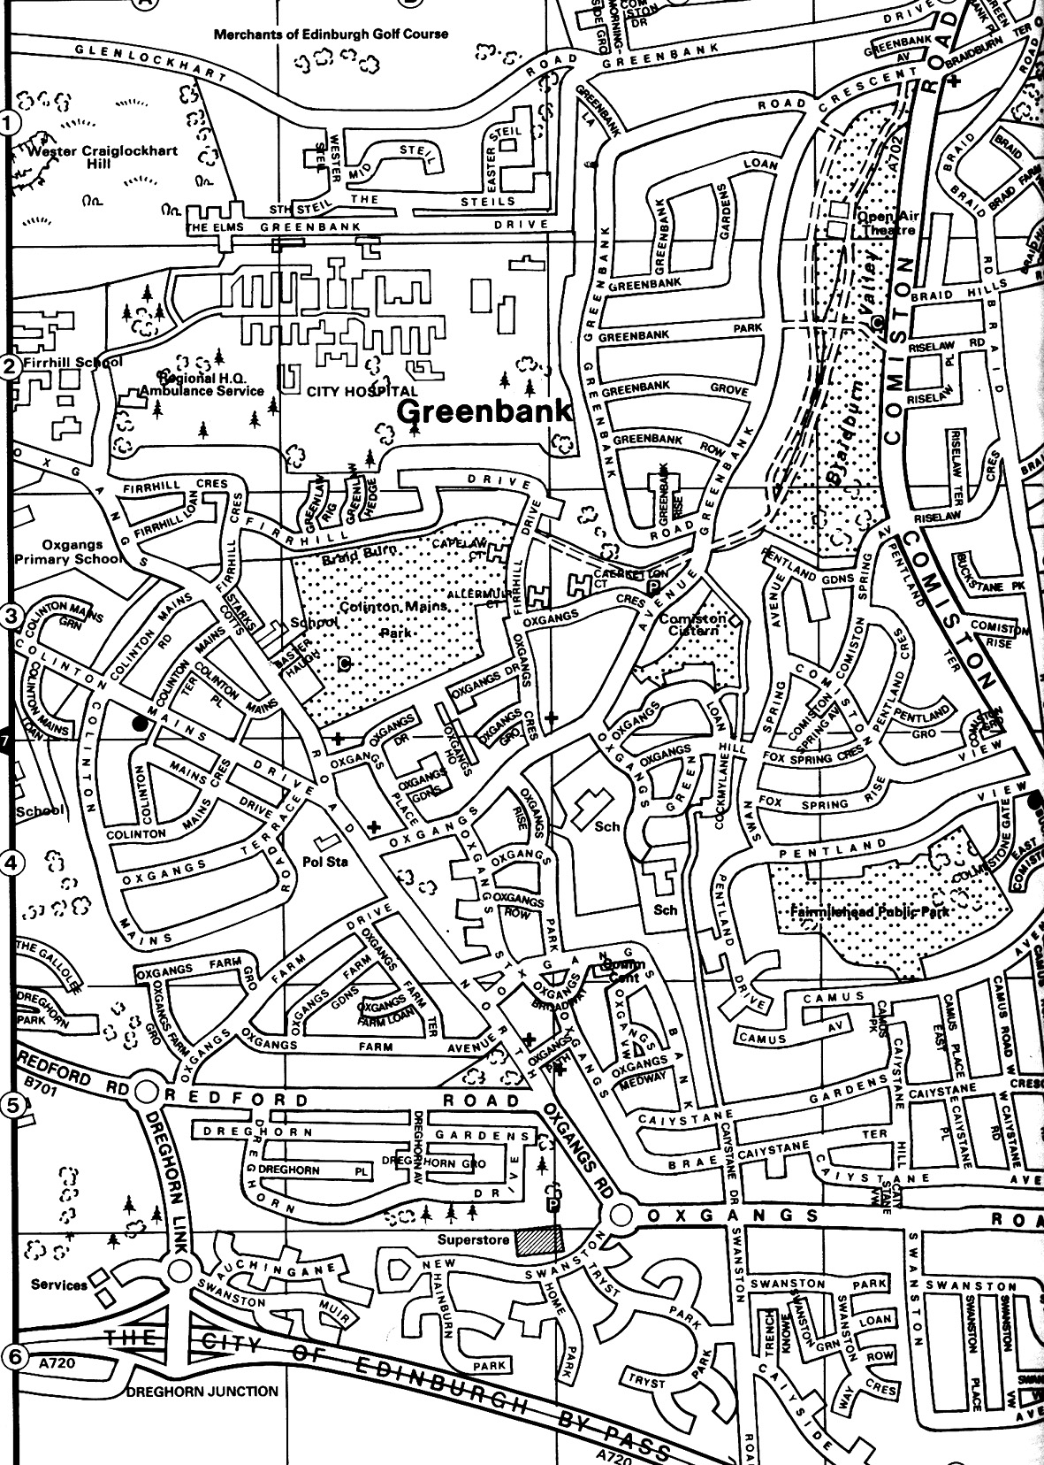

Library
The Twins Club has a large number of books available on multiples & children in genera. The books can be lent out during the sessions for a couple of weeks.

◻ Some library books have not found their way home to Oxgangs. If you have borrowed any, could you check your bookshelves and return any strays!? Don’t worry, no fines!

Note
The insurance we have at Oxgangs doesn’t cover children over five. You may want to bring older brothers or sisters over the holidays but that will, as they say, be “at the owners own risk”.

East Edinburgh / EAST LOTHIAN
at
St Phillips Parish Church, Brunstane Rd North, Joppa

On the 1st and 3rd Monday of each month

10am – 12md
Easy Parking
Coffee available

For more info please contact either

- Carol Frith (Health Visitor),
Esk Medical Centre Tel: 653 0400
or
- Susan Sinclair (mum of twins) Tel: 657 1550
or
- Helen Nettleship (mum of twins)Tel: 665 4321

ALL HELP TO SET UP / TIDY AWAY TOYS etc WOULD BE APPRECIATED

Discounts

We have been trying to negotiate with a number of retailers / clubs in order for Edinburgh Twins Club members to obtain discount. If you already use your card in other shops, please let us know for future Newsletters.

Blessings & Blossoms, 132 St Johns Road, Corstorphine, 0131 334 8322
10% Discount. Childrens Clothes shop.

Cheeky Chimps Indoor Soft Play Centre (Freeport)
HALF PRICE ENTRY. Valid Monday to Friday only. Must show your Twins Club membership card.
Normal Entry Price is £1.50 for under fours and £3 for children over 4 and up to 4ft 9 in height.
Arrangements can be made for cheaper party costs. Contact Angela Caserta on 01501 762 409

CLARKS Shoe Shops
10% discount on production of Twins Club membership card (it does not have to be the TAMBA card). This will apply for all siblings shoes as well ! This only applies to Edinburgh stores (Cameron Toll, Gyle, Princes St, Kinnaird Park & Musselburgh) but we have had a few problems with some of these stores accepting our card – please refer any member of staff to their Regional Manager, Nigel Merritt who has agreed this discount scheme countless times. Please do not try to obtain discount from any other store.

Doodles Ceramic Workshop
29 Marchmont Crescent, Edinburgh
10% discount for all visits. Includes evening visits when mum's can enjoy some peace and quiet with friends.
15% discount for birthday parties booked in either July or August, either in the Doodles studio or with Doodles to Door (which brings all the fun of Doodles to your home or other venue). Subject to Availability. Call Holly on 0131 229 1399

Golden Hands Silver Feet
10% discount. Your little ones hands and feet captured in Bronze, Brass, Aluminium or Stone.......FOREVER - a unique memento or gift. For more info & prices please see www.goldenhands.co.uk or phone Nicky Summer on 0131 665 8628

Jelly Club
10B Kings Haugh, Peffermill Road, Edinburgh. 15% Discount on production of Membership card

Lorac Carpet Services * * NEW * *
10% Discount. Professional carpet and upholstery cleaning, general repairs, odour treatment, specialised re-tufting, specialised oriental rug cleaning. For free advice/estimates contact: Phone 0131 468 0996; Mobile 0775 159 4900; email info@loracservices.co.uk

Nightbridge Designs
15% off custom made soft furnishings, bedding & curtains. Contact: Debbie on 01506 431515

Paul Bradford Designer Cakes
10% Discount. Simple cakes to intricate designs. Look fantastic and taste great too ! Tel: 01506 671133

Rocking Horses
10% discount. If anyone would like to see/ride a large mahogany horse (called Rocky !!), please contact Gill Petrie on 0131 443 2919.
Contact: Jim McAuley, 73 Manse Street, Saltcoats, KA21 5AA. Tel: 01294 466415

Wendy Beardmore, Freelance Public Relations
15% DISCOUNT
As a member of the twins club, I have recently started out doing freelance PR and Marketing, using my maiden name Wendy Robbins. I am mainly helping small businesses and start ups to develop their marketing. If you have your own business and need some help growing this, or indeed if you know someone else in this situation then give me a call.
Call Wendy on 0131 334 9591 or 07771 966 488.

Snippets

MEMBERS’ STORIES

Do you have a Twin or Triplet Story you would like to share with other members? We’d love to hear from you! One of the best ways we can support each other is through our shared experiences – whether that experience has been:

- Difficult: letting others know they’re not alone in their experience can be of immense value and you could even help and inspire others by sharing your methods for dealing with certain situations;

- Joyful: yes, it’s true, many parents find their multiples a true joy, although that may be hard to believe on another ‘one of those days’!; or

- Just Plain Funny: we’ve all had moments of multiple madness that just wouldn’t happen with single children – why not share them and give us all a laugh?!

Many would argue that life with multiples covers All Of The Above! Whatever your experience of multiple parenting, this is the place to share it with people who know what you’re talking about. Please do put pen to paper or get that keyboard clacking and sent your stories in to the Newsletter – contact details below.
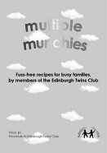

FREE use for members
Thanks to a West Lothian grant, the Twins
Club purchased an all-terrain ‘running’ buggy,
Similar to the one pictured.

Anyone interested in using it should phone Sue Cook on 01506 411881.
Newsletter
Articles to:
Vicki Jarrett
32 Buckstone Row
Edinburgh
EH10 6TP
vjarrett@blueyonder.co.uk

by Thursday 31st March
GET THEM WHILE THEY’RE HOT!
Our fundraising venture into Cookery Book publishing got off to a flying start with the launch of Multiple Munchies: Fuss-free recipes for busy families by members of the Edinburgh Twins Club at the Christmas Party. A good quantity were sold at the party (thanks to everyone who purchased a copy!) but we still have copies available. Cost £5 plus 75p p+p. All proceeds go back into the club. Ideal as a gift and indespensible for a quick meal solution in a busy family kitchen.

Order your copy today! Send a cheque or PO made payable to Edinburgh Twins Club to Karen Winfield, 23 Bluebell Glade, Adambrae Parks, LIVINGSTON EH54 9JJ

Snippets (cont’d)

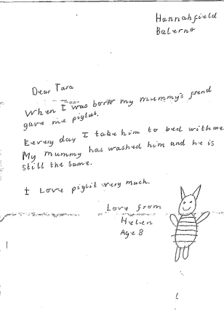

Twins have a special place at New Year!
Along the banks of the Mono River in Benin, West Africa, one small village boasts 21 sets of twins. The vodun, or voodoo religion followed by indigenous people in this region places a special significance on twins. Followers believe twins are living deities that symbolize fertility.
This belief is especially apparent during the Voodoo New Year, which generally falls in September, a time when family structure and spirituality intersect.
As part of Voodoo New Year celebrations, prayers are offered for divine protection of the twin children in the village. It is hoped the twins will bring blessings to the village. The children are dressed in ritual white clothing, and brought to a shrine where food is offered in their name to the spirits. As icons of fertility, twins feature in a ritual in which villagers pray for the success of the next harvest. Cassava flour and palm oil, two staples of the West African diet, are mixed in a ceremonial gourd and poured slowly on the ground. The mixture of flour and palm oil is a sacrifice offered to maintain the fertility which the twins signifiy. The liquid formed by the mixture seeps into the ground, creating a link between the village and the ground which they depend upon for their crops.
Twins are considered beings of divine origin who live forever and will bless all who treat them with reverence and respect. Some cultures view twins as symbols of imbalance. But in Benin, twins are viewed as two halves of the same soul.
CHRISTMAS RAFFLE DONATIONS

The Twins Club would like to offer their thanks and best wishes for a prosperous 2005 to the following generous donors to our Christmas Party Raffle:

Just Art, 81 Morningside Road, Edinburgh
(£5 gift voucher and hand made card)

Dominion Cinema, 18 Newbattle Terrace (Mike Cameron)
(8 tickets)

Studio One Cookshop, 71 Morningside Road (Niall Simpson)
(childrens baking set)

Charlie Miller Hairdressers, 39 Frederick Street (Terri)
(one adult haircut to value of £50)

Kidstop Hairdressers, 86 Morningside Road,
(2 childrens hair cuts)

Pollination Flower Shop, 42 Ashley Terrace (Nick)
(voucher to value of £20)

Touch, 106 Bruntsfield Place (Gill)
(white vase)

Morningside Spice, 74 Morningside Road, (Indian Restaurant)
(£20 voucher)

Henderson Wines, 109 Comiston Road (Mr Henderson) (a twin himself!)
(2 bottles of sparkle and fizz)
After reading our feature The Adventures of Piglet in the last issue of the Newsletter, eight year old Helen, also a twin herself, felt moved to offer Tara Smith some sound advice on what happens when your special friend needs a wash. Thanks for writing in Helen!
Swap Shop

Ora Duoletto twin pram.
A masterpiece of Scandinavian design, with quality construction, smooth suspension and narrow enough to fit through most doors. Converts into a pushchair. Twins web-based discussions rate it as the best. Includes mattress.
£200 ono.

2 Britax Rock-a-tot Deluxe car seats First stage. Never been in any sort of accident. Absolutely fresh.
£15 each

2 John Lewis bouncy chairs.
Fresh turquoise check fabric.
£5 each

2 Baby Bjorn front baby carriers Extremely comfortable and very useful. Also attract lots of ooohs and aahhhs as you walk down the street with Daddy and babies!
£20 each

OR we would sell the lot plus various clothing, bedding and toys for just £250 – a perfect collection of well kept, fresh and clean twin essentials to start you off. Non-smoking home.

Contact: Katie Turner
Tel: 334 3563

Instep-Nipper Twin Ultralight all-terrain jogger/pram
Two storage sacks, rain cover and sun hood/visor. Excellent condition (one year old). Has been terrific to use, certainly one of our best buys
£150
Wanted
Enthusiastic Nanny
2 days per week (Tuesdays & Wednesdays) to care for 10 month old twin girls. Previous twin experience preferred. Own transport is essential. Hours 8am to 6pm.
Please contact Suzanne Howe on 01875 340 547 for further details.

Please note that the Edinburgh Twins Club cannot be held responsible for any purchase made through the Swap Shop or Wanted section. Each deal is entered into privately between the two parties involved (i.e. the seller and the buyer).
You can advertise as often as you wish, but you must notify The Editor each time you wish to advertise again.
Please send all items you wish to advertise to:
Vicki Jarrett: 32 Buckstone Row, Edinburgh EH10 6TP
e-mail: vjarrett@blueyonder.co.uk
Tel: 477-1404

Cot Beds (two)
Pine, new mattresses required, can give details of supplier
£30 each ono

Childcare - Travel Bottle Warmer
(bought in John Lewis)
Recharged by bottle steam steriliser or boiling in the pan.
Very handy but rarely used as we really needed three (we had trips)
£3

3 Xylophones/Pianos (ELC)
£3 each

6 Mothercare Cot bed flat flanalette/cotton sheets
Only used once, 2-lemon, 2-cream, 2-pale green
£2 each or £10 for 6

3 Mothercare Cot bed Cotton Sheets
Only used once, 1-lemon, 1-cream, 1-lilac
£4 each or £10 for the 3

Contact: Jenifer Robertson
Tel: 477 6212

Gro Bags
1 pink quilted 6-18 mths
1 summer towelling unisex 12-18 mths
2 summer towelling unisex 18-36 mths
2 quilted (1 pink, I blue) 18-36 mths
£5 each

Bath Seats
Brand new, never used, still in orignal boxes
£5 each

Tomy Lightshow
Plays soothing music and projects gentle moving lightshow on ceiling. Has straps for attaching to cot and comes with remote control on/off unit.
£5

Cot Bumpers
2 – one with teddy design, one green/purple check.
£2 each

Contact: Vicki Jarrett
Tel: 477 1404

Renault Espace


2.0 Auto MPV (7 Seater)
S Reg – (new shape), 2 months Tax and MOT. 2 Swivel seats and 5 Removable, Electric Windows, Power Steering, Remote Stereo, Central locking, Alarm, Tow Bar, Alloy Wheels,
Excellent Condition, Great Family or Business car.
£4,850 ono

WANTED
Tippitoes door bouncer with metal bar (not plastic)
Twin "coachbuilt" pram (hard bodied) to borrow or buy.

Contact: Mhairi Whyte (for car and wanted)
Tel: 01620 892099

Social Calendar

Children’s Paint an Easter Egg Cup !    Sunday 27th February 11am | The Ceramic Experience, Ocean Drive, near Ocean Terminal, Leith  No pre-payment required  Please pay on the day but indicate number of children attending on return form
Phoenix Card Night    Friday 11th March 8pm | Sarah Warwick’s House  20 Redford Bank  Edinburgh  Please call Sarah for directions on: 441 3722  A chance to have a social evening and look at some of the Phoenix cards from their new collection…a percentage of funds raised will go directly to the club. Lots of stock available to purchase on the night  No payment required, just indicate numbers on the return form.  Just come along and feel free to bring a friend.  We will also be holding a raffle to raise some funds.
The Happy Gang  Sweet Shop Show   Tuesday 29th March 1pm | The Brunton Theatre Mussleburgh  A modern, small child friendly venue  Join in the fun with the Happy Gang for their Easter Show!  Tickets are £6.50 per adult and £5.00 per child. Please send payment with return form indicating numbers.  We will be eligible for a discount depending on numbers and will issue a refund on the day to you if enough people attend.
Parents night out!    Saturday 23rd April 8pm | Tapas Ole, Eyre Place  In the New Town, off the bottom of Dundas Street.  Phone if you need directions  Yippee - book the baby sitter!  Come and join in The Tapas. Good choice of vegetarian, meat and fish dishes.  A lively and friendly atmosphere  Please pay a £5 deposit on booking and indicate how many are coming. If you can’t get Dad along just come solo!

