Edinburgh Twins Club
Newsletter

January 2006

Happy New Year to all our members from everyone on the committee for 2006

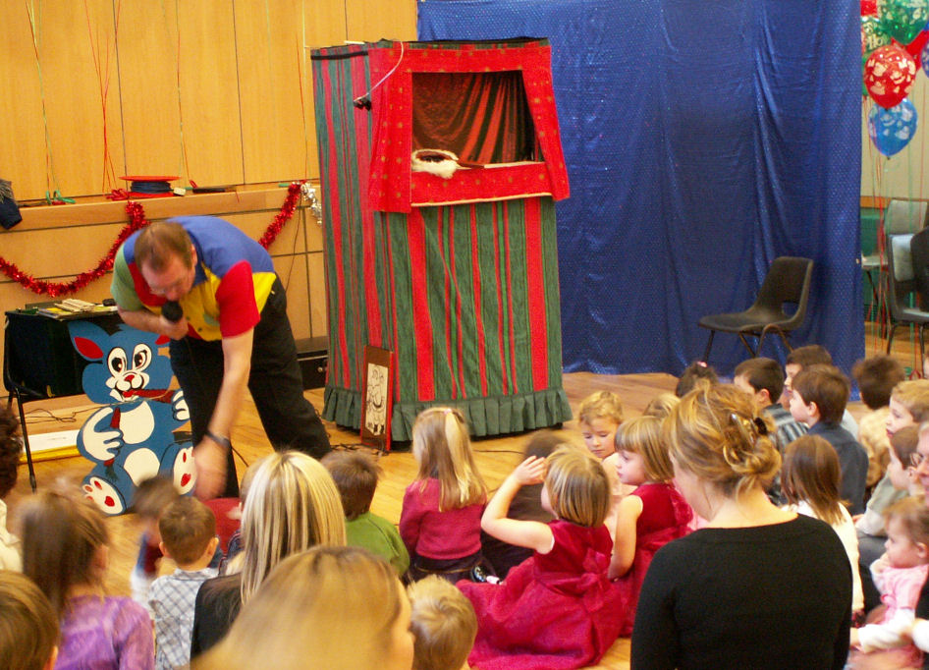
Thank you to all that attended our AGM held at the Murrayfield Hotel on 9th January. It was great to see new members attending. Thank you also to all the members that have stepped forward to join this year’s committee. I am looking forward to the year ahead when I am sure we will see lots of exciting things happening for the club. Six committee members, Vicky, Jenifer, Vicki, Avril, Karen and Gillian have stepped down this year and I would like to take this opportunity, on behalf of the twins club, to thank them for all their hard work and commitment they have shown the club. I hope myself and the new committee members can carry on the high standard achieved over the last few years.

We will be holding many social gatherings this year, so whether you just want a night out with the mums or a family day out with the children we will have something to suit everyone.

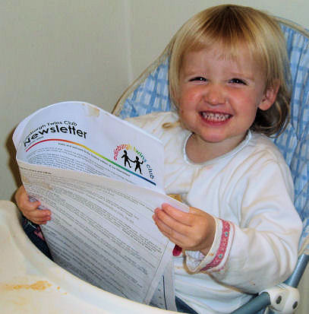
The newsletter is a great way to hear about how other mums and dads managed in certain situations so to keep sending your contributions. We need you to share your stories with us, from difficult to joyful; we want to hear about it. The swap shop is also a great place to pick up a bargain. Please note the new contact details for the newsletter from the next issue forwards.
All ages enjoyed the magic and the Punch and Judy show at our Christmas Party.
There’s something in our Newsletter for everyone!

Please let myself or one of the committee know if you have any suggestions for the twins club, we would love to hear from you.

Best wishes

Jennifer Love
Chairperson
445-3403
jennylove@blueyonder.co.uk

 | Membership Update  Welcoming the newest members of ETC | 2 |  | Discounts  Everyone’s favourite perk – which shops and how much | 9
 | AGM Minutes  Minutes from the Twins Club AGM in January. | 3 |  | Snippets  Bite sized chunks of news, information and trivia | 10
 | Asking for Help  A humorous look from across the pond at this vital skill | 4 |  | Swap Shop  For sale + wanted, everything from buggies to nannies | 11
 | Daytime Activities  Times, venues, directions, news, some photos too! | 6 |  | Social Calendar  A great start to the 2006 calendar! Forms back by 20th February please. | 12
 | Social Snaps  The East Lothian group’s fantastic Halloween Party | 8

Membership Update

Dear Members

We have the following families who have joined the Club since the last newsletter,
WELCOME:
- to Andrea Spink and John Askham, and their twins Joseph Edward and Freddie William born on the 12th of October 2005;
- to Denise and Stuart A’Hara, and their twin boys, James and Ian, who were born in October 2004, siblings for Andrew who will be 3 years old this May;
- to the Walker family, Giulia and Stuart and their twin girls, Alice and Grace, born on 16 August 2005;
- to Anne and John Grzybowski, and their twin girls, Eilidh Jane and Molly Marion, who turned one on the 14th of December;
- to Tracy and Stuart Johnston, and their twins, Niamh and Jake, born on the 16th of August; and;
- to the Elliott family, Anita and Lawrie, and their twins, Jamie and Aidan Elliott, born on the 15th of November last year.
Some of our members have had their babies since we last wrote,
CONGRATULATIONS:
- to Paul and Chris Ryan, and their twin girls born on the 5th of January 2006, Sophie Lily and Eve Lauren; and
- to Morag and Ian Inglis, and their twin girls, Laura and Sarah, who were born on 5th January 2006.

Two sets of twins born on 16th August last year and two sets of twins born on 5th January this year!!!
This hasn’t happened within our membership list before! We will send both families contact details.
Perhaps the four families could write a little bit about their individual experiences for the next newsletter?!
MANY CONGRATULATIONS to all our new arrivals!

At the AGM in January the membership list consisted of 132 families.

ARE YOU LEAVING…We would be really grateful to hear from you should you not wish to continue your membership of the Club. It would be interesting for us to know why you don’t want to continue membership, bearing in mind we are aware that there is perhaps less need for support as the children get older. Also, hearing from you would greatly assist our admin hence a quick call or e-mail would be very much appreciated!

IF THERE IS A MEMBERSHIP FORM WITH THIS NEWSLETTER…your membership is either due or overdue for renewal. Please complete the form and send it with your cheque to Miriam Newton by early March 2006.

PLEASE LET US KNOW YOUR BABY NEWS… Please do not forget to call Miriam or Gillian and let us know news of your arrivals – this really will help us come Newsletter time. If we have missed the birth of your babies, or you are a new member and we have missed you from our list, please let us know so that we can add you to our next newsletter.

Best wishes, and bye…from
Karen Winfield and Gillian Smith

New Membership Committee – Effective From AGM 9 January 2006
Gillian Morrison  37 Tantallon Gardens  LIVINGSTON EH54 9AT   +44 (0) 1506-420 143  gillian_morrison@btinternet.com | Miriam Newton  58 Gamekeepers Road  EDINBURGH EH4 6LS   +44 (0) 131-476 1394  miriam@newtonhouse.net
Please note that we will include you on our membership page within the Newsletter unless we hear otherwise by telephone, e-mail or by your indication on your Application Form when you join.
Edinburgh Twins Club AGM

The Edinburgh Twins Club (the “Twins Club”)
Minutes of Annual General Meeting of the Edinburgh Twins Club
Held at the Murrayfield Hotel, 18 Corstorphine Rd, Edinburgh, EH12 6HN on 9 January 2006 at 8:00 pm

Present: | Officers of the Club: | Absent: | None
 | Vicky Petrie (Chairperson)
 | Jenifer Robertson (Vice-Chairperson/Secretary]
 | Avril Ferrari (Treasurer)
Committee: | Karen Winfield (Membership Secretary)
 | Gillian Smith (Membership Secretary)
 | Sarah Warwick (Social Convenor)
 | Catriona Hepburn (Social Convenor)
 | Vicki Chung (Newsletter Editor)
 | Jenny Love (Daytime Co-ordinator Edinburgh)
Present: | Ordinary Members: 8

- Notice, Quorum and Declaration of Interests
  - The Chairperson noted that due notice of the meeting had been given to all Members of the Club in accordance with article 6.4 the Club’s Constitution (the “Constitution”), and that a quorum was present in accordance with 6.5 of the Constitution.
  - Each of the Members at the meeting declared they were not for any reason disqualified from voting at the meeting or forming part of the said quorum.
  - The Chairperson thanked all the members of the retiring committee for all their help and support over the past year of 2005.
  - The Treasurer produced the report for the accounts year ended 30th September 2005, balance £1,564 and these were signed and approved by the Chairperson.

- Resignations and New Appointments
  - Resignations were accepted from each Member of the Committee by the Chair.

  - In accordance with 4.2, 6.5 and 8 of the Constitution, the new Committee was thereafter appointed as follows:

Chairperson: Jenny Love
Joint Secretaries (and Vice-Chairs): Sarah Warwick and Catriona Hepburn
Treasurer: Gillian Anderson
Membership Secretaries: Miriam Newton and Gillian Morrison
Social Convenor: Kate Gilmour
Daytime Co-ordinator (Edinburgh): Carole Park
Daytime Co-ordinator (West Lothian): VACANT
Newsletter Editor: VACANT
Fundraiser Co-ordinator: VACANT
Website Administrator: VACANT

  - In accordance with article 5.1, it was agreed that any casual vacancies should be filled by the Committee.

- Close
There being no further business the Chairperson declared the Meeting closed.

Signed: | Vicky Petrie
 | Chairperson
Date: | 17/01/06
Asking for help

The following article came to us from a twin mother in America. Although there may be differences between our countries and cultures (and language), much of what she has to say about the vital skill of asking for help is relevant to parents of multiples everywhere. We hope you enjoy this lighthearted look at how to develop this important skill.

Call for Back-Up – Why Twin Moms Must Learn A New Skill

By Suzannah Peel

Twin moms need to be adept at many things. Many of us have ‘multiple’ multi-tasking down to a fine art; breastfeeding two babies while reading to an older child and massaging a woeful pet (or husband !) with one foot; rocking one twin to sleep in a stroller and another in a sling while making supper and catching up with a friend on the phone.

But there’s one thing we all really need to learn but universally struggle to achieve. And that’s the ability to ask for help.

Independence and self-sufficiency count for so much in our culture that we only have to hear the words ‘get help’ whispered and we break out in guilt pangs and stress hives. We’re conditioned by the images of tv and celebrity mag moms to think that we must cope; our friends would admit having plastic surgery or an illicit affair before they’d admit needing help to raise their kids.

Yet there’s nothing to be gained by maintaining this mule-headed position – and quite a lot to be lost. The people who really suffer for our stubborn, stiff-upper-lipped insistence on going it alone are the twins and other children in the family. They bear the brunt of an exhausted, irritable and stressed-out mommy.

There are just two steps to learning how to accept help. First accept the need for it, second practice asking for it.

Ideally asking for help is a skill, like pelvic floor exercises, that should be practiced throughout every twin pregnancy. Use your vast pre-delivery size to your advantage. Get people to help you with shopping, chores, unfinished household jobs. At this stage most people will do anything for you. Usually they’ll do it quickly too and make a fast getaway in case you go into labor on their watch! Use this.

In fact, at any time during the next three years you can play the ‘Mom of Twins’ card to get help, if only you practice dealing this card out. When a friend comes round and you haven’t shoveled out the lounge that morning play the harassed twin mom card and she’ll have her sleeves rolled up before you can say “my house is a skip”.

While pregnant, or if you’re already down and dirty in the twin trenches, accept that you need a lot of help in the ‘early daze’ . If you can, organize a cleaner. Believe me, at first you’re not going to have the time to clean the house yourself. By the time you do, two small people will be messing it up so badly it will just look as if you don’t have time to clean. Multiples Multiply Mess. Most people would think, two toddlers, twice the mess. Wrong. Two toddlers, at least three times the mess. Because while you’re clearing up the mess that the first one’s made, not only does the first one have the chance to go off and make more mess, but the second has a longer time to make more of the mess he was making while the first one made a mess. And that’s going to take you even longer to clear up! I found this principle applied to many things in life with twins! If you already have a cleaner ask her if she can increase her hours for a few months.

If hiring a cleaner try to get one who already has children of her own, particularly if these are your first children. Having a couple of hours of daily support from another mother during the transition to new mom will be invaluable and, apart from the fact that a cleaner with kids is less likely to be squeamish about pools of sicky clothes, you’ll soon be comparing notes on diaper rash and the texture of poo ! (You wait and see!) Another upside of getting a cleaner with kids is that there will no doubt be many days when scrubbing the garbage can is preferable to changing yet another diaper. A cleaner with an experienced pair of maternal hands probably won’t mind swapping jobs with you for a morning.

Of course when hiring help cash can be an issue. If you get given financial help, by grandparents, for instance, when the twins arrive, seriously consider using it to hire help. Tessa’s parents were unable to take much time out from their publishing firm when her twins, Daisy and Bella were born. “They sent us a check and were happy about us using it for whatever we needed at the time. What I felt I really needed was someone to come in and clean up while I spent time with the babies. With the money they sent we were able to hire a housekeeper for the next three months and it saved my life!”

If you can’t afford hired help don’t do without, work round it. You have years to pay back the favors, but right now you and the babies really need them. Anyone is fair game, relatives, friends, neighbours, health visitors, young teenagers who want to earn a bit of pocket money – absolutely anyone with two arms who can hold a baby for just a few minutes while you whip up some Formula, change a dirty diaper or just go to the lavatory! If friends are going to visit make absolutely sure you plan it – never, never, at nap time, but at what you know will be difficult times with the babies – the hour before morning nap, lunchtime, teatime, bath time, early evening. If you can make even one of these days easier on yourself you’re doing well.

One of the most important things you can do to help yourself is to surround yourself – in your neighbourhood, your town, your state, on the phone and the internet, with other twin moms. Find them at your antenatal class, go up and talk to them at hospital appointments (although make sure they’re expecting twins before you bring up the subject – not just enormous!), I have made at
least one lifelong twin mum friend from such beginnings. I stopped her in the street. Do likewise. Invite a twin mom you pass at the mall to sit with you at the nearest coffee shop for five minutes -she’s probably been dying to come over and talk to you. If you get on at any sort of level arrange to meet again. Nobody knows what you’re going through as well as other twin moms do. They might not be the sort of people you would have chosen as friends at any other time, but concentrate on the similarities, not the differences. The central fact in their lives is that of raising twins and this gives you more in common than almost any other group of people. When your sister-in-law, friend or neighbour is coping with their ‘easy’ singleton you two will find immense solace, comfort, support, and likely lifelong friendship in your very own ‘twin bond’. These friends will cry with you, laugh with you, pick you up when you’re down and despairing, be of untold practical help, support you emotionally and make you feel ‘normal’ on days when you are feeling like the only spaced out, poo-covered, porridge-daubed freak automaton on earth ! What more could you ask!

Suzannah Peel is a mom of twins and author of Twins: The Survival Guide. See her new book at www.twinssurvivalguide.com

 BrainStormZ Publishing Ltd
email: brainstormz@bruisyard.plus.com

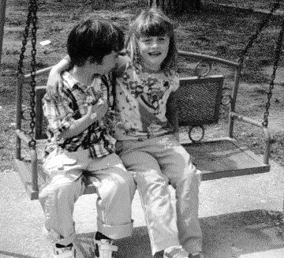
Here’s the latest news from our Tarragona members! Was great to see Jacqui and family at last year’s Singing Kettle. We hope they are all continuing to enjoy their new life in the sun.

A new school year started on the 12th September and for Abigail and Joseph a new school as well. So far all seems to be going well. Joseph and Abigail are making new friends all the time and are picking up more and more Catalan every day. Strangely, more of the people here speak some English – we had expected more English speakers on the coast because of the tourists. Joseph had already had his first English lesson and the teachers read English stories to the class. It seems incredible that from the first year of school 2 ‘foreign’ languages are taught. These classes are taught in Catalan, Castillian is a second language, and English is a third. Favourite lessons at school are music (the music teacher sings silly songs and does silly dances apparently), and gym (three times a week!).

Joseph and Abilgail have got swings rigged up in the olive tree and the garden and there’s even a ladder up the same tree – evenings in Edinburgh were never like this!!

Social Snaps
Halloween Party

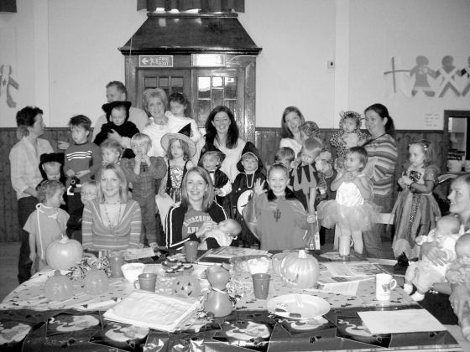

Spooky fun was had by all at the East Lothian Twins Group's first Halloween party. Twinkling turnip lanterns greeted the children as they arrived in fancy dress. Toddlers Samuel and Thomas Buxton won the fancy dress competition as the cutest little witches cats! (see below) They were joined by witches, wizards, devils, nurses, doctors, superman & batman to mention but a few. The children, sorry! witches went dooking for apples and enjoyed Halloween party food. Finally the children got to choose a small Halloween lucky dip present to keep them amused on the way home.

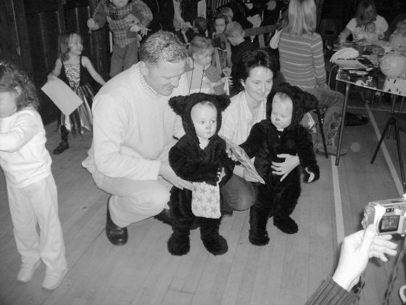

Daytime Activities

Oxgangs Neighbourhood Centre
Firrhill Drive
0131 441 755

Bumps, Babies & Toddlers Group
Thursdays 10am – 11.30am (songs at 11.15am)

£1.20 per member family. £2.40 non-members
Daytime Convenor: Carol Park, Tel: 667-2369

All families & Mums-to-be are very welcome. Meeting other people who understand the joys and hazards of life with twins can really help.

Daytime News

Carole Park has kindly agreed to take responsibility for the running of the Oxgangs group. Carole will be the main contact for people phoning about the club, welcoming new members and will also be responsible for balancing the book and banking monies.

Enquiries to : Carole Park 667 2369

As most of you know the Tuesday group has had to be closed as we did not have a steady about of members attending to keep it going. Thankyou to those of you that took the time to sent back the reply slips, unfortunatley we only received a few replys so are unable to hold another group. We will, however, monitor this and when there is enough interest open another day.

Note
The insurance we have at Oxgangs doesn’t cover children over five. You may want to bring older brothers or sisters over the holidays but that will, as they say, be “at the owners own risk”.

Library

The Twins Club has a large number of books on multiples & children in general. The books can be lent out during the sessions for a couple of weeks at a time.
COLINTON MAINS DRIVE
Oxgangs Neighbourhood Centre

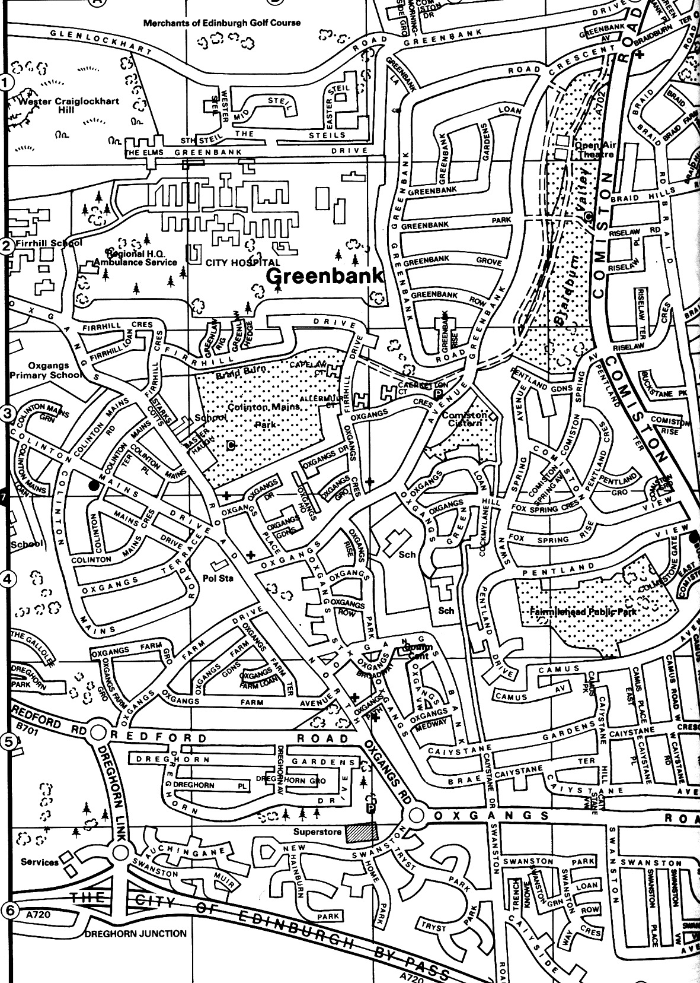

East Edinburgh / EAST LOTHIAN
at
St Phillips Parish Church, Brunstane Rd North, Joppa

On the 1st and 3rd Monday of each month
10am – 11.30am
Easy Parking, Coffee available

For more info please contact either

- Carol Frith (Health Visitor), Esk Medical Centre Tel: 653 0400 or
- Susan Sinclair (mum of twins) Tel: 657 1550 or
- Helen Nettleship (mum of twins)Tel: 665 4321

ALL HELP TO SET UP/TIDY AWAY TOYS WOULD BE APPRECIATED

Daytime Activities cont…

Here are a few photos from the Oxgangs Thursday group.

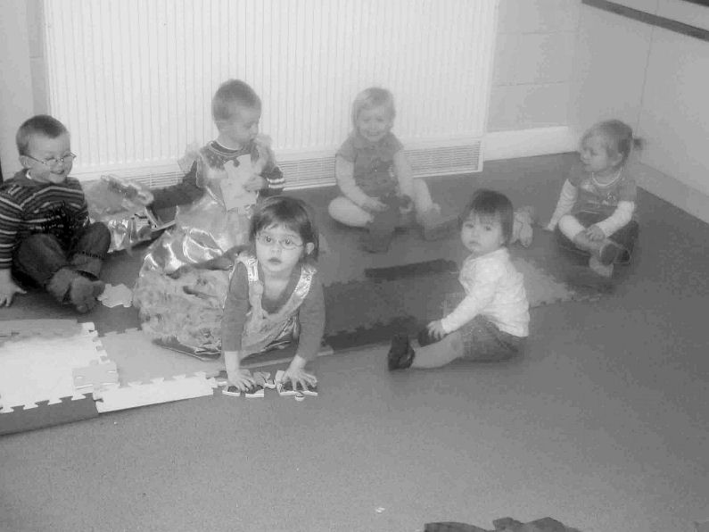

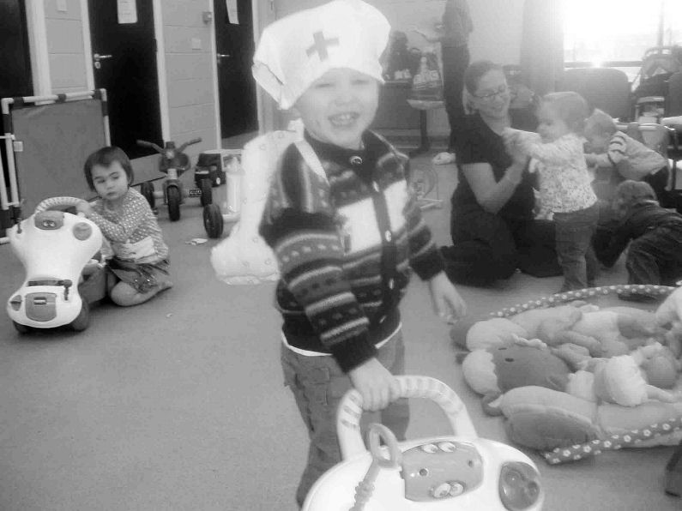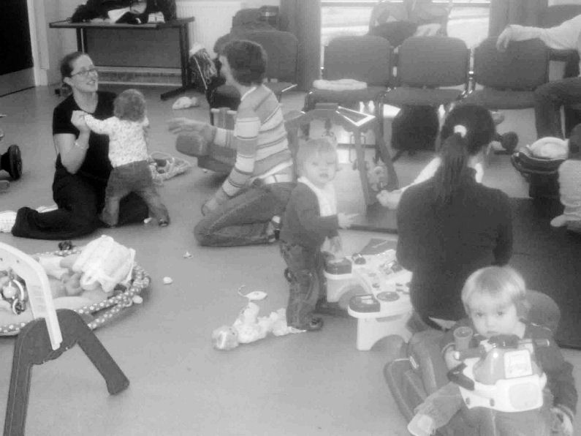

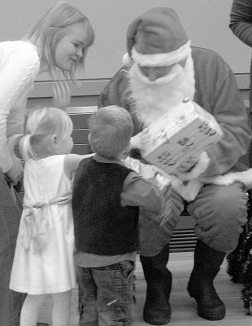
Christmas Party

Murrayfield parish church hall was the venue for the Christmas Party and everyone enjoyed children’s entertainer Scott Lovatt. A special appearance by a certain red-suited gentleman topped off the proceedings with a gift for every child.
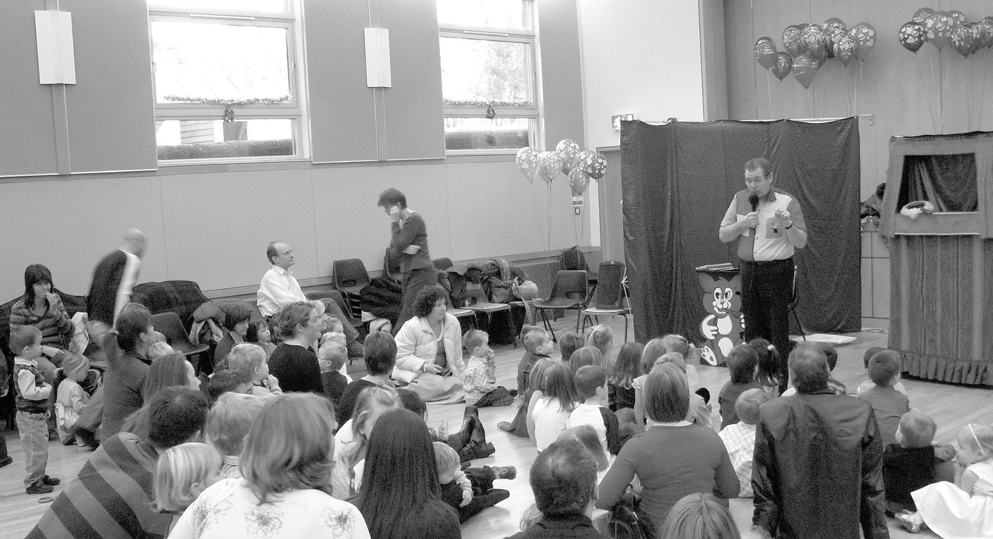
Discounts

We have been trying to negotiate with a number of retailers / clubs in order for Edinburgh Twins Club members to obtain discount. If you already use your card in other shops, please let us know for future Newsletters.

Blessings & Blossoms, 132 St Johns Road, Corstorphine, 0131 334 8322
10% Discount. Children’s Clothes shop.

Cheeky Chimps Indoor Soft Play Centre (Freeport)
HALF PRICE ENTRY. Valid Monday to Friday only. Must show your Twins Club membership card.
Normal Entry Price is £1.50 for under fours and £3 for children over 4 and up to 4ft 9 in height.
Arrangements can be made for cheaper party costs. Contact Angela Caserta on 01501 762 409

CLARKS Shoe Shops
10% discount on production of Twins Club membership card (it does not have to be the TAMBA card). This will apply for all siblings shoes as well! This only applies to Edinburgh stores (Cameron Toll, Gyle, Princes St, Kinnaird Park & Musselburgh) but we have had a few problems with some of these stores accepting our card – please refer any member of staff to their Regional Manager, Nigel Merritt who has agreed this discount scheme countless times. Please do not try to obtain discount from any other store.

Doodles Ceramic Workshop
29 Marchmont Crescent, Edinburgh
10% discount for all visits. Includes evening visits when mums can enjoy some peace and quiet with friends.
15% discount for birthday parties booked in either July or August, either in the Doodles studio or with Doodles to Door (which brings all the fun of Doodles to your home or other venue). Subject to Availability. Call Holly on 0131 229 1399

Golden Hands Silver Feet
10% discount. Your little ones hands and feet captured in Bronze, Brass, Aluminium or Stone.......FOREVER - a unique memento or gift. For more info & prices please see www.goldenhands.co.uk or phone Nicky Summer on 0131 665 8628

Jelly Club
10B Kings Haugh, Peffermill Road, Edinburgh. 15% Discount on production of Membership card

Lorac Carpet Services * * NEW * *
10% Discount. Professional carpet and upholstery cleaning, general repairs, odour treatment, specialised re-tufting, specialised Oriental rug cleaning. For free advice/estimates contact: Phone 0131 468 0996; Mobile 0775 159 4900; email info@loracservices.co.uk

Nightbridge Designs
15% off custom made soft furnishings, bedding & curtains. Contact: Debbie on 01506 431515

Paul Bradford Designer Cakes
10% Discount. Simple cakes to intricate designs. Look fantastic and taste great too! Tel: 01506 671133

Rocking Horses
10% discount. If anyone would like to see/ride a large mahogany horse (called Rocky!!), please contact Gill Petrie on 0131 443 2919.
Contact: Jim McAuley, 73 Manse Street, Saltcoats, KA21 5AA. Tel: 01294 466415

Wendy Beardmore, Freelance Public Relations
15% DISCOUNT
As a member of the twins club, I have recently started out doing freelance PR and Marketing, using my maiden name Wendy Robbins. I am mainly helping small businesses and start ups to develop their marketing. If you have your own business and need some help growing this, or indeed if you know someone else in this situation then give me a call.
Call Wendy on 0131 334 9591 or 07771 966 488.

Snippets

ADVERTISING RATES

The following charges apply to advertisements in the Twins Club Newsletter:

Club Members
Members may advertise a commercial enterprise once for free, any subsequent advertising is charged at £25
Swap Shop and Wanted ads are free to members

Non-members
Non-members may place an advert for a fee of £25

Charges do not apply to the Discounts listings.

TWINS CLUB COMMITTEE


The following positions, still officially vacant at the AGM have subsequently been filled, as follows:
NEWSLETTER EDITOR Kairsty Ashworth
JOINT SOCIAL CONVENOR Katy Archibald
WEBSITE ADMINSITRATOR Rachel Round

There are still vacancies for:
WEST-LOTHIAN DAYTIME CO-ORDINATOR and FUNDRAISING CO-ORDINATOR
If you are interested in either of the above positions, please phone Jenny Love for details (445-3403)

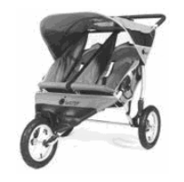
TAMBA
The Edinburgh Twins Club is affiliated to TAMBA (Twins and Multiple Births Association). Membership is separate however. For details of the benefits of TAMBA membership, visit www.tamba.org.uk
or telephone 0870 770 3305
FREE use for members

Thanks to a West Lothian grant, the Twins
Club purchased an all-terrain ‘running’ buggy,
Similar to the one pictured.

Anyone interested in using it should phone Jenny Love on 445-3403.

Newsletter
Articles for the April 2006 issue to:

Kairsty Ashworth
14 Birrell Gardens
Murieston
Livingstone EH54 9LF
Kairsty@Craiksland.freeserve.co.uk

by Friday 31th March
Swap Shop

Mothercare folding highchair
Froggy design. Good condition.
£5

Push along walker
Winnie the Pooh design with detatchable Winnie the Pooh and Tigger plastic toys.
It has been a real favourite. Good condition.
£5

Large Musical toy
Suitable from 6 months. Music plays when leaves of a central book are turned. Also other bits to turn for noises.
Another favourite. Good Condition.
£5

Contact: Gill Anderson
Tel: 447 5462

WANTED
Ideally in reasonably good condition.

2 x coupe type (little tikes or similar) ride in cars (suitable for girl twins)

Little Tikes plastic cube climbing frame with slide.

Plastic see saw/rocker ride on toy for 2 or more (little tikes or similar).

Contact: Mhairi Whyte
Tel: 440 0023
HYPNO-BIRTHING CLASSES

HypnoBirthing is an easy-to-learn method employing deep relaxation, slow breathing patterns and self-guided release of endorphins (our body's natural opiates), which enables mothers to enjoy an unmedicated, safe and gentle birthing, often pain-free, often more quickly.

Pauline Taylor, a Qualified Clinical Hypnotherapist and Certified HypnoBirthing Childbirth Educator, offers group classes in Edinburgh.
Classes are small and private classes are also available. The best time to start a class is in the second trimester but it is never too late.

To register for a HypnoBirthing class or to make any enquiries please phone Pauline on 0131 620 1080.

For further information follow the links on www.edinburghhypnotherapy.co.ukand www.hypnobirthing.co.uk

2 baby driver tricycles
Good condition with handles for pushing
£15 for both

2 Britax Renaissance car seats
9-18kg (about 9 months to 4 years) Excellent condition . Never been in an accident.
£25 each.

Contact: Emma Vickerstaff
Tel: 452 8419

Please note that the Edinburgh Twins Club cannot be held responsible for any purchase made through the Swap Shop or Wanted section. Each deal is entered into privately between the two parties involved (i.e. the seller and the buyer).
You can advertise as often as you wish, but you must notify The Editor each time you wish to advertise again.
Please send all items you wish to advertise to:

Kairsty Ashworth: 14 Birrell Gardens, Murieston, Livingston EH54 9LF
e-mail: Kairsty@Craiksland.freeserve.co.uk
Tel: 01506 409984

Social Calendar
Mums’ Tapas Night    Friday 24th February 7.30pm | Tapas Ole, Eyre Place  In the New Town, off the bottom of Dundas Street.  Phone if you need directions  Come and join in The Tapas. A lively and friendly atmosphere  Good selection of vegetarian, meat and fish dishes in the set menu - please indicate on the return form if you have any special dietary requirements, otherwise set menu will be ordered in advance for all attending.  Please pay a £5 deposit on booking.  www.tapasole.com (for menu details)
Ceramic Experience    Sunday 19th March 11 am | The Ceramic Experience, 2 Ocean Drive, near Ocean Terminal, Leith adjacent to the Royal Yacht Britannia  Get creative and let your kids’ imagination run riot! Paint some egg cups for Easter.  Opportunity for the children to create pottery artwork from a wide variety of shapes with friendly staff on-hand to help. Café and soft play area/ball pool also available.  Pay on the day. Prices start at £3.99 for a coaster, mugs from £7.99 and plates from £8.99  Please book soon, numbers limited  www.theceramicexperience.com
The Purves Puppets  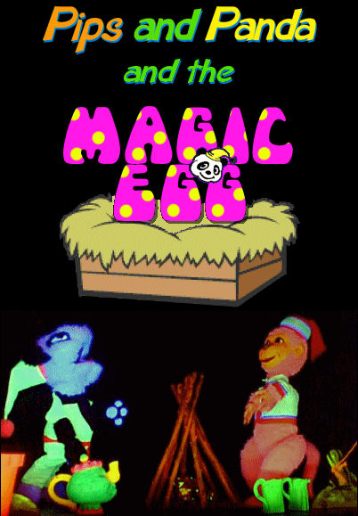  Saturday 22nd April 1.15pm | Purves Puppets, Biggar Puppet Theatre, Broughton Road,  Biggar ML12 6HA  Come along to see Pips and Panda and the Magic Egg from the classic Purves Puppets.  Performance starts 1:30 pm; please arrive at least 15 minutes earlier. Premises open 10 am. Performance lasts 1 hour 30 minutes, including 15 minute interval.  This is a specially designed production for young children up to 7. It is a ‘join in’ story with fun, magic and music to fascinate the kids (and mums/dads too). Souvenir shop, tea room and outdoor picnic tables also available.  £5 per head, payable in advance. Please pay with return form.  Please let us know if disabled access is required.  Website has a map and bus times:  www.purvespuppets.com

