Edinburgh Twins Club
Newsletter

April 2007

Hello and Welcome to the April edition of our Newsletter

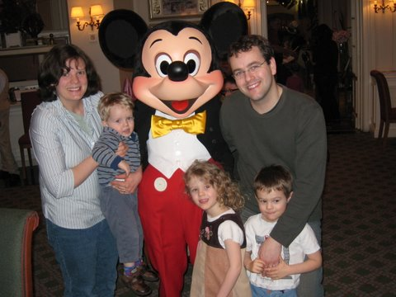
Happy Easter! That probably isn't too significant for most of the families in our club, but our twins are going to school next year, and so we're becoming aware of school holidays. We took an early break this year to Disney Paris which was wonderful apart from the fact that we all went down with a horrible headache and vomiting bug. So I wanted to remind you - if you're planning a holiday add a washbag full of medicine to your packing list... We went with a full bottle of calpol and used it all within 3 days and ended up having to summon an emergency doctor to our hotel room! So - Calpol, Ibuprofen, paracetamol for grown-ups, teething gel, plasters, Karvol, Baby Vicks etc. And if you haven't considered it already then do think about going on the First Aid course that will be coming up. If you have any great holiday recommendations, or other top tips please share them by using the messageboard: http://www.edinburghtwins.co.uk/messageboard/ And let me know if you have any ideas / suggestions!
Best wishes

Rachael Round
Chairperson
01506 639809
rachael@the-rounds.net

 | Membership Update  Welcoming the newest members of ETC | 2 |  | First Aid report | 11
 | 1st few months – how did you cope? | 3 |  | Helen’s birth story | 11
 | Family portrait | 6 |  | Daytime activities  Oxgangs & South Queensferry | 12
 | Chicken pox and the Carlyon Trio | 7 |  | Discounts | 13
 | An afternoon at Gym Tots  Report from first social of the year | 9 |  | Swap shop  Everyone’s favourite perk – which shops and how much | 15
 | Are they identical? | 10 |  | Social Calendar  Spring events for 2007 calendar! Forms back by 30th April please. | 16

Membership Update

We have the following 9 families who have joined the Club since the last newsletter,
WELCOME to:
- Emma & John Dickson, who are expecting twins on 21st May 2007;
- Lyndsay & Chris Simm, and their twins Grace and Emily born on 24th November 2006;
- Sarah & Russell Watkins, who are expecting twins on 27th June 2007;
- Joanna Wilson & Robin Dalgliesh, and their twins Oliver and Harry born on 25th November 2006;
- Julie & Eddie Thomson, and their twins Oliver & Michael born on 7th November 2005;
- Sarah & Matthew Austin, who are expecting twins on 22nd May 2007, siblings for Ella who is 2 in August;
- Nicki & John Denholm, who are expecting twins on 18th August 2007, siblings for Rory who is 2 in July;
- Heather Rae & Steven Wood, and their twins Eilish and Steven born on 20th June 2006;
- Sharon & Colin McDougall, who are expecting twins on 22nd June 2007.

Some of our members have had their babies since we last wrote, CONGRATULATIONS to:
- Emma & James Billett have had their twins Lauren & Eva, born on 1st November 2006;
- Elizabeth & Chris Jones have had their twins Katherine & Madeline, born on 4th December 2006; sisters for Dominic who is 2;
- Helen & Ian Gillies have had their twins Jonathon & Adam, born on 16th January 2007.

Well done and MANY CONGRATULATIONS to all our new arrivals!

Our membership list currently consists of 127 families.

ARE YOU LEAVING…We would be really grateful to hear from you should you not wish to continue your membership of the Club. It would be interesting for us to know why you don’t want to continue membership, bearing in mind we are aware that there is perhaps less need for support as the children get older. Also, hearing from you would greatly assist our admin hence a quick call or e-mail would be very much appreciated!
IF THERE IS A MEMBERSHIP FORM WITH THIS NEWSLETTER…your membership is either due or overdue for renewal. Please complete the form and send it with your cheque to Miriam Newton by mid June 2007.
PLEASE LET US KNOW YOUR BABY NEWS… Please do not forget to call Miriam or Gillian and let us know news of your arrivals – this really will help us come Newsletter time. If we have missed the birth of your babies, or you are a new member and we have missed you from our list, please let us know so that we can add you to our next newsletter.

Best wishes,
Gillian Morrison and Miriam Newton

Membership Committee
Gillian Morrison  37 Tantallon Gardens  LIVINGSTON EH54 9AT  01506 420 143  gillian_morrison@btinternet.com | Miriam Newton  58 Gamekeepers Road  EDINBURGH EH4 6LS  0131 476 1394  miriam@newtonhouse.net
1st few months – how did you cope?
And it’s TWINS Double Hooray!!!!
And they arrive and it’s Marvellous and….. Jolly Hard Work. How do you cope?
There is Feeding and Changing and Bathing and Playing and Sleep-time ( Not that they sleep of course not simultaneously anyway), and Washing and Visitors and Crying and Dressing and getting Dressed yourself and Washed yourself and Fed yourself and getting some Sleep yourself and Tidying and trying to stay sane and once you’ve done it with one the other needs done too and I forgot Health Visitors and Doctors appointments and Sick everywhere and other family members and oops I’ve missed a feed or what about going outside or getting the dinner on , and colic and ….there’s not enough time in the day and I’ve not spoken to an adult all day, and ….it’s the next day already and it’s all happening again …..Help …how can I do all this?
Well you are not alone, we have been through it too – so Lets Ask the Committee – how did they Cope?

Gill: With a Section planned and a house at the top of a hill and an older child who had suffered from Colic, I knew I would be both housebound for weeks and ripping my hair out on a daily basis by 4pm onwards (colic time). With a husband who is never home before 7pm and no family close by I needed a strategy.
I knew that for the first few weeks I needed help at whatever cost. I contacted an agency and secured a maternity nurse for the first 6 weeks (till my section had healed). I insisted on a driver (essential for trips out the house: essential for mental health) and on someone prepared to make the dinner for the family (a godsend as the 4pm-7pm time is when everyone is tired and hungry and demanding. This is hideous to cope with if you are trying to prepare dinner too).
Lesley arrived from 8am till 8pm and was a GODSEND. Expensive but made the first 6 weeks a real joy for us all. And is now a good friend.
After the first 6 weeks I secured a nanny (less expensive) and reduced the hours to 4pm- 8pm. Keri became like one of the family, was happy to cook too and helped with life enormously and stayed for over a year. She also became a good friend. When it was time to cope fully on my own, I found trips out: zoo, botanics etc with lunch in the café the keystone to a happy family.
PS Get Milk delivered and Tescos to deliver Food! Buy a big freezer & get it stocked up, Join Costco. Good Luck

Miriam, mum to Ellie and Amy: Talk about being caught completely unprepared! I had one week of work to go when my waters broke at home at 5pm on a Sunday! I had NOTHING organised! No bag packed, nothing even to go into an empty one and the nursery completely full of junk that had no other home in the house! My master plan had been to finish work and then dedicate 3 or 4 weeks totally to getting everything bought and organised! What can I say but it took me at least 6 months after the girls were born to feel I had caught up and had everything the way I had always visualized. That was achieved with a lot of help from family and good friends. The girls and I spent a total of 5 weeks in hospital so that did give us a small window to try and get things sorted before we came home. However it was very difficult as I was breast feeding and couldn’t be away for any length of time! I left the décor of the nursery to a great friend, did some shopping online (cots, buggy and car seats) and I was very lucky when the ETC Nearly New Sale fell on one of the Saturdays the girls were in hospital and I escaped out and bought practically everything else I needed there!
With my family living in Ireland my sisters and nieces pulled out all the stops! Between them they set up a rota for the summer where one of them flew in on a Monday morning and went home on a Friday evening and the next came the following Monday morning for the next week! Thank goodness I am from a large family and Ellie and Amy came at the beginning of school holidays! The help and support I got from them was fantastic and I truly do not think I would have such happy memories of those early months if I had not had that support. Another pair of hands, adult company and just practical things like cooking and washing was done without even me asking! One sister did two massive freezer cook ups for me which we lived on for months after her departure!
Routine was definitely the name of the game for us. By the time we got the girls home they were in a well established 2.5 to 3 hourly feeds so I stuck to that. Both girls were feed at the same time and nappies changed after to avoid any confusion.
I found after many weeks of the usually winding techniques actually walking up the stairs was the best way to wind them! My advice? Get organised and BE PREPARED EARLY and say yes to all the help people offer and if they don’t offer help ask for help and delegate the work out!

Donna, mum to Niall and Owen I found routine to be one of the best coping tools- although this might seem a bit obvious. Our twins were also early, six weeks, and were in a good feeding pattern when we brought them home. We always fed them together (even if it meant waking one of them up!), every four hours- not on demand, you’d be feeding all day! I also, and still do, change nappies at the same time (saves trying to remember who was changed when!)
Walking them is also a good way of breaking up the day, mine are always quiet in the buggy and I get some fresh air and exercise. We are lucky enough to have both sets of grandparents nearby, so they would often pop in just to make sure everything ok. Good for babysitting too. My mother in law still does my ironing, but it’s a job that she likes!!!

Mims, Mum to Max and Lucy 12 weeks old, I recently met a woman in Costco who stopped to have a look at Max and Lucy who were 7 weeks old. She told me that she was expecting twins. My first response to her was ‘have you got lots of help?’. It never even occurred to me to congratulate her! This pretty much sums up the first few months. The highs are great: the (eventual) first smiles, the feeling of cuddling them both together, the wonder of how you managed to carry them both, the list goes on.
Be warned though, the lows can be pretty bad too. Nobody can prepare you for the adrenaline rush you get on the first night when you get woken by a crying baby. Once you get over the feeling that someone has thrown a bucket of ice in your face, you then realise that there are two crying and the reality hits home. I remember telling my mum that we would like to have the first full day at home together alone. By 9am I was on the phone to her asking how soon she could be with us.
Everyone tells you when you are in hospital that it will be much easier at home when you have all your things about you. The problem is that when you get home, you have all the things, but not a clue what the best way to do things is. It’s amazing how quickly you do find out how to do things and a routine emerges. I’m not talking about bed time routines in the first week, more like being able to get the kettle on to have a cuppa before midday!
The best advice I can give is to talk to other twin mums before they arrive so you have a contact for when they do come. Emotional support is best coming from a mum who has twins, as nobody knows until they have been there themselves. The other piece of advice would be to try to retain a sense of humour! Just in case you think I am making light of it all here are some more things I found out as I went along…..

- Don’t worry about what cot bumpers and quilts you want and have a neutral nursery. Wait till you have the babies and then tell people what range and colour you want as presents.
- Read the books, but just go with the flow until about 6 weeks. We tied ourselves in knots with the bath and bed routine. When we relaxed and let the babies sleep in their swings downstairs till their 10pm sleep all of a sudden they clicked that bath then bed was a good option.
- Don’t panic when the routine doesn’t work one night. Just try again the next night and things will settle again.

- Remember that they can be separated. Leave one baby at home (obviously with a carer!) and take the other to Tesco or wherever. It will be a total breeze compared to having two and gives you time to enjoy them rather than worrying that they will both start crying.
- Get out of the house. It gives you a huge psychological boost to know you can get to the end of the road and all it takes is one admiring passer-by to make you feel really good about yourself.

The good news is that you do survive and you can have a good laugh at what happens to your life…..

- You will be totally sleep obsessed. This gets worse the less sleep you get.
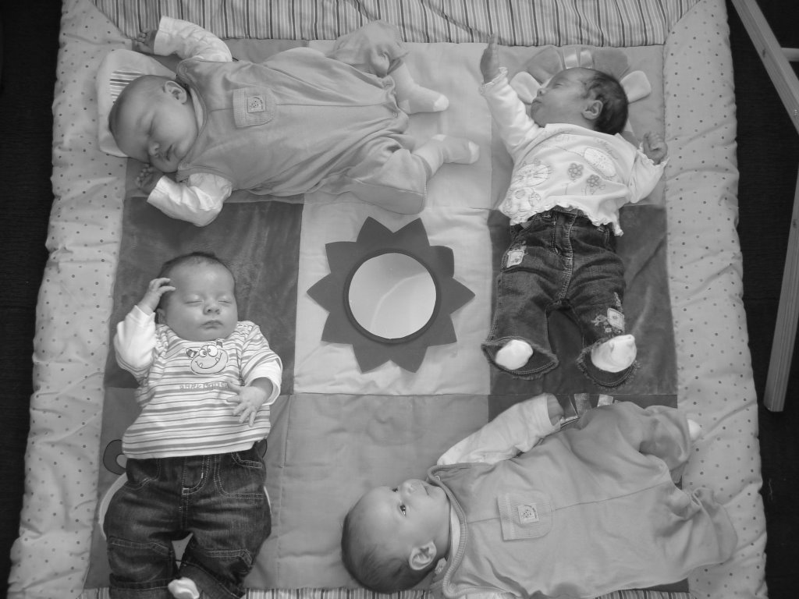
- Your husband will drink lots (well mine would if he got the time).
- You will turn into a Sunday driver when you have the babies and everyone else is a bad driver.
- You will wake up thinking you have a baby on your chest and/or you have lost a baby in your bed.
- You will hear babies cries in an empty house.
- You will feel as though you have a Kate Moss figure after being huge for what feels like forever. This feeling doesn’t last (unfortunately).
- You will need at least two feeds with you whenever you go shopping to the Gyle. No matter how little you need you must be prepared for everyone and their granny to stop you.

Good luck, try to enjoy them and if things get too much give another twin mum a text or call. They may not be able to help, but it’s great to know that you are not the only one living the nightmare that is the first few months.

Sleep deprived and still smiling.

Lesley: I was lucky enough to have 4 weeks maternity leave before my girls arrived. As well as watching a lot of television, I spent those 4 weeks stocking the freezer full of meals, dropping in on a local baby group, and visiting the Oxgangs twins group to get to know the ‘baby scene’ before I had to somehow get to these groups with babies in tow. With no family close by, I knew getting out the house was going to be the only way to keep me sane!
Max and Lucy with Jonathon and Adam
Once the girls were born, we fell into a routine of feeding every 3 hours during the day, and 4 hours at night. Like Donna, we always fed them together (thanks to the EZ 2 nurse feeding cushion), even if it meant waking one up in the middle of the night as her sister had awoken. It didn’t seem to bother them. My husband’s help was also essential to speed up the night feeds. He could change one’s nappy, whilst I burped the other and so on…

When grandparents came to stay they were always put to work: re-stocking the freezer and doing the ironing. After a couple of months however we made a great decision – we got a cleaner for 2 hours a week. This is definitely very worthwhile. When I do get 30 minutes to myself, I don’t have to think about vacuuming or cleaning the toilet!

As I was determined to get out the house, after 6 weeks or so, we went to the breast-feeding group at the local health centre. As the Oxgangs group was quite a trek for me, I never made it back there, but I became a regular at my local NCT bumps and babies group. These groups I found great practice for getting organised for getting out the house (although I rarely arrived there on time!), feeding the girls in public, and getting advice from other new mums. It was great to go somewhere where people understood the difficulties of having very young babies, and no one minded if it all went wrong! Since then the South Queensferry group has started up and we are regulars there.

Mòrag: My little bundles of joy made a break for freedom 12 days after I finished work – a month ahead of schedule (I had convinced myself they would go to 40 weeks – the twins and the consultant had other ideas). Their dad was busy at home painting the nursery, and getting a new carpet fitted while the three of us spent nearly 3 weeks in special care.
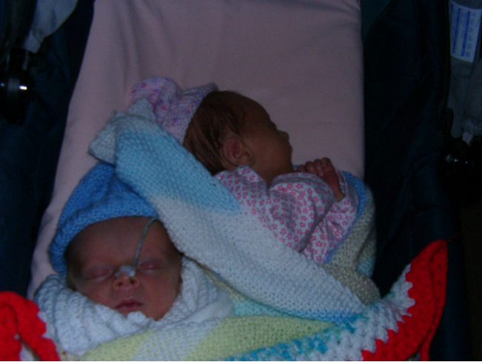
It was so good to be home, but a bit scary after having all these lovely mid-wives about. Having a routine helped a lot. Not that we managed it, but knowing what we were aiming for was useful! I fed and changed together during the day, but didn’t wake the other twin on the night feeds. It made things trickier, but I had this notion that I didn’t want either baby to be treated differently or have any less attention than if they had been born a singleton. This was utter foolishness on my part and turned me into a zombie for a while. The gains they have from being a twin far outweigh the compromises.

Kirstin’s top tip: When feeding the babies during the night, only change their nappies if you really have to! Otherwise it can sometimes take quite a while to settle them back to sleep again!

Logan and Aeryn

Family Portrait
With three kids under three my family is now complete (hubby has threatened to run off to Sulawesi should I even think about producing any more), so just before Christmas I decided the time had come for a family photo. I’ve always preferred spontaneous informal pictures, but looking through the last few years worth there are no pictures with all of us and, apart from some extremely haggard pics taken postnatally in a hospital ward, very few taken of me. So I booked up a photographer. A fair amount of forward planning was required; Fiona, my feisty 2 year old, got very excited and practiced, and perfected, her cheesy grins throughout the day. Every one had a fresh change of clothes 2 minutes before leaving to minimise the usual snot/food/drool stains, and we even managed to get there on time.
I didn’t have particularly high expectations: really just hoping for a picture with no one in tears (including parents). The photographer seemed to think a glowing family portrait would be no bother, and bragged that he’d snapped way tougher families than ours. So we all nested down in front of the white screen. But of course Fiona now totally refused to play. She would not be budged from behind the camera. Until, that is, we tried to take pictures of the twins; then she absolutely had to be in every picture: but face down, lying on the floor. I was all for giving up; I was sure I’d seen a coffee shop near by but the photographer was made of stronger stuff. Out came a flurry of cuddly toys and, with all three photographers making a cacophony of animal noises, we coaxed a glimmer of a smile out of even Fiona. The best bit about using a professional photographer was once they had a selection of photos of every child, they used a bit of computer wizardry to cobble together a group picture, and all of us looking at the camera, eyes open, even smiling. A picture of something that never happened, granted, but no one else needs to know that. It sorted out Christmas presents for grandparents, and I’m pretty pleased with the result. They even airbrushed out the zit I had that day (kidding).

Karin Ewing
Our photos were done by PHOTO EXPRESS, 7 Melville Terrace, Edinburgh (667 2164). The manager has kindly offered 50% off the usual sitting fee for twin club members If you fancy a similar experience.

Chicken pox and the Carlyon Trio.

One teeny wee pustule… that’s how my month from hell started. Its funny how you look back on it and actually it doesn’t seem so bad but at the time it was murder!!
James started first… runny nose, grumpy (grumpier than normal that is!), bit of a temp blah blah. Didn’t think anything of it. Then, the spot on his cheek. Odd I thought, not like him to be plukey and he is too young for puberty spots! Didn’t think anything of it until he got up the next day, his whole trunk covered in little red blisters. Mmmm I thought, it’s the pox! He went from having just a few to having them on every square cm in a matter of hours. I could almost see the popping up in front of my eyes. They were everywhere from top to toe. In his mouth, on his eyes, in his ears, on his “wee fella!”, his fingers, soles of feet. You name it, it had a spot.
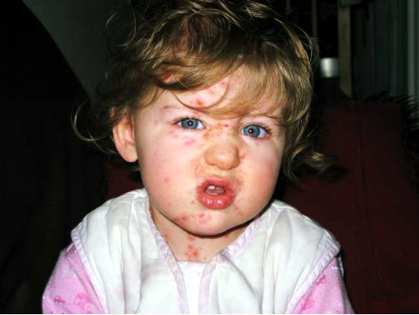
The third night I gave him a bath… and I will be honest. I gagged when I lifted him out… the feeling of his soggy spotty skin on my hands was just vile! Needless to say he had a gentle sponging for the remaining time he had the pox! At one point he got up in the morning and couldn’t speak… so I took him to the GP and she had a good look down his throat, His whole mouth and throat were covered in huge big pox, no wonder he had lost his voice. He also had them on his eardrums! GP gave us Eurax lotion for his spots, as they were so itchy.
The hardest thing was the cabin fever. Being stuck in all the time with one spotty child while the other two climbed the walls with boredom. Getting Eilidh to nursery was hard too as I couldn’t just leave Lurgy boy James in the car while I took her in.
Eilidh and Hannah were fine though so I thought great, maybe they wont get it. You assume with twins they will get it at the same time.. Ha, silly me! James was off nursery for one week. Eilidh loved going “all by herself!” We then had the weeks mid term holiday… still nothing from the girls.
The night before nursery was due back Eilidh got a spot… NOOOO she was so looking forward to going back to nursery (never mind how much I was looking forward to her going back!!!) and now I had to explain she couldn’t go! The next day Hannah got one. Joy!
Its funny cos James had the spots, moaned a wee bit but really just kind of got on with it. He was ill but okay really. Well Eilidh sure made it a drama!! She was so precious about her beautiful skin, “Ohhhh the spots, look at them, ouch they hurt, its bleeding, its on my tongue, its in my eye, they are everywhere, they are itchy, they are sore, they are hot, they are cold…” and on and on she went! Hannah thank goodness can’t speak yet!

The girls had it bad. I thought James had had a bad dose but the girls just had to top him! Hannah ended up at the emergency Drs at the infirmary one night cos she couldn’t sit down her bum was so bad with it, raw and bleeding. Guess its cos she is in a nappy and the spots got infected and sore. Poor wee thing just cried and gasped every time she moved. There is only so much peeing on the carpet from nappy off time I can take! She got Fucidin for her bum, which almost worked over night!
Eilidh didn’t sleep, eat or drink anything for about two days at her worst. Even water was hurting her mouth it was so bad. Hannah drank her bottles but went off her food… NOT like her at all. And do you know the funniest thing was my husband’s reaction to the whole thing. With James it was okay, he had chicken pox, Daddy was concerned but he got over it. With the girls… Ohhhh it was a whole different kettle of fish. Their poor skin, poor wee princesses blah blah. Yeah right! Drama queens more like! Daddy’s little girls are so precious… me, I couldn’t stand the moaning! What are these men like with their daughters, I don’t remember my Dad being like that with me!!

And when that’s all over… The next thing is the scabs… finding them everywhere… in beds, on pillows, in clothes… in hair… for weeks!!! Yuk Yuk Yuk!!! All in all we had four weeks of the pox and I can quite honestly say from the bottom of my heart… if I never see another pox in my life I will be extreemly grateful!

My top tips for dealing with the chicken pox…

Make a Shopping list!
Calamine and aqueous cream. Magical stuff! The lotion is a nightmare and you would be better just pouring it over their heads the amount of time it takes to dab on each and every spot! You can get in your local chemist. This stuff is nice and thick to apply and seems to cool them instantly! Messy though so watch the carpet!
Eurax lotion is also really good if they are extremely itchy. Better than calamine infact!
Piritin, keep them dosed up at all times.
Calpol, dose them up (infact medised helped more)
Loose, cool clothing.
Apparently Bicarb of soda in the bath helps with the itching… it made James scream though… but then he might be weird…
And lastly, Vodka… for mummy of course!! You will need it after listening to whining about itchy spots, all day, hearing it in your sleep, being woken at silly o’clock several times a night because they are itchy and cant sleep.

An Afternoon at Gym Tots
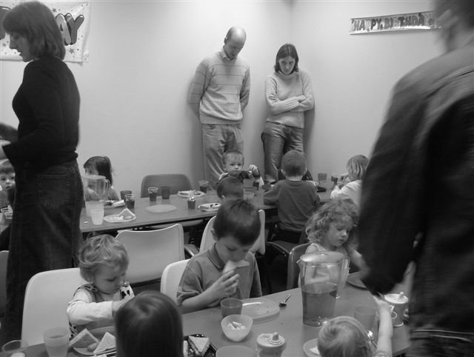
Our 1st social event of the year took place on Saturday 24th February at Gym Tots in South Queensferry. It brought together lots of mums, dads and twins (and their siblings) for a fun afternoon. 18 over 2’s and 11 under 2’s had a great time exploring the soft play areas and making friends, whilst the parents did much the same, in between enjoying a cup of coffee and a cake!
The soft play area is split into 3 age groups - A large padded zone is filled with toys for babies so that they can crawl around and not escape into the older zones. Here we had 3 or 4 sets of twins exploring new toys, whilst their parents were also able to have a chat. My 12 month olds spent most of their time in here, and thoroughly enjoyed ‘jumping’ off the padded walls into daddy’s arms – who needs all these fancy toys!
The next stage up is suitable for walkers (or adventurous crawlers!), and involves climbing up a slope, through a tunnel, and down a slide. A very popular part was where streams of air blow balls into the air – the older ones showing the younger ones how to catch them, or having their hair blown in the wind seemed just as much fun…
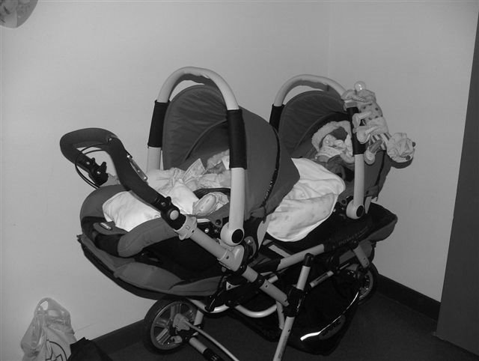
I didn’t make it into the main part, which looked like a maze of tunnels, slides and steps, where the older ones can run and jump (and scream!). All the children certainly seemed to enjoy themselves (and certain parents who also made it round the full course!) but we’ll leave that for another year or so.
Sean and Aisling Al-Gharabally
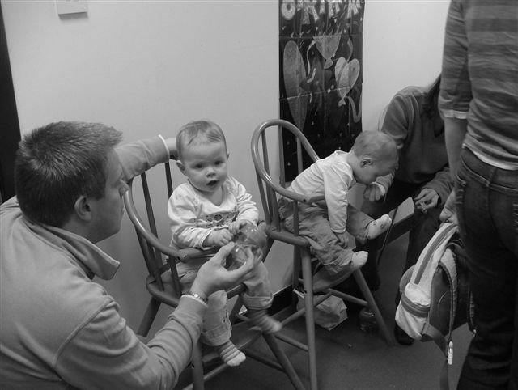
The afternoon finished up with party food for all, in the party rooms, and hopefully lots of tired-out twins fell asleep on their journeys home.
As well as the soft play areas, there is a café serving teas and coffees along with a great selection of home made, healthy food and snacks, next to the bright and airy open plan seating area. And a good thing to remember is that one of the regular events at Gym Tots is “Mums Lie In” on a Sunday morning, which gives Mum and hour to herself and Gym Tots will give Dad a bacon roll and a coffee – see www.gymtots.co.uk for further details!
ARE THEY IDENTICAL?

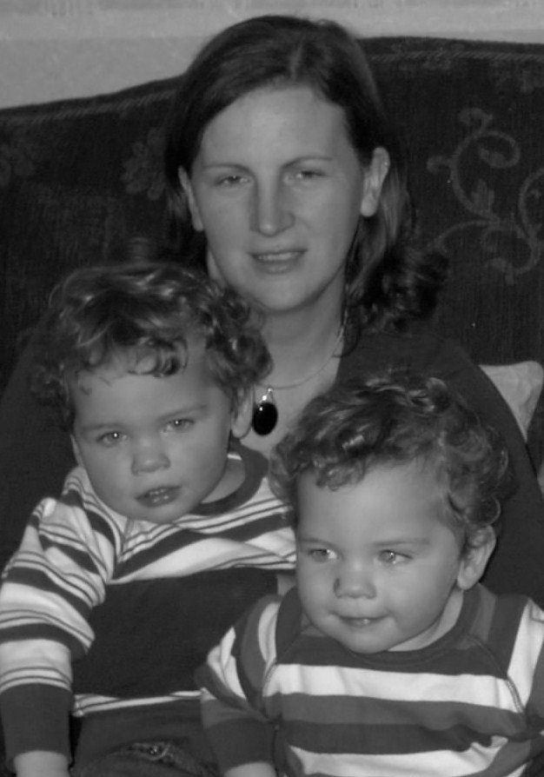
It was the first question asked by my husband and I (after getting over the initial shock!) at the first scan. We were told that they weren’t because they had separate sacs (chorions) and placenta. So we went through the pregnancy preparing ourselves and the house knowing that we were carrying non-identical twins. The boys were born early at 34 weeks and were in special care for the first 2 ½ weeks. While in SCBU we were asked if we wanted a test to determine zygosity (whether they were identical or not), but stupidly we turned it down. We were just happy that they were safe and well and we had no reason at that stage to doubt what we had been told. Also I think having babies kills brain cells and I wasn’t thinking clearly (maybe it was the painkillers after the c-section). In the early days whenever we were asked THAT question we always said they were fraternal. We could tell them apart no problem, especially after Owen developed a “strawberry” mark on his nose when he was a month old. But the strawberry was the only way that the rest of the family could tell them apart. Now that they are two even I can see that they are too similar! Same hair, same eyes etc. I have been questioning whether they are identical or not, researching the internet to read about twins. So I have found out that in same sex twins having separate chorions and placenta doesn’t make them fraternal, it all depends on how early the egg splits after fertilisation. If only I had taken that first DNA test! We are going to get a test done and then once and for all we can answer THAT question without the embarrassment of saying “I don’t know”!
Niall on the left and Owen on the right

Donna Dickinson
Mum to Niall and Owen

Conclusion
I applied for a test pack from the “Multiple Births Foundation”, they first of all send you an application form with which you send your cheque. Then they sent a swab kit with ten swabs for each child in case you find it difficult to get samples. We did not, the boys really enjoyed having these swabs (which looked like one ended cotton buds) rubbed inside their cheeks! The instructions said to use five for each side of the mouth and to rub the inside cheek, gums and lip for 20 seconds. I did Owen’s first while Niall was still asleep in case it was going to be traumatic, then when I was doing Niall’s Owen was trying to get it done again (what a fun game it was!). So the samples were then posted back, now we just had to wait.
The results came back today, only a week and a half after sending them.
And they are IDENTICAL!
First Aid Course
Everyone thinks they may be able to cope, everyone hopes they can cope but can you and would you know what to do when your child starts choking or the woman at the table next to you collapses?
The First Aid Course ran by St John’s ambulance service gave us the basic first aid training to deal with many situations including the ones above. It is a fear of mine that I would freeze in an emergency or not handle it correctly but what the course has given me is confidence by arming me with the basic first aid training I need to get by until an ambulance arrives.
I would highly recommend it to you all and hope that neither I nor you will ever need to use it. There is the opportunity to attend a 1 day course (see the Social Calendar for more information.)

Jenny Love, Mum to Michael and Olivia aged 3 ½

Helen’s birth story
I had a traumatic birth with the girls. Louise came unexpectedly in the bathroom. I was on my own and thankfully Ewan, my 6 year old son, was at his grandparents for it was a bank holiday. I just couldn’t rest that morning. I couldn’t sit down and then laying down was so uncomfortable. I phone up my husband and told him that I was feeling uncomfortable. He said to phone back if I wanted him home. I went up stairs and I was getting worse. I then phoned up my husband again then phoned the midwife. As I was on the phone to the midwife the phone went dead so we lost contact. (I had left the cordless phone off the charger all night. I then went downstairs to get my mobile and found that that also was low on battery power. I got the charger and the mobile upstairs but felt I needed to go to the loo. As I went to sit down Louise’s head came out. I then automatically took over. I got up and then the urge to push came and I must have only pushed 3 times and she shot out onto the bathroom floor. She was gooing so I knew she was alive. I just picked her up and froze not knowing what to do next. I was then in agony as I was then having contractions for Fiona. I was still standing in the doorway of the bathroom when I heard Dave come into the house. I shouted as loud as I could for him to get up here. He just saw all the blood everywhere expecting the worst. I then turned around to show him our daughter. I was in total shock. He went down to his car to get his mobile to phone the hospital. They then relayed to my hubbie what to do. I sat on the bed with towels over me and Louise. There were then 4 paramedics in our bedroom. I didn’t know that the cord was detached until the medic said where is the cord. He then had to clamp it and it had been a good 20 minutes that Louise had been detached so therefore there was a lot of blood loss. My husband went in one ambulance with Louise and I was kept back as the medic was concerned that I would have Fiona quickly. I finally got sent to hospital to find that Fiona was lying transverse (sideways) so she had to be delivered by emergency section. There was an hour between each birth and everything thankfully was well. Louise was X-rayed to check if she had broken any bones in the fall. They both went to special care baby unit for 3 days to keep their temperature up. I was in the delivery suite for 3 days too as I was a little anaemic. Louise weighed in at 5lb.1oz and Fiona at 4lb.7oz. They were born exactly a month early at 36 weeks on 19th September 2005. I feel so lucky and privilege to have such beautiful girls and it could have been a lot worse. I could have had Louise in the street. I always say the Fiona pushed Louis out as Fiona was getting cramped of space!

Helen Massie, mum to Ewan, Louise and Fiona

Daytime Activities- Bumps, babies & toddlers

Oxgangs Group: Thursdays 10-11.45
£2 per member family/ £3.20 non-members (tea + biscuits included, first week free of charge).

Oxgangs Neighbourhood Centre
Firrhill Drive
Edinburgh
Tel: 0131 441 7558

Directions
From town centre:
Drive up Lothian Road, keep going up Bruntsfield Place and Morningside Road, this eventually becomes Comiston Road. Go past South Morningside Primary school, at the second set of lights after this turn right and go along Greenbank Crescent. Turn right again at Oxgangs Crescent and one more right takes you to Firrhill Drive. Be warned; this looks like (and is) a building site. You will see the community centre ahead of you on the right side of the road, and you can park there, beside the building.

From out of town:
Exit the city by pass at Lothianburn. This road takes you to Comiston Road. The junction to Greenbank Crescent is at the second major set of lights, turn left then follow the directions as above.

I have been attending the Oxgangs group now for nearly a year; it’s been a great place to take my 3 year old and twin babies. The children play and I have found the support and friendliness from the other women there invaluable. Anybody is welcome; the children are usually pre-school age, and pregnant women also come along. If you are unsure about where we are please give me a call (0131 446 0551).

New Longniddrie Twins Group
There is the possibility a group will be established in Longniddrie. Keep an eye on the messageboard for developments.

South Queensferry: Fridays 10-11.30
£2 per member family/ £3.20 non-members (tea + biscuits included, first week free of charge).
Our new twins group for bumps, babies and toddlers has started at the fabulous sea-side location of Port Edgar Scouts Hall, South Queensferry. There is a separated area of soft mats filled with playgyms and toys to entertain the younger babies. The rest of the hall is filled with larger toys, including a slide and a play kitchen, to keep energetic toddlers amused. Outside there’s a large grassy area which will be great for running around on during warmer days. Parents and carers can enjoy tea, coffee and a chat. Twin families have been coming from various locations in Edinburgh, West Lothian, Falkirk and Dunfermline. Feel free to be early or late, and we hope to see you there! For more information call Lesley 01506 840792 or Donna 01506 671699
Directions available at www.edinburghtwins.co.uk Quick version: Drive into South Queensferry, follow signs for Port Edgar Marina (directly under the Forth Road Bridge) and after you drive into the marina the Scout Hall is on the waterfront. Park in the car park and walk down (you’ll need a pushchair) or drive through the marina and park at the hall.

Note: The insurance we have for all daytime venues doesn’t cover children over five. You may want to bring older brothers and sisters during the holidays but that will, as they say, be “at the owner’s own risk”.

Library: The Twins Club has a number of books on multiples & children in general at Oxgangs. The books can be lent out during the sessions for a couple of weeks at a time.

'East Edinburgh / EAST LOTHIAN
Please note this group has now ceased.

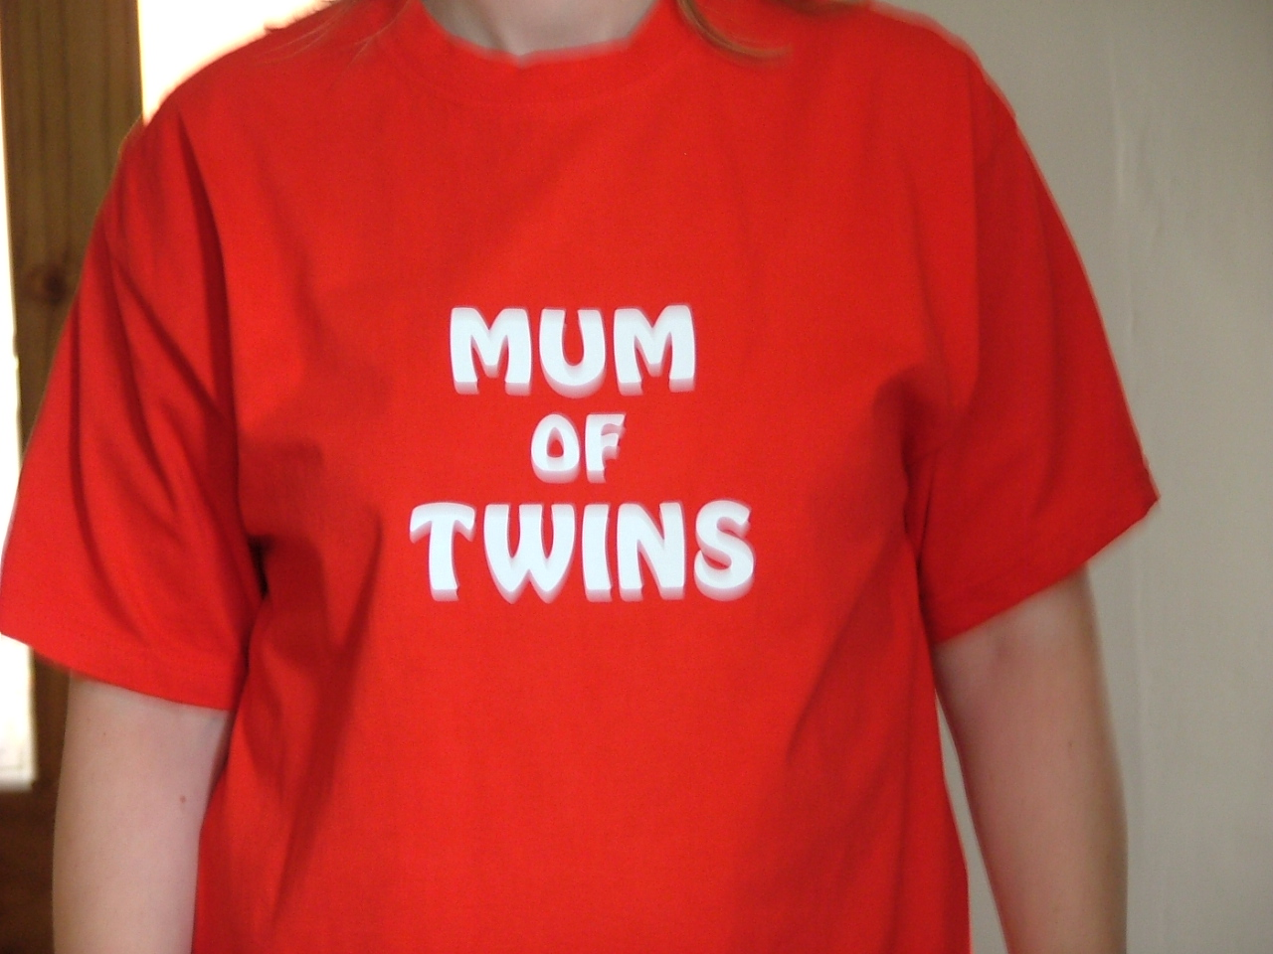
Discounts
We have been trying to negotiate with a number of retailers / clubs in order for Edinburgh Twins Club members to obtain discount. If you already use your card in other shops, please let us know for future Newsletters.
Blessings & Blossoms, 132 St Johns Road, Corstorphine, 0131 334 8322
10% Discount. Children’s Clothes shop.

CLARKS Shoe Shops
10% discount on production of Twins Club membership card (it does not have to be the TAMBA card). This will apply for all siblings shoes as well! This only applies to Edinburgh stores (Cameron Toll, Gyle, Princes St, Kinnaird Park & Musselburgh) but we have had a few problems with some of these stores accepting our card – please refer any member of staff to their Regional Manager, Nigel Merritt who has agreed this discount scheme countless times. Please do not try to obtain discount from any other store.

Doodles Ceramic Workshop
29 Marchmont Crescent, Edinburgh
10% discount for all visits. Includes evening visits when mums can enjoy some peace and quiet with friends.
15% discount for birthday parties booked in either July or August, either in the Doodles studio or with Doodles to Door (which brings all the fun of Doodles to your home or other venue). Subject to Availability. Call Holly on 0131 229 1399
Golden Hands Silver Feet
10% discount. Your little ones hands and feet captured in Bronze, Brass, Aluminium or Stone.......FOREVER - a unique memento or gift. For more info & prices please see www.goldenhands.co.uk or phone Nicky Summer on 0131 665 8628
Jelly Club
10B Kings Haugh, Peffermill Road, Edinburgh. 15% Discount on production of Membership card

Lorac Carpet Services
10% Discount. Professional carpet and upholstery cleaning, general repairs, odour treatment, specialised re-tufting, specialised Oriental rug cleaning. For free advice/estimates contact: Phone 0131 468 0996; Mobile 0775 159 4900; email info@loracservices.co.uk
Nightbridge Designs
15% off custom made soft furnishings, bedding & curtains. Contact: Debbie on 01506 431515
Truly Scrumptious Designer Cakes
10% Discount. Simple cakes to intricate designs. Look fantastic and taste great too! Tel: 01506 671133
Rocking Horses
10% discount. If anyone would like to see/ride a large mahogany horse (called Rocky!!), please contact Gill Petrie on 0131 443 2919.
Contact: Jim McAuley, 73 Manse Street, Saltcoats, KA21 5AA. Tel: 01294 466415

Wendy Beardmore, Freelance Public Relations
15% DISCOUNT. As a member of the twins club, I have recently started out doing freelance PR and Marketing, using my maiden name Wendy Robbins. I am mainly helping small businesses and start ups to develop their marketing. If you have your own business and need some help growing this, or indeed if you know someone else in this situation then give me a call.
Call Wendy on 0131 334 9591 or 07771 966 488.
Little Beau Peep 79 High Street Linlithgow 01506 848196
10% off childrenswear for twins club members.
Shoos (Start-Rite shoes stockist) - 8 Teviot Place, Edinburgh. Tel 0131 220 4626.
10% discount for twins. [Very good service - and Start Rite are great for children with narrow feet as well as "normal" fittings.]

Nippers Nursery, 23 Hopetoun Road South Queensferry Tel: 0131-331-2524
10% discount on all items in our store. We have a range of designer children's wear and baby gifts

Nippers Nursery, 23 Hopetoun Road South Queensferry Tel: 0131-331-7635
5% discount on childcare fee's in our nursery which offers childcare for age 3 months to 5 years. We also offer government funded places for pre-school years.

TAMBA
The Edinburgh Twins Club is affiliated to TAMBA (Twins and Multiple Births Association). Membership is separate however. For details of the benefits of TAMBA membership, visit www.tamba.org.uk
or telephone 0870 770 3305
Newsletter
Articles for the July 2007 issue to:

Kairsty Ashworth
14 Birrell Gardens
Murieston
Livingston EH54 9LF
Kairsty@Craiksland.freeserve.co.uk

by 23rd June


POST NATAL
DOULA SUPPORT

Helping a mother to have the space, time and confidence to more fully enjoy early motherhood. Mother to Mother provides support in the early postnatal weeks. For more information please go to www.mothertomother.co.uk or call Clare on 0131 445 4445

Snippets

Child friendly first aid kit:
Sterile dressing (no 7)
Tape (meopore or primapore)
Tubegauze
Eye pads (no 16)
Triangular bandage (halved)
Non alcoholic wipes

Fever scan or ear thermometer
Character plasters
Savlon
Emergency first aid booklet

Basic graze procedure: Wash out with water, wipe with non-alcoholic wipe, savlon, plaster

Swap Shop – Items for Sale

Please note that the Edinburgh Twins Club cannot be held responsible for any purchase made through the Swap Shop or Wanted section. Each deal is entered into privately between the two parties involved (i.e. the seller and the buyer).
You can advertise as often as you wish, but you must notify The Editor each time you wish to advertise again. Please send all items you wish to advertise to:

Kairsty Ashworth: 14 Birrell Gardens, Murieston, Livingston EH54 9LF
e-mail: Kairsty@Craiksland.freeserve.co.uk
Tel: 01506 409984

Items for Sale  Maclaren Twin Traveller Black & red, removable, washable seat covers. Adjustable seat positions, suitable from birth. Lockable swivel wheels. Comes with five-point harness, hoods (with zipped storage pockets), raincover, basket, foot muffs, head huggers, bottle holder & full set of instructions. Barely used. Cost £220 new - sell for £120 ono  Britax duo isofix car seat (x1) Suitable for 9kg to 18 kg (about 9 months to 4 years). Black & greyish blue, removable, washable cover. Comes with full set of instructions. Can also be used in non-Isofix cars. In nearly new condition Cost £190 new - sell for £75 ono  For any of the above items contact Kirstin Evans 0131 333 2332  ----------------------------------------------------------------  Large selection of clean, good quality girls & boys clothing. NEXT, H & M, ZARA, TESCO makes, sizes ranging from age 2-3, 3-4 & 4-5. Including Joggers, t-shirts, polo shirts, long-sleeved t-shirt tops, linen & cotton trousers, three-quarter length summer trousers, shorts, short-sleeved summer cotton shirts, hand-knitted cardigans, summer jacket, jeans, cords, cardigans, socks, pants, tights, vests, dressing gowns. Perfect for summer holidays, nursery & playing outside. Good prices on all items – e.g. 50p up to £3.  Contact Jane Berry 01875 852992  ----------------------------------------------------------------  2 x Toddler/Junior beds. Pine. Bigger than a cot but smaller & lower than a single bed, slatted bases with detachable bed guards & mattresses with removable hand washable covers. Can also throw in duvets and covers if required. £50 for both ono  Contact Helen Nettleship 0131 665 4321, helennettleship@mac.com  ----------------------------------------------------------------  2* travel cots £15 each ono  Contact Kairsty Ashworth 01506 409984 | Chicco Caddy Single Buggy. Lightweight. Lockable, swivel wheels. Hood and waterproof cover. Carry bag. £50 new. Barely used. £20 ono.  Urban Detour Twin Three Wheeler. Original lighter weight model. Rain cover. Two cosy toes. Good condition. £50 ono  2 Britax clip on car seat trays. Navy blue. Fit eclipse and similar. £5 each ono  ELC dolls house. Chalet style with red roof. Furniture included. £30 ono  Buggy Connectors. Join 2 similar single buggies together. Great for holidays. Used with 2 umbrella folds it’s just like a twin buggy. £10 ono  For any of the above items contact Catriona Hepburn 0131 343 3133  ----------------------------------------------------------------  Urban Detour Double Buggy -£100.00 Great condition lockable, front swivel wheel multi position seats hood with viewing window 2 cosy toes  Raincover basket at bottom  Contact Jenny Love 0131 445-3403  ----------------------------------------------------------------2 pine cot beds, both in excellent condition, 2 positions for the mattresses height, £50 each.  Early Learning Centre 'Happyland' trainset £10, and Safari Park £25. All clean and in excellent condition.  'Ora' twin pram/buggy, suitable for newborns or newborns and toddler, lies completely flat with mattress or with separately adjustable seats. Faces forwards or backwards, good suspension, able to go over rough terrain, includes, pram, raincover, cosytoes & sunshade. Cost £460, will sell for £150.  Contact: gerry.pennycook@blueyonder.co.uk
Social Calendar

Bookstart Rhymetimes    Wednesday 16 May, 3-4pm | Bookstart Rhymetimes - Action rhyme and song sessions for children 0-3  Activities for babies, toddlers and their parents. Bookstart Edinburgh are running this session, just for the Edinburgh Twins Club. It incorporates a mix of songs, rhymes, rhythm and movement, and provides the opportunity to share games, novelty books and toys. These sessions are organised locally and take place in many libraries around the city to encourage parents and carers to share rhymes and songs with babies from birth onwards. Sessions are FREE and great FUN! www.bookstart.co.uk  £ FREE Places are limited, so please book early to avoid disappointment!
Mum’s Night Out    Monday 21 May, 8pm | Mum’s Night Out Fundraiser with Captain Tortue  Join us for an evening of fun and fundraising at Channings (South Learmonth Gardens, Edinburgh) and enjoy an informal presentation by Captain Tortue, sold exclusively by Independent Consultants - French children’s fashion with a difference for babies & children age 6 months to 14 years that are fashionable, practical, easy to wear, colourful and high quality. The Club will receive 10% of sales made on the evening, with an additional £5 for each confirmed booking made for new private parties.  Phoenix Trading Greeting Cards and The Pampered Chef, among others, will also be supporting us on the evening.  £6.50 including glass of wine on arrival and canapés
First Aid    1 Day event, date to be confirmed | Baby and Child First Aid with St Andrew’s Ambulance Association  We are now offering a full day course (6 hours) on a Saturday, costing £25 per person. The date is yet to be confirmed (but will be held during April or May), so if you are interested in attending this course, which will give you knowledge and skills to handle an ‘emergency’ with your children.  £25 per person
Almond Valley Heritage Centre    Saturday 16 June, 10.30-12.30 | Almond Valley Heritage Centre, Livingston  Enjoy the start of summer with a fun packed morning for all the family at Almond Valley. The children can go wild in their own play session, take time to explore the farm buildings that are home to a range of friendly farm animals and travel around Mill Farm in a tractor and trailer. Partygoers are then welcome to stay as long as they wish within the Heritage Centre during normal opening hours. For further details see www.almondvalley.co.uk  £5.50 per child, including play session, ‘party’ food and trailer ride

Contact Kirstin Evans at 0131 333 2332 or alternatively e-mail kirstinevans@hotmail.com for any further information.

