Edinburgh Twins Club
Newsletter

January 2007

Hello and Welcome to the January edition of our Newsletter

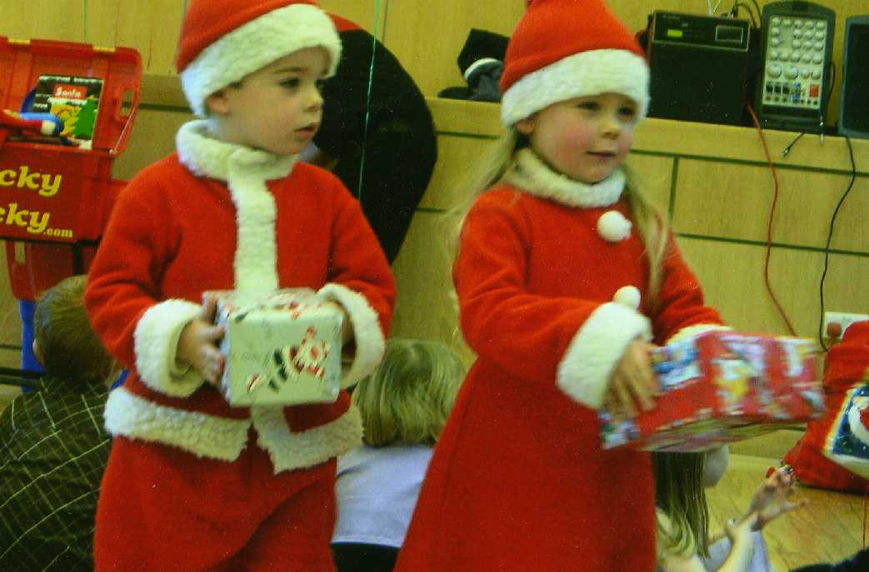
Happy new year! By now no doubt you've managed to clean up the holiday chaos, and I'm probably the only one still finding tinsel in hidden corners of the house, and random piles of stocking toys around the place! Ah well - life is busy with a crowd of little ones, isn't it? :-)

Our AGM was held a few weeks ago and the new committee would like to extend a great vote of thanks to those who're stepping down - Jenny (though she's staying on to be vice-chair with Carol), Kate, Sarah & Catriona. We really appreciate all the work that you, and others before you, have done to make this club. We're delighted to announce that a number of new folks have joined the committee - Karin who'll be organizing Oxgangs, Lesley & Donna who're taking on South Queensferry, Kirstin who'll be working with Katy organizing social events, and Morag taking over the website. And many thanks to those who're staying on - I'm looking forward to our year and a little bit working together.
Kyle & Rachel Blaikie receiving their gifts from Santa

As you get into the swing of this year's routines do consider coming along to the East group, Oxgangs, South Queensferry, social events, or the First Year's group (first Wednesday of each month at St John's). The twins club can be such a great support, and even if you've never come to something before then brave the winter weather and come and join us somewhere! Just this morning I was chatting to a friend who told me that she's had a rough few weeks with a nasty cold doing the rounds on their family (of 6), and that their 7 month olds have been up at least twice at night each... And of course she said "but you know how that feels" and I was able to utter a heartfelt "oh yes". There's something very comforting about knowing you're not the only one, isn't there? :-) Continued overleaf

 | Membership Update  Welcoming the newest members of ETC | 3 |  | East Edinburgh Toddler Reports | 8
 | Edinburgh Twins Club AGM | 4 |  | Swap shop  Visiting Edinburgh art galleries with twins | 12
 | Twinning project update  10-12 November French weekend | 6 |  | Snippets  Everyone’s favourite perk – which shops and how much | 15
 | Social Report – Christmas Party Report | 7 |  | Social Calendar  Autumn events for 2006 calendar! Forms back by 6th November please. | 16

For those of you who are online we've just added a great new feature to our website - a message board! Take a moment to have a look next time you're online, and post a message, or see if there's someone whose questions you can help answer, or someone selling something that you've been looking for. Let us know what you think - and a HUGE thanks to Morag for all her work getting this started - I love it! :-)

Do you occasionally have 10 minutes you'd be willing to give to help with organizing twins club things? We'd love to hear from you if you'd be willing to be on a list of folk who could be called on to help with little things, but who're not up for being on the committee.... Perhaps you'd ask a local business if our club could have a discount with them, or join in setting up the summer fayre, or stuff newsletters into envelopes, or fill in the occasional grant application form. Or if you have any articles you'd be willing to write for the newsletter or questions about what's going on then please let me - or someone else on the committee - know. Just contact me direct, start a subject on the message board, or come to first years sometime and we can chat child-free! :-) We're looking forward to a great new year and I hope that your family find lots of laughter and crazy moments together this year.

Best wishes

Rachael Round
Chairperson
01506 639809
rachael@the-rounds.net

Volunteer for fun
The committeee are looking for willing volunteers to fill the role of social convenor to assist Kirstin, daytime coordinator for East Edinburgh and fundraising. If you are interested, please contact Rachael Round.
Tel: 01506 639809 or e-mail Rachael@therounds.net.
Changes to the Web
"Next time you are online, why not visit our new messageboard on the Edinburgh Twins Club website. There are four forums: one for general discussion; classified adverts for buying/selling and swapping; Things to do in Edinburgh; and an Events announcements
board.
It is a great place to chat to other local multiple parents and carers."

Membership Update

We have the following 10 families who have joined the Club since the last newsletter,
WELCOME to:
- Donna & Brian Dickinson, and their twins Niall and Owen born on 2nd December 2004, brothers for Taylor;
- Kate Thompson & John Brandon, and their twins Elizabeth and Rebecca born on 25th June 2006; sisters for Charlotte who is 2 in February.
- Sophia Marriage & Jonathan Pryce, and their twins Rhona and Freya born on 2nd December 2006, sisters for Phoebe who is 2 in February;
- Vickie & Paul Warrington, and their twins Jack and Oliver born on 21st July 2006;
- Gayle Geddes & David Forsyth, and their twins Robbie and Ellie born on 6th May 2005;
- Gemma Penman and Kenny McDonald, and their twins Mya and Kaitlyn born on 15th October 2005;
- Fiona & Joe Al-Gharabally, and their twins Sean and Aisling born on 12th January 2007;
- Allison & Gavin Brogan, and their twins Abi & Catie born on 10th November 2006;
- Lindsey Ross & Keith Innes, and their twins Terence and Frankie born on 3rd June 2005;
- Heather & Manu Charles, who are expecting twins on 12th March 2007.
Some of our new members have had their babies since we last wrote, CONGRATULATIONS to:
- Sophia Ali & James McConkey have had their twins Harvey & Lucas, born on 21st November 2006, little brothers for Alexandria who is 4 and Evan who is 2;
- Carolyn & Ricky Armstrong have had their triplets, Grace, Laura and Ben also born on 21st November 2006.

Well done and MANY CONGRATULATIONS to all our new arrivals!

Our membership list currently consists of 135 families.

ARE YOU LEAVING…We would be really grateful to hear from you should you not wish to continue your membership of the Club. It would be interesting for us to know why you don’t want to continue membership, bearing in mind we are aware that there is perhaps less need for support as the children get older. Also, hearing from you would greatly assist our admin hence a quick call or e-mail would be very much appreciated!
IF THERE IS A MEMBERSHIP FORM WITH THIS NEWSLETTER…your membership is either due or overdue for renewal. Please complete the form and send it with your cheque to Miriam Newton by mid March 2006.
PLEASE LET US KNOW YOUR BABY NEWS… Please do not forget to call Miriam or Gillian and let us know news of your arrivals – this really will help us come Newsletter time. If we have missed the birth of your babies, or you are a new member and we have missed you from our list, please let us know so that we can add you to our next newsletter.

Best wishes,
Gillian Morrison and Miriam Newton

Membership Committee
Gillian Morrison  37 Tantallon Gardens  LIVINGSTON EH54 9AT  01506 420 143  gillian_morrison@btinternet.com | Miriam Newton  58 Gamekeepers Road  EDINBURGH EH4 6LS  0131 476 1394  miriam@newtonhouse.net
Edinburgh Twins Club AGM

The Edinburgh Twins Club (the “Twins Club”)

Minutes of Annual General Meeting

Of the

Edinburgh Twins Club

held at The Murrayfield Hotel, 18 Corstorphine Rd, Edinburgh, EH12 6HN on 10 January 2007at 8:00 pm

Present: | Officers of the Club: | Absent:
 | Jennifer Love (Chairperson) |  | Sarah Warwick (Vice Chairperson/ Secretary)
 | Gillian Anderson (Treasurer) |  | Catriona Hepburn (Vice Chairperson/ Secretary)
Committee: | Gillian Morrison (Membership Secretary) |  | Kate Gilmour (Social Convenor)
 | Miriam Newton (Membership Secretary)
 | Katy Archibald (Social Convenor)
 | Kairsty Ashworth (Newsletter Editor)
 | Carole Park (Daytime Co-ordinator Edinburgh)
 | Rachel Round (Website Administrator)
Present: | Ordinary Members: 5

Notice, Quorum and Declaration of Interests
  - The Chairperson noted that due notice of the meeting had been given to all Members of the Club in accordance with article 6.4 the Club’s Constitution (the “Constitution”), and that a quorum was present in accordance with 6.5 of the Constitution.
  - Each of the Members at the meeting declared they were not for any reason disqualified from voting at the meeting or forming part of the said quorum.
  - The Chairperson thanked all the members of the retiring committee for all their help and support over the past year of 2006.
  - The Treasurer produced the report for the accounts year ended 30th September 2006, balance £1,233 and these were signed and approved by the Chairperson.

Resignations and New Appointments

The Chair accepted resignations from each Member of the Committee.

In accordance with 4.2, 6.5 and 8 of the Constitution, the new Committee was thereafter appointed as follows:

Chairperson: Rachel Round

Joint Secretaries (and Vice-Chairs): Jenny Love and Carole Park

Treasurer: Gillian Anderson

Membership Secretaries: Miriam Newton and Gillian Morrison

Social Convenor: Kirstin Evans
Daytime Co-ordinator (Edinburgh): Karin Ewing
Daytime Co-ordinator (South Queensferry): Lesley Livingston & Donna Dickinson
Daytime Co-ordinator (East Edinburgh): VACANT

Newsletter Editor: Kairsty Ashworth
Fundraiser Co-ordinator: VACANT
Website Administrator: Mòrag Burgon-Lyon
French Liaison Co-ordinator: Lesley Livingston

In accordance with article 5.1, it was agreed that any casual vacancies should be filled by the Committee.

- Any Other Business

  - The Chairperson proposed that the date of the AGM be moved to early March, and that the financial year end be moved to 31st January. This motion was carried unanimously.

- Close

There being no further business The Chairperson declared the meeting closed.

Signed: | Jennifer Love
 | Chairperson
Date: | 17/01/06




The twinning project visit

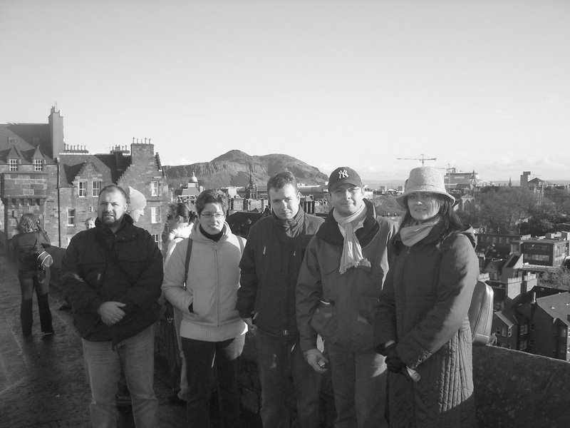
“Bonjour”, “Comment allez-vous?, “Salut” only one person was more surprised than me when I passed my “O” level French exam that was my French teacher. OK we had been to France on holiday more recently but this was different, “Les Jumeaux et plus” were visiting and we were hosting.

A few email exchanges in broken French and broken English had resulted in a clear understanding that Vincent and Natalie were staying with us and they had no special dietary needs. Arrangements were made to meet up and everything was going swimmingly until that phone call! The flight was running four hours late. Then the second phone call the scheduled airport bus was running late! A quick exchange with Eric, the “team” leader, re-arranged the pick up point to try and pull some time back, and hey this bus ran early!! So I met two rather nervous, rather tired, French visitors standing on the roadside in the middle of Mid Lothian industrial estate with barely a house in sight (well not quiet but it must have felt like that to Vincent and Natalie).

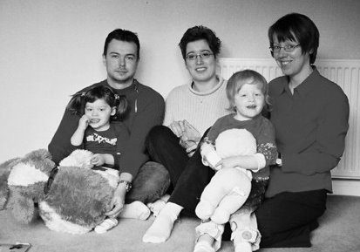
The following morning the girls met our French visitors and after a quick rendition of “Frere Jacques” and a few words of French gleaned from a BBC kids French tutorial video we had been studying for weeks beforehand we were off and running. What fantastic fun it was trying to learn French from real people. What was even better was that Natalie showed the girls how to put bunches in there hair and now they can really aggravate dad with that plaintive cry “we want bobbles in our hair”, because what took Natalie 30 seconds seems to take me half and hour and they still end up looking somewhat lopsided!

A quick tour of some of the more accessible tourist attractions, Forth Bridges, Edinburgh Castle, Royal Mile, Jenners (not sure how that last one got in!) took place on what must have been about the coldest Saturday afternoon in 2006. However, Saturday night showed what “twinning” is all about as members of Edinburgh Twins Club and the Le Mans branch of “Jumeaux et Plus” came together to share good food and drink, but equally importantly good company and conversation. Views and ideas were exchanged on all the usual topics from how much do you pay for nappies to which is the best people carrier by way of can you recommend a good wine/whisky!

Although this was only a short visit it would be nice to think we can build on the experience. Convenient contacts for the “Le Man 24 hours race” is a little mercenary but less so are opportunities to learn a new language and about a different culture which “twinning” provides. Our girls still talk about our French visitors and are still trying to understand why they didn’t drink tea or eat porridge at Breakfast!

Stuart Ashworth

Social Report
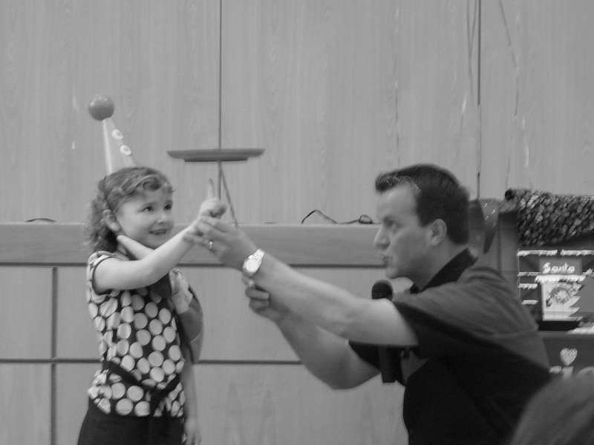
Christmas Party

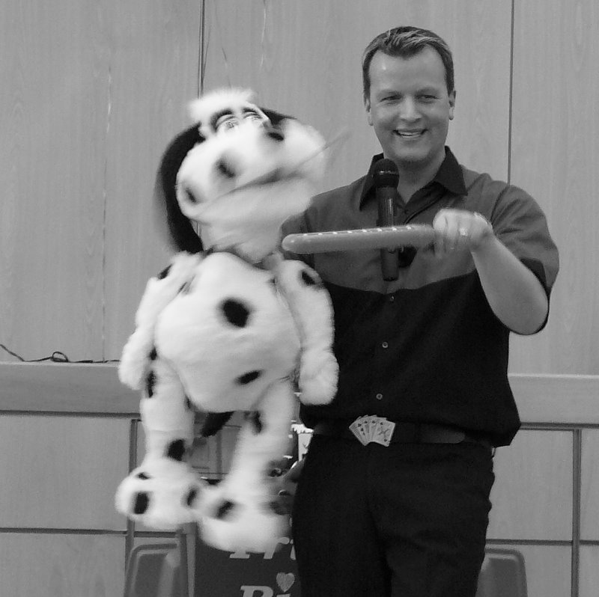
73 children were very well behaved on the 9th of December in Corstorphine. The reason that I know this, is that a very special guest came along to visit them. Santa Claus himself, went along to Corstorphine Parish Church hall to share in the fun of the Edinburgh Twins Club Christmas party. The day started with a fantastic magic show from TrickyRicky, who brought his lovely dog "B I N G O" along to say hello "Woof! Woof!".
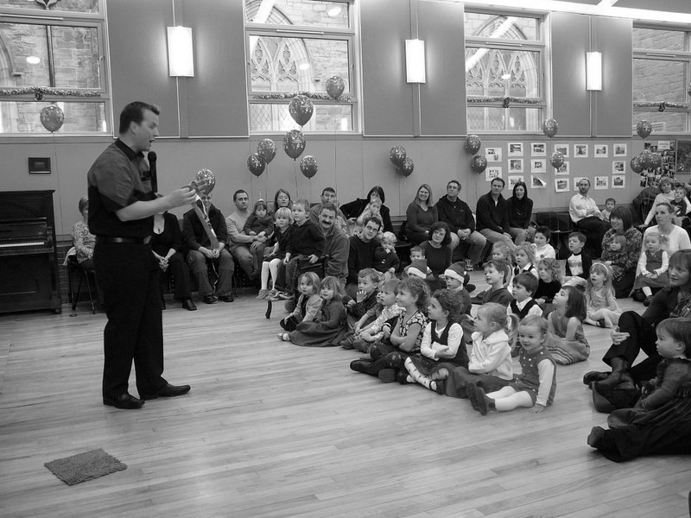

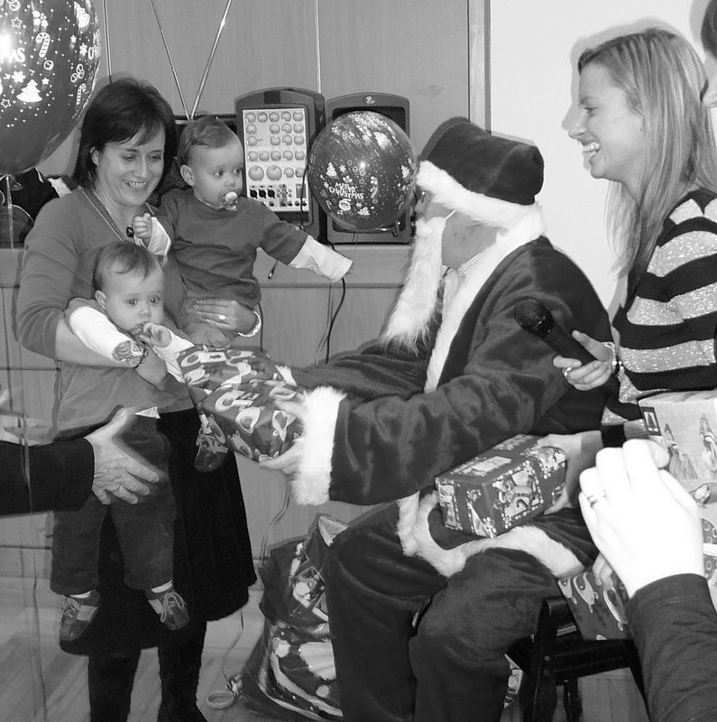

After the magic show, we all began to sing some Christmas songs. The singing of Jingle Bells helped Rudolph, Dasher, Dancer, Prancer, Vixen, Comet, Cupid, Donner & Blitzen find the church roof so they could land. Rudolph had a bit of a cold, which made his nose brighter than normal, but the others helped direct Santa so he could find the church hall. Santa was wonderful with the children as usual and they all really liked the special presents that he had for them. Once Santa had left for his trip back to the North Pole, we all had a picnic that made our tummies very full. Santa’s little helper would like to thank the Kirk Session of Corstorphine Parish Church for allowing us to use such a wonderful venue. Special thanks go to all the committee members of the Edinburgh twins club, for all the planning and organising without which this event would not have been possible. Someone who deserves a special mention, is of course Santa. Thank you Santa!!! Maybe if we sing louder next year, he'll bring one of the reindeer in with him for a carrot!!

Santa’s little helper, The North Pole)

East Edinburgh - Daytime Activities Past…Present…Future?

I cannot believe it is nearly four years since Susan and I waited nervously to see if anyone would share our idea that there was a need for a twins group meeting in the East. A simple phone call a few months earlier from Susan had managed to give me the support I had been needing, simply to be able to talk to someone who understood the ups and downs saw me through some challenging moments. With encouragement from the then chair of the Edinburgh Twins group and funds from my health visitor we set about putting things in place to start up a meeting to help families with multiples come together to share experiences and solutions.

Over the years we have been running, we have tried to listen to those who came along and made changes including; the timing and frequency of the group, offering a choice of fruit as well as the ever welcome choccy biscuit, having a health visitor in attendance when possible with baby scales to help those who were finding trips to baby clinics stressful as well as the addition of different toys to cater for different ages e.g. drawing materials and dressing up costumes.

We have not been able fulfil everything suggested such as having the meeting on a weekly basis and having a set of baby scales available at each meeting (even though we did secure a discount from one of the manufacturers).

We have had a few outings for the whole family as well as adult only nights over the years and last year we also tried out a corporate membership to East Links Family Park in East Lothian which has proved very popular.

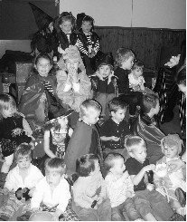

Halloween 2006

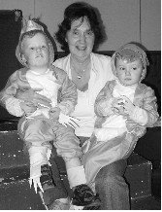

Samuel and Thomas, Halloween costume competition winners from 2005 did it again in 2006 thanks to Grannys handy work

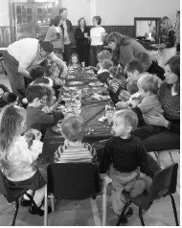

Christmas party 2006 – Goodies to eat

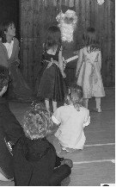

Christmas 2006 – and finally Santa arrives

Now comes the sad bit. After a lot of thought Susan and I have decided it is now time to bow out gracefully. With schooldays approaching we would like to pass over the reins of the east group to a fresh pair of hands (or more than one pair) to keep the group going. The venue we have used is not set in stone so anyone taking it on would be able to consider new premises for a new beginning. As things currently stand funds will cover the venue costs until the end of April.

We would both like to say a BIG thank you to all those families (around 70 at the last count) who have come along since we started whether on a regular basis or more infrequently, without you there would not be a group in the East. We are proud to have received a lot of positive feedback on the atmosphere at the group and we have certainly made some good friends. Phone calls from individuals as well as the Royal Infirmary of Edinburgh to check we are still around suggests there is still a real need for this group to continue. It would great to known that there would still be a group running locally that we can maybe pop into once in a while in the future.

If you would be interested in getting involved in keeping the East Lothian/East Edinburgh group going please please contact Susan or myself or come along to the next group meeting. We are sure you will find it as rewarding and fun as we have over the years.

Helen Nettleship (Mum to Samuel & Beth) - 0131 665 4321
Susan Sinclair (Mum to Jack and Amy & Lucy) – 0131 657 1550

South Queensferry bumps, baby and toddler group
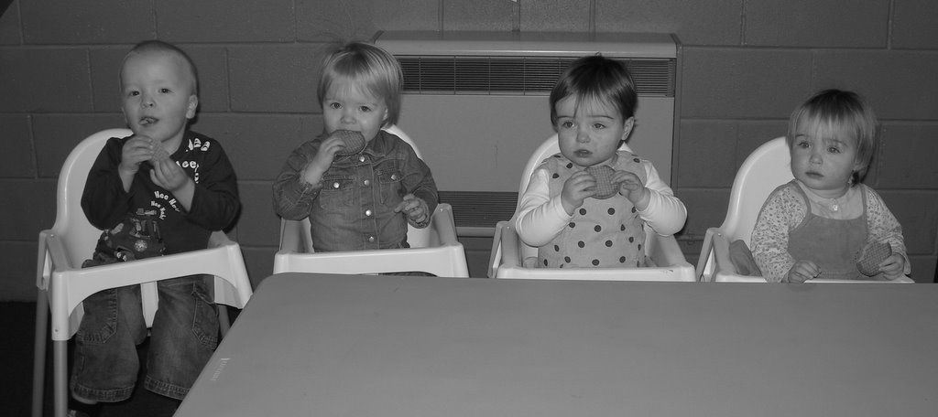
The Twins Club continues to meet weekly at the Scout Hut in South Queensferry on a Friday morning. We have about 8 families who attend regularly, ranging from sleepy young babies to energetic 3 & 4 year olds. A warm welcome awaits any other families who would like to join us, or if you are pregnant with twins, come along and find out more about us before your young family arrives. We meet in a very large hall where there are plenty of toys for all ages, and lots of space for your little ones to run off all that excess energy. We have recently purchased 4 high chairs to help make juice and biscuit time a little more controlled. These are being modelled here by (left to right) Ross, Ellen, Amy and Ellie.
We hope to see you soon.
Lesley (mum to Tamsin and Anna, 11 months) and Donna (mum to Niall and Owen, 2 years)
Daytime Activities

Bumps, Babies & Toddlers Group,
Thursdays 10am - 11.30am; £2 per member family/ £3.20 non-members (includes coffee).
Karin Ewing has kindly agreed to take over the Daytime Convenor role at Oxgangs & she can be contacted on 0131 446 0551.
Look forward to seeing you all there!

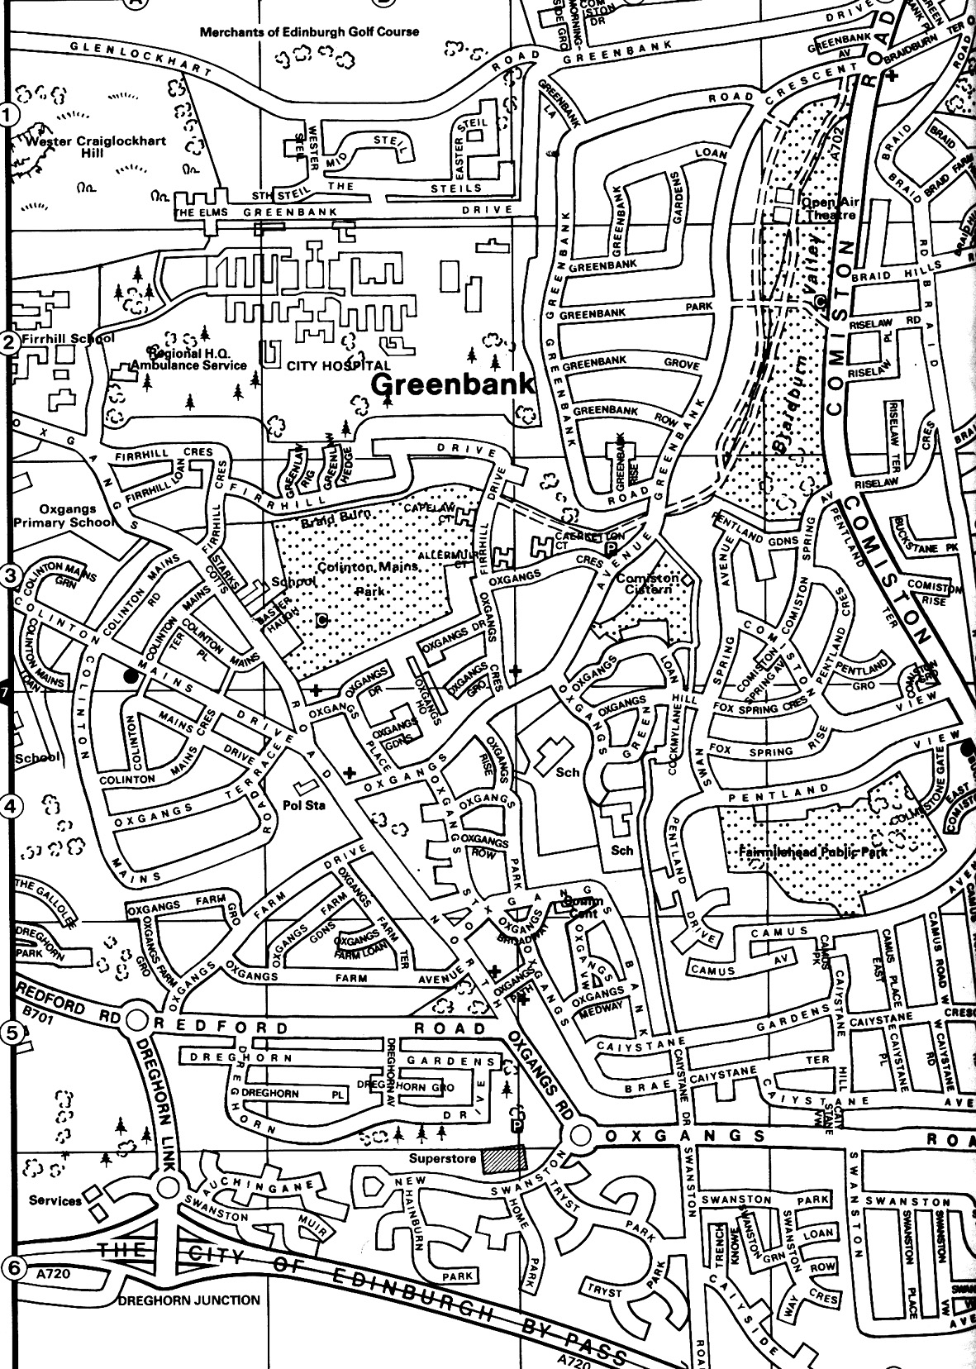

Note: The insurance we have for all daytime venues doesn’t cover children over five. You may want to bring older brothers and sisters during the holidays but that will, as they say, be “at the owner’s own risk”.

Library: The Twins Club has a number of books on multiples & children in general at Oxgangs. The books can be lent out during the sessions for a couple of weeks at a time.

East Edinburgh / EAST LOTHIAN
St Phillips Parish Church, Brunstane Rd North, Joppa
On the 1st and 3rd Monday of each month, 10am – 11.30am
Easy Parking, Coffee available

For more info please contact either
- Carol Frith (Health Visitor), Esk Medical Centre Tel: 653 0400 or
- Susan Sinclair (mum of twins) Tel: 657 1550 or
- Helen Nettleship (mum of twins)Tel: 665 4321

ALL HELP TO SET UP/TIDY AWAY TOYS WOULD BE APPRECIATED

South Queensferry Fridays 10-11.30am
Our new twins group for bumps, babies and toddlers has started at the fabulous sea-side location of Port Edgar Scouts Hall, South Queensferry. There is a separated area of soft mats filled with playgyms and toys to entertain the younger babies. The youngest babies we’ve had so far were 7 week old Andrew and Emily from Edinburgh. Parents of older twins have been great at helping out with the younger babies as they remember how hard it is to juggle changing one sibling’s nappy whilst keeping their twin amused. The rest of the hall is filled with larger toys, including a slide and a play kitchen, to keep energetic toddlers amused. Outside there’s a large grassy area which will be great for running around on during warmer days. Parents and carers can enjoy tea, coffee and a chat. Twin families have been coming from various locations in Edinburgh, West Lothian, Falkirk and Dunfermline. Feel free to be early or late, and we hope to see you there! For more information call Lesley 01506 840792 or Donna 01506 671699
Directions available at www.edinburghtwins.co.uk Quick version: Drive into South Queensferry, follow signs for Port Edgar Marina (directly under the Forth Road Bridge) and after you drive into the marina the Scout Hall is on the waterfront. Park in the car park and walk down (you’ll need a pushchair) or drive through the marina and park at the hall.

Adverts

Organised Mum – Calendars and diaries to help organise busy lives

A big thank you to everyone who supported the Edinburgh Twins Club by buying the Organised Mum calendars and diaries (we got to keep 40% of all proceeds from the sales of the Organised Mum products!) - so far we have raised £91.84! However, we still have five Life Books left at a sale price of £5.00 (including 288 stickers!), perfect for currently un-organised mums! As these remaining five Life Books have been gifted to us by Organised Mum, we could raise a further £25.00 for the Edinburgh Twins Club! To place an order, please contact Kirstin Evans on 0131 333 2332, kirstinevans@hotmail.com or send a cheque payable to Edinburgh Twins Club to 32 Buie Rigg Kirkliston EH29 9FE.


POST NATAL
DOULA SUPPORT

Helping a mother to have the space, time and confidence to more fully enjoy early motherhood. Mother to Mother provides support in the early postnatal weeks. For more information please go to www.mothertomother.co.uk or call Clare on 0131 445 4445

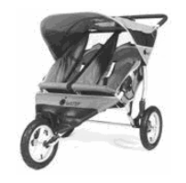
FREE use for members

Thanks to a West Lothian grant, the Twins
Club purchased an all-terrain ‘running’ buggy,
Similar to the one pictured.

Anyone interested in using it should phone Jenny Love on 445-3403.

Swap Shop – Items for Sale

Please note that the Edinburgh Twins Club cannot be held responsible for any purchase made through the Swap Shop or Wanted section. Each deal is entered into privately between the two parties involved (i.e. the seller and the buyer).
You can advertise as often as you wish, but you must notify The Editor each time you wish to advertise again. Please send all items you wish to advertise to:

Kairsty Ashworth: 14 Birrell Gardens, Murieston, Livingston EH54 9LF
e-mail: Kairsty@Craiksland.freeserve.co.uk
Tel: 01506 409984

Items for Sale  1 Easy to Nurse breast feeding cushion. Made of firm foam with detachable washable cover. 2nd cover included. Great condition. £25.00  2 Mama and Pappas baby rocker chairs. Vibrate and musical features. Lemon and turquoise colour covers that are washable. Great condition £25 for the two.  2 Mama and Pappas musical mobiles for over cots. Great condition. £10 for both.  2 Maws baby alarms – Hardly used. Boxed as new. £30 for both.  1 Tomy Baby Link monitor – Hardly used. Boxed as new. £10.00  2 First safety bath safety seats. Great condition. £8 for both  2 Maxi Cosi rear facing car seats (suitable for babies up to 9kgs). Good condition. Never been knocked or in accident. Full instructions. £40.00 for both  1 Mothercare Playnest activity ring. Inflatable “donut” design. Suitable from birth, ideal for those learning to sit up unaided. Perfect condition. £10.00  1 Winne the Pooh soft play activity set for baby. Good condition. £5  2 change mats. Perfect condition. Free!  For any of the above items contact Miriam Newton Phone 0131 476 1394  ----------------------------------------------------------------  2 x mamas and papas Catalina cot/bed. Mattress noti ncluded. Great condition £25 each.  Contact emma.vickerstaff@btinternet.com | Mothercare 'Snuggled Up' Moses basket with bedding, used for 5 months. £15.  2 Mamas & Papas rocking moses basket / carry cot stand, natural wood color. (Cost £28 each new) £15 each.  2 Britax 'Cosy Tot' car seats suitable from birth to 13kg. Never been in an accident. (Cost £95 each new) £20 each.  2 Safety 1st baby rockers, with optional battery powered vibration, from birth to sitting up. £10 each.  Safety 1st 2-in-1 'Discovery Farm' activity centre, Stage 1: 4mths to walking, Stage 2: walking to 4 years. £20.  Tippi Toes door bouncer suitable up to 12kgs. £10.  Lindam door bouncer suitable up to 12kgs. £10.  Floaties swim seat, 3mths to 12 mths. £5.  For any of the above items contact Claire Burrell email: claireburrell@bigfoot.com  Phone 0131 664 0971  The total cost of the items above is £150, but I would be willing to sell everything for £120.  ----------------------------------------------------------------  Britax duo isofix car seat (x1) Suitable for 9kg to 18 kg (about 9 months to 4 years). Black and greyish blue, removable, washable cover. Comes with full set of instructions. Can also be used in non-Isofix cars. In nearly new condition Cost £190 new - sell for £75 ono  Contact Kirstin Evans 0131 333 2332
Items for Sale continued  MACLAREN TWIN TRAVELLER Black and red, removable, washable seat covers. Adjustable seat positions, suitable from birth. Lockable swivel wheels. Comes with five-point harness, hoods (with zipped storage pockets), raincover, basket, foot muffs, head huggers, bottle holder and full set of instructions. Barely used. Cost £220 new - sell for £120 ono  Contact Kirstin Evans 0131 333 2332  ----------------------------------------------------------------  Chicco Caddy Single Buggy. Lightweight. Lockable, swivel wheels. Hood and waterproof cover. Carry bag. £50 new. Barely used.  £20 ono.  Urban Detour Twin Three Wheeler. Original lighter weight model. Rain cover. Two cosy toes. Good condition.  £50 ono  2 Britax clip on car seat trays. Navy blue. Fit eclipse and similar.  £5 each ono  ELC dolls house. Chalet style with red roof. Furniture included.  £30 ono  Buggy Connectors. Join 2 similar single buggies together. Great for holidays. Used with 2 umbrella folds it’s just like a twin buggy. £10 ono  For any of the above items contact Catriona Hepburn: 0131 343 3133  ----------------------------------------------------------------  Urban Detour Double Buggy -£150.00 Great condition lockable, front swivel wheel multi position seats hood with viewing window 2 cosy toes  Raincover basket at bottom  2 Pine Cot Beds £120.00 for both great condition  two position mattress base height panelled ends  One white door/stair gate £5.00  2 x Britax Eclipse Car Seats 40.00 each or two for 75.00 Car seat suitable from 9kg/20lbs to 18kg/40lbs (approx. 9mths to 4yrs). Baby/child faces forwards in a seat with an integral harness secured in a car by an adult seat belt. Optimum side impact protection with softly padded side wings. 5 reclining seat positions. Chest and buckle pads 5 point, 1 pull harness . Removable washable cover  For any of the above items contact Jenny Love Phone 0131 445-3403 | 2 pine cot beds, both in excellent condition, 2 positions for the mattresses height, £50 each.  Early Learning Centre 'Happyland' trainset £10, and Safari Park £25. All clean and in excellent condition.  'Ora' twin pram/buggy, suitable for newborns or newborns and toddler, lies completely flat with mattress or with separately adjustable seats. Faces forwards or backwards, good suspension, able to go over rough terrain, includes, pram, raincover, cosytoes and sunshade. Cost £460, will sell for £150.  2 x McLaren Quest buggies in good condition with raincovers £40 each or £75 for the two.  For any of the above items contact gerry.pennycook@blueyonder.co.uk  ----------------------------------------------------------------  2 x Britax 0+ Rock a Tot 0+ car seats, will attach to IsoFix bases, or can be used alone with seatbelts. Guaranteed NO ACCIDENTS. £25 each.  2 x Britax Iso Fix bases. £25 each.  Mothercare babyseat, navy & red check fabric, £5.  Blossom Farm Play Mat, £5.  Baby Swim seat, 3-12 month size, £5.  Baby Bjorn carrier, £5.  Lindam Day & Night Bottle Warmer, £15  Avent Microwave Steam Steriliser, £5  4 x Medela Haberman Feeders, brand new, still in sealed packets, as recommended by the Tracy Hogg, The Baby Whisperer, for breast fed babies. Cost £16.99 per feeder new, will sell for £10 per feeder.  For any of the above items contact Cara Chambers 0131 620 4644
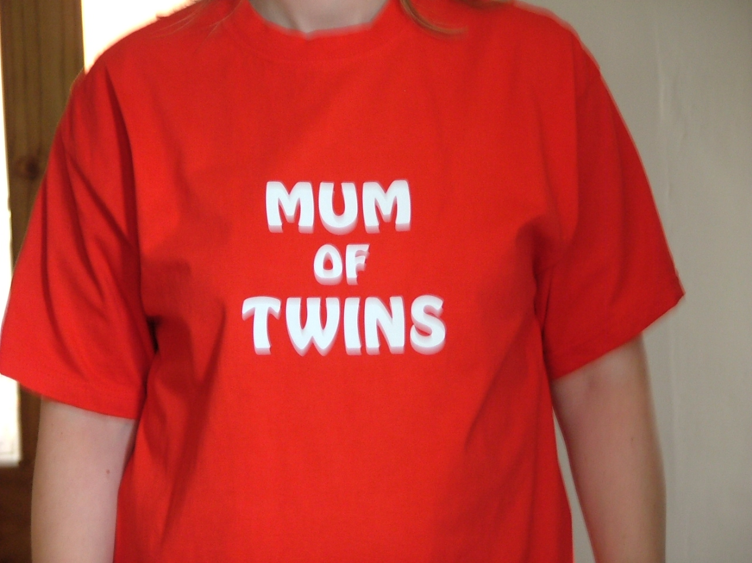
Discounts
We have been trying to negotiate with a number of retailers / clubs in order for Edinburgh Twins Club members to obtain discount. If you already use your card in other shops, please let us know for future Newsletters.
Blessings & Blossoms, 132 St Johns Road, Corstorphine, 0131 334 8322
10% Discount. Children’s Clothes shop.

CLARKS Shoe Shops
10% discount on production of Twins Club membership card (it does not have to be the TAMBA card). This will apply for all siblings shoes as well! This only applies to Edinburgh stores (Cameron Toll, Gyle, Princes St, Kinnaird Park & Musselburgh) but we have had a few problems with some of these stores accepting our card – please refer any member of staff to their Regional Manager, Nigel Merritt who has agreed this discount scheme countless times. Please do not try to obtain discount from any other store.

Doodles Ceramic Workshop
29 Marchmont Crescent, Edinburgh
10% discount for all visits. Includes evening visits when mums can enjoy some peace and quiet with friends.
15% discount for birthday parties booked in either July or August, either in the Doodles studio or with Doodles to Door (which brings all the fun of Doodles to your home or other venue). Subject to Availability. Call Holly on 0131 229 1399
Golden Hands Silver Feet
10% discount. Your little ones hands and feet captured in Bronze, Brass, Aluminium or Stone.......FOREVER - a unique memento or gift. For more info & prices please see www.goldenhands.co.uk or phone Nicky Summer on 0131 665 8628
Jelly Club
10B Kings Haugh, Peffermill Road, Edinburgh. 15% Discount on production of Membership card

Lorac Carpet Services
10% Discount. Professional carpet and upholstery cleaning, general repairs, odour treatment, specialised re-tufting, specialised Oriental rug cleaning. For free advice/estimates contact: Phone 0131 468 0996; Mobile 0775 159 4900; email info@loracservices.co.uk
Nightbridge Designs
15% off custom made soft furnishings, bedding & curtains. Contact: Debbie on 01506 431515
Truly Scrumptious Designer Cakes
10% Discount. Simple cakes to intricate designs. Look fantastic and taste great too! Tel: 01506 671133
Rocking Horses
10% discount. If anyone would like to see/ride a large mahogany horse (called Rocky!!), please contact Gill Petrie on 0131 443 2919.
Contact: Jim McAuley, 73 Manse Street, Saltcoats, KA21 5AA. Tel: 01294 466415

Wendy Beardmore, Freelance Public Relations
15% DISCOUNT
As a member of the twins club, I have recently started out doing freelance PR and Marketing, using my maiden name Wendy Robbins. I am mainly helping small businesses and start ups to develop their marketing. If you have your own business and need some help growing this, or indeed if you know someone else in this situation then give me a call.
Call Wendy on 0131 334 9591 or 07771 966 488.
Little Beau Peep 79 High Street Linlithgow 01506 848196
10% off childrenswear for twins club members.
Shoos (Start-Rite shoes stockist) - 8 Teviot Place, Edinburgh. Tel 0131 220 4626.
10% discount for twins. [Very good service - and Start Rite are great for children with narrow feet as well as "normal" fittings.]

Snippets

I saw a young mother
With eyes full of laughter
And two little shadows
Came following after

Wherever she moved
They were always right there
Holding onto her skirts
Hanging onto her chair
Before her, behind her
An adhesive pair

“Don’t you ever get weary
As day after day
Your two little tagalongs
Get in your way?”

She smiled as she shook
Her pretty young head
And I’ll always remember
The words that she said:

“It’s good to have shadows
That run when you run
That laugh when you’re happy
And hum when you hum
For you only have shadows
When your life’s filled with sun.”

This was forwarded to us by Denise Aitken (twins age 9)

Media Request - TAMBA have received the following media request. Multiple Birth families required for Supernanny. Filming will take place during 2 week periods in April and May. If you are interested please contact: Jude Martin Ricochet Tel: 01273 224800 jude.martin@richochet.co.uk. This media approach has been checked by Tamba.

Are you a twin?
Anna Halliday is a mature student at Napier doing a postgraduate diploma in career guidance. She is doing some reseach into the career paths of twins. The twins she would have to interview would have to be in the world of work, or continuing education, but in their 20s at least, and probably a variety of ages. If you are a twin or know twins who would be willing to particpate then please contact Anna Halliday at Johnandanna@hallidayfamily.fsnet.co.uk

TAMBA
The Edinburgh Twins Club is affiliated to TAMBA (Twins and Multiple Births Association). Membership is separate however. For details of the benefits of TAMBA membership, visit www.tamba.org.uk
or telephone 0870 770 3305
Newsletter
Articles for the April 2007 issue to:

Kairsty Ashworth
14 Birrell Gardens
Murieston
Livingston EH54 9LF
Kairsty@Craiksland.freeserve.co.uk

by 23rd March

Social Calendar

Gym Tots  Saturday 24th February, 2-4pm | Gym Tots, The Loan, South Queensferry (next to Scotmid) on Saturday 24th February 2007 from 2-4pm  Soft Play, with three play areas suitable from 0-10 years, followed by 'party food' in one of the party rooms, hired for the use of the Edinburgh Twins Club.  £7 per child (£3 per child if under 18 months)  (we need to have a minimum of 8 children over 18 months, in order to confirm the booking), please pay on booking
Mum’s Night Out    Friday 23rd March, 8pm | Mum’s Meal out  Time 4 Thai Restaurant  45 North Castle Street  Edinburgh  Tel:01312258822  Cost: £23.85 for 3 course meal
Infectious Grooves    Friday 27th April, 10am | Come and release the rhythm at our Infectious Grooves Workshop at the Scout Hall, Port Edgar Marina, South Queensferry (the venue for our Friday morning Bumps, Babies and Toddler Group). The workshop uses percussion instruments to enhance the learning and play of children. For further details see www.infectiousgrooves.co.uk  £10.00 per family, under 2s £2.00 per family, including refreshments, please pay on booking

Contact Kirstin Evans at 0131 333 2332 or alternatively e-mail kirstinevans@hotmail.com for any further information.

