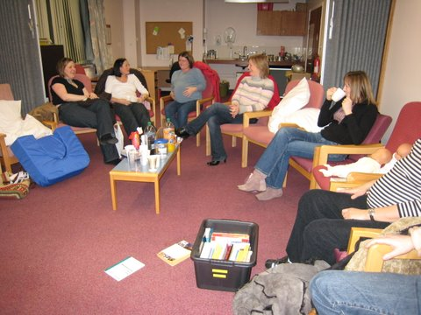
First Year’s Support Group

First Wednesday of each month, 8pm, Parentcraft room, St John’s Hospital, Livingston

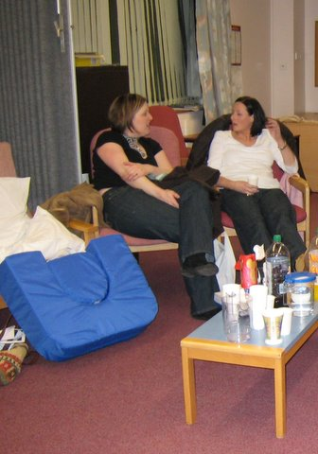
Would you like to talk to someone who’s expecting twins, or who already has them and has some ideas? If so the first year’s support group is for you. This is for pregnant parents and those in their first year of raising multiples. We have speakers, but also time to chat.

It’s a great time to pass on some tips, and hopefully pick some up along the way, as well ask questions of parents whose older twins are tucked up in bed at home and therefore able to concentrate! Bring your babies if you like - its always fun to see them and fabulous for the pregnant parents.

Topics include:
Birth Experiences
Feeding (including breast / bottle, weaning, feeding families)
Mummy-time – idea exchange
Signing with babies
Immunisations etc
Play
Free discussion
Holidays
Multiple-proofing
Baby-soothing tips

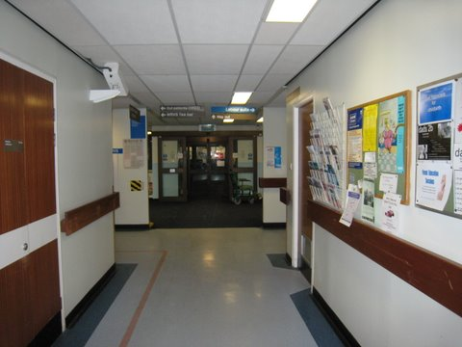
We meet on the first Wednesday of each month at St John's hospital (Livingston) in the parentcraft room. Just go in the maternity entrance, walk past the double doors to the left into labour and delivery, and the room is on your left straight away.

