edinburgh twins club

Edinburgh Twins Club
Newsletter

July 2005

Hello and welcome to the July edition of our Newsletter!

Some exciting things to and to tell you about …Including our Nearly New Sale which was a great success. Special thanks to Catriona Hepburn and all the committee who helped to ensure it all went so smoothly. Also the proposed twinning of our Club with one in Le Mans, France - see page 8 for details of how you can get involved. We are also appealing to you the members to become involved with the committee from January 06; we need some of you to come forward as many of the present committee members will be leaving at the end of this year, myself included. Please read the feature telling you more about what is involved and what fun it is. There is plenty of time to chat it over with us now as the AGM does not happen until January 2006 but it would be great to talk to some of you before then.

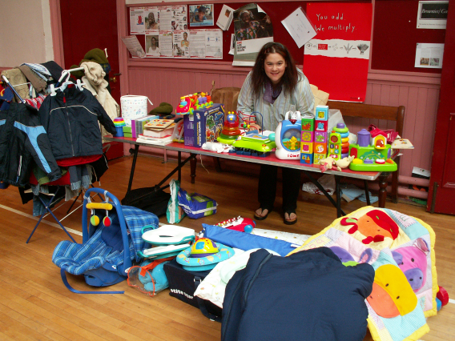
We have for the last time been able to get away for our summer holiday out with the school holidays and save ourselves a fortune. We are back form a very relaxing and warm trip to Belgium at Centre Parcs: a small one particularly good for parents with younger children, a Centre Parcs original called Erperheide. I would highly recommend it, much more chilled we felt than the ones here in Britain and also less expensive, better food and much better weather! But still lots of great fun things for the children to do. We got to read books and relax with a drink often, safe in the knowledge they were playing or making something. In fact we have come home with 2 mouse mats, 2 photo holders and 2 snow scenes, all of them featuring sponge bob square pants! It would be great to hear from you all about your holiday experiences and recommendations as it is always nice to have a personal recommendation so please do something for us to share even if it’s just a few lines and a website address. Campsites and short break recommendations would also be really helpful and perhaps we could make it a regular feature. Also places to eat out and go for trip locally would be a very welcome theme. Just let Vicki Jarrett have your thoughts and ideas. Enjoy the summer!
Vicky Petrie
Chairperson
339-0135
The calm before the storm – our Chairperson prepares for the rush at our Nearly New Sale
victoria@lesterpetrie.freeserve.co.uk
 | Membership Update  Welcoming the newest members of ETC | 2 |  | Flying with Twins  Ideas from TAMBA to take the stress out of flying with multiples | 14
 | Nearly New Sale  News and pics from the twins club sale in June. | 3 |  | Daytime Activities  Times, venues, directions, news. Pay us a visit! | 16
 | Twin books for twins  Some multiple literature to share with your brood | 4 |  | Discounts  Everyone’s favourite perk – which shops and how much | 17
 | Volunteer for fun  What’s in it for you? The current committee spills the beans. | 6 |  | Snippets  Bite sized chunks of news, information and trivia | 18
 | Join the Twins Alliance  A Twin dimension to the historic Scots/French alliance | 8 |  | Swap Shop  For sale + wanted, everything from buggies to nannies | 19
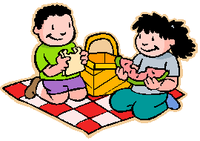 | Top days out with twins  Family friendly venues for shopping and day trips | 12 |  | Social Calendar  Something for everyone! Forms back by 15th August please. | 20
Membership Update

Dear Members
Some of our new members have had their babies since we last wrote, CONGRATULATIONS to:
- Tess and Michael Joyce, and their three baby girls. Triplets Erin, Elizabeth and Norah arrived safely on 10 June, and all are doing very well;
- Miriam and David Newton, on the safe but early arrival of their little girls, Ellie and Amy, born on 17 May at 32 weeks, all doing great;
- Sarah and Clive Docwra who are proud parents of Georgina and Charlotte, who arrived early on 2 June, and all are well; and to
- Susan and John Douglas, proud parents of little Mairin and Frederick (Freddy), who arrived safely on 14 May and all are well.
Well done and many congratulations to all our new arrivals!
We have the following families who have joined the Club since the last newsletter – WELCOME to:
- Fiona and Tim Shaw, who have twins Phoebe and James, born in August 2004;
- Rachael and Matthew Round, who have twins Cameron and Heather, who will be three this month, and a little boy Alasdair who was born in March this year;
- Emma and Graeme Easton, and twins Keira and Rory who arrived in March this year;
- Michele and Simon Justice, who have a little girl, Pippa, who will be six this October, and twins Charlie and Alec born in March 2004;
- Lesley and Alastair Black, who have Caitlin and Melissa who will be two this month;
- Helen and Daniel Harris, parents to Benjamin and Charlotte, born in September last year;
- Helen and Dave Massie, who are expecting twins this October, siblings of Ewan who has just turned six ;
- Alexandra and Darren Roberts, who have twins Milan and Tatjana, born in July last year; and to
- Zillah and James Simpson, who have just moved to Avonbridge near Falkirk with Carrick and Drystan, born in March last year. Welcome to the Club and to Scotland!
Our membership list currently consists of 125 families.
ARE YOU LEAVING…We would be really grateful to hear from you should you not wish to continue your membership of the Club. It would be interesting for us to know why you don’t want to continue membership, bearing in mind we are aware that there is perhaps less need for support as the children get older. Also, hearing from you would greatly assist our admin hence a quick call or e-mail would be very much appreciated!

IF THERE IS A MEMBERSHIP FORM WITH THIS NEWSLETTER…your membership is either due or overdue for renewal. Please complete the form and send it with your cheque to Gillian Smith by late August 2005.

PLEASE LET US KNOW YOUR BABY NEWS… Please do not forget to call Karen or Gillian and let us know news of your arrivals – this really will help us come Newsletter time. If we have missed the birth of your babies, or you are a new member and we have missed you from our list, please let us know so that we can add you to our next newsletter.

LAST BUT NOT LEAST…Gillian and I will be resigning from the Committee in six months or so after two years ‘service’ (!) and we would be delighted to hear from you if you would like more information about becoming the next Membership Secretary (or Secretaries). Please read a little bit more about how Gillian and I got involved later within this newsletter.

Best wishes,

Karen, Membership Secretary

Karen Winfield  23 Bluebell Glade  Adambrae Parks  LIVINGSTON EH54 9JJ   +44 (0) 1506-416 412  Karen@the-winfields.com | Gillian Smith  22 Braid Avenue  Morningside  EDINBURGH EH10 6EE   +44 (0) 131-447 3000  Gillian@bitts22.freeserve.co.uk
Please note that we will include you on our membership page within the Newsletter unless we hear otherwise by telephone, e-mail or by your indication on your Application Form when you join.


The Nearly New Sale on 11th June turned out to be a fantastic success for the Club. Held in St Stephen’s church hall in Stockbridge, it was a great way to raise the profile of the club, as well as a chance for members to clear their attics out and make a bit of money into the bargain. A wonderfully colourful banner was produced for us, largely by the artistic endeavours of the Robertson triplets – thanks girls! All of us sellers were nervous setting up before the doors opened – would enough people turn up or would we be faced with carting all our stuff back to the car and, most horrible to contemplate, shoving it all back under the stairs and in the attic? Would the NCT sale happening on the same day mean no one would come to ours? Would the emotional wrench of parting with the baby stuff cause us to burst into tears at inappropriate moments? In the event, the sale went very well and the two hours were very busy. Most sellers did rather well out of the day, and although some were luckier than others, all considered it worth the effort. We received a lot of positive feedback from the public on the quality, range and price of the goods on sale. There was also more than one enquiry as to when the next sale would be! The current committee feels this would be a fantastic new tradition for the club to carry forward. It’s up to you new committee members to build on this if you feel the same!

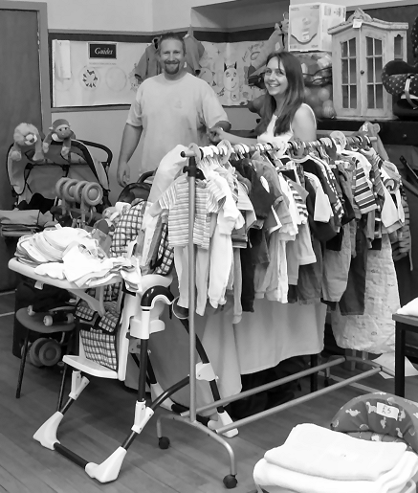
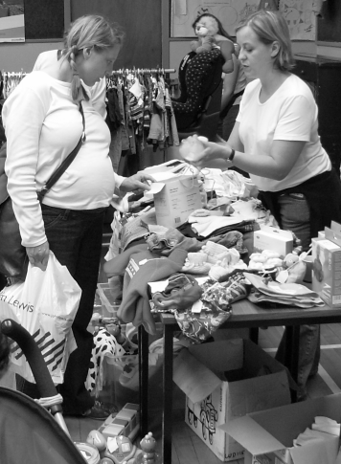
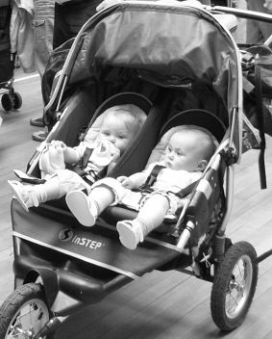

The Whyte twins browse for bargains

Yes, we WILL sell all this stuff!
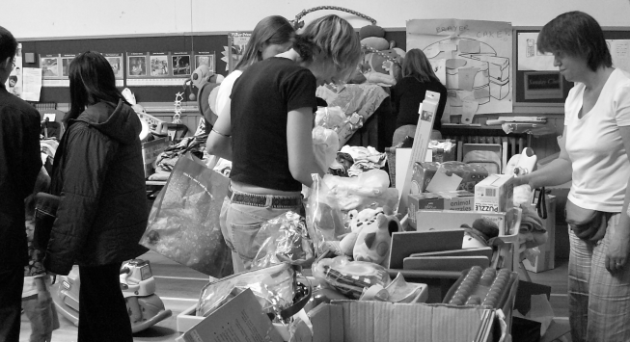
Some last minute shopping

Enormous thanks to all of you who took part and helped make a success of the day: sellers, buyers, browsers, spouses, friends and relatives – including the hard working doormen and tea/coffee/biscuit brigade. Special mention to David Hepburn and Mike Chung for first class canvassing. Thanks!!!
How on earth did we ever get all this stuff in the hall cupboard anyway?

Books about Twins, for Twins

The Twins Club has an extensive collection of books about multiple pregnancy, multiple childbirth, breastfeeding multiples, raising multiples which is kept at Oxgangs and is available to members for borrow. …But what about books for the twins themselves? Those of you with young babies will no doubt already have been told of the benefits of reading with your babies – it’s never too early they say. My two have always enjoyed books and I began wondering whether there were any books for them that featured twins – as I started looking, I discovered that twins are, if anything, over represented in literature, kids’ books being no exception. People have a fascination with twins and, especially identical twins present writers with lots of possibilities for plot twists – unfortunately this results in an awful lot of ‘good twin/evil twin’ type stories, …not exactly a stereotype either twins or their parents are likely to find terribly appealing! So where can our budding bookworms find positive representations of twins with which to identify? Spoilt for choice really… I hope you and your children find something to enjoy together from this list. Thanks to all who helped compile it.

Bill and Ben
Thomas and Friends. My Thomas Story Library.
Based on The Railway Series by Rev.W.Awdry


These little books are good fun and nice and cheap. My boys love to collect them. Thomas and friends has stories about 2 sets of twins: Donald and Douglas, the Scottish twins, and here Bill and Ben, identical twins who are always together. The story is fairly basic as most of The Thomas ones are. Bill and Ben work at the quarry and they find it very boring but one day when rocks start to fall on to the railway line the two of them help save many workmen by helping them escape quickly, showing how kind they are. Ben gets a special mention for waiting for a man who was nearly left behind. In the end the Fat Controller calls them Heroes and they are delighted!
The Same Only Different

Joan Lingard
www.glowwormbooks.co.uk


A beautifully illustrated book about identical twin girls with an emphasis on their differences. Lovely rhyming text suitable for toddlers and older children. Would appeal to any twins but perhaps more to girls than boys.

The Biggest Bed in the World
Lindsay Camp, Jonathan Langley (Illustrator)


Ben's dad wasn't getting much sleep. There were too many children in his bed. Not just Ben, but also his baby brother Billy. And then the twins, Beth and Bart, arrived. There was only one thing for it...Ben's dad fetched his tools, and set to work building the biggest bed in the world. At last he had enough room to sleep comfortably, even after the triplets, Briony, Bella and Boris were born. But, unfortunately for Ben's dad, he still had a problem. The biggest bed in the world was also the heaviest bed in the world and one night, in the middle of the night, it began to move...

The Twinnies
Eve Bunting
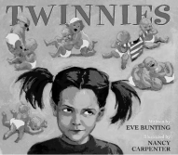
A good one for twins and older siblings. A girl gradually becomes reconciled to the new additions to the family. Each child can think the book is about them!
Twin to Twin
Margaret O'Hair, Thierry Courtin (Illustrator)

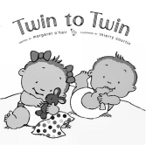
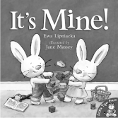

This is a review from Booklist.
A bouncy text and appealing cartoon artwork provide a light hearted glimpse at the busy lives of a brother-and-sister duo. "Double born./Twice the blessing./Double kids./Twice the messing." As buoyant as the staccato rhymes that describe them, the siblings are soon on the move, learning to walk and talk and encountering a range of experiences that will be familiar territory for most preschoolers. It's twice the fun, as they play with toys, enjoy time spent outdoors, eat a meal, and share a bath. At bedtime, after being tucked in by their smiling parents, the youngsters close their eyes, "Double tired/from all their play./Double dreams/for their next day." The colourful digital illustrations echo the breezy tone of the text. The layout is uncluttered and the action is set against clean pastel and white backgrounds.

The Topsy and Tim series
Jean and Gareth Adamson. Ladybird

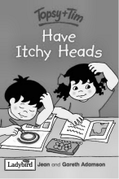
This series has been drastically modernised from our childhood and is now available in a very handy ladybird hardback version ideal for popping in a bag to take out and about. They are obviously non-identical twins who get to do the more basic things, go to the doctor/dentist/park/have a Birthday party etc as well as some slightly older themes, meet the police – personal safety, meet the fire fighters – fire safety, etc. My favourite has to be Topsy and Tim have itchy heads – all you ever needed to know about head lice! They retail at £2.50 in the bookshops but as hardbacks are often in good condition at charity shops and sales.
Little Miss Twins
Roger Hargreaves. World international ltd.

These identical female twins from the Mr Men creator live in a crazy world called Twoland that shows how odd life would be if everything came in twos. Popular again because of its small size making it very portable

It’s Mine
Ewa Lipniacka. Little Tiger press/ The Book People

A large format picture book about Georgie and Jack non-identical twin rabbits who are learning the hard lessons of sharing and being quite cheeky. They end up both catching chicken pox and realising that the most important thing that they have to share is Mummy. This book had very tough pages which meant it survived the rigors of being a favourite bedtime book.

Twins, Two by Two
Catherine Anholt, Laurence Anholt

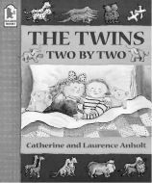
When twins Minnie and Max are read a story about the pairs of animals in Noah's Ark, it gives them an idea for a lively bedtime game. On the stairs, they're tigers; in the bathroom, they splash like crocodiles. But when Dad tucks them up, they curl up like two little mice and fall fast asleep.

.

 Volunteer for fun

The Twins Club needs members to step forward and lend a hand in running the club.

We are all busy these days, rushing from pillar to post to fulfil the demands placed on our time and energy. However, helping run the club takes surprisingly little time and can be very rewarding. Every single member of the current committee had doubts about their ability to find time for anything else, but it’s amazing what can be fitted into a moment here and there. Sadly, there is a very real danger that when the current committee steps down at the end of the year, there will be no one to take their places. Should this happen, the Twins Club will simply cease to exist, leaving current and future families with multiples in Edinburgh without what many of us have found to be a unique source of support and information. Without volunteers the Club cannot survive. So, please, read what the current committee have to say about their experience and consider whether you could help out in future.

Vicky Petrie, Chair. Mum to Ben and Lewis, aged 4.

It certainly has been one of the most enjoyable and sociable voluntary jobs I have ever had. I started as a novice, helping on the committee as a membership person 4 years ago when my twin boys were just very small babies - this job was great as for me it meant I was communicating with people and providing information while being able to fit it in with being a new mum and working part-time. It was for me a way to get to know people in the same position as me and also contribute something back to a club that I felt so grateful to have found as a means of friendship and support. I spent 2 years helping here and then took on the co-responsibility with Jenifer Robertson of social organiser - this was fantastic as it meant going along to many nights out and new daytime activities with my children, perfect! This is my last year in the committee as my boys are now reaching school age and I am honoured to be The Chair Person, mostly because we have a fantastic committee. This job is fun and sociable and I really will miss it but I urge you mums and dads out there to get involved and form the next generation of parents who will keep us alive and going form strength to strength. Please call me for a chat if you want to find out more, I love to hear from you.

Jenifer Robertson, Vice Chair Person. Mum to triplets Eilidh, Lauren and Jema, aged 5.
This is my second year on the committee with my first post being ‘Social’ and I have enjoyed both positions which are obviously completely different. It has been great fun being a committee member, I have made many good friends who have helped me enormously and tried to keep me sane - raising our triplet daughters has not been easy as all of you with multiples will I am sure agree. Being a committee member gives you the chance to voice your opinions as to the way the club is run and we are all able to bounce ideas off each other. It has been great to feel you are really contributing something to the club, as opposed to just attending the children’s and adults activities (obviously being play for the children and eating and drinking for us adults!). This will be my last year on the committee as our girls will be starting school this August and another chapter in our lives will unfold and what it holds who knows! I intend to still be a member of the club for some years to come and will try to write articles for the much loved newsletter so watch this space…

Karen Winfield, Membership Secretary. Mum to Fraser and Mhairi, aged 4.
I heard of the Edinburgh Twins Club through my midwife. A friend introduced me to Gillian Smith (who had just joined the Club), as we were both expecting twins on the same day! Later I was introduced to some of the friends she had made at the Oxgangs meetings. I felt very privileged, as I had not attended a single Club meeting (nor have I to this day!). I met the then Chair of the Club, Sue Cook, who encouraged me to join the committee. After swithering, and wondering if I could be of any use, I spoke to Gillian and we decided that together we would have a bash at membership, and Mel Lawrie (who had been Membership Secretary for two years) helped us get to grips with it. Initially, I was hesitant to put myself forward for the committee. I wasn’t sure how much time I might have. I fit in the admin as and when I can manage, but this really is a role that I can adapt to my spare time. Also, the Club’s families are very patient, understanding and do appreciate that the committee posts are all voluntary. They also know that a multiple mum’s time is precious, and my fellow committee members are supportive of each other too as we all have similar time constraints. Currently, I administer the database on the PC (using Excel) and produce a quarterly report and Gillian deals with the quarterly renewals. Otherwise, our tasks are the same. Jointly we promote the Club at every opportunity (normally by accosting double buggy pushers!). The roles are flexible and can easily be adapted between two or three people to suit. We have enjoyed seeing membership evolve: we now use e-mail and have updated older documents; it has also been great to incorporate the Club’s new logo. I would definitely recommend joining the committee – I have really enjoyed the last eighteen months –it provides the chance to lend support. I can well remember the days when I needed it myself, and still do! It has been a very rewarding time and it has been great to be involved at the heart of the Club. I have met many friends and my children have too. If your work, or other commitments do not allow you to get to Oxgangs, don’t worry, as being a non-attendee is not prohibitive to joining in.

Gillian Smith, Membership Secretary, Mum to Tara and Declan, aged 4.

I became involved in the Twins Club 5 years ago when I discovered I was expecting twins. I went along to Oxgangs, was made to feel very welcome and became friendly with both mums of older twins and expectant mums. I have acquired a whole new circle of friends for both myself and my children which has been invaluable to me. We attended Tuesday afternoons at Oxgangs pretty consistently, joined in the fun on nights out and brought along the children for the many social events. I have got a lot out of the Twins Club since I joined, and I am a firm believer in giving something back. To this end, I was encouraged by the existing committee to join in and so I help out on membership. I have been helping out for 2 years now – time has flown by! Being involved in the membership role is ideal if you are of an inquisitive disposition. You get to know who is already a member, encourage them to stay a member and when you see mums in shops pushing buggies with twins, you can be forgiven for thinking you have a licence to approach and interrogate until they agree to join. All that is involved is sending out of Welcome Packs to our new members, fixing them up with suitable contacts to give our new members a network, sending out membership cards to renewing members and attending the occasional committee meeting. Admittedly I am assisting one of my bestest friends (we were due our twins on the same day) in the membership role, however, it has been a great way to be involved on the committee without it being too onerous or demanding. I would recommend it to any nosey parkers out there!

Jenny Love, Daytime Convenor. Mum to Olivia and Michael, aged 2.

I started attending the twins club when Olivia and Michael were only 6 weeks old. I found it to be a great place to meet people and get advice from parents who had been through the same. I was approached at the end of December last year to join the committee as the Daytime Convenor and jumped at the chance to give something back. I started in January and have found it to be a great way of meeting new parents and offering them advice or passing them to people I knew could help. I have also made good friends with the other committee mums. I attend on a Thursday and occasional Tuesday, collect the money and welcome new attendees. It is a great position and does not involve too much time. I am staying on the committee for another year but would like the chance to change positions. Hopefully one of you Thursday mums could take over.

Sarah Warwick, Social Organiser. Mum to Heather and Beth, aged 3.

I’m currently one of the social events organisers, usually a shared post. I enjoyed doing this job 2 years ago and was happy to do it again but this is my last year so we are looking for some new help. Every 4 months the committee come up with suggestions for child/family/parent events and it is our job to do a bit of research, usually involving making some daytime phone calls in order to get things organised. Once the magazine is out twice a year I receive the social return forms, send the cheques to the treasurer and then confirm the numbers with the venues, and deal with last minute queries. The committee as a whole does a lot to support this position and it is very much a team effort. I have enjoyed seeing both my girls and other families at events that we might otherwise have not got round to if it hadn’t been for the twins so please if you have some time and would enjoy working together with some like minded mums/dads talk to someone on the committee and join in the fun.

Catriona Hepburn, Social Organiser. Mum to Molly and Katie, aged 3.
I am the least likely person to become involved in a committee so if I can do it (and enjoy it!) anyone can. I first got involved by unwittingly attending the AGM in 2003 when Katie and Molly were almost two. We had attended Oxgangs and several social things and I wanted to see how the club was run. Never did I imagine that I would leave that meeting as newsletter editor! It wasn’t really my forte but I managed a couple of newsletters before my PC expired and Vicki stepped in. At the next AGM I became joint social organiser with Sarah. It’s a great position because you get to choose where to go for days/nights out etc. It fits in well with the girls too because most of it can be done in the evening. The thing that has surprised me most is that before I joined the committee I thought I had no spare time and yet I’ve managed to fit it in. Although it really is to do with the girls it is also something that I get a lot out of. It is a great way to get to know other people in the club better and the rest of the committee are supportive, friendly and above all good company. I would recommend it to anyone…hey…at least it gets you out of the house!!

Avril Ferrari, Treasurer, Mum to Eden, aged 5 and Haydon and Finlay, aged 3.

This is my second Treasurer post. My first was for
my local mother and toddlers. I had never
been on a committee prior to that so was a bit
unsure. However, I ended up thoroughly
enjoying it - lots of socialising and not too much
work!! Hence, when the Twins Club was
looking for a new Treasuer I was happy to
volunteer. I should however emphasise that no prior knowledge/exerience is required to do the role of Twin Club Treasurer. The post itself doesn't take up too much time. There is a small steady stream of cheques to be written and banked and a spreadsheet to be maintained. The committee meetings are fun, relaxed and informal. My circumstances have dictated that I've not been been able to take on much more than the immediate Treasurer duties - however there are plenty of opportunities to get involved in other things if you like. After 2 years I will be standing down as Treasurer. I'm glad I've done it. I've learned a lot from the other committee members, met some lovely people and gone along to a lot more events than I otherwise would have done. If you've got a bit of spare time, it's worth getting involved.

Vicki Jarrett, Newsletter Editor, Mum to Andrew and Heather, aged 4.

When the fog of sleep-deprivation cleared enough for me to realise that the club I’d joined when my twins were around a year old was actually run by a committee of volunteers, I wondered what kind of people could find the time. It struck me as an impossible contradiction – as a working mother with young twins, I felt I was lucky to find time to wash my own hair, never mind help run a club. And I never really meant to join, it just sort of happened. I was a regular attendee at Oxgangs Tuesday sessions since I live in the area and don’t work on Tuesdays it was great way to meet other mums who understood twin issues and simply to get out of the house. The club needed someone who was there regularly to take over the vacancy for a daytime organiser and, since I was going to be there anyway, it really wasn’t any hassle to count up the money and do the book. Little did I suspect this made me a member of the committee. I’ve ended up, since October last year when Catriona’s PC went doolally, producing the Newsletter and also had the chance to design a new logo for the Club, which I really enjoyed. As it turns out, committee members are not super-mums, or people with too much time on their hands – they’re a really friendly bunch of folk squeezing a few hours here and there out of their hectic lives to give something back. I’m glad I’ve had the chance but have new avenues to pursue in the new year so am hoping to be able to pass the Newsletter to another member. The Newsletter has had many incarnations in the past as the editorship has changed hands so the current style is not ‘cast in stone’. It’s produced in Word, so a working knowledge of that is useful. Anyone who’d like to have a go, please just email or phone to find out more.

BY THE WAY…despite the fact that the current committee are all Mums, there is no embargo on Dads joining! Any willing multiple parent is more than welcome - we are an equal opportunities committee! ☺

 Join the Multiples Alliance!


Hello from Le Mans, France…

My name is Eric Danguy des Déserts, I am the chair person of a charity like yours called Jumeaux et Plus (Twins and more) in Le Mans, France (the place of the famous car race) for all the multiples’ parents in our county: about 220 families. Jumeaux et Plus is a member of a National Federation Jumeaux et Plus in Paris, like TAMBA for you. There are 72 charities like that in France, almost one per county.

We are also a support group for parents of multiples with many activities like prams and pushchairs renting, a bulk buy service of disposable nappies, baby foods and milk cans. We organize some men and women nights out (one time the women, one time the men, one time both…), of course some activities for the children like carnivals in March, Halloween in October, picnic in June, meetings with parents for sharing experiences about multiples, conferences with a paediatrician and so on…

We are working as a lobby group to influence the government and the politicians (MPs etc.) into favouring and respecting the multiples parents’ social rights. For example, after four years of lobbying in our county, we have just obtained a subsidy of 400 euros per child for the parents of multiples to help us to buy clothes, cots, furniture, prams, pushchairs etc. after their births. It a great victory for us.

I have been thinking of twinning my charity with another one for 3 three years I think and fortunately, after sending my e-mail, I received Vicky’s reply, I was delighted. More over, I have been dreaming of visiting Scotland for many years and also… I am a single malts drinkers and I like Rugby!

So I would like to organize a twinning with your twins club, for putting Scottish and French families in touch with each other and offering the chance to make friends and sharing experiences about children. I hope you will be as enthusiastic as me about this twinning and you will be numerous.

Few things about me:

I am thirty-four years old, married, three daughters: the elder, Maële, is 8 years old and the younger, Elen and Nolwenn, are 6 years old.

I live in Le Mans where I work in Gendarmerie Force Control Room. My wife works in a chemist's shop.

I like travelling, cinema (Sci-Fi movies) and DVD, music (fan of Texas, The Beautiful South and The Housemartins, The Beatles, Pink Floyd etc.), mechanical sports like Formula One and Rallying, Rugby, Belgian beers and ... single malts as you already know!

I look forward to seeing you soon!

Cordially Yours, Eric Danguy des Déserts.

A couple of recipes both called Auld Alliance. Strictly for the grown-ups as both contain one of Eric’s favourite Scottish exports!

This deceptively simple cheese cream is delicious served as a cream pate for the first course or at the end of a meal as a savoury.

Serving Size : 4
350 g Roquefort cheese
Whisky
Pound the cheese to a thick cream. Add drop by drop as much whisky as it will 'drink' to make a firm cream.
Pack into small earthenware pots and chill in the
fridge for 3 to 4 hours.
Serve with hot buttered toast or oatcakes.
This one brings together ingredients and techniques from France and Scotland for a rich and tasty dish. Serves: 2
4oz butter
2 chicken breasts, each cut into three pieces
4oz baby button mushrooms, cleaned.
2tbsp plain flour
5-6 large shallots, thinly sliced
2 tsp sugar
1/2 pt chicken stock
1/4 cup whisky
1/4 cup evaporated milk
1 tbsp dried tarragon or 2tbsp fresh tarragon, chopped.
Coat the chicken pieces in the flour, then brown in half the butter along with the mushrooms.
Transfer to a casserole dish. Add the remaining butter to the pan and, once melted, add the shallots and sugar and stir until caramelized.
Stir in the stock to deglaze the pan, then mix in the whisky, milk and tarragon and pour over the chicken.
Cover the casserole dish and cook in a moderate oven (180C) for an hour and a half.Serve with a potato dish: for preference, try a potato gratin or dauphinoise - you can lower the oven temperature a little if you need to match them up.

Bonjour!

Well you can see the article written here for us by Eric from the ‘Jumeaux et Plus’ group based in Le Mans, France. I hope you find it interesting and think this is an excellent idea for our Club.

I received an email from Eric earlier this year via our website suggesting that he would like to twin with a Club in Scotland, one of the ideas being to put families in touch with each other and to extend European relations ‘Auld Alliance’ style. After discussing it with the committee, it was agreed that this would be a nice idea and worth pursuing further.

Some of the things we have talked about are:

- Arranging to put families in touch with each other
- Advertising pen friends for children/families
- Arranging visits to each other (where funding allows)

Obviously these things all depend on how the members of the club feel and if indeed any of you wish to be involved in such a way.

Eric has been very enthusiastic and keen to further relations especially with a Scottish Club.
He and I have been corresponding by email regularly and now have a mutual exchange of twin related chat. This has been interesting as it has also let me see how they run their club in France and particularly their local area one, although Eric is also president of the national club, our equivalent to TAMBA.

We have also been exchanging twin-related stories and tales, which has been very useful and a great way to share parenting trials and tribulations which are often similar wherever you are!

I would like to suggest to you that we could make this an official Twinning and organise some events around this for the future.

I know we are all very busy and time is precious and often non existent but I think this could be an interesting slant to the Club and offer additional benefits to members such as pen pals etc.

We are looking into possibly obtaining some funding to take this forward with maybe a meeting of the clubs some time in 2006.

I would love to hear from you if you think this is a good idea and whether you would indeed be interested in any of the suggestions.

I would ask you to return the slip below to me, email me, or call me if you have any thoughts, ideas or feelings about this.

Merci Beaucoup!
Vicky Petrie

TWINNING WITH JUMEAUX ET PLUS

Name :
Tel number:
Email:
Address:

Would you like to be involved in helping with The Twinning of our Club ?

If yes have you any particular areas of interest or expertise ?
(For example, Fundraising ? European interests?)

Would you be interested in corresponding with a French family by email or letter?

Any other ideas for events?

Thanks so much for taking time to think about this I hope it may enthuse some of you out there with a European feeling!

Vicky Petrie, 14 Braehead Loan, Edinburgh EH4 BBL. Tel: 339 0135

victoria@lesterpetrie.freeserve.co.uk

 Twins in Tarragona, part 2…

Last issue, Jacquie’s first instalment told us how her family moved lock, stock and barrel to Tarragon in Spain and the trials, tribulations and pleasures of setting up a new life in a new place – especially with twins in tow! Here, the continuing story gives a fascinating insight into the differences and similarities between settling twins into school, here and abroad.

Since my last contribution things have moved on apace. We now have an NIE number, a car, got Joseph and Abigail settled in school and have found a house we ant to buy. It’s hard to believe we’ve been here over four months – some days it still feels like a holiday.

Joseph and Abigail started school just before Easter and have settled in well. I’m still undecided as to whether putting them in separate classes is a good or a bad thing. In different classes they make twice as many friends – they share them and meet up at playtime. Their teachers are totally different: Joseph’s teacher gives him kisses and cuddles when he does something well or gets upset and regularly gives the class sweets. Abigail’s teacher rarely smiles but lets the class play outside more. The syllabus in the school is quite structured – we had to buy workbooks which they are getting through. There’s one for language, one for numbers, one for music, one for nature and one for seasonal festivals. They include lots of colouring, writing, cutting and gluing. At the end of each term the children get to bring them home so we can see what they’ve done.

St. George’s Day (April 23rd) or St Jordi, is a big thing here for the kids. There was a disco in the school yard for the 6-12 year olds and all the children got to stick green paper on a huge dragon. Every school year made something different to bring home – the 5 year olds made a dragon bookmark. I learnt more about Saint George this year than in all my years in England – for example, did you know that it was the blood of the dragon that coloured the rose petals red?

We are in the process of buying a house near to a small town called Horenc de Penedes. It’s ideally situated: 20 minutes from the beach, 50 minutes to Barcelona and 30 minutes to the mountains. The house has five bedrooms and a large swimming pool – plenty of room for visitors. We get the keys in early July and expect to move in after our visit to the UK – just in time for the children to start a new school in September.

Looking forward to catching up with the news – see you at the singing kettle in July.

Hasta Iuego
Adios
Y Buenos Nochos
Jacquie, Allan, Abigail and Joseph Welch

Holiday Cottage Available

If you can’t make it to Spain this year, why not try a break in the Yorkshire Dales? Only 3½ hours’ drive from Edinburgh.

We have a three-bedroomed (1 double, 1 twin and 1 single bedroom, plus 2 travel cots!) in Middleham, Wensleydale, available for any length stays. The village is the centre of the North’s horse racing industry and is perfect for family breaks. There are several child-friendly pubs nearby, lots of nice places to visit (20 minutes from Lightwater Valley, several farm parks, The Forbidden Corner for children of all ages).

For details of availability and prices, contact:
Patrick Ralph
1 New Hall Road
Chesterfield, Derbyshire

Social Snaps
East Links Family Park

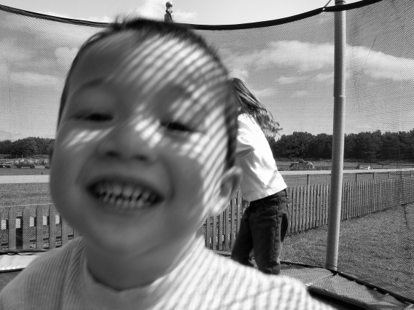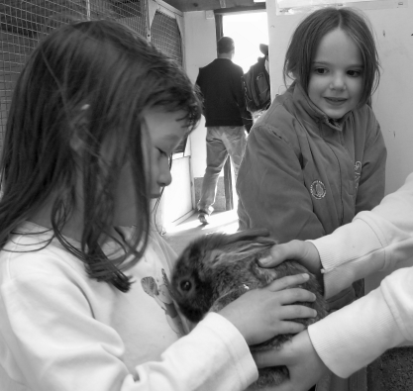

A great day out was had by all at the end of May on the Twins Club outing to East Links Family Park at West Barns, near Dunbar. This really is a family friendly venue with loads of different activities to keep the little people amused. You can buy bags of feed to feed to the many and varied animals – pellets for those with four legs (lamas, goats, sheep, deer, donkeys), seed for those with two (ducks, chickens etc). There is a narrow gauge railway that takes you around the area and the kids can throw feed to the animals. You can also either walk round or exercise those leg muscles chauffeuring the kids on two or four -seated pedal-powered go karts – great fun but don’t expect to be running any races the next day! There’s an area for kids to hold animals of the smaller, fluffier kind (rabbits, guinea pigs etc), pony rides, a small indoor soft play, a couple of outdoor skating rinks with some very nifty sit-down skateboard things, half a dozen big trampolines. Basically, on a nice day, which we were lucky enough to have, you can spend all day here and still have to drag them away at home time. Highly recommended.

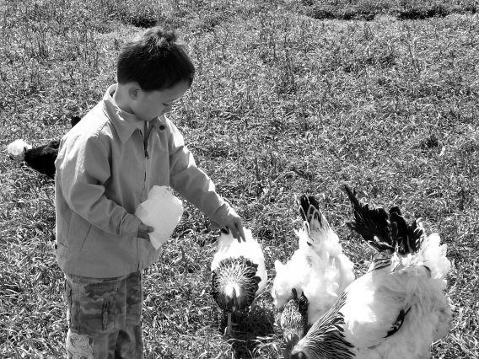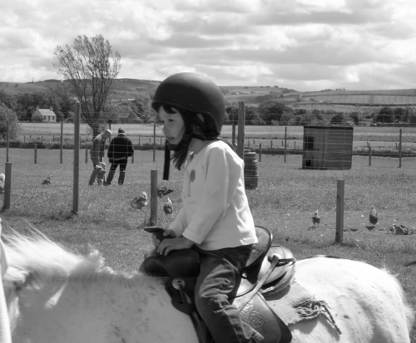

For more information see www.eastlinks.co.uk
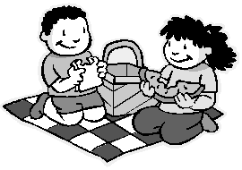
Top places to visit with twins

Dawn Blaik attends the East Lothian group with her twins Rachel and Kyle. She had the brilliant idea of compiling a list of family-friendly places in the Edinburgh area suitable to visit with young twins. It’d be great to keep this list up to date and to build on it so if you’d like to recommend a shop or venue to add to the list, please either get in touch with Dawn, who maintains the list in a folder for members at the East Lothian group (see Daytime page for address) or send them in to the Newsletter.

Venturing out with twins takes a lot of planning, especially in the early days. I found that there was nothing worse than arriving somewhere only to find that the twin pram didn’t fit through the door or that there wasn’t a baby feeding/changing room (and despite what the books tell you, I didn’t find it was easy to discreetly breast feed two babies at the same time!) I thought we could maybe help ease new parents through the early days by sharing our experiences and indeed help each other as we reach different stages with our children. I’ve put together some information about favourite places to visit with our twins, now aged 2, and would appreciate everyone’s input.
Dawn Blaik


Shopping

John Lewis in Edinburgh City Centre
New parent & baby facilities on 4th floor, access by wide glass lift.
2 baby bottle warmers
3 changing mats
Shielded area for mothers breast feeding
Parent toilet with changing mat
Nappy machine selling one nappy, wipe and nappy disposal bag
Restaurant has plenty of high chairs
Downside: St James car park does not have a lift so access is impossible with twin pram – suggest you use Greenside car park across the road.

Marks & Spencer in Gyle Shopping Centre
Parent & baby trolleys available
Wide automatic doorways and one-level shopping
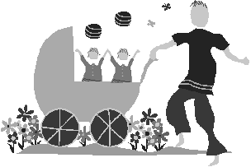
Two parent & baby feeding/changing rooms next to coffee shops
Downside: Only one bottle warmer & changing mat. Private area for breast feeding is inside ladies toilet rather than in parent & baby room. However, coffee shops provide flasks of hot water at counter to heat baby bottles at your table if purchasing something from the coffee shop (NB. One flask does two baby bottles).

Ikea at Straiton Retail Park
Parent & baby parking places at entrance
Outside play area at entrance
Free crèche and soft ball pit for 3-7 year olds just inside entrance
Parent & baby room on ground floor
Restaurant – several highchairs
Microwave for heating baby food
2 baby bottle warmers
Free disposable bibs
Plastic bowls & cutlery for children
Only about 50p for children’s’ main course and piece of fruit

Dobbies Garden Centre
Parent & baby parking spaces at entrance
Wide automatic doors for twin prams (double seat trolleys for babies up to 13kg only)
Shopping on one level inside and outside
Restaurant – several highchairs
Microwave for heating baby food and baby bottle warmer
Parent and baby changing room
Outside play area to front of garden centre with 2 baby swings (to avoid arguments!)
Outside play area to rear of garden centre for older children

Days Out
Botanical Gardens, Inverleith
Free entry
Car parking on street outside (no restrictions)
Lots of flat walks for wide prams – squirrels and pigeons galore!
Pond with ducks and swans
Main ‘Terrace’ coffee shop has baby changing facilities, a few highchairs and indoor and outdoor seating areas.
Tip: take a travel rug and picnic or meet friends and enjoy the barbeque provided at the Terrace café while the children play safely around you.

Loanhead Leisure Centre
Baby paddling pool & toys
Main swimming pool has shallow end
Family changing area with large family cubicles with baby changing table so you & your partner can share changing babies.

Dalkeith Country Park, entrance at foot of Dalkeith High Street
Free entrance October-March, £2 per adult over summer
Free car parking at entrance
Nice quiet walk for wide prams & young children around park past old Dalkeith Palace, passing a field with horses and a grassy picnic area.
Large wooden adventure play area with super fort for older children.
Courtyard with picnic tables, toilets, goats & hens roaming freely to amuse the children.
Coffee shop (open summer months only)

Vogrie Country Park, Gorebridge
Free entry to park
Large pay & display car park at entrance
2 play areas (one at car park and other just past main house)
Flat walk down to the main house, suitable for wide prams and young children.
Lots of other walks on rougher pathways (not suitable for wide prams but OK if you have baby carriers or children are steady on their feet).
Large grassy area for children to run around and picnic.
Miniature steam train that young children may sit on runs on alternate Sundays during the summer months
Crazy golf & 9 hole public golf course suitable for older children.
Café – see below!

Seabird Centre, North Berwick
Clean, safe beach with seawater paddling pool.
Parking adjacent to beach and golf course
Seabird Centre on beach: Has coffee shop selling hot and cold snacks, several highchairs and will provide hot water to heat baby bottles on request, additional seating provided outside on decking area which can be accessed by a twin pram through the side gate at the entrance to the centre.
Toilet facilities including baby changing.

Yellowcraigs Beach, Near Dirleton
Clean, safe beach only a 5 minute level walk from the car park.
£1.70 car park charge for the day (April – September only)
New adventure playground next to car park with smaller slide and climbing frame for toddlers
Toilet facilities

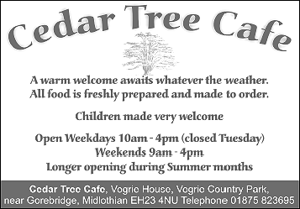
We’d all agree raising twins is a demanding job. Add a new baby to the equation and things get complicated. Not all of us would consider it an ideal time then, for a new business venture! So, hats off to Twins Club member Mel Smith who after this spring’s arrival of new baby Hannah (a sister for Liam and Rachel, aged 4), has gone into partnership running the Cedar Tree Café at Vogrie Country Park. An ideal day out and a twin-friendly café too! Good luck Mel!

Top 10 tips for flying with multiples

The following tips were provided by TAMBA, we felt they were worth reproducing here for those of you contemplating jetting off for the summer with your children. We hope you find them useful.

1. What are the rules on flying with my multiples?

The Civil Aviation Authority provided these rules on flying with infants:

- CAA regulations require that all passengers are secured by means of the seat belt provided whenever the seat belt sign is on.
- In the case of infants under the age of 2 years and young children up to the age of 3 years, restraint should be achieved in one of the following ways:
- Infants under six months of age must be secured on an adult’s lap by means of a supplementary loop.
- Children under 2 years of age must be seated either on an adult’s lap (with the supplementary loop) or properly secured in a car type safety seat provided by the passenger and acceptable to the airline, or an aircraft type safety seat specifically designed for infants provided by the airline.
- It is not permitted for children or adults to sleep on the floor of an aircraft.
- The use of a car type or aircraft type safety seat is permitted for children between six months and 3 years of age.

The policy on the criteria and use of car type safety seats can differ between airlines. In the UK, a safety seat must be fitted in the same direction as the passenger seat on which it is positioned. For further information on use of car type safety seats, passengers are advised to contact the airline with which they are travelling. It is important to ascertain whether the car type safety seat a passenger is proposing to use would be acceptable to the airline. For further information contact the CAA at www.caa.co.uk or telephone them on 020 7379 7311.

2. How many adults do I need to fly with my multiples?

Although each child under 6 months must be seated on an adult’s lap, airlines differ in their policy regarding how many adults are required for children between 6 months and 2 years travelling in car seats. This may well mean that although you have paid for seats for your multiples, you may not be able to fly with them if there are fewer adults in your party than infants.

3. How much baggage allowance will I get?

Infants on laps do not usually get any baggage allowance although a small charge is usually made for their ticket. If you pay for a seat, they are usually entitled to some allowance.
Think about what you need to pack in your hand baggage for your trip. Hand baggage will need to include any nappies and sacks, baby wipes, snacks, drinks and cups, bibs, dummies, lollipops, change of clothing and favourite teddy.

4. Will my party be able to sit together?

Airlines are restricted by their safety regulations. In some aircraft there is only one spare oxygen mask per row, this means that only one infant can travel on an adult’s lap in each row on this type of aircraft. Your party may be separated and asked to sit behind each other or across an aisle.

5. Will bassinets be available and will I have to book them in advance?

This is an area where airlines often give conflicting advice. You will need to book bassinets in advance. Make sure they know how many bassinets you need; they may assume you need one. Once again, you may be separated and asked to sit across an aisle from each other.

6. Will I be able to take my buggy to the gate?

Airlines are usually obliging in letting families keep buggies until the last minute, but they are sometimes unable to accommodate double or triple buggies at the departure gate. You may want to think about single buggies and pushchair connectors.

7. Are there any tips for the airport and the plane?

- Ask at the special needs check-in desk, they are sometimes obliging if they see a double or triple buggy in the queue, they may be willing to check you in so that you don’t need to stand in a long line trying to entertain your children. Experience has proven that check-in staff are particularly helpful when presented with a buggy full of crying babies!
- Ask if the airport has a play area. This will be an ideal opportunity for your toddlers to run off some energy and hopefully be ready to sleep when they get on board. If there is no area available, try to wear them out yourself. Better they run around the departure lounge, than they want to try and do it on board.
- Get on the plane last. Make sure your children can run about in the lounge, and spend as little time as possible on the aircraft. The earlier you get on, the longer they have to sit still on your lap.
- For older children, lollipops are ideal for dealing with ear pressure problems. Younger children can use a dummy or a drink. Don’t forget to take an extra lolly or drink for each landing.
- For short flights, try to schedule flying around nap time. If you can get your children to sleep in their usual routine, everyone is happier. Young babies will be most comfortable in a baby sling, they can stay in the sling, or on your lap, with their seatbelts on for landing and take off and then strapped to you for comfort during the flight.
- Flying can dehydrate the body so take extra drinks – preferably water. For very young bottle fed babies, consider watering down milk to increase fluid intake. Avoid fizzy drinks and offer small amounts frequently. Take extra bottles and baby cups, airlines do not carry these.
- Remember that seat belts must be fastened when the seat belt sign is on. This can seem very annoying if you have just got your children off to sleep, but there are important safety reasons for this rule.

8. What about long haul flying?

- Remember that flying with children before they are mobile is easier than flying with toddlers who want to run about and won’t necessarily settle for a sleep on board.
- Once your children reach about 3 years old, there are a few good ways of tempting them to behave. Try wrapping small presents, these should only be small. You can use crayons, cars, sweets, small pots of playdoh, playing cards and anything else you think they may enjoy. These presents can be used as a distraction when things get frantic, or as a reward, perhaps for sleeping, or sitting quietly watching TV for half an hour. Once of the presents should be a new t-shirt, which you can give as you approach your destination and arrive with far less Ribena and chocolate stains.
- DO NOT take noisy toys or anything with lots of small pieces which will end up all over the floor and have everyone scrambling around under the seats.
- Think about flying at night. If your children settle well in their beds, try to keep to their usual routine. Once on board, they can stay up for the first meal and then get into pyjamas ready for sleep. They can have stories and a bedtime drink as they do at home. Don’t forget teddy!
- If all else fails, be prepared. Go to your GP before you travel long haul and discuss using a suitable antihistamine. This can be used as a short term sedative as a last resort. It is obviously better not to have to resort to this tactic, but sometimes children get overtired and will be unable to settle without help. It is kinder to everyone to help them sleep if you need to. Be careful to test out your sedative before you travel, it can make some children hyperactive!

9. How will we eat onboard with our laps full of children?

Some airlines will let parents eat at separate times so that they can swap babies. You may find this useful, bit in may not be any use if you each have a baby on your lap. Don’t even think about hot drinks when flying with babies or toddlers. In the restricted space, they are just too dangerous. You may want to take some snacks for the whole family. Eating is also a good distraction for children.

10. What happens if my children spill drinks over each other or are sick?

If you can find room, take a change of clothing for everyone. Accidents will happen and you will be very uncomfortable on your long haul flight if you have to sit in wet or dirty clothes

GOOD LUCK AND HAPPY HOLIDAYS!!
Daytime Activities

COLINTON MAINS DRIVE

Oxgangs Neighbourhood Centre
Firrhill Drive
Bumps, Babies & Toddlers Group
0131 441 755

Tuesdays 3pm – 4.30pm (songs at 4.15pm)
Thursdays 10am – 11.30am (songs at 11.15am)
£1.20 per member family. £2.40 non-members
Daytime Convenor: Jenny Love, Tel:445-3403

All families & Mums-to-be are very welcome. Meeting other people who understand the joys and hazards of life with twins can really help.

Daytime News

Lately we have noticed that our Tuesday afternoon club has had a very low attendance. It will get even lower after the holidays as many of the regular attendees will be starting school. There are a number of options to be considered:
- Would a morning session be more convenient for members?
- Would a different day (and/or time) be more convenient?
- Should this session be cancelled altogether, leaving just the Thursday morning meeting?
Could those of you who come along to Oxgangs have a think about this and let one of the committee members know what you would like to happen? Thanks.

Library

The Twins Club has a large number of books on multiples & children in general. The books can be lent out during the sessions for a couple of weeks.

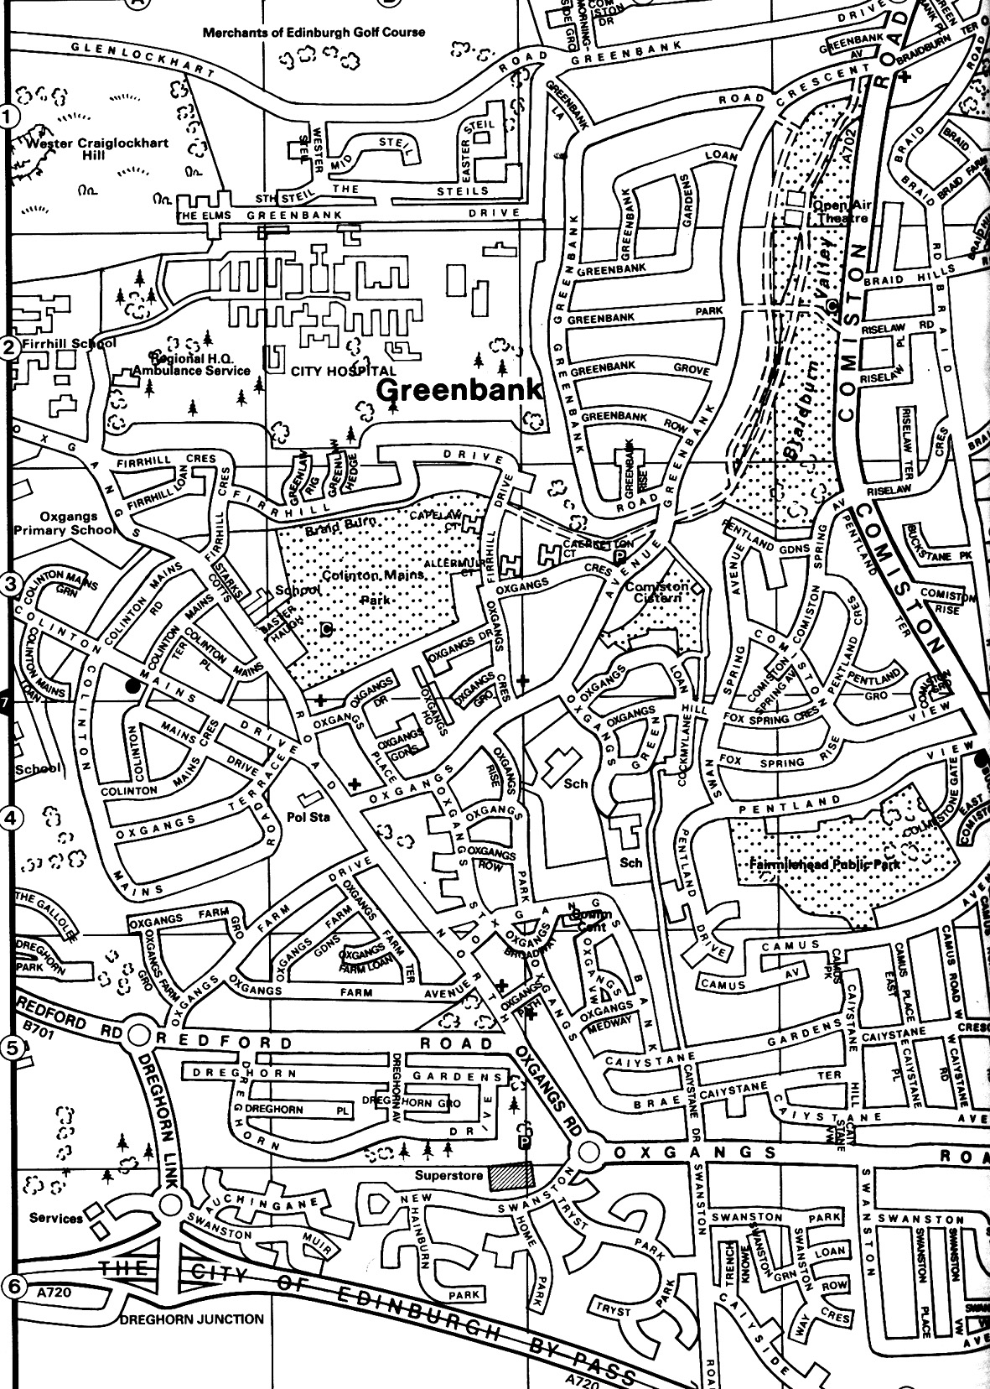
Oxgangs Neighbourhood Centre

Note
The insurance we have at Oxgangs doesn’t cover children over five. You may want to bring older brothers or sisters over the holidays but that will, as they say, be “at the owners own risk”.

East Edinburgh / EAST LOTHIAN
at
St Phillips Parish Church, Brunstane Rd North, Joppa

On the 1st and 3rd Monday of each month
10am – 11.30am
Easy Parking, Coffee available

For more info please contact either

- Carol Frith (Health Visitor), Esk Medical Centre
Tel: 653 0400 or
- Susan Sinclair (mum of twins) Tel: 657 1550 or
- Helen Nettleship (mum of twins)Tel: 665 4321

ALL HELP TO SET UP/TIDY AWAY TOYS WOULD BE APPRECIATED

Discounts

We have been trying to negotiate with a number of retailers / clubs in order for Edinburgh Twins Club members to obtain discount. If you already use your card in other shops, please let us know for future Newsletters.

Blessings & Blossoms, 132 St Johns Road, Corstorphine, 0131 334 8322
10% Discount. Children’s Clothes shop.

Cheeky Chimps Indoor Soft Play Centre (Freeport)
HALF PRICE ENTRY. Valid Monday to Friday only. Must show your Twins Club membership card.
Normal Entry Price is £1.50 for under fours and £3 for children over 4 and up to 4ft 9 in height.
Arrangements can be made for cheaper party costs. Contact Angela Caserta on 01501 762 409

CLARKS Shoe Shops
10% discount on production of Twins Club membership card (it does not have to be the TAMBA card). This will apply for all siblings shoes as well! This only applies to Edinburgh stores (Cameron Toll, Gyle, Princes St, Kinnaird Park & Musselburgh) but we have had a few problems with some of these stores accepting our card – please refer any member of staff to their Regional Manager, Nigel Merritt who has agreed this discount scheme countless times. Please do not try to obtain discount from any other store.

Doodles Ceramic Workshop
29 Marchmont Crescent, Edinburgh
10% discount for all visits. Includes evening visits when mums can enjoy some peace and quiet with friends.
15% discount for birthday parties booked in either July or August, either in the Doodles studio or with Doodles to Door (which brings all the fun of Doodles to your home or other venue). Subject to Availability. Call Holly on 0131 229 1399

Golden Hands Silver Feet
10% discount. Your little ones hands and feet captured in Bronze, Brass, Aluminium or Stone.......FOREVER - a unique memento or gift. For more info & prices please see www.goldenhands.co.uk or phone Nicky Summer on 0131 665 8628

Jelly Club
10B Kings Haugh, Peffermill Road, Edinburgh. 15% Discount on production of Membership card

Lorac Carpet Services * * NEW * *
10% Discount. Professional carpet and upholstery cleaning, general repairs, odour treatment, specialised re-tufting, specialised Oriental rug cleaning. For free advice/estimates contact: Phone 0131 468 0996; Mobile 0775 159 4900; email info@loracservices.co.uk

Nightbridge Designs
15% off custom made soft furnishings, bedding & curtains. Contact: Debbie on 01506 431515

Paul Bradford Designer Cakes
10% Discount. Simple cakes to intricate designs. Look fantastic and taste great too! Tel: 01506 671133

Rocking Horses
10% discount. If anyone would like to see/ride a large mahogany horse (called Rocky!!), please contact Gill Petrie on 0131 443 2919.
Contact: Jim McAuley, 73 Manse Street, Saltcoats, KA21 5AA. Tel: 01294 466415

Wendy Beardmore, Freelance Public Relations
15% DISCOUNT
As a member of the twins club, I have recently started out doing freelance PR and Marketing, using my maiden name Wendy Robbins. I am mainly helping small businesses and start ups to develop their marketing. If you have your own business and need some help growing this, or indeed if you know someone else in this situation then give me a call.
Call Wendy on 0131 334 9591 or 07771 966 488.

Snippets

ADVERTISING RATES

The following charges apply to advertisements in the Twins Club Newsletter:

Club Members
Members may advertise a commercial enterprise once for free, any subsequent advertising is charged at £25
Swap Shop and Wanted ads are free to members

Non-members
Non-members may place an advert for a fee of £25

Charges do not apply to the Discounts listings.

Remember that the new Twins Club website is now live. It can be found at:

http://www.edinburghtwins.co.uk.

The listing of social events is now updated regularly and we are hoping to add more features and information in the coming months.

Please let us know what you think via the e-mail address webmaster@edinburghtwins.co.uk. If you have any ideas for extra content or functionality, send them in too.

TAMBA
The Edinburgh Twins Club is affiliated to TAMBA (Twins and Multiple Births Association). Membership is separate however. For details of the benefits of TAMBA membership, visit www.tamba.org.uk
or telephone 0870 770 3305
FREE use for members
Thanks to a West Lothian grant, the Twins
Club purchased an all-terrain ‘running’ buggy,
Similar to the one pictured.

Anyone interested in using it should phone Sue Cook on 01506 411881.
CUT-PRICE CLAMBERING

If you have a CityCard Discount Card (should have come with your copy of the Outlook magazine from the City of Edinburgh Council) you can get 2 for the price of 1 into Clambers soft play at the Commonwealth Pool. £2 instead of £4 for 45 mins – a worthwhile saving!

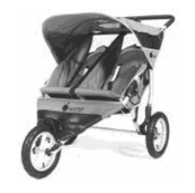
FREE use for members
Thanks to a West Lothian grant, the Twins
Club purchased an all-terrain ‘running’ buggy,
Similar to the one pictured.

Anyone interested in using it should phone Sue Cook on 01506 411881.
Newsletter
Articles to:
Vicki Jarrett
32 Buckstone Row
Edinburgh
EH10 6TP
vjarrett@blueyonder.co.uk

by Friday 30th September
Swap Shop

E-Z-2-Nurse foam cushion
Foam U-shaped cushion designed to help with breastfeeding twins simultaneously. Includes separate cushion for the mother's back. To the best of my knowledge not available from outlets in the UK. Excellent condition.
£35

E-Z-2-Nurse inflatable cushion
Inflatable U-shaped cushion designed to help with breastfeeding twins simultaneously. Includes separate cushion for the mother's back, pump and cloth partial cover. Good condition.
£20

Contact: Alexis Woolley
Tel: 0131 667 2908

2 First Years reclining 3-Stage Feeding Seats
Can be used from birth to toddler - space saving (and longer lasting) alternative to a high chair! They attach securely to a chair. See these items at www.firstyears.com
£20 for both

Contact: Fiona Constable
Tel: 476 9167
Email: fionaconstable@blueyonder.co.uk

2 Britax Rock-a Tot car seats
Suitable birth to 13kg (birth to around 12-15 months). Rear-facing car seats with carry handle and sun canopy. Blue Napolina fabric covers. Ideal as soothing rockers and chairs for feeding. Washable covers. Good condition. Never been in accident.
£15 each or £25 for both

Jonelle white parasol.
Suitable for single buggy. Never used-still in original packaging.
£6
Please note that the Edinburgh Twins Club cannot be held responsible for any purchase made through the Swap Shop or Wanted section. Each deal is entered into privately between the two parties involved (i.e. the seller and the buyer).
You can advertise as often as you wish, but you must notify The Editor each time you wish to advertise again.
Please send all items you wish to advertise to:

Vicki Jarrett: 32 Buckstone Row, Edinburgh EH10 6TP
e-mail: vjarrett@blueyonder.co.uk
Tel: 477-1404

2 Single Buggies.
Mothercare Jive stroller: navy/lilac with shopping basket. Hardly used.
Mothercare Tango Stroller: aqua/circle design. With shopping basket, raincover and hood. Good condition.
Good for holidays or for taking just one baby out.
£15 each or £25 for both.

Baby Bjorn carrier
Black with black/white gingham trim. From 1wk to approx 10 months. Comfortable baby carrier with baby facing towards you or outwards.
£15

Tomy Baby carrier
With detachable cover: From 1wk to approx 10 months. Comfortable carrier with baby facing towards you or outwards. Denim colour with tartan type trim.
£15

Galt Playnest
Inflatable 'farm' design. Suitable from birth upwards. Very good condition.
£10

Contact: Fiona Irving
Tel: 477 6674

Early Learning Centre rocker (red). Suitable for one, two or three children.
£10 ono

2 Gap Monkey Suits
Very cute! Age 3-6 months.
£10 each ono

2 Baby-a-floats.
One 6-10kgs. One 9-15kgs.
£5 ono

Contact: Catriona Hepburn
Tel: 336 1062

Double pushchair
Mothercare Atlanta Twin.
It wasn’t our main pushchair and so is in reasonable condition. Suitable from birth, the seats move independently. Has cosy toes and rain apron and good shopping basket space. Blue/ green design with navy bumper bar (detachable)
£25

Emmaljunga Twin Pushchair
Navy with reflective detail on a sprung chassis with adjustable handle. Includes hood, sunshade, cosy toes, rain cover and large shopping tray. The seat unit can be front or rear facing with the seat backs and foot rests moving independently. From birth to three years for a smooth and easy ride. It made a snug pram for my premature twins over their first winter and has been well loved. Good used condition with many miles to go. Cost £550 new.
£150

Mothercare Baby Walker
Blue dinosaur design with fixed yellow tray. Adjustable height. Good used condition.
£8

Contact: Sarah Warwick
Tel: 441 3722

2 Clippasafe Harness and Reins sets
Complete with anchor straps for use in highchairs.
Navy blue. Boxed. Suitable 6mths to 4 yrs
£6 for both

2 pairs Floaties Arm bands
Age 3-24 months
Boxed
£5 for both

Contact: Helen Nettleship
Tel: 665 4321
Email: helennettleship@mac.com

Social Calendar

The Singing Kettle    Sunday 24th^{th} July 3pm | The Festival Theatre, Edinburgh  For those of you who have booked remember to come dressed as a Cosmic Princes, Alien or Space Cadet. The tickets will be with you shortly.
Purves Puppet Show    Saturday 27th August 1.30pm | Purves Puppet Theatre Biggar  Well sign posted off the A702 as you enter Biggar (about 45mins from Edinburgh)  Tickets £4.50 per person as a group rate so pay on booking.  A family show lasting 90 mins including a 15 min interval. Humour, dance, magic and music ranging from traditional Scottish to rock. Mairi is a girl running away from her wicked uncle who gets caught up in the world of Spike the hedgehog and Nessie.  Free parking at the theatre and a garden for picnics with play area. There is a conservatory with light refreshments and small shop.  www.purvespuppets.com
Parents’ Night Out    Saturday 3rd September 8pm | Pizza Express, 23 North Bridge, followed by…  Feel free to come along to both or either part. Fuel up on pizza or pasta then join us on the Mercat Ghost Hunter Tour meeting 15 mins before the 10.30pm start from the Mercat Cross on the High Street. If we survive we finish at the Canongate Graveyard at midnight.  Please pay a £5 deposit per person for the Pizza and the full group rate of £7 per person on booking for the tour. www.mercat_tours.co.uk
The Jungle Book    Sunday 2nd October 10.45am | Dominion Theatre, Newbattle Terrace  The showing in May was unfortunately cancelled due to the late returns of bookings so we are giving plenty of notice for this favourite classic. Come and sing along. This is a private screening so don’t be afraid to bring your terrors along, they’ve dealt with it all before at the dominion and still let us return!  £3 per person. Please pay on booking

