edinburgh twins club
Edinburgh Twins Club
Newsletter

October 2004

Dear Everyone,

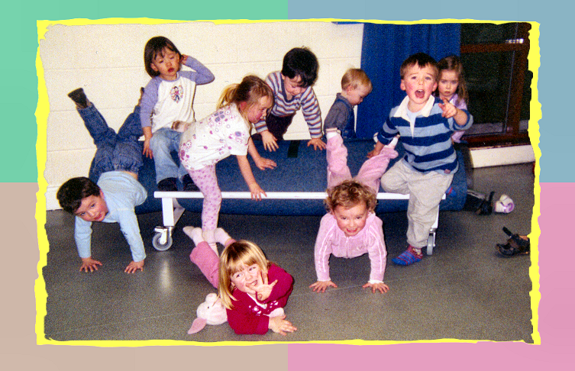
Welcome to the Autumn/Winter edition of the Twins Club newsletter. This is a very special newsletter as we are launching our wonderful new Twins Club logo and we have introduced some colour into our newsletter as well. I think these improvements are more than a welcome addition to our newsletter. A big thank-you to Vicki Jarrett for designing the new logo for us.

In addition, we have launched our new web site with the new logo as well. Do check out http://www.edintwinsclub.co.uk. Many thanks to Gary Winfield for all his hard work on this. Hope you enjoy visiting it.

Of course, the main highlight of the season is the Twins Club Christmas Party - and I'm very much looking forward to seeing most of our families at this event - so please book as soon as possible!

Regards,
Alison Andrew
Chairperson
Tel: 0131 334 1139

Toddler Taming at Oxgangs runs into a few wee problems

AGM moved to January 2005. Please see Agenda on page 12.

 | Membership Update  Welcoming the newest members of ETC | 2 |  | Candid Camera  Oxgangs disposable camera eventually gets developed | 9
 | The Adventures of Piglet  The true adventures of a girl and her special pal | 3 |  | Big Cook’s Book  Give us your favourite home recipes and see them in print | 10
 | Running Scared  From couch potato to runner, then back to the couch | 4 |  | Discounts  Everyone’s favourite perk – which shops and how much | 11
 | Halloween Fun  Scottish traditions, yummy recipes and double disguises | 6 |  | Snippets  Bite sized chunks of news and information | 12
 | A Question of Twins  Quiz Night drama and some mind-boggling questions | 7 |  | Swap Shop  For sale + wanted, everything from buggies to nannies | 14
 | Daytime Activities  Times, venues, directions. Pay us a visit! | 8 |  | Social Calendar  Another great selection. Forms back by 12th Nov. | 16
Membership Update

Dear Members

Congratulations to Paula and Andy Westaby who had two little girls, Iona and Erin, on the 19th of April 2004. We hope all is going well.

We would like to welcome to the following families who have joined the Twins Club since the last newsletter:

- Kathryn and Alistair Henry of Livingston, who are expecting their babies in January;
- Claire and Mark Burrell of Edinburgh, who are also expecting their babies this January.

WELCOME TO OUR NEW MEMBERS AND CONGRATULATIONS AGAIN TO THE WESTABY FAMILY!

Our membership list consists of 128 families. Our membership list is increasing but the “summer” has been quiet. Therefore, we would be pleased if you pass on the benefits of the Club to any new families you might meet with twins, triplets or more! We would be happy to send you some contact cards to carry around if you feel you would be comfortable giving them out to new Mums and/or Dads you might meet who have not heard of the Club. [The Gyle and McArthur Glen both being very likely venues for this!].

If you have joined the Club recently [or joined a while ago] and still have your “Family History Record” sheet to forward, please return it to us for our records. Thank you.

If there is a Membership Form with this newsletter your membership is either due or overdue for renewal. Please complete the form and send it with your cheque to Gillian Smith by mid November 2004.

If you would like to speak to someone about ANYTHING to do with having multiples, the ETC has a list of volunteers willing to discuss a variety of subjects – CONFIDENTIALLY. PLEASE VOLUNTEER if you have had your babies recently and would not mind sharing your experiences. Please notify us of the topics you would be happy to discuss. Your name would only be passed on when someone requests someone to talk to. A BIG thank you to those that have volunteered!

PLEASE do not forget to call Karen or Gillian and let us know your baby news – this really will help us come Newsletter time. If we have missed the birth of your babies, or you are a new member and we have missed you from our list, please let us know so that we can add you to our next newsletter.
As of January 2005, the annual membership fee will be increasing to £10. The fee has not risen for many years, so this rise simply reflects the effect of inflation on our running costs. Since the entire fee can be recouped during just a couple of visits to Clarks using the Twins Club discount, we hope you agree, ten pounds a year still constitutes amazing value for money.

Karen and Gillian
Membership Committee:
Karen Winfield  23 Bluebell Glade  Adambrae Parks  LIVINGSTON EH54 9JJ   +44 (0) 1506-416 412  Karen@the-winfields.com | Gillian Smith  22 Braid Avenue  Morningside  EDINBURGH EH10 6EE   +44 (0) 131-447 3000


The Adventures of Piglet

My favourite thing in the whole world is my Piglet. He goes everywhere with me. He has been to all my friends houses, my playgroup and nursery, my holidays and he goes to bed with me EVERY NIGHT. Sleep isn’t the same without him. He is my first love. Unfortunately he is a bit dirty because I can’t bear to be without him, even if he were to go in the washing machine. Mummy has tried to be clever and buy some “reserve” Piglets, and at first I was too little to know how cunning and sly mummies can be, but no, despite having 3 other Piglets - 2 exactly the same, I know exactly which one is my Dirty Piglet. And only he will do.
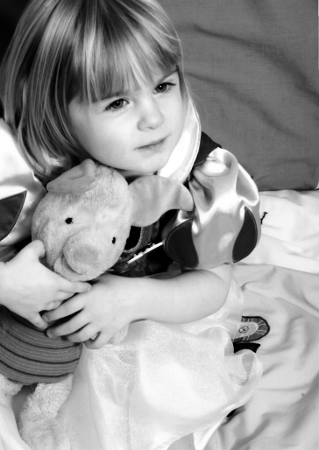
However, he can be a little bit naughty and go on adventures. I get really worried that I will never see him again. The first of his big adventures was the afternoon we visited the Twins Club at Oxgangs. He was with me when I was playing there. But when I got home and it was time for bed … he wasn’t there. My Mummy searched all over the house for him. He could not be found. I had to go to sleep without him. It was horrible. But Mummy had an idea. Maybe he had hidden in the Toy Cupboard at Oxgangs Twins Club? That nice lady, Janet Wright, came to my rescue and searched for him on the Thursday morning. We were re-united by teatime. Esmee and Ishbells Mummy drive round to my house and gave him back to me.

Then there was the day I dropped (threw) him out of my buggy on the way back from the Twins Club - that was always happening - but Mummy normally realised he had gone and would go back and rescue him. But that day she didn’t. When I got home and it was time for bed … he wasn’t there. Mummy had an idea. What if she looked along the route that we had walked in the buggy? So off she went in the car, and he was waiting for us, on a wall next to a gate. In Braid Road. So we were reunited - again.

There have been other times he has got lost because I have put him in my lunch-box and closed it (that almost fooled Mummy), he has hidden in my brothers’ bed and Declan hasn’t told me.

But Piglets biggest adventure was when we went to Florida in America. We were visiting Walmarts. I was picking some clothes (as you do when you are a young lady of 3) - I was deliberating over a beautiful pair of Care Bear PJ’s. Daddy had put Piglet in the trolley and left it “parked” while he took my brother to the toilet. When he came back, the trolley had vanished. AND SO HAD PIGLET!!! I was distraught. Maybe someone had stolen him. Daddy and I went to the Customer Service Desk and tried to find him. He wasn’t there. To distract me (so he thought) Daddy bought me a dolly - giant Ariel - who was beautiful and she kept me happy for the rest of the day. But she was hard and cold and wasn’t good to sleep with. I was missing Piglet badly. Next day we were at a huge shopping centre. There was a Disney shop and they had new clean Piglets. Daddy bought me one. And it felt good. But something was missing. Sleep was better that night, but I wanted my Dirty Piglet. Clean Piglets don’t smell the same. Mummy phoned Walmarts as a last resort to see if Piglet had turned up. To my delight the lady on the phone said there was a “well loved Piglet” waiting for me! He was there, sitting patiently but looking a bit dirty. I couldn’t wait. Next day Daddy took me in the car to Walmarts. We went up to the Customer Service Desk and I could see Piglet. The lady realised straight away and let me cuddle him. I couldn’t speak. I was so happy. I needed to give him lots of cuddles and sniffs to get used to his slightly new smell. I don’t ever want him to go on any more adventures again. I missed him so much. So if you spot him trying to get away from me once more, STOP HIM! He is not allowed and I would be desolate if I lost him forever, so if by chance you ever see a lonely dirty looking Piglet, then please return him to Tara Smith c/o Edinburgh Twins Club. You will make a little girl very happy!

Tara Smith, Age 3 ¾
 Running Scared

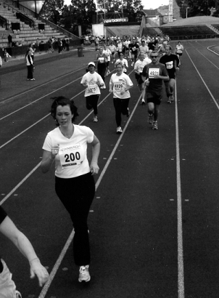
The Edinburgh City Challenge 10K road race is an annual event incorporating a 1.5K Fun Run. Some of you will remember last year the Twins Club took part in the Fun Run by staging our own Sponsored Toddle which was very successful in raising money for Simpsons (see next page). Some mums even ran the 10K race themselves. I was totally in awe that any mother with young twins even had the energy left to run for a bus, never mind 10 kilometres around Edinburgh on a Sunday morning. Nevertheless, having had it in mind to make an effort to get fit, I promised myself I would do the race the next year. This was a pretty daunting concept. As any of you who have met me in an advanced state of jollity on a social night can confirm, I’m not exactly a ‘my body is a temple’ type of person. All the same, I wanted to get back into my old pre-pregnancy jeans and, with a whole year to prepare, how could I fail? All well and good, but did you know the Road to Good Intentions is actually paved with Galaxy Bars?

The winter went by and I was no fitter, not surprising having not trained at all. With Spring approaching, I decided to scare myself into action by doing the Race for Life 5K. I managed to raise some money for Cancer Research but at the same time proved to myself as I lay, purple and perspiring on the grass after the run, just how much work I had to do before I could live through double the punishment. Right at that moment, the idea of getting up and doing another 5K straight away was unthinkable. I was scared….so scared I decided to sign myself up for the 10K as soon as they were taking applications just so that I couldn’t back out. Agreeing to canvas for sponsorship for the Twins Club was the final tie I couldn’t break. Somehow I had to do it.

The next couple of months I made an effort to get out and run at least once, usually twice a week, gradually increasing my distance, not worrying about how long it was taking me, just concentrating on finishing the distance without needing a crash cart and an oxygen tent. At first, I was going so slowly I was being overtaken by wee old women with their shopping bags. The first time I ran seven miles without stopping I knew I could do the 10K. It was now a question of whether or not I could do it in a time that wasn’t totally humiliating. I went to a proper sports shop and bought some proper running shoes. This was getting serious. I put in a few more seven mile stretches and things were looking, if not exactly good by athletic standards, pretty damn astounding for me.

A week before the race, I looked at the course and realised it involved rather a lot of hills. Oops! I’d been training on the flat. The thought of making things more difficult by running uphill just hadn’t occurred to me. So, I decided to try it, if only once before the race. When I got home, Mike and the kids were genuinely concerned I was going to pass out. The kids asked, ‘Mummy, why are you all red and wet?’. I decided to designate the remaining days before the race to ‘rest days’.

◄ Help! I think I’m being followed!

The day of the race I got up before the kids (that’s ridiculously early) and tried really hard not to feel sick. The temptation to change my name and emigrate was only held back by the realisation my passport had expired. In the event though, I surprised myself. Not only did I not die, or get crushed under the wheels of the sweeper bus, I actually managed to complete the course in less than an hour. Amazing! Of course, I was roundly beaten by around three thousand people, but I’m concentrating on the nearly two thousand others that were behind me. It’s all a matter of perspective. When I got home and the kids greeted me with a big beautifully wrapped box of Belgian chocolates and a card, and Mike presented me with a bottle of champagne, I knew it’d all been worth it. Needless to say, the kids ‘helped’ with the chocs.
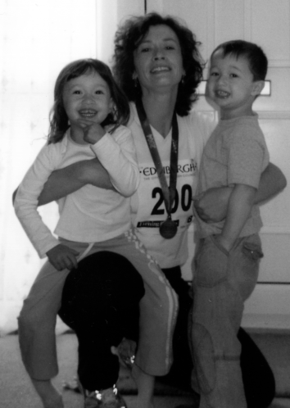
Enough photos! GIVE ME THE CHOCOLATE NOW!

The champers went down a treat for mummy and daddy after the kids were tucked up in bed. The combination of Champagne and chocolate is an extraordinarily effective cure for sore muscles.

Apart from the benefits of getting some exercise and fulfilling a personal ambition, I’m glad I got the chance to raise some money for the Club. As a mother of twins who are my first (and last – and, yes, I’m sure!) children I didn’t have much of a clue and was really helped a lot by making it along to the Oxgangs meetings and talking to other parents. So this was a chance to give something back. A grand total of £310 was raised for the Club. Many thanks to all of you who sponsored me.

This should also prove to those of you who think yourselves unfit – if I can do it, anyone can!

Vicki Jarrett

PRESENTATION TO THE SPECIAL CARE BABY UNIT
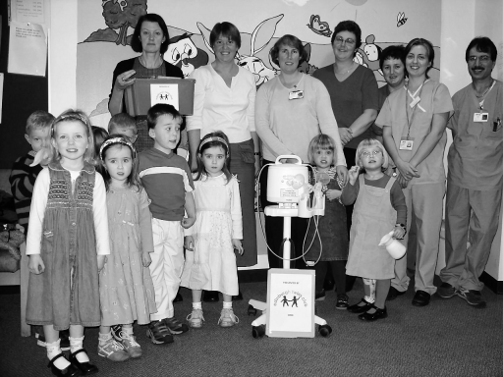
On the 20th of October we were finally able to present our gifts bought with the £1500 raised from the 1.5km fun run last year to the SCBU at the new RIE. Thank you again to the participants and sponsors of this event. After discussion with the unit they asked us to buy an extremely high tech breast pump, to help those mums often struggling to produce the small amounts of milk that can be so crucial to the extremely premature babies. This used the bulk of the money. The rest has been spent on a selection of books to be loaned out from the unit, and on a small sofa ideal for those precious cuddles. We thought the books could be useful to help fill the gaps in the long days, when the parents don’t want to wander as far as a bookshop and are on caring for multiples, and on the ‘premature experience’.
Simpson’s Special Care Christmas Card are avialable at http://www.sscb.org


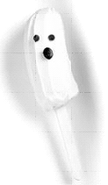
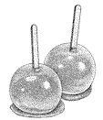


Halloween customs in Scotland consist chiefly of children going door to door "guising": dressing up and offering entertainment in return for gifts. Halloween parties have various games, for instance 'Dooking fur aiples' where the children retrieve apples floating in a basin of water using only their teeth. Sprinkle flour on the surface of the water for ghostly faces. For younger children 'Forkin fur aiples' is an easier task, where the children stand on a chair and hold a fork handle in their teeth, taking aim, they drop it into the basin and get to keep any apple they skewer. Young ones may also have more luck dooking for unshelled monkey nuts. A very messy, but fun, game is 'treacle scones' where children have to eat a scone covered in treacle hanging on a piece of string, without using their hands.

Banana Ghosts
Makes 2
Ingredients
1 ripe banana
1 ½ oz white chocolate
raisins or milk choc chips
Method
Remove any stringy fibers from the peeled banana, then cut it in half widthwise. Push a lolly stick into each half through the cut end, then cover them with cling film and freeze until firm (about 3 hours). Melt the white chocolate either in the microwave (takes about 1min on high) or on the hob in a bowl placed in a pan of boiling water. With a butter knife, spread the melted white chocolate on the frozen banana halves.
Put the lollies on a grease-proof-paper-covered dish. Press on choc chips or currants for eyes and mouths and return them to the freezer until ready to serve.

Toffee Apples
Ingredients
6 medium-sized eating apples
8oz (250gm) granulated sugar
1/8 pint/ 65ml water
Method
Heat the sugar and water together in a pan, stirring until the sugar is dissolved and the mixture boils. Boil, without stirring, until the toffee reaches the crack stage (mixture turns pale brown and toffee turns solid when a small piece is dropped into cold water.) Fasten each apples on a wooden lolly stick and dip into the toffee mixture. Twist each apple round to coat it well with toffee. Stand on a greased tray to set with the sticks upright. If there is any toffee mixture left pour into a greased flat tin and mark in squares. Break when cold.
You can also use the toffee recipe above to make treacle toffee. Just add a couple of tablespoonfuls of treacle to the mixture.

Witches Sticky Fingers
Ingredients Makes 18
6 oz (175g) raisins
4 oz (125g) chopped nuts
3 oz (75g) butter
6 oz (175g) clear honey
1 tsp baking powder
3 eggs
6 oz (175g) flour
Cooking Instructions
Pre-heat the oven to 350F, Gas Mark 4, 180C. Put the butter and honey into a bowl and beat together until soft. Add the eggs and beat into the mixture. Sift together the baking powder and flour and blend into the mixture. Fold in the nuts and raisins. Grease a 12” x 9” (23cm) shallow baking tin and spread the mixture evenly on to it. Bake in the pre-heated oven until golden brown, about 30 minutes. Cut into fingers and cool on a wire rack before serving.

Double Disguises

- Pair of furry Dice (especially if they're tied together!!)
- Angel and Devil
- Bride & Bridegroom
- Puppy & Kitten
- Mr. & Mrs. Potato Head
- Thing 1 and Thing 2 from Dr. Seuss
- Bee & Honey Pot
- Fish & Chips
- Tatty & Neep
- Tom & Jerry
- Mickey & Minnie Mouse
- Pebbles & BammBamm from the Flinstones

A Question of Twins…


Two wannabee Magnus Magnusons + twelve wise men (and women !) gathered for a meeting of minds not seen since that Major bloke cheated on Who Wants to be a Millionaire.

It was an evening full of firsts: Jenifer Robertson was first to arrive for a social event (first time ever!!): Gill Petrie was unable to hide from the quiz by being the question master: the boardroom (yes the boardroom!!) of the Murrayfield Hotel faced it's hardest challenge yet : the hosting of the Edinburgh Twins Club quiz night.

Neil & Ian, our very own Carol Vorderman & Richard Madely, put in a sterling effort as quiz masters. Obviously a lot of time, effort and research went into each series of 10 questions.
There was though a devious twist in the tale - the questions or answers centered around twins! This led to some interesting answers and guesses.

We split into 3 teams of 4 and after a hard fought battle (interjected with copious amounts of alcohol) we found our winners who ran away with the title by a good 1/2 point.

The spoils (prizes) were handed out to the winners, raffle prizes were gratefully received and from the winning team came the gracious cries of "L O S E R" "L O S E R" to those of us who questioned their winning score!

A great night thoroughly enjoyed by all. Finally a big thanks to Neil & Ian whose hard work made the quiz so enjoyable and here's looking forward to the next one.

John Petrie

For those of you who couldn’t make it along on the night…here’s a selection of questions to boggle your minds – no peeking at the answers ‘till you’re finished!


- Which male actor from the TV series L.A. Law had twin boys in 1992?
- Which women’s tennis ace had fraternal twins in 2001 at the age of 39 which she raises in the US with her female partner?
- Which actor had twin boys who ‘boldly’ appeared in the first movie version of their father’s TV series?
- Which famous British Playwright fathered twins?
- Which religious order was founded by twins?
- Name the 2 time Golf US Open champion to have had twin boys.
- Does the American golfer Kirk Triplett have twins, triplets or quads?

- Which world famous footballer had twins at the age 56?
- Which US President has twin daughters Jenna & Barbara?

- Which Oscar winning American actress had twins at the age of 47?

Daytime Activities
COLINTON MAINS DRIVE
Oxgangs Neighbourhood Centre

Directions: Colinton Mains Drive/Oxgangs North
Oxgangs Avenue
Oxgangs Crescent
Firrhill Drive

Oxgangs Neighbourhood Centre
Firrhill Drive
Bumps, Babies & Toddlers Group
0131 441 7558

Tuesdays 3.00 – 4.30pm (songs at 4.15pm)
Thursdays 10.00 – 11.30am (songs at 11.15am)
£1 per family

All families & Mum’s-to-be are very welcome. Meeting other people who understand the joys and hazards of life with twins has certainly helped me and it’s great to see the children playing and growing up.

Daytime News!

Helen Stewart and Vicki Jarrett have kindly agreed to take joint responsibility for the running of the Oxgangs groups. Vicki usually attends on Tuesday and Helen on Thursday.

They will be the main contacts for people phoning up enquiring about the club, welcoming new members and will also be responsible for balancing the book and banking any monies.

Enquiries to: Helen Stewart Tel: 477 7722 or
Vicki Jarrett Tel: 477 1404

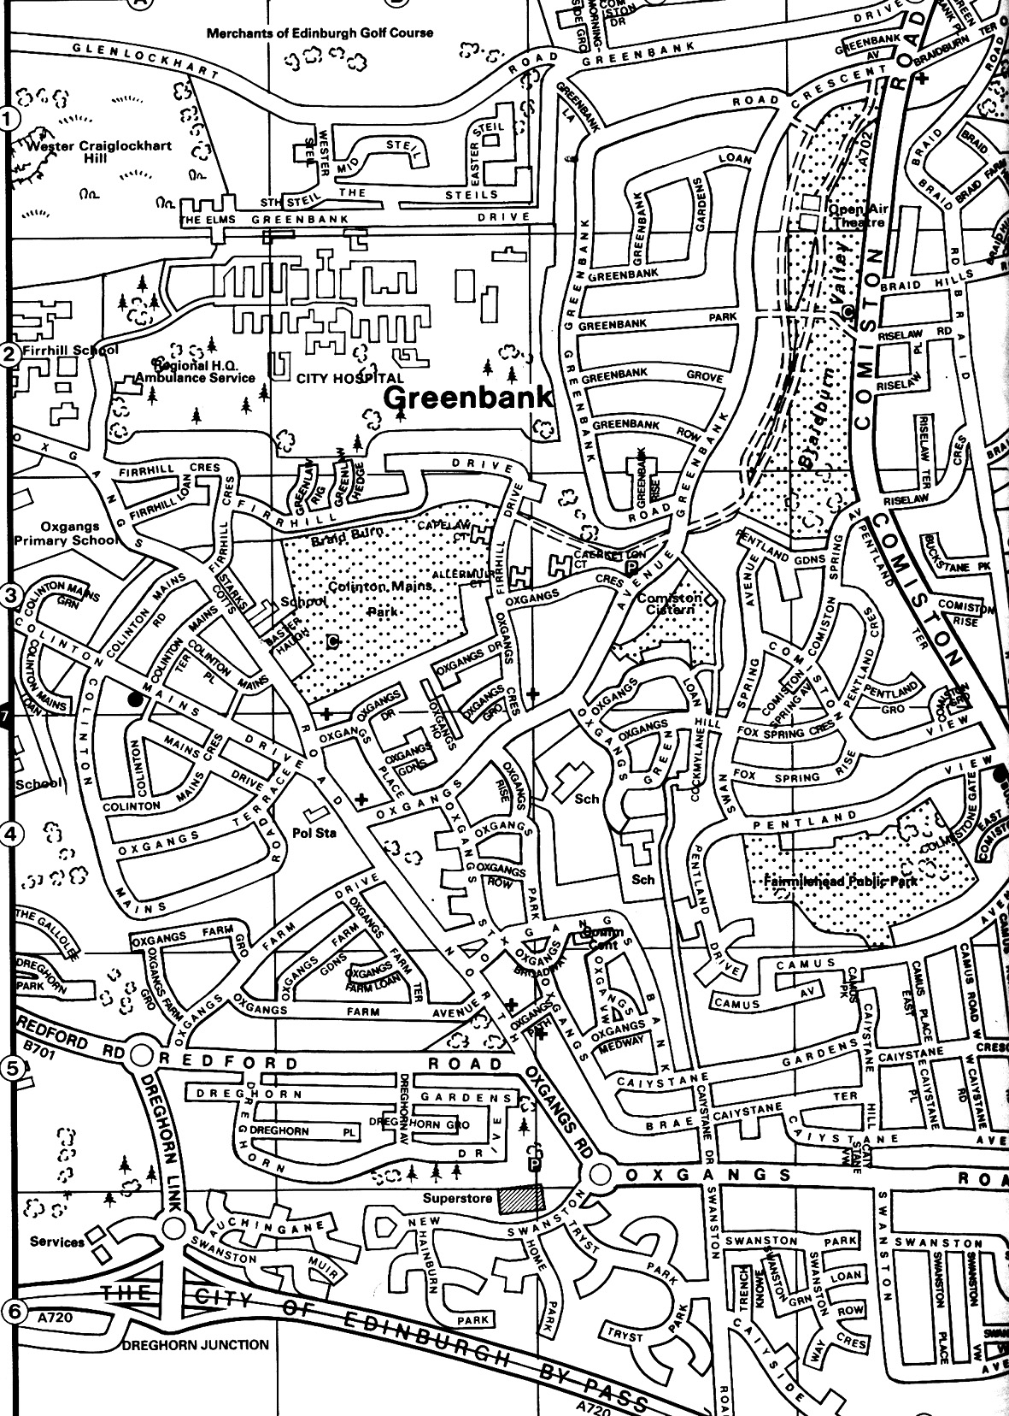

Library
The Twins Club has a large number of books available on multiples & children in general - available to any members who are interested. The books can be lent out during the sessions for a couple of weeks.

Note
The insurance we have at Oxgangs doesn’t cover children over five. You may want to bring older brothers or sisters over the holidays but that will, as they say, be “at the owners own risk”.

East Edinburgh / EAST LOTHIAN
at
St Phillips Parish Church, Brunstane Rd North, Joppa

On the 1st and 3rd Monday of each month

10am – 12md
Easy Parking
Coffee available

For more info please contact either

- Carol Frith (Health Visitor),
Esk Medical Centre Tel: 653 0400
or
- Susan Sinclair (mum of twins) Tel: 657 1550
or
- Helen Nettleship (mum of twins)Tel: 665 4321

ALL HELP TO SET UP / TIDY AWAY TOYS etc WOULD BE APPRECIATED

Candid Camera

Quite some time ago, a disposable camera was left in the Twins Club box at Oxgangs. This poor camera has been remembered and forgotten again more times than we care to admit. However, it has, eventually been used up and developed. The results span a couple of years! Some familiar faces…

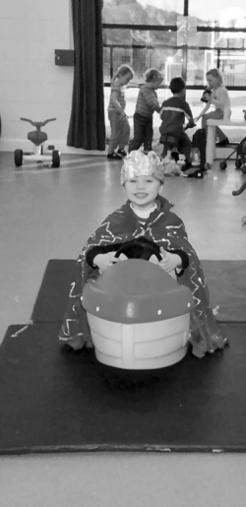
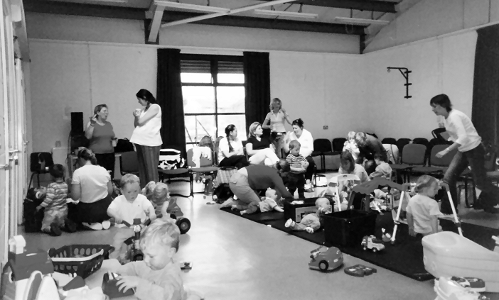
A busy Oxgangs with the full range of Babies, Bumps and Toddlers.
A Royal visit!
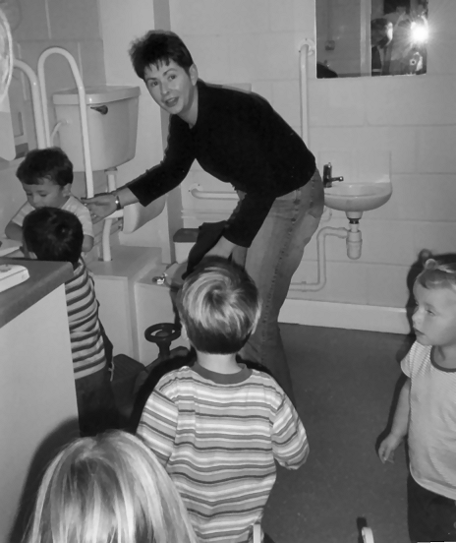

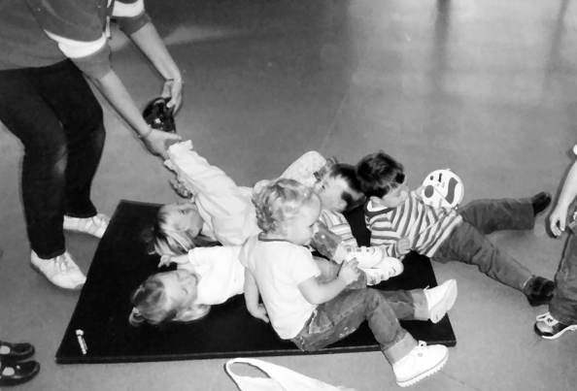

How many toddlers can YOU take to the toilet at one time?
Leg Found. Appears to belong to a male toddler, 2-3 years. Anyone missing a leg fitting this description please contact the Newsletter.
The disposable camera is an excellent idea, provided people remember to use it. A new one will be bought soon and be kept in the Club box. Pics for the Newsletter are always welcome, especially more of babies, as the toddlers seem to be hogging the limelight!

Big Cook Little Cook Can’t Cook Won’t Cook…

The Committee have been looking at new and exciting ways of fundraising recently and one idea was to produce:
THE EDINBURGH TWINS CLUB RECIPE BOOK

We hope to have this available for sale at this year’s Christmas Party but, as you can imagine, we will have to get a move on! The cook book idea has been adopted by many schools, clubs etc and has proved a fun and very successful way of generating funds. By purchasing the Book, you will not only be supporting your Club but receiving (hopefully) easy, practical, fun recipes to try at home!!! So, first things first! Let’s get it produced!

PLEASE SEND ME YOUR RECIPE IDEAS!!!
Your recipes can be:
- for babies and children only, in the form of home baking or cooking;
- for family meals: simple delicious dishes the whole family can sit down to;
- snazzy lunch box/quick bite recipes for meals for kids on the move; or
- adult only meals that are quick and easy when you have finally got the little ones off to sleep!!!

The recipes should be:
- your own, or an adaptation of your favourite chef’s!
- listed in imperial and metric where possible (don’t worry, I will try to convert them if not!)
- fairly simple – nothing too complicated please! We are hoping to make life easier!

FINALLY:
- Your recipes should be given a quirky name of your own choice!

SO, PLEASE SEND YOUR RECIPE IDEAS TO:

Karen Winfield, 23 Bluebell Glade, Adambrae Parks, LIVINGSTON EH54 9JJ
karen@the-winfields.com
ASAP – Deadline 10th November 2004
OR
Kill two birds with one stone and:
Write your recipe on the back of your Social Return form!

Please quote your recipe name clearly, and state your own family name and contact details.
Please indicate if we will have permission to use your NAME ONLY (no contact details) at the foot of your published recipe.

We have yet to decide a TITLE FOR THE BOOK so please send/e-mail me your suggestions for the book’s title. The winning Title will be drawn by our Chair at the Committee Meeting on 17 November 2004 and announced at the Christmas Party, as the books (hopefully) go on sale. (Selling Price to be confirmed.)

THANK YOU, IN ANTICIPATION OF A GREAT BOOK and an easier life in the kitchen…

Discounts

We have been trying to negotiate with a number of retailers / clubs in order for Edinburgh Twins Club members to obtain discount. If you already use your card in other shops, please let Catriona Hepburn (details on page 2) know for future Newsletters.

Blessings & Blossoms, 132 St Johns Road, Corstorphine, 0131 334 8322
10% Discount. Childrens Clothes shop.

Cheeky Chimps Indoor Soft Play Centre (Freeport)
HALF PRICE ENTRY. Valid Monday to Friday only. Must show your Twins Club membership card.
Normal Entry Price is £1.50 for under fours and £3 for children over 4 and up to 4ft 9 in height.
Arrangements can be made for cheaper party costs. Contact Angela Caserta on 01501 762 409

CLARKS Shoe Shops
10% discount on production of Twins Club membership card (it does not have to be the TAMBA card). This will apply for all siblings shoes as well ! This only applies to Edinburgh stores (Cameron Toll, Gyle, Princes St, Kinnaird Park & Musselburgh) but we have had a few problems with some of these stores accepting our card – please refer any member of staff to their Regional Manager, Nigel Merritt who has agreed this discount scheme countless times. Please do not try to obtain discount from any other store.

Doodles Ceramic Workshop * * NEW * *
29 Marchmont Crescent, Edinburgh
10% discount for all visits. Includes evening visits when mum's can enjoy some peace and quiet with friends.
15% discount for birthday parties booked in either July or August, either in the Doodles studio or with Doodles to Door (which brings all the fun of Doodles to your home or other venue). Subject to Availability. Call Holly on 0131 229 1399

Golden Hands Silver Feet
10% discount. Your little ones hands and feet captured in Bronze, Brass, Aluminium or Stone.......FOREVER - a unique memento or gift. For more info & prices please see www.goldenhands.co.uk or phone Nicky Summer on 0131 665 8628

Jelly Club
10B Kings Haugh, Peffermill Road, Edinburgh. 15% Discount on production of Membership card

Nightbridge Designs
15% off custom made soft furnishings, bedding & curtains. Contact: Debbie on 01506 431515

Paul Bradford Designer Cakes
10% Discount. Simple cakes to intricate designs. Look fantastic and taste great too ! Tel: 01506 671133

Rocking Horses
10% discount. If anyone would like to see/ride a large mahogany horse (called Rocky !!), please contact Gill Petrie on 0131 443 2919.
Contact: Jim McAuley, 73 Manse Street, Saltcoats, KA21 5AA. Tel: 01294 466415

Wendy Beardmore, Freelance Public Relations * * NEW * *
15% DISCOUNT
As a member of the twins club, I have recently started out doing freelance PR and Marketing, using my maiden name Wendy Robbins. I am mainly helping small businesses and start ups to develop their marketing, and currently have a number of clients, among them Doodles which is featured in this newsletter.
If you have your own business and need some help growing this, or indeed if you know someone else in this situation then give me a call. Since I have only just started out, I have the advantage of being affordable and flexible, and I'd love to hear from you.
Call Wendy on 0131 334 9591 or 07771 966 488.

Snippets

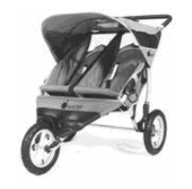

AGM
Notice is hereby given that the Annual General Meeting of the Edinburgh Twins Club will be held at the Murrayfield Hotel, Corstorphine Road on Monday 10th January 2005 at 8pm.

The business will be as follows:

- To consider the report from the Chairperson and the Treasurer
- To approve the accounts for the year to 30th September 2004
- To elect the Officers and Committee for the following year.
- Any other relevant business
FREE use for members
Thanks to a West Lothian grant, the Twins
Club purchased an all-terrain ‘running’ buggy,
Similar to the one pictured.

Anyone interested in using it should phone Sue Cook on 01506 411881.
Royal Bank of Scotland donates £250
to Edinburgh Twins Club

The Royal Bank of Scotland has donated a Community Cashback Award of £250 to Edinburgh Twins Club. This money is a welcome addition to our funds. A big 'Thank-You' to Royal Bank of Scotland for recognising the support that Edinburgh Twins Club provides to families.
Newsletter
Articles to:
Catriona Hepburn
11 East Barnton Gardens
Edinburgh
EH4 6AR
hbox1@tiscali.co.uk

by Friday 31st December
FUNDRAISING IDEAS

The committee would love to hear from any members with ideas for fundraising activities. Anything considered, from jumble sales to sponsored potty juggling. All funds raised will go towards improving services to you, the members, so get your thinking caps on! Contact any member of the committee if you have an idea.
We need donations of raffle prizes for this years Christmas party – anything would do, bottle of something fruity, nice box of biscuits, knitted tea cosy, wide screen TV, that sort of thing… Please get in touch with the social committee if you have anything you’d like to donate.
Snippets (cont’d)


CHARITY WALK FOR MAGGIE’S CANCER CARING CENTRES

Keith Archibald, Dad of Robert and Lindsay (Oxgangs Thursday group) is taking part in a sponsored hike in Vietnam in aid of Maggie’s Cancer Caring Centres. Any sponsors or donations would be gratefully received.

Charity disco with live band on Saturday 6th November at 7.30pm at The Agenda, Corstorphine, Edinburgh. Tickets £6, either in advance or at the door. All welcome.

Contact Katy or Keith on 334 1506

The new Twins Club website goes live to coincide with this Newsletter and the unveiling of our new logo. It can be found at:


http://www.edinburghtwins.co.uk.

At the moment it is fairly bare and basic, but we hope to add more features over the coming months. To begin with we have most of the facilities of the old website, but in a cleaner more modern design.

Please let us know what you think via the e-mail address webmaster@edinburghtwins.co.uk. If you have any ideas for extra content or functionality, send them in too.

Swap Shop

Musical Mobiles (two)
For attaching to cot, tiny love symphony-in-motion, 3 classical tunes including Beethoven, Bach and Mozart, volume control, battery operated music box, swivel arm with 3 hanging brightly coloured soft animals, sliding beads, detachable push-button music box for long term use, 15 mins of music, in original packaging
£15 each

Grobag toddler sleep bag
Cream with Noah’s ark animal design, for age 3-6 years, 1.0 tog, safely zip at front, hardly used, excellent condition
£10

Contact: Jane Berry
Tel: 01875 852 992
Email: jane.wberry@btopenworld.com

Snowsuits with mitts (two)
3-6 months, never worn. 1 blue, 1 cream, teddy motif.
£10 for both

Contact: Dee Armstrong
Tel: 664 0355

Implast Twin Pram
Black/cream fleece. Brand new wheels, hardly used. Adjustable individual seats, rear or front facing, hood, 2 cosy-toes, 1 cover, rain cover & shopping tray.
£300

M&P Bouncy Chairs (two)
Pale green/yellow. Never used. Battery pack on chair with bounce, vibration & musical options.
£15 each

M&P Musical Mobiles (two)
Brand new, never used.
£25 for both

3-way Vibrating Carrier
Mothercare. Grey/blue. Brand new, never used.
£20

Contact: Jennifer Love
Tel: 445 3403

Britax Car Booster Seats (two)
With back and shoulder rest. Blue check. Age 4-6 years (15-36kg). Excellent condition. Sell for half price.
£25 each

Contact: Catherine Longmore
Tel: 664 4233

Babydan Babyden
Winner of Best Playpen Buy 2000 in Babies Best Buy magazine. Suitable for up to 24 months. Full opening door. Polyester filled mattress with cotton front and water resistant nylon reverse. Adult only release handle. Was £80 new. Very good condition. Large enough for 2 babies.
£35.

Instep Twin Nipper
All-terrain buggy. 2 years old. Very light weight - 9kg. Blue with silver trim. Very good condition. Rain cover. Out and About matching cosy toes (£39 new). Buggy £299 new.
£150

Contact: Gillian Smith
Mob: 0771 4203306

Brittax Rock-a-Tot Deluxe Car Seat
With rain hood. In excellent condition. Never been involved in any accidents. Instructions all included. Blue Napolina cover. New £80
£25

Mothercare Antigua Highchair
Very good condition. Yellow and blue. Instructions included. Easy folding, fixed tray design.
£15

Tomy Walkabout Digital Baby Monitor
Excellent condition. Light and sound indicators and temperature display. Baby unit has night light, Instructions.
£10

Mothercare Antigua Highchairs (two)
Well used but good condition. Folding, removable adjustable tray, height adjustable legs and backs. Convert into low chairs. Instructions included. Easy folding, fixed tray design.
£30 for both/£15 each

Boys M&S Snowsuits (two)
6-12 months. Hardly used, excellent condition. Navy blue with hoods, hands and feet.
Free to good home.

Box of Baby and Toddler toys
Excellent mixture of first and toddler toys, including shape sorters, stacking rings, play mat etc.
Free to good home.

Contact: Vicky Petrie
Tel: 339 0135

Mamas & Papas Twin Aria
Complete with cosy-toes and rain cover. Bought two years ago but only used for 18 months (as our car buggy) so in pretty good condition.
£125

Baby Dan Play Pen
White with red fabric base and full set of room fixings.
£45

Contact: Catriona Hillhouse
Tel: 467 0363
Email: CatrionaHillhouse@Bigfoot.com

High Chairs (two)
2 slim-based high chairs each with a steel effect frame, blue/ivory check patterned seat and back (Mamas and Papas pattern) and a lemon detachable tray.
£15 each

Potty Seats (two)
2 stable potty seats each in white surround with a little duck motif on the back and a yellow removable potty (Mothercare)
£3 each

Contact: Karen Winfield
Tel: 07866 713 780

Mothercare Antigua High Chairs (two)
Fold flat, multi-position seat/height
Blue, blue check plastic material, good condition. Cost £65 new
£20 each

Britax Rock-a-Tot Car Seat
Hardly used
£20

Tomy Safari Baby Carrier
Birth – 9.5kg
Face in/out/nursing position
£10

Mothercare Baby Walker
Sit in
£10
Wooden Playpen
Traditional square design. Invaluable!
£20

Little Tykes sit on and push along toys (two)
One blue horse, one purple dragon
10 mths+
£10 each or both for £15

Swap Shop (cont’d)

Sit on and push along wooden tricycle
£5

Inflatable baby swim chairs (two)
£8 for the two

Swim Pants 6-18mths (two)
Yellow, unisex
£5 for both

Moses basket
Plain woven type + mattress + some bedding
£5

Changing mats (two)
Perfect condition.
£5 for both

Fisher Price Electric Helter Skelter
Fully functional. Music, lights. All balls present
£10

Backpack Baby Carrier
For 6mths+
£10

Ikea white moulded high chairs (two)
Stacking, detachable trays and legs
£5 each

Arm Bands (one pair)
First size and
Top and tail bowls (two)
Free

Box of mixed toys including play mat
Bags of girls’ baby clothes sizes from “tiny baby” to 18mths
Many other smaller baby items, please ask
Any donations welcome
Contact: Sarah or Mike Warwick
Tel: 441 3722

“Ascot” Mothercare Pine Cot
Drop side and mattress
V good condition, occasional use in grandparents house
£40

Mothercare Antigua High Chairs (two)
V good condition (grandparents). Cost £65 new
£30 each

Contact: Lilian Warwick
Tel: 663 7958

Emmal Junga Twin Pram/Pushchair
Includes twin carrycot/pushchair/chassis/rain cover.
Navy. Very good condition.
£200

Contact: Ruth Chandler
Tel: 01875 870 794

Bebe Confort High Chairs (two)
Multi adjustable height. Fold flat for storage. Large
removable plastic trays. Very sturdy. Navy/white.
Wipe clean. Good condition.
£25 each

Smoby Push and Ride Cars (two)
(Argos pg1220). Easy to push for outings (I managed both!).
Ideal for twins that fight in the buggy! Removable parent
handle and foot plate to convert to play cars at home.
£15 each

Contact: Catriona Hepburn
Tel: 336 1062

Instep-Nipper Twin Ultralight all-terrain jogger/pram
Two storage sacks, rain cover and sun hood/visor
Excellent condition (one year old). Has been terrific to use, certainly one of our best buys
£200 ono

Cot Beds (two)
Pine, new mattresses required, can give details of supplier
£50 each ono

Contact: Jenifer Robertson
Tel: 477 6212

Please note that the Edinburgh Twins Club cannot be held responsible for any purchase made through the Swap Shop or Wanted section. Each deal is entered into privately between the two parties involved (i.e. the seller and the buyer).
You can advertise as often as you wish, but you must notify Catriona each time you wish to advertise again.
Please send all items you wish to advertise to:
Catriona Hepburn: 11 East Barnton Gardens, Edinburgh EH4 6AR
E-Mail: hbox1@tiscali.co.uk
Tel: 336 1062
Are you really hassled in the morning?
Could you do with an extra pair of hands?
Person needed to share nanny.
Ideally Morningside area
Phone Gillian Anderson: 447 5462
Alexander & Oliver
from Broxburn / West Lothian
born in March 2004
are looking for a
FULL TIME NANNY
to look after them from January 2005
Experience essential / Experience with twins even better
Driver preferred
Tel. 01506 859986
Social Calendar

Mums night out!  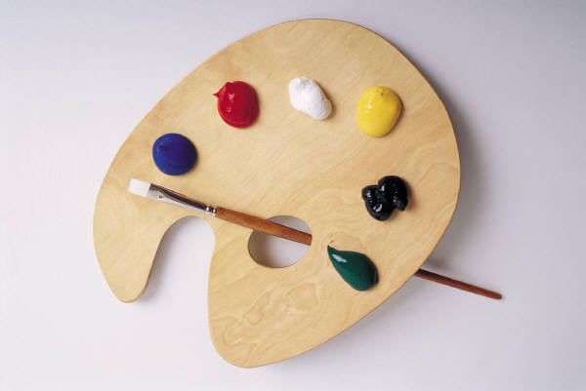  Saturday 27th November at 7.30pm | The Ceramic Experience  Time again for our Christmas bash!  This year we have booked The Ceramic Experience…this includes a chance to create your own art work and enjoy a glass or two of wine and a buffet…let’s show the kids what we mums can do!  Currently in hope Street but it will have moved by then to Ocean Drive, near Ocean Terminal, Leith.  We plan to organise pick up points from different ends of town. Please say on your return form if you would like to be included in the transport arrangements and where you live.  £12 includes cost of wine and buffet. Please pay with return form.  Art to be paid for separately on the night…!
Children’s Christmas Party    Saturday 11th December 10-12pm | The upper Belgrave Hall,  Belgrave Road  Corstorphine  Our annual party for the children. Fun includes entertainer, children’s party food box, music, raffle, games and a present for the children from Santa.  Our special entertainer this year is Gary James and stone the Crow.  £12 per family.  Please include details of all children attending, ages and names, for Santa. Indicate on return form.
Peter Pan    Sunday 23rd January at 11am | Dominion Cinema, Newbattle Terrace, Morningside  Tuck up at the cosy Dominion for a showing of the Disney classic - Peter Pan.  Pop corn at the ready!  Please pay £3 per person on booking and return with your form.

Please can you also indicate on your return any suggestions for next year’s social events?

What could you recommend or suggest?
What would you like to try?
Please let us know….it is for you !

Thanks

Vicky and Jenifer

