Issue1: While running the command getting an error “Unable to find vcvarsall.bat”

Issue2: error: command ‘mt.exe’ failed with exit status 31

Agenda: Building C extension in Python

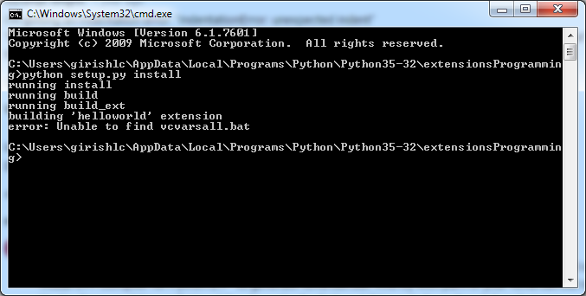

Fix:

* Search for the file vcvarsall.bat, it would be in MS visual studio installation folder

C:\Proram Files(x86)\Microsoft Visual Studio\2017\Professional\VC\Auxiliary\Build

* Update this path in the file msvc9compiler.py which is present in C:\Python27\Lib\distutils\
* In query_vcvarsall(version, arch=’x86’): function,
* vcvarsall = “C:/Proram Files(x86)/Microsoft Visual Studio/2017/Professional/VC/Auxiliary/Build”+”vcvarsall.bat”
* Append ld_args.append('/MANIFEST') line after the below line

    ld_args.append('/MANIFESTFILE:' + temp_manifest)



