Mimica Record (By Elton)

Solution Overview
This solution consists of two major projects:
- Windows Forms Application
- Microsoft Unit Tests
Windows Forms Application
Functionality
The application monitors user interactions via both mouse and keyboard, feeding a queue with captured events. This process depends entirely on user activity on the computer.
A service called EventHookService is responsible for capturing these interactions.
Simultaneously, a background service called ScreenCaptureService takes screenshots every 200ms, keeping only the most recent one in memory. The screenshot interval is configurable via the appsettings.json file.
Whenever an event occurs, it is added to the queue, awaiting storage in the event log on the local disk.
Another background service, CSVEventLogService, dequeues events and saves both screenshots and event logs to the disk. The frequency of this process is also configurable in appsettings.json.

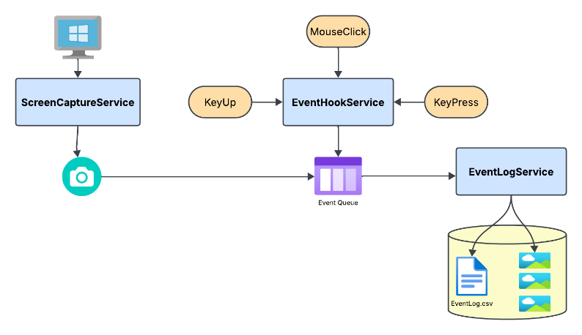
Technical Details
- Dependency Injection (DI): Services are injected into the main application using DI (see Program.cs), allowing seamless replacements (e.g., replacing CSVEventLogService with XMLEventLogService). This also improves testability.
- Parallel Execution: CSVEventLogService and ScreenCaptureService run concurrently.
- Event Queue Processing:
  - EventHookService captures mouse and keyboard events and adds them to a ConcurrentQueue shared between the main thread and CSVEventLogService.
  - Each event is linked to a screenshot before being added to the queue.
  - CSVEventLogService processes queued events, saving screenshots as screenshot_<DateTimeStamp>.png and updating the corresponding event entry with the file path.
  - The event data is then saved in eventlog_<DateStamp>.csv.
Multi-User Support
If multiple users log into the same computer, their logs remain separate.
Storage Location
- Event logs: C:\<user>\Mimica\EventLogs
- Screenshots: C:\<user>\Mimica\ScreenShots
Log Format
The event log files are stored in CSV format, with each entry containing event details along with the corresponding screenshot file path.
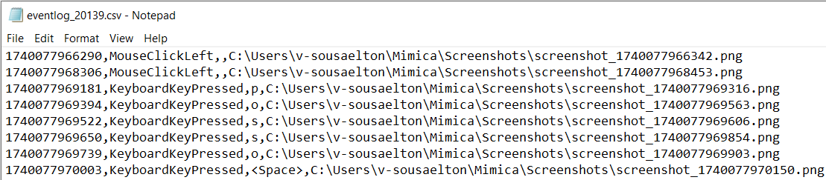
Project Structure
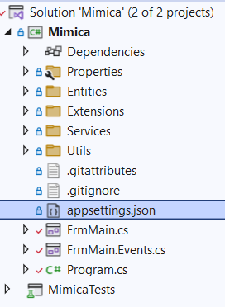
Entities
Contains entity classes (models):
- Event
- EventType
Extensions
Contains extension methods:
- DateTimeExtension
- EventExtension
- NumberExtensions
Services
Contains core services used by the application:
- CSVEventLogService / ICSVEventLogService
- EventHookService / IEventHookService
- ScreenCaptureService / IScreenCaptureService
Utils
Contains static utility classes:
- KeyboardUtil
Windows Forms
The main form's logic and events are organized into separate files:
- FrmMain.cs (Business logic)
- FrmMain.Events.cs (Event handlers)

