Results and Discussion
Descriptive statistics revealed variability in team performance, with total goals conceded ranging from 0 to multiple per match.
The combined bar chart below shows the top 10 teams that conceded the most and the least goals, helping to profile defensive vulnerabilities.
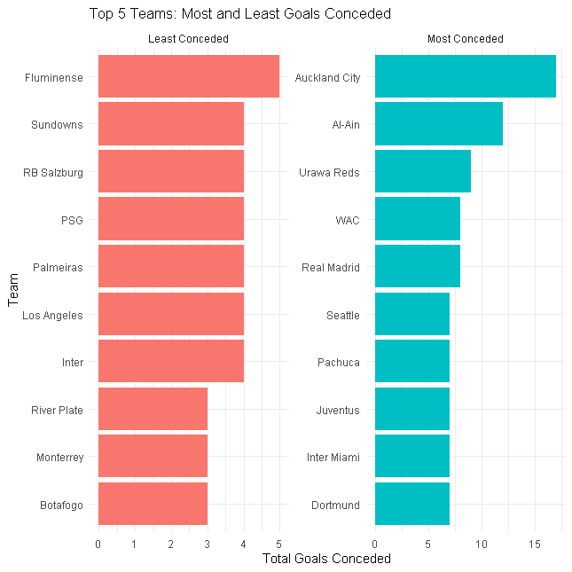
The chart below shows the survival curve for the time of goal concession by the teams that participated in the 2025 FIFA Club World Cup.
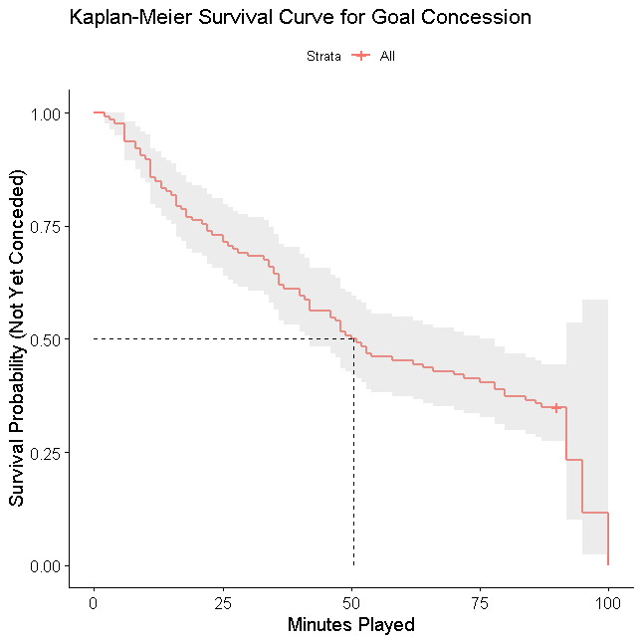
Kaplan-Meier analysis revealed that the probability of not conceding a goal decreases significantly after the 60th minute.
The table below shows the result of the Cox Proportional Hazards model for the selected predictors for time to goal concession.
Covariates | Coefficient | Hazard ratio | p-value | Upper CI | Lower CI
Opponent strength | 0.1041 | 1.1097 | 0.2564 | 0.9271 | 1.3283
Possession of opponent | 0.0160 | 1.0161 | 0.1297 | 0.9953 | 1.0373
Errors leading to shot | -0.0956 | 0.9088 | 0.4261 | 0.7180 | 1.1502
Red card by team | -0.1546 | 0.8568 | 0.6062 | 0.4760 | 1.5421
Free Kicks Conceded | -0.0303 | 0.9701 | 0.2756 | 0.9186 | 1.0245
Corner kicks conceded | -0.0234 | 0.9769 | 0.5939 | 0.8966 | 1.0645
Gk Saves | -0.1792 | 0.8360 | 0.0088 | 0.7311 | 0.9558
Big chances of opponents | 0.3182 | 1.3746 | < 0.0001 | 1.2307 | 1.5353
Interceptions | 0.0093 | 1.0094 | 0.8191 | 0.9318 | 1.0934

The Cox Proportional Hazards model showed that opponent strength, possession of opponent, errors leading to shots and red cards were significant predictors of earlier goal concessions.
The table below shows the result of the proportional hazard assumption test.
Covariates | Chi-square | Degree of freedom | p-value
Opponent strength | 1.9382 | 1 | 0.164
Possession of opponent | 0.0054 | 1 | 0.942
Errors leading to shot | 0.3711 | 1 | 0.542
Red card by team | 3.3185 | 1 | 0.069
Free Kicks Conceded | 0.9446 | 1 | 0.331
Corner kicks conceded | 0.1574 | 1 | 0.692
Gk Saves | 0.2770 | 1 | 0.599
Big chances of opponents | 0.0315 | 1 | 0.859
Interceptions | 1.7018 | 1 | 0.192
GLOBAL | 11.0905 | 9 | 0.270

The proportional hazards assumption was tested and held for the majority of variables.
The findings align with existing sports analytics literature, confirming that situational and disciplinary factors greatly influence defensive outcomes.

