# LISTA DE QUADROS

|  |  |  |
| --- | --- | --- |
| 1 | Teste Tabela. |  |

# LISTA DE FIGURAS

|  |  |  |
| --- | --- | --- |
| 1 | **Mermaid** |  |
| 2 | **Lorem ipsum** |  |

# LISTA DE SIGLAS E ABREVIATURAS

|  |  |  |
| --- | --- | --- |
| 1 | ABNT - Associação Brasileira de Normas Técnicas; |  |
| 2 | APA - American Psychological Association; |  |

# Hello World

## Second level heading

Lorem ipsum dolor sit amet, consectetur adipiscing elit. Sed vitae diam eget risus var (LINKED ART, 2021a).

**undefined 1: Mermaid**

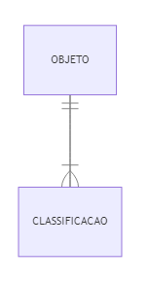

**Fonte:** Elaborado pelo autor.

### Third level heading

Lorem ipsum dolor sit amet, consectetur adipiscing elit. Sed vitae diam eget risus var. (LINKED ART, 2021a)

#### Fourth level heading

Lorem ipsum dolor sit amet, consectetur adipiscing elit. Sed vitae diam eget risus var. (LINKED ART, 2021b)

##### Fifth level heading

Lorem ipsum dolor sit amet, consectetur adipiscing elit. Sed vitae diam eget risus var. (LINKED ART, 2021a, 2021b)

###### Sixth level heading

Lorem ipsum dolor sit amet, consectetur adipiscing elit. Sed vitae diam eget risus var.

**undefined 2: Lorem ipsum**

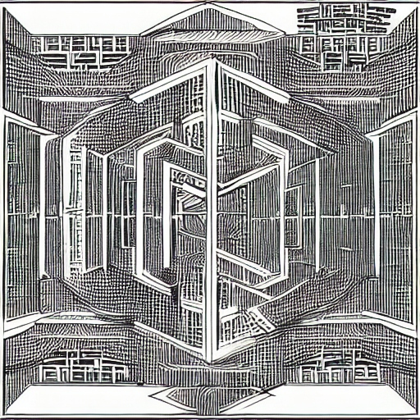

Lorem ipsum

# First level

undefined 1: Teste Tabela.

| Name | ID |
| --- | --- |
| John Doe | 1 |
| John Smith | 3 |

Fonte: Elaborado pelo autor.

## Second level

### Third level

rock bottom.

# Referências

LINKED ART. **Linked Art**. 2021a. Disponível em: https://linked.art/. Acesso em: 20 maio. 2023.

LINKED ART. **Community - Linked Art**. 2021b. Disponível em: https://linked.art/community/. Acesso em: 20 maio. 2023.