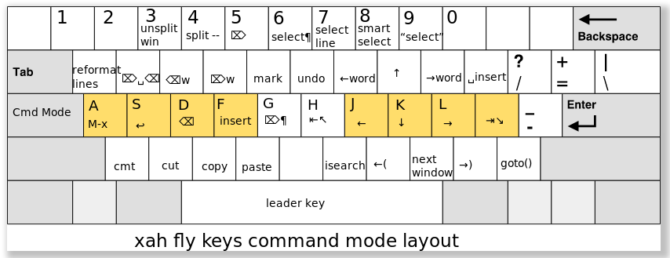
`xah-fly-keys' Minor Mode Bindings:

key binding
--- -------

C-a mark-whole-buffer
C-d pop-global-mark
C-n xah-new-empty-buffer
C-o find-file
C-s save-buffer
C-t xah-pop-local-mark-ring
C-v yank
C-w xah-close-current-buffer
C-z undo
ESC Prefix Command
SPC xah-fly-leader-key-map
' xah-cycle-hyphen-underscore-space
, xah-next-window-or-frame
- xah-backward-punct
. xah-forward-right-bracket
/ xah-goto-matching-bracket
0 xah-pop-local-mark-ring
1 xah-extend-selection
2 xah-select-line
3 delete-other-windows
4 split-window-below
5 delete-char
6 xah-select-block
7 xah-select-line
8 xah-extend-selection
9 xah-select-text-in-quote
; xah-end-of-line-or-block
= xah-forward-punct
[ hippie-expand
` other-frame
a helm-M-x
b xah-toggle-letter-case
c xah-copy-line-or-region
d xah-delete-backward-char-or-bracket-text
e xah-backward-kill-word
f xah-fly-insert-mode-activate
g xah-delete-current-text-block
h xah-beginning-of-line-or-block
i previous-line
j backward-char
k next-line
l forward-char
m xah-backward-left-bracket
n isearch-forward
o forward-word
p xah-insert-space-before
q xah-reformat-lines
r xah-kill-word
s open-line
t set-mark-command
u backward-word
v xah-paste-or-paste-previous
w xah-shrink-whitespaces
x xah-cut-line-or-region
y undo
z xah-comment-dwim
C-+ text-scale-increase
C-- text-scale-decrease
C-0 scroll-up-command
C-1 xah-next-user-buffer
C-2 xah-previous-user-buffer
C-3 previous-error
C-4 next-error
C-5 xah-previous-emacs-buffer
C-6 xah-next-emacs-buffer
C-7 xah-previous-user-buffer
C-8 xah-next-user-buffer
C-9 scroll-down-command
<f8> xah-fly-command-mode-activate-no-hook
<f9> Prefix Command
<f11> xah-previous-user-buffer
<f12> xah-next-user-buffer
<home> xah-fly-command-mode-activate
<menu> xah-fly-command-mode-activate

