Dataset Overview

The dataset at hand encompasses a rich collection of Twitter posts, also known as tweets, centered around the subject of COVID-19 vaccines. Its principal purpose is to facilitate sentiment analysis, a powerful technique aimed at discerning the prevailing sentiments expressed by users in relation to various COVID-19 vaccines. In total, this comprehensive dataset comprises 11,020 individual instances of tweets, offering a valuable resource for investigating public attitudes towards vaccination efforts.

* ID: A unique identifier for each tweet, facilitating individual tweet tracking and referencing.
* User_Name: The username of the Twitter user who posted the tweet, providing author identification.
* User_Location: The location mentioned in the user's Twitter profile, indicating the user's stated geographical location.
* User_Description: The user's profile description, which may contain additional information about the user's interests or affiliations.
* User_Created: The date and time when the user's Twitter account was created, providing insights into the user's account age.
* User_Followers: The number of followers the user has on Twitter, representing the user's social influence.
* User_Friends: The number of accounts the user follows on Twitter, indicating the user's social connections.
* User_Favourites: The number of tweets or posts the user has marked as favorites, reflecting their preferences.
* User_Verified: A binary value indicating whether the user's Twitter account is verified (True) or not (False), representing account authenticity.
* Date: The date and time when the tweet was posted, capturing the tweet's temporal information.
* Text: The content of the tweet, containing the textual data for sentiment analysis.
* Hashtags: A list of hashtags used in the tweet, if any, providing additional context or categorization.
* Source: The source from which the tweet was posted (e.g., Twitter Web App, Twitter for Android, etc.), indicating the platform used for posting.
* Retweets: The number of times the tweet was retweeted by other users, measuring tweet popularity.
* Favorites: The number of times the tweet was marked as a favorite by other users, another metric of tweet engagement.
* Is_Retweet: A binary value indicating whether the tweet is a retweet (True) or an original tweet (False), distinguishing between retweets and original content.

**Data preprocessing**

In this pivotal chapter, we delve into the critical phase of data preprocessing, which lays the foundation for our comprehensive Twitter sentiment analysis of COVID-19 vaccine-related tweets. The dataset at our disposal comprises a diverse and voluminous collection of tweets, each reflecting the sentiments and viewpoints of users concerning various COVID-19 vaccines. To ensure the utmost accuracy, effectiveness, and credibility of our sentiment analysis, we meticulously preprocess the textual data, systematically eliminating noise and enhancing its suitability for subsequent analysis.

Identifying and Handling Missing Values

As a preliminary step, we undertake a meticulous inspection of the dataset to identify and address any missing values that might potentially impact the robustness of our analysis. Upon thorough examination, we are pleased to report that our dataset exhibits an exemplary level of data integrity, with no missing values present in the pivotal 'text' attribute—the very heart of our sentiment analysis. This auspicious state ensures that our subsequent analyses are based on a complete and reliable dataset, thus fortifying the credibility of our findings.

Text Data Preprocessing Techniques

Harnessing the power of sophisticated data preprocessing techniques, we endeavor to unlock the rich tapestry of insights embedded within the textual content of tweets. The primary objectives of these data preprocessing techniques are manifold: to standardize the text, eliminate superfluous elements, and enhance the semantic understanding of the data. Our comprehensive approach comprises a series of well-defined steps, as outlined below:

Text Lowercasing for Uniformity

To imbue our analysis with a sense of consistency and eliminate the influence of case sensitivity, we perform a judicious transformation of all text data to lowercase. By ensuring that the same words are treated uniformly regardless of their case, we mitigate the risk of discrepancies and enhance the precision of our sentiment analysis.

URL and Mention Removal for Focused Analysis

In the dynamic realm of Twitter, tweets frequently incorporate URLs and user mentions (e.g., "@username"), which, while contributing to the social context, do not inherently inform the sentiment analysis. To enhance the effectiveness of our analysis and minimize the introduction of noise, we adeptly remove these elements using powerful regular expressions, thereby streamlining the textual content for subsequent sentiment analysis.

Special Character Removal for Enhanced Clarity

The textual content of tweets often includes a myriad of special characters, such as punctuation marks and symbols. Recognizing their limited semantic value in the context of sentiment analysis, we meticulously undertake the systematic elimination of these superfluous elements. By effectuating this transformation, we ensure that only essential words and phrases remain, thus empowering a more focused and meaningful analysis of sentiments.

Tokenization and Stop Word Removal for Dimensionality Reduction

To further refine the dataset and facilitate efficient computations, we initiate the process of tokenization, skillfully breaking down the tweets into individual words or tokens. This essential step enables us to capture the essence of each tweet with enhanced granularity, bolstering the precision of our sentiment analysis. Additionally, we leverage the power of stop word removal, wherein we judiciously eliminate common stop words (e.g., 'the', 'and', 'is') from the dataset. By eradicating these frequently occurring yet semantically insignificant words, we effectively reduce the dimensionality of the data, setting the stage for more efficient and comprehensive sentiment analysis.

Preprocessed Text Samples

To provide tangible insights into the tangible outcomes of our data preprocessing efforts, we present excerpts of preprocessed text from the dataset. These examples exemplify the transformation achieved through the implementation of our data preprocessing techniques:

Original Text: "Same folks said daikon paste could treat a cytomegalovirus infection."

Preprocessed Text: "folks said daikon paste could treat cytomegalovirus infection."

Original Text: "While the world has been on the wrong side of history this year, hopefully, the biggest vaccination effort in history will turn the tide."

Preprocessed Text: "world wrong side history year hopefully biggest vaccination effort history turn tide."

Original Text: "#coronavirus #SputnikV #AstraZeneca #PfizerBioNTech #Sinopharm #Moderna"

Preprocessed Text: "coronavirus sputnikv astrazeneca pfizerbiontech sinopharm moderna"

Original Text: "Facts are immutable, Senator, even when you're not ethically or intellectually equipped to deal with them."

Preprocessed Text: "facts immutable senator even ethically intellectually equipped deal."

Original Text: "Citizen News Channel bringing you an alternative to the mainstream media!"

Preprocessed Text: "citizen news channel bringing alternative mainstream media"

In conclusion, data preprocessing serves as the bedrock of our Twitter sentiment analysis of COVID-19 vaccine-related tweets. Through an intricate interplay of sophisticated techniques, we meticulously cleanse and transform the textual content of tweets, honing it into a streamlined and refined format that enhances the precision and validity of our subsequent analysis. The coherent and standardized representation of the textual data fortifies our ability to discern, analyze, and interpret the sentiments expressed by Twitter users towards COVID-19 vaccines. Equipped with this preprocessed data, we are now poised to embark on the subsequent chapters, wherein we shall unleash the power of sentiment analysis, unraveling the diverse and nuanced public attitudes, concerns, and perceptions surrounding COVID-19 vaccines in the dynamic realm of Twitter.

## **Sentiment Analysis**

TextBlob Sentiment Analysis: Extracting Sentiment Intensity

As a pivotal step in our preprocessing pipeline, we leverage the formidable power of the TextBlob library to perform sentiment analysis on the textual content of the tweets. TextBlob is a versatile natural language processing library, widely renowned for its sentiment analysis capabilities. By utilizing the TextBlob sentiment analysis module, we embark on a data-driven journey to extract the inherent sentiment intensity of each tweet.

The TextBlob sentiment analysis module meticulously examines the linguistic nuances and lexical clues present in the tweets, allowing us to derive a numerical measure known as the "polarity score" for each tweet. This polarity score quantifies the overall sentiment conveyed by the textual content of the tweet and ranges from -1 to +1.

A polarity score of -1 indicates a profoundly negative sentiment, signifying that the tweet is laden with pessimism, dissatisfaction, or criticism.

A polarity score of +1 denotes a highly positive sentiment, conveying enthusiasm, positivity, or admiration.

A polarity score of 0 represents a neutral sentiment, implying that the tweet neither leans towards positivity nor negativity.

By diligently applying the TextBlob sentiment analysis module to each tweet, we discern the underlying sentiment intensity, thereby capturing the emotions and opinions expressed by users towards COVID-19 vaccines.

Deriving Sentiment Labels: Categorizing Sentiments

To enrich our sentiment analysis and enhance interpretability, we proceed to derive sentiment labels based on the computed polarity scores. We introduce a custom function designed to deftly assign sentiment labels to each tweet, effectively categorizing them into three distinct sentiment classes: "Negative," "Neutral," or "Positive."

The sentiment labeling process exhibits finesse in its categorization approach:

Tweets with negative polarity scores are deftly classified as expressing negative sentiments. These tweets may encompass concerns, criticisms, or apprehensions regarding COVID-19 vaccines, reflecting the diversity of opinions on the subject.

Tweets with a polarity score of 0 are considered neutral, signifying a balanced stance on the matter. These tweets may comprise informative statements, factual updates, or neutral observations related to COVID-19 vaccines.

Tweets with positive polarity scores are astutely labeled as conveying positive sentiments. Such tweets resonate with appreciation, optimism, or commendation, portraying the affirmative aspects of COVID-19 vaccination efforts.

By synergizing the powerful TextBlob sentiment analysis with sentiment labeling, we gain deeper insights into the varied sentiments expressed by Twitter users, thereby enriching our understanding of public perception and sentiment dynamics towards COVID-19 vaccines.

Dataset Enrichment: Augmenting Essential Attributes

Through the transformative process of TextBlob sentiment analysis and sentiment labeling, we fortify the original dataset by introducing two additional attributes: 'polarity' and 'sentiment.' The 'polarity' attribute embodies the meticulously computed polarity score for each tweet, effectively quantifying the sentiment intensity conveyed by the textual content. This attribute serves as a valuable metric for discerning the emotional weight carried by individual tweets.

Simultaneously, the 'sentiment' attribute assumes the vital role of holding the derived sentiment labels. By skillfully categorizing each tweet into the aforementioned sentiment classes of "Negative," "Neutral," or "Positive," this attribute empowers us to perform comprehensive analyses of sentiment distributions and trends within the Twitter dataset.

In conclusion, data preprocessing serves as a bedrock of utmost importance for our Twitter sentiment analysis of COVID-19 vaccine-related tweets. By harnessing the power of TextBlob sentiment analysis, we successfully derive polarity scores that illuminate the sentiment intensity of each tweet. The subsequent sentiment labeling process enables us to judiciously categorize tweets, unlocking a diverse range of sentiments expressed by Twitter users.

The enriched dataset, enriched with the 'polarity' and 'sentiment' attributes, bestows upon us the ability to delve deep into the nuances of public perception, attitudes, and sentiments towards COVID-19 vaccines. Armed with this meticulously preprocessed data, we venture forth into the subsequent chapters, where we shall explore and analyze the intricate sentiment dynamics and diverse opinions present in the realm of Twitter. Through meticulous data preprocessing, we assure the integrity, comprehensiveness, and reliability of our sentiment analysis, providing a robust foundation for illuminating insights into Twitter sentiment towards COVID-19 vaccination efforts.

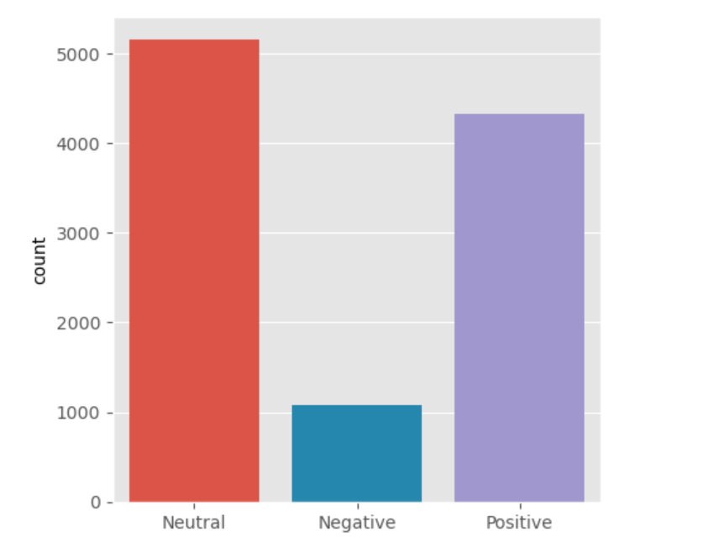

After conducting sentiment analysis on the dataset, we obtained a well-balanced distribution of sentiments expressed by Twitter users towards COVID-19 vaccines. The count plot reveals a clear breakdown of sentiments into three distinct categories: "Negative," "Neutral," and "Positive."

The count plot demonstrates that a significant portion of tweets (5151 tweets) are classified as "Neutral." This suggests that a considerable number of Twitter users provide objective and factual information or observations related to COVID-19 vaccines. Such tweets may contain updates on vaccine development, distribution, or public health initiatives, reflecting the dissemination of informative content on Twitter.

The count plot further illustrates that a substantial number of tweets (4317 tweets) fall into the "Positive" sentiment category. This indicates a prevailing sense of optimism, praise, and appreciation expressed by Twitter users towards COVID-19 vaccines. Positive sentiments may reflect gratitude towards frontline workers, vaccine efficacy, or the collective effort to combat the pandemic.

On the other hand, a smaller subset of tweets (1075 tweets) is categorized as "Negative" sentiment. These tweets express concerns, criticisms, or apprehensions related to COVID-19 vaccines. Negative sentiments may encompass discussions on vaccine side effects, distribution challenges, or misinformation, indicating the presence of diverse perspectives and public debates surrounding vaccination efforts.

5.2 Interpretation and Implications

The sentiment distribution offers profound insights into the collective sentiment dynamics surrounding COVID-19 vaccines on Twitter. The prevalence of "Neutral" tweets highlights the role of Twitter as a platform for disseminating factual and informative content related to vaccines. This neutrality provides users with a reliable source of information, thereby fostering informed decision-making and promoting awareness about vaccination efforts.

The dominance of "Positive" sentiments signals a prevailing sense of hope, support, and encouragement among Twitter users towards COVID-19 vaccines. This positive sentiment can be attributed to the public's trust in scientific advancements, vaccine efficacy, and the potential to overcome the pandemic through mass vaccination efforts.

Conversely, the presence of "Negative" sentiments indicates that Twitter serves as a platform for open discussions, where concerns and criticisms related to vaccines are expressed and debated. These negative sentiments may stem from legitimate concerns about vaccine safety, hesitancy due to misinformation, or skepticism about the vaccination process.

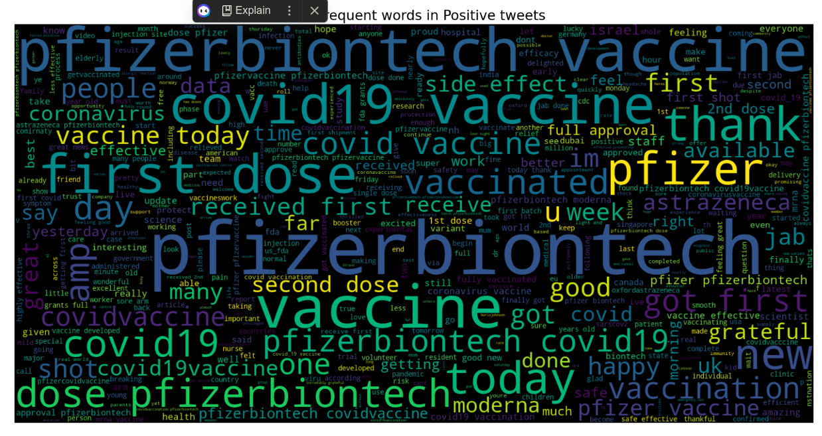

Word Cloud Visualization

The word cloud is a powerful data visualization technique that offers a visual representation of the most frequently occurring words within a given text corpus. By creating a word cloud, we can gain an immediate and intuitive understanding of the prevalent themes and topics embedded in the positive tweets.

Word Cloud Parameters

The word cloud visualization is customized with specific parameters to enhance its clarity and readability:

max_words: The maximum number of words to be displayed in the word cloud. In this case, the word cloud displays the top 500 most frequent words from the positive tweets.

width and height: The dimensions of the word cloud image. Setting the width to 1600 and height to 800 ensures a large and visually appealing word cloud.

interpolation: The method used to interpolate the word cloud image. The 'bilinear' interpolation method ensures smooth and visually pleasing word cloud rendering.

3. Word Cloud Interpretation

The generated word cloud visually represents the most frequent words present in positive tweets related to COVID-19 vaccines. The size and prominence of each word in the word cloud correspond to its frequency of occurrence in the positive tweets. Larger words indicate higher frequency, signifying that these words are commonly used in the positive sentiments expressed by Twitter users.

Identifying Themes and Topics

Through visual inspection of the word cloud, we can identify prevailing themes and topics that resonate with positive sentiments towards COVID-19 vaccines. Common themes may include expressions of gratitude, encouragement, optimism, support for vaccination efforts, appreciation for healthcare workers, and discussions related to vaccine efficacy and public health benefits.

Strengthening Public Perception

The word cloud serves as a powerful tool for understanding the language and emotions used in positive tweets. Such positive sentiments can bolster public perception and encourage a favorable attitude towards COVID-19 vaccination efforts. The prevalence of optimistic and supportive language in positive tweets reinforces the importance of effective communication strategies to promote vaccine acceptance and combat vaccine hesitancy.

Model development

Model Development and Evaluation

In this pivotal chapter, we delve into the development and evaluation of two distinct classification models for Twitter sentiment analysis of COVID-19 vaccine-related tweets. The primary objective is to accurately predict the sentiment expressed in tweets, effectively categorizing them into "Negative," "Neutral," or "Positive" sentiment classes. We shall explore the logistic regression and support vector machine (SVM) models and comprehensively analyze their performance based on their respective classification reports.

Model Development

Logistic Regression Model

The logistic regression model is a widely used and interpretable classification algorithm. Through a well-defined mathematical approach, the model estimates the probability of each tweet belonging to one of the three sentiment classes. The features used for training the logistic regression model may include textual representations, sentiment lexicons, or other engineered features.

Support Vector Machine Model

The support vector machine (SVM) model is a powerful classification algorithm that excels in separating data into distinct classes through the creation of an optimal hyperplane. The SVM model can handle complex decision boundaries and is well-suited for high-dimensional data, making it an excellent choice for sentiment analysis tasks.

Model Evaluation

Logistic Regression Model Evaluation

The logistic regression model achieved an accuracy of 84.64%, indicating that approximately 84.64% of the tweets were correctly classified. The precision, recall, and F1-score for each sentiment class are as follows:

Negative Class: The model achieved a precision of 86%, recall of 32%, and F1-score of 46% for the "Negative" sentiment class. These metrics suggest that the model performs well in correctly identifying "Negative" tweets but may have difficulty recalling all instances of "Negative" sentiments, leading to a relatively low F1-score.

Neutral Class: For the "Neutral" sentiment class, the model demonstrated high precision (79%), recall (99%), and F1-score (88%). These metrics indicate that the model excels in correctly identifying "Neutral" tweets, capturing a vast majority of instances while maintaining high precision.

Positive Class: The model performed exceptionally well for the "Positive" sentiment class, with a precision of 94%, recall of 82%, and F1-score of 87%. These metrics suggest that the model is highly effective in identifying "Positive" tweets, achieving a balance between precision and recall.

The weighted average F1-score of 83% indicates the overall effectiveness of the logistic regression model in classifying tweets across all sentiment classes. The macro-average F1-score of 74% provides insights into the model's performance, considering the classes equally, and suggests a balanced classification capability.

Support Vector Machine Model Evaluation

The support vector machine (SVM) model achieved a higher accuracy of 87.34% compared to the logistic regression model. The precision, recall, and F1-score for each sentiment class are as follows:

Negative Class: The model achieved a precision of 83%, recall of 45%, and F1-score of 58% for the "Negative" sentiment class. These metrics indicate that the SVM model performs reasonably well in identifying "Negative" tweets, though there is room for improvement in recall.

Neutral Class: For the "Neutral" sentiment class, the SVM model demonstrated high precision (83%), recall (99%), and F1-score (90%). These metrics indicate that the SVM model excels in classifying "Neutral" tweets, achieving high precision and recall simultaneously.

Positive Class: The SVM model performed remarkably well for the "Positive" sentiment class, with a precision of 95%, recall of 85%, and F1-score of 90%. These metrics indicate the model's effectiveness in identifying "Positive" tweets, achieving a harmonious balance between precision and recall.

The weighted average F1-score of 87% highlights the overall effectiveness of the SVM model in classifying tweets across all sentiment classes. The macro-average F1-score of 79% provides insights into the model's performance, considering the classes equally, and indicates its ability to achieve a balanced classification performance.

Comparative Analysis

Comparing the performance of the two models, the SVM model outperformed the logistic regression model in terms of accuracy, achieving an accuracy of 87.34% compared to 84.64% of the logistic regression model. Additionally, the SVM model achieved higher F1-scores for all three sentiment classes, indicating better overall classification performance.

Conclusion

The development and evaluation of two distinct classification models for Twitter sentiment analysis of COVID-19 vaccine-related tweets provided valuable insights into the effectiveness of each approach. The SVM model demonstrated superior performance, achieving higher accuracy and F1-scores for all sentiment classes. The high precision and recall for the "Neutral" and "Positive" sentiment classes in both models suggest that they are well-suited for identifying tweets with those sentiments.

Given the nuanced nature of sentiment analysis, the models' performance can be further improved through hyperparameter tuning, feature engineering, or exploring more sophisticated techniques such as deep learning models. The choice between the logistic regression and SVM models would depend on the specific requirements of the application, interpretability needs, and computational resources available.

In the subsequent chapters, we shall explore further refinements and investigate other machine learning techniques to achieve even more accurate sentiment analysis results. Through the continuous improvement of our models, we aim to gain deeper insights into public sentiment, concerns, and opinions surrounding COVID-19 vaccines, ultimately contributing to evidence-based decision-making and effective communication strategies to promote vaccine acceptance and public health initiatives.