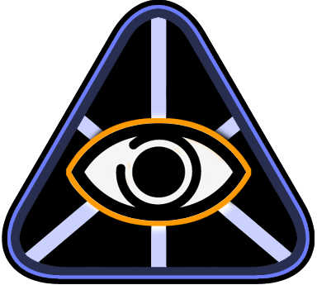

OmniMap API

OpenGL Integration Guide

Version 2.0.3

Last updated: August 15, 2008


Contents

1
OmniMap API 1
OpenGL Integration Guide 1
Overview 3
Intended Audience 3
Developer Requirements 3
Assumptions 3
OmniMap API Components 4
OmniMap API Architecture 5
Demo Program Case Study 6

© 2007 The Elumenati, LLC. All rights reserved. The Elumenati and the Elumenati logo are registered trademarks of The Elumenati, LLC. Other trademarks and brands are the property of their respective owners. The information in this document belongs to The Elumenati, LLC.

Notice of non-liability:
The Elumenati, LLC is providing the information in this document to you AS-IS with all faults. The Elumenati, LLC makes no warranties of any kind (whether express, implied or statutory) with respect to the information contained herein. The Elumenati, LLC assumes no liability for damages (whether direct or indirect), caused by errors or omissions, or resulting from the use of this document or the information contained in this document or resulting from the application or use of the product or service described herein. The Elumenati, LLC reserves the right to make changes to any information herein without further notice.

Please send any questions or comments to support@elumenati.com.

Overview
This document is a guide for integrating the OmniMap Geometry Correction Library API into existing OpenGL applications. The document will provide an overview of the library's architecture, and how it fits into an existing OpenGL application, followed by a case study of the steps required to integrate the OmniMap API into a sample OpenGL program.

For more information, see the OmniMap API Configuration Guide and the OmniMap API Class Documentation included with the OmniMap installer.

Intended Audience
This document is written for programmers interested in implementing geometry correction within their real-time OpenGL application for use with the Elumenati OmniFocus range of products.

Developer Requirements
- Microsoft WindowsXP
- GPU supporting OpenGL 2.0
- Visual Studio 2005

Assumptions
This document assumes the developer has installed the OmniMap API from the installer program OmniMap.msi,and used the default location for the installation. The default installation location for the OmniMap API is:

C:\Program Files\Elumenati\OmniMap

In this document, we will refer to this folder as <InstallationDir>. So if you have chosen to install the OmniMap API in a location other than the default location, <InstallationDir> refers to that location.

OmniMap API Components
The OmniMap API is shipped with documentation, the example program referred to in this document, C++ header files, lib files and corresponding DLLs. The documentation includes this document, the API Configuration document, and detailed class documentation in HTML format.

The class documentation can be found in:
<InstallationDir>/docs/classdocs

The header files are found in:
<InstallationDir>/include

The library files can be found in:
<InstallationDir>/lib

The DLL's can be found in:
<InstallationDir>/bin

The example program can be found in:
<InstallationDir>/examples

OmniMap API Architecture
The OmniMap API is designed to be easily integrated into existing OpenGL applications. The main class that provides the dome rendering functionality is called OmniMap. The OmniMap object is constructed with arguments for the width and height of the final output:

OmniMap omniMapObj = OmniMap::OmniMap(width, height);

To generate a scene for a dome, the OmniMap class needs to call the application's rendering function 3 or 4 times with a modified viewing frustum and viewing angle. The rotation and viewing angles of each channel are dependent upon the dome configuration specified in the Lua script files omnimap_startup.lua, and omnimap_user_edit.lua. Each of these render passes is managed by the OmniMapChannelBase class. In the application where the rendering of a single frame is done, a call is made to the OmniMap object telling the OmniMap object which function to call for rendering a single channel. That call looks like:

omniMapObj->ForEachChannel(renderFunction);

where renderFunction is a pointer to a function that takes a pointer to an OmniMapChannelBase object as an argument:

void renderFunction(OmniMapChannelBase *channel);

ForEachChannel will call the renderFunction once for each channel. Prior to making that call, the OpenGL projection matrix has been set to the projection required to render the channel, and the OpenGL Modelview matrix has been set to the correct rotation to render the channel. The application programmer can access these values through the OmniMapChannelBase class interface. As each channel is rendered, the resulting image is placed into an OpenGL texture.

When all channels have been rendered, the application calls:

omniMapObj->PostRender()

This method will composite the channels and spherically project them onto the display.

Demo Program Case Study
This section describes what was done to create the project file for the Demo project located in:
<InstallationDir>\examples\demo\demo_dome_enabled\Source

- Open Visual Studio Workspace File
  - Open the Visual Studio Workspace for the dome enabled Demo program by double-clicking on “Demo.sln” in this directory.

- Add OmniMap include Directory.
  - Using the properties dialog for the Demo project, we first added the include path for the OmniMap API include files to the property:
Configuration Properties
C/C++
General
Additional Include Directories

That path is :
<InstallationDir>\include
In the project file, it is referenced relative to the Source directory. It is
refererenced as ../../../../include.

- Add OmniMap API Directory
  - Using the same properties dialog, we then added the library path for the OmniMap API library files to the property:
Configuration Properties
Linker
General
Additional Library Directories

That path is :
<InstallationDir>\lib
In the project file, it is referenced relative to the Source directory. It is
referenced as ../../../../lib.

- Add OmniMap library dependency.
  - Finally, using the same properties dialog, we added the OmniMap library to the list of libraries to link with the Demo application. That property is:
Configuration Properties
Linker
Input
Additional Dependencies

That library is OmniMap.lib for the Release configuration, and OmniMapD.lib for
the Debug configuration.

- Edit “Basecode.cpp”
  - The changes to the code are shown in the example program in <InstallationDir>\examples\demo\demo_dome_enabled\Source
The changes made for OmniMap integration are commented and surrouned by
#if defined(USE_OMNIMAP)
#endif
  - The changes include the following:
    - Add Omnimap header file
    - Add glew header file
    - Nest render() function - or display() function – inside the fun() function. The fun() funcion will be called once for each OmniMap render channel. The application programmer is required to call the following methods in the sequence shown here:
// Push matrices, set projection, model view matrix
// enable frame buffer object for this channel’s rendering
chan->beginRenderToChannel();
// The application’s rendering code
Render();
// Pop matrices, disable frame buffer object
chan->endRenderToChannel();

The rest of the code shown in the example is for demonstration purposes, but is not
required.

    - Update quit() and resize() functions.
    - Update the render function (or display code) to insure that all rendering calls happen inside the render function AND that all scene updates happen outside the render function.
    - Set up the render channel.
    - Replace the display code in the main loop with the Omnimap display code.
    - Delete Fullscreen message box – if present
    - Create the Omnimap object
    - Compile and Run.
- Set Omnimap Parameters
  - For details on setting OmniMap parameters, see the OmniMap Configuration Guide. OminMap parameters control where the projector is located, the direction of the projector, the orientation of the display and other configurable parameters. The parameters are set using Lua scripts. The default location of the configuration files is a directory called OmniMapConfig, located in the working directory of the program. The OmniMap library looks for a file called OmniMapConfig/omnimap_startup.lua. The location or name of that file can be changed using the 3rd argument to the OmniMap class constructor. There are two other LUA files referred to by OmniMapConfig/omnimap_startup.lua in the OmniMapConfif directory: omnimap_user_edit.lua, and omnimap_dome_wiz_ai.lua. If these files are not in the directory called OmniMapConfig, then the reference to them must be modified in OmniMapConfig/omnimap_startup.lua. The lines to be changed are:
Dofile(“OmniMapConfig/omnimap_user_edit.lua”)
Dofile(“OmniMapConfig/omnimap_dome_wiz_ai.lua”)
The parameters to the dofile call must be the correct paths to the two files.
  - Omnimap Coordinate System: Right Hand Rule where the X-vector is to the RIGHT, the Y-vector is UP and the Z-vector is AWAY from the user’s gaze. The images below show the coord system in both a horizontal and vertical dome.

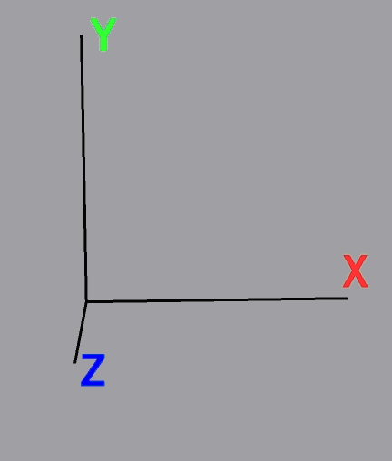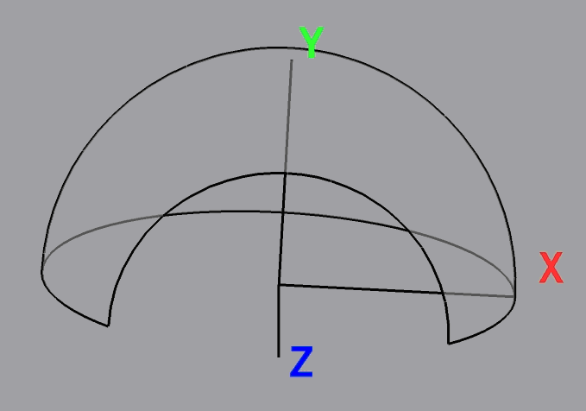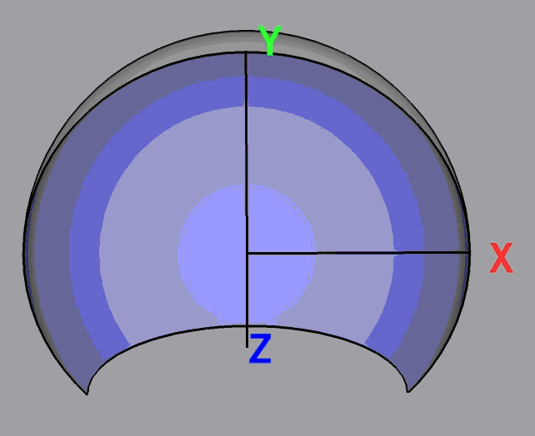

  - Parameters like dome style (horizontal, vertical), number of render channels and projector and audience position are set in the Lua (ASCII) file omnimap_startup.lua in the <InstallationDir>\bin\OmniMapConfig directory.
  - The most common parameters however have been assembled into more the file omnimap_user_edit.lua in the same directory.
  - Run the program. Make sure that the directory containing the OmniMap DLLs is in your path. The directory is <InstallationDir>\bin.

