Omnimap Geometry Correction Lib

Internal copy released to SCISS

Do not distribute

Developer Requirements

WindowsXP

New Nvidia GPU

Visual Studio 2005

Extract hallway.rar

Extract omnimap.rar into the source directory

There are three directories created

A lib directory

A include directory

And a config directory

Plus some dll files are extracted into the main directory

Setting Up the Visual Studio Workspace

Go to the property page of the workspace

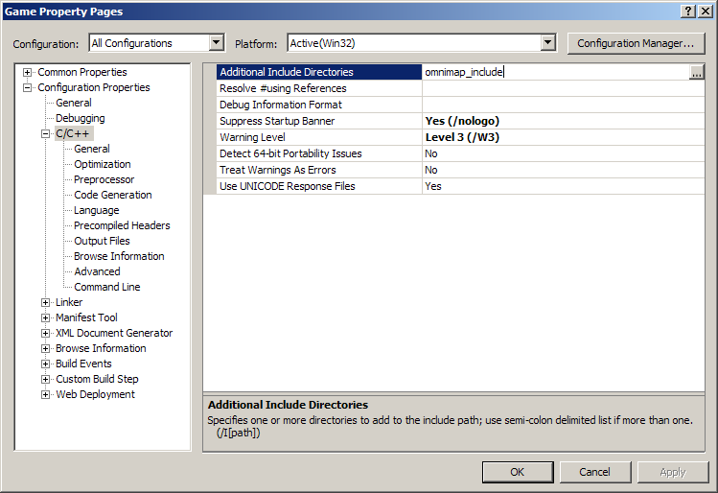

Add omnimap_include as an additional include directory

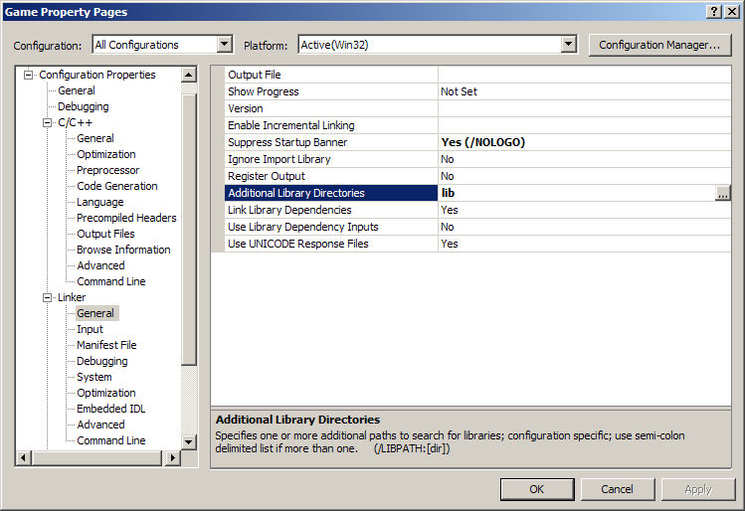

Add lib as an additional library directory

Edit Basecode.cpp

// ** SYSTEM LIBRARIES **
// ----------------------
#pragma comment(lib, "opengl32.lib")
#pragma comment(lib, "glu32.lib")
#pragma comment(lib, "glaux.lib")
#pragma comment(lib, "winmm.lib") // Sound

#include "omnimap.h"
// ** SYSTEM HEADER FILES **
// -------------------------
#include <gl\glew.h>
#include <windows.h>
#include <gl\gl.h>
#include <gl\glu.h>
#include <stdio.h>

OmniMap *OmnimapLib=0;

void Render();
void SetupRenderChannelTextureContext();

void fun(pOmniMap_Channel chan)
{

chan->beginRenderToChannel();
gluPerspective(120.0f, (float)OmnimapLib->resWidth / (float)OmnimapLib->resHeight, 2, 150.0f);
// Aspect ratio of window
SetupRenderChannelTextureContext();
Render();
chan->endRenderToChannel();

}

// ** DECLARATIONS **
// ------------------
HDC hDC = NULL; // Device context
HGLRC hRC = NULL; // Rendering context
HWND hWnd = NULL; // Window handle
HINSTANCE hInstance; // Instance of application

int SCREEN_WIDTH = 1024;
int SCREEN_HEIGHT = 768;
int SCREEN_DEPTH = 16;

bool active = true;
bool fullScreen = true;

float frameInterval = 0.0f;

// ** FUNCTION PROTOTYPES **
// -------------------------

// Misc
LRESULT CALLBACK WndProc(HWND, UINT, WPARAM, LPARAM);

// Map
void LoadGLTextures();
void LoadMap();
void RenderScene();

// FX
void RenderSteam(float);
void RenderBubbles(float, int, float);
void RenderSpace(float);
void RenderFade(float);
void RenderDoors();

// Movement
void OpenDoor(float);
void MoveCamera(float);

// ** RESIZE SCREEN **
// -------------------
void ReSizeScreen(int width, int height)
{
// Prevent a divide by zero
if (height == 0)
{
height = 1;
}

// (x, y, width, height)
glViewport(0, 0, width, height); // Viewport wholescreen, could make smaller
glMatrixMode(GL_PROJECTION); // Set projection matrix
glLoadIdentity(); // Reset projection matrix

// NOTE: FOV below is set to 90 to give impression tunnel is longer than it actually is,
// normally this would be 45 degrees.

// (FOV, width -> height ratio, closest clip, furthest clip)
gluPerspective(90.0f, (float)width / (float)height, 2, 150.0f); // Aspect ratio of window

glMatrixMode(GL_MODELVIEW); // Set modelview matrix
glLoadIdentity(); // Reset modelview matrix

if(OmnimapLib)
{
OmnimapLib->resWidth =width;
OmnimapLib->resHeight =height;
OmnimapLib->ScriptingEngine->RunString("onResize()");
OmnimapLib->ScriptingEngine->RunString("ConsolePrintString(\"calling onResize() after switching to res %d,%d\")",width,height);
}

}

// ** INITIALISE OPENGL **
// -----------------------
int InitOpenGL()
{
glEnable(GL_TEXTURE_2D); // Enable texture mapping

glBlendFunc(GL_SRC_ALPHA,GL_ONE); // Set blending function for translucency
glShadeModel(GL_SMOOTH); // Enable smooth shading
glClearColor(0.0f, 0.0f, 0.0f, 1.0f); // Background
glClearDepth(1.0f); // Depth buffer
glEnable(GL_DEPTH_TEST); // Enable depth testing
glDepthFunc(GL_LESS); // Type of depth testing
glHint(GL_PERSPECTIVE_CORRECTION_HINT, GL_NICEST); // Perspective calculations

// Load from files
LoadGLTextures();
LoadMap();

// Fogging
float fogColor[4] = {0.0f, 0.0f, 0.0f, 1.0f};

glFogi (GL_FOG_MODE, GL_LINEAR); // Type of fogging
glFogfv (GL_FOG_COLOR, fogColor); // Fog colour (black)
glFogf (GL_FOG_DENSITY, 0.2f); // Density
glHint (GL_FOG_HINT, GL_DONT_CARE); // Perspective calculations
glFogf (GL_FOG_START, 120.0f); // Start of fogging from camera
glFogf (GL_FOG_END, 150.0f); // End of fogging
glEnable(GL_FOG); // Enable fogging

// Env Mapping
glTexGeni(GL_S, GL_TEXTURE_GEN_MODE, GL_SPHERE_MAP); // Set sphere texture generation mapping for S
glTexGeni(GL_T, GL_TEXTURE_GEN_MODE, GL_SPHERE_MAP); // Set sphere texture generation mapping for T

PlaySound("audio/music.wav", NULL, SND_FILENAME | SND_ASYNC | SND_LOOP); // Play music loop

return true;
}

// ** DE-INITIALISE OPENGL & WINDOW **
// -----------------------------------
void DeInit()
{
// Stop audio
PlaySound(NULL, NULL, SND_PURGE);

// Return to desktop
if (fullScreen)
{
ChangeDisplaySettings(NULL, 0);
ShowCursor(true);
}

// Release and delete RC
if (hRC)
{
if (!wglMakeCurrent(NULL, NULL))
MessageBox(NULL, "Failed to release DC & RC", "DoH!", MB_OK | MB_ICONEXCLAMATION);
if (!wglDeleteContext(hRC))
MessageBox(NULL, "Failed to release rendering context", "DoH!", MB_OK | MB_ICONEXCLAMATION);

hRC = NULL;
}

// Release DC
if (hDC && !ReleaseDC(hWnd, hDC))
{
MessageBox(NULL, "Failed to release device context", "DoH!", MB_OK | MB_ICONEXCLAMATION);
hDC = NULL;
}

// Destroy window
if (hWnd && !DestroyWindow(hWnd))
{
MessageBox(NULL, "Failed to release hWnd", "DoH!", MB_OK | MB_ICONEXCLAMATION);
hWnd = NULL;
}

// Unregister class
if (!UnregisterClass("Game", hInstance))
{
MessageBox(NULL, "Failed to unregister class", "DoH!", MB_OK | MB_ICONEXCLAMATION);
hInstance = NULL;
}
}

// ** SETUP PIXEL FORMAT **
// ------------------------
bool SetupPixelFormat()
{
int PixelFormat;
static PIXELFORMATDESCRIPTOR pfd= // pfd says how we want the window to be
{
sizeof(PIXELFORMATDESCRIPTOR), // Size of pixel format descriptor
1, // Version number (always 1)
PFD_DRAW_TO_WINDOW | // Format to support window
PFD_SUPPORT_OPENGL | // Format to support opengl
PFD_DOUBLEBUFFER, // Format to support double buffering
PFD_TYPE_RGBA, // Request RGBA format
SCREEN_DEPTH, // Select color depth
0, 0, 0, 0, 0, 0, // Color bits ignored
0, // No alpha buffer
0, // Shift bit ignored
0, // No accumulation buffer
0, 0, 0, 0, // Accumulation bits ignored
16, // 16Bit z-buffer (depth buffer)
0, // No stencil buffer
0, // No auxiliary buffer
PFD_MAIN_PLANE, // Main drawing layer
0, // Reserved
0, 0, 0 // Layer masks ignored
};

// Get a device context
if (!(hDC=GetDC(hWnd)))
{
DeInit();
MessageBox(NULL, "Failed to create a device context", "DoH!", MB_OK|MB_ICONEXCLAMATION);
return false;
}

// Choose a pixel format that best matches above
if (!(PixelFormat=ChoosePixelFormat(hDC,&pfd)))
{
DeInit();
MessageBox(NULL, "Failed to find a suitable pixelformat", "DoH!", MB_OK|MB_ICONEXCLAMATION);
return false;
}

// Set pixel format chosen above
if(!SetPixelFormat(hDC,PixelFormat,&pfd))
{
DeInit();
MessageBox(NULL, "Failed to set the pixelformat", "DoH!", MB_OK|MB_ICONEXCLAMATION);
return false;
}

// Get a rendering context
if (!(hRC=wglCreateContext(hDC)))
{
DeInit();
MessageBox(NULL, "Failed to create a rendering context", "DoH!", MB_OK|MB_ICONEXCLAMATION);
return false;
}

// Activate rendering context
if(!wglMakeCurrent(hDC,hRC))
{
DeInit();
MessageBox(NULL, "Failed to activate the rendering context", "DoH!", MB_OK|MB_ICONEXCLAMATION);
return false;
}

return true;
}

// ** CREATE THE WINDOW **
// -----------------------
bool CreateGLWindow(char* title)
{
WNDCLASS wndClass; // Windows class structure
DWORD dwExStyle; // Windows extended style
DWORD dwStyle; // Windows style
RECT wndRect; // Windows dimensions

wndRect.left = 0;
wndRect.right = SCREEN_WIDTH;
wndRect.top = 0;
wndRect.bottom = SCREEN_HEIGHT;

hInstance = GetModuleHandle(NULL); // Grab an instance for the window

wndClass.style = CS_HREDRAW | // Redraw on horizontal size
CS_VREDRAW | // Redraw on vertical size
CS_OWNDC; // Window has own DC
wndClass.lpfnWndProc = (WNDPROC)WndProc; // Handles the windows messages
wndClass.cbClsExtra = 0; // No extra window data
wndClass.cbWndExtra = 0; // No extra window data
wndClass.hInstance = hInstance; // Set the instance
wndClass.hIcon = LoadIcon(NULL, IDI_WINLOGO); // Default icon
wndClass.hCursor = LoadCursor(NULL, IDC_ARROW); // Default cursor
wndClass.hbrBackground = NULL; // No background
wndClass.lpszMenuName = NULL; // No menu
wndClass.lpszClassName = "Game"; // Class name

if (!RegisterClass(&wndClass)) // Register window class
{
MessageBox(NULL, "Failed to register window class", "DoH!", MB_OK | MB_ICONEXCLAMATION);
return false;
}

if (fullScreen)
{
DEVMODE dmSettings; // Device mode
memset(&dmSettings, 0, sizeof(dmSettings)); // Clear memory
dmSettings.dmSize = sizeof(dmSettings); // Size of devmode structure
dmSettings.dmPelsWidth = SCREEN_WIDTH; // Screen width
dmSettings.dmPelsHeight = SCREEN_HEIGHT; // Screen height
dmSettings.dmBitsPerPel = SCREEN_DEPTH; // Bits per pixel
dmSettings.dmFields = DM_BITSPERPEL |
DM_PELSWIDTH |
DM_PELSHEIGHT;

// Try set selected mode
if (ChangeDisplaySettings(&dmSettings, CDS_FULLSCREEN)!= DISP_CHANGE_SUCCESSFUL)
{
if (MessageBox(NULL, "Fullscreen mode not supported by your video card\nDo you want to use windowed mode instead?",
"Screen mode", MB_YESNO | MB_ICONQUESTION)==IDYES)
{
fullScreen = false;
}
else
{
return false;
}
}
}

if (fullScreen) // If still in fullscreen
{
dwExStyle = WS_EX_APPWINDOW; // Window extended style
dwStyle = WS_POPUP; // Window style
ShowCursor(false);
}
else
{
dwExStyle = WS_EX_APPWINDOW | WS_EX_WINDOWEDGE; // Window extended style
dwStyle = WS_OVERLAPPEDWINDOW; // Window style
}

AdjustWindowRectEx(&wndRect, dwStyle, false, dwExStyle); // Adjust window to size

// Create the window
if (!(hWnd = CreateWindowEx(dwExStyle, // Extended style
"Game", // Class name
title, // Window title
dwStyle | // Defined window style
WS_CLIPSIBLINGS | // Required window style
WS_CLIPCHILDREN, // Required window style
0, 0, // Window position
wndRect.right - wndRect.left, // Window width
wndRect.bottom - wndRect.top, // Window height
NULL, // No parent window
NULL, // No menu
hInstance, // Instance
NULL))) // Don't pass anything to WM_CREATE
{
DeInit();
MessageBox(NULL, "Failed to create window", "DoH!", MB_OK | MB_ICONEXCLAMATION);
return false;
}

// Setup the pixel format
if (!SetupPixelFormat())
{
return false;
}

// Finalise window
ShowWindow(hWnd, SW_SHOW);
SetForegroundWindow(hWnd);
SetFocus(hWnd);
ReSizeScreen(SCREEN_WIDTH, SCREEN_HEIGHT);

// Initialise opengl
if (!InitOpenGL())
{
DeInit();
MessageBox(hWnd, "Failed to initialise", "DoH!", MB_OK | MB_ICONEXCLAMATION);
return false;
}

return true;
}

// ** CALCULATE FRAMERATE **
// -------------------------
void CalculateFrameRate()
{
static float FPS = 0.0f; // Frames per second
static float lastTime = 0.0f; // Time from last frame
static float frameTime = 0.0f; // Current frame time
char strFrameRate[10] = {0}; // Window title

// Get current time in seconds
float currentTime = GetTickCount() * 0.001f;

// Set frame individual
frameInterval = currentTime - frameTime;
frameTime = currentTime;

// Increase frame counter
FPS++;

// If a second has passed refresh FPS
if (currentTime - lastTime > 1.0f)
{
lastTime = currentTime;

// Show FPS in title bar
sprintf(strFrameRate, "FPS: %d", int(FPS));
SetWindowText(hWnd, strFrameRate);

FPS = 0.0f; // Reset counter
}
}

void onQuit()
{
if(OmnimapLib)
delete OmnimapLib;
OmnimapLib=0;

}

// ** WndProc - Handles Window Messages **
// ---------------------------------------
LRESULT CALLBACK WndProc(HWND hWnd, // Window handle
UINT uMsg, // Message for window
WPARAM wParam, // Additional message info
LPARAM lParam) // Additional message info
{
switch (uMsg) // Check for window messages
{

// Windows active state changes
case WM_ACTIVATE:
{
if (!HIWORD(wParam)) // Check minimisation state
{
active = true;
}
else
{
active = false;
}

return 0;
}

// Power saving operations
case WM_SYSCOMMAND:
{
switch (wParam)
{
case SC_SCREENSAVE:
case SC_MONITORPOWER:
return 0;
}
break;
}

// Window closed
case WM_CLOSE:
{
PostQuitMessage(0);
onQuit();// delete OmnimapLib on exit
return 0;
}

// Escape key pressed
case WM_KEYDOWN:
{
if (wParam == VK_ESCAPE)
{
onQuit();// delete OmnimapLib on exit
PostQuitMessage(0);
}

return 0;
}

// Screen resized
case WM_SIZE:
{
ReSizeScreen(LOWORD(lParam),HIWORD(lParam)); // LOWORD = width, HIWORD = height
return 0;
}
}

// Pass uhandled messages to DefWindowProc
return DefWindowProc(hWnd,uMsg,wParam,lParam);
}

// all rendering calls are put into function so it can be called in the render channel loop.

void Render()
{

glClear(GL_COLOR_BUFFER_BIT | GL_DEPTH_BUFFER_BIT); // Clear screen and depth buffer
glLoadIdentity(); // Reset view

RenderSpace(frameInterval);
RenderDoors();
RenderScene();

// Render particles
glDepthMask(GL_FALSE); // Disable z-buffer writes

RenderSteam(frameInterval);

RenderBubbles(-2.5, 1, frameInterval);

RenderBubbles(13.5, 2, frameInterval);

glDepthMask(GL_TRUE); // Re-enable z-buffer writes
glFlush();

RenderFade(frameInterval);

}

void SetupRenderChannelTextureContext()
{
glEnable(GL_TEXTURE_2D);
glTexGeni(GL_S, GL_TEXTURE_GEN_MODE, GL_SPHERE_MAP);
glTexGeni(GL_T, GL_TEXTURE_GEN_MODE, GL_SPHERE_MAP);

}

void SetupProjectiveTexturingTextureContext()
{

glEnable(GL_TEXTURE_2D);
glTexGeni(GL_S, GL_TEXTURE_GEN_MODE, GL_EYE_LINEAR);
glTexGeni(GL_T, GL_TEXTURE_GEN_MODE, GL_EYE_LINEAR);
}
// ** MAIN LOOP **
// ---------------
WPARAM MainLoop()
{
MSG msg;

while(1)
{
if(PeekMessage(&msg, NULL, 0, 0, PM_REMOVE)) // Check for message
{
if (msg.message == WM_QUIT)
{
break;
}
else
{
TranslateMessage(&msg); // Find out what message does
DispatchMessage(&msg); // Run message
}
}
else
{
if (active)
{
// any update must happen outside of the channel render loop
OpenDoor(frameInterval);
MoveCamera(frameInterval);
// channel render loop
ForEachChannel( OmnimapLib, fun);
SetupProjectiveTexturingTextureContext();
OmnimapLib->PostRender();

SwapBuffers(hDC);

CalculateFrameRate();
}
}
}

DeInit();
return (msg.wParam); // Return from program
}

// ** MAIN **
// ----------
int WINAPI WinMain(HINSTANCE hInstance, // Instance
HINSTANCE hPrevInstance, // Previous instance
LPSTR lpCmdLine, // Command line parameters
int nCmdShow) // Window show state
{

// skip screen mode
if(false)
/*if (MessageBox(NULL, "Fullscreen? (Recommended)", "Screen mode", MB_YESNO | MB_ICONQUESTION) == IDYES)*/
{
if (MessageBox(NULL, "1024 * 768 resolution? (Recommended)", "Screen mode", MB_YESNO | MB_ICONQUESTION) == IDYES)
{
SCREEN_WIDTH = 1024;
SCREEN_HEIGHT = 768;
}
else
{
SCREEN_WIDTH = 800;
SCREEN_HEIGHT = 600;
}
}
else
{
fullScreen = false;
SCREEN_WIDTH = 640;
SCREEN_HEIGHT = 480;
}

// Create window
if (!CreateGLWindow("3D Engine"))
return 0;
// create object
OmnimapLib = new OmniMap(SCREEN_WIDTH,SCREEN_HEIGHT);

// Run main loop

return MainLoop();
}

Compile and run!

