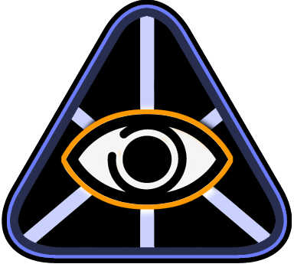

OmniMap API

Configuration Guide

Version 0.9.1

Last updated: March 8, 2007


Contents

Overview 3
Intended Audience 3
Assumptions 3
Basic Settings 4
Lens Type 4
Level of Detail 4
Projector Position 4
Audience Position 5
Heads Up Display 5
Advanced Settings 6
Channel Resolution 6
Frame Buffer Objects 6
Near and Far Clipping Planes 6
Dome Configuration Specific Channel Parameters 7

© 2007 The Elumenati, LLC. All rights reserved. The Elumenati and the Elumenati logo are registered trademarks of The Elumenati, LLC. Other trademarks and brands are the property of their respective owners. The information in this document belongs to The Elumenati, LLC.

Notice of non-liability:
The Elumenati, LLC is providing the information in this document to you AS-IS with all faults. The Elumenati, LLC makes no warranties of any kind (whether express, implied or statutory) with respect to the information contained herein. The Elumenati, LLC assumes no liability for damages (whether direct or indirect), caused by errors or omissions, or resulting from the use of this document or the information contained in this document or resulting from the application or use of the product or service described herein. The Elumenati, LLC reserves the right to make changes to any information herein without further notice.

Please send any questions or comments to support@elumenati.com.

Overview
This document is a guide for configuring the OmniMap Geometry Correction Library API into existing OpenGL applications. The OmniMap library is designed to allow great flexibility in the way it renders the final image to the screen. That flexibility is provided through Lua scripts (http://www.lua.org). These scripts are located in a directory called OmniMapConfig that is required to be located in the working directory of your application. This document describes the configuration parameters that can be set in these scripts. The first section describes the most basic settings. The second section describes more advanced settings that require a deeper knowledge of how OmniMap works.

For more information, see the OmniMap API OpenGL Integration Guide and the OmniMap API Class Documentation included with the OmniMap installer.

Intended Audience
This document is written for programmers interested in implementing geometry correction within their real-time OpenGL application for use with the Elumenati OmniFocus range of products. It is also meant as a guide for users that are configuring the OmniMap-enabled applications.

Assumptions
This document assumes the developer has installed the OmniMap API from the installer program OmniMap.msi (available at http://www.elumenati.com), and used the default location for the installation. The default installation location for the OmniMap API is:

C:\Program Files\Elumenati\OmniMap API

In this document, we will refer to this folder as <InstallationDir>. So if you have chosen to install the OmniMap API in a location other than the default location, <InstallationDir> refers to that location.

Basic Settings
Basic settings are accessed in the file OmniMapConfig/omnimap_user_edit.lua. These settings are intended for users of OmniMap enabled applications. The settings in this file include:

- The type of lens
- The level of detail with which to render the final scene
- The projector position in the dome
- The audience position in the dome
- Display/Don't display the OmniMap Heads Up display
- The resolution of the channels

Lens Type
The type of lens is set with the line:

func_CurrentLens = LensCrop_HDome
or
funcCurrentLens = LensCrop_VDome

These are basic configurations for Elumenati domes. LensCrop_HDome is for the horizontal configuration, and LensCrop_VDome is for the vertical configuration. These are the configurations currently supported by the default version of the OmniMap API.

Level of Detail
The level of detail of the shape of the final rendered image is set with the line:

DomeTessellation = 100

To increase the level of detail of the shape, change 100 to a higher number, to decrease lower the number.

Projector Position
Projector position is set with the line:

Point_ProjectorPosition = Vector(0,0,0)

This represents the x,y,z coordinate for the center of the dome.

To coordinate system of various dome configurations are shown in the drawings below:

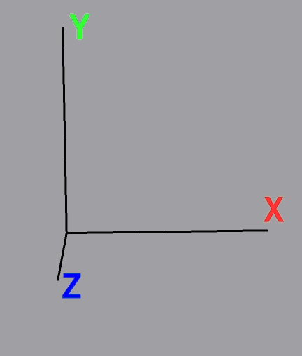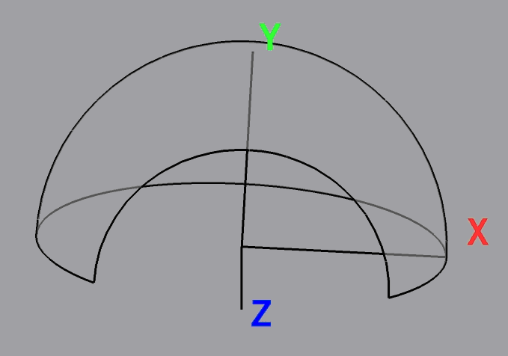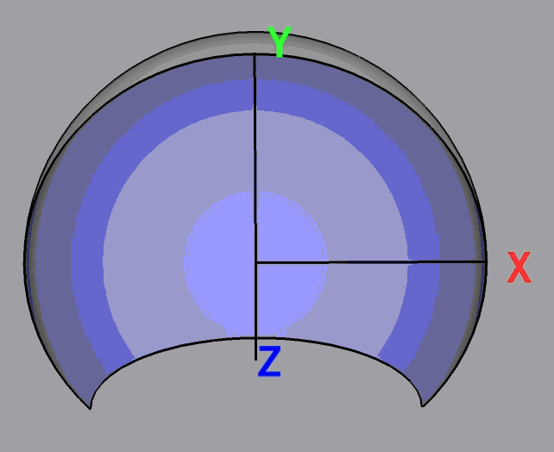

Standing in the center, and looking to the back of the dome, positive X is to the right, positive Y is up, and positiive Z is straight back. By default, the size of the dome radius is 1.0 units. This can be changed in the advanced settings in omnimap_dome_wiz_ai.lua. (See the following section “Advanced Setttings”)

Audience Position
The audience position is set with the line:

AudiencePos = Vector(0.0, 0.0, 0.0)

The coordinate system is as described above.

Heads Up Display
The OmniMap API heads up display displays the contents of the render channels that make up the final image in squares in front of the final image. The heads up display is turned on with the line:

SetOmnimapParameter(“displayHUD”, “true”)

To turn off the heads up display, just replace “true” with “false”.

Advanced Settings
The advanced settings are intended for use by developers of OmniMap enabled applciations. Those settings can be found in OmniMapConfig/omnimap_dome_wiz_ai.lua. The configuration parameter in this file include :

- Channel Resolution
- Whether or not to use frame buffer objects
- The near and far clipping plane for channel rendering.
- Which channels to enable
- The fields of view for each channel
- The projector orientation
- The starting view orientation
- The dome center
- The dome orientation

Channel Resolution
Channel resolution is set with the line:

channelRes = 1024

This is the resolution of the frame buffer or pbuffer textures used for rendering each channel. The number should always be a power of 2.

Frame Buffer Objects
Whether to use frame buffer objects or pbuffers for rendering the channels is set with the line:

usefbo = true

Setting this value to false will force the channel rendering to be done with pbuffers instead of frame buffers.

Near and Far Clipping Planes
The near and far clipping planes for channel rendering are set with the lines:

nearclip = .1
farclip = 1000

These values should be set to the values that your application would set them to without the use of the OmniMap API. If your application changes these values, you can do this after calling OmniMapChannelBase::BeginRenderToChannel.

Dome Configuration Specific Channel Parameters
Channels are enabled based on which dome configuration has been chosen in the omnimap_user_edit.lua file. If you want to modify which channels that are rendered, or how those channels are rendered, you can do it in this file. But you should be careful when doing this. Look for lines of the form:

if(func_CurrentLens == LensCrop_HDome) then

The true branch of this clause will set the parameters appropriately for the the Horizontal Dome configuration. Parameters that can be set are defined in the following table:

Parameter | Explanation
Vec_ProjectorLookVec | This is the direction the projector faces
Vec_ProjectorUpVec | This is the Up diriection of the projector
DomeOrientation | The orientation of the dome.
BaseViewDirection | The starting direction of the view
BaseViewHeadsUp | The up direction of the view
LeftFovY | The field of view in the Y direction for the left channel. The field of view parameters can be set as low as 90 degrees. Setting the field of view less than that will leave seams in the scene.
RightFovY | The field of view in the Y direction for the right channel
TopFovY | The field of view in the Y direction for the top channel
BottomFovY | The field of view in the Y direction for the bottom channel
FrontFovY | The field of view in the Y direction for the front channel
BackFovY | The field of view in the Y direction for the back channel
UseTopChannel, UseBottomChannel, UseLeftChannel, UseRightChannel, UseFrontChannel, UseBackChannel | These are boolean values that control whether or not to render a channel.

