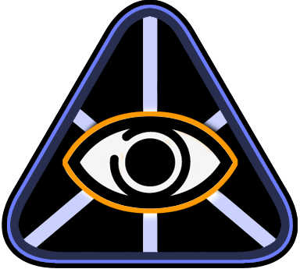

OmniMap API

OpenGL Integration Guide

Version 0.9.1

Last updated: March 8, 2007


Contents

Overview 3
Intended Audience 3
Developer Requirements 3
Assumptions 3
OmniMap API Components 4
OmniMap API Architecture 5
Demo Program Case Study 6
Demo Program Source Code 9

© 2007 The Elumenati, LLC. All rights reserved. The Elumenati and the Elumenati logo are registered trademarks of The Elumenati, LLC. Other trademarks and brands are the property of their respective owners. The information in this document belongs to The Elumenati, LLC.

Notice of non-liability:
The Elumenati, LLC is providing the information in this document to you AS-IS with all faults. The Elumenati, LLC makes no warranties of any kind (whether express, implied or statutory) with respect to the information contained herein. The Elumenati, LLC assumes no liability for damages (whether direct or indirect), caused by errors or omissions, or resulting from the use of this document or the information contained in this document or resulting from the application or use of the product or service described herein. The Elumenati, LLC reserves the right to make changes to any information herein without further notice.

Please send any questions or comments to support@elumenati.com.

Overview
This document is a guide for integrating the OmniMap Geometry Correction Library API into existing OpenGL applications. The document will provide an overview of the library's architecture, and how it fits into an existing OpenGL application, followed by a case study of the steps required to integrate the OmniMap API into a sample OpenGL program.

For more information, see the OmniMap API Configuration Guide and the OmniMap API Class Documentation included with the OmniMap installer.

Intended Audience
This document is written for programmers interested in implementing geometry correction within their real-time OpenGL application for use with the Elumenati OmniFocus range of products.

Developer Requirements
- Microsoft WindowsXP
- GPU supporting OpenGL 2.0
- Visual Studio 2005

Assumptions
This document assumes the developer has installed the OmniMap API from the installer program OmniMap.msi,and used the default location for the installation. The default installation location for the OmniMap API is:

C:\Program Files\Elumenati\OmniMap API

In this document, we will refer to this folder as <InstallationDir>. So if you have chosen to install the OmniMap API in a location other than the default location, <InstallationDir> refers to that location.

OmniMap API Components
The OmniMap API is shipped with documentation, the example program referred to in this document, C++ header files, lib files and corresponding DLLs. The documentation includes this document, the API Configuration document, and detailed class documentation in HTML format.

The class documentation can be found in:
<InstallationDir>/docs/classdocs

The header files are found in:
<InstallationDir>/include

The library files can be found in:
<InstallationDir>/lib

The DLL's can be found in:
<InstallationDir>/bin

The example program can be found in:
<InstallationDir>/examples

OmniMap API Architecture
The OmniMap API is designed to be easily integrated into existing OpenGL applications. The main class that provides the dome rendering functionality is called OmniMap. The OmniMap object is constructed with arguments for the width and height of the final output:

OmniMap omniMapObj = OmniMap::OmniMap(width, height);

To generate a scene for a dome, the OmniMap class needs to call the application's rendering function 3 or 4 times with a modified viewing frustum and viewing angle. The rotation and viewing angles of each channel are dependent upon the dome configuration specified in the Lua script files omnimap_startup.lua, and omnimap_user_edit.lua. Each of these render passes is managed by the OmniMapChannelBase class. In the application where the rendering of a single frame is done, a call is made to the OmniMap object telling the OmniMap object which function to call for rendering a single channel. That call looks like:

omniMapObj->ForEachChannel(renderFunction);

where renderFunction is a pointer to a function that takes a pointer to an OmniMapChannelBase object as an argument:

void renderFunction(OmniMapChannelBase *channel);

ForEachChannel will call the renderFunction once for each channel. Prior to making that call, the OpenGL projection matrix has been set to the projection required to render the channel, and the OpenGL Modelview matrix has been set to the correct rotation to render the channel. The application programmer can access these values through the OmniMapChannelBase class interface. As each channel is rendered, the resulting image is placed into an OpenGL texture.

When all channels have been rendered, the application calls:

omniMapObj->PostRender()

This method will composite the channels and spherically project them onto the display.

Demo Program Case Study
This section describes what was done to create the project file for the Demo project located in:
<InstallationDir>\examples\demo\demo_dome_enabled\Source

- Open Visual Studio Workspace File
  - Open the Visual Studio Workspace for the dome enabled Demo program by double-clicking on “Demo.sln” in this directory.

- Add OmniMap include Directory.
  - Using the properties dialog for the Demo project, we first added the include path for the OmniMap API include files to the property:
Configuration Properties
C/C++
General
Additional Include Directories

That path is :
<InstallationDir>\include
In the project file, it is referenced relative to the Source directory. It is
refererenced as ../../../../include.

- Add OmniMap API Directory
  - Using the same properties dialog, we then added the library path for the OmniMap API library files to the property:
Configuration Properties
Linker
General
Additional Library Directories

That path is :
<InstallationDir>\lib
In the project file, it is referenced relative to the Source directory. It is
referenced as ../../../../lib.

- Add OmniMap library dependency.
  - Finally, using the same properties dialog, we added the OmniMap library to the list of libraries to link with the Demo application. That property is:
Configuration Properties
Linker
Input
Additional Dependencies

That library is OmniMap.lib for the Release configuration, and OmniMapD.lib for
the Debug configuration.

- Edit “Basecode.cpp”
  - The changes to the code are shown in the Demo Program Source Code section below (on page 9), highlighted in red.
  - The changes include the following:
    - Add Omnimap header file
    - Add glew header file
    - Nest render() function - or display() function – inside the fun() function. The fun() funcion will be called once for each OmniMap render channel. The application programmer is required to call the following methods in the sequence shown here:
// Push matrices, set projection, model view matrix
// enable frame buffer object for this channel’s rendering
chan->beginRenderToChannel();
// The application’s rendering code
Render();
// Pop matrices, disable frame buffer object
chan->endRenderToChannel();

The rest of the code shown in the example is for demonstration purposes, but is not
required.

    - Update quit() and resize() functions.
    - Update the render function (or display code) to insure that all rendering calls happen inside the render function AND that all scene updates happen outside the render function.
    - Set up the render channel.
    - Replace the display code in the main loop with the Omnimap display code.
    - Delete Fullscreen message box – if present
    - Create the Omnimap object
    - Compile and Run.
- Set Omnimap Parameters
  - For details on setting OmniMap parameters, see the OmniMap Configuration Guide. OminMap parameters control where the projector is located, the direction of the projector, the orientation of the display and other configurable parameters. The parameters are set using Lua scripts. The default location of the configuration files is a directory called OmniMapConfig, located in the working directory of the program. The OmniMap library looks for a file called OmniMapConfig/omnimap_startup.lua. The location or name of that file can be changed using the 3rd argument to the OmniMap class constructor. There are two other LUA files referred to by OmniMapConfig/omnimap_startup.lua in the OmniMapConfif directory: omnimap_user_edit.lua, and omnimap_dome_wiz_ai.lua. If these files are not in the directory called OmniMapConfig, then the reference to them must be modified in OmniMapConfig/omnimap_startup.lua. The lines to be changed are:
Dofile(“OmniMapConfig/omnimap_user_edit.lua”)
Dofile(“OmniMapConfig/omnimap_dome_wiz_ai.lua”)
The parameters to the dofile call must be the correct paths to the two files.
  - Omnimap Coordinate System: Right Hand Rule where the X-vector is to the RIGHT, the Y-vector is UP and the Z-vector is AWAY from the user’s gaze. The images below show the coord system in both a horizontal and vertical dome.

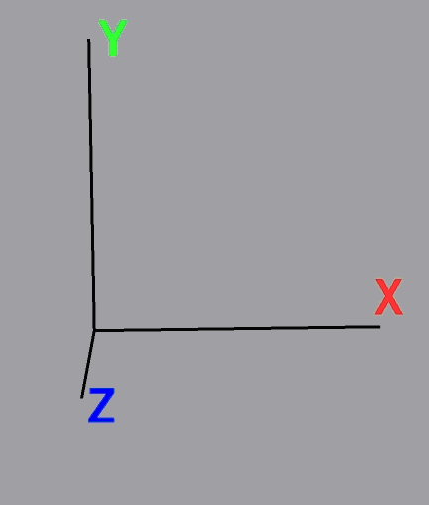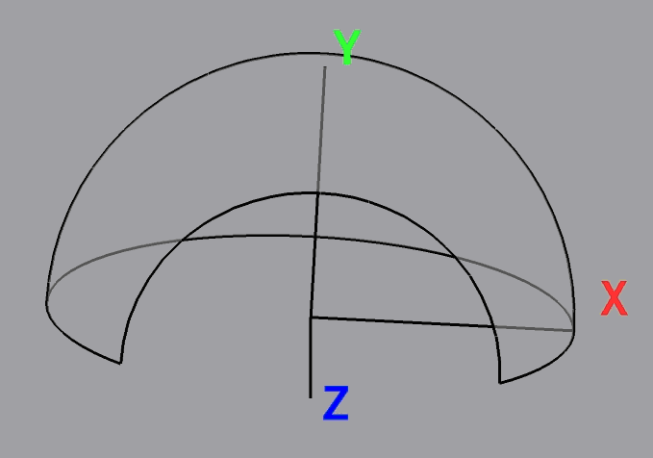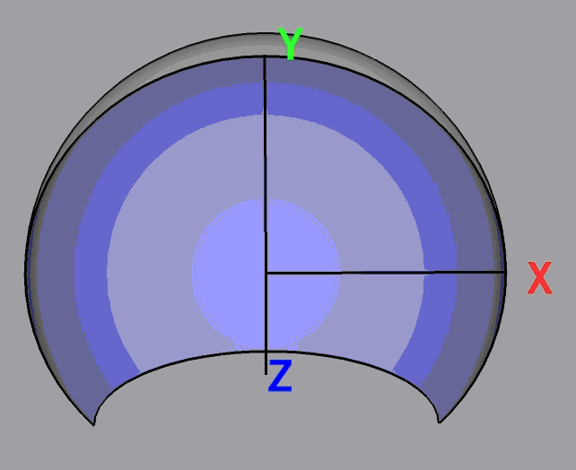

  - Parameters like dome style (horizontal, vertical), number of render channels and projector and audience position are set in the Lua (ASCII) file omnimap_startup.lua in the Source/OmniMapConfig directory.
  - The most common parameters however have been assembled into more the file omnimap_user_edit.lua in the same directory.
  - Run the program. Make sure that the directory containing the OmniMap DLLs is in your path. The directory is <InstallationDir>\lib.

Demo Program Source Code

// ** SYSTEM LIBRARIES **
// ----------------------
#pragma comment(lib, "opengl32.lib")
#pragma comment(lib, "glu32.lib")
#pragma comment(lib, "glaux.lib")
#pragma comment(lib, "winmm.lib") // Sound

// Add Omnimap header file
#include "omnimap.h"
// ** SYSTEM HEADER FILES **
// -------------------------
#include <gl\glew.h>
#include <windows.h>
#include <gl\gl.h>
#include <gl\glu.h>
#include <stdio.h>

OmniMap *OmnimapLib=0;

void Render();
void SetupRenderChannelTextureContext();

// Nest render() function - or display() function – inside the fun() function.
// The fun() funcion will be called once for each OmniMap render channel.
void fun(OmniMapChannelBase *chan)
{
// Shows how to get a channel name from the channel pointer.
std::string channelName = OmnimapLib->GetChannelName(chan);
// Setup the modelview and projection matrices.
chan->beginRenderToChannel();
// Shows how to get metadata set in the lua scripts from a channel
// In this case the metadata is called ExampleMetaData and is an integer.
GenericDataContainer * cont=
chan->ChannelMetaData.IndexDataMap("ExampleMetaData");
int ExampleMetaData= 0; if(cont) ExampleMetaData = cont->GetINT();
// Shows how to get a number variable from the lua script
double var2fromlua = OmnimapLib->ScriptingEngine->GetVariableNumber("nearclip");
// Shows how to get a number variable from the lua script
double var4fromlua = OmnimapLib->ScriptingEngine->GetVariableNumber("farclip");
//SetupRenderChannelTextureContext();
Render();
chan->endRenderToChannel();
}

// ** DECLARATIONS **
// ------------------
HDC hDC = NULL; // Device context
HGLRC hRC = NULL; // Rendering context
HWND hWnd = NULL; // Window handle
HINSTANCE hInstance; // Instance of application

int SCREEN_WIDTH = 1024;
int SCREEN_HEIGHT = 768;
int SCREEN_DEPTH = 16;

bool active = true;
bool fullScreen = true;

float frameInterval = 0.0f;

// ** FUNCTION PROTOTYPES **
// -------------------------

// Misc
LRESULT CALLBACK WndProc(HWND, UINT, WPARAM, LPARAM);

// Map
void LoadGLTextures();
void LoadMap();
void RenderScene();

// FX
void RenderSteam(float);
void RenderBubbles(float, int, float);
void RenderSpace(float);
void RenderFade(float);
void RenderDoors();

// Movement
void OpenDoor(float);
void MoveCamera(float);

// ** RESIZE SCREEN **
// -------------------
void ReSizeScreen(int width, int height)
{
// Prevent a divide by zero
if (height == 0)
{
height = 1;
}

// (x, y, width, height)
glViewport(0, 0, width, height); // Viewport wholescreen, could make smaller
glMatrixMode(GL_PROJECTION); // Set projection matrix
glLoadIdentity(); // Reset projection matrix

// NOTE: FOV below is set to 90 to give impression tunnel is longer than it actually is,
// normally this would be 45 degrees.

// (FOV, width -> height ratio, closest clip, furthest clip)
gluPerspective(90.0f, (float)width / (float)height, 2, 150.0f); // Aspect ratio of window

glMatrixMode(GL_MODELVIEW); // Set modelview matrix
glLoadIdentity(); // Reset modelview matrix

if(OmnimapLib)
{
OmnimapLib->resWidth =width;
OmnimapLib->resHeight =height;
OmnimapLib->ScriptingEngine->RunString("onResize()");
OmnimapLib->ScriptingEngine->RunString("ConsolePrintString(
"calling onResize() after switching to res %d,%d\")",
width,height);
}

}

// ** INITIALISE OPENGL **
// -----------------------
int InitOpenGL()
{
glEnable(GL_TEXTURE_2D); // Enable texture mapping

glBlendFunc(GL_SRC_ALPHA,GL_ONE); // Set blending function for translucency
glShadeModel(GL_SMOOTH); // Enable smooth shading
glClearColor(0.0f, 0.0f, 0.0f, 1.0f); // Background
glClearDepth(1.0f); // Depth buffer
glEnable(GL_DEPTH_TEST); // Enable depth testing
glDepthFunc(GL_LESS); // Type of depth testing
glHint(GL_PERSPECTIVE_CORRECTION_HINT, GL_NICEST); // Perspective calculations

// Load from files
LoadGLTextures();
LoadMap();

// Fogging
float fogColor[4] = {0.0f, 0.0f, 0.0f, 1.0f};

glFogi (GL_FOG_MODE, GL_LINEAR); // Type of fogging
glFogfv (GL_FOG_COLOR, fogColor); // Fog colour (black)
glFogf (GL_FOG_DENSITY, 0.2f); // Density
glHint (GL_FOG_HINT, GL_DONT_CARE); // Perspective calculations
glFogf (GL_FOG_START, 120.0f); // Start of fogging from camera
glFogf (GL_FOG_END, 150.0f); // End of fogging
glEnable(GL_FOG); // Enable fogging

// Env Mapping
glTexGeni(GL_S, GL_TEXTURE_GEN_MODE, GL_SPHERE_MAP); // Set sphere texture generation mapping for S
glTexGeni(GL_T, GL_TEXTURE_GEN_MODE, GL_SPHERE_MAP); // Set sphere texture generation mapping for T

PlaySound("audio/music.wav", NULL, SND_FILENAME | SND_ASYNC | SND_LOOP); // Play music loop

return true;
}

// ** DE-INITIALISE OPENGL & WINDOW **
// -----------------------------------
void DeInit()
{
// Stop audio
PlaySound(NULL, NULL, SND_PURGE);

// Return to desktop
if (fullScreen)
{
ChangeDisplaySettings(NULL, 0);
ShowCursor(true);
}

// Release and delete RC
if (hRC)
{
if (!wglMakeCurrent(NULL, NULL))
MessageBox(NULL, "Failed to release DC & RC", "DoH!", MB_OK | MB_ICONEXCLAMATION);
if (!wglDeleteContext(hRC))
MessageBox(NULL, "Failed to release rendering context", "DoH!", MB_OK | MB_ICONEXCLAMATION);

hRC = NULL;
}

// Release DC
if (hDC && !ReleaseDC(hWnd, hDC))
{
MessageBox(NULL, "Failed to release device context", "DoH!", MB_OK | MB_ICONEXCLAMATION);
hDC = NULL;
}

// Destroy window
if (hWnd && !DestroyWindow(hWnd))
{
MessageBox(NULL, "Failed to release hWnd", "DoH!", MB_OK | MB_ICONEXCLAMATION);
hWnd = NULL;
}

// Unregister class
if (!UnregisterClass("Demo", hInstance))
{
MessageBox(NULL, "Failed to unregister class", "DoH!", MB_OK | MB_ICONEXCLAMATION);
hInstance = NULL;
}
}

// ** SETUP PIXEL FORMAT **
// ------------------------
bool SetupPixelFormat()
{
int PixelFormat;
static PIXELFORMATDESCRIPTOR pfd= // pfd says how we want the window to be
{
sizeof(PIXELFORMATDESCRIPTOR), // Size of pixel format descriptor
1, // Version number (always 1)
PFD_DRAW_TO_WINDOW | // Format to support window
PFD_SUPPORT_OPENGL | // Format to support opengl
PFD_DOUBLEBUFFER, // Format to support double buffering
PFD_TYPE_RGBA, // Request RGBA format
SCREEN_DEPTH, // Select color depth
0, 0, 0, 0, 0, 0, // Color bits ignored
0, // No alpha buffer
0, // Shift bit ignored
0, // No accumulation buffer
0, 0, 0, 0, // Accumulation bits ignored
16, // 16Bit z-buffer (depth buffer)
0, // No stencil buffer
0, // No auxiliary buffer
PFD_MAIN_PLANE, // Main drawing layer
0, // Reserved
0, 0, 0 // Layer masks ignored
};

// Get a device context
if (!(hDC=GetDC(hWnd)))
{
DeInit();
MessageBox(NULL, "Failed to create a device context", "DoH!", MB_OK|MB_ICONEXCLAMATION);
return false;
}

// Choose a pixel format that best matches above
if (!(PixelFormat=ChoosePixelFormat(hDC,&pfd)))
{
DeInit();
MessageBox(NULL, "Failed to find a suitable pixelformat", "DoH!", MB_OK|MB_ICONEXCLAMATION);
return false;
}

// Set pixel format chosen above
if(!SetPixelFormat(hDC,PixelFormat,&pfd))
{
DeInit();
MessageBox(NULL, "Failed to set the pixelformat", "DoH!", MB_OK|MB_ICONEXCLAMATION);
return false;
}

// Get a rendering context
if (!(hRC=wglCreateContext(hDC)))
{
DeInit();
MessageBox(NULL, "Failed to create a rendering context", "DoH!", MB_OK|MB_ICONEXCLAMATION);
return false;
}

// Activate rendering context
if(!wglMakeCurrent(hDC,hRC))
{
DeInit();
MessageBox(NULL, "Failed to activate the rendering context", "DoH!", MB_OK|MB_ICONEXCLAMATION);
return false;
}

return true;
}

// ** CREATE THE WINDOW **
// -----------------------
bool CreateGLWindow(char* title)
{
WNDCLASS wndClass; // Windows class structure
DWORD dwExStyle; // Windows extended style
DWORD dwStyle; // Windows style
RECT wndRect; // Windows dimensions

wndRect.left = 0;
wndRect.right = SCREEN_WIDTH;
wndRect.top = 0;
wndRect.bottom = SCREEN_HEIGHT;

hInstance = GetModuleHandle(NULL); // Grab an instance for the window

wndClass.style = CS_HREDRAW | // Redraw on horizontal size
CS_VREDRAW | // Redraw on vertical size
CS_OWNDC; // Window has own DC
wndClass.lpfnWndProc = (WNDPROC)WndProc; // Handles the windows messages
wndClass.cbClsExtra = 0; // No extra window data
wndClass.cbWndExtra = 0; // No extra window data
wndClass.hInstance = hInstance; // Set the instance
wndClass.hIcon = LoadIcon(NULL, IDI_WINLOGO); // Default icon
wndClass.hCursor = LoadCursor(NULL, IDC_ARROW); // Default cursor
wndClass.hbrBackground = NULL; // No background
wndClass.lpszMenuName = NULL; // No menu
wndClass.lpszClassName = "Demo"; // Class name

if (!RegisterClass(&wndClass)) // Register window class
{
MessageBox(NULL, "Failed to register window class", "DoH!", MB_OK | MB_ICONEXCLAMATION);
return false;
}

if (fullScreen)
{
DEVMODE dmSettings; // Device mode
memset(&dmSettings, 0, sizeof(dmSettings)); // Clear memory
dmSettings.dmSize = sizeof(dmSettings); // Size of devmode structure
dmSettings.dmPelsWidth = SCREEN_WIDTH; // Screen width
dmSettings.dmPelsHeight = SCREEN_HEIGHT; // Screen height
dmSettings.dmBitsPerPel = SCREEN_DEPTH; // Bits per pixel
dmSettings.dmFields = DM_BITSPERPEL |
DM_PELSWIDTH |
DM_PELSHEIGHT;

// Try set selected mode
if (ChangeDisplaySettings(&dmSettings, CDS_FULLSCREEN)!= DISP_CHANGE_SUCCESSFUL)
{
if (MessageBox(NULL, "Fullscreen mode not supported by your video card\nDo you want to use windowed mode instead?",
"Screen mode", MB_YESNO | MB_ICONQUESTION)==IDYES)
{
fullScreen = false;
}
else
{
return false;
}
}
}

if (fullScreen) // If still in fullscreen
{
dwExStyle = WS_EX_APPWINDOW; // Window extended style
dwStyle = WS_POPUP; // Window style
ShowCursor(false);
}
else
{
dwExStyle = WS_EX_APPWINDOW | WS_EX_WINDOWEDGE; // Window extended style
dwStyle = WS_OVERLAPPEDWINDOW; // Window style
}

AdjustWindowRectEx(&wndRect, dwStyle, false, dwExStyle); // Adjust window to size

// Create the window
if (!(hWnd = CreateWindowEx(dwExStyle, // Extended style
"Demo", // Class name
title, // Window title
dwStyle | // Defined window style
WS_CLIPSIBLINGS | // Required window style
WS_CLIPCHILDREN, // Required window style
0, 0, // Window position
wndRect.right - wndRect.left, // Window width
wndRect.bottom - wndRect.top, // Window height
NULL, // No parent window
NULL, // No menu
hInstance, // Instance
NULL))) // Don't pass anything to WM_CREATE
{
DeInit();
MessageBox(NULL, "Failed to create window", "DoH!", MB_OK | MB_ICONEXCLAMATION);
return false;
}

// Setup the pixel format
if (!SetupPixelFormat())
{
return false;
}

// Finalise window
ShowWindow(hWnd, SW_SHOW);
SetForegroundWindow(hWnd);
SetFocus(hWnd);
ReSizeScreen(SCREEN_WIDTH, SCREEN_HEIGHT);

// Initialise opengl
if (!InitOpenGL())
{
DeInit();
MessageBox(hWnd, "Failed to initialise", "DoH!", MB_OK | MB_ICONEXCLAMATION);
return false;
}

return true;
}

// ** CALCULATE FRAMERATE **
// -------------------------
void CalculateFrameRate()
{
static float FPS = 0.0f; // Frames per second
static float lastTime = 0.0f; // Time from last frame
static float frameTime = 0.0f; // Current frame time
char strFrameRate[10] = {0}; // Window title

// Get current time in seconds
float currentTime = GetTickCount() * 0.001f;

// Set frame individual
frameInterval = currentTime - frameTime;
frameTime = currentTime;

// Increase frame counter
FPS++;

// If a second has passed refresh FPS
if (currentTime - lastTime > 1.0f)
{
lastTime = currentTime;

// Show FPS in title bar
sprintf(strFrameRate, "FPS: %d", int(FPS));
SetWindowText(hWnd, strFrameRate);

FPS = 0.0f; // Reset counter
}
}

void onQuit()
{
if(OmnimapLib)
delete OmnimapLib;
OmnimapLib=0;

}

// ** WndProc - Handles Window Messages **
// ---------------------------------------
LRESULT CALLBACK WndProc(HWND hWnd, // Window handle
UINT uMsg, // Message for window
WPARAM wParam, // Additional message info
LPARAM lParam) // Additional message info
{
switch (uMsg) // Check for window messages
{

// Windows active state changes
case WM_ACTIVATE:
{
if (!HIWORD(wParam)) // Check minimisation state
{
active = true;
}
else
{
active = false;
}

return 0;
}

// Power saving operations
case WM_SYSCOMMAND:
{
switch (wParam)
{
case SC_SCREENSAVE:
case SC_MONITORPOWER:
return 0;
}
break;
}

// Window closed
case WM_CLOSE:
{
PostQuitMessage(0);
onQuit();// delete OmnimapLib on exit
return 0;
}

// Escape key pressed
case WM_KEYDOWN:
{
if (wParam == VK_ESCAPE)
{
onQuit();// delete OmnimapLib on exit
PostQuitMessage(0);
}

return 0;
}

// Screen resized
case WM_SIZE:
{
ReSizeScreen(LOWORD(lParam),HIWORD(lParam)); // LOWORD = width, HIWORD = height
return 0;
}
}

// Pass uhandled messages to DefWindowProc
return DefWindowProc(hWnd,uMsg,wParam,lParam);
}

// all rendering calls are put into a separate function so it can be called in the render channel loop.

void Render()
{

glClear(GL_COLOR_BUFFER_BIT | GL_DEPTH_BUFFER_BIT); // Clear screen and depth buffer
glLoadIdentity(); // Reset view

RenderSpace(frameInterval);
RenderDoors();
RenderScene();

// Render particles
glDepthMask(GL_FALSE); // Disable z-buffer writes

RenderSteam(frameInterval);

RenderBubbles(-2.5, 1, frameInterval);

RenderBubbles(13.5, 2, frameInterval);

glDepthMask(GL_TRUE); // Re-enable z-buffer writes
glFlush();

RenderFade(frameInterval);

}

void SetupRenderChannelTextureContext()
{
glEnable(GL_TEXTURE_2D);
glTexGeni(GL_S, GL_TEXTURE_GEN_MODE, GL_SPHERE_MAP);
glTexGeni(GL_T, GL_TEXTURE_GEN_MODE, GL_SPHERE_MAP);

}

void SetupProjectiveTexturingTextureContext()
{

glEnable(GL_TEXTURE_2D);
glTexGeni(GL_S, GL_TEXTURE_GEN_MODE, GL_EYE_LINEAR);
glTexGeni(GL_T, GL_TEXTURE_GEN_MODE, GL_EYE_LINEAR);
}
// ** MAIN LOOP **
// ---------------
WPARAM MainLoop()
{
MSG msg;

while(1)
{
if(PeekMessage(&msg, NULL, 0, 0, PM_REMOVE)) // Check for message
{
if (msg.message == WM_QUIT)
{
break;
}
else
{
TranslateMessage(&msg); // Find out what message does
DispatchMessage(&msg); // Run message
}
}
else
{
if (active)
{
// any update must happen outside of the channel render loop
OpenDoor(frameInterval);
MoveCamera(frameInterval);
// channel render loop
OmniMapLib->ForEachChannel(fun);
SetupProjectiveTexturingTextureContext();
OmnimapLib->PostRender();

SwapBuffers(hDC);

CalculateFrameRate();
}
}
}

DeInit();
return (msg.wParam); // Return from program
}

// ** MAIN **
// ----------
int WINAPI WinMain(HINSTANCE hInstance, // Instance
HINSTANCE hPrevInstance, // Previous instance
LPSTR lpCmdLine, // Command line parameters
int nCmdShow) // Window show state
{

// skip screen mode
if(false)
/* if (MessageBox(NULL, "Fullscreen? (Recommended)", "Screen mode", MB_YESNO | MB_ICONQUESTION) == IDYES)*/
{
if (MessageBox(NULL, "1024 * 768 resolution? (Recommended)",
"Screen mode", MB_YESNO | MB_ICONQUESTION) == IDYES)
{
SCREEN_WIDTH = 1024;
SCREEN_HEIGHT = 768;
}
else
{
SCREEN_WIDTH = 800;
SCREEN_HEIGHT = 600;
}
}
else
{
fullScreen = false;
SCREEN_WIDTH = 640;
SCREEN_HEIGHT = 480;
}

// Create window
if (!CreateGLWindow("3D Engine"))
return 0;
// create object
OmnimapLib = new OmniMap(SCREEN_WIDTH,SCREEN_HEIGHT);

// Run main loop

return MainLoop();
}

