INSTRUCTIONS:

1) REQUIREMENTS:
- Stable Internet connection
- Windows 10
- Google Chrome

2) Folder “Constant Optimization”:
- Inside the folder there are 3 .exe files named 'barret.exe', 'evo.exe', 'kane.exe', and one subfolder named 'Data' with a .xlsx file named 'database'. (and this “read me” file)

3) Check your Chrome version:
- Open Google Chrome
- Go to the options menu (usually accessible by clicking on the three vertical dots in the upper right part of the window)
- Click on 'Settings', and a new menu will open
- Click on 'About Chrome' and look for the Chrome version reported, only the first three numbers are needed.
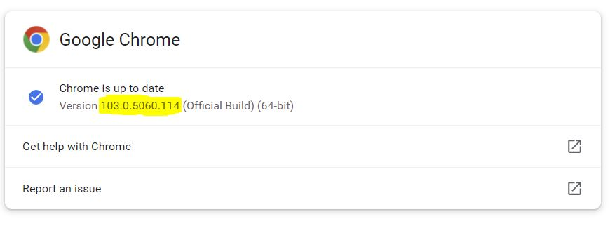

4) Download the Chrome Driver: To make the .exe files work, another file must be downloaded.
- Click on this link https://chromedriver.chromium.org/downloads
- Download the correct file for windows according to the first three numbers of your Chrome version
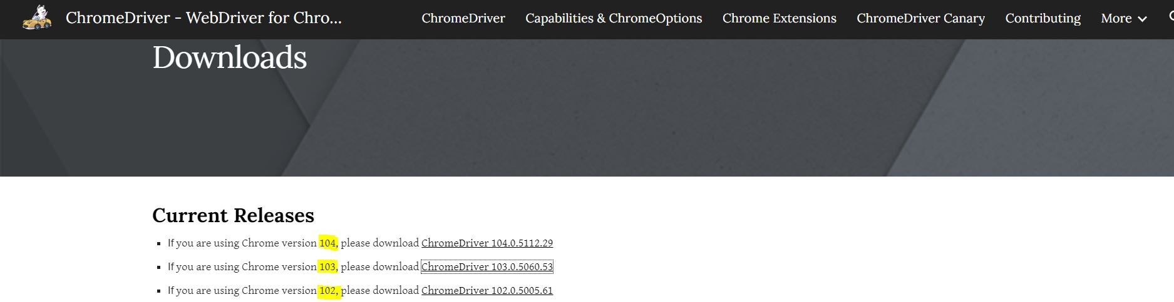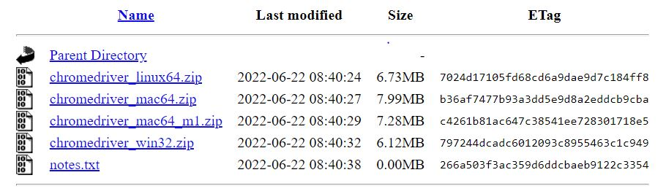
- Extract the ‘chromedriver.exe’ file from the zip folder
- Paste it into the 'Constant Optimization' folder

At this point everything is ready. You just need to fill the 'DATABASE.XLSX' file with your data following replacing the few example lines provided and click on the .exe file of each formula.

5) BASIC INFORMATION:
- Only one of the .exe files should be run at the time
- The software performs the calculation for one eye every thirty seconds to avoid websites overwhelming
- After clicking on the .exe file, two windows will open:
1) A Chrome window with the website of the formula
2) A Command Prompt window
- You can follow the progression on the Command Prompt window where some information about each calculation is displayed
- Either the Command Prompt window and the Chrome window can be minimized without interrupting the software’s execution
- 'Argos' and 'Keratoconus' columns are specific for Evo and Kane formulas respectively and will not be used for the other formulas. Fill the columns with 'yes' or 'no'
- "Lens Thickness", "CCT" (Central Corneal Thickness), and 'WTW' (White To White) are optional parameters, if you don't intend to use them leave the columns empty
- To shorten optimization time it is suggested to write in the A-CONSTANT column the ULIB or IOL.CON constant for the referred IOL. This number MUST be the same for each eye in the database.
- At the end of the calculation, a new .xlsx file will appear inside the folder. The file will have two sheets:
1) the 'DATA' sheet: a copy of the original file with the optimized A-Constant in the respective column and the 'Predicted Refraction', the 'Prediction Error', and the 'Absolute Error' columns
2) the 'SUMMARY' sheet: contains a summary of the calculation with some basic statistics.

6) Pay attention to:
- DO NOT CHANGE the files or folder name or extension
- DO NOT CHANGE the database column names
- ALWAYS UPDATE YOUR CHROME DRIVER FILE ACCORDING TO YOUR CHROME VERSION BEFORE STARTING
- When an error is displayed on the Command Prompt window first check all previous points and the excel file, most of the problems are due to miswritten values
- Ignore error messages in the Command Prompt window when they are not followed by software’s interruption

