

American International University-Bangladesh (AIUB)  
Department of Computer Science  
Faculty of Science &Technology (FST)  
Fall 22 23

Section: C  
Software Quality Assurance and Testing

Car Rental Management System

A Report submitted

By

|  |  |  |
| --- | --- | --- |
| SN | Student Name | Student ID |
| 1 | Ismail Hossain Rishad | 20-43002-1 |
| 2 | Khan, Mansib Ahasn | 19-40093-1 |
| 3 | Rahat , Kamal Uddin | 18-39160-3 |
| 4 | Nafiz Azad | 18-39268-3 |

Under the supervision of

**ABHIJIT BHOWMIK**

Associate Professor, Computer Science

American International University - Bangladesh

**Checked By Industry Personnel**

Name:

Designation:

Company:

Sign:

Date:

Software Test Plan

for

< Car Rental Management System>

Version 1.0 approved

Prepared by

**Ismail Hossain Rishad**

American International University – Bangladesh

08/12/2022

**Checked By Industry Personnel**

Name:

Designation:

Company:

Sign:

Date:

Table of Contents

Revision History 3

1. TEST PLAN IDENTIFIER: RS-MTP01.3 3

2. REFERENCES 3

3. INTRODUCTION 3

Background to the Problem 3

Solution to the Problem 4

4. REQUEIREMNT SPECIFICATION 4

4.1 System Features 4

4.2 System Quality Attributes 4

4.3 System Interface 5

4.4 Project Requirements 5

5. FEATURES NOT TO BE TESTED 5

6. TESTING APPROACH 5

6.1 Testing Levels 5

6.2 Test Tools 6

6.3 Meetings 6

7. TEST CASES/TEST ITEMS 6

8. ITEM PASS/FAIL CRITERIA 7

9. TEST DELIVERABLES 7

10. STAFFING AND TRAINING NEEDS 8

11. RESPONSIBILITIES 8

12. TESTING SCHEDULE 8

13. PLANNING RISKS AND CONTINGENCIES 9

14. APROVALS 9

# Revision History

|  |  |  |  |
| --- | --- | --- | --- |
| Revision | Date | Updated by | Update Comments |
| 0.1 | 2022.11.29 | Khan, Mansib Ahsan | First Draft |
| 0.2 | 2022.12.02 | Ismail Hossain Rishad | Second Draft |
| 0.3 | 2022.12.03 | Rahat, Kamal Uddin | Third Draft |
| 0.4 | 2022.12.03 | Nafiz Azad | Fourth Draft |
|  |  |  |  |
|  |  |  |  |
|  |  |  |  |
|  |  |  |  |
|  |  |  |  |

# TEST PLAN IDENTIFIER:RS-MTP01.3

# REFERENCES

# Software Requirement Specification (SRS) Document : [elusivemansiv/CRMS_SRS (github.com)](https://github.com/elusivemansiv/CRMS_SRS)

* Git Reference: [elusivemansiv/Car-Rental-Management-System-Renter-part- (github.com)](https://github.com/elusivemansiv/Car-Rental-Management-System-Renter-part-)

# INTRODUCTION

## Background to the Problem

Our general purpose is to create a car rental management system that benefits both the renter and the provider. In our city, someone might own many vehicles that they aren't using, allowing them to rent them out to others who might want to use them for his or her requirements at a specific moment. In our city, someone might own many vehicles that they aren't using & on the other hand someone might not have enough money to buy a new car. Those who own multiple unused cars can post their unused cars on this site as a rental option. & Those who don't have enough money to buy a new car or don't want the hassle of buying a new car and

don't want the hassle of making car documents. They can rent their desired cars for a specific time period. For the customer, money and time can both be saved.

## Solution to the Problem

This Car Rentals Agency is a web application built using the Laravel framework and core PHP, with expressive and clean syntax. It takes the hassle out of renting a car by making routine chores in the agency easier, such as: Customer registration: new users are be able to register online and print a membership card. Automatic database update if a reservation is made or a new customer is registered. Customer feedback: There is a way for customers to provide feedback. It offers awesome design, powerful display and built on HTML5 & CSS3, Bootstrap and much more.

# REQUEIREMNT SPECIFICATION

## System Features

* List down the system functional requirements that describes the system’s functionalities

**1. User Login**  
Functional Requirements

**1.1** The software shall allow users to login with their given username and password

If the username and/or password has been inserted wrong the system to retry login.

**1.2** If the number of login attempt exceed its limit (5 times), the system shall block the user account login for one hour *[optional function]*

Priority Level: High  
Precondition: user have valid user id and password

**2. User Registration**  
Functional Requirements

The software shall allow users to registration with their given Role, first name, last name, email, address, nid, driving license, date of birth, phone number and password.

User name, Phone Number and Email will be check for registration. There will be no duplicate Email, Phone number and username.

Priority Level: High

**3. Dashboard Page (Renter)**  
Functional Requirements

**3.1** In the dashboard page user (Renter) will see the navigation, Approval Table and Progress.

**3.2** See Message, User name and user image.

Priority Level: High

Precondition: login into the software and profile need to validate.

**4. Profile**   
Functional Requirements

**4.1** Even user need to verify their account because this is finances related company. User need to verify their NID, email and phone number.

**4.2** Edit up some necessary information in profile section.

Priority Level: High

Precondition: login into the software and profile need to validate.

**5. Service (Add a new car)**   
Functional Requirements

**5.1** The software shall allow users to post a car for rent. It will allow user to fill car name, car model, car type, car number, rent price, date of buying, color, Sit number, details and picture.

**5.2** Edit and Delete up some necessary information in View Car list section.

Priority Level: High

Precondition: login into the software and profile need to validate.

**6. Customer Request Approval page**  
Functional Requirements

**6.1** See all type of car rent request from customer

**6.2** Can accept or decline order request.

Priority Level: medium

Precondition: Open the website.

**7. Service Review Page (Post Car Video)**   
Functional Requirements

**7.1** The software shall allow users to post a car video for actual owner justification. It will allow user to upload video file.

**7.2** Edit and Delete up some necessary information in My Car Videos section.

Priority Level: High

Precondition: login into the software and profile need to validate.

**8. Home Page**  
Functional Requirements

**8.1** See all type of available rent Cars list

Priority Level: medium

Precondition: Open the website.

**9. Logout**   
Functional Requirements

**9.1** Login section will be expired.

**9.2** Login token will be expired.

Priority Level: medium

Precondition: must login into the system.

## System Quality Attributes

**Reliability**

* In a technological environment, the data communication protocol must maintain the reliability and quality of data and voice transmission.
* The memory system must be non-volatile, for example, CDMA/GSM.

**Availability**

* + - * In the event of a communication problem, the system will be shut down;
      * In the event of a communication problem, the system will be shut down;
      * The system must be manually restarted by maintenance employees or the director of management after an untrustworthy shutdown.
      * No inconsistency in the account should be introduced throughout the system's booking
      * The system/booking system will be shut down as a result of this.

**Security**

* + - * The system must comply with AIMS security requirements.
      * The system must have two levels of security, one for login verification and the other for code verification, both of which are authenticated by the CMS software.
      * During code transmission, the encryption standard must be triple DES.
      * The password should be between six and ten characters long.
      * Customer names should not be included in passwords because they are easily compromised.
      * Numbers, hyphens, and underscores can all be used in passwords.
      * The user should be given only three attempts to log in, after which his booking should be canceled.
      * Every room will have a security camera put near it.

## System Interface

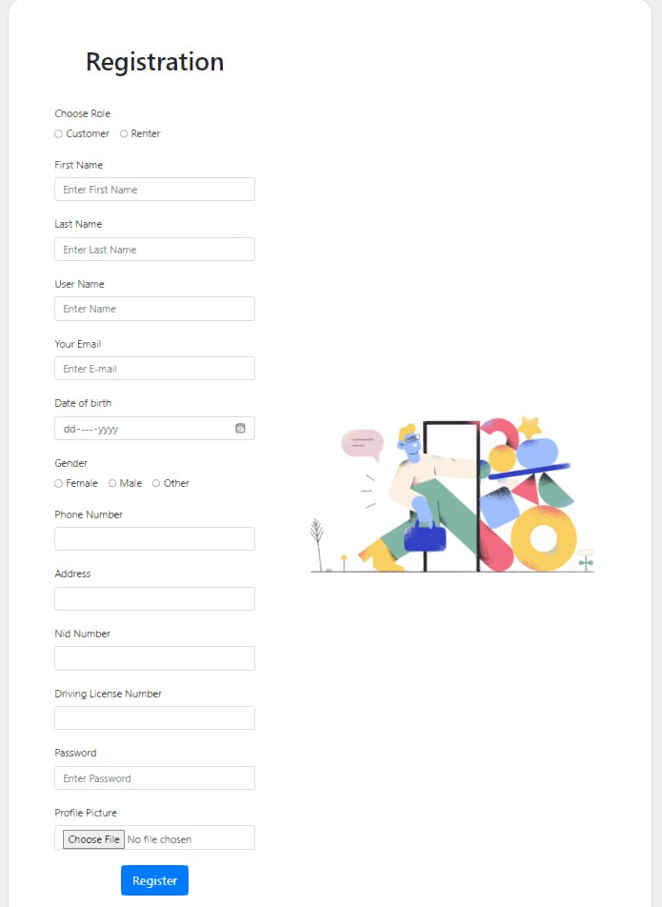

Figure 1: Registration Page

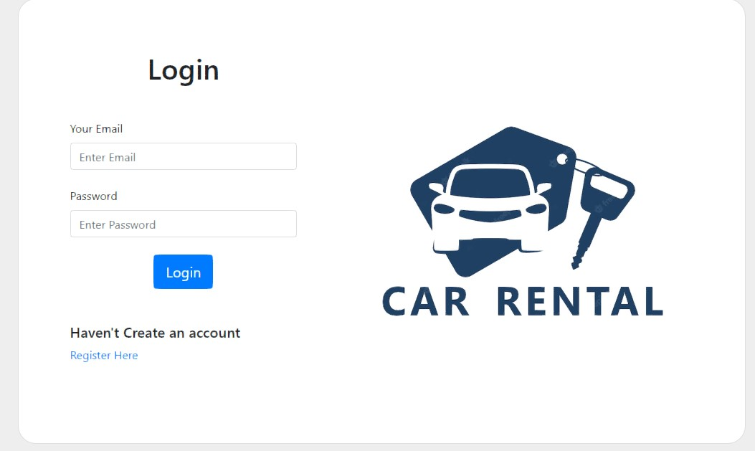

Figure 2: Login Page

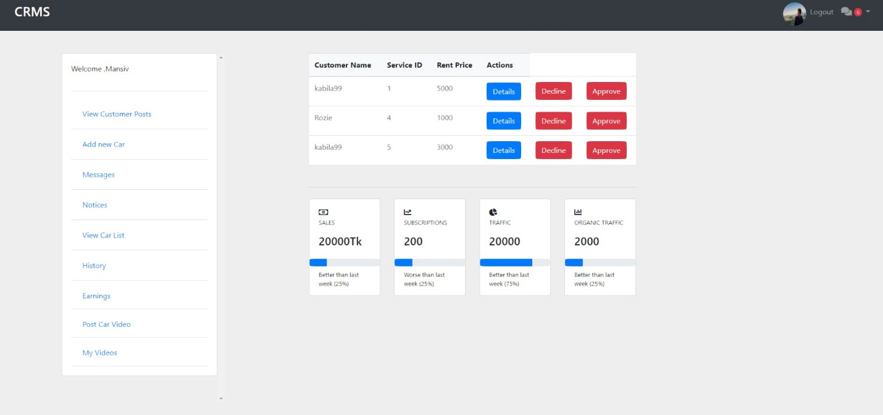

Figure 3: Dashboard Page (Renter)

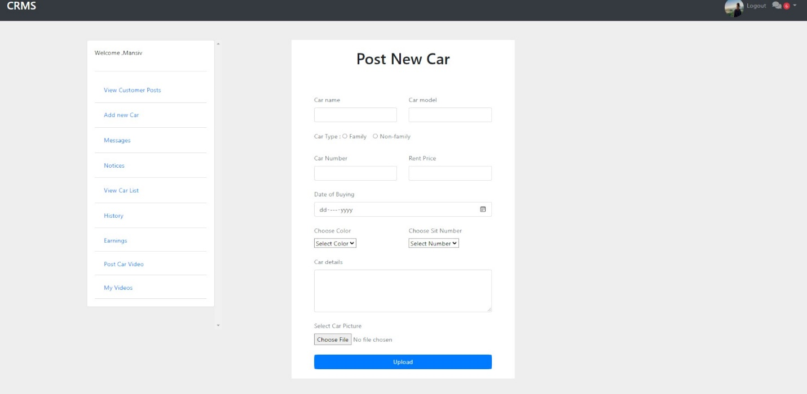

Figure 4: Post Car for Rent Page

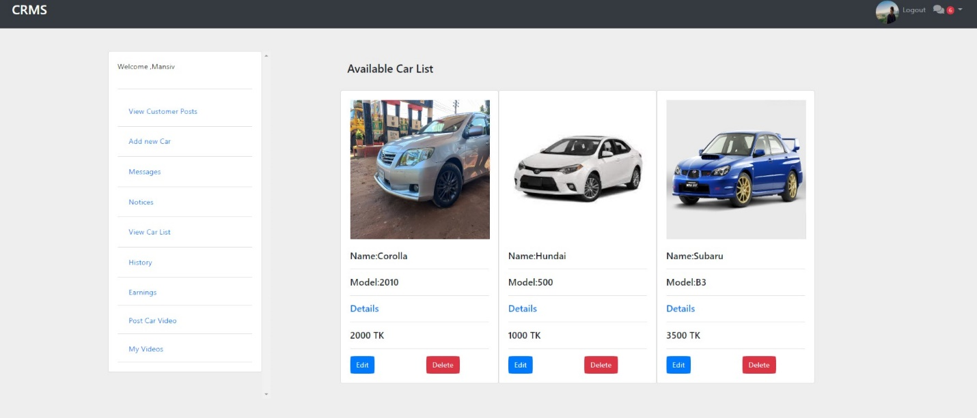

Figure 5: Car list Page

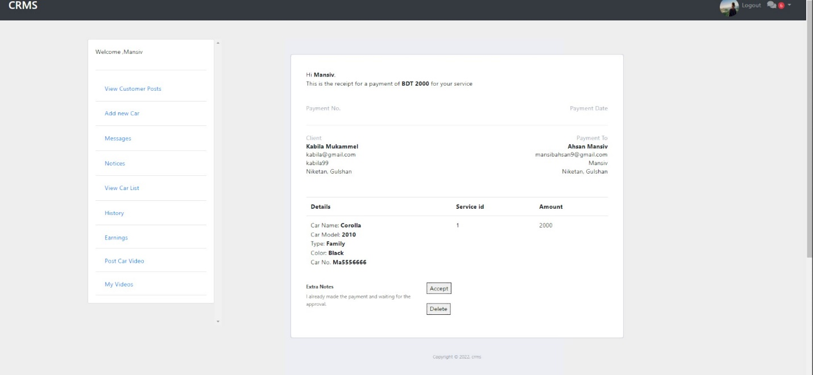

Figure 6: Approval Page

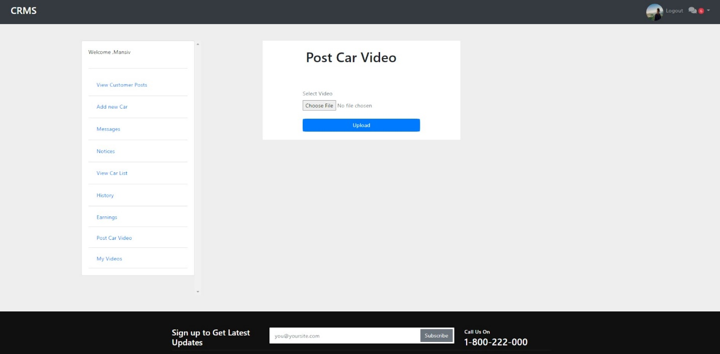

Figure 7: Review for Car Video Page

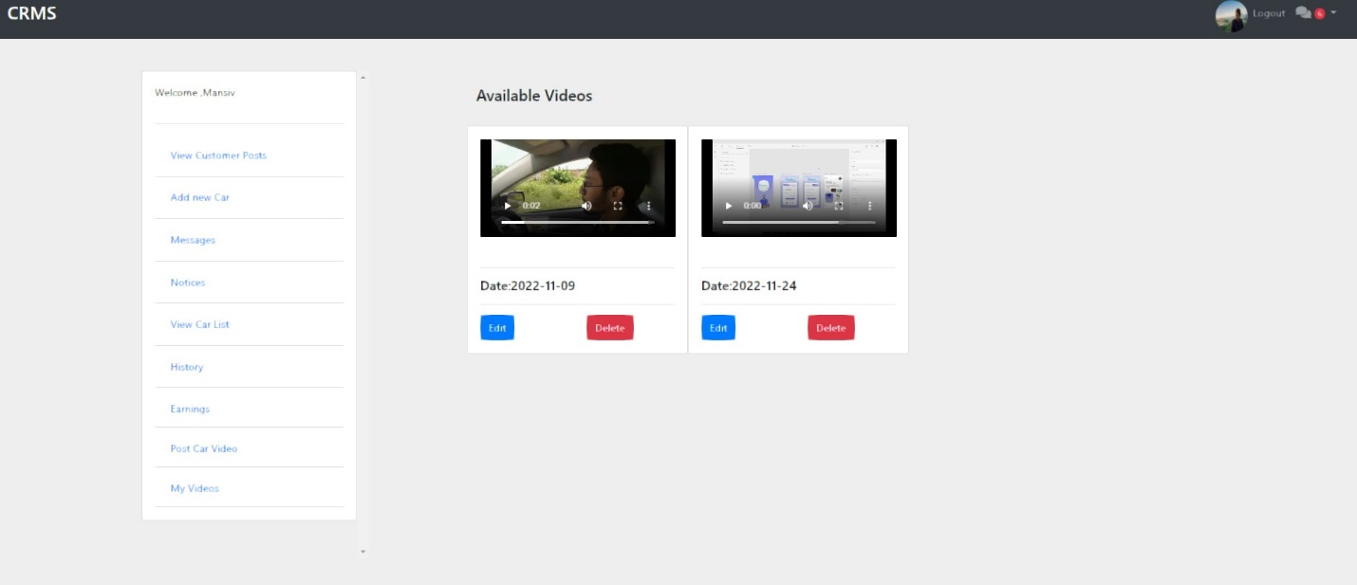

Figure 8: Watch Video Page

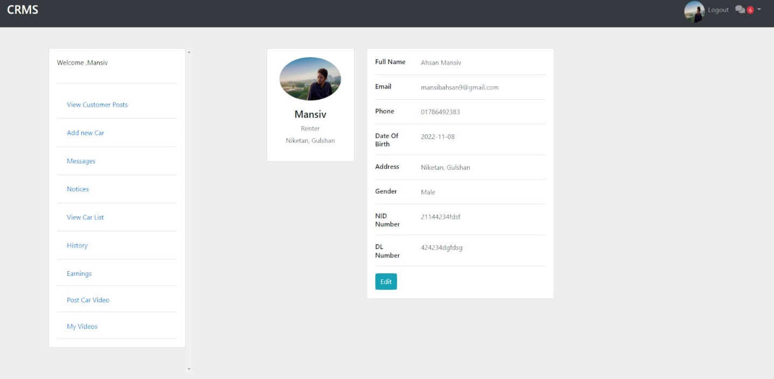

Figure 8: Profile Page

## Project Requirements

* Time: 4 Months (Estimated)
* Budget of 4 Lac (Estimated) BDT ➢ Need team of 04 members.
* Members should have technical knowledge
* A space for collaboration.
* Dedicated IDE for development

# FEATURES NOT TO BE TESTED

The following is a list of the areas that will not be specifically addressed. All testing in these areas will be indirect as a result of other testing efforts. For example:

* PC based spreadsheet analysis applications using Reassigned Sales data. Because these applications are completely under the control of the customer and are outside the scope of this project. The necessary data base format information will be provided to the customers to allow them to extract data. Testing of their applications is the responsibility of the application maintainer/developer.

# TESTING APPROACH

## Testing Levels

In this project, we will implement a test plan for the **Car Rental Management System**. To continue testing software in relation to the project, we need to go through three major stages of testing. Several test levels need to be addressed.

A **white-box testing** technique that tests the internal structure of an application. White-box testing requires a tester to step through the code line by line to ensure that internal operations are performed according to specifications and that all internal modules are properly implemented. We can use white-box testing during the development of our hotel management system to ensure that our system is functioning properly. Currently, there are several different types of white-box testing and these types of strategies can be used in test planning.

**Unit testing** is one of the basic steps performed in the early stages. Most testers prefer to see if a particular cord unit is working. Unit tests are one of the general steps performed for each activity because they help eliminate basic and simple bugs. Therefore, after completing each unit and module, we can create a test case and run a unit test to see if the module works as expected. For unit tests, there are also static and dynamic unit tests.

**The static analysis** step contains testing some of the static elements in our code. This step is performed to find one of the defects or errors that can occur in our application code. This step is important to rule out simple errors early in the testing process. **Dynamic analysis** is the next step in static analysis in a typical path test. Dynamic analysis helps us analyze and run the source code according to our

requirements. The final stage of the step helps in analyzing the output without affecting the process

Also, for our **Car Rental Management System,** we will implement **System integration testing** or **SIT**. SIT is mainly done to check how individual modules interact with each other when integrated into a system as a whole. It is conducted after unit testing and will be done each time when a new module is added to the system. SIT test cases focus on the interface between the system components.

And last but not least we will go through **Acceptance testing**. With the help of our development team, it will be done by the final users. They will check whether our system meets all the user requirements or not.

## Test Tools

At the industry level, there are a number of different test tools that can be used to test a 'Donate Money for Needy People' software application. Some examples of these tools include:

* + 1. Automated testing tools: These tools can be used to automate the testing process, allowing developers to quickly and efficiently test the software.
    2. Load testing tools: These tools can be used to simulate high levels of usage on the software, to ensure that it can handle large amounts of data and traffic without crashing or experiencing other issues.
    3. Security testing tools: These tools can be used to test the security of the software, to ensure that it is protected against potential threats and vulnerabilities.
    4. User experience testing tools: These tools can be used to test the user experience of the software, to ensure that it is intuitive and easy to use.

Overall, the use of test tools is an essential part of the software development process, as they help developers to ensure that the software is functioning properly and meets the necessary requirements.

At the industry level, there are many different software applications that can be used to test a 'Donate Money for Needy People' software application. Some common examples of testing software that may be used in this context include:

1. Selenium: This is an open-source automated testing tool that is commonly used for web application testing.
2. JMeter: This is a performance testing tool that can be used to assess the performance of a software application under different load conditions.
3. Burp Suite: This is a security testing tool that is commonly used to test the security of web applications.
4. User Zoom: This is a user experience testing tool that can be used to assess the usability, accessibility, and overall user satisfaction with a software application.
5. Postman: This is a popular software tool that is used for testing and developing APIs (Application Programming Interfaces). It allows users to create, test, and share APIs, as well as collaborate with others on API development.
6. Microsoft Project: This is a powerful bug tracking and project management tool that is widely used in the software industry. It provides a range of features and capabilities, including the ability to create and manage issues, track progress, and integrate with other tools and platforms.

Overall, there are many different software applications that can be used to test a 'Donate Money for Needy People' software application at the industry level. The specific tools that are used may vary depending on the specific needs and goals of the project.

## Meetings

A software testing meeting is a meeting where individuals involved in the testing of a software application come together to discuss the progress of the testing, any issues that have been identified, and any necessary next steps. This may include discussing the results of the testing, identifying any defects or flaws in the software, and determining how to address these issues. The goal of the meeting is to ensure that the software is functioning properly and meets all of the necessary requirements before it is released to the public.

During the software testing meeting, attendees may include the project manager, senior test engineer (test lead), junior test engineer, testing manager, and database analyst, among others. These individuals may provide updates on the testing process, discuss any issues that have been identified, and provide input on how to address these issues. The meeting may also involve reviewing and discussing test results, as well

as discussing any necessary changes or modifications to the software.

Overall, a software testing meeting is an important part of the software development process, as it allows individuals involved in the testing to come together and collaborate on ensuring the success of the project.

# TEST CASES/TEST ITEMS

|  |  |  |  |  |  |
| --- | --- | --- | --- | --- | --- |
| Project Name: Car Rental Management System | | | Test Designed by: Nafiz Azad | | |
| Test Case ID: CR_101 | | | Test Designed date: 30/11/2022 | | |
| Test Priority (Low, Medium, High): High | | | Test Executed by: Rahat Kamal Uddin | | |
| Module Name: User Registration | | | Test Execution date: 2/12/2022 | | |
| Test Title: Fill up registration form | | | | | |
| Description: Test registration form by giving input to all the fields and must give unique username, email and phone number. | | | | | |
| Precondition (If any): | | | | | |
| Test Steps | Test Data | Expected Results | | Actual Results | Status (Pass/Fail) |
| 1. Go to Registration Page 2. Complete all Input fields.   3.Click Register button | (Role, First name, Last Name, Username, Email,  Date of Birth, Gender, Phone number, Address,  NID Number, DL number, Password, Profile pic) | Registration Successful and Redirect to Login page | | As expected, | Pass |
| Post Condition: User data will go to database and redirect to login page | | | | | |

|  |  |  |  |  |  |
| --- | --- | --- | --- | --- | --- |
| Project Name: Car Rental Management System | | | Test Designed by: Nafiz Azad | | |
| Test Case ID: CR_102 | | | Test Designed date: 30/11/2022 | | |
| Test Priority (Low, Medium, High): high | | | Test Executed by: Rahat Kamal Uddin | | |
| Module Name: User Login | | | Test Execution date: 5/12/2022 | | |
| Test Title: Fill up login form | | | | | |
| Description: Test login form by giving input to all the fields and must give unique email and Correct Password | | | | | |
| Precondition (If any): User must register | | | | | |
| Test Steps | Test Data | Expected Results | | Actual Results | Status (Pass/Fail) |
| 1. Go to Login Page. 2. Complete all input fields with valid data.   3.Click Login button | Email:mansibahsan9@gmail.com  Password:123456 | Login successful and redirect to dashboard page | | As expected, | Pass |
| Post Condition: User is validated with database and successfully login to account. The account session details are logged in the database. | | | | | |

|  |  |  |  |  |  |
| --- | --- | --- | --- | --- | --- |
| Project Name: Car Rental Management System | | | Test Designed by: Ismail Hossain Rishad | | |
| Test Case ID: CR_103 | | | Test Designed date: 4/12/2022 | | |
| Test Priority (Low, Medium, High): High | | | Test Executed by: Mansib Ahsan Khan | | |
| Module Name: Create New Car | | | Test Execution date: 6/12/2022 | | |
| Test Title: Add Car For Rent | | | | | |
| Description: Test Add a new car form by giving input to all the fields and must give Car picture and unique Car number. | | | | | |
| Precondition (If any): User(Renter) must login | | | | | |
| Test Steps | Test Data | Expected Results | | Actual Results | Status (Pass/Fail) |
| 1. Click Add new Car in navbar. 2. Complete All the field with valid data.   3.Click Upload button | Car name: BMW  Car Model: M3 | Posted successfully | | All the field is required. | Fail |
| Post Condition: User is validated with database and successfully login to account. The account session details are logged in the database. | | | | | |

|  |  |  |  |  |  |
| --- | --- | --- | --- | --- | --- |
| Project Name: Car Rental Management System | | | Test Designed by: Ismail Hossain Rishad | | |
| Test Case ID: CR_104 | | | Test Designed date: 9/12/2022 | | |
| Test Priority (Low, Medium, High): Medium | | | Test Executed by: Khan, Mansib Ahsan | | |
| Module Name: Upload Car Video | | | Test Execution date: 10/12/2022 | | |
| Test Title: Upload Car Video For Review | | | | | |
| Description: Test upload a new car video form by giving required format input | | | | | |
| Precondition (If any): User(Renter) must login | | | | | |
| Test Steps | Test Data | Expected Results | | Actual Results | Status (Pass/Fail) |
| 1.Click Post Car video in navbar.  2. Complete the field with valid data.    3.Click Upload button | Choose file:VID_20200930124630.mp4 | Uploaded Successfully | | As expected, | Pass |
| Post Condition: User is validated with database and successfully login to account. The account session details are logged in the database. | | | | | |

|  |  |  |  |  |  |
| --- | --- | --- | --- | --- | --- |
| Project Name: Car Rental Management System | | | Test Designed by: Khan, Mansib Ahsan | | |
| Test Case ID: CR_105 | | | Test Designed date:11/12/2022 | | |
| Test Priority (Low, Medium, High): High | | | Test Executed by: Ismail Hossain Rishad | | |
| Module Name: Edit Profile | | | Test Execution date:12/12/2022 | | |
| Test Title: Update user profile | | | | | |
| Description: Test edit user profile information | | | | | |
| Precondition (If any): User(Renter) must login | | | | | |
| Test Steps | Test Data | Expected Results | | Actual Results | Status (Pass/Fail) |
| 1. Click Profile   Pic icon at top nav.  2. Edit the field with valid data.    3.Click Update button | Upload Photo:  Annotation 2022-11-02 204904.jpg | Updated Successfully | | As expected, | Pass |
| Post Condition: User is validated with database and successfully login to account. The account session details are logged in the database. | | | | | |

|  |  |  |  |  |  |
| --- | --- | --- | --- | --- | --- |
| Project Name: Car Rental Management System | | | Test Designed by: Khan, Mansib Ahsan | | |
| Test Case ID: CR_106 | | | Test Designed date: 11/12/2022 | | |
| Test Priority (Low, Medium, High): Medium | | | Test Executed by: Ismail Hossain Rishad | | |
| Module Name: Logout | | | Test Execution date: 12/12/2022 | | |
| Test Title: logout from user profile | | | | | |
| Description: Test logout from system | | | | | |
| Precondition (If any): User(Renter) must login | | | | | |
| Test Steps | Test Data | Expected Results | | Actual Results | Status (Pass/Fail) |
| 1. Click logout button at top of navbar. |  | Logged out | | As expected | Pass |
| Post Condition: User is validated with database and successfully login to account. The account session details are logged in the database. | | | | | |

# ITEM PASS/FAIL CRITERIA

The test process will be completed once the initial set of distributors have successfully sent in reassigned sales data for a period of one month and the new EDI data balances with the old ZIP/FAX data received in parallel. When the sales administration staff is satisfied that the data is correct the initial set of distributors will be set to active and all parallel stopped for those accounts.

# TEST DELIVERABLES

* Acceptance test plan
* System/Integration test plan
* Unit test plans/turnover documentation
* Screen prototypes
* Report mock-ups
* Defect/Incident reports and summaries
* Test logs and turnover reports

# STAFFING AND TRAINING NEEDS

The importance of skilled personnel and teams in the construction and delivery of a project cannot be overstated. A team of skilled professionals is required to perform this job properly. Because the project can be finished on budget and on schedule with skilled workers and staff; otherwise, a lack of skilled workers can make it difficult to complete the project on time. As a result, it should be thoroughly tested to ensure that the personnel and workers are qualified for the project. To develop and ensure that various skill-based training sessions can be scheduled. Project manager, senior test engineer (test lead), junior test engineer, testing manager, database analyst and other professionals make up the team. If a senior test engineer is unavailable for a period of time, the project manager can take over or replace the junior engineer with someone who has the necessary abilities.

# RESPONSIBILITIES

|  |  |  |  |  |  |
| --- | --- | --- | --- | --- | --- |
|  | Team Manager | Project Manager | Development Team | Test Team | Client |
| Acceptance test plan |  |  |  |  |  |
| Integration test plan |  |  |  |  |  |
| Unit test plans |  |  |  |  |  |
| Screen prototypes |  |  |  |  |  |
| Report mock-ups |  |  |  |  |  |
| Defect/Incident reports and summaries |  |  |  |  |  |
| Test logs and turnover reports |  |  |  |  |  |
| Screen & Report prototype reviews |  |  |  |  |  |
| Change control and regression testing |  |  |  |  |  |

# TESTING SCHEDULE

Time has been allocated within the project plan for the following testing activities. The specific dates and times for each activity are defined in the project plan timeline. The persons required for each process are detailed in the project timeline and plan as well. Coordination of the personnel required for each task, test team, development team, management and customer will be handled by the project manager in conjunction with the development and test team leaders. Schedule must be done using any PM tool.

|  |
| --- |
| Figure 1:Project Plan |

|  |
| --- |
| Figure 2:Project Gantt-chart |

|  |
| --- |
| Figure 3: Task name |

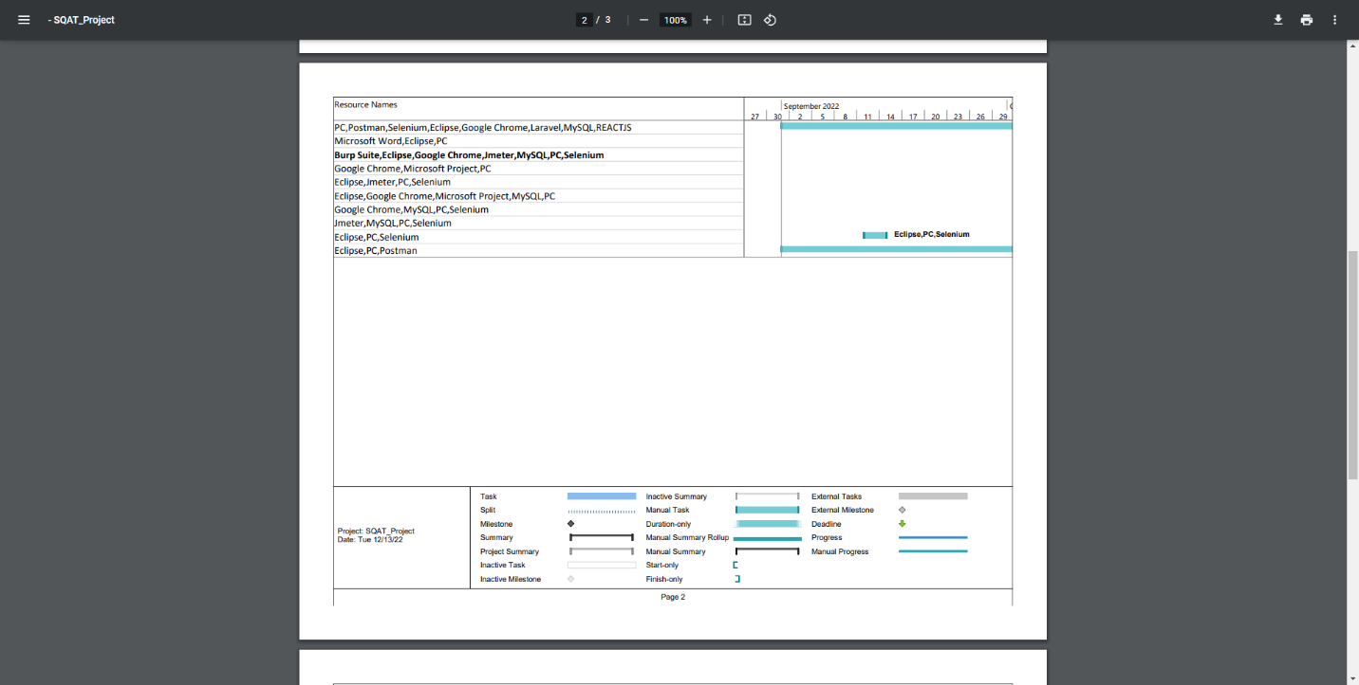

Figure 4: Resource Names

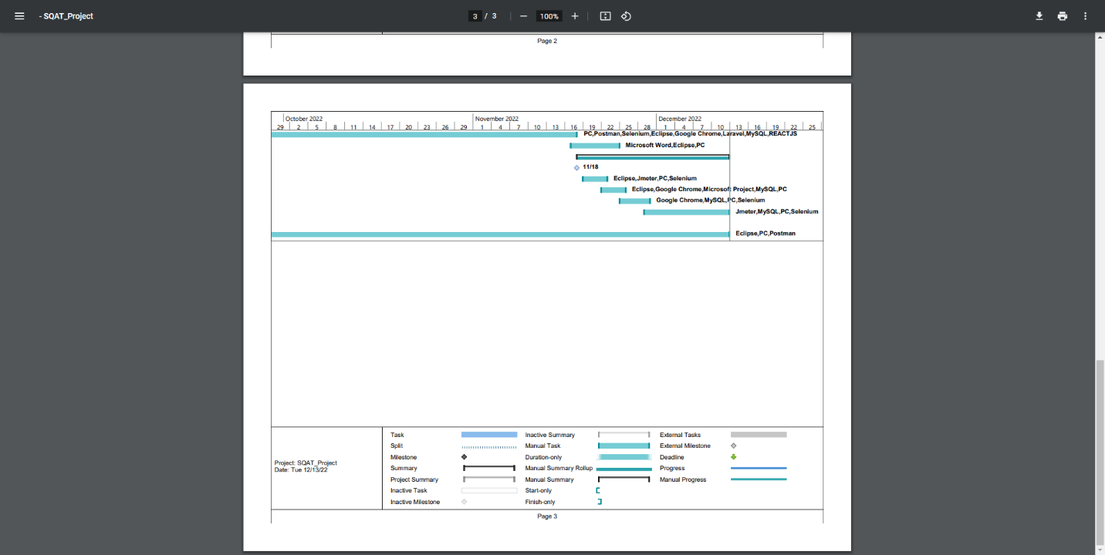

Figure 5:Progress Gantt Chart

# PLANNING RISKS AND CONTINGENCIES

Risks can have a big impact on a software development project's success. For instance, risks connected to the timetable can result in delays, which can increase project costs and even generate client displeasure. Inaccurate cost estimates can also result in cost-related hazards, which can have an adverse effect on the project's overall success and cause financial problems.

The success of a project can also be adversely affected by technical debt, which is brought on by subpar code. Other developers may find it challenging to read and comprehend this kind of code, which may make it challenging for them to maintain or modify the code. Additionally, rushed or improperly tested code may include a significant number of errors that degrade overall functionality of the software.

Effective communication with stakeholders is also crucial for the success of a software development project. If stakeholders are not engaged and do not provide feedback and input in a timely manner, it can hinder the progress of the project and impact its overall success.

In order to mitigate these risks and ensure the success of a software development project, it is important to have a thorough understanding of the potential risks and take steps to address them. This can involve conducting thorough testing, engaging with stakeholders effectively, and implementing risk management strategies to minimize the potential impact of risks on the project.

# APROVALS

|  |  |
| --- | --- |
| **Project Manager** | Ismail Hossain Rishad |
| **Developer** | Khan, Mansib Ahsan |
| **Test Lead** | Nafees Khan |
| **Test Planner** | Nafiz Azad |
| **Tester** | Rahat Kamal Uddin  Md Sabbir  Iftekhar Ifti |
| **End User** | Md Redoy  S.M Shahriar  Bristi Gayali |