*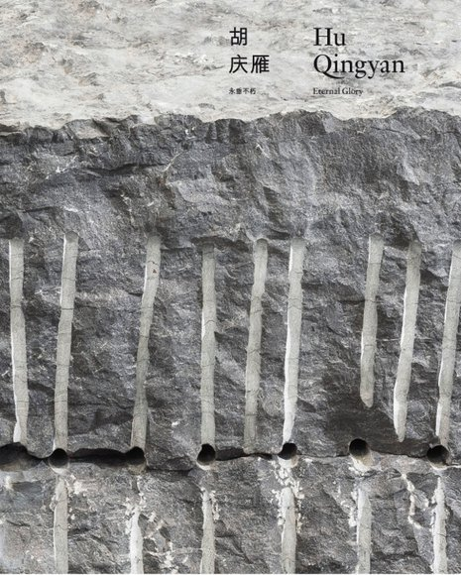*

*Eternal Glory*

Galerie Urs Meile, Beijing-Lucerne, 2015  
With an interview by Jérôme Sans and a text by Wang Chunchen  
Softcover, 114 pages  
25 x 20 cm  
ISBN: 978-3-906134-30-7

#### 2013Cover_HuQingyan.jpg *Reincarnation in A New Guise*

Galerie Urs Meile, Beijing-Lucerne, 2013  
With an interview by Karin Seiz  
Softcover, 36 pages  
25 x 21 cm  
ISBN: 978-3-9524064-1-0

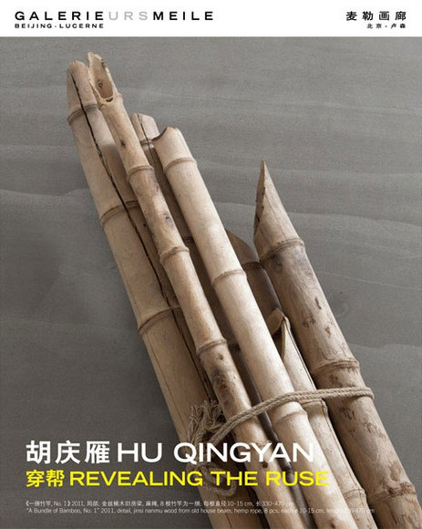

#### *REVEALING THE RUSE*

Published by: Galerie Urs Meile, Beijing-Lucerne, 2011  
With a text by Liu Libin  
Leporello, 10 pages  
25 x 20 cm